Analytical Model for Heat Absorption: Lessons Learned From a One Dimensional Model

Joshua Stimson1, a), Michael Ward1, Peter Docker2, John Sutter2, Jim Kay2,   
Trevor Rayment2 and Sofia Diaz Moreno2

1Birmingham City University, Faculty of Computing, Engineering and the Built Environment, Millenium Point, 1 Curzon Street, Birmingham, West Midlands, B4 7XG, United Kingdom

2Diamond Light Source Ltd, Harwell Science and Innovation Campus, Chilton, Didcot, Oxfordshire, OX11 0DE, United Kingdom

a)Corresponding author: joshua.stimson@bcu.ac.uk

**Abstract.** An analytical model was constructed of a single silicon crystal monochromator. This model was used to examine the heat transfer processes within the monochromator. It was discovered that extracting heat from the top surface of the monochromator could cause the peak temperature to be below the surface of the crystal; this dislocation was shown to be approximately 10% of the thickness of the crystal when 20% of the input power was extracted from the top surface.

# Understanding the Problem – The Current System

Most X-ray synchrotron facilities use monochromators composed of single crystals of silicon to extract X-rays of a selected wavelength from the broad spectrum emitted by the radiation source. The unwanted radiation heats the crystal non-uniformly as it is absorbed, inducing strains that broaden the diffracted beam, increase its divergence and degrade its bandwidth1. To deal with this heat load, many facilities use liquid nitrogen to cool their crystals2–4, while facilities with lower heat loads use water cooling systems4. Such cooling systems are classified as direct if the coolant is in contact with the crystal and indirect if a path of thermally conducting materials separates the coolant from the crystal.

Current cooling designs have been sufficient until now, but planned increases in the X-ray flux generated by synchrotrons and X-ray free electron lasers are intensifying the demands on their performance. This work details the preliminary findings of a collaborative PhD program associating the Diamond Light Source and Birmingham City University. The first crystal of the indirectly cooled 4-bounce silicon-crystal monochromator (Fig. 1.a) in use on the Diamond beamline I20 will be reviewed here as a practical case for future improvements in cooling.



Heat delivered by beam

Heat flowing in and out of element dx

Heat radiated from surface

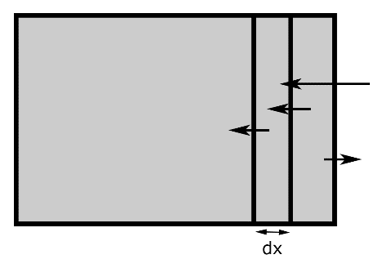

**a) b)**

**FIGURE 1**. a) The monochromator crystal assembly as used at Diamond Light Source, consisting of two single silicon crystals held in a copper heat exchanger. An indium foil is visible between these, as well as the copper pipes that carry the liquid nitrogen to the heat exchanger.   
b) Simple one dimensional model showing the heat transfer processes present in the crystal.

The thermal distortion of the monochromator crystals is now limiting the performance of many synchrotron sources and the development of an effective monochromator cooling system is therefore a priority for all synchrotron sources. The analysis of such a complex structure is necessarily complicated as it involves many different types of material, thermal and mechanical junctions, all of which can lead to results that are particularly difficult to interpret. In order to better understand heating and the resultant distortion of the monochromator we have developed a simple one dimensional analytical model, shown above in Fig. 1.b). This will help us to investigate the basic physics of power absorption, heat flow and deformation, particularly in a simple, bulk crystal. A one-dimensional model is justified if the incident beam illuminates the crystal surface uniformly (as could be done with a wiggler beam), if the cooling occurs only at the crystal surface opposite the incident beam, all the crystal’s side surfaces are perfectly insulated and the cooling is applied to the end surface of the crystal.

# Understanding the Physics - the Analytical Model

To begin to understand the underlying physics of the system we designed and built a one dimensional analytical model. We first considered the general heat diffusion equation as shown in Eq. a,



where *x* is the length coordinate, *t* is elapsed time, *ρ* is the density of the material, *c* is the specific heat capacity, *T*(*x*,*t*) is the temperature, *k*(*T*(*x*,*t*)) is the linear thermal conduction as a function of temperature and *P*(*x*) is the input power at the given point x.

This equation governs the heat flow within any solid body. In this case, the input power of the system, *P*(*x*), is the power deposited by the light beam, as given in Eq. b. Here we have assumed a monochromatic beam; in reality both the initial intensity and attenuation coefficient would change with each wavelength. Also, we have not accounted for the amount of energy carried away by the Bragg diffracted beam as this would be very low compared to the intensity of the sum of the other wavelengths.



where *μ* is the attenuation coefficient (dependent on the wavelength of light and material) and *I*0 is the intensity of the beam at the surface.

We have simplified the heat diffusion equation by considering the crystal to be in the steady state:



As a first approximation we have simplified our calculations by assuming *k* to be independent of temperature. This is expected to be valid for a thin crystal that exchanges little power with its surroundings, as then the temperature should be nearly uniform along the crystal’s length. This gives us the following equation:



The other process present in the crystal is heat loss due to radiation, as shown in Eq. e below. Rather than being included in the heat diffusion equation this process is applied separately as an iterative process; the radiation is reliant on the surface temperature, but also changes it. As such we must recalculate the power loss iteratively until we reach equilibrium. It is important to note that in situ a heat shield cooled by liquid nitrogen has been installed opposing the monochromator crystal; this allows radiation from the crystal to the shield for a net loss of energy, rather than from the environment to the crystal for a net gain.



where dP is the number of joules lost to the environment per unit time, ε is the emissivity of the material, σ is the Stefan-Boltzmann constant, Tcrystal is the temperature of the hot surface of the crystal, Tshield is the temperature of the heat shield, maintained at 80K to optimize radiation, and A is the surface area.

As our simple analytical model was based on a second order differential we required two boundary conditions. Equation (e) is already one boundary condition, but because this is complex, the temperature and the temperature gradient at the rear surface of the crystal have been chosen here. The former was set to 80K to emulate a flow of liquid nitrogen, while the latter was defined in terms of the percentage of incident power such that we could model the radiation from the opposite surface, which here is treated as a small perturbation that balances the total power flow into and out of the crystal.

# Results - the Peak Temperature

We ran our analytical model using the values given in Table 1 below. The absorption coefficient was chosen assuming a 12keV beam, as this is the peak power at the aforementioned I20 beamline. The intensity at the surface assumes the beam delivers 500W uniformly across the crystal surface, 1mm on each side. The thermal conductivity used is that of silicon at 80K, as is the emissivity. The cross-sectional area and crystal thickness are not those used at the I20 but are simplifications.

**TABLE 1.** Description of variables used throughout simulations.

|  |  |  |  |
| --- | --- | --- | --- |
| **Variable Name** | **Represents** | **Value** | **Units** |
| μ | Absorption coefficient | 48.42 [5] | 1/m |
| I­0 | Intensity at surface | 5e8 | W/m2 |
| k | Thermal conductivity | 1900 [6] | W/m/K |
| ε | Emissivity | 0.7 [7] |  |
| A | Cross-sectional area | 1e-6 | m2 |
| x | Crystal thickness | 0.1 | m |

The first observation we made was that contrary to popular belief, thinner crystals are less susceptible to overheating, as shown in Figure 2.a). The most important factor here appears to be the distance between the absorbing region and the cooling system. This means thicker crystals have a larger region at constant positive temperature gradient, giving rise to a peak temperature dependent on the thickness of the crystal.

The second interesting discovery was that the hottest part of the crystal is not at the surface. As the penetration depth of X-rays in silicon is significant7 and energy is lost from the surface in the form of grey body radiation, the point with the highest temperature is actually some distance inside the crystal. This phenomenon was first observed assuming significant heat loss due to grey body radiation; approximately 20% loss gave the results shown in Fig. 2.a). Note that the range of temperature shown in Fig. 2.a) is indeed small enough (about 6 K) to validate the initial assumption of temperature-independent thermal conductivity.

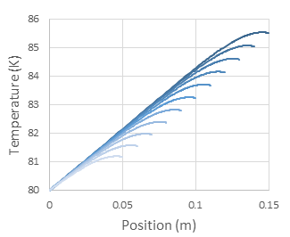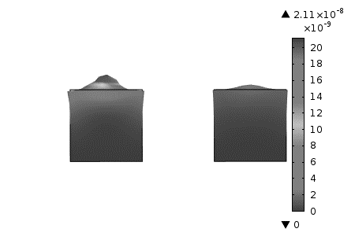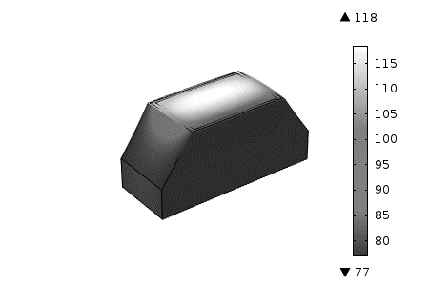

**a) b) c)**

**FIGURE 2**. a) Graph showing the temperature at varying depths; each line shows a different length of crystal from 0.05m to 0.15m.   
b) Finite element simulation showing the difference between a plateau lift (left) with heat source within the block and a heat bulge (right) with surface heat source; both heat sources are 10W point sources. The colour bar shows deformation in metres.   
c) Finite element simulation of a monochromator crystal with incident beam power of 500 W. Deformation is scaled x100. The colour bar shows absolute temperature in deg K.

We then ran the analytical model with more physical terms, based on the I20 beamline at the Diamond Light Source; the beam was modelled as 25mm x 38mm delivering a total power of 500W. We also modelled a heat shield, setting the cold temperature for the grey body radiation at 80K. However, due to the region reaching peak temperatures being within the beam footprint, which is only on the scale of millimeters, and with the hottest region barely reaching 200K, the energy loss is very small – approximately 60mW. This only pushes the peak heat below the surface an order of nanometers. However, we note that in this case more accurate treatments of Eq. (c) are required because the thermal conductivity varies from 19.5 W cm−1 K−1 at 80 K to 3.2 W cm−1 K−1 at 200 K, invalidating the initial assumption that thermal conductivity is independent of temperature for a model of more realistic dimensions. Methods for obtaining such solutions are now under development.

Although this shows us that the phenomenon is not significant in practice it gives rise to an interesting possibility; if we were to cool the surface of the crystal sufficiently to drive the temperature peak into the body of the crystal, it should be possible to cause the thermal distortion to produce a plateau lift rather than a bulge, as shown in Fig. 2.b). By reducing the variation of the deformation we would diffract fewer wavelengths of light, reducing both the wavelength spread and the divergence. This would require us to extract approximately 20% of the incident power from the surface, either through radiation, surface cooling or a mixture of both.

# The Third Dimension - Finite Element Analysis

Although a one dimensional model is useful to help us understand the mechanisms at work within the crystal, it is far from physically complete. In order to truly understand the heat flow in the system, we needed to consider all three dimensions. While it is possible to build an analytical model from base principles in three dimensions it is very constrained as to what boundary conditions it can model. Instead we have used finite element analysis software, namely COMSOL Multiphysics. This has allowed us more freedom, as we can enter more varied physical constraints.

We first used the FEA software to confirm our earlier findings, running the same boundary conditions as those given in Table 1 above to ensure our results were accurate. The exception to this was the thermal conductivity; as COMSOL is a more powerful program than our analytical model we were able to read in a full range of thermal conductivities from 0K to 400K, apply an interpolation and interrogate it for the appropriate k(T). Once again we observed a peak temperature within the material, showing that our earlier models were correct.

Once this was complete, we moved on to modelling complete silicon crystals as shown in Figure 2.c). These simulations used the dimension of the silicon monochromator crystals used at the I20 beamline at Diamond Light Source. The crystals are 0.038m thick, with a diffracting surface of 0.025m x 0.018m. We also used the interpolated thermal conductivity mentioned above and the physical constants from Table 1. So far, we have assumed a universal intensity across the surface of the crystal akin to that produced by a wiggler emission source. This has shown us that although the system only reaches a peak temperature of 118K, there is quite a varied thermal deformation across the surface; this broadens the bandwidth of the diffracted beam.

Currently our focus is on the mechanisms through which the X-rays interact with the crystal. We are considering a number of mechanisms, including Bragg diffraction, Fresnel reflection, photon-phonon interactions, and free hole and electron production - the last of which could lead to a higher thermal conductivity than previously expected.

# References

1 L. Zhang, M. Sánchez Del Río, G. Monaco, C. Detlefs, T. Roth, A.I. Chumakov, and P. Glatzel, J. Synchrotron Radiat. **20**, 567 (2013).

2 D.H. Bilderback, a K. Freund, G.S. Knapp, and D.M. Mills, J. Synchrotron Radiat. **7**, 53 (2000).

3 P. Marion, L. Zhang, and L. Goirand, in *Proceeding MEDSI 2006* (Grenoble, 2006).

4 P. Carpentier, M. Rossat, P. Charrault, J. Joly, M. Pirocchi, J.L. Ferrer, O. Kaïkati, and M. Roth, Nucl. Instruments Methods Phys. Res. Sect. A Accel. Spectrometers, Detect. Assoc. Equip. **456**, 163 (2001).

5 S. Seltzer and J. Hubbell, Natl. Inst. Stand. Technol. (1995).

6 C.J. Glassbrener and G.A. Slack, Phys. Rev. **134**, A1058 (1964).

7 ICRU, *Radiation Quantities and Units* (Bethesda, 1980).