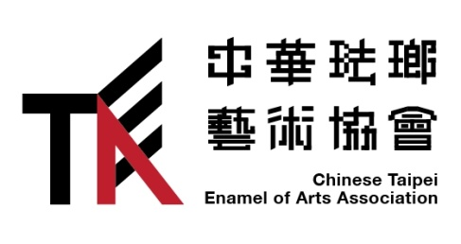
【炙－國際當代琺瑯展】
◎展覽企劃 | 中華琺瑯藝術協會Chinese Taipei Enamel of Art Association
◎策展人 | 吳竟銍、楊炘彪
◎主辦單位 | 國立台灣工藝研究發展中心
◎協辦合作 | CC Gallery 藝文空間、三丰金屬漆藝工作室。
預計展期 | 2018年 4-8月
預計場地 | 工藝研究發展中心 台北分館 4F

將文字當中的「炙」在中國字意來說，代表了「熱得燙手，譬喻貴氣焰很盛」。透過火、溫度與時間的淬鍊，展現出如夕陽般五彩光輝的琺瑯創作。琺瑯工藝之中，表現技法眾多，藝術家或創作者專注於不同技術的展現之下，更需要將內心的感受透過色彩、造型以及對於材料的專業，才有辦法將琺瑯工藝的作品完成。

琺瑯工藝於公元前5至6世紀希臘人曾燒過掐絲琺瑯，至6世紀拜占庭帝國時期琺瑯工業盛行，在10至13世紀初為掐絲琺瑯的鼎盛期，大多以宗教器物為大宗。在南宋約西元12 世紀掐絲琺瑯技術向東傳入中國，蒙古元朝時，政策上重視工匠，手工業因而一路發展 ，至15世紀中期，琺瑯器在中國十分盛行。也由於中國人早在東漢時便能燒出瓷器，在數百年歲月累積的燒窯經驗和技術之下，演進為基礎，開始大量燒製琺瑯器。在現今的琺瑯工藝裡，日本將琺瑯稱作為「七寶燒」則中國稱「景泰藍」，在不同國家的創文化下，也創作出多樣性的琺瑯風格與藝術。藝術家藉由不同工藝器物的元素以及創作思維，來表現琺瑯工藝。將琺瑯以珠寶、首飾、器物到藝術創作等方式來展現琺瑯的多元性。

參展資格與格式
作品包含
每位藝術家3~5件系列作品。以琺瑯內容為主之創作。
作品形式為下列幾種：
- 首飾
- 器物
- 物件或牆面繪畫

報名
不收取任何報名費用。並請妥善填寫表格於期間內以郵件方式寄給主辦單位。方便印製宣傳品與專刊。
展出作品須寫下保險金額與販售金額，於報名表格內。並請將報名表格以電子郵寄給主辦單位。主辦單位將會與電子郵件回覆收到資訊與否。販售作品空間則將收取一半的費用。
聯絡資訊
台灣新北市樹林區學勤路398號 中華琺瑯藝術協會。吳竟銍 先生
Phone： +886-226683310 Cellphone：+886-910957350
e-mail:enamel.tw@gmail.com

郵寄方式
建議以EMS或AIR Mail為主，避免以FedEx 或UPS寄送，以免被刻關稅。建議詢問附近郵局有關特快專遞服務。

作品寄還
作品將於展出後將寄送還給藝術家。
責任藝術家需將自行將作品運送保險。主辦單位將會於展期間將作品保險。

協議
主辦單位將有權利使用展出作品之照片作為公開宣傳、出版等相關活動於展覽期間。

通知
藝術家須將個人資料表格、作品照片一張個人照，高解析度300dpi以郵寄方式寄給主辦單位。方便做於海關報稅，並用於製作專輯使用。

ZHI-International Contemporary Enamel
Jewelry and Object Exhibition

Organisers: National Taiwan Craft Research and Development Institute, Chinese Taipei Enamel of Art Association
Curator: WU,CHING-CHIH, YANG XIN-BIAO
Cosponsorship: CC Gallery, Three Trees Studio

The main theme of this Enamel Exhibition refers to firing, comes from taking apart the Chinese word “ZHI”. Through firing, temperature and time, creating various brilliant enamel works. Among numerous enameling techniques, the artist must focus on certain approach, with unique sense of beauty and develop certain wayto manage material in order to create the works.

The ancient Greeksbegan using cloisonné enamel around 5-6th century B.C. The enamel industry began to thrive from6th century A.D. during the Byzantines era and reached an apex between 10-13th A.D. The Byzantines then began to use cloisonné more widely to create images, mostly on religious objects. By the 12th century, the cloisonné technique reached China. During the Yuan dynasty, the emphasis on craftsmanship makes the handcraft industry prosper, continuing until the 15th century.Since the Chinese had already been manufacturing porcelain since Eastern Han dynasty, it was a natural adaptation of the technique for making enamel and as a result the enamel vessels began to be made in large quantities. Nowadays, enamel iscalled「七宝焼(shippoyaki)」in Japan , and「景泰藍(Jing Tai Lan)」in China. This form of art continues to evolve in different cultures with varied styles as artists express through hnumerous forms ranging from objects, jewelries, to vessels.

This exhibition,presented by National Taiwan Craft Research & Development Institute and Chinese Taipei Enamel Arts Association, will feature the enamel collections from The Japan Shippo Conference and The Enamel Arts Foundation from California. Furthermore, the Chinese Taipei Enamel Arts Association will showcase enamel artworks from Taiwan, China, Korea, United States, England, Canada, Lithuania and Australia.

【炙－國際當代琺瑯展】
◎展覧企画 |中華琺瑯芸術協会Chinese Taipei Enamel of Art Association
◎プロデューサー | 吳竟銍、楊炘彪
◎主催|国立台湾工芸研究発展センター
◎協力| CC Gallery 藝文空間、三丰金屬漆藝工作室。
予定会期 | 2018年 4-8月
予定会場 |国立台湾工芸研究発展センター台北分館 4F

展覧企画| 文字 吳竟銍

中国語言葉「炙」と言う意味は、「手をかざせば焼けるように熱い、権勢が強く大いに気炎を盛り上がる」比喩である。琺瑯創作は火と温度と時間を掛け、夕焼けのような輝かしさを表現される工芸です。琺瑯工芸の中、技術を表現するのが多く、芸術家あるいは作者は異なる技術を求め、心の中に感じられた事を色彩と造形等で、又は材料に関する専門な知識を通し、この上で琺瑯工芸の作品が完成することができます。
琺瑯工芸は紀元前5～6世紀イオニア人がエマイユ・クロワゾネ（有線七宝）を制作された事があると言われています。6世紀東ローマ帝国時代から琺瑯工業が盛んになり、10世紀～13世紀までエマイユ・クロワゾネの最高峰時期と言われた、主には宗教もの、ロザリオ等を作られていた。中国大陸では南宋約12世紀の頃からエマイユ・クロワゾネ技術が東から中国に伝わり、モンゴル元朝の時、制度により工匠を重視し、それから15世紀中までには七宝器が中国で盛んになり。または後漢時期から焼き物技術の進歩が著しい、数百年の経験に重ねて窯焼き経験と技法の基で琺瑯器を大量生産するようになった。現在、日本には「七宝焼」という、中国では「景泰藍」ジン‧タイ‧ランと呼ぶ。文化的異なる国にも様々な琺瑯作品を発展される、芸術家は違うの工芸技法と創作想いによって、ジュエリー、アクセサリー、器、オブジェを創作あらゆるな分野で琺瑯工芸の多様性を表現している。

応募資格、応募作品
応募一人3～5点シリーズ作品。主には琺瑯で仕上げた作品。
作品の形式：
1.ジュエリー
2.器
3.オブジェや壁掛け七宝画

중화칠보 예술협회
炙(구울 적)국제현대칠보전
전시기획︱ 중화칠보예술협회
주최자︱오진지(吳竟銍)、 양흔표(楊炘彪)
협찬기관︱CC Gallery예술문화공간、삼봉(三丰)금속옻칠예술작업실
예상전시기간︱2018년 4-8월
예상전시장소︱공예연구발전센터 타이베이별관 4층
전시기획︱글 오진지吳竟銍

「炙」이라는 글자는 중국어에서 “손을 델 정도로 뜨겁고 권문귀족들의 권세가 세다는 것을 비유적으로 말한다. ”이라는 뜻이다. 칠보작업을 할 때 우리는 불﹐온도와 시간등 요소들을 가지고 어려운 과정을 통해 노을빛과 같은 풍부하고 찬란한 색깔을 만들어 내었다. 칠보공예는 여러가지 기법들을 포함하고 있다. 그렇지만 작가들은 여러가지 기법으로 작품을 표현하는 데 집중해야 할 뿐만아니라 자기마음속의 감정을 색깔﹐조형과 재료에 대한 전문적인 지식등을 통해서 칠보작품을 완성할 수 있다.

參展資格與格式
참가자격과 격식
作品包含
작품설명
每位藝術家3~5件系列作品。以琺瑯內容為主之創作。
작가마다 3-5건의 시리즈 작품은 출품하고 칠보위주의 작품이어야 한다.
作品形式為下列幾種：
작품형식은 아래와 같다.
1.首飾 악세서리
2.器物 기물
3.物件或牆面繪畫 소품과 액자작품

一、基本資料
基本資料Porfile
姓名name | Stephen Bottomley | 國籍nationality | British
Email | stephenbottomley@hotmail.com | 聯絡電話phone | +44 (0) 7812040068
地址address | 10 Victoria Park Neuk, Trinity, Edinburgh, EH64NG Midlothian, Scotland, United Kingdom, GB
國內外參展經驗及得獎紀錄experience  (中英文) | Professor Stephen Bottomley is the Head Of School of Jewellery at Birmingham City University.  Stephen trained at the Royal College of Art (MPhil RCA 1999-2001) and the University of Brighton (MA 1996-98) which included a key period at Rhode Island School of Design, USA graduate metal programme in 1998. Previous study includes Hasting College of Art, Sussex (BTEC Foundation 1985-6), West Surrey College of Art and Design, Surrey (BA Hons 3D-Design metals 1986-89), Sir John Cass Institute of Art & Design, London (1992 Special studies Programme)  The Prince’s Youth Business Trust Award and an Enterprise Allowance Scheme helped established his first studio in 1990 in Brighton, Sussex.  Bottomley lectured at Hastings College of Art for twelve years (1992- 2004), with concurrent years at the University of Brighton and the Surrey Institute of Art & Design (2000-04), before moving to Sheffield Hallam University as course leader of Metalwork and Jewellery (2004-08).  Between 2003-2007 he served as Vice Chair and then the fourth chairman for the national Association for Contemporary Jewellery (ACJ). In 2008 he moved to Scotland to take post as Head of Jewellery and Silversmithing at Edinburgh College of Art, who subsequently merged with the University of Edinburgh in 2011. Bottomley joined Birmingham  City University in 2017 as Head of School of Jewellery and Professor of Jewellery.
個人簡介statement  (中英文) | Inspired by the rhythm and patterns found in oriental motifs and mathematical geometry, I seek to capture their inherent beauty in fine metalwork and contemporary jewellery.  New digital technologies alongside the ancient Goldsmith’s craft combine to translate these surfaces qualities to metal by etching and printing techniques. Vitreous enamel is often applied to my jewellery to reinforce the animated state of these enriched patterns through transparent coloured layers.
網址website | http://klimt02.net/jewellers/stephen-bottomley

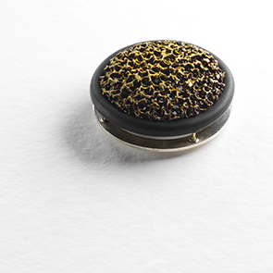 Moss Brooch

二、參展作品基本資料(自行複製增加)
1 做品名稱(中英文)： Moss Brooch, 2014

材質materials (中英文) | Copper, Bronze, White Metal, Stainless Steel and Enamel
產品尺寸size | Approx 45mm Diamater
產品簡介(中英文)description | Brooch
產品照片work picture  (see above) | (請提供產品高解析度之照片數張)
售價Sales price | NT 29000 | US 970
保險金額Insurance Value | NT 14500 | US 485

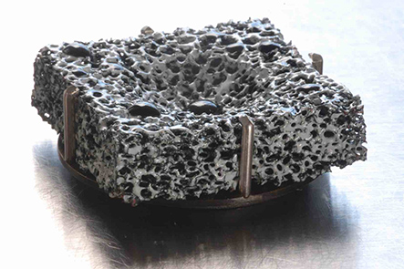
Heat Exchanger

2 做品名稱(中英文)：Heat Exchange Brooch 2012

材質materials (中英文) | Copper, Bronze, White Metal, Stainless Steel and Enamel
產品尺寸size | 30mm x 30 x 8mm
產品簡介(中英文)description | Brooch
產品照片work picture
(see above)
售價Sales price | NT 19000.00 | US 630
保險金額Insurance Value | NT 9500.00 | US 320

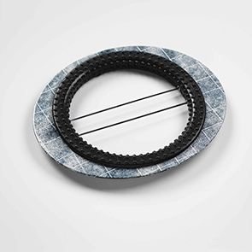
Traces Black

- 做品名稱(中英文)： Traces Black
材質materials (中英文) | enamel, steel + rubber
產品尺寸size | Approx 110 x 95 x 4 mm
產品簡介(中英文)description | Brooch
產品照片work picture  (see above) | (請提供產品高解析度之照片數張)
售價Sales price | NT 29000 | US 970
保險金額Insurance Value | NT 14500 | US 485

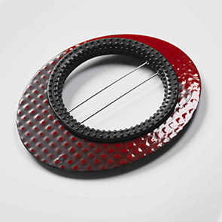
Traces Red

- 做品名稱(中英文)： Traces Red
材質materials (中英文) | enamel, steel + rubber
產品尺寸size | Approx 110 x 95 x 4 mm
產品簡介(中英文)description | Brooch
產品照片work picture | (請提供產品高解析度之照片數張)
售價Sales price | NT 29000 | US 970
保險金額Insurance Value | NT 14500 | US 485

