โครงการการจัดประชุมว�ชาการนานาชาติ ดนตร�กับการพัฒนาสังคมวัฒนธรรมอาเซียน

PGVIM INTERNATIONAL SYMPOSIUM

th
AUGUST 30

-st

aStEPPriTncEesMs GBaElyaRni1Vad2h0a1n7a
Institute of Music, Thailand

Message from
Associate Professor Khunying Wongchan Phinainitisatra
President of Princess Galyani Vadhana Institute of Music

The International Symposium “Music, Myths & Realities” was initiated in accordance with the three-part mission of the Princess Galyani Vadhana Institute of Music:
1) to support young artists; 2) to develop new knowledge through interdisciplinary research; and 3) to promote a better understanding of music among the general public. These three goals reflect the vision of Her Royal Highness Princess Galyani Vadhana.

The 2017 Princess Galyani Vadhana Institute of Music's International Symposium was an exciting and fruitful event. Over the course of three days, academics, artists and students engaged in discussions about topics that contribute to a re-shaping of classical music in this region and that enhance our understanding of music’s ability to improve our lives.

The Institute is indebted to our 2017 keynote speakers, Professor Nigel Osborne, Dr. Kat Agres, Professor Robert Cutietta, Associate Professor Dr. Narutt Suttachitt, Peter Veale, Dr. Jean-David Caillou t, Professor Shinuh Lee, Professor Dieter Mack, Professor Bernard Lanskey, Dr. Verne de la Pe a, and Anant Narkkong. I would also like to thank all the presenters whose work makes a meaningful contribution to our understanding of music.

This book captures many of the ideas discussed during the symposium and provides some wonderful food for thought. We hope that the papers herein will be a source of information and inspiration for our ASEAN and international colleagues as they continue to work towards the development of a classical music culture that is uniquely ours.

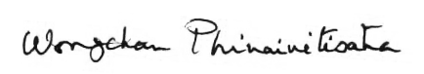

Associate Professor Khunying Wongchan Phinainitisatra
President of Princess Galyani Vadhana Institute of Music

Message from the Editor

Dr. Elissa Miller-Kay
Princess Galyani Vadhana Institute of Music

It has been my pleasure to edit the proceedings of the third International Symposium at the Princess Galyani Vadhana Institute of Music (PGVIM), “Music, Myths & Realities.” This year’s symposium featured a diverse array of presentations and discussions covering all manner of myth—from the ancient stories that helped our ancestors make sense of the world around them to the present-day stories we tell ourselves about the meaning of art.

These proceedings include a sampling of the thought-provoking scholarship that was on display at this year’s symposium. Topics include examinations of the ancient Ya-Y eh music and dance tradition of China and of the Plaeng Na Chumporn folksongs of Southern Thailand, two perspectives on the compositional process, research into new strategies for higher music education, discussions of the lives and compositions of guitarist Francisco T rrega, Dr. Saisuree Chutikul, and HRH King Bhumibol Adulyadej of Thailand; and an investigation into the tensions between traditional music practices and modern systems of musical commodification. These works reflect the vibrant state of music scholarship in Southeast Asia. They will no doubt provoke more discussion as we continue to study, question, and examine the myths we live by.

My sincere thanks to all the authors.

Dr. Elissa Miller-Kay
the Princess Galyani Vadhana Institute of Music

Committee of PGVIS Reviewers
Professor Nigel Osborne Reid Professor of Music at the University of Edinburgh, UK Professor Professor Jacques Moreau Cefedem Rhône- Aples, France
Professor Dieter Mack Musikhochschule Lübeck, Germany
Professor Sngkn Kim Seoul National University, Korea
Professor Dr. Narongrit Dhamabutra Faculty of Fine and Applied Arts, Chulalongkorn University Assistant Professor Dr. Ramasoon Sitalayan Faculty of Fine and Applied Arts, Chulalongkorn University Associate Professor Dr. Narutt Suttachitt Faculty of Education, Chulalongkorn University
Assistant Professor Dr. Rangsiphan Khangkhan Faculty of Education, Chulalongkorn University Assistant Professor Dr. Dneya Udtaisuk Faculty of Education, Chulalongkorn University Dr. Natthawut Boriboonviree Musicologist
Mr. Anant Nakkong Faculty of Music, Silpakorn University
Dr. Jiradej Setabundhu Princess Galyani Vadhana Institute of Music
Dr. Anothai Nitibhon Princess Galyani Vadhana Institute of Music
Dr. Chanyapong Thongsawang Princess Galyani Vadhana Institute of Music
Dr. Jean-David Caillouët Princess Galyani Vadhana Institute of Music
Dr. Elissa Miller Key Princess Galyani Vadhana Institute of Music

Content

Music and Socio-cultural Developments of the ASEAN “MUSIC, MYTHS & REALITIES“

Message from President of Princess Galyani Vadhana Institute of Music 6

Message from the Editor Committee of PGVIS Reviewers

Music Composition “Spirit of Isan” for Symphony Orchestra 10
Akapong Phulaiyaw

Spanish Hero: What Lises Behind Tárrega’s Legend 17
Apichai Chantanakajornfung

Art Songs in Thailand: Arranging and Performing Dr. Saisuree Chutikul’s Vocal Works 23
Chanyapong Thongsawang

49 King’s Compositions in Every Heart of Thai People 30
Dneya Udtaisuk

Narot, Copyrighted, All Rights Reserved: On the Tension between Music Copyright 44
and Religious Authority
John T. Giordano
The Dim Lit Subterranea of the Ancient Mind: the influence of place 56
in ‘inspired’ composition.
Jonathan Day
Western Music Theory Development through Co-Operative Learning Processes 69
Natsarun Tissadikun
Conservation and Continuation of Thai Folk Song: A Case Study Pleng Na Chumporn 76
Ponglada Thampitakkul
Ya-Y eh and the Spirit of Humanity 85
Shang-Wen Wang

Music and Socio-cultural Developments of the ASEAN “MUSIC, MYTHS & REALITIES“

The Dim Lit Subterranea of the Ancient Mind: the influence of place in ‘inspired’ composition.

Jonathan Day
Birmingham City University

With references to Claude Debussy, Felix Mendelssohn, Ludwig van Beethoven, Jonathan Harvey, Carl Jung, Konrad Lorenz, Herman Hesse, Mary Webb, John Corbett and Anthony Stevens, and examples drawn from my work.

Music, Myth and Realities is perhaps the most relevant possible platform for the presentation of this work. As a composer and performer I have for my whole life been fascinated by the arcane and exercising mechanisms of creation. The experience is tantalising, felt at those astonishing times when something almost palpable, tangible seems to flow through one, like a grainy stream of golden light or something multifaceted and sparkling with the most fascinating colours. Such creative moments can seem other-worldly, despite their presence in the midst of the workroom or on the mountainside, and despite their necessary resolution into something solid – musical vibrations, tonalities, timbres and phonemes plaited with those human created absolutes – infinity, eternity, purity, light, love. They are stunning moments, elevated times, but also confusing and challenging. Where does that ‘river’ come from, why is there the sense of ‘flow’? How do
we each, as the birthing body/being, relate to the finished work made as a result? Debussy said that “music must come from the shadows” and Mahler commented that

The creation and the genesis of a work is mystical from beginning to end since one—himself unconscious—must create something as though through outside inspiration. And afterwards one scarcely understands how it happened.1

I argue that such experiences – and the products of such experience – exist at the edges of myth, mythic and mythos, and so sit perfectly here.There is another reason for placing this work. In my own life, the ASEAN countries have contributed so much musically. As a doctoral student many years ago I visited Bali, Lombok, Bintan, Batam, Malaysia and Singapore in order to experience their indigenous music first hand. I visited Thailand repeatedly later on. I was quickly stripped of my culturally imbued orientalist assumptions as I saw the role of this vital music – holding ancient tradition and, at the same time, expressing with a subtlety I could only begin to appreciate, the nuances of the

modern world and the astonishing speed of globalisation. I recall an example – a Wayang Kulit performer in Ubud, Bali, adding into his ancient tales a young man on a moped shouting that ubiquitous sound of Kuta – ‘Transport?’ So many long days spent pursuing with such passion what I believed at the time to be the heart of the ‘authentic’ – auditioning ‘gender’ in the Balinese village of Klunkung, going from forge to forge and smith to smith listening for a particular sound. Or dark evenings driving from artist to artist looking for ‘genuine’ Balinese dance masks – in opposition to the often very lovely creations served up for tourists. Being involved with PGVIM, then, and sharing the stage with so many astonishing and virtuosic musicians, really brings so much of what I want to say ‘home’.

I will try to speak academically, theoretically and personally. I am writing about music and those two things together are, in a way, an insoluble problem – or, as Charles Ives had it, The Unanswered Question. Jazz pianist Thelonius Monk said “writing about music is like dancing about architecture” (a phrase famously repeated by Frank Zappa).2 Musical writing is possible, and interesting, but it cannot contain music.

Beethoven, as John Blacking points out, was

invariably angry when asked to express the meaning of his music: first he thought and hoped that the meaning of the music was perfectly clear, and second he was afraid that his poetic idea would be misinterpreted as a programme of which the music was a mere description.3
In other words, he was concerned with people seeking extra musical meaning through language. The music is the meaning, since meaning at this level cannot be contained by language. Composer Jonathan Harvey writes,

for too long music has been described in terms derived from verbal language and its modes of organization – narrative and plot for instance – and in terms derived from visual concepts: structure seen in notation or imagined like an object or journey we move around or through. These are borrowed perspectives and they are inadequate for music. The structure of music is not reducible to these other discourses. It is something much more profound, mysterious and difficult to get at.4

Therapist Gary Ansdell supports this, writing,

I do not suggest that music represents anything else that can be put into words, images or even feelings. I mean that it is meaningful, that it makes sense in itself.5

Mendelssohn believed that “the thoughts which are expressed by a piece of music are not too indefinite to be put in words, but on the contrary too definite”.6 Suzanne Langer observes “music can reveal the nature of feelings with a detail and truth that language cannot approach”.7

So here I will attempt to use language to ‘dance’ with the mythos and the mystery within composition, particularly as these relate to place, to Genius Loci.

1 Harvey, Jonathan, In Quest of Spirit, University of California Press, Berkeley, 1999, 28.
2 An earlier version, “writing about music is as illogical as singing about economics” was published in New Republic, February 19th, Hamilton Fish V: New York, 1918
3 Blacking, John, Music, Culture and Experience, University Of Chicago Press: Chicago, 1995, 36.
4 op cit p 27.
5 Ansdell, Gary, Music for Life, Jessica Kingsley Publishers: London, 1995, 13.
6 Cooke, Deryck, The Language of Music, Oxford, Oxford University Press, 1959, 12.
7 Langer, Suzanne, Philosophy in a New Key, Mentor: New York, 1948, 191.

Preamble

My most recently released music – a work called ‘Atlantic Drifter’ – was produced while touring in Europe and North America, as an experiment in response to place. I sensed that place was acting on my work, causing particular responses and reactions
and I wondered if that could be captured. Could any of that fleeting ‘feeling’ of being somewhere come through in the performance?

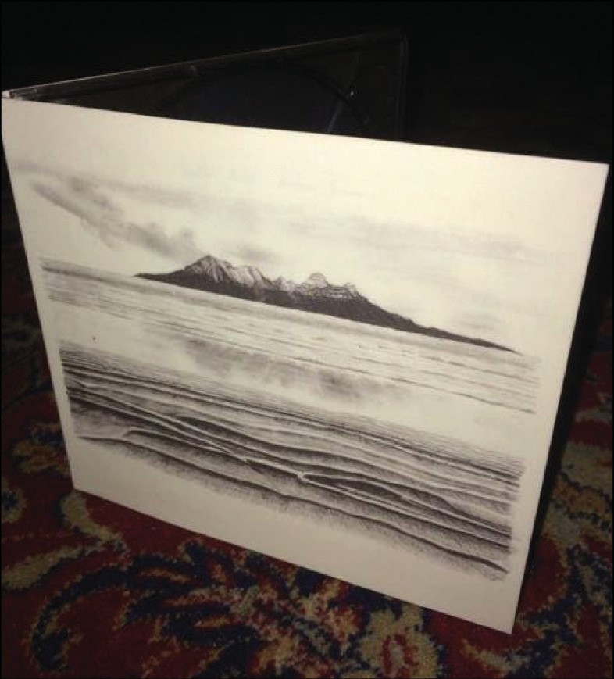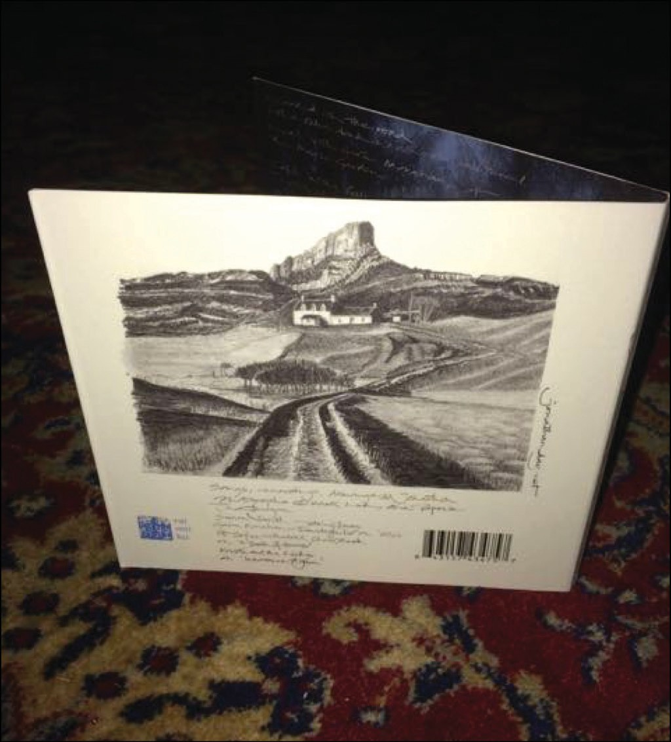

Figure 1. Jonathan Day, 2015, Atlantic Drifter, Niimiika/Proper Records, Shropshire/London

The music was released on CD and online (Spotify, iTunes, Apple Music etc) and was well received critically. Some of the critics’ comments were, unintentionally, intriguing. Helen Gee, writing for magazine Folk Radio UK, said “Jonathan’s guitar (is) blazing like the sun through the morning mists”.8
She is exactly right, in that the piece had been written very early one summer morning, walking across fields full of mist that was slowly breaking up as the sun shone on it. The work does not directly reference this anywhere, so I began wondering how this communication might work.

8 Gee, Helen, http://www.folkradio.co.uk/2015/09/jonathan-day-atlantic-drifter/

Composition / Spontaneous Composition / Improvisation is ‘deep’.

The origins and genesis of compositional practice are shrouded in mystery. Some of this is an affectation, some is an inescapable reality.

Jonathan Harvey writes,

I take no joy in composing if I set out in broad daylight knowing exactly what I want. Each new work must grope out into some dark region, in which the imagination and the unconscious can operate together.9

I am conflating improvisation and composition somewhat, taking the line that improvisation can also be styled instantaneous composition.10 In inspired composition, instantaneous or otherwise, we seek something - a thing/state/experience which is ‘other’ than our everyday or ‘non compositional’ state, some (thing/place) ‘beyond’. Harvey continues,

Each new work must grope out into some dark region... It must be full of contradiction - of “uncertainties, Mysteries, doubts, without any irritable reaching after fact and reason” as the poet John Keats said. It must live in ambiguity.11

John Corbett, in Jazz Amongst the Discourses, writes of

the all-consuming desire on the part of the performer for the unknown, the uncharted, the
search for area beyond territory (...) the nomadic impulse is certain but problematic.12

Herman Hesse,13 writes in his philosophical novel
Steppenwolf,

from a dance hall there met me, as I passed by, the strains of jazz music hot and raw as the steam of raw flesh. Jazz was repugnant to me and yet (...) it's raw and and savage gaiety reached an underworld of instinct.14

Hesse is emphasising the otherness of the composing/ improvising experience and outcome. It seems to exist within, emerge from, to even seek, an alternative state to our everyday default reality. Music engages and overlaps the mythic.

The Desire for Depth

In the writing of the composers, authors and philosophers so far examined, there is frequent mention of ‘instinct’ and the ‘unconscious’. Herman Hesse, again, talks of music, as “the sacred sense of beyond, of timelessness, of a World which had an eternal value “and says of creative endeavour “our only guide is our homesickness.”15

He is suggesting that in playing or ‘deep’ listening we experience something. I want to argue that this is an escape from, or a stilling of, the apparatus of our frothy and functional ‘constructed selves’, and an escape to

9 Harvey, Jonathan, In Quest of Spirit, University of California Press, Berkeley, 1999, 28.
10 It is also important to note here that the familiar ‘classical’ polarity between composer and performer reflects in many ways the capitalist notion of division of labour, and is very often absent in musical creation and performance in cultures around the world.
11 op cit, 28.
12 Corbett, John, “Ephemera Underscored: Writing Around Free Improvisation”, in Krin Gabbard (ed.) Jazz Among the Discourses, Duke University Press: Durham, 1995, 224.
13 Hesse was a contemporary of Carl Jung, and perhaps one of the most able exponents of the ideas for which Jung subsequently became famous.
14 Hesse, Herman, Steppenwolf, Penguin: London, 1923, 40.
15 ibid, 173 – 4.

a deeper place — ‘water from a deeper well’, as Emmylou Harris describes it.16 What do I mean by constructed selves? The philosopher Schopenhauer argues two things that are important for us here: that our personalities are constructs created by us to survive the trauma of existence, and that in music we can escape our created personas into something deeper.17 His theme is taken up by many others including, notably, philosophers Judith

Butler and Peggy Phelan.18 In playing and ‘deep listening’ some performers and listeners refer to ‘disconnection’ from their everyday (normality).19 In the experience of the beautiful, the ‘cool’ in jazz; in the improvisational moment and in deep listening we escape — with great relief, albeit temporarily — the intense, consuming effort of the perpetration of the ‘created self’, and experience ‘connection’ to the nameless fecund immensity that is our context.

Herman Hesse writes “I was myself no longer. My personality was dissolved in the intoxication of the festivity like salt in water.”20 This echoes other descriptions of inspired composing/improvising/deep listening. The experience is even embodied in the everyday language used to describe such events. I have often heard people say “I lost myself in the music.” When we ‘come back to ourselves’ after such experiences, they can leave us refreshed and renewed. Psychoanalytic philosopher Jacques Lacan’s notion of 'tearing the veil’ is relevant here.21 Hesse writes,
It demonstrates to anyone whose soul has fallen to pieces that he can rearrange these pieces of a previous self in what order he pleases and so attain to an endless multiplicity of moves in the game of life...from the pieces of the disintegrated self [we] build up ever new groups with ever new interplay and suspense and new situations that are eternally inexhaustible.22

Although this ‘falling to pieces’ may sound very negative, if we accept that our personas are constructed, then such a shaking up and rearranging—a departure and a reconvening—are possibly very positive; refreshing, like the shedding of clothes for a shower or a swim, a returning to a more primal state. Music, in short, renews us.

If we accept the desire for depth, what can we understand about that state?

The Nature of Depth

Why then is this kind of depth desirable? Why do the composers cited seek it so fervently? Or, if it may not be successfully sought, why do they create the conditions for its arrival and wait around hopefully? We even have, as an opposition, the antithetical b te noir condition (I say it in sepulchral tones) the creative ‘block’.

16 Harris, Emmylou, Wrecking Ball, Elecktra: New York, 1995.
17 Schopenhauer, Arthur, Essays and Aphorisms. '10': Penguin Classics, 1970, 162.
18 Butler, Judith, Gender Trouble. New York: Routledge: London and New York, 1990; Phelan, Peggy, Unmarked: the politics of performance, Routledge: London and New York, 1993.
19 Pauline Oliveros, a pioneer in this are a of thinking notes that “Sounds carry intelligence. Ears do not listen to sounds; the brain does” https://www.youtube.com/watch?v=_QHfOuRrJB8 and Oliveros, Pauline, Deep Listening: A Composer's Sound Practice, iUniverse: Lincoln Nebraska, 2005.
20 op cit, 191. He reflects this further when he writes: “in this music was a feeling of time frozen into space and above it there quivered a never ending and superhuman serenity, an eternal laughter” op cit, 174-5
21 Lacan, Jacques, “From the Function of the Veil.” Seminar 4, The Object Relation, WW Norton & Co: London, [1956] 2005, 155-164.
22 op cit, 217

It is possible to argue that during inspired times, times in which something is happening that can be clearly experienced yet not at all easily explained, we are accessing and experiencing overlap with something in us that is both ancient and profound. I call it ‘the dim lit subterranea of the ancient mind’. Let us try to account for it. I am initially going to cite Carl Jung. I hope to persuade you not to see this as some kind of dubious psycho babble but instead as the germ of more recent enquirers’ solid and replicable proofs that much of what we see and experience comes to us as inheritance through our DNA. Jung says,

the essential thing, psychologically, is that in dreams, fantasies, and other exceptional states of mind [such as when improvising/composing] the most far-fetched mythological motifs and symbols can appear autochthonously at any time, often, apparently, as the result of particular influences, traditions, and excitations working on the individual, but more often without any sign of them. These "primordial images" or "archetypes," as I have called them, belong to the basic stock of the unconscious psyche and cannot be explained as personal acquisitions. Together they make up that psychic stratum which has been called the collective unconscious.23

Jung argues that ‘collective unconscious’ or ‘race memory’—those aspects of our deep cognition that are genetically inherited—leak traces into our deep cognition that we can access ‘in exceptional states of mind.’ He explains this idea further,
individual consciousness (...) is in the highest degree influenced by inherited presuppositions (...) The collective unconscious comprises in itself the psychic life of our ancestors right back to the earliest beginnings.24

The solidity of Jung’s ideas is established by more recent thinkers, drawing on scientific advances not available to Jung.25 Anthony Stevens points out that “DNA itself can be inspected for the location and transmission of archetypes.” He suggests that “DNA is the replicable archetype of the species.”26

Ethologist Konrad Lorenz’s work with animal behaviour also demonstrates that much of what we see and experience comes to us as inheritance through our DNA. Lorenz demonstrated, working with wolves and ducks, that a great deal of behaviour is inherited. His perhaps most famous experiment involves the rearing of a male duck in complete isolation from other ducks. When eventually the drake was introduced to females he was able to execute a perfect courtship dance, without ever having seen one before. His behaviour was genetically predicated. Stevens observes that this applies in its own way to us:

Ethology shows us that each species is equipped with unique behavioural capacities that are adapted to its environment and, even allowing for our greater adaptive flexibility, we are no exception.27

23 Jung, Carl, ”The Significance of Constitution and Heredity in Psychology" Collected Works vol. 8, [1929] 1960, 112.
24 ibid
25 the structure of DNA was first identified by Watson and Crick in 1953, at the Cavendish laboratory of the University of Cambridge. Pray, Leslie, “Discovery of DNA structure and function: Watson and Crick”, Nature Education 1 (1), Nature Publishing Group: London, 2008, 110.
26 Samuels, Andrew, Jung and the Post-Jungians, Routledge: New York and London, 1986, 19.
27 ibid

Much of our musical inclination and practice emerges from inherited and biochemical aspects of ourselves (as I argued in my book The Politics of Navigation).28

This linkage to our inherited past is beautifully described in the novel Gone to Earth by Mary Webb, written at the same time Hesse and Jung were working. Speaking of a feral girl singing at a gathering, she writes,

‘Poor child!’ (...) ‘Is it a mystical longing or a sense of sin that cries out in her voice?’

It was neither of those things; it was nothing that Edward could have understood at that time, though later he did. It was the grief of rainy forests and the moan of stormy water; the muffled complaint of driven leaves; the keening – wild and universal
– of life for the perishing matter that it inhabits.

Hazel expressed things that she knew nothing of, as a blackbird does. For, though she was young and fresh, she had her origin in the old, dark heart of earth, full of innumerable agonies, and in that heart she dwelt, and ever would, singing from its gloom as a bird sings in a yew-tree. Her being was more full of echoes than the hearts of those that live further from the soil; and we are all as full of echoes as a rocky wood – echoes of the past, reflex echoes of the future, and echoes of the soil (these last reverberating through our filmiest dreams, like the sound of thunder in a blossoming orchard). The echoes are in us of great voices long gone hence, the unknown cries of huge beasts on the mountains; the sullen aims of creatures in the slime; the love-call of the bittern. We know, too, echoes of things outside our ken – the thought that shapes itself in the bee’s brain and becomes a waxen box
of sweets; the tyranny of youth stirring in the womb; the crazy terror of small slaughtered beats; the upward push of folded grass, and how the leaf feels in all its veins the cold rain; the ceremonial that passes yearly in the emerald temples of bud and calyx – we have walked those temples; we are the sacrifice on those altars. And the future floats on the current of our blood like a secret argosy. We hear the ideals of our descendants, like songs in the night, long before our firstborn is begotten. We, in whom the pollen and the dust, sprouting grain and falling berry, the dark past and the dark future, cry and call.29

The Agency of Place

In light of the ideas presented so far it is a clear possibility that playing in a particular place and time will result in very particular influences bearing on the player; the effects of the so-called genius loci, the spirit of place.

A great number of composers and improvisers acknowledge the inspirational role of place in their work. The instances are far too numerous to catalogue in this short piece, although such an undertaking would be useful and fascinating. I can, however, usefully describe some of my own experimental compositions responding to space. I am able to report on these in depth.

A Grampus still swims in Fingal's Cave30

Last summer I was in Fingal’s Cave, the exact place that so inspired Mendelssohn’s Hebrides Overture. It is part of a small, steep cliffed islet set in the brilliant blue but very stormy Sea of the Hebrides, in the North

28 Day, Jonathan, The Politics of Navigation, Verlag Dr. Mueller: Saarbrucken, 2008.
29 Webb, Mary, Gone to Earth, Jonathan Cape: London, 1928, 69–70.
30 Grampus is an ancient name for Orca, sometimes called Killer Whales.

Atlantic. The cave is formed from columns of basaltic lava, running up into the vaulted ceiling – each one is multi faceted. The acoustic is astonishing; every sound fracturing on the stones and sparkling around the space. As soon as I began to sing, a thousand sound colours seemed to light the gloom. Sometime before sailing to

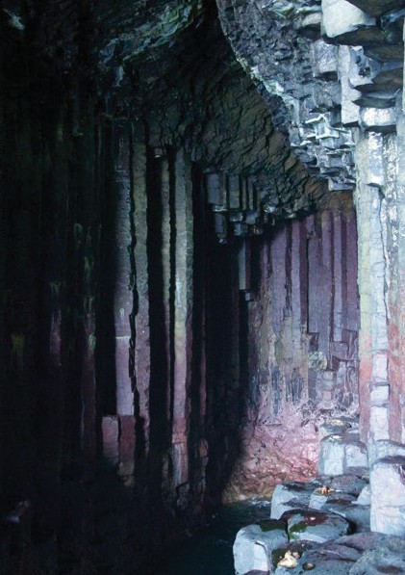

Figure 2. Jonathan Day, 2016, Fingal’s Cave, collection of the author.

the cave I had talked with an ancient man on the road from Tarbert to Hushinish, on the nearby island of Na Hearadh. He told me of the tiny whaling ships sailed long ago by local people as they worked to make a living from this demanding Northern place. His words chimed with some 7th century Gaelic poetry I was reading about the wild, wide world, as seen through
those long-ago eyes. The poetry mixed with the old man’s tale inspired the song’s verses. The music’s refrain came from another source, as a kind of counterpoint. The sea that crashes restlessly into the cave is home to families of Orca whales. They have an ancient bloodline and are genetically distinct from other populations. These ancient dynasties pre-date the arrival of humans: they are the first peoples of these wild seas. Many native creatures have been driven to extinction in these islands and seas, but the whales speak of the hope of survival; a hope of a world we can share and coexist in. They sing of a dream of healing. Surely the day must come, when we will walk in harmony with the world. This is our birth right—as it is theirs. The world belongs to all of us, animate and inanimate alike, as we belong to it.

My writing responded to the poetry, to the old man and to my revisioning of the world as those ancient writers saw it. These threads were woven together in and by the sound world of Fingal’s Cave. A sketch for the piece is available here: https:// soundcloud.com/jonathan-day/a-grumpus-still- swims-in-fingals-cave.

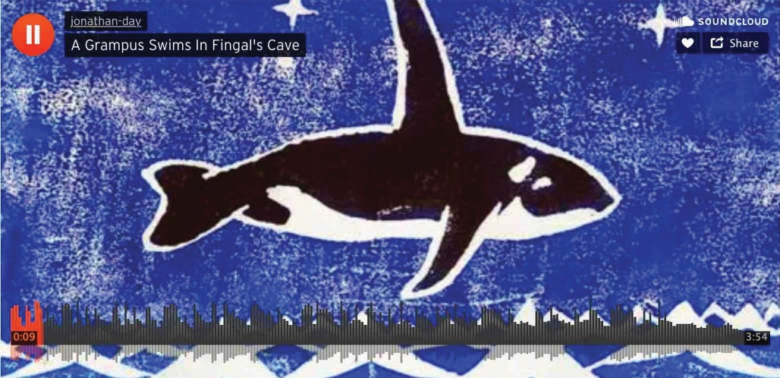

Figure 3. A Grampus still swims in Fingal's Cave on the website Soundcloud.

9th June 1924

I have been inspired for a long time by the story of George Mallory and Andrew Irvine. These men set out early on the morning of 9th June 1924 to climb to the summit of Mount Everest, the world’s tallest mountain. As far as anyone knew, no had ever been to the summit before. This is certainly possible, since the Mountain is revered as Chomolungma ‘Mother Goddess of the World’ – the sanctity suggests that the summit may have remained unvisited. The climbers were last seen high on the mountain going strongly for the top, before they disappeared into cloud and were never seen alive again. I wondered how it must have been for these men who most probably reached the summit in no more than leather boots, tweeds and cotton windproofs. How would it feel to be so high, in so wonderful and remote a place? Having had exposure once myself,
while surfing in February, I knew there to be a wondful kind of mystical aspect to it. After a long day in a near freezing ocean I floated out to sea on my surfboard completely blissfully, absorbed by the web of late orange sunset light spread like a net over the Atlantic. Friends came and pulled me in, wondering what on earth I was doing. As the poet TS Elliot wrote, “until Human voices wake us and we drown...”31

In order to write the piece I spent many days climbing in ice and snow. My mountains were not nearly so high as Everest but they gave a feeling of the isolation, the splendour, the elevated sense of mind and the danger. A recording of the Music, Myth and Realities performance is here: https://youtu.be/BpSIymqjFcc.

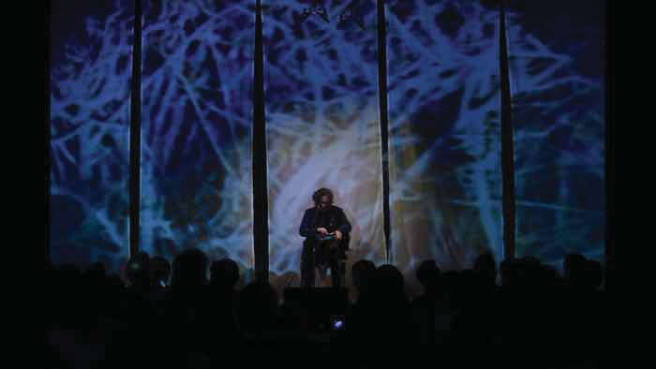

Figure 4. Performing the work 9th June 1924 at PGVIM as part of the Symposium Performance “Myths and Traditions,”Wednesday 30th August 2017.

31 Eliot, T S, The Love Song of J Alfred Prufrock, Faber: London, 1972.

An Oriole Above the Tian Shan

It would be easy to only include works made in places that are romantically or poetically powerful. I am drawn to such places, but I am keenly aware that for others, the darkest and grimmest of spaces can also be powerfully inspiring. This last piece had its birth in one of my least favourite places of all: the inside of a long haul airplane. I loathe flying for many reasons. Travelling back from Hong Kong one time, I flew over the Tian Shan at sunset. The gathering dark—the dimming of the day over these remote and stunning mountains was powerful. The air seemed to be almost solid in the last light, like something you could hold and touch. I saw in my mind’s eye a Golden Oriole, a gorgeous black and sulphur yellow bird I had seen before on the ground. It was wheeling high over these rocky mountains in this dense golden air, in company
with many other bird beings, brilliant and strange. Some of these were real—the Japanese Red Crowned Crane, the Lamergaier; and some, like Garuda, kinnari and apseras, mythical. The piece grew from this; my imagining of the sounds of these wonderful entities, explored through extended woodwind techniques, as they celebrated their life and particularity high on these uplifting, invisible winds. The work is for wind sextet and live electronics. A score and a performance are available here https://youtu.be/4ZH2L_LC2Mc

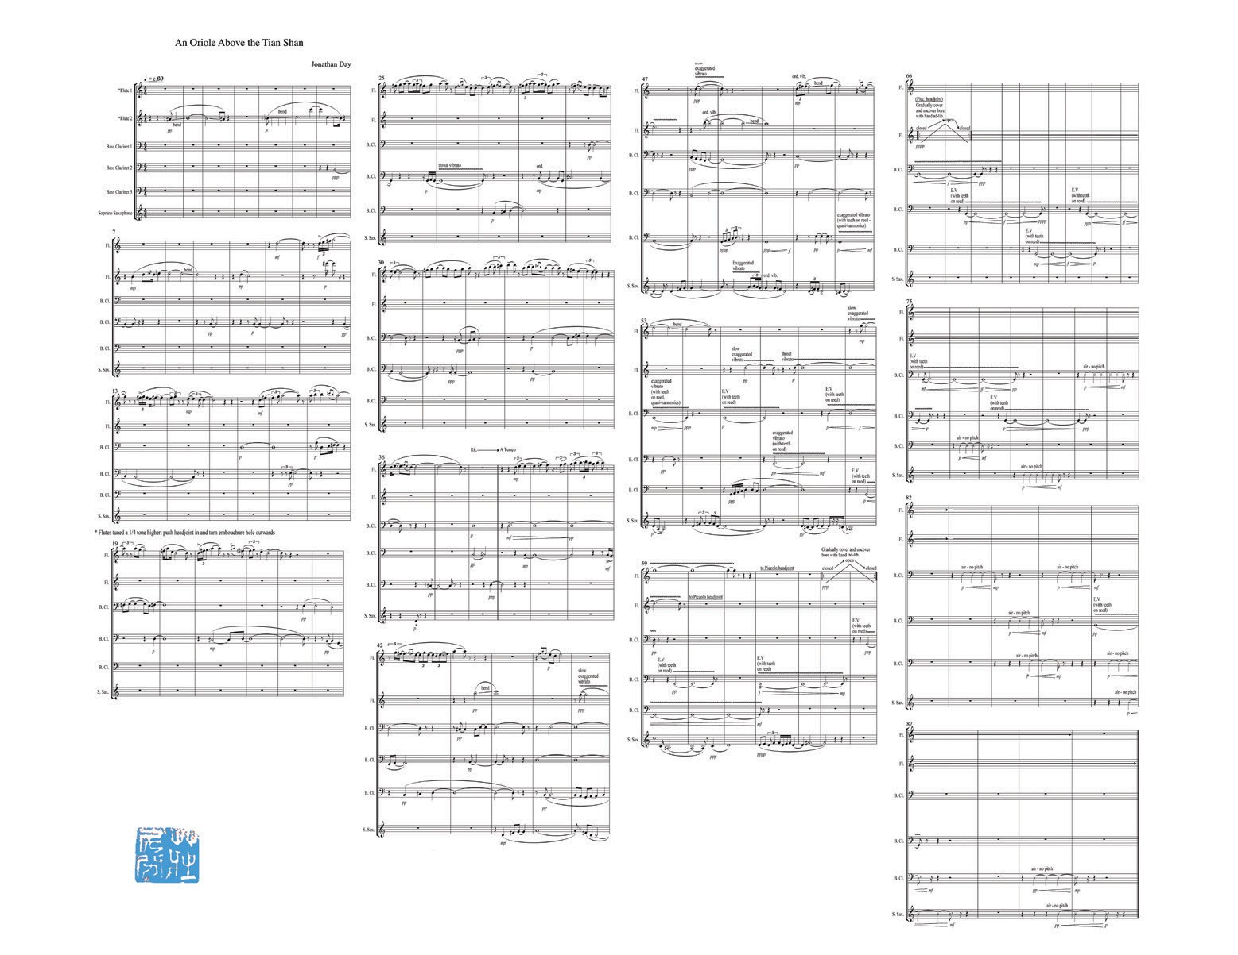

Figure 5. Score of An Oriole Above the Tian Shan.

Language of the Unconscious

The works I have described include music written on (and in) a glacier, beside oceans, blue and grey, high in mountains in the teeth of a gale, deep in forests and more. There is a danger inherent in choosing to work in such places that is perhaps best described by Caspar David Friederich’s famous painting Wanderer Above the Sea of Fog.

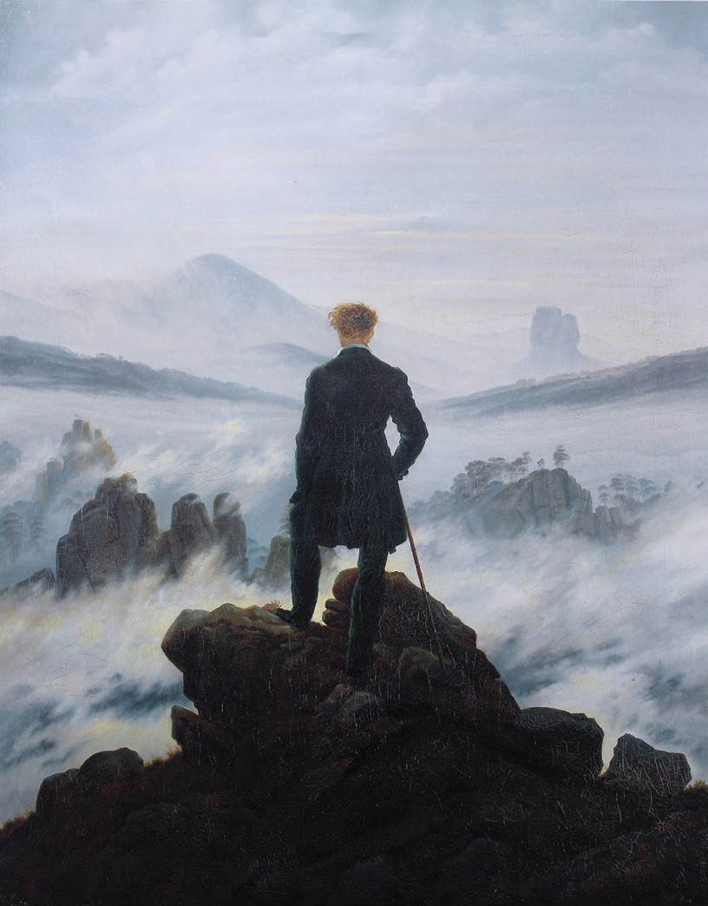
Figure 6. Caspar David Friedrich, 1819, Wanderer above the Sea of Fog, Kunsthalle Hamburg, Hamburg, Germany

It may well be lovely, challenging or even profoundly disturbing to be a composer-performer in these situations and environments, but does it matter to anyone else? Can anything of these creative experiences be shared and communicated?

I think it’s fair to say that communication through composition and performance is not always intended or desired, but is very often achieved nonetheless. If indeed we are writing from a place deeply beyond the everyday, and certainly far past the capacity of language to describe, why should that be? Jacques
Lacan offers an answer when he argues for a structure to the unconscious that is para–linguistic in nature. Psychologist Anthony Stevens writes,

Lacan went beyond the proposition that the unconscious is a structure that lies beneath the conscious world; the unconscious itself is structured, like a language.

Lacan posited that the unconscious is organised in an intricate network governed by association, above all 'metaphoric associations'. The existence of the network is shown by analysis of the unconscious products: dreams, symptoms, and so on.32

If we can accept that, we have a model for the kind of communication we are discussing. According to Lacan, when we are in an ‘exceptional state,’ such as deep listening or inspired creativity, the structuring of the unconscious imparts a meta-linguistic quality to improvisation/composition, thus allowing a very deep, numinous communication. We may sense within the music half perceived echoes of the ancient and profound; music becomes a window into myth.

The desire we feel for ‘depth’ is a desire not only to experience and dwell in that dim lit subterranean place/ state but to forge there, from the materials at hand, a new language, or new words for an old one, that speaks of the wonderful and terrible as never before.

Jazz author John Corbett writes,

Improvisation does not simply mean the death of language, however for in the place of the dead language—the disfigured and defiled codes – a new one emerges, more vibrant than the last.33

Our desire, our longing, takes us to deep ‘places’ that stretch over the edge of what is known—transporting us to profound and ancient landscapes in which we know ourselves more deeply and more fully, places

which resound and chime with myth. Our interaction with physical experiential place, part of what we may style our ‘realities’, is a powerful partner in helping us to access our deep and ancient selves, and offers a powerful language/dialect with which to speak. The music that emerges from this interaction of myth and reality is particular. The power of it reaches across race, language and creed and speaks of the profundity of our humanity, both ancient and in the now, sharing this spinning world, travelling through time and the star splashed blackness. It takes us out of the peculiarities and specifics of the day and helps us to remember painter Paul Gauguin’s questions: “Where do I come from? What am I? Where am I going?”.34 It does this not in trite sound bites or slogans but in a deep knowing, beyond words. It allows us to refresh and renew; to come again to our deeper, ancient selves.

Schopenhauer, as we saw at the beginning, argues that music can (not always, but often) take us into our deep cognition, both underlying and transcending the superficial froth of persona. Jung shows that when composing we are engaged with a profound and ancient
network of meaning, intimation and intuition. Lacan shows that we can communicate and navigate this network together, commune in this beyond-words meta language, less everyday certainly, less functional, but having profound significance and importance.

Schopenhauer thought music a timeless, universal language, comprehended everywhere, that can imbue global enthusiasm.35 Music is something we heard first in the womb, as the fascinating gurgling of our mothers and the strange intimations of a world to come, as we ourselves came into being. When music mediates between and arbitrates myth and reality, it may at times constitute the genetically inherited language of our deep selves. As Viktor Zukerkandl wrote

Wittgenstein was wrong to say when words run out there is only silence. When words run out we can sing.36

In music, together, we can navigate the dim lit subterranea of the ancient mind.

32 op cit, 19. This sits very well with Noam Chomsky’s notion of the ‘language instinct’ as a set of inherited potentialities and predilections. See also Pinker, Steven, The Language Instinct, William Morrow and Company: New York, 1994.
33 Corbett, John, “Ephemera Underscored: Writing Around Free Improvisation”, in Krin Gabbard (ed.), Jazz Among the Discourses, Durham: Duke University Press: Durham, 1995, 224.
34 Gauguin, Paul, Where do I come from, what am I, where am I going? Museum of Fine Arts, Boston, 1897–1898
35 Schopenhauer, Arthur, Essays and Aphorisms, '10', Penguin Classics: London, 1970, 162.
36 Zukerkandl, Viktor, Sound and Symbol, Princeton University Press: Princeton, 1968.

Bibliography

Ansdell, Gary, Music for Life, Jessica Kingsley Publishers: London, 1995.

Blacking, John, Music, Culture and Experience, University Of Chicago Press: Chicago, 1995.

Butler, Judith, Gender Trouble, Routledge: London and New York, 1990.

Cooke, Deryck, The Language of Music, Oxford, Oxford University Press, 1959.

Corbett, John, “Ephemera Underscored: Writing Around Free Improvisation”, in Krin Gabbard (ed.) Jazz Among the Discourses, Duke University Press: Durham, 1995.

Day, Jonathan, The Politics of Navigation, Verlag Dr. Mueller: Saarbrucken, 2008.

Eliot, T S, “The Love Song of J Alfred Prufrock”, Selected Poems, Faber and Faber: London, 1972.

Gee, Helen, http://www.folkradio.co.uk/2015/09/ jonathan-day-atlantic-drifter/

Harris, Emmylou, Wrecking Ball, Elecktra: New York, 1995.

Harvey, Jonathan, In Quest of Spirit, University of California Press: Berkeley, 1999.

Hesse, Herman, Steppenwolf, Penguin: London, 1923.

Jung, Carl, ”The Significance of Constitution and Heredity in Psychology" Collected Works vol. 8, Princeton University Press: Princeton, [1929] 1969.

Lacan, Jacques, “From the Function of the Veil”, Seminar4, The Object Relation, WW Norton & Co: London, [1956] 2005.
Langer, Suzanne, Philosophy in a New Key, Mentor: New York, 1948.

Oliveros, Pauline https://www.youtube.com/watch?v=_ QHfOuRrJB8

Oliveros, Pauline, Deep Listening: A Composer's Sound Practice, iUniverse: Lincoln, Nebraska, 2005.

Phelan, Peggy, Unmarked: the politics of performance, Routledge: London and New York, 1993.

Pinker, Steven, The Language Instinct, William Morrow and Company: New York, 1994.

Pray, Leslie, “Discovery of DNA structure and function: Watson and Crick”, Nature Education 1 (1), Nature Publishing Group: London, 2008.

Samuels, Andrew, Jung and the Post-Jungians, Routledge: New York and London, 1986.

Schopenhauer, Arthur, Essays and Aphorisms, '10', Penguin Classics: London, 1970.

Webb, Mary, Gone to Earth, Jonathan Cape: London, 1928.

Zukerkandl, Viktor, Sound and Symbol, Princeton University Press: Princeton, 1968.

