Fluid-Structure Interaction Analysis of Flexible Plate with
Partitioned Coupling Method.
W.Z. Limª*, R.Y. Xiao^{b}
ªFaculty of Computing, Engineering and the Built Environment, Birmingham City University, Birmingham, B4 7XG, United Kingdom
^{b}Department of Urban Engineering, School of The Built Environment and Architecture, London South Bank University, Borough Road, London, SE1 0AA, United Kingdom

Abstract
The development and rapid usage of numerical codes for fluid-structure interaction (FSI) problems are of great relevance to researcher in many engineering fields such as civil engineering and ocean engineering. This multidisciplinary field known as fluid-structure interaction has been expanded to engineering fields such as offshore structures, tall slender structures and other flexible structures applications. The motivation of this paper is to investigate the numerical model of two-way coupling FSI partitioned flexible plate structure under fluid flow. The adopted partitioned method and approach utilised the advantage of the existing numerical algorithms in solving the two-way coupling fluid and structural interactions. The flexible plate was subjected to a fluid flow which causes large deformation on the fluid domain from the oscillation of the flexible plate. Both fluid and flexible plate are subjected to the interaction of load transfer within two physics by using the strong and weak coupling methods of MFS and Load Transfer Physics Environment respectively. The oscillation and deformation results have been validated which demonstrate the reliability of both strong and weak method in resolving the two-way coupling problem in contribution of knowledge to the feasibility field study of ocean engineering and civil engineering.
Keywords: fluid-structure interaction, flexible plate structure, two-way coupling, partitioned method, numerical simulation

1.0 Introduction
The growth of technology and multidisciplinary field known as fluid-structure interaction FSI has drawn significant interests from many researchers and engineers worldwide. This multi-physics analysis started from a single phase analysis of fluid and structural mechanics with combination of both disciplines under continuum mechanics with interaction surrounding it (Benra et al, 2011). Studies and investigations of fluid structure interaction begin to develop from the early 1970s to the late 1980s and the various techniques in the numerical simulation of fluid structure interaction evolving rapidly in recent years. Generally, in the analytical solution, FSI can be categorized as one-way coupling or two-way coupling problems and the solutions for such problems are mostly solved by numerical methods. There were several examples and approaches of work done in solving the one-way coupling problems as presented by Lim et al (2013) for the gravity dam problem and Lim et al (2016) for the offshore structure problem. As for the two-way coupling problem, the best example to describe this FSI problem is the fluid flow that is driven by an inflow condition to an elastic structure as depicted in Fig. 1. The evolving flow acting on the surface of the structure has caused a deformation and this deformation changes the flow domain and the sequential feedbacks between the both fields is called two-way coupling (Richter, 2010). There are many approaches and work done of such practice in solving the widely studied vortex-induced oscillation flexible structure such as the vortex-induced transverse vibrations of a cylinder by Khalak, A. and Williamson, C. (1999) and Wick, T. (2011). Similar investigation was extended by Jauvtis et al (2003) undergoing two-dimension oscillations. Further studies in comparisons between the numerical and experimental results were carried out by Wei et al (1995) and Yamamoto et al (2004). Therefore, such problem of flexible structure deformation from the fluid flow has further motivate the work of the present paper in studying the classical model of a simple two dimensional flexible plate presented by Wall et al (2007) and Dettmer, W. and Perić, D. (2006). The aim of this study is to justify the numerical techniques and feasibility of the two-way coupling partitioned method under the weak and strong systems that could further contribute into other offshore flexible structure applications of Xu et al (2018), Gao et al (2011) and Martin et al (2017).

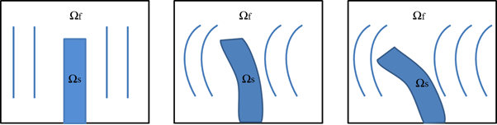
Fig. 1 Example of a fluid motion imposed on an elastic structure (Two-way Coupling, FSI)

2.0 Two-Way Coupling Partitioned Method
The coupling system known as partitioned method is an approach where two distinct solvers such as fluid and structure are solved separately with consideration of interaction between the fluid flow and displacement of the structure. Both fluid and structure equations are simply integrated in time and the interface conditions are enforced asynchronously. These mean that the fluid flow does not change while the solution of the structural equations is calculated and vice versa. Such approach requires a coupling algorithm that allow the interaction and preserves the software modularity in order to determine the solution of the coupled problem where information can be transferred between the two solvers (Degroote et al, 2009). Therefore with this method, the present paper particularly focus on the approach of two-way coupling when both fluid and structure fields are able to interact fully with each other. The two-way coupling can be categorized into either weakly or strongly coupling system where both allow interaction between two distinct solvers. In Fig. 2, the mechanism of weak coupling shows that in every time-step $t_{n}$ to $t_{n+1}$, both problems are solved separately where the fluid flow problem, $S_{f}$ at time $t_{n}$ is fully dependent on the flow and structure problem at time $t_{n}$. However, the interaction at time $t_{n+1}$ is not taken into account and the same approach applies to the structure problem. As for the strong coupling system, the interface between both domains is crucial and this system allows parallel solution of both fluid and the structure domains depicted in Fig. 3. This mechanism shows that two domains are solve independently in a decoupled way with an iterative interaction loop between each time-steps as indicated and it is also considered as a further development of the partitioned approach (Richter, 2010). The application of partitioned method is also an advantage to various approach and schemes for different multi-physics fields such as Lim et al (2013), Lim et al (2016), Wall et al (2007), Habchi et al (2013), Degroote et al (2008), Degroote et al (2010), Song et al (2013) and Dettmer, W. and Perić, D. (2008).
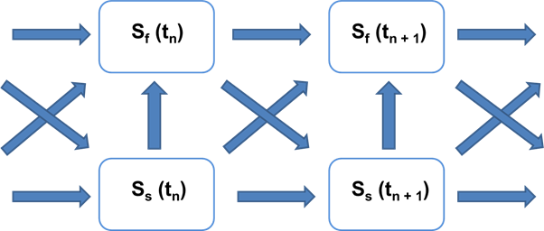

Fig. 2 Two-way partitioned solution of the weakly coupled system.

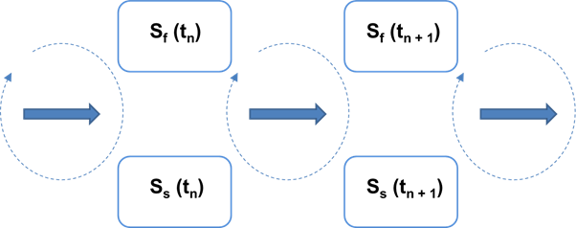

Fig. 3 Two-way partitioned solution of the weakly coupled system.

3.0 Governing Equations
With the partitioned method approach, the computational technique is implemented under the governing equations of fluid and structural mechanics in association with the Finite Element Method, Lagrangian Formulation and the Arbitrary Lagrangian-Eulerian (ALE) formulation. Such technique is employed in solving the oscillating two-way coupling of flexible plate within the framework of ANSYS APDL.

3.1 Fluid Flow
The fluid flow equations are governed by Navier-Stokes equations of incompressible flow which also defined by the laws of conservation of mass, momentum, and energy. The laws are discretised with a finite element based technique with the expressed terms of partial differential equations (Ansys, 2009).

3.1.1 Continuity Equation
Following is the continuity equation of the fluid flow:
$\frac{∂ρ}{∂t}+\vec{∇}⋅\left(ρ\vec{v}\right)=0$ (1)
where $\vec{v}$ is the velocity vectors for component in the x, y and z directions. $ρ$ is the density of the fluid and $t$ is the time shown in the equation above. The rate of change of density can be replaced by the rate of change of pressure:
$\frac{∂ρ}{∂t}=\frac{∂ρ}{∂P}\frac{∂P}{∂t}$ (2)
3.1.2 Incompressible Equation
$\frac{∂ρ}{∂P}=\frac{1}{β}$ (3)
where $P$ is the pressure and $β$ is bulk modulus of the fluid flow.

3.1.3 Momentum Equation.
Equation (4) shows the relationship between stress and rate of deformation of the fluid:
$\vec{τ}=\left[λtr\left(∇\vec{u}\right)-P\right]\vec{I}+μ\left(∇\vec{u}+∇\vec{u^{T}}\right)$ (4)
where $\vec{τ}$ , $P$, $\vec{u}$, $μ$ and $λ$ represent the stress tensor, the fluid pressure, orthogonal velocity vectors, dynamic viscosity and second coefficient of viscosity, respectively. Equation (5) is the Navier-Stokes equations from the transformation of momentum equations when the second coefficient of viscosity and the divergence of the velocity is zero for a constant density fluid.
$\frac{∂ρ\vec{v}}{∂t}+\vec{∇}⋅\left(ρ\vec{v}⊗\vec{v}\right)=ρ\vec{g}-\vec{P}+\vec{R}+\vec{∇}⋅\left(μ_{e}∇\vec{v}\right)+\vec{T}$ (5)

where $ρ$ is the density of the fluid and $μ_{e}$ is the effective viscosity. The following g, R and T represent the acceleration due to gravity, distributed resistances and viscous loss terms, respectively with subscript x, y and z as the coordinate directions.

3.1.4 Pressure Equation
The pressure equation in the expression of relative pressure is present as:
$P_{abs}=P_{ref}+P_{rel}-ρ_{0}⋅\vec{g}⋅\vec{r}+\frac{1}{2}ρ_{0}\left(\vec{ω} x \vec{ω} x \vec{r}\right)⋅\vec{r}$ (6)
where $ρ_{0}$, $P_{ref}$ , $\vec{g}$, $P_{abs}$, $P_{rel}$, $\vec{r}$, and $\vec{ω}$ are the reference density, reference pressure, gravity vector, absolute pressure, relative pressure, rotating coordinate system vector position of fluid particle and angular velocity respectively. Equation (7) is the result of combining the momentum equations into vector form as shown below:
$ρ\frac{D\vec{v}}{Dt}+2ρ\vec{ω} x \vec{v}+ρ\vec{ω} x \vec{ω} x \vec{r}=ρ\vec{g}-\vec{∇}P_{abs}+μ\vec{∇}⋅\left(\vec{∇}\vec{v}\right)$ (7)
where $\vec{v}$, $μ$, and $\vec{ρ}$ are the velocity vector in global coordinate system, fluid viscosity and fluid density respectively.

3.1.5 Turbulence Equation
In turbulence flow field, the velocity, $V_{x}$ can be expressed in terms of mean value, $\overline{V_{x}}$ and fluctuating component, $V_{x}^{'}$:
$V_{x}=\overline{V_{x}}+V_{x}^{'}$ (8)
In the Navier-Stokes equations, the instantaneous velocity equation is time averaged where the fluctuating component is zero and the time average of the instantaneous value is the average value. Equation (9) is the arbitrarily time interval for the integration:
$\frac{1}{∆t}\int_{0}^{δt}{V_{x}^{'} dt=0 ; }\frac{1}{δt}\int_{0}^{δt}{V_{x} dt=\overline{V_{x}} }$ (9)
Equation (10) is the expression of Reynolds stress terms, $\vec{σ^{R}}$ after the substitution of Equation (8) into the momentum equations.
$\vec{σ^{R}}=-∇⋅\left(ρ\vec{V^{'}}⊗\vec{V^{'}}\right)$ (10)
The turbulent viscosity, $μ_{t}$ of standard k-model is shown below:
$μ_{t}=C_{μ}ρ\frac{k^{2}}{ϵ}$ (11)
where k, $C_{μ}$ and $ϵ$ are the turbulent kinetic energy, turbulence constant and turbulent kinetic energy dissipation rate respectively.

3.1.6 Arbitrary Lagrangian-Eulerian, ALE Formulation
The ALE formulation (Donea, J. And Huerta, A., 2003) is considered and applied in solving the two-way coupling problem of fluid structure interaction. ALE formulations are used to solve the problems where the fluid domain changes with time and movement of finite element to satisfy the boundary conditions at the moving interface(s). Such formulation has also been applied in many examples such as Bathe, K. J. And Zhang, H. (2009), Lim et al (2013), Lim et al (2016) and Dettmer, W. and Perić, D. (2008). The time derivative terms are essentially rewritten in terms of the moving frame of reference as expression in Equation (12):
$\frac{δ∅}{δt} ⎸_{fixed frame}=\frac{δ∅}{δt} ⎸_{moving frame}-\vec{W}⋅\vec{∇}∅$ (12)
where $∅$ is the degree of freedom and $\vec{W}$ is the velocity of the moving frame of reference.

3.1.7 Segregation Solution Algorithm
For the coupling algorithm, the SIMPLEF algorithm is employed together with the coupled pressure and momentum equations (Versteeg, H. And Malalasekera, W., 2007). From each iteration, the change in the product of density and velocity are approximated by considering the changes separately through linearization process (Ansys, 2009).

3.2 Structure
The flexible plate equation is solved by using a finite element approach as shown in Equation (13) below:
$\vec{M}⋅\vec{\ddot{u}}+\vec{C}⋅\vec{\dot{u}}+\vec{K}⋅\vec{u}=\vec{F}$ (13)
where $\vec{M}$ , $\vec{\ddot{u}}$ , $\vec{K}$ , $\vec{\ddot{u}}$, $\vec{\dot{u}}$ and $\vec{u}$ are the mass, damping coefficient, stiffness, acceleration, velocity, and displacement vectors, respectively.

3.2.1 Neo-Hookean Isotropic Hyperelasticity
The material of flexible plate for the numerical analysis is the Neo-Hookean isotropic hyperelasticity material which defined by a strain energy density potential that characterizes elastomeric and foam type material where all straining is reversible. The Neo-Hookean is the forms of strain energy potential, W provided for the simulation of incompressible or nearly incompressible hyperelastic materials whereby $μ$ is the initial shear modulus of the materials and d is the material incompressibility parameter.
$W=\frac{μ}{2}\left(I_{1}-3\right)+\frac{1}{d}{\left(J-1\right)}^{2}$ (14)
$I_{1}$ and $J$ are the first invariant and second invariant stress tensor respectively. The initial bulk modulus is related to the material incompressibility parameter as:
$K=\frac{2}{d}$ (15)
where K is the initial bulk modulus.
3.3 Coupling Equations
Between the interaction of the fluid and flexible plate, the mesh interface causes the pressure exert a force applied to the plate structure and the plate motions then produce an effective fluid load. Equation (16) below is the governing finite element matrix:
$\left[\vec{M_{s}}\right]\vec{\ddot{u}}+\left[\vec{K_{s}}\right]\vec{\ddot{u}}=\vec{F_{s}}-ρ_{0}{\left[\vec{R}\right]}^{T}\vec{\ddot{u}},$
$\left[\vec{M_{f}}\right]\vec{\ddot{P}}+\left[\vec{K_{f}}\right]\vec{\ddot{P}}=\vec{F_{f}}-ρ_{0}{\left[\vec{R}\right]}^{T}\vec{\ddot{u}},$ (16)
where $\vec{M}$ , $\vec{\ddot{U}}$ , $\vec{K}$ , $\vec{F}$, $\vec{P}$ and $\vec{\left[R\right]}$ are the mass, acceleration, stiffness, force, pressure and coupling matrix of effective surface area associated with each node on FSI respectively. A single equation is produced by combining the two equations from Equation (16) and place the load quantities of structure and fluid on the left hand side of the equations. This denotes that the nodes on a fluid-structure interface have both displacement and pressure degrees of freedom:
$\left[\begin{matrix}\vec{M_{s}} & 0 \\ ρ_{0}\vec{R^{T}} & \vec{M_{f}}\end{matrix}\right]\left(\begin{matrix}\vec{\ddot{U}} \\ \vec{\ddot{P}}\end{matrix}\right)+\left[\begin{matrix}\vec{K_{s}} & -\vec{R} \\ 0 & \vec{K_{f}}\end{matrix}\right]\left(\begin{matrix}\vec{U} \\ \vec{P}\end{matrix}\right)=\left(\begin{matrix}\vec{F_{s}} \\ F_{f}\end{matrix}\right)$ (17)

4.0 Numerical Model: Oscillation of Flexible Plate
For the two-ways coupling FSI analysis, the classical model of a vibrating flexible plate induced by the fluid flow was used for the purpose of validation and verification on the numerical capabilities of the weak and strong partitioned method. This could also provide the justification of the accuracy and robustness between both partitioned methods. ANSYS APDL was used as the computational platform for the analysis of the weak and strong coupling with the Multi-Field Solver (Single-Code) representing the strong coupling system and the Load Transfer Physics Environment as the weak coupling system in this case.
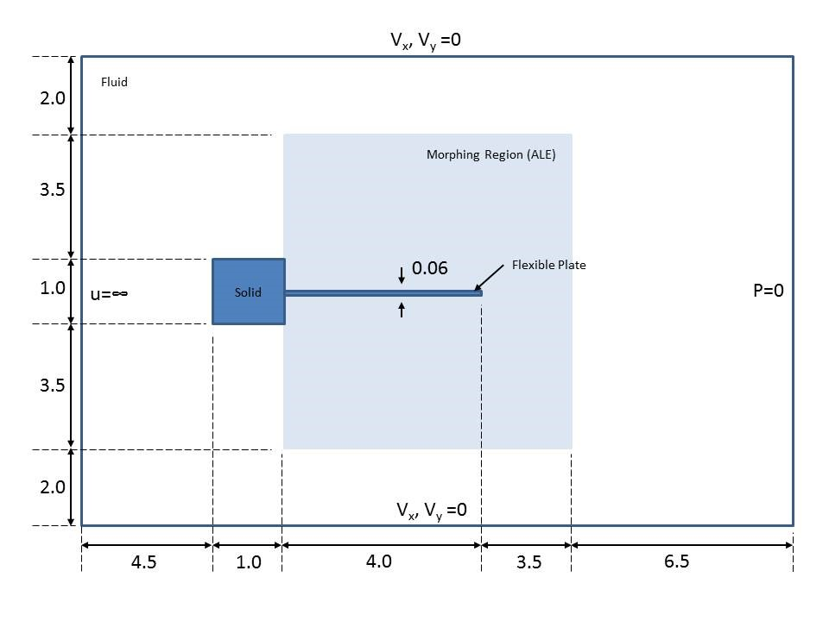
Fig. 4 The typical two dimensional geometry and boundary conditions of the fluid flow induced oscillation of flexible plate.

The classical two dimensional numerical model of the flexible plate example was created with the ANSYS APDL submerged in an incompressible fluid flow with the compatible two dimensional elements, FLUID141 for the fluid domain and PLATE183 for the flexible plate. Both FLOTRAN-CFD and Structural discipline were employed respectively to the fluid and plate domain. The flexible plate was attached to the fixed square rigid body in the centre of the downstream face. The fluid flow was set to a uniform velocity inflow, on the far end in the x-direction as shown in Fig. 4 and the zero pressure was set on the other end in the x-direction. In the undeformed configuration the plate was aligned with the far field flow. The vortices which separate from the corners of the rigid body generate lifting forces that excite oscillations of the flexible plate. Both the geometry and the boundary conditions of the model are shown in Fig.4. The material parameters of the fluid are taken from Dettmer, W. and Perić, D. (2008) where the viscosity and density of the fluid are $μ^{f}=1.82 x {10}^{-4}$ Pa.s and $ρ^{f}=1.18 x {10}^{-3}$ gcm⁻³ respectively. The inflow fluid flow velocity was chosen as $u_{∞}=51.3$ cms⁻¹ and therefore the Reynold number taken as, $Re=ρ^{f}Du_{∞}/μ^{f}=333$ whereby D = 1 is the diameter of the square rigid body. As for the solid and flexible plate, the density, shear and bulk moduli were specified as $ρ^{s}=0.1$, $μ^{s}=9.2593 x {10}^{5}$ Pa.s and $K^{f}=2.78 x {10}^{6}$ respectively. The Young Modulus, $E=2.5 x {10}^{6}$Pa and the Poisson’s ratio $ν=0.35$. The overall corresponding material properties can be referred to Table 1 below.

Table 1 Materials properties for the fluid flow induced flexible plate.
Material | Fluid | Solid + Flexible Plate
Viscosity | 1.82 x 10⁻⁴ | -
Density | 1.18 x 10⁻³ | 0.1
Shear Moduli | - | 9.2593 x 10⁵
Bulk Moduli | - | 2.78 x 10⁶
Young Modulus | - | 2.5 x 10⁶
Poisson’s Ratio | - | 0.35

In accordance to the element compatibility allowance for the FSI problem in ANSYS, the two dimensional element of FLUID141 for the fluid domain and PLANE183 element for the solid domain were employed and computed in this numerical example. FLUID141 (Ansys, 2009) geometry and the element was defined by four nodes (quadrilateral) and isotropic material properties. The FLUID141 element was used to model transient fluid systems that involve fluid or non-fluid regions. The conservation equations for viscous fluid flow and energy were solved in the fluid region and this element was categorized as the FLOTRAN CFD discipline element to solve fluid-solid interaction analysis. The velocities were obtained from the conservation of momentum principle, and the pressure was obtained from the conservation of mass principle. The degrees of freedom involved in this numerical example were velocities and pressure where the temperature was ignored. The turbulence model was invoked with the involvement of turbulent kinetic energy and the turbulent kinetic energy dissipation rate. The PLANE183 element is a higher order two dimension element that consists of 8-node or 6-node element having two degrees of freedom at each node: translations in the nodal x and y directions. This element is used for an isotropic hyperelasticity material property by the employment of Neo Hookean forms of strain energy potential that will produce large deflection or displacement of the flexible plate. The element is suitable for the case of incompressible hyperelastic materials and the geometry features of this element (Ansys, 2009). Thus, with all the appropriate material properties and element compatibility for the FSI problem considered, the two dimensional numerical model was created as shown in Fig. 5 and Fig. 6 based on the typical model illustrate in Fig. 4. The FLUID141 element was assigned to the fluid domain and the morphing region or non-structural region. The fluid and morphing regions are meshed with triangular shape element in total element of 6992 that consists of 3609 number of nodes. The morphing region was associated with the ALE formulation which allows large deformation of the fluid elements that corresponds to the large displacement of the flexible plate and Fig. 6 illustrates the solid domain assigned to the PLANE183 element.

4.1 Coupling Methods
The partitioned approach of coupling methods Multi-Field Single-Code, MFS and Load Transfer Physics Environment adapted in the ANSYS APDL platform are considered and compared on this numerical FSI problem. The MFS coupling solver is specified as strong coupled system of partitioned method and the solution method is specifically shown in Fig. 7. It solves sequential coupled field problems for a large class of coupled analysis problems. Each physic is treated sequentially and each matrix equation is solved separately where the MFS solver iterates between each physics field until the loads transferred across physics interfaces converge.
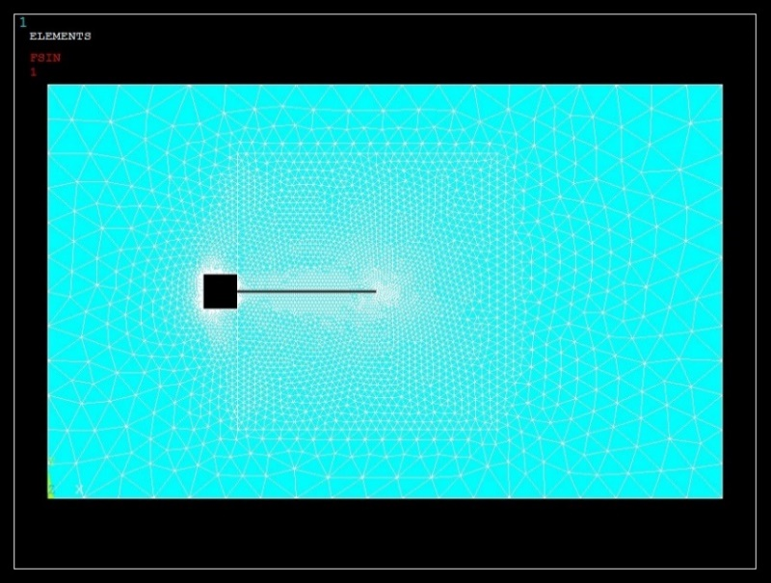
Fig. 5 Two-dimensional fluid flow domain and morphing region (ALE) of the typical fluid flow induced oscillation of flexible plate model in the two-way coupling FSI problem.
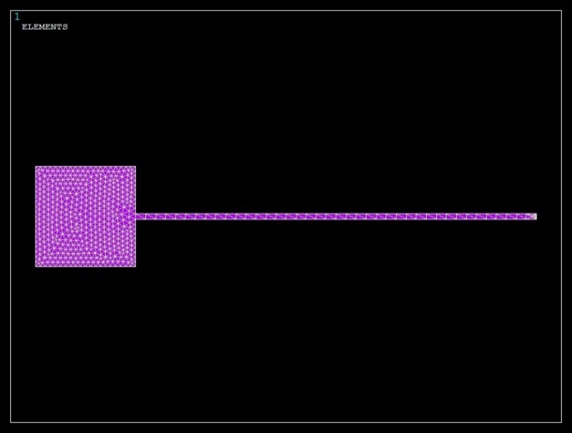
Fig. 6 Two-dimensional solid domain and the flexible plate of the typical fluid flow induced of flexible plate model in the two-way coupling FSI problem.
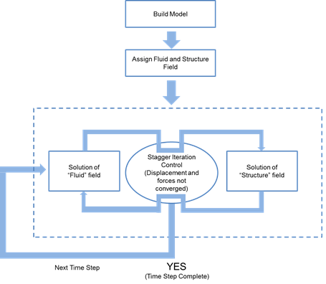
Fig. 7 Solution procedure of Multi-Field Single-Code coupling (MFS) for the FSI Oscillating Plate (Strong Coupling System).

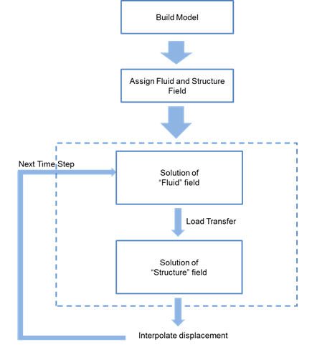
Fig. 8 Solution procedure of Load Transfer Physics Environment for the FSI Oscillating Plate (Weak Coupling System).
The Load Transfer Physics Environment is consider as weak coupled system of partitioned method under a developed user looping system with the ANSYS parameter design language (APDL). The looping of the weak coupling system is shown in Fig. 8 and the input of one physics analysis depends on the results from another analysis. In this paper, the numerical problem is treated as a two-way coupling approach and both methods are categorized in the load transfer coupling that involve multiple surface interactions between the fluid and structural domain especially at the solid and plate surfaces.

5.0 Results and Discussion
From the strong coupling analysis, the outcome of the vorticity pressure and displacement results for the flexible plate can be viewed in Fig. 9 and Fig. 10 respectively. The fluid flow and oscillation of the flexible plate started off at rest with Time = 0.0 s and the inflow velocity $u_{∞}$ was applied instantaneously until Time = 2.0 s. The tip of the plate increase oscillating gradually proportional to the time history from Time = 0.0 s to Time = 2.0 s in Fig. 11 along with the typical flow patterns displayed in the vorticity pressure diagrams of the morph region (ALE) shown in Fig. 9. Through the inspection of results illustrated on Fig. 9 and Fig. 10, the oscillating flexible plate induced by the vorticity pressure fluid flow has shown a good agreement in the both distributions pattern along in the time history from Time = 0.0 s to Time = 2.0 s. These results for the strong coupling system in MFS can justify the capability of partitioned strong coupling in resolving the FSI problem of two-ways coupling. The vorticity pressure of the fluid flow normally occurs along the gap and edges between the flexible plate and the rigid square body which are quite noticeable for the distribution patterns shown in Fig. 9 with the representation of the blue colour contour. The oscillating flexible plate was recorded along with the time history building up from rest and this can best be referred to the graph plotted in Fig. 11. Curve in Fig. 11 clearly shows that the flexible plate increase gradually oscillating due to the induced vorticity pressure from the fluid flow and the highest amplitudes of the oscillating tip displacement, d is 1.73 cm between the time frame of Time = 0.0 s and Time = 2.0 s.

The result was compared with the numerical result from Dettmer, W. and Perić, D. (2006) for the build-up of oscillations from rest and curves were plotted in Fig. 12 for close observation. Snapshot of time frame from Time = 0.0 s to Time = 2.0 s was taken in this comparison and the oscillation distribution pattern of the flexible plate agrees well with the results obtained in Dettmer, W. and Perić, D. (2006). The convergence in the strong coupling system in MFS is stringent and the stability of the coupling is questionable owing to its computational efficiency by improving a proper correlation in the interfaces load transfer and map meshing in the morph region. Despite this, the oscillation of the flexible plate has demonstrated a convincing result which has better symmetrical curve and smoothness as compared to the result from Dettmer, W. and Perić, D. (2006). A conclusive study of the compared amplitude oscillating tip of flexible plate justified the accuracy and robustness of this partitioned strong coupling system coping the two-ways FSI problem although further attempt of such examples might needed to improve the periodic long term response of the flexible plate.

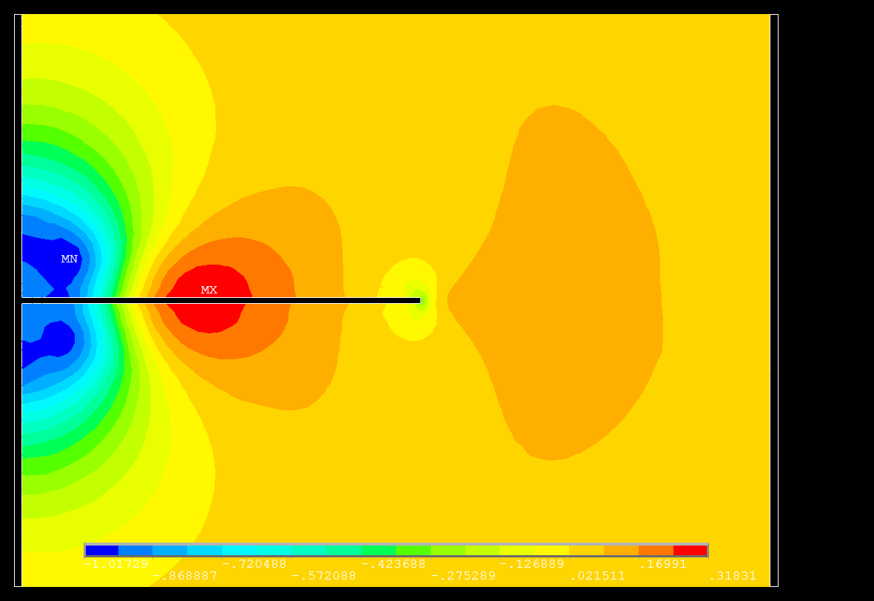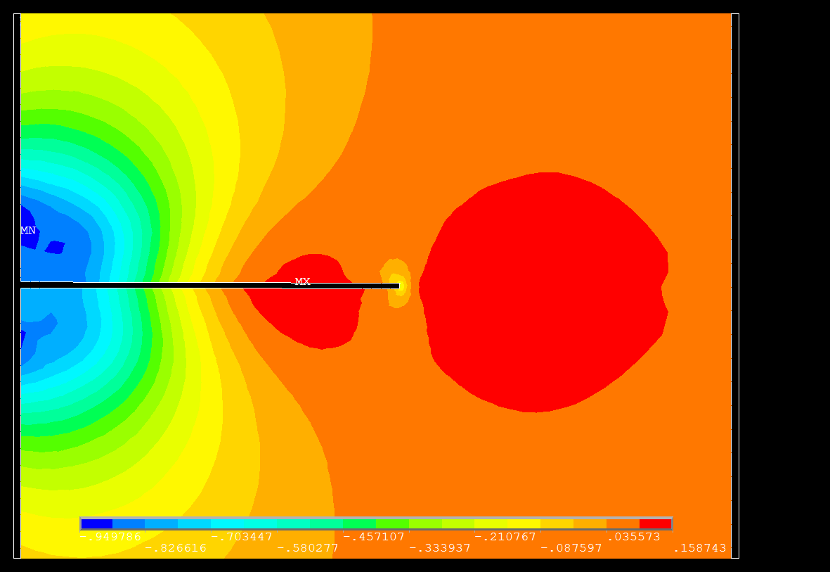
(a) Time = 0.05s (b) Time = 0.10s
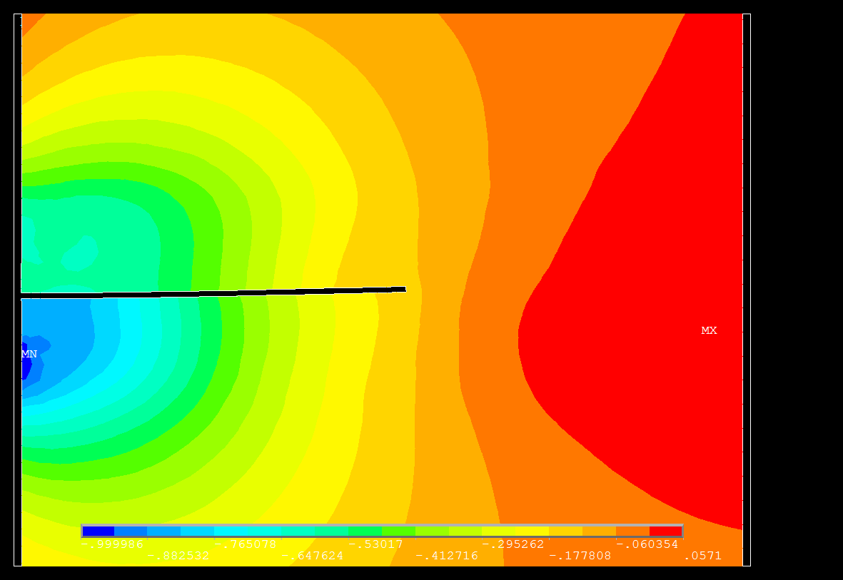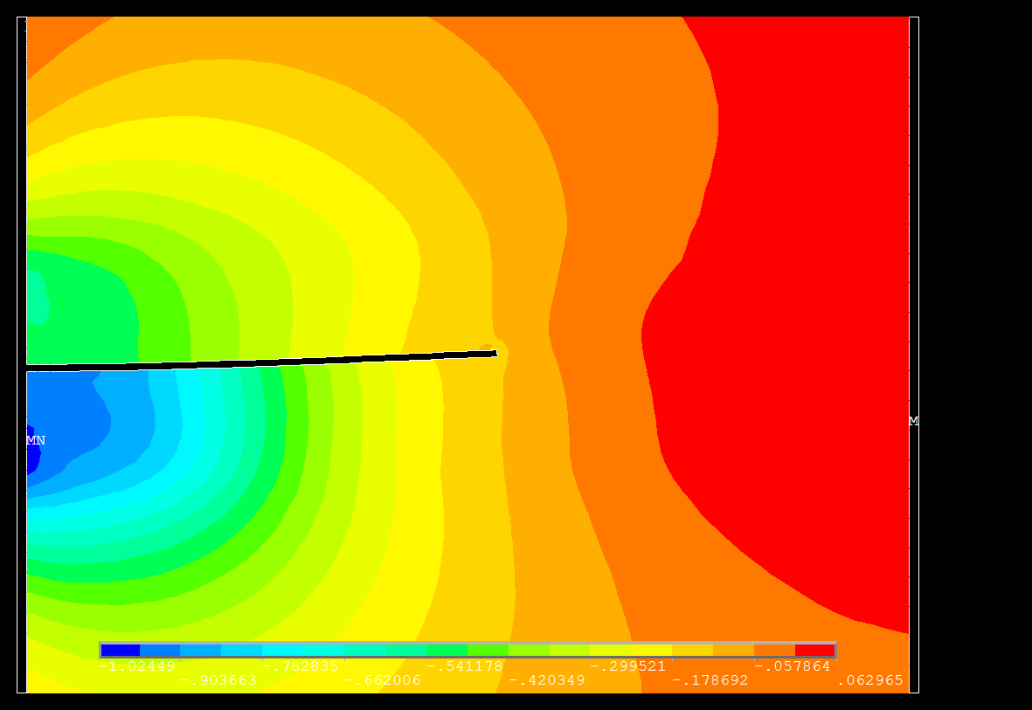
(c) Time = 0.85s (d) Time = 0.90s
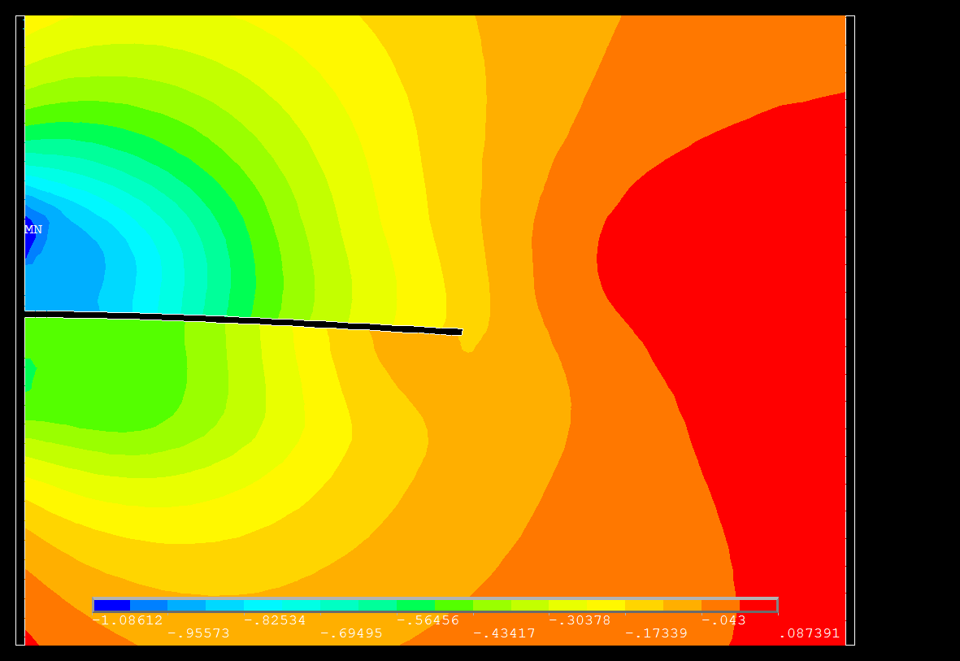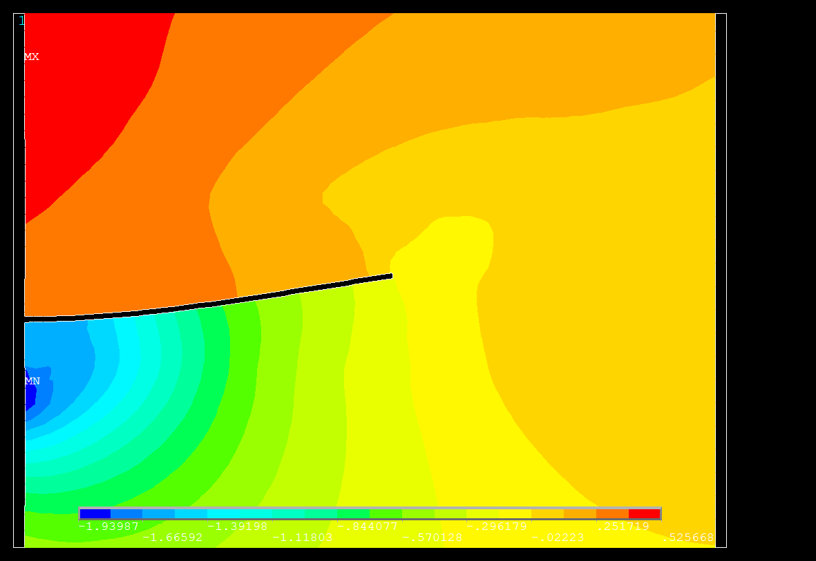
(e) Time = 1.05s (f) Time = 1.45s
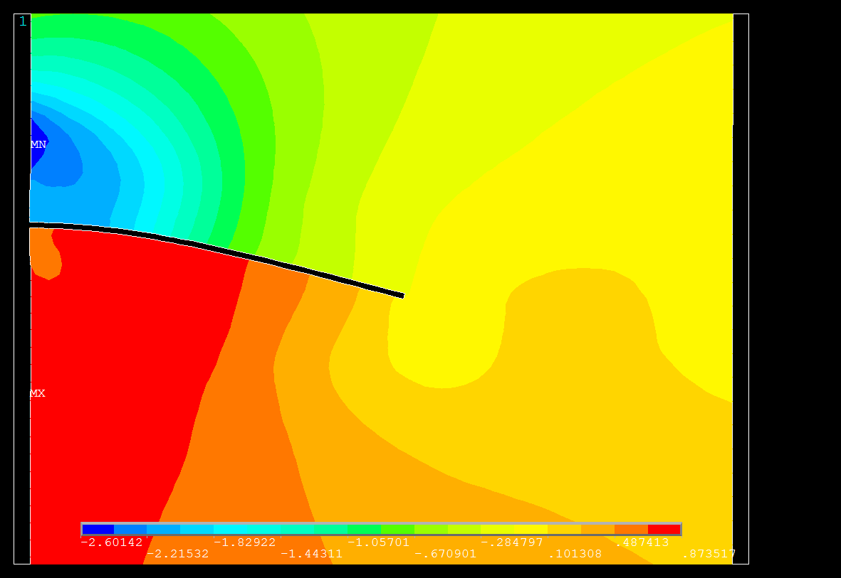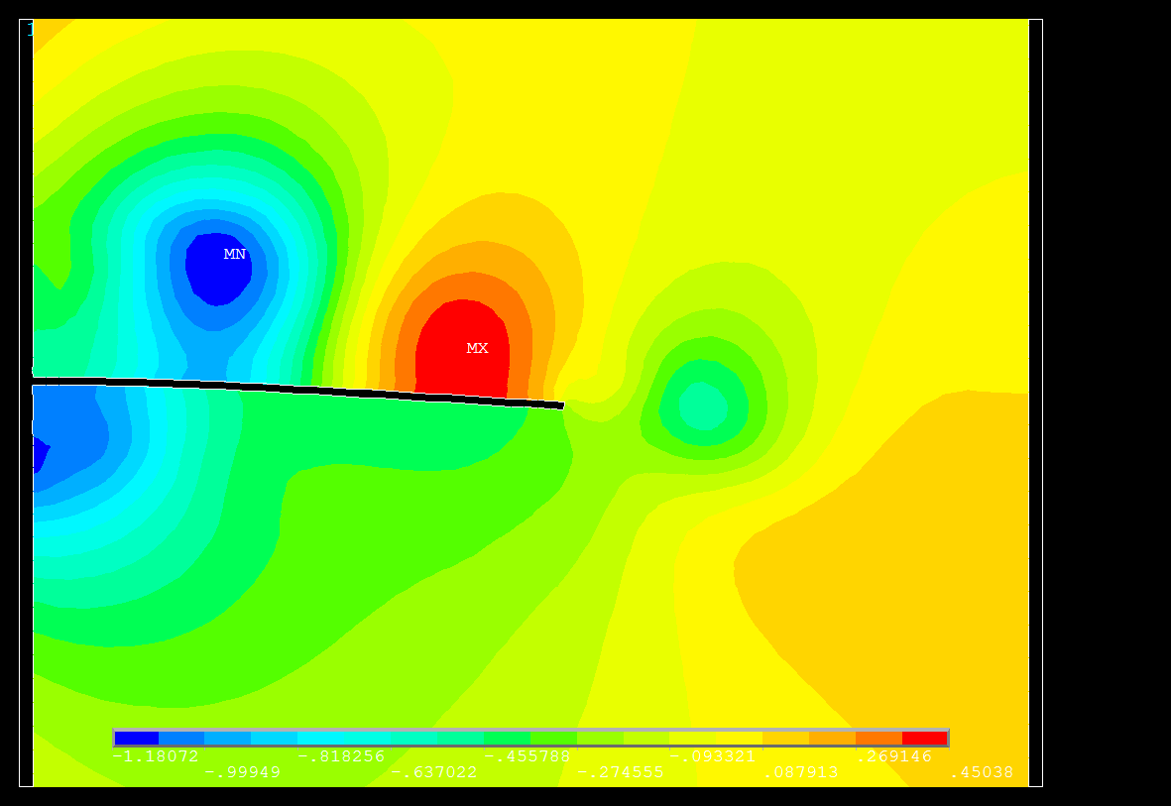
(g) Time = 1.55s (h) Time = 1.60s
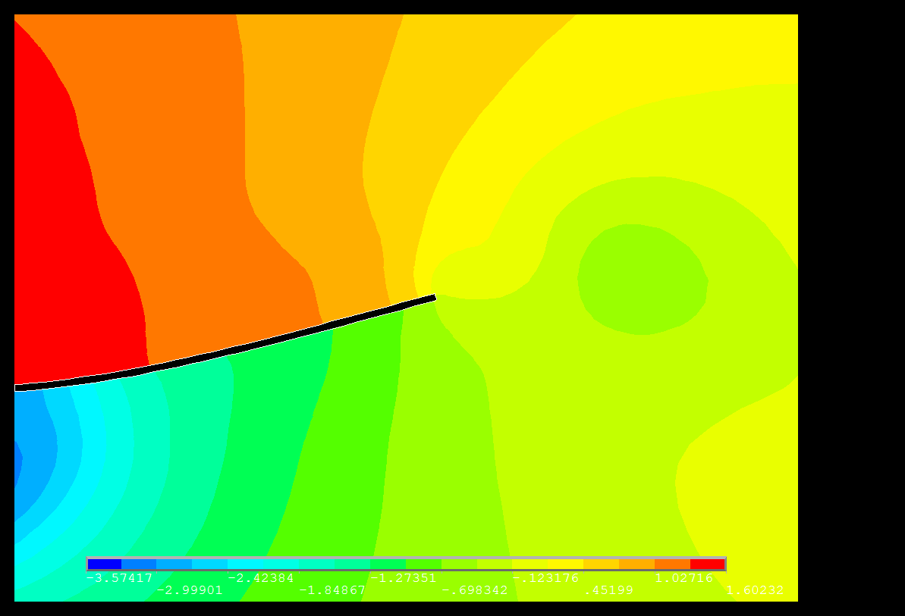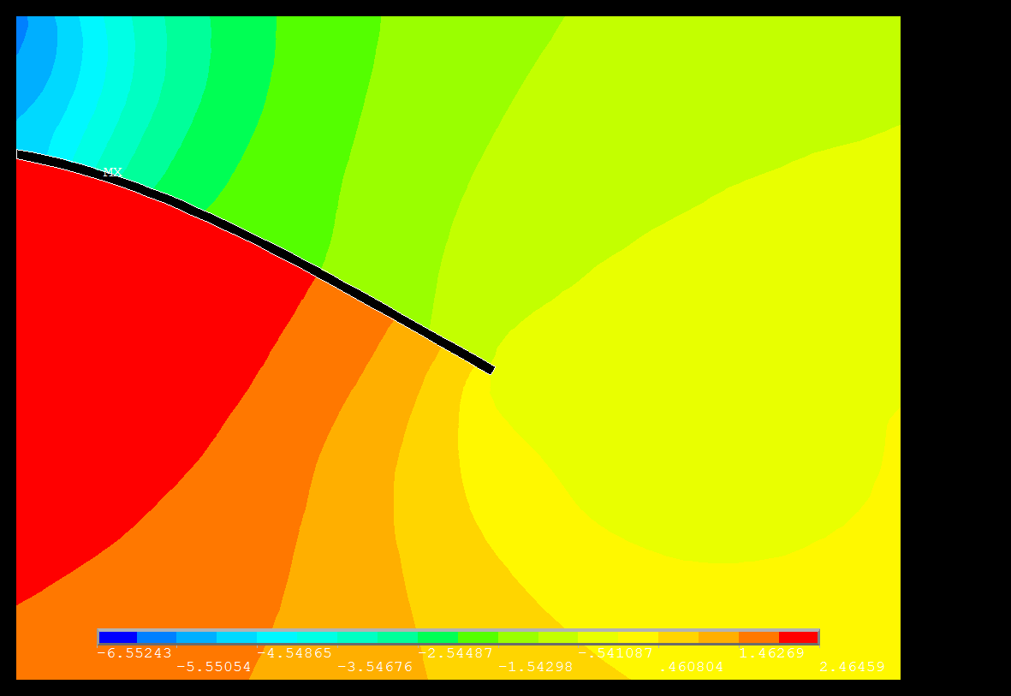
(i) Time = 1.65s (j) Time = 1.80s

Fig. 9 Typical vorticity pressure distributions pattern in morph region (ALE) with (a) Time = 0.05s; (b) Time = 0.10s; (c) Time = 0.85s; (d) Time = 0.90s; (e) Time = 1.05s; (f) Time = 1.45s; (g) Time = 1.55s; (h) Time = 1.60s; (i) Time = 1.65s; (j) Time = 1.80s in the fluid flow induced oscillations of the flexible plate. (Multi-Field Solver with Single-Code, MFS).

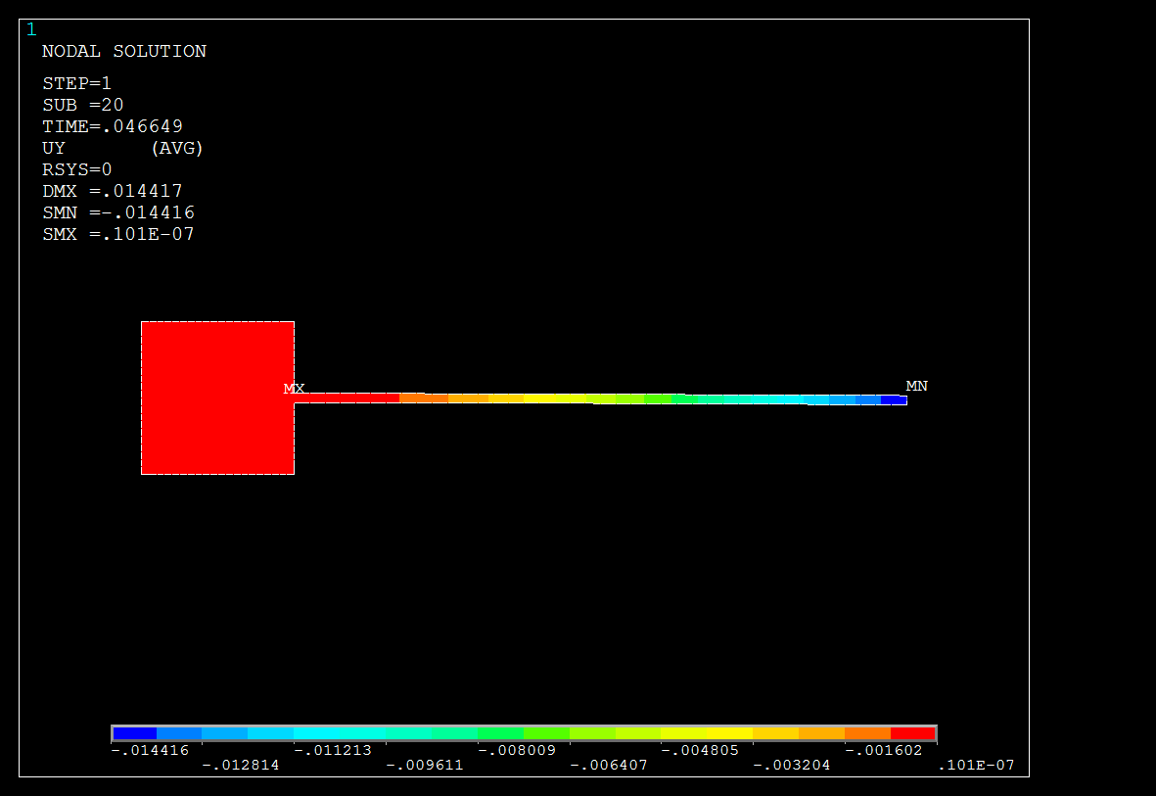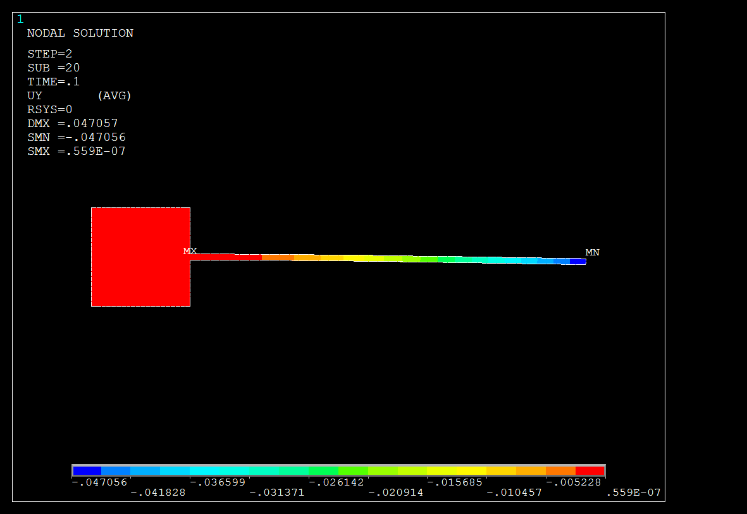
(a) Time = 0.05s (b) Time = 0.10s
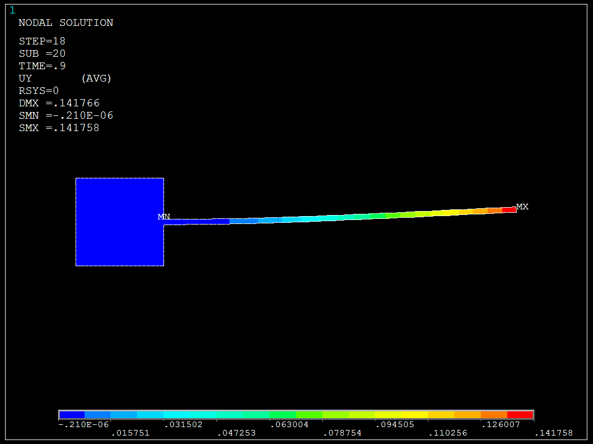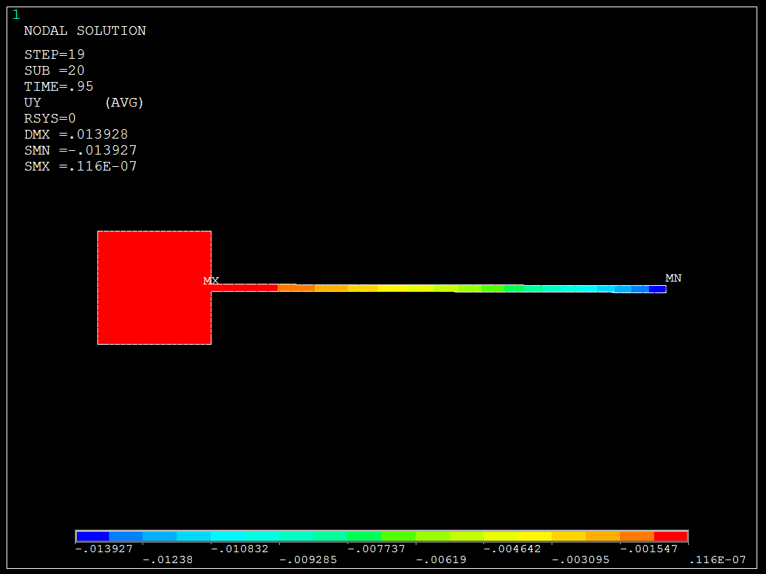
(c) Time = 0.85s (d) Time = 0.90s
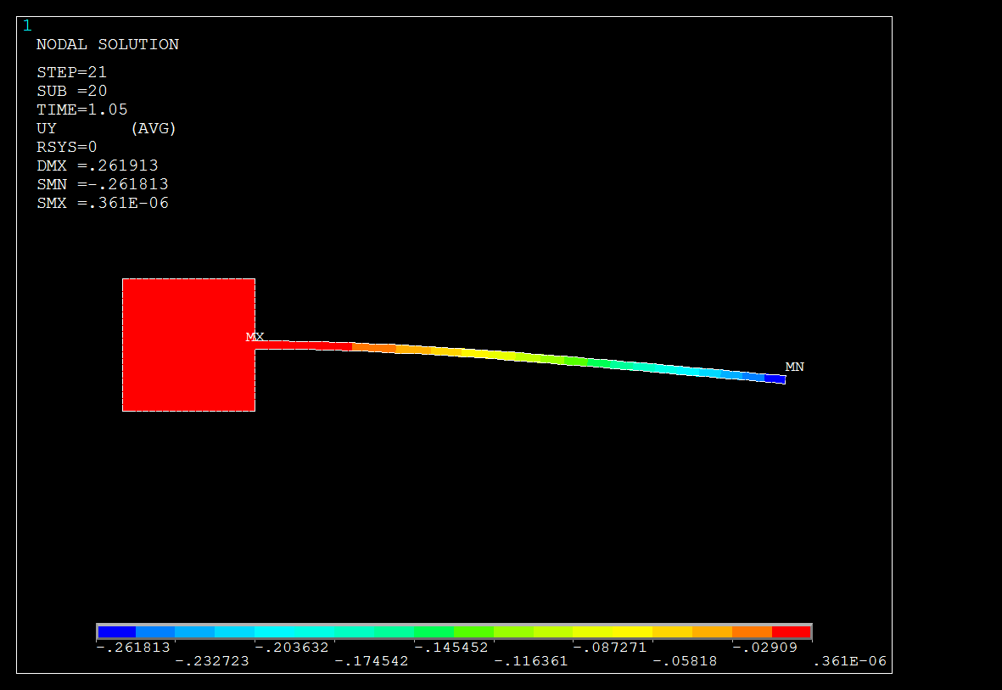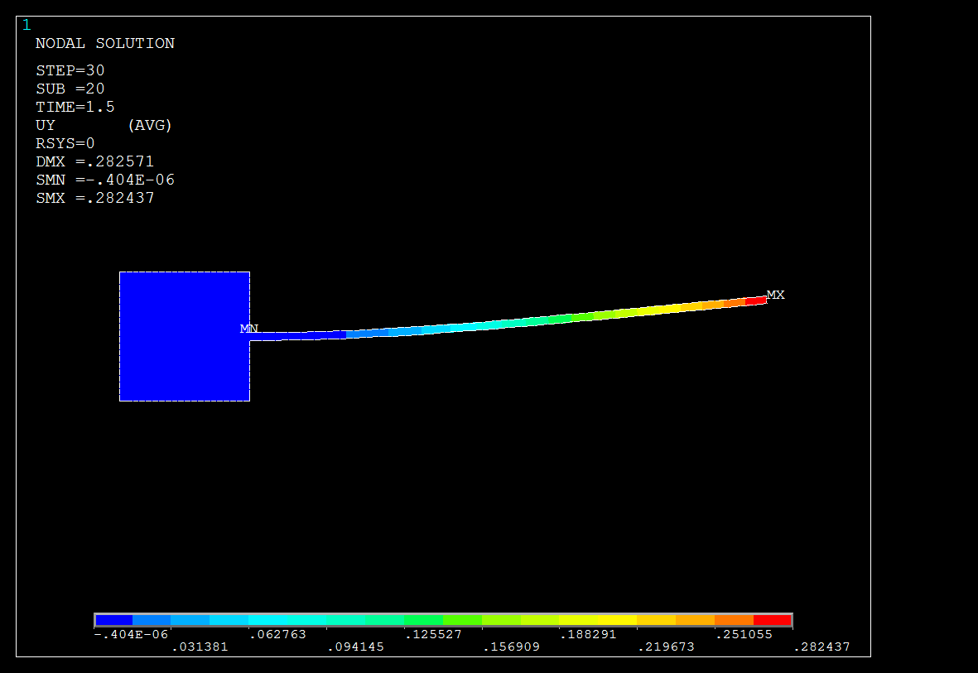
(e) Time = 1.05s (f) Time = 1.45s
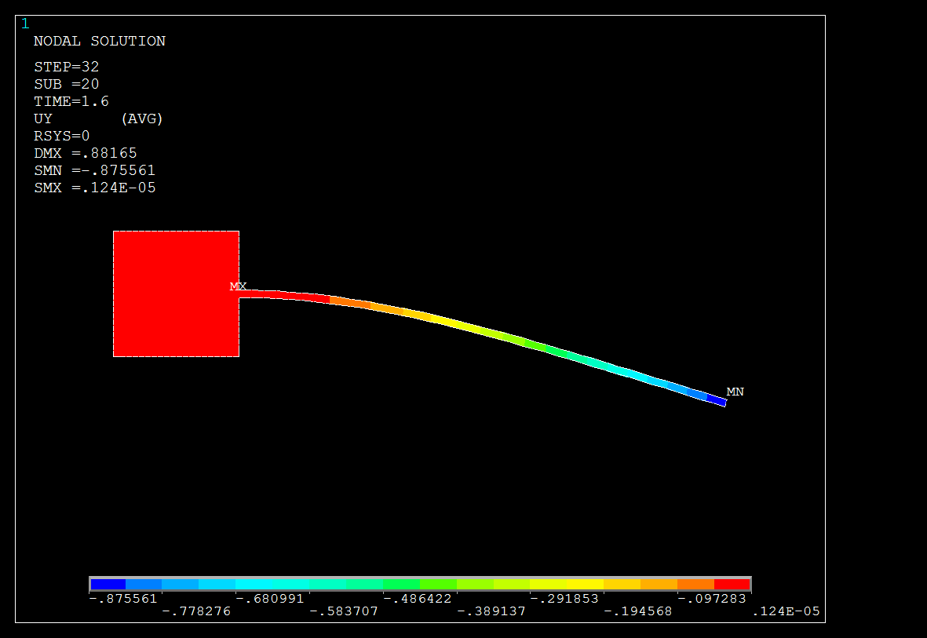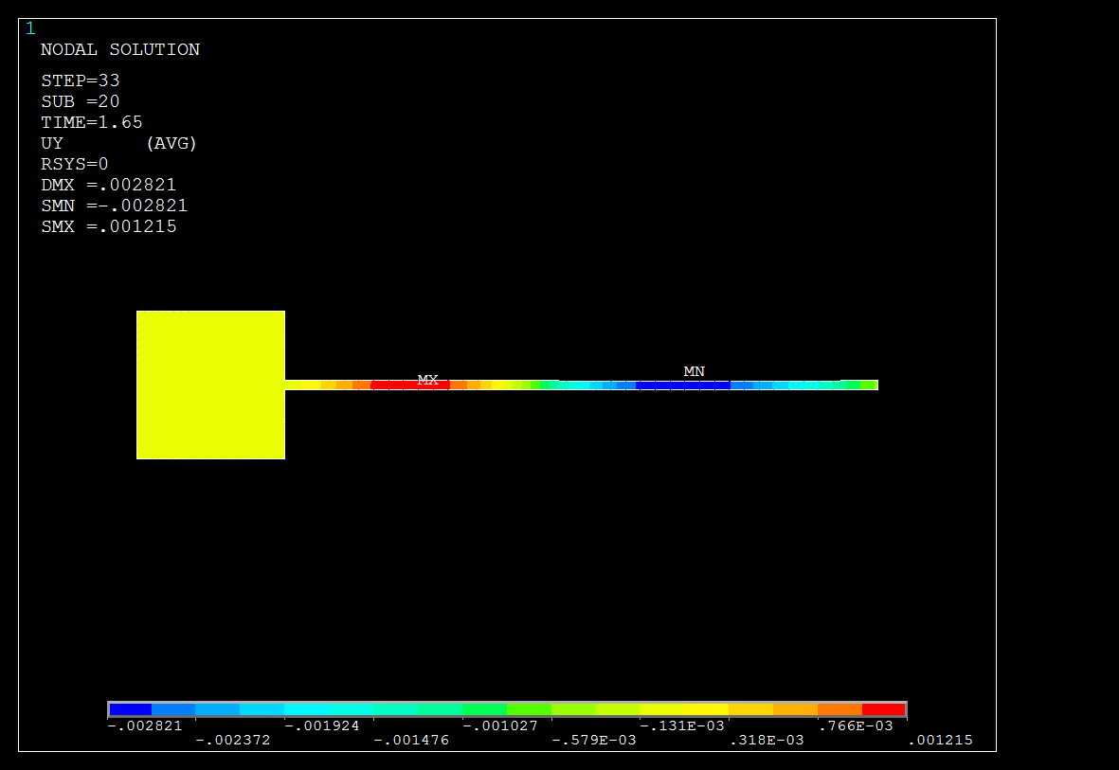
(g) Time = 1.55s (h) Time = 1.60s
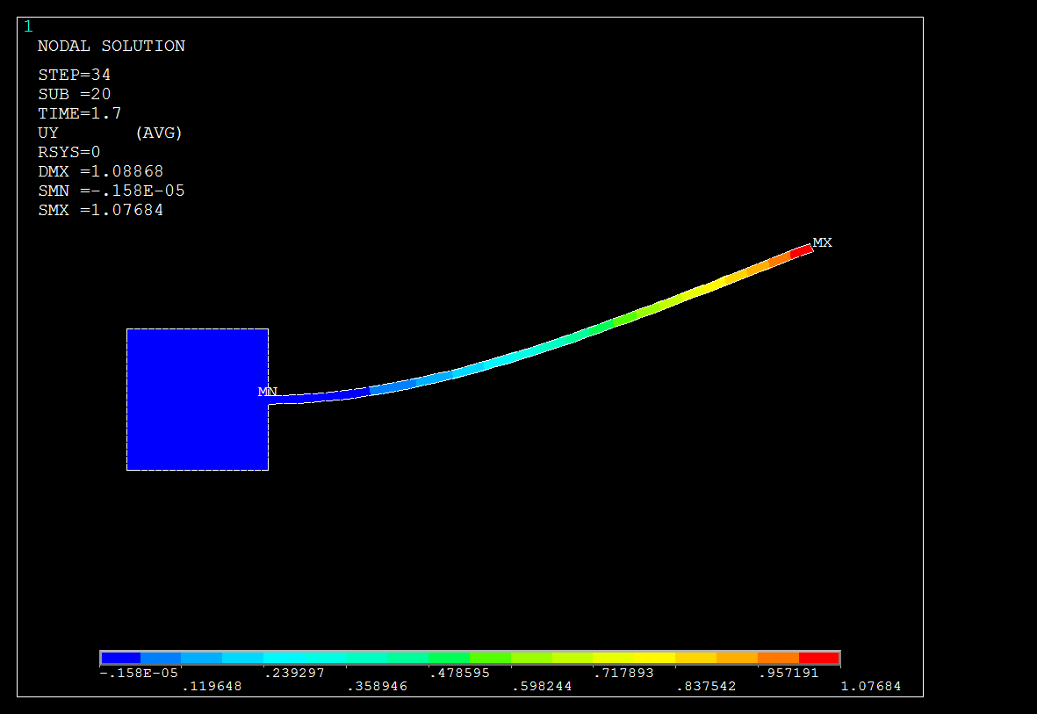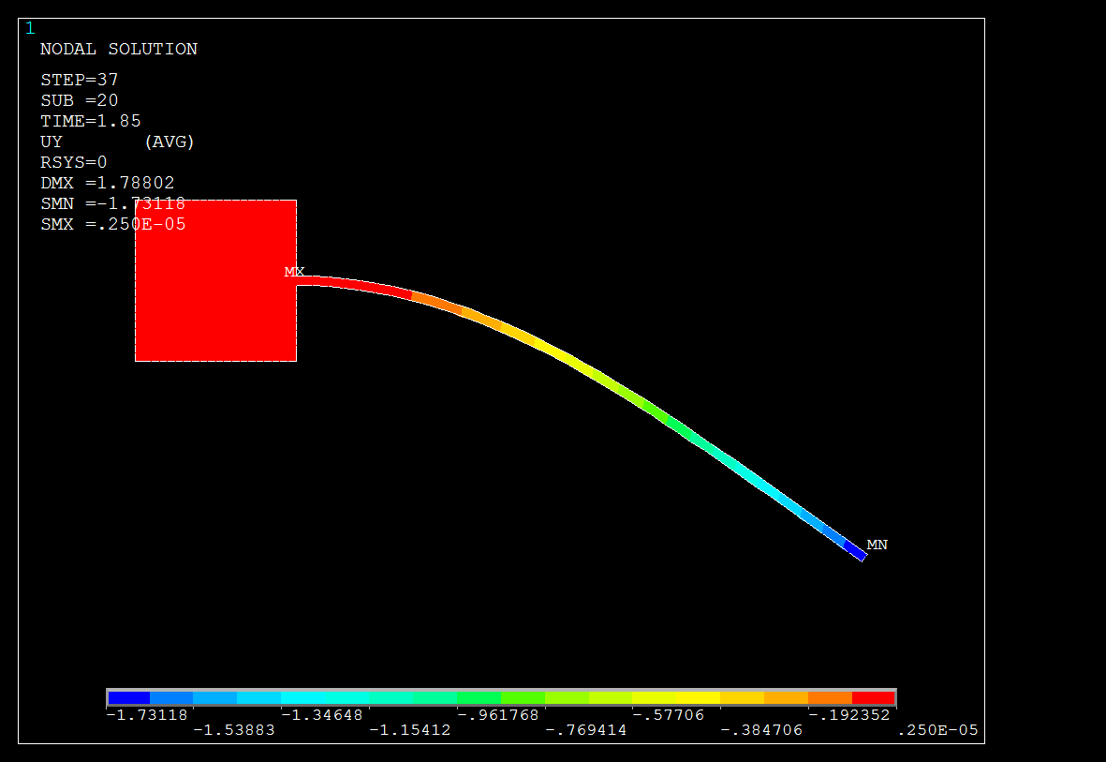
(i) Time = 1.65s (j) Time = 1.80s

Fig. 10 Typical displacement distributions pattern of the oscillating flexible plate induced by the vorticity pressure with (a) Time = 0.05s; (b) Time = 0.10s; (c) Time = 0.85s; (d) Time = 0.90s; (e) Time = 1.05s; (f) Time = 1.45s; (g) Time = 1.55s; (h) Time = 1.60s; (i) Time = 1.65s; (j) Time = 1.80s in the fluid flow induced oscillations of the flexible plate. (Multi-Field Solver with Single-Code, MFS).

In the next section, a weak coupling partitioned method was used in the similar example of fluid flow induced oscillation of the flexible plate where comparison and discussion were made. Based on the weak coupling analysis, the vorticity pressure and displacement results were shown in Fig. 13 and Fig. 14 respectively for the flexible plate. The oscillation of the flexible plate was measured from Time = 0.0 s at rest to the Time = 2.0 s under an inflow velocity $u_{∞}$= 51.3 cm/s. The oscillating on the tip of the plate increases gradually in proportion to the time history as shown in Fig. 14. The mapping of the ALE onto the morph region has resulted in the typical flow patterns displayed in the vorticity pressure diagrams of the morph region (ALE) in Fig. 13. Looking at the results shown in Fig. 13 and Fig. 14, close agreement were obtained between the vorticity pressure fluid flow inducing the oscillating flexible plate in the both distributions pattern along in the time history from Time = 0.0 s to Time = 2.0 s.
The ALE function allowed the positioning of the oscillating flexible plate onto the fluid morphing region as illustrated. This has made possible in the weak coupling system of the Load Transfer Physics Environment method and clearly justified the capability such method in resolving the FSI problem of two-ways coupling. The curve in Fig. 15 can best described the oscillating behavior of the flexible plate with the time step size t = 0.05. Fig. 15 clearly shows that the flexible plate increase gradually oscillating owing to the induced vorticity pressure from the fluid flow and the highest amplitudes of the oscillating tip displacement, d is 1.68 cm occurs between the time frame of Time = 1.8 s and Time = 2.0 s. On the next Fig. 16, the result was compared to the numerical result from Dettmer, W. and Perić, D. (2006) for the build-up of oscillations from rest and graphs were plotted for better comparison and observation. Such results were compared when the applied time step size, t = 0.05 based on the observation and analysis of the results, the differences of the oscillation pattern in the beginning of time history have shown that the load vector of force and displacement were weakly transferred between the specified interface boundary condition. It is noticeable that the weak coupling system has a slow responsive oscillation in time in comparison with the results from Dettmer, W. and Perić, D. (2006). However, a sudden built up of the oscillating amplitude became similarly close to the numerical results from Dettmer, W. and Perić, D. (2006) along with the time.
These could be the cause of weakly coupled interaction surface and the loose contact convergence of the load transferred between the fluid field and the solid field. The stability of the ALE mapping in this weak coupling could be problem too. Nevertheless, the application of the developed loop command has proven to be working well for a weak coupling system in a two-way FSI problem. And the smoothness of the symmetrical oscillations curve result obtained in weak coupling synchronize as compared to the result from Dettmer, W. and Perić, D. (2006). It could be concluded that the method and numerical analysis has justified its capability of resolving problem in regards to this two-way FSI coupling method. More attempts of two-way problems are required to improve the coupling interface boundary condition and to overcome the delay oscillation responding with time. Thus, conclusion can be made that the strong and weak partitioned method system of MFS and Load Transfer Physics Environment have proven to be able to solve the problem of two-way FSI problems with their respective capability and computational techniques developed.

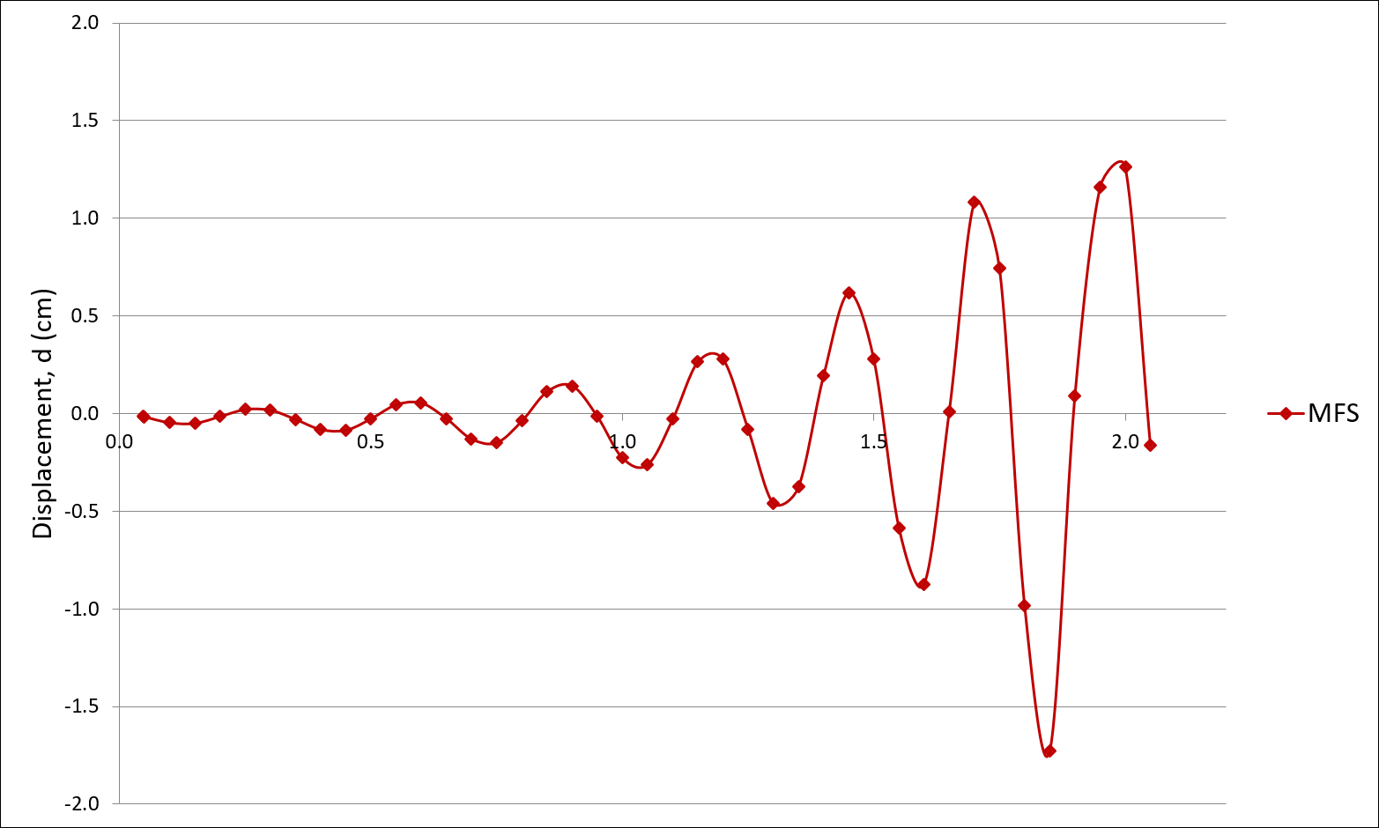
Fig. 11 Build-up oscillations of the flexible plate induced by the vorticity pressure of fluid flow from rest; vertical displacement of the tip of the flexible plate; time step size of $∆$t = 0.05; strong coupling partitioned method; in (Multi-Field Solver with Single-Code, MFS).
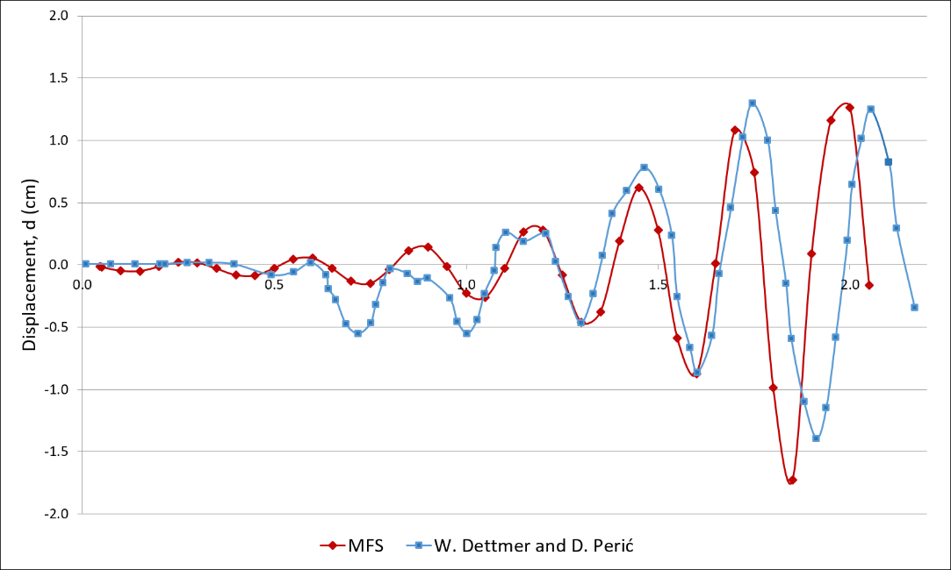
Fig. 12 Comparison numerical result of build-up oscillations of the flexible plate induced by the vorticity pressure of fluid flow from rest; vertical displacement of the tip of the flexible plate; in the time step size of $∆$t = 0.05; strong coupling partitioned method; in (Multi-Field Solver with Single-Code, MFS).

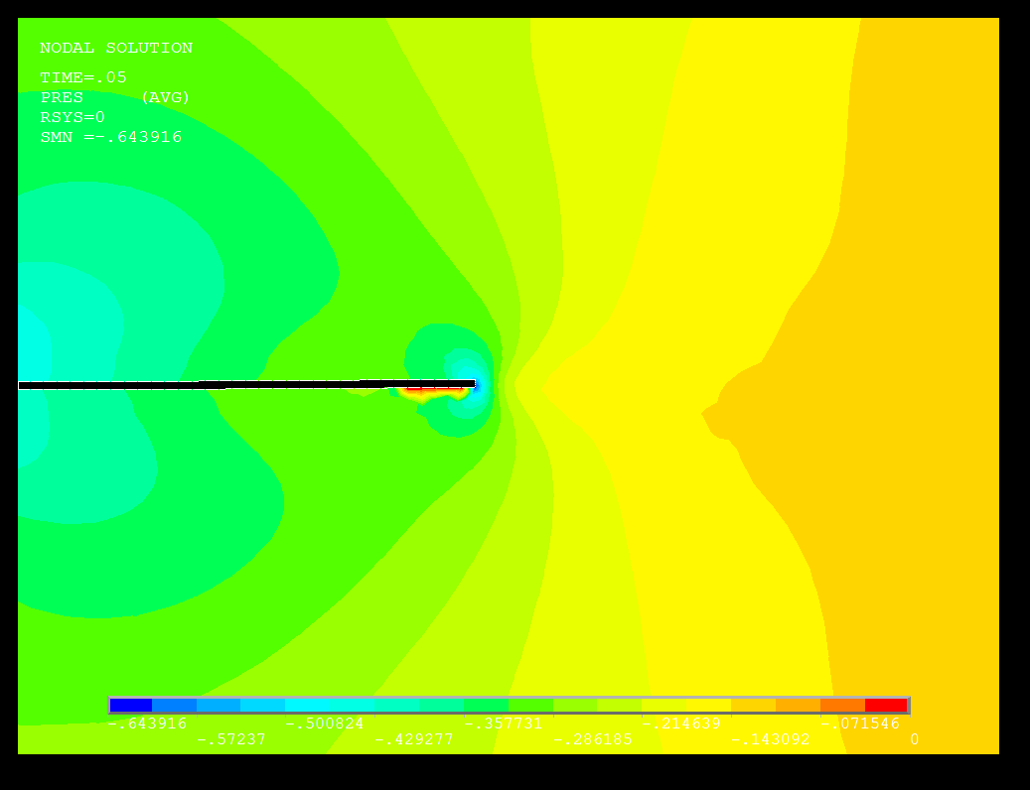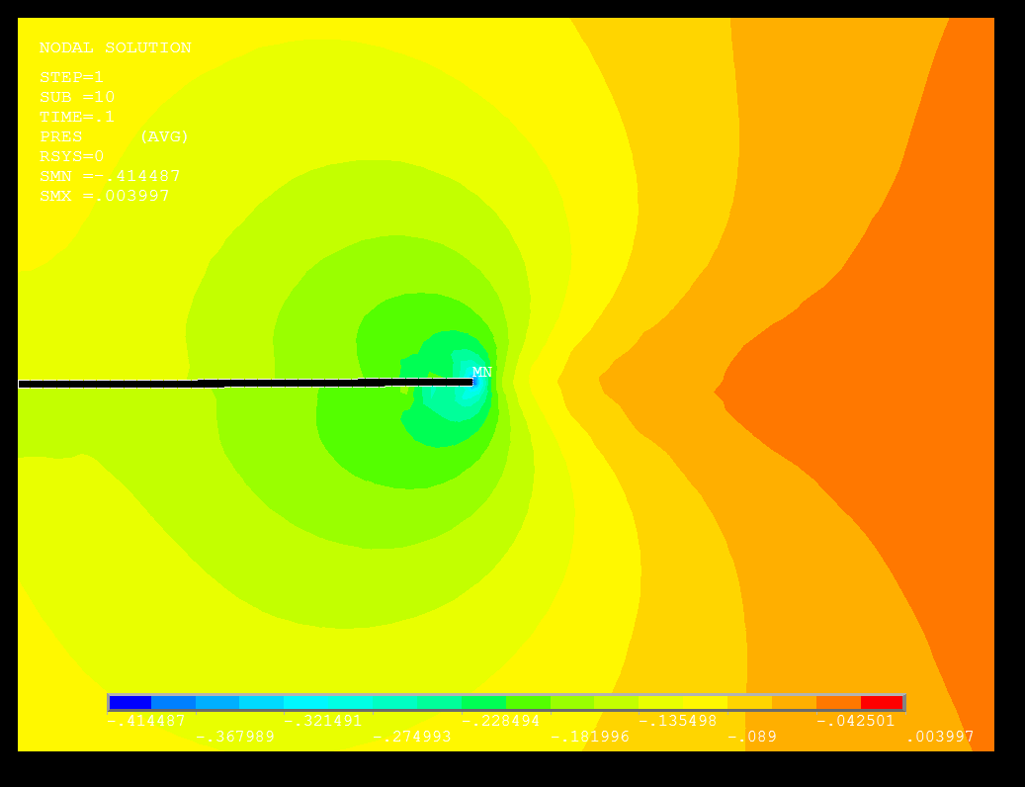
(a) Time = 0.05s (b) Time = 0.10s
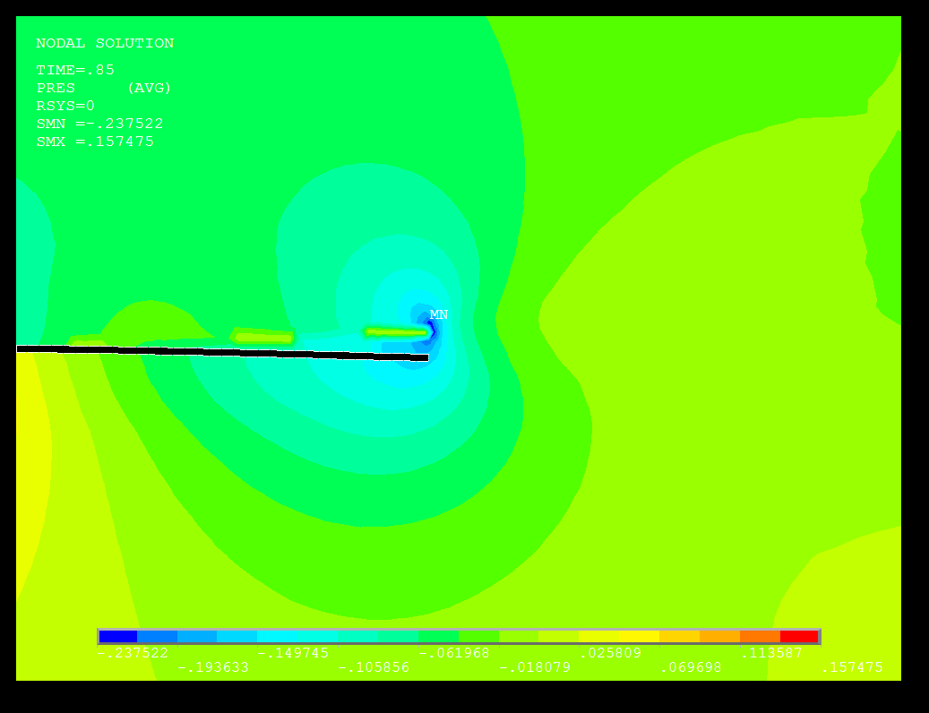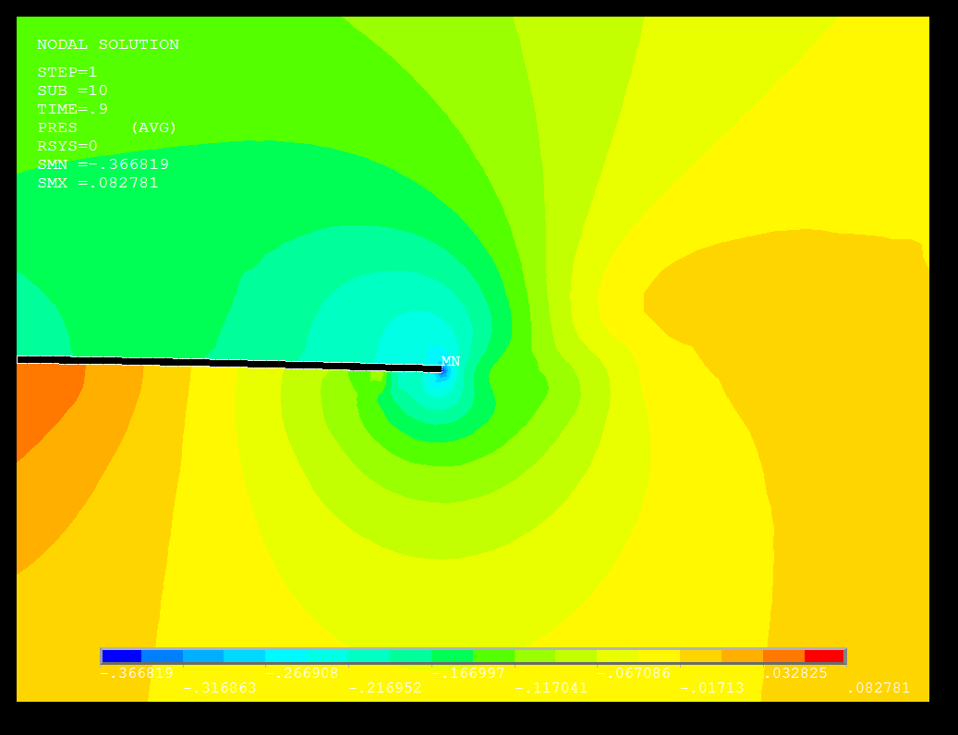
(c) Time = 0.85s (d) Time = 0.90s
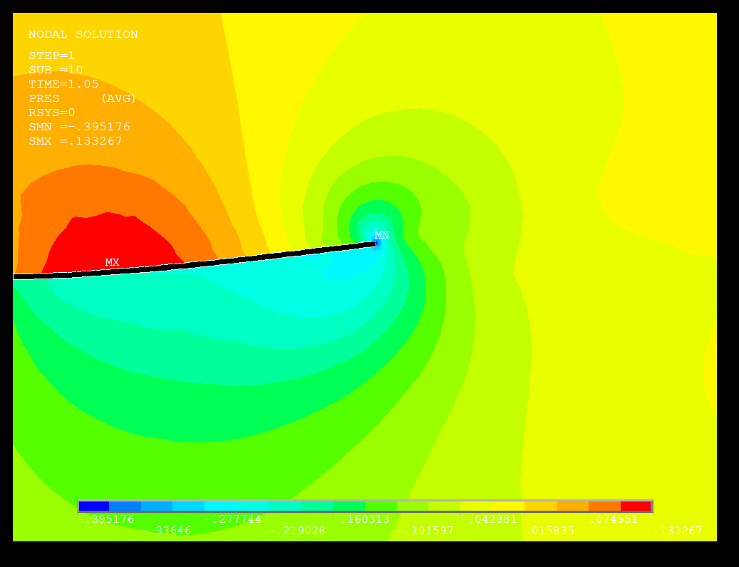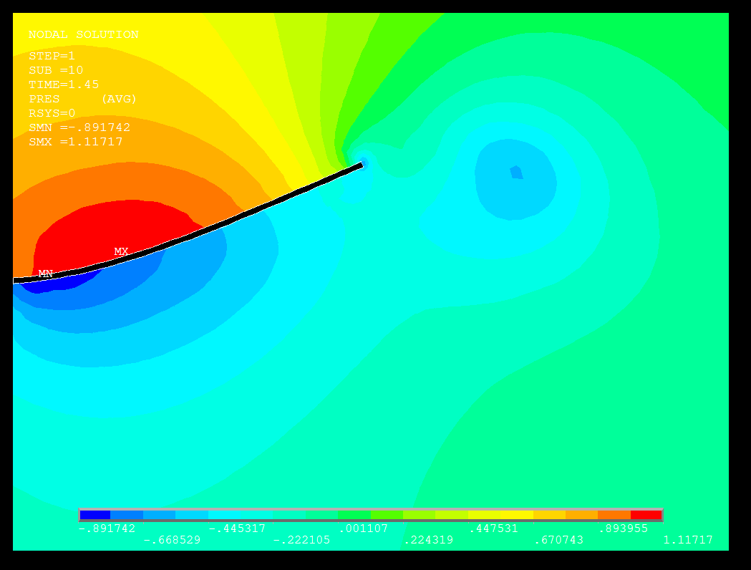
(e) Time = 1.05s (f) Time = 1.45s

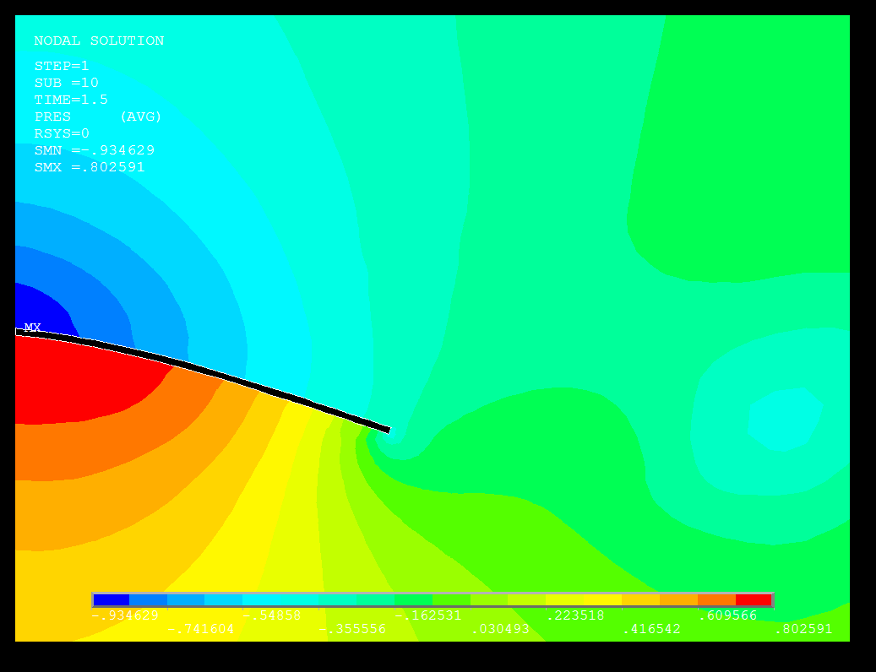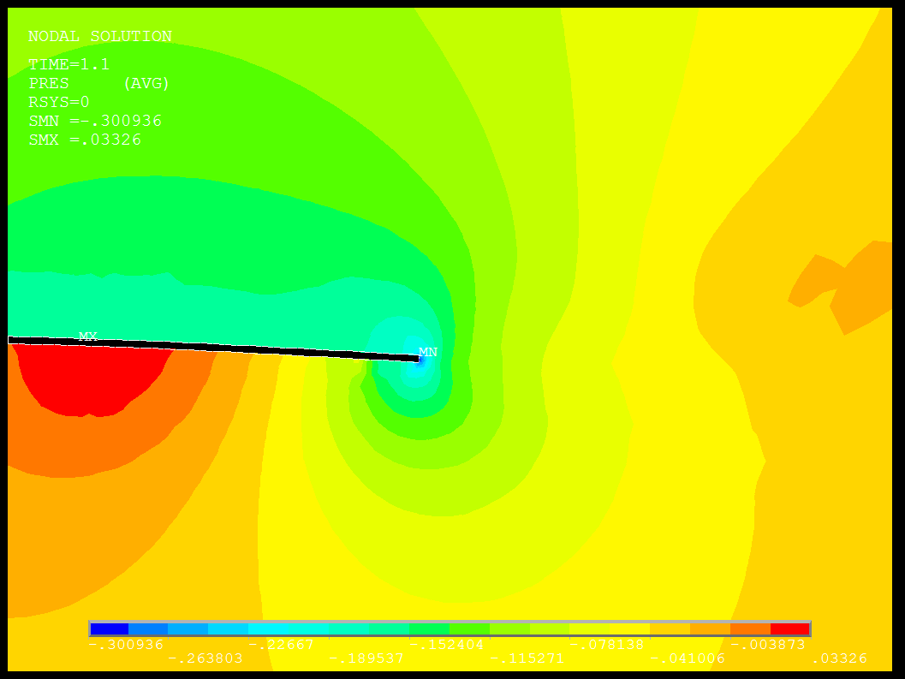
(g) Time = 1.55s (h) Time = 1.60s
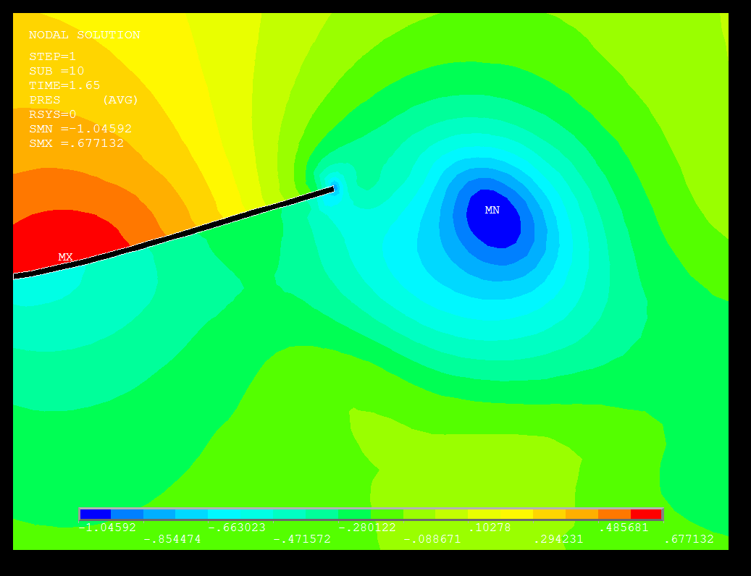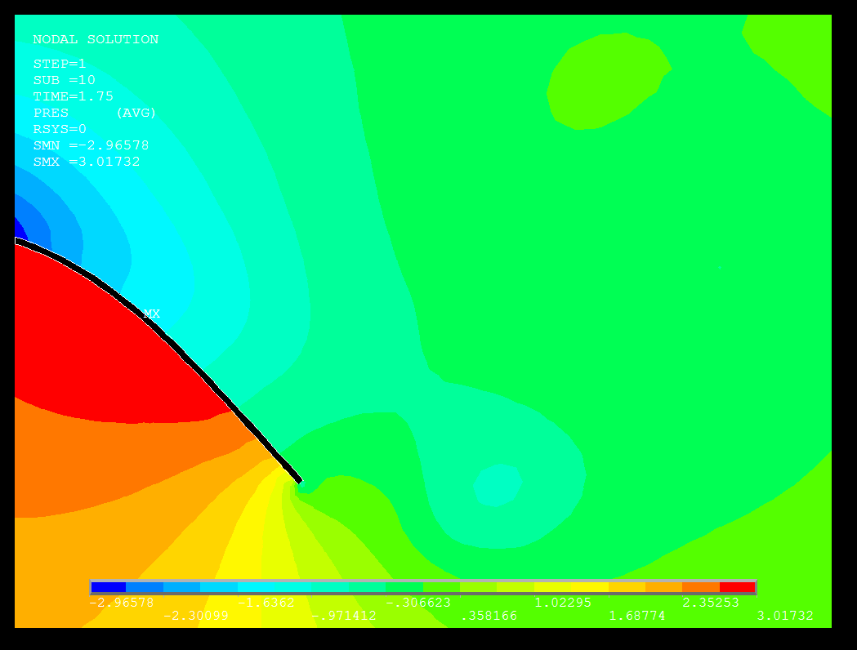
(i) Time = 1.65s (j) Time = 1.80s

Fig. 13 Typical vorticity pressure distributions pattern in morph region (ALE) with (a) Time = 0.05s; (b) Time = 0.10s; (c) Time = 0.85s; (d) Time = 0.90s; (e) Time = 1.05s; (f) Time = 1.45s; (g) Time = 1.55s; (h) Time = 1.60s; (i) Time = 1.65s; (j) Time = 1.80s in the fluid flow induced oscillations of the flexible plate. (Load Transfer Physics Environment).

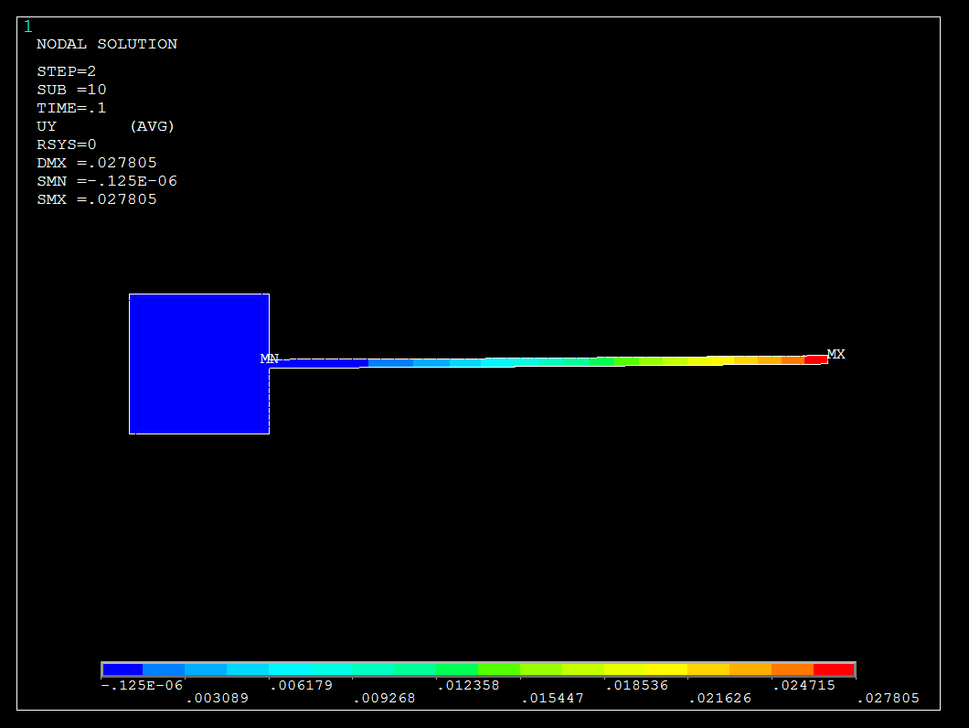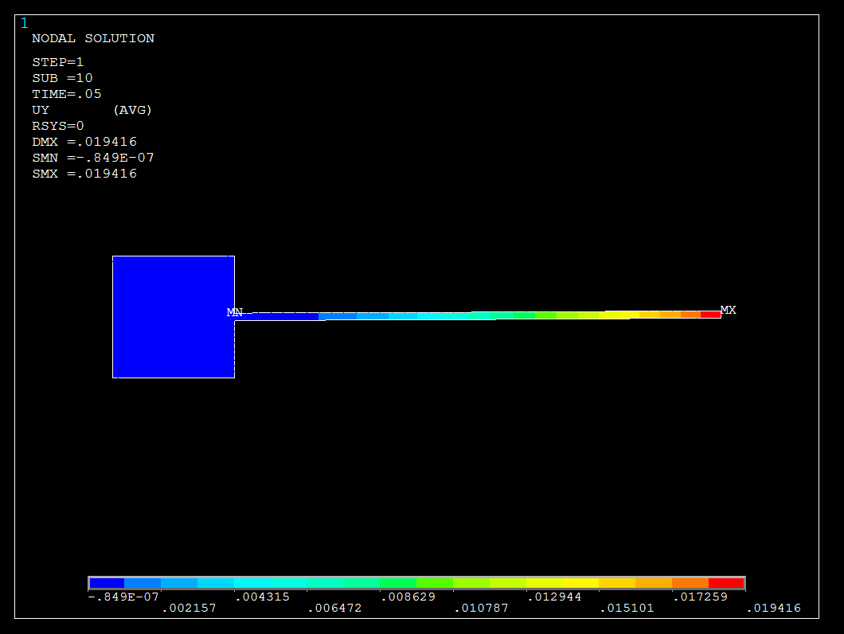
(a) Time = 0.05s (b) Time = 0.10s
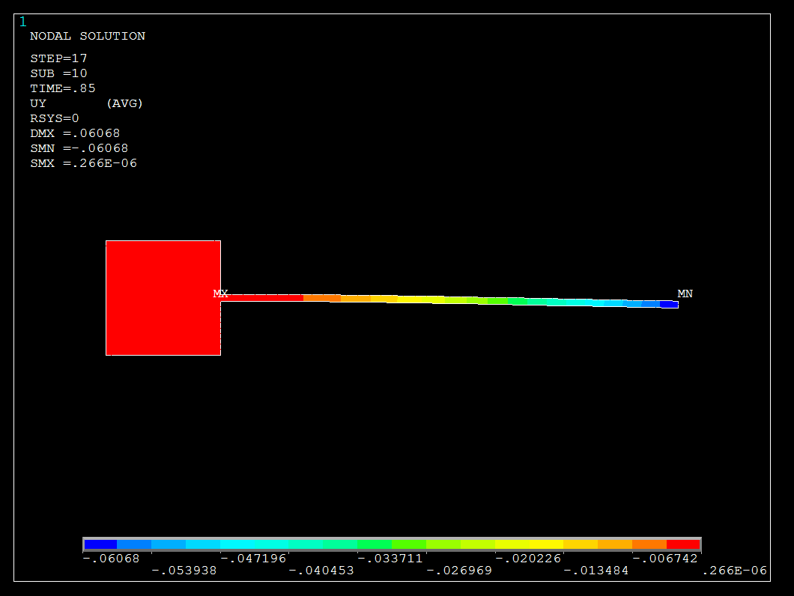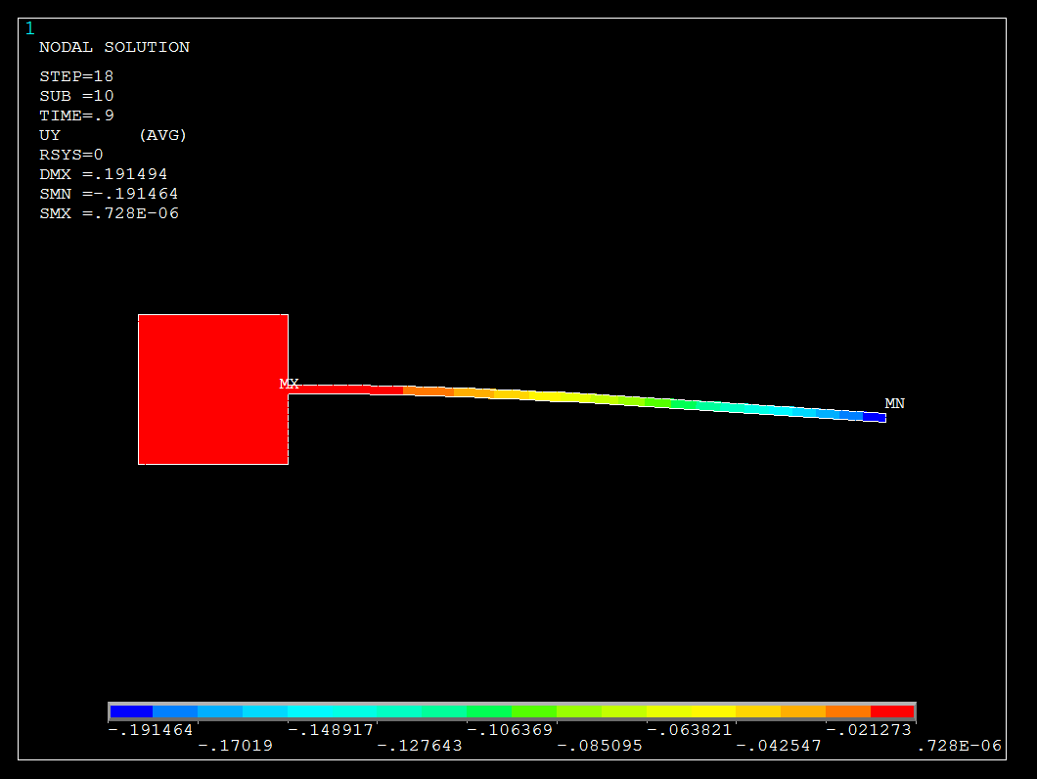
(c) Time = 0.85s (d) Time = 0.90s
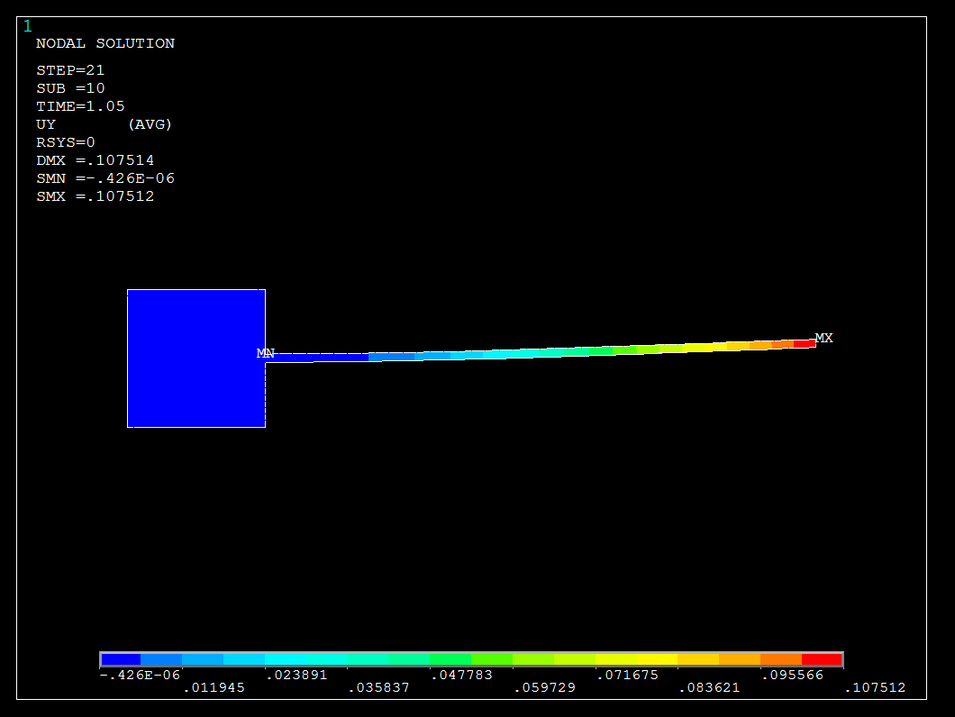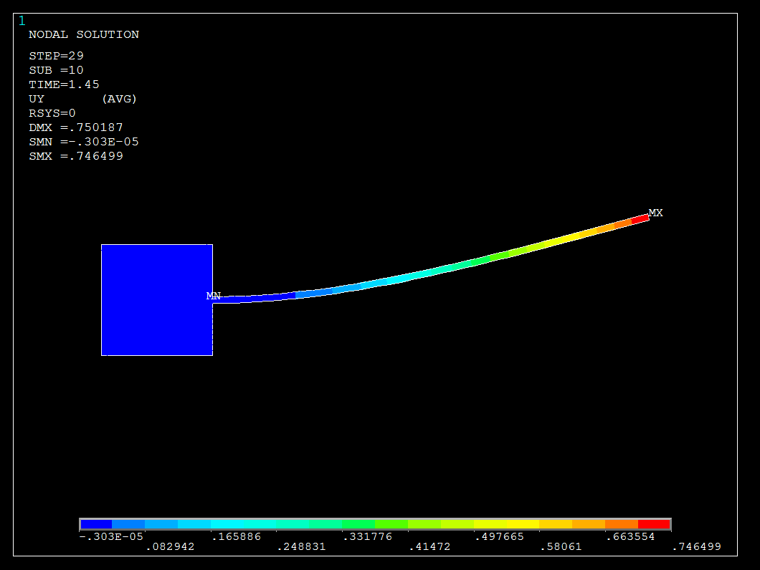
(e) Time = 1.05s (f) Time = 1.45s

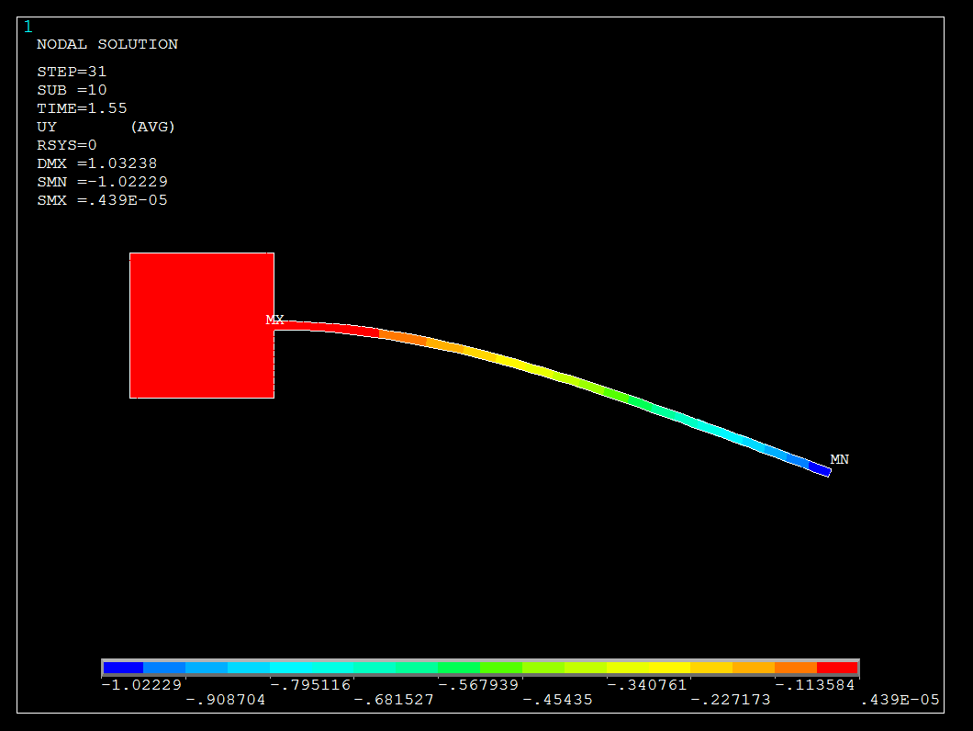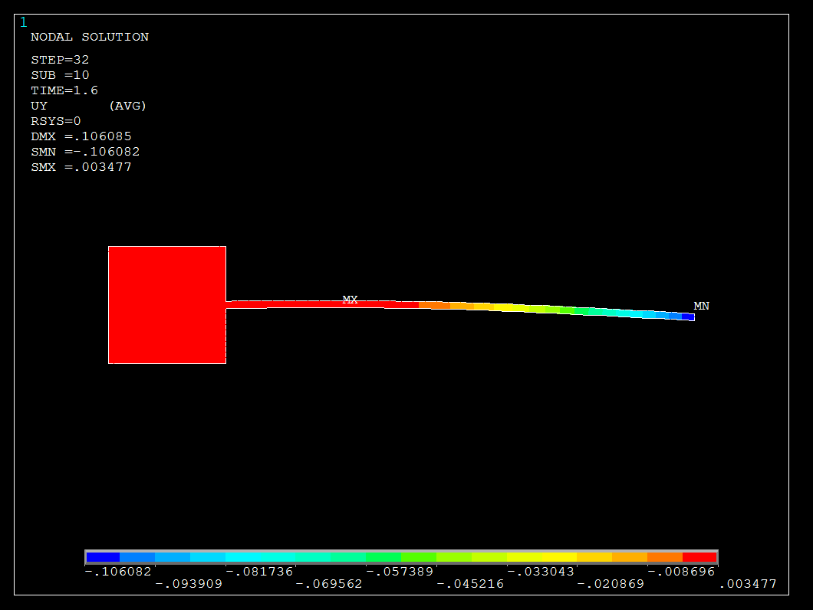
(g) Time = 1.55s (h) Time = 1.60s
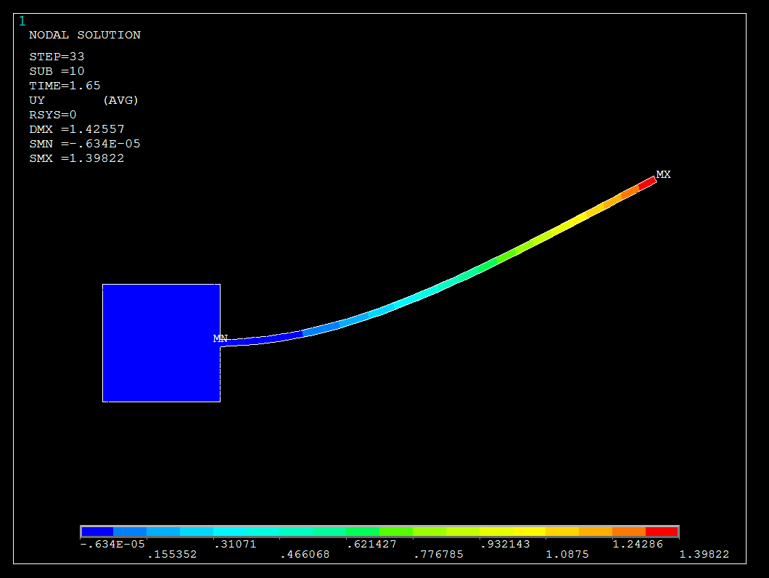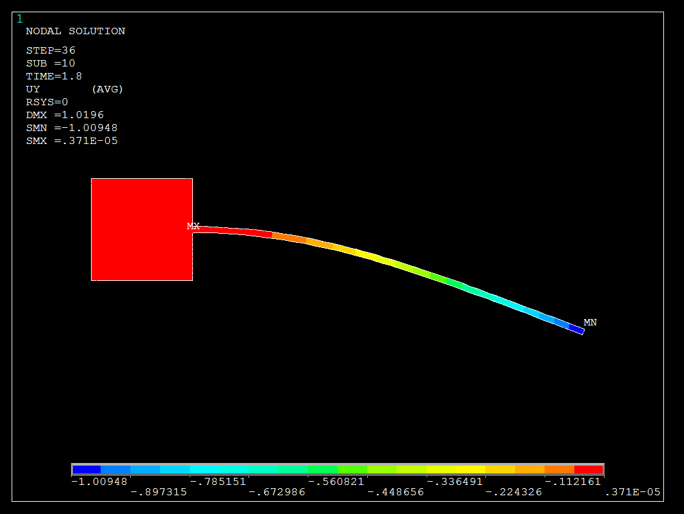
(i) Time = 1.65s (j) Time = 1.80s

Fig. 14 Typical displacement distributions pattern of the oscillating flexible plate induced by the vorticity pressure with (a) Time = 0.05s; (b) Time = 0.10s; (c) Time = 0.85s; (d) Time = 0.90s; (e) Time = 1.05s; (f) Time = 1.45s; (g) Time = 1.55s; (h) Time = 1.60s; (i) Time = 1.65s; (j) Time = 1.80s in the fluid flow induced oscillations of the flexible plate. (Load Transfer Physics Environment).

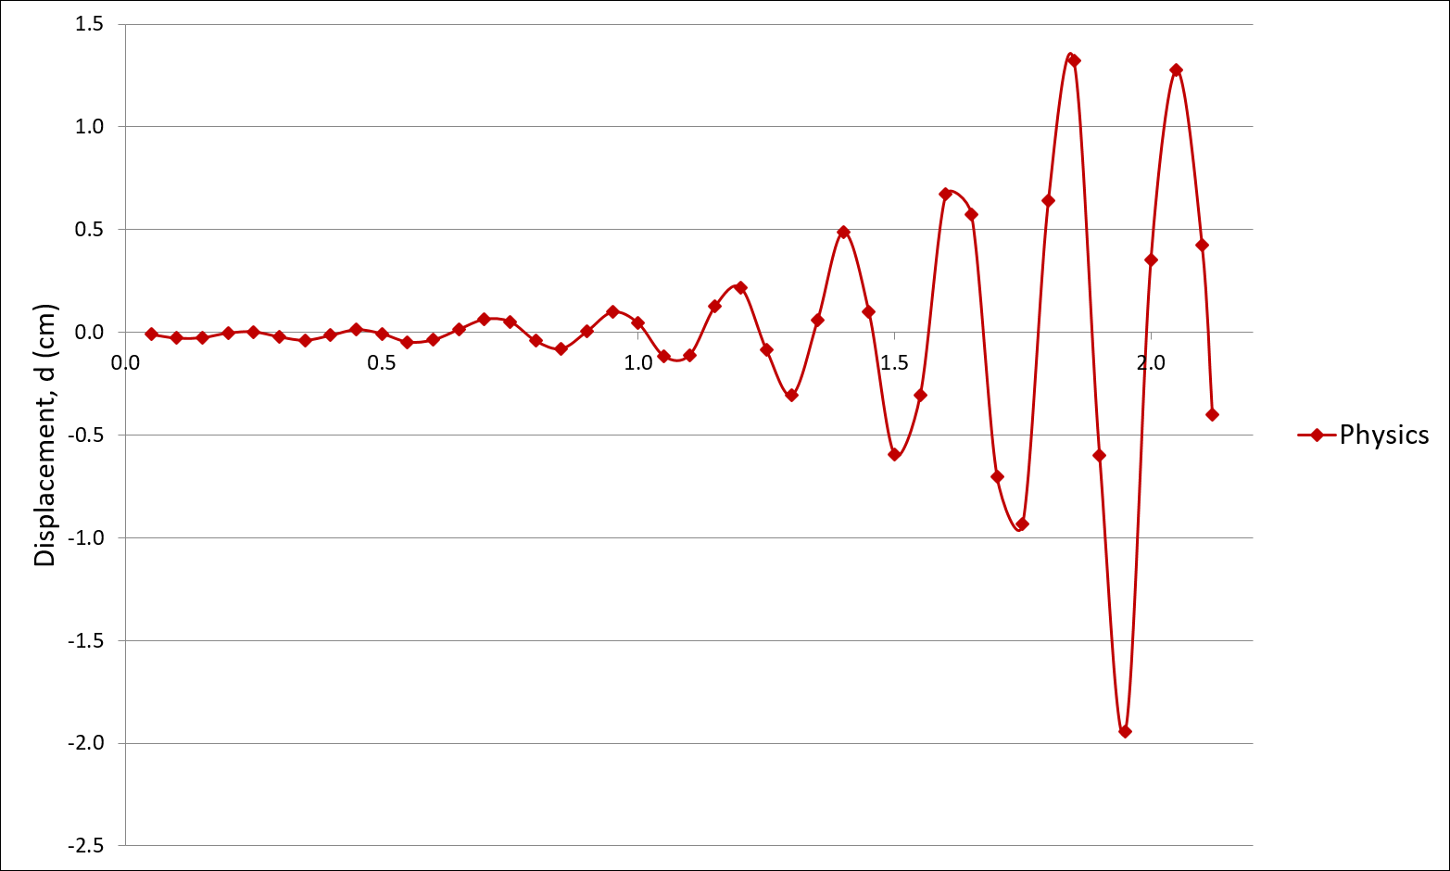
Fig. 15 Build-up oscillations of the flexible plate induced by the vorticity pressure of fluid flow from rest; vertical displacement of the tip of the flexible plate; time step size of $∆$t = 0.05; weak coupling partitioned method; in (Load Transfer Physics Environment).
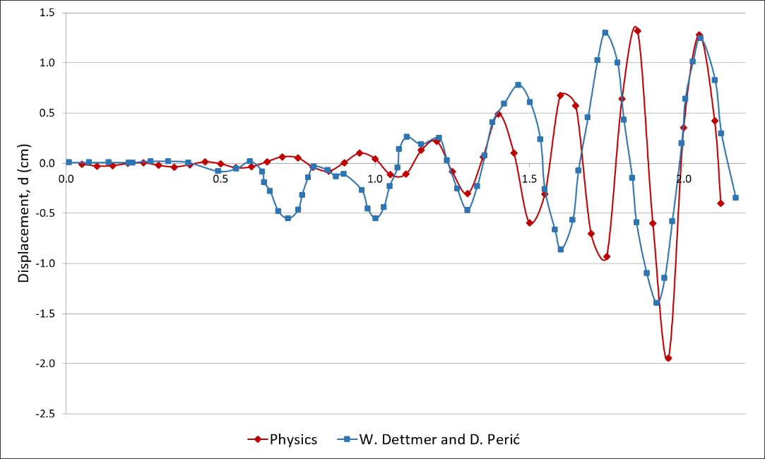
Fig. 16 Comparison numerical result of build-up oscillations of the flexible plate induced by the vorticity pressure of fluid flow from rest; vertical displacement of the tip of the flexible plate; in the time step size of $∆$t = 0.05; weak coupling partitioned method; in (Load Transfer Physics Environment).
6.0 Conclusions
The flexible plate used in this paper was to illustrate the differences between the coupling algorithms for both strongly and weakly coupled user developed system of the partitioned methods in contribution to the knowledge of feasibility studies in the area of fluid and structure interaction under the two-way coupling system. The feasibility and capability of both methods have been tested and compared. From the numerical results obtained, it proved that both weak and strong coupled interaction field are capable of transferring the respond of force from the water and deformation of the structure between the interacted surfaces. In both examples, the plate responded to the pressure impact through the interaction surface or region with the distribution patterns being similar. However, the small differences in comparisons to Dettmer, W. and Perić, D. (2006) results of the oscillating plate deflection value could be caused by the stringent convergence in the strong coupling algorithm whereas the weak coupling algorithm has loose convergence within the surface of interaction. The strong coupling system proven to be approximately close to the result of Dettmer, W. and Perić, D. (2006) while the developed techniques of the weak coupling system was proven to be more flexible in term of the existing APDL in ANSYS but further development will be require to improve the weak convergence between surface interactions in obtaining much accurate oscillating result. Hence, both assigned weak and strong two-way coupling algorithm prove to be an ideal approach in assessing and providing solutions of both single or multiple scale surface interactions of offshore structures and tall flexible structures problems especially in the field of civil and ocean engineering.

References
ANSYS (2009). Documentation release 12.0.
Bathe, K. J. and Zhang, H. (2009) “A mesh adaptivity procedure for CFD and fluid-structure interactions”. Computers & Structures, 87(1112):604-617.
Benra, F. K., Dohmen, H. J., Pei, J., Schuster, S., and Wan, B. (2011) “A comparison of one-way and two-way coupling methods for numerical analysis of fluid-structure interactions”. Journal of Applied Mathematics.
Degroote, J., Bruggemanl, P., Haelterman, R., and Vierendeels, J. (2008) “Stability of a coupling technique for partitioned solvers in FSI applications”. Computers & Structures, 86:2224-2234.
Degroote, J., Bathe, K.-J., and Vierendeels, J. (2009) “Performance of a new partitioned procedure versus a monolithic procedure in fluid-structure interaction”. Computers & Structures, 87:793-801.
Degroote, J., Haelterman, R., Annerel, S., Bruggeman, P., and Vierendeels, J. (2010) “Performance of partitioned procedures in fluid structure interaction”. Computers & Structures, 88(78):446-457.
Dettmer, W. and Perić, D. (2006) “A computational framework for fluid structure interaction: finite element formulation and applications”. Computational Mechanics in Applied Mechanics and Engineering.
Dettmer, W. and Perić, D. (2008) “On the coupling between fluid flow and mesh motion in the modelling of fluid structure interaction”. Computational Mechanics, 43(1):81-90.
Donea, J. and Huerta, A. (2003) “Finite element methods for flow problems”. Wiley.
Gao, R., Tay, Z., Wang, C., and Koh, C. (2011). Hydroelastic response of very large floating structure with a flexible line connection. Ocean Engineering, 38:1957-1996.
Habchi, C., Russeil, S., Bougeard, D., Harion, J. L., Lemenand, T., Ghanem, A., Valle, D. D., and Peerhossaini, H. (2013) “Partitioned solver for strongly coupled fluid structure interaction”. Computers & Fluids, 71(0):306-319.
Jauvtis, N. and Williamson, C. (2003) “Vortex-induced vibration of a cylinder with two degrees of freedom. Journal of Fluids and Structures, 17:1035-1042.
Khalak, A. and Williamson, C. (1999) “Motions, forces and mode transitions in vortex-induced vibrations at low mass-damping”. Journal of Fluids and Structures, 13:813-851.
Lim, W. Z., Xiao, R., T., H., and Chin, C. S. (2013) “Partitioned methods in computational modelling on fluid-structure interactions of concrete gravity-dam”. Computer and Information Science.
Lim, W. and Xiao, R. (2016) “Fluid-structure interaction analysis of gravity based structure (GBS) offshore platform with partitioned coupling method”. Ocean Engineering, 114:1-9.
Martin, T., Schacht, S., Riesen, P., and Paschen, M. (2017). Efficient implementation of a numerical model for flexible net structures. Ocean Engineering, 150:272-279.
Richter, T. (2010) “Numerical methods for fluid-structure interaction problems”. University of Heidelberg.
Song, M., Lefranois, E., and Rachik, M. (2013) “A partitioned coupling scheme extended to structures interacting with high-density fluid flows. Computers & Fluids, 84(0):190-202.
Versteeg, H. and Malalasekera, W. (2007) “An introduction to computational fluid dynamics the finite volume method”. Pearson Education Limited.
Wall, W. A., Genkinger, S., and Ramm, E. (2007) “A strong coupling partitioned approach for fluid structure interaction with free surfaces”. Computers & Fluids, 36(1):169-183.
Wei, R., Sekine, A., and Shimura, M. (1995) “Numerical analysis of 2D vortex induced oscillations of circular cylinder”. Numerical Methods in Fluids, 21:993-1005.
Wick, T. (2011) “Fluid-structure interactions using different mesh motion techniques”. Computers & Structures, 89:1456-1467.
Xu, W., Zhang, S., Liu, B., Wang, E., and Bai, Y. (2018). An experiment study on flow-induced vibration of three and four side-by-side long flexible cylinders. Ocean Engineering, 169:492-510.
Yamamoto, C., Meneghini, J., Saltara, F., Fregonesi, R., and Jr., J. F. (2004) “Numerical simulations of vortex-induced vibration on flexible cylinders”. Journal of Fluids and Structures, 19:467-489.

