‘Waiting for the Wow Factor’ – Perspectives on Computer Technology in Classroom Composing

Dr. Kirsty Devaney,
Birmingham City University
Kirsty.devaney@bcu.ac.uk

Abstract
Due to advancements, affordability and increased accessibility of technology, composing using computer technology has become prevalent in English secondary music classrooms. Despite this, there is still little research investigating the ‘educational practices’ (Savage, 2010) of technology resulting in teaching and learning approaches involving technology, often going ‘unquestioned’ in the GCSE music classroom (Savage 2012: 178). This paper explores how and why computer technology is being used for composing in upper secondary school music classrooms in England. Data were collected through a mixed methodology approach involving five case study schools and a survey of 112 classroom music teachers in England. Findings outline both positive and negative aspect of using computer technology to compose, such as how it was often perceived as a shortcut, however it can be argued that the computer software encourages a linear approach to composing, and the unrealistic MIDI sounds can be a demoralising factor for students’ creativity.

Key Words:
Composing, Computer, Technology, Creativity, Assessment, Classroom, Playback, Processes

Introduction
Composing has been a statutory and assessed part of English classroom music since the late 1980s, due in part to the efforts of composer-educators such as Paynter, Dennis and Schafer who promoted the ‘practices of composers’ (Finney 2011: 53) in classroom music education. The introduction of curriculum composing into formal schooling was said to have had ‘a rocky start’ (Mills 2005: 37) with many music teachers feeling ‘daunted’ (Mills 2005: 37) at the prospects of teaching it. Many teachers were concerned that they lacked necessary the skills and composing experience to teach it (Simmonds 1988; Odam 2000; Sheridan and Byrne 2002; Webster 2003; Barrett 2006; Francis 2012; Hickey 2012; Lewis 2012; Winters 2012). With recent advancements and increased accessibility and affordability of music technology, composing using technology has become prevalent in English secondary school music classrooms, however many music teachers express feeling uncertain about using technology due to limited experience and training (Seddon 2006) in music technology. Despite the prevalence of technology, there is still little research into the ‘educational practices’ (Savage, 2010) of using technology in music education; therefore the use of technology has often gone unquestioned at GCSE (Savage, 2012: 178).

This paper reports the results of an exploratory study into the teaching and learning of composing at examination level in secondary schools in England. Taking a mixed method approach, data were collected through an online survey of 112 music teachers including 9 follow-up telephone interviews, 5 case study schools involving classroom observations of key stage 4 (KS4) and key stage 5 (KS5) composing lessons, semi-structured interviews with music teachers and focus group interviews with students. In addition, interviews were conducted with 5 composer-educators allowing for different perspectives on the topic. Three research questions emerged relating to the use of technology during composing lessons in upper secondary (14-18 years) teaching:

- How are students using computer technology when composing at examination level?
- What are the perceived benefits to using computer technology for composing at examination level?
- What effect does using computer technology have on students’ composing and creative practices?

Research Context

Technology in the Music Classroom

Developments in digital technology have dramatically transformed how music is performed and composed (Savage 2012; Green 2002). The introduction of technology into the music classroom has been widely debated (Vulliamy 1980; Folkestad, Hargreaves and Lindström 1998; Green 2002; Cain 2004; Nilsson and Folkestad 2005; Reynolds 2005; Savage 2005, 2010, 2012; Wise Greenwood and Davis, 2011; Kardos 2012; Wise 2016) causing researchers and teachers to reflect on the uses of technology. Technology has been viewed by some as promoting a more inclusive and ‘egalitarian’ approach to music education (Folkestad, Hargreaves and Lindström 1998: 83), allowing students without formal instrumental training to engage in composing and music making (Folkestad, Hargreaves and Lindström 1998; Nilsson and Folkestad 2005; Reynolds 2005; Kardos 2012). The use of professional and semi-professional music software in the classroom has also enabled students to experience ‘real world’ music making (Wise, Greenwood and Davis 2011), and compose in musical styles and genres that are more ‘culturally relevant’ (Gall and Breeze 2005: 427). On the other hand, the drive to modernize music in the classroom has been an area of contention (Spruce 1996) with some music teachers arguing that technology has the potential to undermine fundamental concepts of music education (Cain 2004; Wise 2016) and threaten ‘core values and principles’ (Savage 2012: 178). An example of this concern is students using pre-composed samples and loops that can be selected, moved and layered, as a method of composing; as Cain (2004) asks ‘does the term “composing” include manipulating sound samples composed by other people?’ (p.217). Although this potentially challenges traditional notions of composing (Gall and Breeze 2007), the use of sampling has been popularised within professional music-making and the method of manipulating pre-existing samples to create new works has been termed ‘plunderphonics’ (Oswald, 1985).

This study considers music teachers’ rationales for using computer technology at KS4 and KS5 for composing. Savage (2007) identified two main uses of technology:

- Extrinsic – Technology is used as a method to support teaching of traditional musical tasks
- Intrinsic – Technology is used to explore new possibilities and sounds

Savage (2007) discovered that many music teachers preferred an extrinsic approach to technology allowing them to ‘do what they have always done’ (p.286), rather than using the technology to achieve new musical and educational goals. For example, using a computer programme to compose instrumental music. This use of technology in music lessons has been commonly viewed as a way to save time (Savage 2007), however some have criticized the use of technology as an efficiency tool that exclusively reinforce ‘traditional compositional practices’ (Beckstead 2001: 47), and norms (Savage 2012; Wise 2016). Instead, Wise, Greenwood and Davis (2011) consider how technology could be used to ‘offer…something different?’ (p119) in the music classroom, such as exploring processes and practices of experimental electro- acoustic genres such as Musique Concrete and Elektronische Musik.

Composing Processes and Technology

Sloboda commented in 1986 that composing was the ‘least studied and least well understood’ (p.103) aspect of music education. However, investigations into the practices of composers has been a ‘growing field’ within research (Mellor, 2008: 251) and many researchers have since sought to capture and explain composing processes (Bunting 1988; Kratus 1989; Kennedy 1999; Bamberger 2003; Burnard and Younker 2004; Collins 2005; Fautley 2005; Biasutti 2012). Much of this research considered composing as a domain of creativity and viewed within the context of Wallas’ (1926) four-stage model of creativity as shown below:

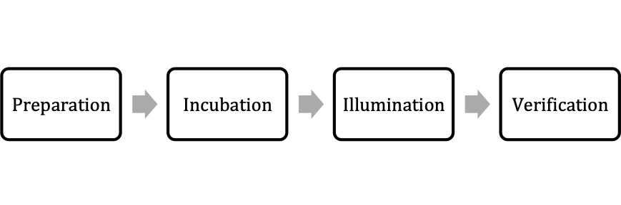
Figure 1: Four-stage model of creativity (Wallas 1926)

Researchers have since adapted this model to illustrate how creativity is a non-linear process (Craft 2000; Webster 2003; Burnard and Younker 2002, 2004; Collins 2005). Taking Wallas’ (1926) four stages as a basis, Burnard and Younker (2002, 2004) outlined six diverse composing models including: linear, recursive, regulated (2002), as well as floater, serial, and staged (2004). Students who took a linear approach displayed little fluctuation between Wallas’ four stages whereas students who took a recursive pathway were much more fluid between the stages (Burnard and Younker 2002). Although the research above illustrates how composing processes can be non-linear and diverse, much of this research has excluded the role and influence of technology.

As technology has become a fundamental part of composing for many composers (Folkestad, Hargreaves and Lindström 1998), questions arise into how technology may alter the composing process. Folkestad, Hargreaves and Lindström (1998) tracked students’ composing processes when using technology and outlined two main composing strategies: horizontal and vertical. Students following a horizontal composing process often composed ‘from beginning to end’ (Folkestad, Hargreaves and Lindström 1998: 88) whereas the vertical composing process described how composing and arranging were interrelated. Interestingly, Mellor (2007, 2008) found that when students composed using a compute, they all used a vertical approach to composing. Gall and Breeze (2005) stated that the use of technology ‘open[s] up a very different kind of access to the composition process’ (Gall and Breeze 2005: 430) and changes how students compose. The link between the use of technology and composing processes is still an under researched area and it remains unclear how computer technology may influence student’s creativity and composing.

Research Methods

As this research sought to investigate events, behaviours and perspectives taking place in the social world, I drew on research methods from interpretivist, constructivist and phenomenological paradigms. To investigate composing teaching and learning in English upper secondary education, multiple data-gathering techniques were employed, including case study and survey research. Perspectives on the use of technology were gathered from a range of participants including music students, classroom teachers and composers-educators. Adopting a case study approach allowed for in-depth data collection in real-life everyday settings (Yin 2009), thus capturing the wider socio-cultural and historical influences (Stake 1995) within its natural setting of the classroom (Punch 2009). The survey also enabled the research to reach many more music teachers in England allowing exploration into the ‘bigger picture’ (Denscombe, 2010: 141), helping to illustrate the extent of any issues raised in the case studies.

The study followed the British Educational Research Association 2011 ‘Ethical guidelines for educational research’, ensuring research was conducted in a ‘responsible and morally defensible way’ (Gray 2014: 68). The study also gained ethical approval from the university’s ethics committee. Confidentiality of the participants was considered throughout and participants’ identity were anonymized and given pseudonyms. Participation was voluntary and informed consent was given throughout the research process from all involved in the study.

Research Sample
Selection of participants often took a purposive maximal sampling approach, whereby the sample was selected not necessarily to ‘ensure representativeness’ (Simons, 2009: 30) but to find the ‘widest possibility’ (Seidman, 1998: 45) and cases that were ‘information rich’ (Patton, 2015: 264). In addition, convenience sampling was used to find participants that would take place in the study.

Qualitative data were collected from five case study schools through classroom observations, semi-structured interviews with music teachers, and focus group interviews with students. By using multiple case studies (Creswell 2013) this allowed for different perspectives and rich data collection across different settings as shown below:

Table 1: Overview of case studies

Setting | Qualification | Use of technology
School 1  (Academy) | GCSE | Mixture of Logic Pro, GarageBand and Sibelius
School 2  (Academy) | GCSE | Logic Pro with MIDI keyboards attached to 15 mac computers
School 3  (Grammar) | GCSE  AS and A-level | All using Sibelius
School 4  (Sixth form college) | AS-level | Most using Sibelius, 2-3 students using Logic Pro
School 5  (Academy) | AS-level | All using Sibelius

As can be seen from table 1, nearly all settings used Sibelius, or a Digital Audio Workspaces (DAWS) such as Logic Pro or GarageBand. The software used often depended on the resources available to the teachers as well as the qualifications being studied, for example very few students at AS-level or A-level used DAWS to compose due to concerns from teachers that it would hinder their final composing coursework result due it not being written using western classical notation.
Focus group interviews took place with GCSE and AS/A-level students in groups of 3-5 students during their class time. The focus group interviews aimed for students to have their ‘perspectives, attitudes, beliefs, views and opinions’ (Punch, 2009: 46) heard in a more ‘naturalistic’ (Wilkinson, 2004: 180) setting. The gender balance for the focus groups conducted in all five schools was skewed towards male participants with a total of 20 male students and only 7 female students. An explanation for this over-representation of was due to one setting being an all-boys school, and another school where the GCSE class had mostly male students. The classroom observations took place during their regular KS4 and KS5 music lessons and were conducted as a non-participatory observer. The allowed for the collection of ‘live’ data within a ‘naturally occurring social situation’ (Robson, 2002: 396).
The mixed methodology approach included an online survey gathering both qualitative and quantitative data from KS4 music teachers. The survey was conducted in 2016 and collected 112 responses from a wide range of school types as show below:

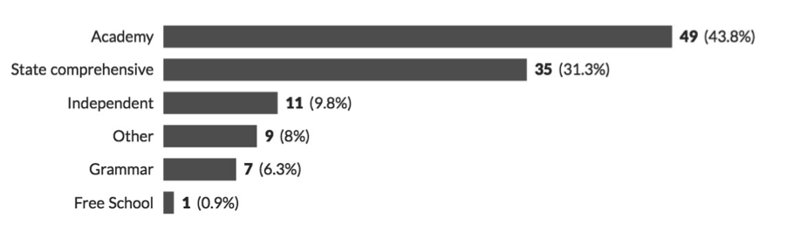

Figure 2: Range of school types reflected in the KS4 survey

A range of GCSE examination boards were also reflected in the survey, as show below:

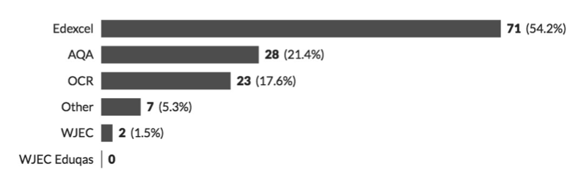
Figure 3: Range of KS4 examination boards being taught in the schools surveyed
The telephone interviews allowed participants to expand on answers to the survey in more detail and depth. Participation was voluntary resulting in self-selection bias (Floyd and Fowler,2002; Gray 2014) and of the 47 teachers who opted to take part in the telephone interviews, 10 were selected through purposive sampling (Patton 2015) with the aim of achieving maximum variation in the data.

In addition to the survey and case studies, 5 composer-educators were selected for interview offering potentially different perspectives on the topic under investigation. These participants identified primarily as composers but had at least 5 years of experience teaching in and/or out of schools. The principal investigator identified the composer-educators due to previous work with them and some had been involved with a previous research project lead by Birmingham City University a few years before this study.

Data Analysis
All research interviews were audio recorded and transcribed, allowing for data analysis. Due to a lack of pre-existing theories and substantial literature around the topic of enquiry, elements of grounded theory, developed by Glaser and Strauss (1967), were adapted and utilized during the research process. Although a contested research method (Charmaz 2014), grounded theory was viewed as a way to generate theory that was ‘grounded in data’ and ‘developed inductively’ (Punch 2009: 130), using it more as a general ‘research strategy’ (Punch 2014: 132) rather than a rigid set of rules. This emergent method allowed the research to ‘unfold’ (Robson 2002: 5), with collection and analysis ongoing (Cohen et al. 2007: 492). Data were analysed using a line-by-line, open coding approach, becoming more ‘general’ and ‘abstract’ (Punch 2014: 178) with each stage of the coding process. Thematic analysis, developed by Braun and Clarke (2014) was also used as a way of ‘identifying, analysing, and reporting patterns (themes) within data’ (Braun and Clarke 2006: 6).

Findings

Results from the study illustrate the prevalence of technology being used in secondary music classrooms with 71.4% (34.8%+36.6%) of music teachers stating that students used technology between 60-100% of the time when composing at KS4:

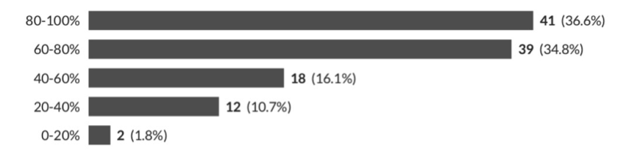
Figure 4: Percentage of time student spend on technology to compose at KS4

Teachers commented that technology was ‘fundamental’ (Teacher 1), ‘essential’ (Teacher 2) and ‘at the centre’ (Teacher 3), with some disclosing that the majority of composing took place using technology:

Teacher 4: Almost all composition work is completed in this way

Teacher 5: Use of macs and Sibelius…on which all composition work is done

92% of teachers also believed that access to technology was either important, or very important for KS4 music students:

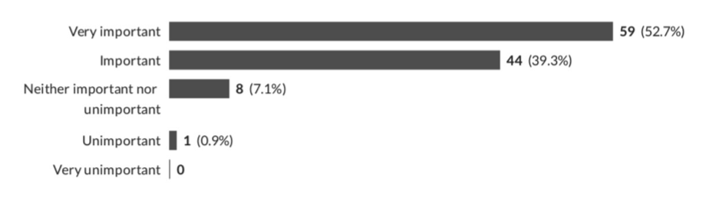
Figure 5: Importance of technology in composing at KS4

Thus, illustrating the importance of technology for composing at KS4. The data from the survey also revealed that the most common composing software used was either notation software programmes such as Sibelius, or Digital Audio Workspaces (DAWS) such as Logic Pro or Cubase. However, some teachers commented that the use of technology often depended on the student:

Teacher 6: [It] varies massively between pupils

Teacher 7: [The] figure is based on those who select this pathway. It is right for some but not for all

Teacher 8: So much of this depends on the individual however - some work best away from computers etc. and for others using the technology suits them

Teacher 9: It varies a lot depending on the student

This paper will explore why students use computer technology so frequently, how the role of technology was viewed by participants, and the effect this had on their composing and creative processes.

Technology as a Shortcut

Many teachers in the study admitted that the main rationale for using technology for composing at examination level was due to the belief that it was quicker than traditional methods:

Teacher 10: Oh yeah I mean it's quicker to compose. You know they can cut and paste sections which are minimalism [laugh]…obvious shortcut

Teacher 11: They've been given a shortcut [using samples] rather than taking the longer route

Teacher 12: It's instant, you don't have to you write things out, you can put it straight in there and if you don't like it you can delete it and try something else. It's all very quick

Teacher 13: It makes life a lot easier in the editing process, to go back and rub out a load of notes and you don't have to rewrite bars and things

Teachers described how technology acted as a ‘shortcut’ (Teacher 10, 11) for composing. This was important due to the limited amount of time given for covering the GCSE and A level syllabi in schools:

Teacher 14: Personally don't get a massive timeframe really when it comes down to it that they've got to produce to compositions. So I think that [technology] really helps with the time pressure as well

The concern for time was also very prevalent during the case studies as one of the teachers started each lesson reminding students of the limited amount of time left on the course:

Teacher 15: We're running out of time basically

Teacher 15: …four weeks, not a lot of time in reality

Throughout the study teachers repeatedly expressed the difficulties of ensuring their students reached their target grades, with some feeling grades were unrealistic:

Teacher 18: I am told by SLG [senior leader group] I need to guarantee grades of A, A*

Teacher 17: …the vast amount of pressure in school to get above average results

Teacher 10: 97% of my year 11s have A or A* as their target. Within that, I have girls that are less than grade 2 on an instrument and I also have girls who have vocal lessons and haven't done music apart from key stage three. So I have very, very high target grades.

Teachers also felt responsible and accountable for their students’ marks:

Teacher 12: We've got to get them the best marks that we can because otherwise it reflects on us as teachers.

Teacher 11: As a teacher we ultimately have these projected targets

Teacher 16: It must be understood that teachers are under pressure to secure good examination results

This pressure resulted in teachers finding quick and reliable methods of securing examination grades, of which technology played an important role in this:

Teacher 14: We've seen a big increase in the composition marks… I would say I'm almost completely reliant on technology

This was even more prevalent when teachers had students who were deemed as lower ability in music where technology was viewed as a way of supporting students and ensuring higher composition marks:

Teacher 19: We’ve got a lots of low ability students so they, they can't play it on the piano to see what it sounds like, so being able to hear Sibelius is really helpful.

Teacher 20: …technology can be quite an enabler

Another key benefit of using technology was that it could automatically produce a score for students:

Teacher 14: Everybody that has done it on the Sibelius can just press print and I've got these five students ‘miss I don't know how to produce a score’

Teacher 21: I get quite stressed at the prospect of students who don't have a score. For example, those who have used Cubase.

Although examination boards acknowledge a variety of notational methods such as staff, graphic, and tab notation many teachers believed there was a bias in marking towards music composed in using western classical notation:

Teacher 22: It worries me that some examiners will ‘look down on’ other forms of notation

Over half of KS4 teachers (56.2%) in the survey encouraged students to notate their compositions using western classical notation:

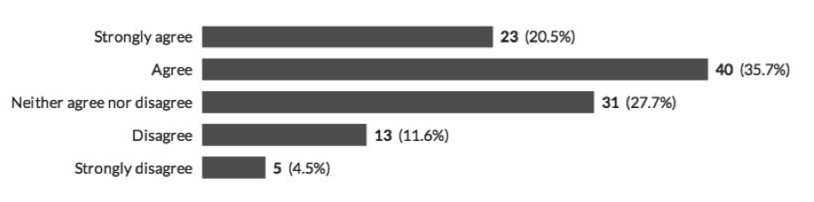
Figure 6: Results from teachers when asked if they encourage students to notate their composition using of western classical notation

Notation was also a particular concern for teachers teaching composing at KS5, therefore the use of technology, with its ability to produce a score, aided this.

When and How to Use Technology?

Although many teachers perceived technology as a quicker and a more reliable way to compose at KS4 and KS5, it became clear there were some strong beliefs regarding when and how students should use technology. Many teachers expressed that students should not start composing directly onto the computer, but instead should start creating musical ideas on an instrument:

Teacher 23: We use Sibelius but encourage pupils to compose their ideas on an instrument first before moving to the computer

Teacher 24: Some pupils prefer to get ideas using their instrument before putting their ideas into the computer

Teacher 14: I encourage them at the early stages to not sit in front of a computer. So I'd say at the early stages that's when they're trying to get ideas at home or going into a practice room

Teacher 13: I've always insisted on my kids having the ideas first then having the technology to either notate or realise the ideas

Teacher 20: I tend to push them more at the initial stages of working away
from my computer

Even though students were encouraged to use their own instruments, it appeared that use of instruments was mainly reserved to generate initial ideas, rather than throughout the composing process.

Many teachers in the study appeared to encourage students to use the computer as a ‘notational tool’ (teacher 25) rather than a ‘composition tool’ (teacher 26), believing that students should already have a clear musical idea before using the computer. Although teachers discussed how technology was used during the whole composing process there also appeared to be a disapproval regarding using the computer to create and generate new compositional ideas. There appeared an assumption that music created solely on technology would result in worse compositions:

Teacher 20: Too much technology a bit stifling in terms of creatively. I've never seen any particularly convincing examples of peoples improvising into Sibelius and anything good coming out of it….

The composer-educators similarly warned of an over-reliance on Sibelius, with one composer saying it can lead to ‘uncreative, unimaginative and quite un-human’ (Composer 1) compositions. Another composer-educators also warned how students can become controlled and driven by the computer software, saying the become a ‘Sibelius Composer’:

Composer 2: If you only use Sibelius then you can start to compose for the things that Sibelius does well, rather than as a tool to do what do you want to do as a composer

These statements above warn of using technology too much, or at the wrong time when composing, thus eliciting assumptions held about correct composing processes and creative pathways.

Real Sound

Although one of the main benefits to using technology when composing was that it was quicker, it also appeared to have negative effect on students’ composing. Students in the focus groups found that the unrealistic MIDI sounds of the computer programmes had a significant demoralising effect on their motivation and confidence to compose. Students revealed a disliked for the MIDI sounds of Sibelius, calling them ‘fake’ (student 1):

Student 1: Yeah it sounds quite regimented, and electronic

Student 2: Sibelius sounds are like really horrible

Student 3: Sibelius doesn't sound very good

Students were disappointment when comparing what they wanted their music to sounds like, with what they heard via the MIDI playback function:

Student 4: The computer it kind of loses, you don't really have any emotion in it. Obviously that comes when you're actually perform it with like live players, but that sometimes I have to think about how good that actually sounds on real instruments

Student 2: It's weird but it doesn't really sound like music as such because it's not what it would sound like if someone played up

Student 4: I just find it really irritating because I want, because I have it in my head like and I want it to sound amazing but then you listen to it on Sibelius and you're like oh my God, it's like awful [laugh]

Student 4: The sounds don't really help but then it's frustrating having ideas in your head and then not being out to get it down properly. So right now I don't like my composition

They also discussed how the sounds did not inspire new ideas or motivate them to continue. Student 3 expressed that when hearing the MIDI version of her composition, she felt disappointed by what she heard compared to what she imagined in her head:

Student 3: I think the problem is like you're listening to your piece and it sounds okay but like it's not got that “wow factor” to it

These examples highlight a significant disconnect between the expectations of a live performance sound, compared with the electronic playback sounds. The lack of understanding and use of acoustic instruments when composing was also commented on by Ofsted (2009):

…the particular timbre and characteristics of each instrument were not exploited and the music produced was extremely difficult to play on the instrument chosen (Ofsted 2009: 35).

Due to the computer programme being able to play anything that is written, students can be deceived about practicalities of the instruments they are composing for; as Teacher 13 commented students get an ‘unrealistic view of what the instruments are capable of’.

The composer-educators commented on the importance of hearing real acoustic sounds as a motivating factor:

Composer 2: Having live acoustic instruments that are of good quality and available for people to play and to write for is really important

Composer 3: I think hearing their music performed live is really important

Composer 4: Having their music performed live…It's very important. And once it's happened once then that's when you get the buzz

The composer-educators signaled the importance of hearing music live for composers calling it ‘absolutely vital’ (composer 1), and asking ‘if it's not going to get heard…what's the point?’ (composer 1). Given the stressed importance of this learning opportunity, the KS4 survey data revealed that very few music students have their compositions performed live:

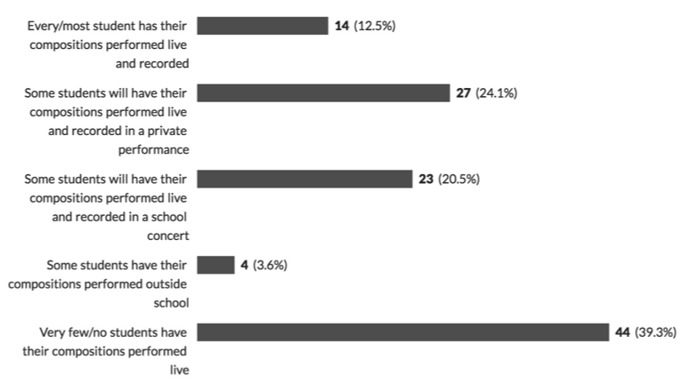

Figure 7: Regularity of live performances of KS4 compositions
Reasons for the lack of live performances included a lack of time, funding and resources in the majority of schools. Although those that were able to have live performances outlined benefit such as boosting student confidence and enthusiasm, teachers who had campaigned for live performances revealed that it did not improve their examination grades enough to warrant the investment of time or money:

Teacher 29: The impact on the students’ results do not make enough of a difference for it to be worth the time

This highlights the unfortunate prioritising and difficult decisions teachers have to make under the current performance-based educational landscape.

Discussion

Data collected from the study illustrates the importance and centrality of technology for composing at examination level, however many music teachers used technology extrinsically (Savage 2007) viewing it as efficiency tool allowing students to compose in traditional methods more quickly than pencil and manuscript paper (Beckstead 2001; Savage 2012; Wise 2016). The use of computer technology also encouraged a linear approach to composing whereby teachers could easily monitor progress over time by counting the number of bars, or seconds of music students had composed during the lesson. Although students spent the majority of their composing time using technology, many music teachers felt strongly that composing should start by using instruments and lead onto technology once musical ideas had be generated:

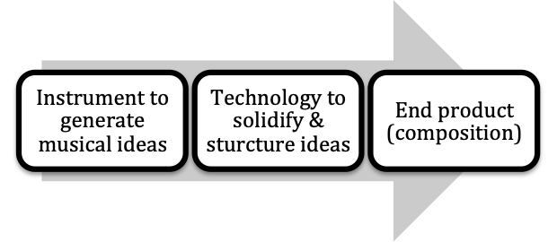
Figure 8: Instruments first, technology second
In this model of composing, use of instruments was deemed appropriate for generating initial ideas, what Wallas’ (1926) called the ‘preparation’ stage (figure 1). There was a sense from the teachers and composer-educators that there was an optimum time for students to move from instruments to using computer software. There was very little evidence of students using instruments at later stages of the composing process, including at the end as many composition were ‘performed’ on the computer (see figure 8), rather than by live musicians.

Students in the study reported how they often experienced ‘composers block’ and were dissatisfied with what they had composed. Through the focus group interviews it became apparent that the MIDI sounds created by the software were a significant contributing factor to students’ dissatisfaction, with some students expressing that their compositions did not always sound like what they imagined in their head. Although students seemed to be experiencing a barrier as a result of using the computer programmes, music teachers in the study rarely acknowledged any problems relating to use of technology to compose. This links to some of the criticism around Prensky’s ‘digital natives’, whereby instead of assuming students can use technology instinctively, they still require teachers to guide them to be able to use the tools ‘wisely and purposefully’ (Martinez, 2011: 7)

The composer-educators also highlighted the importance of hearing their compositions live, calling it a pivotal moment in motivating them to compose. Encouraging a more fluid relationship between using live instruments and technology, as illustrated below (figure 9), could be a way of supporting students experiencing a ‘block’, allowing them to re-engaging with “real” sound and feel motivated:

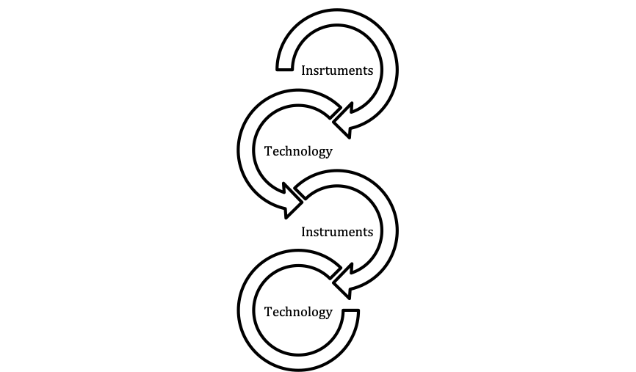

Figure 9: Hypothetical relationship between instruments and technology throughout the composing process

Overall, there seemed to be a lack of consideration by music teachers into the potential complex and messiness of composing processes. Instead there was a preference towards more clear and linear composing approach that was easier to manage in the classroom, as well as easier to track progress week to week, of which technology played a fundamental role in doing. The study uncovered that the majority of teachers felt under significant pressure to ensure their students achieved set grades, and under the current performance-based accountability measures in schools they often felt they had no option but to teach composing in a very formulaic, linear and ‘composing by numbers’ way. Therefore, composing progress that was not as visible or easily measured; such as self-reflection, time away, deleting ideas, or improvising, was not as valued or encouraged as much as students inputting notes onto the computer.

Final Remarks

Although Prensky (2010) asserted that technology can ‘help or hinder the educational process’ (p.3), very few teachers in the study commented on the limitations of technology. In contrast, the students explained how the computer software could discourage and demotivate their composing. Unfortunately, the study discovered that opportunities for students to have their compositions performed live were very limited due to time, resources and funding even though the composer-educators advocated it as being crucial for the development of young composers. Although this study highlighted how technology was central to classroom composing at KS4 and KS5, teachers expressed that this was mostly due to the limited time available to teach composing within the music qualifications; therefore technology was deemed as a ‘shortcut’ for traditional composing methods. At a time where the arts in school are being squeezed for time and money (Daubney and Mackrill 2017), and teachers are under ‘hyper accountability’ (Mansell 2007) measures in school, it is unsurprising that teachers viewed technology viewed as an effective tool for ensuring good grades at composing at KS4 and KS5, but were least concerned with the negative aspects.

A greater understanding is needed to fully understand how technology can be used within creative composing processes. Wise (2016) advocated for a new and ‘radical pedagogical approach’ (p.286) to the use of technology in the music classroom; however, significant training and support is needed to support music teachers’ for this. Ofsted (2009) reported that music teachers often struggle to keep up with the rate of technological advancements and Henley (2011) recommended that more research and a national plan for music technology was needed to support music teachers further. School leaders, examination boards and policy makers need to consider the time, resources and funds needed to provide training and support for music teachers to incorporate technology creatively into composing at KS4 and KS5. In encouraging a more fluid and creative approach to technology and live instruments; taking into account that progress in composing takes time and may not be linear, we can ensure students have a more positive and realistic experience of composing in the classroom; thus allowing them to experience the ‘wow factor’ (student 3).

Limitations of the Study and Areas for Further Research

Readers should be aware of a number of potential limitations within the study. Firstly, as raised earlier in the paper, the gender balance of students within the focus-group interviews was over-representative of male participants. It is well documented that perceptions of proficiency with technology can vary depending on gender (Armstrong, 2011: 2), whereby boys are often perceived as ‘experts’ (ibid.). More research into this field is recommended for future studies. Secondly, within this study the use of technology was limited to notation software programmes and DAWS, however wider uses of technology such as live coding and laptop orchestras, were not examined. Exploring the models outlined in this research in the context of these creative music technology initiatives would be worthy of further investigation. Finally, data was collected between 2014-2016. Since this time music GCSE and AS/A-level examinations have been revised to become more ‘rigorous’ (Gove, 2013), and the landscape of classroom music education has become increasingly politicised and uncertain, with many school having to suspend music and/or music technology courses due to funding (Daubney, Spruce, Annetts, 2019). It is recommended that new data could be collect in light of these more recent developments.

Biography

Kirsty Devaney is a Birmingham based composer, researcher and educator. Her music has been performed by professional contemporary music ensembles, aired on Radio 3 and shortlisted for a British Composer Award. As a practitioner Kirsty found the ‘Young Composers Project’ has worked with young people across the UK, including most recently with the London Symphony Orchestra. She completed her PhD at Birmingham City University in 2018 and was awarded the prestigious Anna Craft Award for research into ‘Creativity in Education’ from the British Education Research Association. She is now working as a research assistant at Birmingham City University.

References
Armstrong, V. (2011). Technology and the gendering of music education. Farnham: Ashgate.

Bamberger, J. (2003), ‘The development of intuitive musical understanding: a natural experiment’, Psychology of Music, 31:1, pp. 7-36.

Barrett, M. (2006), ‘Creative collaboration: an 'eminence' study of teaching and learning in music composition’, Psychology of Music 34:2, pp. 195-218.

Beckstead, D. (2001), ‘Will technology transform music education?’, Music Educators Journal, 87:6, pp. 44–49.

British Educational Research Association (2011) Ethical Guidelines for Educational Research, London.
Biasutti, M. (2012), ‘Group music composing strategies: a case study within a rock band’, British Journal of Music Education, 29:3, pp. 343-357.

Braun, V. and Clarke, V. (2006), ‘Using thematic analysis in psychology’ Qualitative Research in Psychology 3:2, pp. 77-101.

Braun, V. and Clarke, V. (2014), ‘What can “thematic analysis” offer health and wellbeing researchers? ‘, International Journal of Qualitative Studies on Health and Well-being, 9:1, pp. 1-2.

Bunting, R. (1988), ‘Composing Music: Case Studies in the Teaching and Learning Process’, British Journal of Music Education, 5:3, pp. 269-269.

Burnard, P. and Younker, B. A. (2002), ‘Mapping Pathways: Fostering creativity in composition’, Music Education Research, 4:2, pp. 245-261.

Burnard, P. and Younker, B. A. (2004), ‘Problem-solving and creativity: insights from students' individual composing pathways’, International Journal of Music Education, 22(1), pp. 59-76.

Cain, T. (2004), ‘Theory, technology and the music curriculum’, British Educational Research Journal, 21:2, pp. 215–221.

Charmaz, K. (2014), ‘Grounded Theory in Global Perspective Reviews by International Researchers’. Qualitative Inquiry, 20:9, pp. 1074–1084.

Cohen, L., Manion, L. and Morrison, K. (2007), Research methods in education, London, RoutledgeFalmer.

Collins, D. (2005), ‘A Synthesis Process Model of Creative Thinking in Music
Composition’, Psychology of Music, 33:2, pp. 193-216.

Craft, A. (2000), Creativity Across the Primary Curriculum: Framing and Developing
Practice, UK, Routledge.

Creswell, J. W. (2013), Qualitative Inquiry & Research Design, United States of
America, SAGE Publications Inc.

Daubney, A. and Mackrill, D. (2017), ‘Changes in Secondary Music Curriculum Provision over time 2012-16: Summary of the research’ ISM, March, https://www.ism.org/images/files/Changes-in-Secondary-Music-Curriculum-Provision-2012-16_Summary-final.pdf. Accessed 9th March 2019.
Daubney, A., Spruce, G., & Annetts, D. (2019). Music Education: State of the
Nation. Retrieved from https://www.ism.org/images/images/State-of-the-Nation-Music-Education-WEB.pdf

Denscombe, M. (2010), The Good Research Guide for small-scale social research projects, England, Open University Press

Fautley, M. (2005), ‘A new model of the group composing process of lower
secondary school students’, Music Education Research, 7:1, pp. 39-57.

Finney, J. (2011), Music education in England 1950-2010: A Child-Centred Progressive Tradition, England, Ashgate.

Floyd, J. and Fowler, J. (2002), Survey Research Methods, London, SAGE.

Folkestad, G., Hargreaves, D. J. and Lindtröm, B. (1998), ‘Compositional Strategies in Computer-Based Music-Making’, British Journal of Music Education, 15:1, pp. 83-97.

Francis, J. (2012), ‘Teaching composing with an identity as a teacher-composer’, British Journal of Music Education, 29:2, pp. 163-170.

Gall, M. and Breeze, N. (2005), ‘Music composition lessons: the multimodal
affordances of technology’, Education review 57:4, pp. 415-433.

Gall, M. and Breeze, N. (2007), ‘The sub-culture of music and ICT in the classroom’,
Technology, Pedagogy and Education, 16:1, pp. 41-56.

Glaser, B. and Strauss, A. (1967), The discovery of grounded theory: strategies for
qualitative research, New York, Aldine de Gruyter.
Gove, M., Department for Education. (2013) Oral statement by Michael Gove on education reform https://www.gov.uk/government/speeches/oral-statement-on-education-reform Accessed 1st November 2019.
Gray, D. E. (2014), Doing Research in the Real World, England, SAGE Publications Ltd.

Green, L. (2002), How popular musicians learn: a way ahead for music education, Aldershot, Ashgate.

Henley, D. (2011), Music Education in England In England: Department for Education and the Department for Culture, Media and Sport and the Department for Education

Hickey, M. (2012), Music Outside the Lines, Ideas for Composing in K-12 Music Classrooms, USA, Oxford University Press.

Kardos, L. (2012), ‘How music technology can make sound and music worlds
accessible to student composers in Further Education colleges’, British Journal of Music Education, 29:2, pp. 143-151

Kennedy, M. A. (1999), ‘Where does the music come from? A comparison case-study
of the compositional processes of a high school and a collegiate composer’, British Journal of Music Education, 16:2, pp. 157-177.

Kratus, J. (1989), ‘A Time Analysis of the Compositional Processes Used by Children Ages 7 to 11’, Journal of Research in Music Education 37:1, 5.

Lewis, R. (2012), ‘Composing the curriculum: teacher identity’, British Journal of Music Education, 29:2, pp. 153-161.

Mansell, W. (2007), Education by Numbers: The Tyranny of Testing, Great Britain, Politico's Publishing.

Martinez, S., & Prensky, M. (2011). Is the digital native a myth? Learning & Leading with Technology, 39(3), 6-7.

Mellor, L. (2007), ‘Computer-based composition in the Primary school: An investigation of children's "creative" responses using the CD Rom Dance eJay’, European Society for the Cognitive Sciences of Music 11:1, pp. 61-88.

Mellor, L. (2008), ‘Creativity, originality, identity: Investigating computer-based composition in the secondary school’, Music Education Research, 10:4, p. 451-472

Mills, J. (2005), Music in the School, Oxford, Oxford University Press.

Nilsson, B. and Folkestad, G. (2005), ‘Children's practice of computer-based composition’, Music Education Research, 7:1, pp. 21-37.

Odam, G. (2000), ‘Teaching Composing in Secondary Schools: the Creative Dream’, British Journal of Music Education, 17:2, pp. 109-127.

Ofsted, Office for Standards in Education, Children's Services and Skills (2009) Making more of music: An evaluation of music in schools 2005/08
Oswald, J. (1985). Plunderphonics, or Audio Piracy as a Compositional Prerogative.
Paper presented at the Wired Society Electro-Acoustic Conference, Toronto. http://www.plunderphonics.com/xhtml/xplunder.html Accessed 1st November 2019.

Patton, M. Q. (2015), Qualitative research and evaluation methods, London, SAGE.

Prensky, M. (2010), Teaching Digital Natives - Partnering for Real Learning USA, Corwin

Punch, K. (2009), Introduction to Research Methods in Education, London, SAGE
publications Ltd.

Punch, K. (2014), Introduction to social research: quantitative & qualitative approaches, London, SAGE.

Reynolds, N. (2005), ‘The Computer as Scaffold, Tool and Data Collector: Children Composing with Computers,’ Education and Information Technologies 10:3, pp. 239–248.

Robson, C. (2002), Real World Research, United Kingdom, Blackwell.

Savage, J. (2005), ‘Sound2Picture: developing compositional pedagogies from the sound designer's world’, Music Education Research, 7:3, pp. 331-348.

Savage, J. (2007), ‘Pedagogical Strategies for Change’, in Finney, J. and Burnard, P.
(eds.) Music Education with Digital Technology. London: Continuum.

Savage, J. (2010) ‘A survey of ICT usage across English secondary schools’, Music Education Research, 12:1, 89-104
Savage, J. (2012), ‘Those who can, play; those who can’t, use music tech?’ in C.
Philpott, C. and G. Spruce (eds.) Debates in Music Teaching. Oxon: Routledge, pp.169-184

Seddon, F. A. and O'Neill, S. A. (2006), ‘How does formal instrumental music tuition (FIMT) impact on self- and teacher-evaluations of adolescents' computer-based compositions?’ Psychology of Music, 34:1, pp. 27-45.

Sheridan, M. and Byrne, C. (2002), ‘Ebb and flow of assessment in music’, British Journal of Music Education, 19:2, pp.135-143.

Simmonds, R. (1988), ‘An Experiment in the Assessment of Composition’, British Journal of Music Education, 5:1, pp. 21-21

Sloboda, J. (1986), The musical mind: the cognitive psychology of music, Oxford, Clarendon.

Spruce, G. (1996), ‘Assessment in the arts - Issues of objectivity’, in SPRUCE, G.
(ed.) Teaching music. London: Routledge.

Stake, R. E. (1995), The Art of Case Study Research California, SAGE Publications, Inc.

Wallas, G. (1926), The Art of Thought, London, Jonathan Cape.

Webster, P. R. (2003) 'Conference Keynotes: Asking music students to reflect on their creative work: encouraging the revision process', Music Education Research, 5:3, pp. 243-249.
Wilkinson, S. (2004), ‘Focus group research’, in D. Silverman (ed.) Qualitative Research: Theory, Method and Practice. 2nd ed. London: SAGE, p.177-199

Winters, M. (2012), ‘The challenges of teaching composing’, British Journal of Music Education, 29:1, pp. 19-24.

Wise, S. (2016), ‘Secondary school teachers’ approaches to teaching composition using digital technology’, British Journal of Music Education, 21:2, 215–221.

Wise, S., Greenwood, J. and David, N. (2011), ‘Teachers’ use of digital technology in
secondary music education; Perceptions and issues’, British Journal of Music Education, 28:2, pp. 117-134.

Yin, R. K. (2009), Case Study Research Design and Methods, United States of America, Sage Publications Inc.

