Paper for DISCOURSE & SOCIETY

Title: Collective identity and discourse practice in the followership of the Football Lads Alliance on Twitter

Version: 2

Date: 12/09/19

Address:
MP326
School of English
Birmingham City University
City Centre Campus
Millennium Point
Birmingham B4 7XG
United Kingdom

Email: mark.mcglashan@bcu.ac.uk

Short title for running head: Collective identity and discourse practice

Size of the paper in words: 7,739 (incl. titles, references, and endnotes)

Abstract
Previous studies of online (collective) identity have explored how social media-specific practices like hashtags can enable identity construction (Page 2012) and affiliation with a wider community of users (Zappavigna 2018). Practices such as mentioning and retweeting has also been discussed in the literature (McEnery, McGlashan, & Love 2015) but the practice of following as a discourse practice is underexplored. This paper presents a corpus-based Critical Discourse Analytical approach to the study of collective identity on Twitter that focuses on the relationships between following and language use, and details a study conducted on the language used by followers of the Football Lads Alliance – a protest group who say they are “against all extremism”. This approach was fruitful in identifying correlations between salient discourses in follower profile descriptions and their tweets, and suggests that a portion of the followership constructs identity in relation to radical right-wing and populist discourse specifically concerning Islam/Muslims.

Keywords
Corpus-based Critical Discourse Analysis, Corpus-based Critical Discourse Studies, Discourse Analysis, Corpus Linguistics, Communities of Practice, Discourse Communities, identity, social media, Twitter

Bionote
Mark McGlashan is Lecturer in English Language at Birmingham City University’s School of English where he teaches undergraduate and postgraduate programmes in English Language and Linguistics. His research interests predominantly centre on social issues relating to nationalism, racism, sexism, and homophobia; and how methods from Corpus-based (Critical) Discourse Studies, Social Semiotics, and Multimodality may facilitate their study. His recent work has focused on data from online sources such as newspaper websites, forums, and social media to analyse the language of rape threats, far-right nationalism, and antisemitism.

Collective identity and discourse practice in the followership of the Football Lads Alliance on Twitter
Mark McGlashan
Birmingham City University
Abstract
Previous studies of online (collective) identity have explored how social media-specific practices like hashtags can enable identity construction (Page 2012) and affiliation with a wider community of users (Zappavigna 2018). Practices such as mentioning and retweeting has also been discussed in the literature (McEnery, McGlashan, & Love 2015) but the practice of following as a discourse practice is underexplored. This paper presents a corpus-based Critical Discourse Analytical approach to the study of collective identity on Twitter that focuses on the relationships between following and language use, and details a study conducted on the language used by followers of the Football Lads Alliance – a protest group who say they are “against all extremism”. This approach was fruitful in identifying correlations between salient discourses in follower profile descriptions and their tweets, and suggests that a portion of the followership constructs identity in relation to radical right-wing and populist discourse specifically concerning Islam/Muslims.
Keywords
Corpus-based Critical Discourse Analysis, Corpus-based Critical Discourse Studies, Discourse Analysis, Corpus Linguistics, Communities of Practice, Discourse Communities, identity, social media, Twitter
Introduction
On October 7th 2017, a march ‘against extremism’ organised by the Football Lads Alliance (FLA) took place in central London. The protest garnered little coverage from mainstream news outlets but did receive some attention on the websites of UK-based publications the Daily Mail, the Independent, the Socialist Worker, and the Spectator. Accounts of attendee numbers differ widely between different sources. The Spectator reported that, “[a]n estimated 10,000 fans brought Park Lane [the beginning of the march route] to a standstill”, whereas the Daily Mail reported a figure of 30,000. The FLA themselves reported a number of 60,000 via their social media channels.

There was little known about the organisation of the now-defunct FLA except that John Meighan founded the group on Facebook with a short-term aim to organise a protest in response to various incidents of terrorism, such as the Manchester Arena Bombing (22/05/17) and the London Bridge Attack (03/06/17). The short-term goals, emotive rhetoric, and relatively short lifespan of the FLA may reflect “the populist allure of social media activism” and a kind of engagement facilitated by “the very medium of contemporary social media platforms” wherein “enthusiasm is short-lived, following a boom and bust cycle” (Gustafsson & Weinryb 2019: 4-5). Prior to deactivation, the FLA’s Twitter biography read as,

A movement - Uniting the Football Family Against Extremism 7th October our last march with over 60,000 in attendance FLA.

As such, the FLA self-identified as a ‘movement’ (sometimes ‘family’) and operated mainly online using platforms like Facebook, Twitter and YouTube. Although the organisation and membership of the FLA was not formally defined, the purpose of the
group seemed more clearly interpretable as shown by the language used in Figure 1. Alongside numerous images of flags bearing the FLA logo and colours of various football clubs, Figure 1 contains a series of statements appearing to celebrate diversity and unity (“TOGETHER WE ARE STRONGER”), whilst also rejecting ‘extremism’ and extremist ideological positions (inter alia sexism, racism, fascism; “WE ARE NOT RACIST · WE ARE NOT FASCIST · WE ARE NOT SEXIST · WE ARE NOT NAZIS · WE ARE NOT BIGOTS […] WE ARE NOT FAR LEFT · WE ARE NOT FAR RIGHT · WE ARE AGAINST EXTREMISM”). Figure 1 further positions the FLA as a single, distinctive group that does not claim affiliation with any other political or protest groups (“WE ARE UNITED · WE ARE FLA”), which, given what the group rejects, suggests diversity in terms of things like sex, culture, race, football club affiliation, and political orientation. Many of these concerns were reflected in a manifesto published on the group’s website (Figure 2).

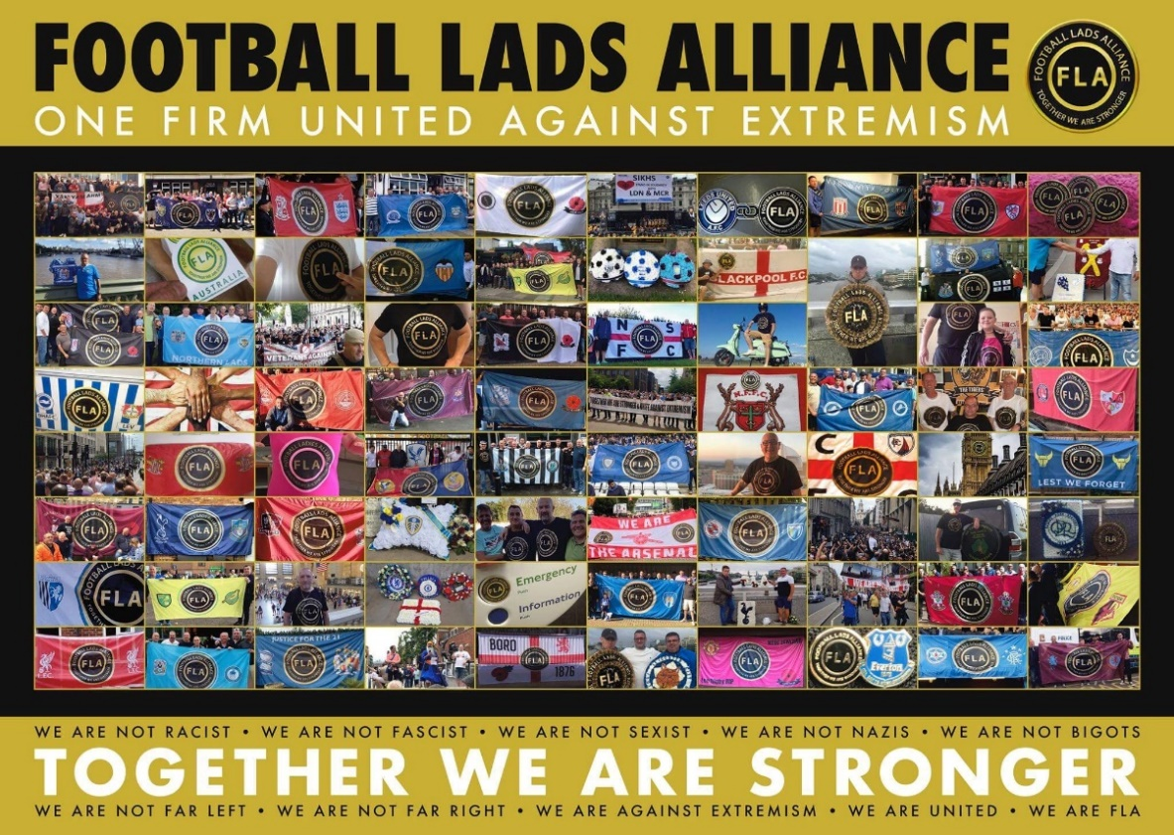
Figure 1
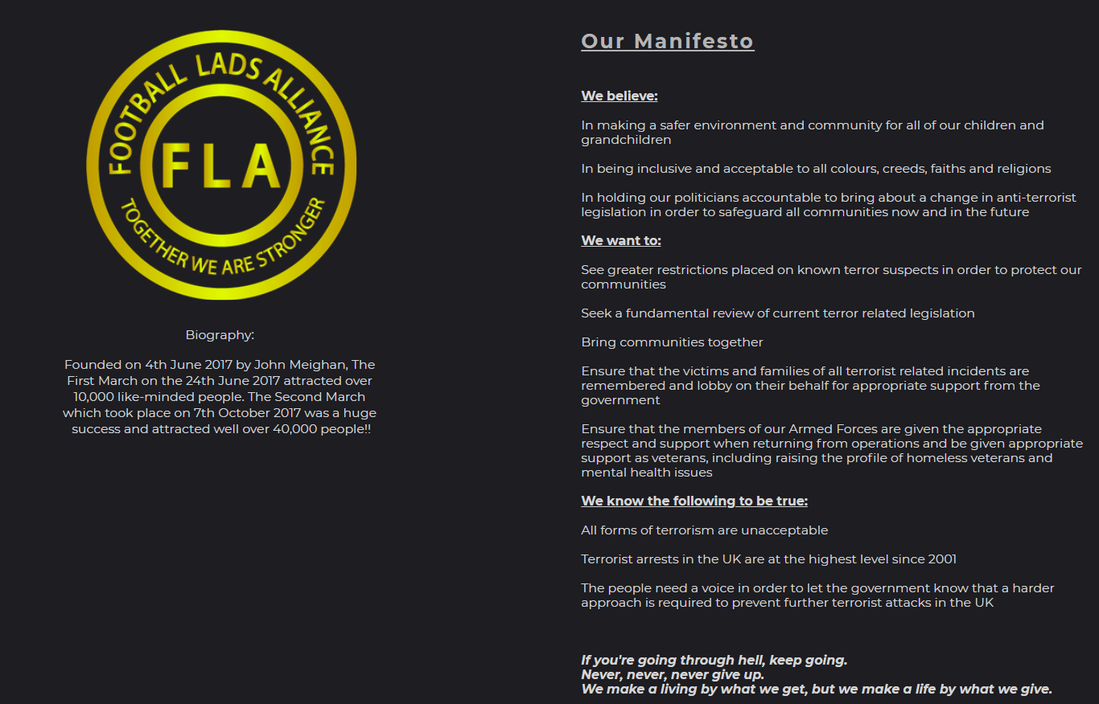
Figure 2: FLA Manifesto

Despite the FLA taking an explicit stance against extremism, some of the FLA’s behaviours suggest implicit links to groups and assumptions of ideologies that do have links to extremist ideological positions. Meighan has given few interviews mainly to online, right-wing media outlets such as the blog Shy Society and to the YouTube channel Make Britain Great Again (MBGA). Shy Society states, “if your politics are common-sense and patriotic, you’re one of us”. They regularly write on issues such as race and take a negative stance towards ‘liberals’ and politicians on the political left. They have also conducted an interview with Anne Marie Waters, leader of For Britain, a far-right offshoot of the United Kingdom Independence Party (UKIP), founding member of Sharia Watch UK, and co-leader (along with Paul Weston) of Pegida UK, an organisation founded by Tommy Robinson, which acts as a UK offshoot of the German anti-Islam Pegida organisation. Waters’ co-leader Paul Weston has links to UKIP, British National Party (BNP), English Defence League (EDL), the now-defunct British Freedom Party, and is Chairman of Liberty GB, a far-right nationalist political party. MBGA describe themselves as, “a right-wing media outlet to balance the bias of the BBC. We promote traditional British freedoms and values, including democracy, for all Britons, regardless of their race, gender, sexuality or religion. We oppose the European Union, Sharia law, feminazism and multiculturalism”. Much of the content published by MBGA relates to Brexit, ‘free speech’, patriotic nationalism and figures like the former leader of the street-level, anti-jihadist protest movement the EDL and current political advisor to UKIP Tommy Robinson (aka. Stephen Christopher Yaxley-Lennon).

Explicit connections between the FLA and other populist nationalist movements became clearer when, during a FLA-organised march in Birmingham on 24/03/2018, leader John Meighan introduced a bill of speakers, which included Anne Marie Waters, Luke Nash-Jones of MBGA; and Aline Morars, co-founder of the German anti-immigrant movement 120 decibel, which protests against ‘imported violence’ – the sexual assault of women by migrants. In his introductory comments to the Birmingham march, Meighan also acknowledged Tommy Robinson as “[standing] up for what’s right in this country – free speech” and that “we’re here today protecting free speech”, suggesting an alignment of purpose. Meighan goes on to say,

You know, yeah. There’s been a clear agenda against us. Erm, you know. And it’s been quite apparent since the last march, you know, the stuff that’s been written, the conversations I’m having with the press, erm, all they want to do is label us as far-right, erm, all we are is working-class people. We’re the people of this country and all we want is a safer place for our children and grandchildren. Look, at the end of the day, we all know, it’s all gone quiet now – there hasn’t been no attacks for a while – but, we all know that, we’re, you know, only one day or a month or whatever away from another attack. So, we have to keep going. We can’t stop doing what we’re doing, erm, and we have to keep going until the government, you know, make changes until the government take us seriously and, you know, the press… we won’t go away

Whilst the FLA could be described as a loose network of hard-core football fans with no official membership, they position themselves as defenders of democratic freedoms, the working class, and British values/patriots; claim legitimacy through opposition to extremism/terrorism, and have links to a broad (international) coalition of anti-Islamic, counter jihad, and right-wing organisations. This description virtually mirrors similar characterisations of the EDL (Copsey, 2010). Thus, the identity that the FLA presents – one of inclusivity – is suggestive of an ideological stance that differs with their associates. In response, this paper focuses on how followers of the FLA Twitter account (@lads_alliance) interpret and recontextualise the FLA’s proposed stance against all forms of terrorism and extremism through examining both followers’ autobiographical discriptions of themselves (‘bios’) and the communications that they engage in (‘tweets’). In so doing, this paper highlights that the discourse practices of a group’s followership may be as important a resource for defining a group’s purpose and collective identity as is the official party line, if not more so.

Groups like the FLA (such as the EDL) have been examined in previous research through the analysis of their online communication, including work that examines discourses related to the EDL on Twitter (McEnery, et al. 2015) and discourses “created by individuals who associate with the group [EDL]” on Facebook (Brindle 2016). Specifically, Brindle (2016) examined and compared the relationships between texts produced by EDL leaders and individuals’ posts to 56 comment threads on EDL’s main Facebook page. Despite this, to my knowledge, there is no academic work on the FLA from a linguistic perspective or that attempts to examine the discourse practices in the online followership of a similar group. More broadly, this paper presents a corpus-based approach to the analysis of a group’s identity primarily in terms of those shared identities and discourse practices adopted by its followership and considers how these shared identities/practices relate to the identity presented by a group’s leadership. As such, this approach goes beyond simple affiliation – following or use of a hashtag, for example, does not equate to alignment of purpose – but instead considers how alignment of purpose can be facilitated through followership. The following research question guides this research:

- What identities do followers of the FLA (@lads_alliance) appear to represent, construct and aggregate around?
Corpus-based Critical Discourse Studies & online (collective) identity
This section begins by situating the work within the growing field of Corpus-based Critical Discourse Studies, an approach that draws together theory and methods from the fields of CDS and Corpus Linguistics (CL). Following this, an approach to the analysis of (collective) identity in a particular online context (Twitter) is proposed by drawing on theories, including ambient affiliation (Zappavigna 2018), Discourse Community (Swales, 1990), and Community of Practice (Wenger, 1998), which are subsequently located within a Corpus-based Critical Discourse Studies framework. This background informs the main focus of the paper: how (collective) identity is discursively negotiated in texts (i.e. biographies, tweets) produced by followers of the @lads_alliance Twitter account.

Discourse is taken here to be a context-dependent social and semiotic practice, which is simultaneously socially constituted and constitutive (Reisigl & Wodak, 2009, p. 89). That is, the semiotic behaviours (linguistic or otherwise) that we engage in – and through which discourse is realised – are conditioned by their past (situations of) use, but also influence and shape potential future (contexts of) use. For CDS, particular attention is given to the relationships between discourse and ideology – “ideologies are typically expressed and reproduced by discourse” (van Dijk 2009: 79) – and the plurality of different ideological perspectives from which discourse (or discourses) may come to be signified. Of specific interest to CDS are those discourses that support inequitable social power relations to which CDS aims to provide routes to demystification and change (Fairclough & Wodak 1997).

CDS typically approaches a semiotic artefact – text – as a way in to discourse and, in turn, “discourses make ideologies ‘observable’ [as] it is only in discourse that they may be explicitly ‘expressed’ and ‘formulated’” (van Dijk 2005: 732). Language, images, etc. in texts thus provide evidence of the existence of discourses within texts and of discursive relations between texts through recontextualisation (Krzyżanowski 2016), for example. Historically, CDS research has focused on the ‘traditional’ print media practices of, inter alia, political parties (Richardson & Wodak 2009) and news media outlets (Fowler 1991), with some thought being given to the relationships between discourse practices of text production/producers and consumption/consumers – the basic idea being that texts influence and are influenced by these discourse practices. Increasingly, however, attention has turned towards the analysis of digital (and online) text types, which present both opportunities and obstacles to CDS scholars (KhosraviNik & Unger 2016), including new forms of social practice (e.g. hashtags, hyperlinking, liking) and access to a vast amount (and variety) of texts, text types and metadata. Speculative new subfields have even been proposed to account for social media-specific practices (e.g. Social Media Critical Discourse Studies, KhosraviNik 2017). Of interest to this study, however, are relationships between producers and consumers in online contexts (Baker & McGlashan, forthcoming) wherein dynamics of production and consumption are pluralistically enacted as part of new sites for, and configurations of, online discourse practice. These new practices require us to ask whether things like likes/retweets/following are constitutive forms of production and consumption and whether such practices need more theoretical and methodological attention. This paper understands following to be a constitutive act wherein the discourse practice of consumption is not just done – a text is not simply read – but enacted within a social structure that codifies participants’ identities in terms of this consumption (followers), their relationship to a producer, and their continuing commitment to future consumption.

Applying Corpus Linguistic (CL) methods within CDS research is, by now, nothing new (Baker, et al. 2008: 274). Indeed, as an emergent field, Corpus-based CDS is growing in popularity (cf. Marchi & Taylor 2018). Yet, combining CL and CDS is not without controversy, and the theoretical and methodological compatibility of the fields has been discussed extensively (Baker, et al. 2008; Mautner 2009), including discussions of cherry-picking (Baker & Levon 2015; Widdowson 2004) and decontexualisation (Widdowson 2000). Nevertheless, CL offers numerous techniques that have been used to provide ways in to analyses of large collections of language through the identification of somehow statistically salient/(in)frequent linguistic units (e.g. lemma), structures (e.g. n-grams) or correlations (e.g. collocation). For CDS researchers, quantitatively-defined linguistic patterns (and exceptions) may be suggestive of (un)common practices and, thus, as potential evidentiary ‘traces’ (Sunderland 2004) of discourse, a starting point for more qualitative analyses of that discourse. These methods are applied here to provide a way in to discourses through which followers of the @lads_alliance Twitter account negotiate and construct their (collective) identities in the texts that they produce (i.e. biographies, tweets) alongside the concurrently articulated practice of following. The suggestion being that followers’ identity – and their understanding of these identities – are evidenced by – and contingent on – a range of practices (including the non-linguistic) that facilitate affiliation.

Regarding collective identity, contemporary theories of identity query both ‘strong’ (essentialist) and ‘weak’ (constructivist) understandings of identity (Brubaker & Cooper 2000). A fully essentialist account of identity does not explain the potential fluidity and multiplicity of identities within and between different contexts. Yet a fully constructivist theory of identity does not account for “the sometimes coercive force of external identifications” (ibid.: 1) like nationality, gender or class; identifications which may at times be unavoidably shared with others and which may be difficult to self-determine. This study is concerned with how identities are discursively enacted and represented and so takes the view that the identities that are enacted and represented are those that are considered relevant to users in those practices they engage in. As such, the study considers what (collective) identities are constructed in texts produced by followers, the discourse practices that occur around those texts, and the social conditions that shape those texts and discourse practices. When analysing (collective) identity in discourse, I draw on Koller’s (2012) approach to the analysis of collective identity in discourse as well as the notions of Community of Practice (CoP; Wenger 1998) and Discourse Community (Swales 1990: 21-32), which understand communities as “an aggregate of people who come together around mutual engagement in an endeavor [sic]” (Eckert & McConnell-Ginet 1992: 464) through which,

Ways of doing things, ways of talking, beliefs, values, power relations – in short, practices – emerge […]. As a social construct, a community of practice is different from the traditional community, primarily because it is defined simultaneously by its membership and by the practice in which that membership engages
(Eckert & McConnell-Ginet 1992: 464)

As such, collective identities are taken to be constructed through both membership and the kinds of shared linguistic and discursive repertoires evident in texts produced by that membership. Given that texts form part of this definition, it is important to consider contemporary linguistic approaches to identity and collectivity in the context of social media (Hardaker & McGlashan 2016; Page 2012, 2018) but also to consider how practices integral to the specific social media platform being studied (here, Twitter) may form part of what a community does when mutually engaging in an endeavour. For example, practices such as hashtagging, mentioning, and retweeting could also be taken into account as discourse practices that afford identity construction and affiliation (Zappavigna 2018). Zappavigna (2017: 216) articulates the notion of ambient affiliation, which is “where […] individuals do not necessarily have to interact directly, but may engage in mass practices such as hashtagging in order to participate in particular kinds of ‘belonging’”. Although many linguistic studies of Twitter use particular linguistic items, including hashtags, as search terms to facilitate data collection (e.g. Kries 2017), this approach may not be unproblematic as a starting point for the analysis of community, which is the focus of this study. A community of practice is assumed to have a shared repertoire of discourse practices, which may include the use of particular hashtags – metadiscursive markers reflecting particular topics, themes or sentiments (McEnery, McGlashan, & Love 2015). However, the pre-selection of a specific hashtag or hashtags may limit the researcher’s access to the potentially heterogenious discourse participants and practices that constitute a community, and by extension, it may limit researchers’ access to a potential variety of topics, sentiments and discourses within a community. In response, this paper presents an approach to the study of community that first considers following as a discourse practice as a ‘way in’ to the study of an online community of practice.
Data & methodology
Data collection began on 18/10/2017 through the Twitter Application Programming Interface (API) accessed using the R twitteR package. Although it is not within the purview of this paper to outline API access and use, any Twitter account holder is able to collect data from Twitter this way. As this study was interested in discourses present in the followership of the @lads_alliance (and the collective identities therein) of those who voluntarily affiliate with the FLA, access to the profiles and tweets of the followers of the @lads_alliance Twitter account had to be gained. The choice was therefore made to begin with non-linguistic (although linguistically negotiated) followership relations before moving onto linguistic analysis.

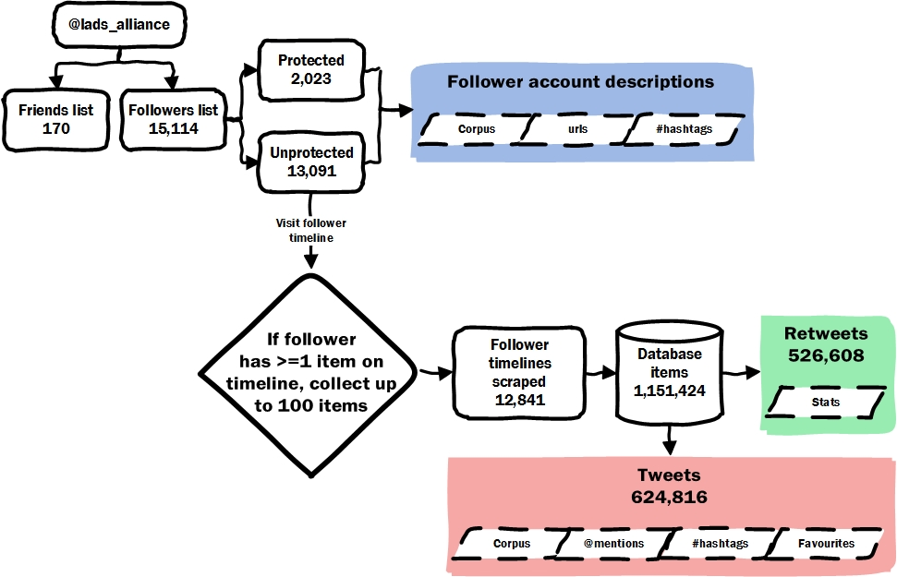
Figure 3: data collection flowchart
The Twitter API enables the generation of followers and friends (accounts followed by a user of interest) lists. As shown in Figure 3, @lads_alliance followed 170 different Twitter accounts (@lads_alliance’s friends) and had 15,114 followers. Having identified follower accounts, it was possible to find out which of those accounts were protected (n=2,023) or unprotected (n=13,091). Only approved followers can view a protected Twitter account’s activity, whereas the activity on unprotected accounts can be accessed and viewed by the public. However, even without being able to view account activity, it is possible to collect some account information, such as screen name, twitter handle, description and the profile image for the account. A corpus was created from all of the descriptions (i.e. user biographies) found within the account information dataset. These descriptions provide a place for autobiographical user description and thus may contain instances of explicit identity performance; that is, self-identification. The resultant descriptions corpus contained 93,274 tokens (excl. mentions, hashtags, URLs). Following this, each unprotected follower account was visited and checked to identify timeline activity (i.e. whether accounts had posted or retweeted any tweets). If an unprotected follower’s timeline contained at least 1 tweet/retweet item then a maximum of 100 items were collected from that follower’s timeline. Following this procedure, a total of 1,151,424 items were collected from 12,841 different user timelines (an average of 89.67 items per timeline). 624,816 of these items were tweets, which contain 5,896,328 tokens and were used to populate the tweets corpus. The remaining 526,608 items were retweets, which were used to populate a retweets corpus, which is not discussed further in this paper due to limitations of space. Both the descriptions corpus and the tweets corpus are large collections of unique text files resembling ‘traditional’ corpora making them amenable to corpus techniques premised on word frequency. A corpus-driven approach (Tognini-Bonelli 2001) is taken to the analysis of both corpora with candidates for lingusitic analysis being identified through the analysis of token frequency lists, which provide a way in revealing frequently used lemma/semantic categories and thus shared language in the @lads_alliance CoP.

The analysis occurs in two stages. The first stage involves the identification of salient linguistic items and discursive strategies for (collective) identity construction in a frequency wordlist derived from the descriptions corpus. Stage two of the analysis examines draws on findings from stage one to examine how identity is constructed and performed in language used in tweets and correlates this with language in the biographies, which is arguably a far more explicit kind of self-identification identity work. As such, this approach is interested in understanding how followers’ identities – and their understanding of these identities – are evidenced by and contingent on a range of discursive practices (linguistic and non-linguistic) facilitating the enactment/representation of affiliation.
Analysis
The first stage of analysis focuses on an investigation into the frequency of use of linguistic items in the descriptions corpus. Table 1 gives a list of the top 30 most frequent lexical words in the descriptions corpus ranked in order of frequency; grammatically closed-class words were excluded. These words were then grouped into semantic categories following qualitative inspection of their contexts of occurrence in order to investigate meaningful patterns of use (Table 2). For example, the most frequent term fan is exclusively found to be an abbreviation of ‘fanatic’ and, when used, is most frequently used to express fandom in relation to football (Example 1).

English. Anti globalisation. Traditional values. #lufc fan. RT not always endorsement. Views my own.
Example 1
Rank | Frequency | Word | Rank | Frequency | Word
1 | 826 | fan | 16 | 233 | father
2 | 621 | love | 17 | 224 | united
3 | 420 | proud | 18 | 214 | supporter
4 | 411 | football | 19 | 209 | city
5 | 382 | fc | 20 | 208 | ham
6 | 346 | life | 21 | 207 | away
7 | 323 | holder | 22 | 207 | like
8 | 296 | season | 23 | 205 | man
9 | 291 | london | 24 | 200 | england
10 | 290 | ticket | 25 | 200 | rangers
11 | 255 | west | 26 | 200 | time
12 | 253 | views | 27 | 195 | just
13 | 247 | music | 28 | 190 | will
14 | 244 | family | 29 | 188 | one
15 | 242 | dad | 30 | 182 | home
Table 1
Category | Terms
Fandom (football) | fan, football, fc, holder, season, ticket, west, united, supporter, city, ham, away, man, rangers, home
Fandom (other) | music
Evaluation | like, just, will
Social actor | holder, family, dad, father, supporter, man
Place | west, London, city, ham, England, home
Twitter | views
Miscellaneous | time, one
Table 2
The most densely populated category in Table 3 is ‘Fandom (football)’ containing references to football clubs (e.g. fc, rangers, united, city) and self-identification as a supporter, which may involve long-term financial commitment to a club through purchase of a season ticket or being a season ticket holder. Some of these terms occur in multiple categories. For example, the self-identifications supporter and holder occur in both the ‘Fandom (football)’ and ‘social actor’ category because, although these terms are mainly related to football fandom, the nominalisations also signal particular functionalised identities whereby “social actors are referred to in terms of an activity, in terms of something they do” (van Leeuwen 2008: 42). Other forms of social actor representation evident in the ‘social actor’ category include the relational identifications family, dad, and father, which represent “social actors in terms of their personal, kinship, or work relations to each other” (van Leeuwen 2008: 43); and the gendered classification man. Further categorisations were developed to account for self-identification of non-football related fandom (‘fandom (other)’), forms of linguistic evaluation (‘evaluation’; Martin & White 2005), and Twitter-specific conventions (‘Twitter’) such as including ‘views my own’ in one’s biography as a disclaimer to distance a user’s views from the views of their employer, for example. The categories evident in Table 3 begin to reveal some evidence of shared linguistic practices in the biographies that comprise the descriptions corpus and begin to suggest evidence of a community of men interested in football (which seems self-evident given that the group is called the Football Lads Alliance).

Category | Terms
Politics | eu, right, brexit, politics, great, political, news, speech, ukip, stand, left, support, freedom, patriot, conservative, pc
Religion | islam, god, religion, soul, atheist
Table 3
The categories evident in Table 3 begin to reveal some evidence of shared linguistic practices in the biographies that comprise the descriptions corpus and begin to suggest evidence of a community of men interested in football (which seems self-evident given that the group is called the Football Lads Alliance). An extended analysis of the 200 most frequent lexical words in biographies found that, alongside categories identified in Table 2, broader grammatical categorisations (e.g. noun, verb, adjective, adverb) and further semantic categories for ‘politics’ and ‘religion’ were evident (Table 3), which suggests that, although gender and football identities are most frequent, identities within this followership appear also to be frequently constructed in relation to politics and religion, specifically Islam. Qualitative concordance analysis of biographies containing terms in these politics and religion categories found that identities were often performed and constructed in relation to these categories with evaluative language being used to signal stance, for example: ‘UKIP supporter’, ‘Totally anti left wing, anti EU and anti Islam’, ‘Anti Islamic and detest the left wing as much. Working class and proud of it’. Of particular note was the use of evaluative language to signal (dis)affiliation, whereby identities such as national or political identities were represented favourably (or neutrally) in biographies alongside contrasting negative representations of the political, religious, cultural, etc. ‘other’ (Example 2) thereby construing us vs. them identities and relationships (Wodak 2011).

Spurs born and bred. English infidel and therefore apparently Islamaphobic. Non PC. Love Europe,hate EU. If any of that offends, best not follow me.
Example 2
Project Manager - English, Anti-Islam, Pro-Brexit, Pro-Bacon #Bluehand
Pro Brexit, pro Trump. Anti far left facists.
Example 3

One prominent strategy of signalling religious/political (dis)affiliation identified in biographies was use of the antonymous prefixes ‘pro’ (in favour of) and ‘anti’ (against) (Example 3). Although numerous strategies for signalling religious/political (dis)affiliation were evident in biographies, the antonymy of pro-/anti- prefixes provides a semantic basis for comparing and contrasting (dis)affiliation on a quantitative basis in biographical descriptions. To examine how this strategy was used by followers across the whole descriptions corpus a search for the strings ‘pro’ or ‘anti’ was conducted. This search returned 1,217 biographies (8.05% of user profiles in the entire sample) for consideration. Although this search enabled the identification of candidates for study, it also returned instances where ‘pro’ also matched biographies containing terms like ‘promoter’, ‘professional’, etc. and ‘anti’ also matched words such as ‘quantity’. Through qualitative concordance analysis of matching strings, false positives were discounted and a range of orthographic representations of pro-/anti- prefixation were identified (e.g. ‘pro life’, ‘pro-life’, ‘antisocial’, ‘#antiliberal’, ‘anti EU / Islam / BBC’). Those words/phrases modified by anti-/pro- are listed and categorised in Table 4.

category |  | pro | anti
politics | parties/  politicians/  figures/  campaigns | #brexit; #forbritain; #maga; #trump; amw; annemarie waters; brexit; leave.eu; maga; pres.trump; president trump; tommy; total brexit; trump; ukip | #labour; corbyn; labour; liblabcon; lying corrupt politicians ; may; sf/ira; snp
 | left wing/  liberal politics |  | #antileftard; #antiliberal; #farleft; alt-left; left; left wing; left wing politics; leftard; leftism; leftist; lefty's; liberal; liberal bullshit; sjw; sjw cults; sjws; the left; the vile, hate-filled, anti-semitic far-left
 | (global) establishment |  | #antiglobalist; establishment; globalisation; globalism; globalist; new world order; nwo; system
 | philosophy/  values | conservatism; constitution; democracy; freedom; gun; liberty; rights; secular; the monarchy; tradition; western values; working class | #antifa; #antimarxist; #socialism; all destroyers of western culture and values; communist; corruption; everything & everybody that is anti-constitution.; fa; facist; far anything!; fasciste; feminism; feminist; hypocrisy; marxist; monarchist; regressive; relativism; social engineering; socialism; socialist; statist; totalitarian
 | Political  Correctness  (PC) |  | pc; #antipc; #politicalcorrectness; extreme political correctness; pc politics; political correctness; political correctness types
 | European  Union  (EU) | a reformed european union | eu; #antieu; #eu; eu and all it stands for; eu but love europe; eu dictatorship; eu diktators; eu not anti europe; political union
 | (im)migration | assimilation; controlled borders; controlled immigration; immigration | invasion #islam terrorists; mass immigration; nazi/sharia immigration; uncontrolled immigration
 | transport |  | dvsa; tfl; uber
 | economy | business; graduate tax; public owned oil, gas, water, electricity, prisons, transport, telecoms ect.; reformed banking; trade | austerity; corporatism; greed; tax
 | family, etc. | choice; family; life; unconditional interfaith marriage
religion | general | god | #religion; religion; religious extremism; theist
 | Islam | bacon | #anti_jihad; #antiislam; #radicalislam; #sharialaw; creeping sharia; deathcult; halal; halal slaughter; invasion #islam terrorists; is; islam; islam/sharia law; islamic; islamification; islamisation; islamisation of great britain; islamism; jihad; nazi/sharia immigration; radical islam not anti muslim; religion especially the barbaric, murderous cult of islam; religion, esp. islam; sharia; sharia law; the violent political ideology that is islam; theist, esp jihadist islam
 | Judaism |  | #antizionist; jew; semitism; Zionist
 | Catholicism |  | pope
place | Britain/UK | #union; all things british; britain; british; england; everything british; gb; great britain; make great britain again; my country; uk; uk sovereignty; union; unionist; wolverhampton
 | Europe | europe; european | european
 | Israel | #israel; isreal; isreali | isreal hatred
 | other | america; canadian identity; india; ireland; us; west
culture | news media | @prisonplanet; real news | bbc; bentnews bbc; celebrity; cnn; msm
 | public discussion | discussion; free speech; freedom of speech; speech | silencing
 | reason | common sense; logic; facts
 | diversity | equality; equality 4 all; equality between men & women of every race; gay; lgb..(not t) | #antimulticulturalism; multiculturalism
 | ‘race’ | white | antiracismday; racist; white guilt
 | sport | wolves fc | animal abuse; blood-sport
war/peace | armed forces/war | armed forces; british armed forces; defence; forces | nato; pointless wars; war
 | peace | kindness; peace for all
 | extremism |  | extremist; terrorism
 | violence and subjugation |  | fgm; rape; subjugation
transgression | identity |  | #snowflake; idiot; idiots; morons
 | Behaviour |  | silliness; social; stupid mischief
Table 4
Exploration of the categories in Table 4 finds that some categories (e.g. politics) contain a greater number and diversity of terms and subcategories than others (e.g. culture) but also that some categories show patterns of exclusive occurrence with either pro- (e.g. Britain/UK) or anti- (e.g. political correctness (pc)). Moreover, some cases also revealed that both pro- and anti- prefixes could be used within the same category in order to articulate the same discourse. For example, in the public discussion category ‘anti-silencing’ and ‘pro free speech’ both articulate a ‘discourse of free speech’ in reaction to a presupposed threat to free public discussion, and ‘pro-bacon’ was found to articulate a coded anti-Islamic sentiment for one user – pork being haram (unlawful) for Muslims to consume.

Table 4 also shows that identities appear to be constructed most diversely/numerously in relation to politics, religion, and place. Language used within these categories show oppositional identity constructions. For example, followers were only ever against left wing/liberal politics, (global) establishment, Political Correctness (PC), and transport in the most populous category (politics) but only in favour of Britain/UK in the place category. Indeed, a pro-Britain/UK stance is typically set up in opposition to some of those more diversely populated categories relating to religion (Islam) and politics (European Union (EU), Political Correctness (PC)), which contributes to an oppositional identity construction wherein a follower’s understanding of their Britishness/UK identity excludes relationships with the EU, Islam, PC, and the political left (Example 4).

mcfc season ticket holder, love all animals, pro uk anti EU, strong opinions, really angry at what's going on in the world, its gone mad!
Proud to be British. Non-Partisan. Pro-UK ~ Anti-EU ~ Anti-Islamisation ~ Anti-PC ~ Anti-Hypocrisy #Brexit
Put an end to political correctness. Anti EU, Pro Great Britain. Using leftist tears to water the plants.
Example 4
Furthermore, identity is also constructed through the simultaneous exclusion of multiple categories in bios, which suggests interdiscursive relations are made between out-group categories to articulate (dis)identification with particular groups and discourse, which are positioned as threats or as damaging influences. For example, articulating a stance against the EU, Islam, and immigration simultaneously (Example 5) might suggest that these things are related, making it possible for anti-EU discourse to also stand for anti-immigration/immigrant and/or anti-Islam discourse, and vice-versa.

Proud dad, safc fan, brexiteer! Anti EU, anti political correctness, anti left wing politics!
• common sense • right of centre • logic will prevail • pro-Brexit • let's get back to being a civilised nation • non-PC • Anti-EU • Anti-Multiculturalism
Pro: West, Free speech, LGB..(Not T) Anti: SJW cults, Islam, EU. Still can't take the internet seriously, hence occasional shit posting
Christian, Patriot. Proud to be White. Proud to be British. Pro white. Anti-EU. Anti-immigration. Anti-white guilt. Anti-Jew/Islam #14/88
Example 5
Regarding RQ1, findings in Table 4 and the accompanying analysis of a selection of FLA follower profiles suggest that alongside the practice of following, shared practices for explicit (dis)identification exist within followers’ biographies, and that these practices reveal the FLA’s followership CoP to, in some part, rely on pro-nationalist, anti-left wing, anti-immigrant, and Islamophobic discourse. Indeed, many of these sentiments align with ideological preoccupations of the contemporary European radical right, which include:

defending national, ‘European’ or ‘Western’ values; putting a brake on growing migration inflows from north Africa and Asia; waging a ‘war’ against radical ‘Islamist’ and Jihadi groups; challenging state multiculturalism; fighting against (national and ‘European’) identity dilution; campaigning for a ‘fortress Europe’; scrapping the European Union’s Schengen border zone; even destroying the EU as a whole; as well as addressing unemployment and falling living standards on behalf of the national community
(Kallis 2019: 363)

This finding suggests a divergence between followers of @lads_alliance and the FLA’s stated opposition to racism, bigotry and political affiliation (Figure 1) and belief “in being inclusive and acceptable to all colours, creeds, faiths and religions” (Figure 2).

A further stage of analysis examines correlations between language found in the descriptions corpus and the tweets corpus. A case study of terms found in one of the most densely populated categories in Table 4 – religion: Islam – is given here. The terms in this category characterise Islam as violent (deathcult, barbaric, murderous, violent) and invasive (invasion #islam terrorists, creeping sharia, islamification, islamisation), including drawing parallels between Islam, fascism and immigration (nazi/sharia immigration). The search term “jihad|islam|sharia|deathcult|halal”, derived from terms found in the religion: Islam category in Table 4, were found in biographies of 229 unique accounts which contributed 10,064 tweets to the tweets corpus. A lexical word frequency list was then derived from these tweets (Table 5).

Rank | Frequency | Word | Rank | Frequency | Word
1 | 422 | Will | 16 | 194 | Time
2 | 418 | Just | 17 | 182 | Right
3 | 343 | People | 18 | 179 | See
4 | 332 | Like | 19 | 178 | Via
5 | 304 | Get | 20 | 168 | Muslims
6 | 279 | Islam | 21 | 166 | Country
7 | 270 | Now | 22 | 166 | Go
8 | 244 | Muslim | 23 | 165 | Police
9 | 232 | Us | 24 | 164 | Hate
10 | 227 | Know | 25 | 161 | Never
11 | 220 | Uk | 26 | 153 | White
12 | 219 | Think | 27 | 152 | Want
13 | 213 | Well | 28 | 150 | Back
14 | 201 | Good | 29 | 149 | Got
15 | 198 | Need | 30 | 143 | Islamic
Table 5
Table 5 shows Islam, Islamic, Muslim, and Muslims appearing within the 30 most frequent lexical words in this subsection of the tweets corpus and their use was accounted for by 827 tweets (0.13% of the tweets corpus) sent from 154 unique accounts (1.18% of all unprotected accounts) with biographies making reference to Islam as identified in Table 4.

Previous work has found that the term Islamic carries a negative discourse prosody (Baker, et al. 2013), which was also reflected in this subsection of the tweets corpus. Islamic was found to most frequently take the lemma of ‘terror’ as a lexical collocate, occurring as part of n-grams such as Islamic terror, Islamic terrorism, etc. as shown in Table 6.
This AND the next 20 | Islamic terror | attack will be nothing to do with Islam
have enough police officers to deal with | Islamic terror | attacks
Then round them up & jail /deport | islamic terror | plotters under new laws in all Western
balls to act to protect it's people from | islamic terrorism
No | Islamic terrorism | in Poland - they have the right idea1
 | Islamic terrorism | is created by other religions very being
to muslim grooming gangs & refugee | Islamic terrorist | attacks in Britain
One day, what is happening in UK / EU ( | Islamic terrorist | attacks on an almost monthly basis)
Just like we do with | Islamic terrorist | attacks in our country
wants to shut down the 'safe spaces' for | Islamic terrorists | , but she won't shut down radical
our leaders are responsible for importing | islamic terrorists | “we have all been shit on and everyone
Similar shit is said about how "peaceful" | Islamic terrorists | were before they stabbed/blew up/ran
Table 6
Rank | Frequency | N-gram
1 | 55 | Islam is
2 | 39 | A muslim
3 | 32 | Of islam
4 | 27 | The muslim
5 | 16 | Muslims are
Table 7
A more general analysis of the n-grams in which the terms Islam, Islamic, Muslim, and Muslims occur (Table 7) found frequent constructions specifying identity through relation and specification. Islam is, the most frequent of these n-grams, and Muslims are were found to function as part of intensive relational clauses, which specify identity (Halliday & Matthiessen 2014), and the of-genitive of Islam was used frequently. Discourses emerging from tweets that contain intensive relational constructions (e.g. Islam is/muslims are) position Islam and Muslims as a (violent) threat (Table 8).

Very wise. | Islam is | a dangerous cult which mandates violence until Islam is the ONLY permissible doctrine. Disgusting.
Not doing anything is full blown suicidal stupidity. | Islam is | full blown fascism.
 | Islam is | not compatible with western society. Time for people to wake up and realise this threat and change to the demographic is real
"Many | muslims are | peaceful but that does not make Islam peaceful". True.
Id say these | muslims are | pigs but that's unfair to pigs
"Radical terrorists" aka | muslims, are | just another cog in the finely tuned gears of Islam
Table 8: ‘Islam is’/’muslims are’ a threat
Further evidence of ‘islam as a (violent) threat’ discourse is revealed in concordances of the genetive of Islam (Table 9) in which L1 collocates reveal that threat is articulated in one way through literal reference to growth (growth, spread) and medicalised metaphors of growth (birth, cancer). Although “inanimate possessors tend to occur preferably with the of-genitive” (Rosenbach, 2008), it appears here that Islam is still attributed agency (“has reared its ugly head”).

To protect the growth | of Islam | by duping the masses into thinking only extremists are the problem & that Muslims & the kafir can coexist.
Love these people...Eastern Europeans understand the ideology of hate and will not tolerate the spread | of Islam
The malignant cancer | of Islam | has reared its ugly head in Barcelona. When will this madness end?
Islam has massacred over 670 million people since the birth | of Islam | Islam doesn't belong in the west
Table 9
Conclusion
This paper presented a novel methodological approach to the analysis of collective identity construction within an online CoP wherein the discourse practice of following was used as the starting point for data collection and a subsequent corpus-driven analysis of the discursive relationships between language found in texts (i.e. biographies and tweets) produced by followers of the FLA. This approach offers a method of studying identification in online communities than is not present in the current literature. Studies tend to preselect features shared between texts, such as hashtags (e.g. Kries 2017; Chiluwa & Ifukor 2015) to identify collective action and belonging but practices such as following as meaningful, constitutive, and active forms of identification are understudied. In response, this paper suggests that following – as an act of identifying oneself within a consumptive role – can be used as a ‘way in’ to the analysis of an online community as it enables a consideration first of discourse practice rather than text. Although the analysis here does not detail all of those discourses present in the corpora analysed, this approach affords the ability to explore how followers may construct (collective) identities using both biographies and tweets by examining the elaborative relationships between these text types. A specific finding here suggests that followers of the FLA who identify themselves in relation to Islam/Muslims in their biographies also tweet negatively about Islam/Muslims.

More broadly, analysis of the FLA CoP found that a portion of the followership constructs identity in relation to radical right-wing and populist discourse specifically concerning Islam/Muslims, which diverges from the FLA’s projected identity. Although it could be argued that, due to the public characteristics of social media, the FLA had little control over who follows them, and as the FLA have stated they are ‘not racist’ and against ‘all extremism’ this membership does not represent them. However, evidence of a followership engaging in nationalistic/populist discourse might highlight a sophisticated followership that recognises ‘calculated ambivalence’ (Engel & Wodak 2013) in the group’s message. The approach taken made possible the ability to explore how identities explicitly presented in biographies might be further (and intertextually) specified when viewed in relation to discourses found in tweets sent by fellow followers with similar biographies.

References
Baker, P., & Levon, E. (2015). Picking the right cherries? A comparison of corpus-based and qualitative analysis analyses of news articles about masculinity. Discourse & Communication, 9(2), 221-36.
Baker, P., & McGlashan, M. (forthcoming). Critical Discourse Analysis: a comparison of discourses around Romanians in The Daily Express with its readers’ comments. In S. Adolphs, & D. Knight, The Routledge Handbook of English Language and the Digital Humanities. London: Routledge.
Baker, P., Gabrielatos, C., & McEnery, T. (2013). Discourse Analysis and Media Attitudes: the representation of Islam in the British press. Cambridge: Cambridge University Press.
Baker, P., Gabrielatos, C., KhosraviNik, M., Krzyżanowski, M., McEnery, T., & Wodak, R. (2008). A useful methodological synergy? Combining critical discourse analysis and corpus linguistics to examine discourses of refugees and asylum seekers in the UK press. Discourse & Society, 19(3), 273-306.
Brindle, A. (2016). Cancer has nothing on Islam: a study of discourses by group elite and supporters of the English defence league. Critical Discourse Studies.
Brubaker, R., & Cooper, F. (2000). Beyond "identity". Theory and Society, 29, 1-47.
Chiluwa, I. & Ifukor, P. (2015). ‘War against our children’: stance and evaluation in #BringBackOurGirls campaign discourse on Twitter and Facebook. Discourse & Society26(3): 267-96.
Copsey, N. (2010). The English defence league: Challenging our country and our values of social inclusion, fairness and equality. London: Faith Matters.
Eckert, P., & McConnell-Ginet, S. (1992). Think practically and look locally: language and gender as community-based practice. Annual Review of Anthropology, 21, 461-490.
Engel, J., & Wodak, R. (2013). 'Calculated ambivalence' and holocaust denial in Austria. In R. Wodak, & J. E. Richardson, Analysing Fascist Discourse: European fascism in text and talk (pp. 73-96). New York: Routledge.
Fairclough, N. (1992) Discourse and Social Change. Cambridge: Polity Press
Fairclough, N., & Wodak, R. (1997). Critical Discourse Analysis. In T. A. van Dijk, Discourse as Social Interaction (pp. 258-84). London: Sage.
Fowler, R. (1991). Language in the News: discourse and ideology in the British press. London: Routledge.
Halliday, M. A., & Matthiessen, C. M. (2014). Language as Social Semiotic: the social interpretation of language and meaning (4th ed.). London: Routledge.
Hardaker, C., & McGlashan, M. (2016). "Real men don't hate women": Twitter rape threats and group identity. Journal of Pragmatics, 91, 80-93.
Kallis, A. (2019). Islamophobia and the radical right in Europe: nostalgia or alternative utopia? In I. Zempi, & I. Awan, The Routledge International Handbook of Islamophobia (pp. 363-73). London: Routledge.
KhosraviNik, M. (2017). Social Media Critical Discourse Studies (SM-CDS). In J. Flowerdew, J. E. Richardson, J. Flowerdew, & J. Richardson (Eds.), The Routledge Handbook of Critical Discourse Studies (pp. 582-96). London: Routledge.
KhosraviNik, M., & Unger, J. (2016). Critical Discourse Studies and social media: power resistance and critique in changing media ecologies. In R. Wodak, & M. Meyer (Eds.), Methods of Critical Discourse Studies (3rd ed., pp. 206-33). London: Sage.
Kries, R. (2017). #refugeesnotwelcome: anti-refugee discourse on Twitter. Discourse & Communication, 11(5), 498-514.
Krzyżanowski, M. (2016). Recontextualisation of neoliberalism and the increasingly conceptual nature of discourse: Challenges for critical discourse studies. Discourse & Society, 27(3), 308-21.
Marchi, A., & Taylor, C. (2018). Introduction: partiality and reflexivity. In C. Taylor, & A. Marchi, Corpus Approaches to Discourse: A critical review (pp. 1-15). London: Routledge.
Martin, J. R., & White, P. R. (2005). The Language of Evaluation: appraisal in English. New York: Palgrave Macmillan.
Mautner, G. (2009). Corpora and Critical Discourse Analysis. In P. Baker, Contemporary Corpus Linguistics (pp. 32-46). London: Continuum.
McEnery, T., McGlashan, M., & Love, R. (2015). Press and social media reaction to ideologically inspired murder: the case of Lee Rigby. Discourse & Communication, 9(2), 237-59.
Page, R. (2012). The linguistics of self-branding and micro-celebrity in Twitter: the role of hashtags. Discourse & Communication, 6(2), 181-201.
Page, R. (2018) Narratives Online: shared stories in social media. Cambridge: Cambridge University Press.
Reisigl, M., & Wodak, R. (2009). The Discourse Historical Apprach (DHA). In R. Wodak, & M. Meyer, Methods in Critical Discourse Analysis (2 ed., pp. 87-121). London: Sage.
Richardson, J. E., & Wodak, R. (2009). Recontextualising fascist ideologies of the past: right-wing discourses on employment and nativism in Austria and the United Kingdom. Critical Discourse Studies, 6(4), 251-67.
Rosenbach, A. (2008). Animacy and grammatical variation - findings from English genetive variation. Lingua, 151-71.
Sunderland, J. (2004). Gendered Discourses. Basingstoke: Palgrave Macmillan.
Swales, J. (1990). Genre Analysis: English in academic and research settings. Cambridge: Cambridge University Press.
Tognini-Bonelli, E. (2001). Corpus Linguistics at Work. Amsterdam: John Benjamins.
van Dijk, T. A. (2005). Politics, ideology, and discourse. In R. Wodak, Encyclopedia of Language & Linguistics: volumen on politics and language (pp. 728-40). Amsterdam: Elsevier.
van Dijk, T. A. (2009). Critical Discourse Studies: a sociocognitive approach. In R. Wodak, & M. Meyer, Methods of Critical Discourse Analysis (pp. 62-86). London: Sage.
van Leeuwen, T. (2008). Discourse and Practice: new tools for critical discourse analysis. Oxford: Oxford University Press.
Wenger, E. (1998). Communities of Practice: learning, meaning and identity. Cambridge: Cambridge University Press.
Widdowson, H. G. (2000). On the limitations of linguistics applied. Applied Linguistics, 21(1), 3-25.
Widdowson, H. G. (2004). Text, Context, Pretext: Critical issues in discourse analysis. Oxford: Blackwell.
Wodak, R. (2011). 'Us' and 'them': inclusion and exclusion - discrimination via discourse. In G. Delanty, R. Wodak, & P. Jones, Identity, Belonging and Migration (pp. 54-77). Liverpool: Liverpool University Press.
Zappavigna, M. (2017). Twitter. In C. Hoffman, & W. Bublitz, Pragmatics of Social Media (pp. 201-24). Berlin: Mouton De Gruyter.
Zappavigna, M. (2018). Searchable Talk: hashtags and social media metadiscourse. London: Bloomsbury.

http://www.dailymail.co.uk/news/article-4958848/Thousands-football-fans-march-against-terror-London.html
http://www.independent.co.uk/news/uk/home-news/football-lads-alliance-inside-far-right-march-london-edl-london-a7988451.html
https://socialistworker.co.uk/art/45443/Racism+was+at+the+heart+of+Football+Lads+Alliance+march
https://blogs.spectator.co.uk/2017/10/the-football-lads-alliance-is-a-working-class-movement-and-the-political-class-wants-to-ignore-it/
https://shysociety.co.uk/2017/06/27/meet-the-man-behind-britains-new-street-movement-with-a-difference/
https://www.youtube.com/watch?v=13oZtyxSzE8
https://shysociety.co.uk/2017/07/11/is-white-the-new-black/
https://shysociety.co.uk/2017/10/07/anne-marie-waters-i-want-to-keep-the-britain-we-know/
http://www.shariawatch.org.uk
https://libertygb.org.uk
https://www.youtube.com/channel/UCoWe8JjDi-0wrdzo--2htHw/about
https://www.120-db.info/en/
https://www.youtube.com/watch?v=pk3spgRrnsA
https:// twitter.com
https://cran.r-project.org
https://cran.r-project.org/web/packages/twitteR/

