TITLE: Experimental results of the hydrological performance of a permeable pavement laboratory rig
SHORT TITLE: Lab results of the hydrological performance of a permeable pavement rig
Vasiliki G. Ioannidou¹, Scott Arthur²
¹ School of Engineering and the Built Environment, Birmingham City University, Curzon Street, Birmingham, B4 7XG, UK
(vasiliki.ioannidou@bcu.ac.uk; tel.: 0044 (0) 121 300 4006; ORCID: 0000-0003-3083-9723)
² School of Energy, Geoscience, Infrastructure and Society (EGIS), Heriot-Watt University, Edinburgh, EH14 4AS, UK
(Sarthur@hw.ac.uk)

ABSTRACT
There is an increasing amount of everyday flood incidents around the world, the impact of which poses a challenge on the society, economy and environment. Under the Water Framework Directive (2000/60/EC), green infrastructure through the use of sustainable drainage systems (SuDS) is the recommended policy to manage and treat storm water runoff. Given the limited published experimental information on permeable interlocking concrete block pavements, this paper presents novel results from an experimental laboratory study on a permeable interlocking concrete block pavement rig, investigating the short-term hydrology of the pavement, and water quality aspects related to the retention capacity of suspended solids (SS) through the pavement structure. Results of the volume analysis demonstrate high capability of the permeable structure to reduce the concentration time and attenuate the storm. Water quality testing was employed mainly as an indicator of the tendency of the suspended solids retention by the structure, indicating increase tendency in the sediment mass retention progressively after each rainfall event. Experimental results obtained on the present study have direct application on the implementation of PICPs in car parking lots, urbanised pavement structures, and pedestrianised walkways.

Keywords: storm water runoff; SuDS; permeable pavements; hydrological performance; experimental work; suspended solids

ACKNOWLEDGEMENTS
The authors gratefully acknowledge the permitted access to the laboratory facilities and equipment in the School of EGIS at Heriot-Watt University, the technical support from the laboratory and academic staff, and Marshalls Limited for providing material for the testing rig described in this paper. A previous shorter version of the paper has been presented in the 3rd International Conference of EWaS, Lefkada Island, Greece, 27–30 June 2018.

HIGHLIGHTS
- Repeatable rainfall simulation events were carried out in the laboratory to assess the hydrological performance of a permeable pavement rig made of interlocking concrete blocks.
- Volume analysis demonstrated high storm water attenuation capacity of the pavement structure.
- Water quality testing in terms of suspended solids indicated positive response of the retention of the suspended solids mass through the structure, albeit more experiments would be required to quantify the sediment mass retention capacity and the clogging rate of the structure.

LIST OF ACRONYMS
MC Moisture Content
PICPs Permeable Interlocking Concrete Blocks
SS Suspended Solids
SuDS Sustainable Drainage Systems
VWC Volumetric Water Content

INTRODUCTION
The growing demands of the construction of impervious surfaces, in order to meet the needs of public and personal vehicular and pedestrian transportation result in increased surface runoff in the urban landscape [1]. This has a direct impact on the society, economy and environment, as impervious surfaces produce greater proportions of storm water surface runoff, increase in the peak flows and decrease of the concentration time, overall resulting in more frequent flooding incidents all over the world. The current policy enforced to alleviate this situation is provided under the Water Framework Directive (2000/60/EC) stating that green infrastructure provided by using sustainable drainage systems (SuDS) is the recommended policy to manage and treat storm water runoff [2]. SuDS mimic nature to manage and treat storm water whilst aggregating the benefits of managing quantity (flooding), quality (pollution) and biodiversity/amenity [3-5].
There are various forms of SuDS which help prevent flooding and clean up contaminants, including constructed wetlands, pervious pavements, green roofs, and ponds. Pervious pavements could play an important role in reducing flooding, as they constitute an everyday component of the urban landscape. In particular, two-thirds of the total rain amount that falls on impervious surfaces within urban catchments falls on pavements, which results in excessive runoff generation, containing various contaminants, and obstructing groundwater recharge [6]. Application of pervious pavements has been a popular practice over the last decade both in Europe and in the USA [7-8]. In the UK, the systematic use of grass concrete installations and small-element permeable concrete blocks appeared in 1980’s, while it was in early 2000 that the usage of permeable block designs was commercially established in the market [3]. In Australia, however, permeable paving systems constitute an emerging technology, where several installations having been existing for more than 10 years [9].
As permeable pavements, and particularly permeable interlocking concrete blocks (PICPs), constitute a relatively new technology applied in Europe, there is a paucity of experimental data on the hydrological response of this particular pavement structure. Attempting to bridge this gap, this paper presents the experimental work carried out in the laboratory on a PICP pavement rig, investigating the hydrological performance and suspended solid mass retention of the structure. This study focuses particularly on the short-term hydrology of the pavement, and on the way that runoff percolates through the structure during a range of different rainfall events, as well as on the water quality testing of fine sand to assess the retention of the suspended solids mass through the structure.

METHODOLOGY – EXPERIMENTAL SETUP
This section describes the materials and methods employed to achieve the tests. The overall aim of this experiment was to collate empirical data in order to assess the hydrological performance of the permeable pavement and the SS retention capacity. It has to be noted that evaporation from the permeable surface during the rainfall was negligible, due to the indoors nature of the experiment. For each test, rainfall duration, rainfall volume, and drainage volume were considered. The retention time and storage volume of the structure were computed, by monitoring the inflow and outflow readings [10].
Experimental Setup-Apparatus
The entire experimental setup is illustrated in Figure 1. Water was delivered by a pump system. A rainfall simulator, consisting of nine uniformly spaced sprayers, was set up above the pavement surface. The applied rainfall intensities were collected by a flow meter. The water filtrating through the pavement layers was collected in a steel reservoir at the bottom of the rig setup (see Figure 1), where it was weighed using a scale. The reservoir capacity was 60 l. The data was measured by a CR800 data logger (Campbell Scientific). The pavement was assumed to have zero slope, and evaporation losses were assumed to be negligible, due to the indoors nature of the experiment.
In the sub-grade layer, eight time-domain reflectometry (TDR) probes (CS650-Campbell Scientific) were installed to measure the moisture content (MC) every 30 sec, transferring the data to the data logger. The MC probes were placed at two levels in the sub-grade, with an arrangement of five probes located at the upper layer (i.e. at 75mm) and three at the bottom layer (i.e. at 225mm). Furthermore, temperature (T) and relative humidity (RH) data of the lab environment were collected at a rate of every 30 sec.
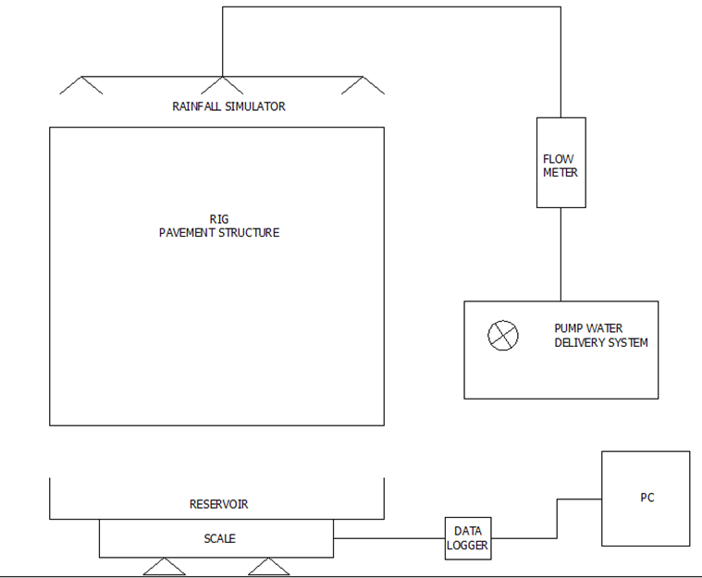
Figure 1: The entire experimental setup.
The rainfall simulator had a layout of 9 sprayers, arranged by 3x3 in space. A dense brass mesh was placed between the sprayers and the pavement surface in order to attain the necessary rain fall droplet intensity.
Experimental Materials
The experimental testing was carried out on a one-meter square of permeable pavement in the hydraulics lab, at Heriot-Watt University, UK. The permeable pavement was constructed in a box made of strong polypropylene and supported by a steel frame. The rig dimensions were 116 cm x 100 cm x 100 cm, with one side made of Perspex to allow visibility of the thickness of materials and the layout of the pavement structure, as shown in Figure 2. The construction complied with British Standards [11], [12] and with the standard specification used by Marshalls for their Priora Paving System. Artificial rainfall was delivered through spray nozzles (Delavan) and measured via a CR800 data logger (Campbell Scientific). The pavement rig was divided into four layers, as illustrated in Figure 2, comprising:
- Impermeable rectangular concrete modules (Priora), 80 mm thickness, and 200mm x 100mm dimensions
- Bedding course, 50 mm thickness
- Sub-base layer, 350 mm thickness
- Sub-grade layer, 300 mm thickness
- A Geotextile (1mm thickness) was placed between sub-base and sub-grade to prevent from migration of sand into course aggregate, and over the stainless-steel outflow tank.
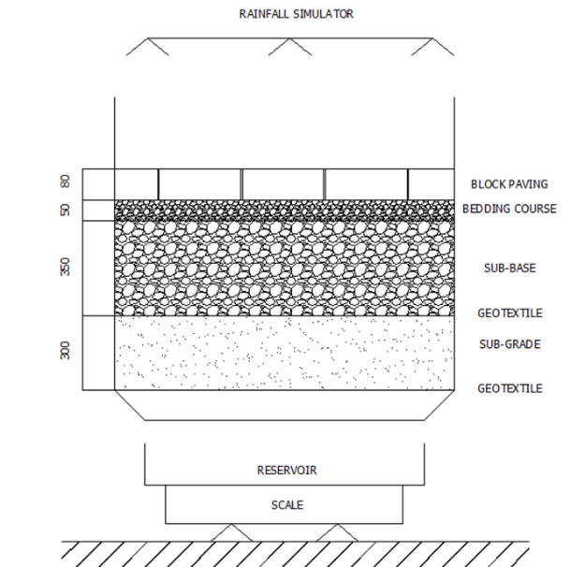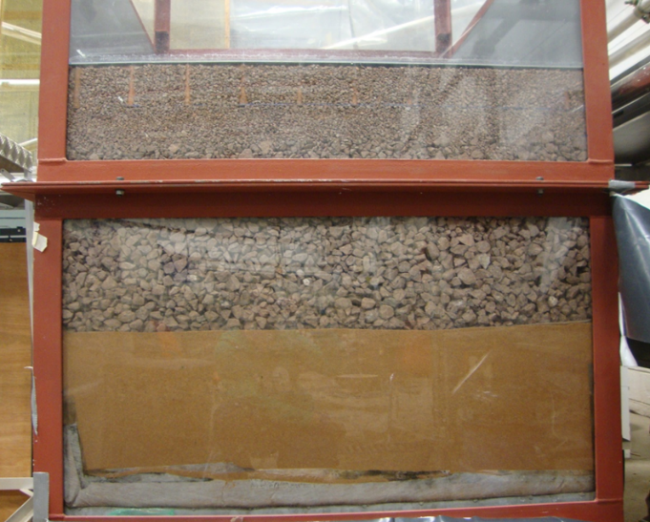
BRASS MESH
Figure 2: (Left) Schematic of the vertical cross-section of the rig pavement illustrating the total vertical installation. Dimensions on vertical axis are in mm; (Right) Picture of cross-section of the pavement structure [10].
The bedding course consisted of 2-6 mm fine aggregate, and the sub-base level of 10-20 mm coarse aggregate. The material was washed prior usage in order to remove potential fine particles. The sub-grade consisted of 0.064 mm to 2 mm clean sand and had uniform grading according to [13]. Beneath the sub-grade layer, a second permeable geotextile was installed to prevent sandy material from being taken with the outflow. The total depth of the rig was 780 mm. The saturated hydraulic conductivity was 218 mm/hr.
Experimental procedure
The experimental process involved repeatable rainfall simulation events, applied at a fixed rainfall intensity and duration. The rainfall simulation was repeated over four weeks, with a duration of 15 minutes. The simulated rainfall events were conducted over a seven-day cycle. The sequence of the rainfall simulations was once per day between Tuesday and Friday (days 2 to 5), with zero rainfall on days 1, 6 and 7 (namely Monday and weekend). The selected rainfall intensity was I = 25.56 l/h = 426 ml/min, which is representative for Edinburgh city, selected for the Heriot-Watt University site from the Flood Estimation Handbook (FEH). Sprayers were calibrated appropriately to ensure that the total rainfall rates matched the desired rainfall intensity. The experiments were carried out over four weeks successively and consisted of two phases including measurement of the outflow and testing the water quality of the SS.
In order to determine the amount of moisture that each layer of the rig is able to hold, laboratory investigation was undertaken. In particular, samples of one block, and samples of some amount of fine aggregate, coarse aggregate and sand were collected and tested in the Geotechnical Laboratory at Heriot-Watt University. The materials were baked in the oven for 24 hours, followed by weighing the mass of each specimen on a scale. Subsequently, the materials were submerged in water for 24 hours, so that they become sufficiently wet. Then, the wet materials were left for half an hour out of the water, so that the extra water was drained off, and each sample was weighed. The difference between the wet and dry mass of each material gave the estimated moisture content uphold of each material.
Sediment size selection and load
According to [14], the type of land usage affects the sediment accumulation procedure. From a field research conducted for different land uses in different cities, the sediment load displayed a range of 3 to 749 g/m², with site averages fluctuating between 26 and 220 g/m². The average diameter of surface sediments is between 150 and 4000 μm. Furthermore, it is stated that sediments in runoff consist of very fine particles; in particular, it was found that nearly 78% of the runoff sediments constitute of particles with diameters smaller than 50 μm. In addition, it is regarded that smaller particles result in higher concentrations of pollutants. In their research, [14] placed 100 g of very fine sediment on an area of 1 m². Therefore, 100 g of sediments were selected to be placed on the pavement surface, with sand size 75μm and below. This particle size is sufficiently small and is still found in runoff in high percentage [14]. A smaller size of 50 μm might not have noticeable effect on the SS tests, based on the literature findings.
Water quality tests for SS
Two filters were used for each water quality experiment for SS and the average of the two weights was used in the results of the relevant rainfall event. There was a standard procedure followed for the SS tests, where the filters to be used were washed with distilled water prior to the test, dried in the oven for 24 hours and weighed on the balance to get the clean filter mass. The complete process of the water quality tests for SS is described in the Appendix B.
The mass of the retained SS was calculated by Equation 2.1:
$ρ=\frac{1000×\left(b-a\right)}{V}$ (2.1)
Where,
ρ = content of SS (mg/l);
b = mass of the filter after the filtration (mg);
α = mass of the filter before the filtration (mg);
V = volume of the sample (ml). If the sample is weighed, consider 1g as equivalent to 1 ml.

RESULTS & DISCUSSION
In this study, a series of laboratory tests were carried out aiming to assess the hydrological performance, volume uptake and water quality in terms of suspended solids detainment of a permeable pavement structure made of interlocking concrete blocks. This section presents the results obtained from the relevant analyses involved, along with associated discussion of the results.
Soil moisture of the sub-grade
As described in the Methodology section, the moisture content (MC) was measured at two different levels within the sub-grade. The MC or Volumetric Water Content (VWC) in the sub-grade layer constitutes a representative index of the level of dryness of the materials. From the overall eight probes installed in the sub-grade, VWC results of the top (probe 1) and bottom level (probe 8) are presented in Figure 3. The results of the VWC (see Figure 3) show that VWC responded to a rainfall event at the start of week 3 (indicated in Figure 3 by the dashed vertical line). Until that time, VWC kept increasing gradually during each storm event. It is inferred that the sub-grade was very dry during the first two weeks of rainfall simulations, as demonstrated by the zero outflow discharge until the eighth successive rainfall event. This is explained by the fact that the pavement structure experienced a preceding dry period of six months. The results of this study indicate that rainfall response is linked to the sub-grade conditions and would encourage the implementation of such structure also in drier Mediterranean climate.

Figure 3: Levels of VMC for weeks 1 and 2 of the experimental periods.
From the data obtained during the zero outflow period (i.e. weeks 1 and 2), it is observed that the initial MC value was below 0.08, while the initial MC value before the start of the outflow production was 0.174. The low MC value, i.e. 0.08, may justify the delayed start for the outflow production, occurring during the ninth rain event. Due to the dryness of the materials of the rig the water applied through the simulations required a series of successive eight rainfall events to reach the bottom layer of the structure, as water was being absorbed by the unsaturated materials of the underlying layers.
From Figure 3 it is also observed that after the first storm event, the MC of the top layer of the sub-grade responded immediately, indicating a continuous, rapid increment of the moisture content after each succeeding rain event. The abrupt peaks of the VWC of probe 1 reflect each storm event, while the straight horizontal line, at value 0.11, corresponds to the three days that passed without any rainfall application, including weekends and Mondays. Furthermore, it is noted that the VWC measurements at the bottom layer display a higher and more stable tendency compared with the VWC of the top layer.
MC data analysis of the sub-grade during weeks 3 and 4 (i.e. outflow discharge from the pavement structure) indicates that the VWC increases gradually, receiving a stable value by the end of week 3 and onward. Probe 1 at the top layer displays greater variability compared to probe 8 located at the bottom layer, before and after each rain event, ultimately obtaining a value of approximately 0.174 at the start of the rain event. Overall, week 4 suggest a gradual increase of VWC both for the top and bottom levels, ultimately receiving a fixed value at each layer of the sub-grade.

Figure 4: Levels of VMC for weeks 3 and 4 of the experimental periods.
Correlation between the MC value at the beginning of each rainfall event and the discharged volume for the moisture probes 1 and 8 during the wet weeks is illustrated in Figure 5 and Figure 6. In both figures the coefficient of determination (R²) was used to understand how close the observed data is to the fitted regression line, which is the line that best fits the observed values, attempting to derive relationships between the MC at the start of each test and the obtained discharged volume.
As observed in Figure 5 and Figure 6, the observed values of both of the two MC probes examined present an appreciable variance compared to the regression line. During weeks 3 and 4, VWC for probe 1 with respect to the volume discharged, corresponded to R² = 0.3239, while the equivalent correlation for probe 8 received a value of R² = 0.1089. In general, the higher the coefficient of determination, R², the better the model fits the data. Therefore, it could be suggested that probe 1 (top level) exhibited a better relationship of the observed data than probe 8, as it had on average less points with significant deviations.
Overall, according to the obtained results, a relationship between the MC at the beginning of each rainfall event and the discharged volume exists, albeit not strong, as the points are spread out and there are significant deviations between some points and their equivalent point on the best fit line. This entails that implementation of more rainfall events is required to form a more comprehensive understanding of this relationship.

Figure 5: Correlation of discharged volume and MC at start for probe 1 during Weeks 3 & 4

Figure 6: Correlation of discharged volume and MC at start for probe 8 during Weeks 3 & 4
The dispersion of the obtained values in Figure 5and Figure 6, along with the results obtained could be justified by the fact that the materials of the rig responded to produce outflow on Day 2 of week 3, namely two weeks after the start of rainfall tests. Taking this into consideration, it could be argued that at the start of each rainfall event the MC would be different from the previous day, as the materials had experienced a dry period of six months and reaching week 4 of successive rainfall events they still appear to not have been totally saturated. Therefore, it would be expected that implementation of further rainfall tests would wet the materials more to ensure they have reached saturation level, whereas the sub-grade would have also become more saturated. Considering the above, results obtained would display a more robust relationship between the MC at start and the discharged volume of storm water.
Moisture content retention by the materials of the rig
Investigation was carried out to identify the moisture uptake by the materials of the rig before the first runoff generation, as detailed in Appendix A. The results obtained are presented in Table 1. It is concluded that sand displays high MC retention capacity compared with the block and the aggregate layers.
The rig produced no outflow during weeks 1 and 2 of the experiments, which implies that the total inflow until the end of week 2 was 51.12 l. This interesting result could be considered as the first response of the materials attributable to the prolonged dry period that the pavement structure experienced (i.e. 6 months), and could be considered as a recovery period for the MC levels. Consequently, MC levels have dropped significantly due to the preceded drought, and thus all the amount of water soaking into the pavement structure ended up being absorbed completely by the dry materials, until the time they started being saturated.
Table 1: Results of the experiment of the moisture content retention by the materials of the rig.
Material | Dry mass (g) | Wet mass (g) | Moisture content (g) | Moisture content (%)
Block | 3257.5 | 3386.5 | 129 | 3.8
Fine aggregate | 466.0 | 489.0 | 13 | 2.7
Aggregate | 427.4 | 435.3 | 7.9 | 1.8
Sand | 276.3 | 304.3 | 28 | 9.2
Overall, the total water uptake of the rig was estimated at 60.2 l. The total water inflow until the first outflow generation was 51.12 l (deriving from 6.39 (l) × 8 (rainfall events)), value which is close to the total water uptake estimate. The difference in the result is possibly attributed to the time required for the saturated samples of the materials to evaporate / drain some portion of the water that has remained on them. After their submersion into water for 24 h, the samples were let to drain off the water for 0.5 h. Therefore, it is inferred that this time duration was not sufficient for the water to evaporate or to drain adequately off their surface, thus diverging slightly from the final estimate value.
Hydrological performance
In total, sixteen rainfall event simulations were undertaken on the permeable pavement. The pavement required nine rainfall events to produce the first outflow. This resulted from the prolonged dry period during which the pavement materials remained dry. During the ninth event, in testing week 3, outflow was observed approximately ten minutes after the start of the rainfall.
Hydrograph
Figure 7 illustrates the lag time between the inflow and the peak of the outflow, as well as the runoff reduction and the attenuation capacity of the permeable pavement structure for the first outflow produced. Furthermore, Figure 7 shows the typical hydrograph produced for the tested rainfall intensity. The outflow lasted for approximately 7 h after the rainfall stopped, as seen in Figure 8. This result demonstrates the high attenuation attributes of the permeable pavement structure. The maximum outflow measured was 2.8 l/h (Figure 7).

Figure 7: Typical hydrograph for the tested rainfall intensity, also indicating the lag time between inflow and outflow, week 3, day 2.

Figure 8: Outflow rate (l/hr) for the first outflow event, week 3, day 2.
Total volume analysis
It was anticipated that results obtained during the weeks of outflow production (i.e. weeks 3 and 4) would show some difference compared to the results obtained during the zero outflow (i.e. weeks 1 and 2). The first eight storm events produced zero outflow, with storm water being absorbed by the pavement materials, and each storm event contributing to the gradual saturation of the pavement structure. Outflow volume analysis, described in this section, indicates gradual increase of the storm attenuation capacity between testing weeks 3 and 4. 7h after the start of the outflow, the discharged volume was 1.055 l, as observed in Figure 9, corresponding to 16.5%.

Figure 9: Discharged volume achieved 7 h after the start of outflow production in Week 3, day 2 test.
The average outflow for the tested rainfall intensity (i.e. 25.56 l/h) was analysed, as presented in Table 2. The last column in Table 2 indicates the average volume drained as a percentage of the total rainfall volume (i.e. 6.39 l). Results show that the amount of water discharged from the pavement between weeks 3 and 4 ranged from 16.52% to 77.30% of the total rainfall volume applied on the pavement. These results are in agreement with those stated by [15], who found an average value of 67% of rainfall to be drained. Results of Table 2 demonstrate the promising performance of the pavement rig to effectively abate storm water runoff resulting from successive rainfall events.
Table 2: Outflow characteristics, including outflow amount and duration, and start delay, associated to the pavement conditions for the tested rainfall intensity.
Testing week | Pavement condition | Average outflow (L) | Average outflow duration (h) | Average start delay (min) | Average outflow % rainfall volume
3 | Day 1 | 0 | 0 | 0 | 0.00
3 | Day 2 | 1.055 | 7 | 10.5 | 16.52
3 | Day 3 | 3.116 | 10 | 7.0 | 48.77
3 | Day 4 | 3.832 | 12 | 6.0 | 59.97
3 | Day 5 | 4.072 | 14 | 6.5 | 63.73
4 | Day 1 | 0 | 0 | 0 | 0.00
4 | Day 2 | 2.176 | 6 | 6.0 | 34.06
4 | Day 3 | 3.600 | 9 | 7.0 | 56.28
4 | Day 4 | 4.170 | 12 | 6.5 | 65.26
4 | Day 5 | 4.939 | 14 | 6.0 | 77.30
Note: day 1 (i.e. Monday) included no storm event; days 2-5 (i.e. Tuesday – Friday) included storm simulations.
During week 3, the outflow demonstrated an increasing trend successively after each rainfall event. At the end of week 3, the maximum outflow value corresponded to 9 l/h, as illustrated in Figure 10. In Figure 10, each spike corresponds to each storm event implemented every day for 15 min. The average peak outflow in week 3 was approximately 6.6 l/h with a mean duration of 11.25 h. Similarly, outflow in week 4 exhibited an increasing route, albeit smoother compared to week 3, as presented in Figure 11. The maximum generated outflow in week 4 was 12 l/h. The average peak outflow for week 4 was estimated at 10.1 l/h. During week 4, outflow required 6–7 min to be generated after the start of the rainfall simulation. The storm attenuation duration on Day 2 of week 4 lasted approximately 6 h, and gradually increased to 14 h until Day 5 of week 4.

Figure 10: Outflow pattern after each test during week 3.

Figure 11: Outflow pattern after each test during week 4.
Figure 10 and Figure 11 demonstrate that the outflow duration of all the storm events was considerably longer than the rainfall duration, which was 15 min, demonstrating the good storm attenuation capacity of the pavement.
Volume data analysis of week 3 suggested that the discharged volume from the permeable pavement during week 3 ranged from 16.5% (in Day 2) to 63.7% (in Day 5). The mean attenuation duration during week 3 was approximately 13 hours, which demonstrates the advantageous capability of the permeable pavement to reduce the peak concentration time and mitigate stormwater runoff. The maximum total volume that was discharged at the end of week 3 was approximately 12 l, as seen in Figure 12.

Figure 12: Cumulative volume of water discharged from the pavement structure during week 3.
Figure 13 shows the total volume discharged from the pavement during week 4, which was 14.9 l. From the volume data analysis, it was found that on Day 2 the discharged volume of the permeable pavement was 34%, while on Day 5 the equivalent percentage reached 77.3%.

Figure 13: Cumulative volume of water discharged from the pavement structure during week 4.
Summarising, the average attenuation duration during weeks 3 and 4 was approximately 10.5 h, demonstrating the potential of the interlocking concrete blocks permeable pavement to reduce the peak concentration time and to mitigate storm water runoff. The delay to the start of the outflow for the least wet event (week 3, day 2) was approximately 10 min, whilst it decreased to 6 min for the following the successive rainfall simulations during the same week. This result indicates the capacity of the pavement structure to still perform well even when conditions are wetter.
Suspended solids
The lack of outflow during weeks 1 and 2 of the rainfall testing scheme had affected the start date of the water quality for SS testing. During Week 3 of the testing period, when the first outflow occurred, two water quality for SS tests were carried out. Those tests allowed a preliminary understanding of how the SS retention differs with regards to the plain freshwater application on the pavement. Water quality for SS tests were carried out during Week 4 of the testing scheme, and aimed to assess how effective the retention of the sediment load placed on the paving surface is. The results of the water quality for SS testing are outlined as follows based on the week they were undertaken.

Solids retention of the plain freshwater application in Week 3
The SS results obtained in Week 3 are presented in Table 3 and Table 4, following the process described in Appendix B. Calculating ρ, in equation 2.1, the volume of the sample was 100 ml. Results of the two water quality for SS testing carried out in Week 3 indicate that SS concentration was 130 and 105 mg/l respectively.
Table 3: Results of SS of Day 4, Week 3 (only clear water application)
Week 3, Day 4 | Filter 1 | Filter 2 | Average
M₁ (g) | 61.203 | 62.421
M₂ (g) | 61.109 | 62.329
M₃ (g) | 61.204 | 62.423
M_{clean filter} (g) | 0.094 | 0.092
M_{filter+SS} (g) | 0.095 | 0.094
ρ (mass of SS retained) (g) | 0.012 | 0.014 | 0.013
SS Concentration (mg/l) | 120 | 140 | 130

Table 4: Results of SS of Day 5, Week 3 (only clear water application)
Week 3, Day 5 | Filter 1 | Filter 2 | Average
M₁ (g) | 61.195 | 62.415
M₂ (g) | 61.108 | 62.368
M₃ (g) | 61.196 | 62.416
M_{clean filter} (g) | 0.087 | 0.047
M_{filter+SS} (g) | 0.088 | 0.048
ρ (mass of SS retained) (g) | 0.011 | 0.010 | 0.011
SS Concentration (mg/l) | 110 | 100 | 105

Solids retention after sediment load application on pavement surface in Week 4
Results of the water quality for SS testing retention during Week 4 are presented on a day to day basis in Table 5, Table 6, Table 7 and Table 8.
Table 5: Results of SS of Week 4, Day 2, after sediment application
Week 4, Day 2 | Filter 1 | Filter 2 | Average
M₁ (g) | 61.180 | 62.405
M₂ (g) | 61.108 | 62.329
M₃ (g) | 61.181 | 62.406
M_{clean filter} (g) | 0.072 | 0.076
M_{filter+SS} (g) | 0.073 | 0.077
ρ (mass of SS retained) (g) | 0.016 | 0.012 | 0.014
SS Concentration (mg/l) | 160 | 120 | 140

Table 6: Results of SS of Week 4, Day 3, after sediment application
Week 4, Day 3 | Filter 1 | Filter 2 | Average
M₁ (g) | 61.188 | 62.404
M₂ (g) | 61.115 | 62.332
M₃ (g) | 61.191 | 62.405
M_{clean filter} (g) | 0.074 | 0.071
M_{filter+SS} (g) | 0.076 | 0.073
ρ (mass of SS retained) (g) | 0.023 | 0.013 | 0.018
SS Concentration (mg/l) | 230 | 130 | 180

Table 7: Results of SS of Week 4, Day 4, after sediment application
Week 4, Day 4 | Filter 1 | Filter 2 | Average
M₁ (g) | 61.189 | 62.419
M₂ (g) | 61.115 | 62.349
M₃ (g) | 61.192 | 62.420
M_{clean filter} (g) | 0.074 | 0.070
M_{filter+SS} (g) | 0.077 | 0.071
ρ (mass of SS retained) (g) | 0.026 | 0.010 | 0.018
SS Concentration (mg/l) | 260 | 100 | 180

Table 8: Results of SS of Week 4, Day 5, after sediment application
Week 4, Day 5 | Filter 1 | Filter 2 | Average
M₁ (g) | 61.198 | 62.419
M₂ (g) | 61.120 | 62.333
M₃ (g) | 61.202 | 62.422
M_{clean filter} (g) | 0.078 | 0.086
M_{filter+SS} (g) | 0.082 | 0.089
ρ (mass of SS retained) (g) | 0.04 | 0.036 | 0.038
SS Concentration (mg/l) | 400 | 360 | 380

On Day 2 of Week 4, 100 g of fine sand (diameter 75μm and below) was applied on the paving surface. The results obtained after each rain simulation showed that the pavement structure had a good sediment retention capacity at the end of the fourth rainfall event. The SS mass detected in the outflow indicated slight variation from Day 2 to Day 4, while on Day 5 the test showed a small increase in the sediment mass retention, as observed in Tables 5-8. Due to the lack of outflow production over the first two weeks of rainfall testing period, SS tests were not carried out, therefore this positive tendency of the suspended matter retention observed may not be conclusive, since the initially scheduled SS testing period of four weeks would have provided a larger dataset of results with potentially a more comprehensive picture of the SS retention capacity of the pavement structure. From the results obtained, however, it is estimated that the suspended matter needs time to move within the structure, and thus more rainfall applications would be required to let it pass completely through the pavement layers, as suggested by Figure 14 and Figure 15.
The results of the clear water SS tests are reasonable when compared to those after the sediment application. Some slight difference between the clear water and the water including sediments is observed, indicating increase of retention capacity during the sixth application in row, which is explained by the fact that some sediment portion seems to have reached the bottom layer of the pavement structure after the sixth successive rainfall event.
Summarising, albeit there is a positive increasing tendency observed in the retention of SS mass through the pavement structure, the SS results obtained do not permit to draw a firm conclusion yet. A series of further tests would be required to approve or ratify this hypothesis. In addition to this, the applied sediment load at the start of Week 4 did not pass completely through the joints of the pavement top layer at the end of that week, which was also a parameter that contributed to the low final SS concentrations obtained, as observed in Figure 14 and Figure 15. It is therefore possible that a little portion of the applied sediment load might have reached the bottom of the structure after the fourth rainfall event in Week 4. Therefore, more water quality tests in terms of suspended solids would be required to firmly assess the performance of the pavement and its clogging capacity.
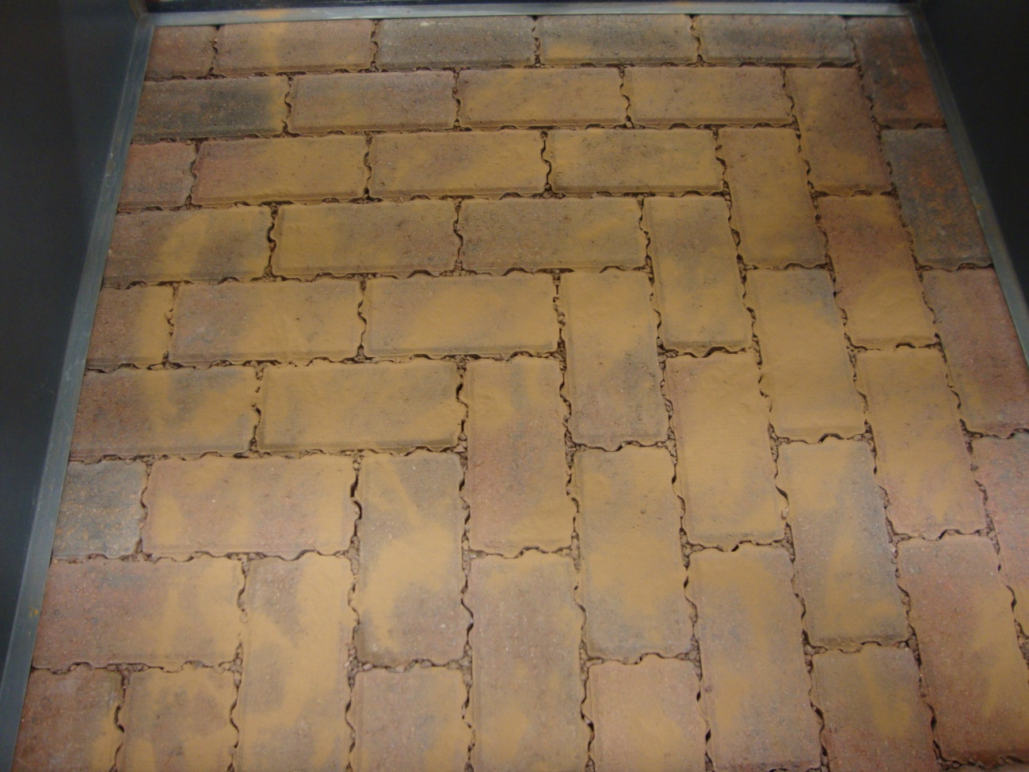
Figure 14: Sediment load application at the beginning of Week 4 (Day 2)

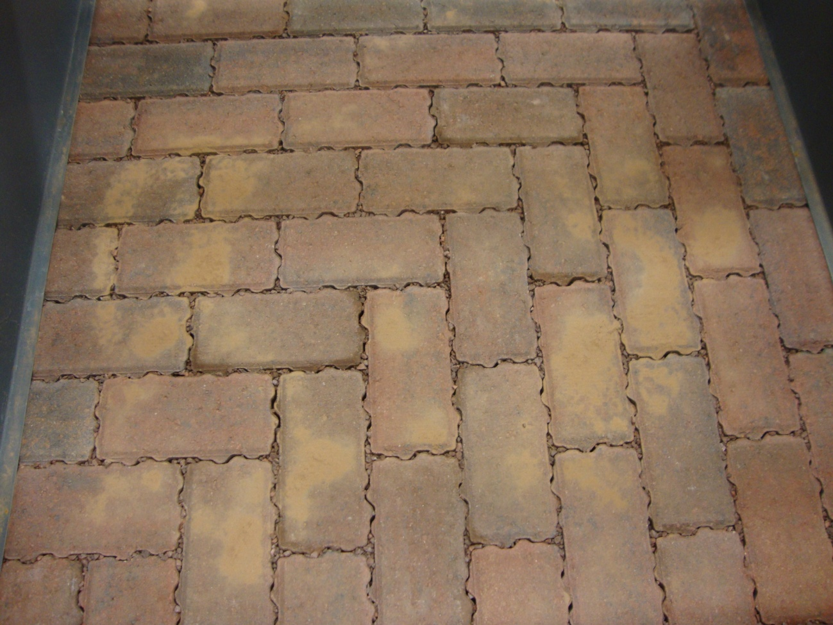
Figure 15: Remaining sediment load at the end of Week 4 (Day 5)

CONCLUSIONS
Storm water storage capacity and long attenuation period following a storm are important parameters for SuDS design and operation. Given the limited published experimental information on permeable interlocking concrete block pavements, this paper presents novel results from an experimental laboratory study on a permeable interlocking concrete block pavement rig, investigating the short-term hydrology of the pavement, and water quality aspects related to the retention capacity of suspended solids (SS) through the pavement structure. Empirical data and research findings from a permeable pavement rig and rainfall simulations were carried out to quantify and assess the hydrological performance of the permeable pavement, for a certain rainfall intensity and duration. In addition to this, water quality testing in terms of suspended solids (SS) mass retention capacity through the pavement was attempted. The conclusions drawn from this study were:
- High storm water attenuation ability of the pavement was demonstrated by the mean outflow duration of 10.5 h after the rainfall event.
- More than 50% of the total rainfall volume was retained within the permeable pavement structure, suggesting significant storm water storage capacity.
- The response of the outflow varied with pavement condition. Prolonged dry periods (in this case of six months) result in decreasing the moisture content of the pavement materials, resulting in no outflow production for several rainfall events during the start of the wet season. This finding also encourages application of permeable pavements into drier Mediterranean climates. More outflow was produced gradually from the pavement structure once the pavement wetness increased.
- The pavement structure responded positively to the sediment retention capacity following the successive rainfall simulations applied. The SS mass detected in the outflow indicated slight variation during the first tests, whilst indicated a gradual, albeit small increase in the sediment mass retention during the last test. The lack of outflow generation during the first weeks of the experimental period, due to the dryness of the materials of the structure, affected accordingly the number of the water quality for SS testing applied.

REFERENCES
- Sansalone, J.; Kuang, X.; Ranieri, V. Permeable Pavement as a Hydraulic and Filtration Interface for Urban Drainage. Journal of Irrigation and Drainage Engineering, 2008, 134 (5), 666-674. (Accessed on: 28/5/2013).
- European Commission. Towards better environmental options in flood risk management. 2018. Available online: http://ec.europa.eu/environment/water/flood_risk/better_options.htm (Accessed on: 21/01/2018).
- Pratt, C; Wilson, S; Cooper, P. CIRIA C582. Source control using constructed pervious surfaces – Hydraulic, structural and water quality performance issues. Construction Industry Research and Information Association (CIRIA), London, 2002.
- Woods-Ballard, B.; Kellagher, R.; Martin, P.; Jeffries, C. Bray; R. & Shaffer, P. CIRIA C697. The SUDS manual. CIRIA, London, 2007.
- Blanc, J.; Scott, A.; Wright, G.; Beevers, L. Sustainable urban drainage systems (SUDS) and flood management in urban areas. CREW Report, 2012.
- Lucke, T; Beecham, S. Field investigation of clogging in a permeable pavement system. Building Research & Information, 2011, 39 (6), 603-615. (Accessed on: 20/05/2013).
- Pagotto, C.; Legret, M; Le Cloirec, P. Comparison of the hydraulic behaviour and the quality of highway runoff water according to the type of pavement. Water Research, 2000, 34 (18), 4446-4454. (Accessed on: 13/5/2013).
- Brown, C.; Chu, A.; Bert van Duin; Valeo, C. Characteristics of Sediment Removal in Two Types of Permeable Pavement. Water Quality Resources Journal, 2009, 44 (1), 59-70. (Accessed on: 13/5/2013).
- Beecham, S.; Pezzaniti, D.; Kandasamy, J. Stormwater treatment using permeable pavements. Water Management, 2012, 165 (WM3), 161-170. Institution of Civil Engineers (ICE) Proceedings. (Accessed on: 20/5/2013).
- Ioannidou, V.G. & Arthur, S. (2018). Hydrological Response of a Permeable Pavement Laboratory Rig for Stormwater Management. Efficient Water Systems (EWaS) 3rd Conference, Lefkada Island, Greece, 27-30 June. https://doi.org/10.3390/proceedings2110607
- British Standards Institution. BS EN 13242:2003, Aggregates for unbound and hydraulically bound materials for use in civil engineering work and road construction. BS EN 13242:2003, BSI.
- British Standards Institution. Pavements constructed with clay, natural stone or concrete pavers Part 13: Guide for the design of permeable pavements constructed with concrete paving blocks and flags, natural stone slabs and setts and clay pavers. BS 7533-13:2009, BSI.
- British Standards Institution (1981). Code of practice for site investigations. BS 5930:1981, BSI.
- Deletic, A., & Orr, D. W. (2005). Pollution buildup on road surfaces. Journal of Environmental Engineering, ASCE, 131(1), 49 - 59. https://doi.org/10.1061/(ASCE)0733-9372(2005)131:1(49).
- Abbott, C.; Comino-Mateos, L. In-situ hydraulic performance of a permeable pavement sustainable urban drainage system. Water and Environment Journal, 2003, 17, 187–190.

Appendix A
The analytical steps followed for the estimation of the water uptake by each layer of the rig is described as follows:
- Step 1: Estimation of the water uptake of the block layer. The experimental rig consisted of 50 blocks. According to the results of Table 1, each block can retain 129 g of water. Consequently, the blocks’ layer can hold overall: 129 (g) × 50 = 6450 g = 6.45 kg.
- Step 2: Estimation of a known volume of a container which will assist to measure the weight and volume of the remaining layers. The volume of the container used for this purpose was: V_{c} = 27 × 14 × 8 = 3,024 cm³.
- Step 3: Estimation of the volume and weight of the fine aggregate layer. The volume of the fine aggregate layer was: 5 × 100 × 100 cm³ = 50,000 cm³. The volume of the fine aggregate layer accommodates the volume of the container 16.5 times. The weight of the container filled up with fine aggregate was: W₁ = 3.435 kg. As a result, the total weight of the fine aggregate of the rig was: W_{fine_aggr_total} = 3.435 × 16.5 = 56.7 kg. According to the results of Table 1, 466 g of the dry fine aggregate can hold 13 g of water; consequently, the total mass of the dry aggregate in the rig can retain 8064.6 g = 1.58 kg of water.
- Step 4: Estimation of the volume and weight of the aggregate layer. The volume of the aggregate layer was: V_{aggr} = 35 × 100 × 100 cm³ = 350,000 cm³. The volume of the aggregate layer accommodates the volume of the container 115.7 times. The weight of the container filled up with aggregate was: W₂ = 3.771 kg. As a result, the total weight of the aggregate of the rig was: W_{aggr_total} = 3.771 × 115.7 = 436.3 kg. Based on Table 1, 427.4 g of the dry aggregate can hold 7.9 g of water; therefore, the total mass of the dry aggregate in the rig can retain 8064.6 g = 8.07 kg of water.
- Step 5: Estimation of the volume and weight of the sand layer. The volume of the sand layer was: V_{sand} = 30 × 100 × 100 cm³ = 300,000 cm³. The volume of the sand layer accommodates the volume of the container 99.2 times. The weight of the container filled up with aggregate was: W₃ = 4.387 kg. Therefore, the total weight of the aggregate of the rig was: W_{sand_total} = 4.387 × 99.2 = 435.19 kg. According to Table 1, 276.3 g of the dry sand can hold 28 g of water; hence, the total mass of the dry sand in the rig can retain 44101.77 g = 44.10 kg of water.

Appendix B
The water quality tests on SS were carried out according to the following process:
- 250 ml of sample were collected from the outflow tank, approximately three hours after the experiment's end.
- All the equipment (cylinders, plates, funnel, etc.) was rinsed well with distilled water before the filtering process.
- The mass of the clean glass plate was weighed on the balance.
- The mass of the clean filter within the glass plate was weighed on the balance. This filter was already filtered with distilled water and dried in the oven for 24 hours.
- The outflow sample was filtered in the filtering device which was connected to a pressure line (the tap).
- The wet filter was placed back to the glass plate and the same process was done for the second filter.
- Both of the wet filters were placed in the oven for approximately two hours.
- The dried filters were lead for desiccation for one hour.
- The mass of each dried filter was weighed on the balance.

