Developing a football-specific talent identification and development profiling concept – The Locking Wheel Nut Model
Adam L. Kelly^{1,2}*, Craig A. Williams², and Mark R. Wilson²
¹Faculty of Health, Education, and Life Sciences, Birmingham City University, Birmingham, West Midlands, United Kingdom and ²College of Life and Environmental Sciences, University of Exeter, Exeter, Devon, United Kingdom
*Corresponding author: Adam.Kelly@BCU.ac.uk; +44 (0)1213 316145; @AdamKelly07
Abstract
Whilst talent identification and development are often used interchangeably, they are different constructs; talent identification can be described as the process of recognising current participants with the potential to achieve expertise in a particular sport, whilst talent development can be considered as providing the most appropriate learning environment to realise potential (Vaeyens et al., 2008; Williams & Reilly, 2000; Russell, 1989). Meylan et al. (2010) state how a one-dimensional approach whilst identifying and developing talented players within a youth football setting can produce inaccurate decisions and inadequate support, through eventual expertise in football not solely dependent on one standard skill-set. Therefore, an interdisciplinary approach addressing the environmental, psychological, sociological, physiological, technical, and tactical predictors should be applied (Sarmento et al., 2018). Performance profiling has been identified as an effective method to support player development (Butler & Hardy, 1992), and is widely applied within professional football academies in England since the implementation of the Elite Player Performance Plan (EPPP) in 2012 (Premier League, 2013; Williams & Drust, 2012). Working on a simple analogy, a locking wheel nut has a patterned indent alongside a key, which matches this unique outline, thus only when the correct key is inserted will the nut be able to be wholly efficient. Subsequently, this notion is applied to the proposed profiling concept of the ‘Locking Wheel Nut Model’ (LWNM). This is supported by empirical research outcomes (Kelly, 2018), that present what characteristics support both the talent identification and development processes in elite youth football from a fully-integrated interdisciplinary perspective.
Keywords: Talent; Identification; Development; Academy; Youth; Football
Introduction
According to Williams & Franks (1998), key stages in the talent development process begins with detection. This identification of talented youth football players often initiates a pathway into a professional football academy, where they are signed and become part of a singular club’s programme and philosophy. Football academies in England provide specialist training programmes established and funded by professional football clubs, with the primary objective of developing players towards the professional level (Elferink-Gemser et al., 2012). Between the ages of 8 and 16 years, young players join an academy on schoolboy terms (i.e., part-time attendance). Then at aged 16 years, those players who show continued progress are selected to undertake a two year full-time youth training scheme known as an academy scholarship. In the elite youth football development pathway, upon completion of the scholarship, players either sign a professional contract or are released. As a result of the difficulties in achieving a professional contract, over 90% of players who join an academy fail to make it as a professional (Mills et al., 2012). Therefore, it is in each individual academy’s interests and responsibility to provide their elite youth football players the maximum opportunity to develop and reach their potential.
Traditionally, talent identification environments within academies would perform player selection and progression verdicts based on subjective analysis (Reilly et al., 2000a; Williams & Reilly, 2000; Williams et al., 1999). However, it is now widely accepted that the use of opinions alone can result in misjudgements and inaccurate decisions (Zuber et al., 2016; Meylan et al., 2010). Thus, over the recent years, the use of science-based support systems offering a greater multi-dimensional approach to talent identification have been implemented within elite youth football (Forsman, 2016; Unnithan et al., 2012). For example, tools and specialist practitioners, such as sport scientists, strength and conditioning coaches, performance analysts, sports psychologists, and nutritionists, have been developed and employed to support technical coaching staff to identify and develop talented individuals that have potential to progress into professional football players (Williams & Drust, 2012).
Early research surrounding talent identification in youth football involved a multidisciplinary methodology to assess what distinguished elite and sub-elite youth football players. For instance, Williams & Franks (1998) revealed potential predictors of talent in youth football by breaking down sport science strands including physical, physiological, psychological, and sociological characteristics. During further investigation, Reilly et al. (2000b) used 31 (16 elite and 15 sub-elite) young players matched for chronological age (aged 15 to 16 years) where physiological, psychological, and technical variables were assessed. These tests included anthropometric and physical fitness, psychology questionnaires, and anticipation and football-specific skill tests. They revealed the most influential discriminating factors in favour of elite players included agility, sprint time, ego orientation, anticipation skill, leaner, possessed greater power, and were more tolerant to fatigue (Reilly et al., 2000b).
Holt & Dunn (2004) advanced knowledge regarding player development following an initial investigation with English and Canadian youth players. They produced a qualitatively-derived theoretical model that indicates characteristics including discipline, commitment, and resilience, together with positive social support, facilitates the successful transition from youth to professional level. In a supplemental investigation, Holt & Mitchell (2006) enhanced the model through integrating hope theory, which revealed players with high hope had a greater chance of achieving professional status. Toering et al. (2009) support the role of self-efficacy when discriminating elite and non-elite players when investigating elite youth Dutch players. Van Yperen (2009) also attempted to distinguish elite and non-elite players, revealing goal commitment, engagement in problem-focussed coping behaviours, and social support seeking successfully differentiated players who reached professional level and those who did not. Similarly, presented through Gagne’s (2009) Differentiating Model of Giftedness and Talent, Mills et al. (2012) transcribed interviews with ten expert development coaches, who were qualified at UEFA ‘A’ or UEFA ‘Pro’ Licence level, to attempt to identify factors perceived to influence the development of elite youth football academy players. Interestingly, drawing from the six interrelated higher-order categories that represented the characteristics perceived to manipulate player development, Mills et al. (2012) revealed psychological characteristics have a significant influence. For instance, four of the six categories were psychological qualities including resilience, goal-directed attributes, intelligence, and awareness, together with sport-specific attributes and environmental factors.
As the governing body for football in England, the FA is responsible for formulating and implementing current developmental strategies for coach education and the national training programme (The FA, 2013). Using a multidisciplinary approach, the FA has adopted the ‘Four Corner Model’ (FCM) into their syllabus, which considers technical/tactical, physical, psychological, and social factors by dividing them into the four corners. This method of talent development facilitates a ‘player centred’ approach which identifies specific characteristics that relate to each of the four factors, allowing the coach or practitioner to identify certain weaknesses which creates individual learning objectives to assist player development (The FA, 2013). Thus, outlining a range of factors that may need to be addressed if a young player is to reach their potential. This simplistic framework has the appropriate theoretical context and simplicity for both clubs and coaches to apply to their practical environments. Although isolated age-specific investigation is not uncommon, combined research considering the whole development pathway within each of the four corners is limited.
The Premier League’s EPPP has had an influential role of the application, investment, construction, and assessment of the academy structure in England. The EPPP aim to improve youth football development in England by proposing to modernise talent identification and recruitment including research in such areas as physiological parameters, relative age effects, psychological profiling, motivation, decision making, technical ability, and attainment rates (Premier League, 2013). The six initial fundamental principles of the EPPP include; 1) increasing the number and quality of home-grown players, 2) create more time for players to be coached, 3) improve coaching provision, 4) implement a system of effective measurement and quality assurance, 5) positively influence strategic investment, and 6) seek significant gains in every aspect of player development (Premier League, 2013). They aim to do this through four main capacities; coaching, classification, compensation, and education (Premier League, 2013). The academy category system is part of the EPPP, where academies are reviewed every three years and categorised between 1 and 4, with categorisation the result of an independent audit. The implementation of the EPPP has reformed academies multidisciplinary approach through the development of their training programme and contact hours, with a holistic a coaching approach alongside a hybrid programme with a local school common themes.
The most notable rule changes from the previous system is the abolition of the 90-minute rule, where clubs could only sign players aged under-18 if they live within 90 minutes travel of the training facility, and the fixed tariff for transfers of players under-18, which replaces the independent tribunal compensation system (Premier League, 2013). For example, players aged 9 to 11 years have a fixed fee of £3,000 per year spent at an academy, and £12,500 to £40,000 per year spent at an academy (depending on category) for players aged 12 to 16, with further fees available on appearances in the clubs first team (Premier League, 2013). As a result of increased revenue for the Premier League clubs, there is a rise in the transfer fees paid for players. Due to the increasing expenditure on players, larger clubs have begun sourcing talented players at a young age by buying them from fellow academies. By doing so, it may be suggested the top clubs will eventually have the best youth player’s, with future hope of them becoming skilled enough to help their team reach their optimal goals of trophies, European qualification, or sustaining higher league status (Grossmann et al., 2015; Elliott & Weedon, 2011; Darby, 2007). Therefore, professional youth development systems spend years and large sums of money attempting to develop players that are talented enough to help their team achieve these goals, or in many cases, to gain financial profit from future transfer fees (Mann et al., 2017; Morris et al., 2016).
Thus, developing a player capable of playing in the Premier League can be profitable for Category 3 academies or lower league football clubs, by selling them to Category 1 and 2 academies or Premier League and Championship clubs respectively. Consequently, this not only sustains the smaller clubs youth academy, but in many cases the entire football club (Relvas et al., 2010). Furthermore, the larger clubs benefit from having the best youth players in the country which, if they become top professionals, have been bought at a cut down price. Additionally, producing young players that eventually make a professional clubs first team can escalate the price, particularly due to the Bosman Ruling. As a result, the rationale of the proposed LWNM is to illustrate the current environmental, psychological, sociological, physiological, technical, and tactical youth football development techniques applied in English academies to support a greater holistic approach to talent identification and development (Sarmento et al., 2018; Forsman, 2016).
Methods
Data was collected across one football season within a male professional football academy (n=98; aged 8 to 16 years). Data collection methods included the participation history questionnaire, psychological characteristics for developing excellence questionnaire (PCDEQ), socioeconomic postcode data, physical performance, anthropometric measures, relative age, technical tests, match analysis statistics, perceptual-cognitive expertise (PCE), and match simulations. Two coaches, as trained assessors (UEFA Pro, ‘A’, or ‘B’ Licenced alongside either the FA Advanced Youth Award or the FA Youth Award) from each age group (under-9 to under-16), were asked to rank their players from top to bottom in relation to current ability from a holistic perspective. This produced a linear classification of high-performing players down to their low-performing counterparts, with each age group then split into thirds using tertiles. This created a group of ‘high-performers’ who represent the top third, and a group of ‘low-performers’ who represent the bottom third. This enabled a distinct comparison between the high-performers and low-performers within each age group, with the middle third discarded from the study (n=34).
Due to the differing results between age groups as a result of their chronological age, such as older players generally having had more time playing, and subsequently have higher hours of engagement, data was standardised using Z-scores within their respective age group, to allow an unbiased grouping of players. The assumptions were tested by examining high- and low-performers using a two-tailed independent sample t-test. The t-test is used to compare the values of the means from the high- and low-performers, to test whether it is likely that the samples from the populations are different. Results found that 24 significant factors that differentiated high- and low-performers (Figure 1) from 54 collective measures (Kelly, 2018). Subsequently, an interdisciplinary talent identification concept is presented through the LWNM.
The Locking Wheel Nut Model
Locking wheel nuts were originally invented to prevent alloy wheel theft as a result of an individualised key required to manipulate its release. These were created to replace a generic lug nut, which is easily deployed through their specific design. Working on a very simple principle, each locking wheel nut has a patterned indent alongside a key which matches this unique outline, thus only when the correct key is inserted will the nut be able to be wholly efficient. This locking wheel nut concept is applied to illustrate the talent identification process in elite youth football through the proposed LWNM. This is a result of applying the methodology and visual design of the locking wheel nut, through recognising the concept of an individualised approach while observing critical requirements to achieve expertise within a specific process. Similarly to the locking wheel nut, it is important to understand where the player fits within the LWNM, through identifying and categorising individual strengths and weaknesses through player profiling. Conversely, without all the relevant information, the coach may not have the precise ‘key’ to support optimum talent identification and subsequent development. Following successful recruitment within an academy setting, a coach acts as a key to support each player’s holistic development through targeting individual strengths and weaknesses that are illustrated from a fully-integrated multidisciplinary perspective. Whilst observing the LWNM, the environmental factors surround the psychological, sociological, physiological, technical, and tactical disciplines, as a result of the interchangeable outcomes that are created from particular activities.
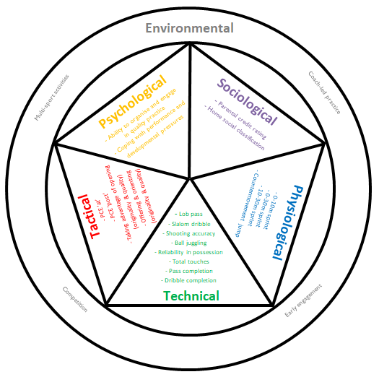
Figure 1. The Locking Wheel Nut Model – significant influencing characteristics for high-performance that were illustrated in Kelly’s (2018) research
The LWNM has been developed through identifying the discipline-specific characteristics, which have been identified as influential factors in the talent identification process in an English football academy. Subsequently, within each of these disciplines, there are characteristics for coaches and practitioners to consider when identifying potential elite youth football players. The environmental factors, that create the foundation to the opportunity for engagement, surround the other five significant disciplines; psychological, sociological, physiological, technical, and tactical.
A ‘user friendly’ concept
There have been a number of attempts to distinguish the talent identification and development processes. The LWNM supports MacNamara & Collins’ (2014) proposal of moving beyond prescriptive models, through providing a user-friendly framework relevant to the applied environment. Additionally, the LWNM also maintains Butler & Hardy’s (1992) early theory and application of performance profilling in sport, through its flexible approach together with the support for coaches and practitioners to understand their footballers within several aspects. Gulbin & Weissensteiner (2013) state that there is a gap that is constantly growing between theory and practice in talent identification and development. They argue this is due to limitations, inconsistencies, and contradictory contentions from literature, which result in stakeholder’s scepticism regarding the usefulness of current research. Additionally, Cushion et al. (2012) suggest that it can take at least 10 years before research is applied to coaching practice. They argue coach education remains ‘fixed’ while research continues to evolve. Similarly, researchers often fail to generate clear guidelines for practitioners to simplify the practical enactment. Pankhurst & Collins (2013) also believe there is lack of coherence in the understanding of talent development systems and processes between key stakeholders and researchers, and a deficiency of research into the importance of this relationship.
Therefore, the aim of the LWNM is to adopt a ‘user friendly’ approach while implementing contemporary data from reliable and valid methodologies. Moreover, from a football viewpoint, the LWNM further develops the current ‘four corner model’ that is commonly applied within football organisations and academies in England (Unnithan et al., 2012), which was initially created by Williams & Reilly (2000) almost two decades ago. Additionally, this model also has the advantage of incorporating influential talent identification characteristics within each discipline. Consequently, the LWNM assists coaches and practitioners alike regarding the significant factors that support superior overall performance within each discipline, therefore creating a greater understanding of the talent identification process within an academy environment.
From a talent development perspective, this model can also support a coach or practitioner, and subsequently their players, through gauging current performance from an interdisciplinary viewpoint to facilitate the opportunity to develop individual strengths and weaknesses. Therefore, this model applies an individualised approach, similar to Gulbin & Weissensteiner’s (2013) 3D-AD ‘beehive’ conceptual model of expertise. Furthermore, it may be considered each player’s patterned indent on the LWNM regarding each of these factors may differ depending of what activity the player is engaging in, whilst also highlighting how one player can look very different from another within the same age group (Figure 2). Consequently, the LWNM provides a flexible user-friendly concept for an applied talent identification and development process in elite youth football.
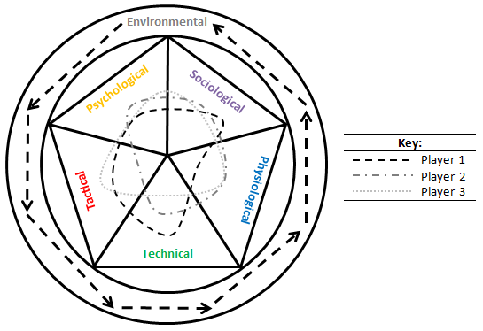
Figure 2. The Locking Wheel Nut Model – three player example
An ‘interdisciplinary’ approach
By identifying an individual players locking wheel nut, a coach or practitioner is firstly able to identify whether the potential athlete possesses the relevant characteristics required to engage in an elite youth football setting. Secondly, professional staff within an academy environment are able to illustrate strengths and weaknesses within each discipline, thus facilitating the ability to create an individualised support programme, such as incorporating football-specific technical and tactical strategies, alongside performance analysis, physiotherapy/sports therapy, sport science, strength and conditioning, psychology, and education and welfare support, where required.
As a result, not only does the LWNM offer a fully-integrated multidisciplinary approach to talent identification, it also highlights the interdisciplinary nature of the talent development process (Figure 3). The term ‘interdisciplinary approach’ has been applied to this model, as a consequence of the research from each discipline combining and working in conjunction to develop and apply a shared conceptual framework, that integrates discipline-specific concepts and methodologies to address a common research focus (Buekers et al., 2017; Szostak, 2007; Youngblood, 2007).
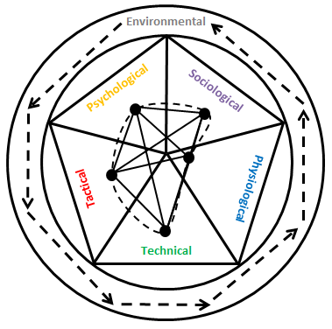
Figure 3. The Locking Wheel Nut Model – an example of the application of an interdisciplinary concept
Locking Wheel Nut Model Template
Following the illustration of specific developmental activities within the environmental section that surround the LWNM, coaches and support staff are encouraged to identify a player’s potential developmental strengths and weaknesses inside the LWNM. This is completed through marking an individual’s potential within each discipline on a Likert scale (1 = poor to 10 = excellent), that can be supported using both subjective and objective measures (Figure 4). Once these characteristics have been identified, through applying supporting research driven factors (Figure 1), they can get drawn together to identify the player’s ‘locking wheel nut’ to illustrate their profile (Figure 2) to support an interdisciplinary approach to talent identification (Figure 3). Space for notational comments are also available within the model to provide relevant feedback (Figure 4).
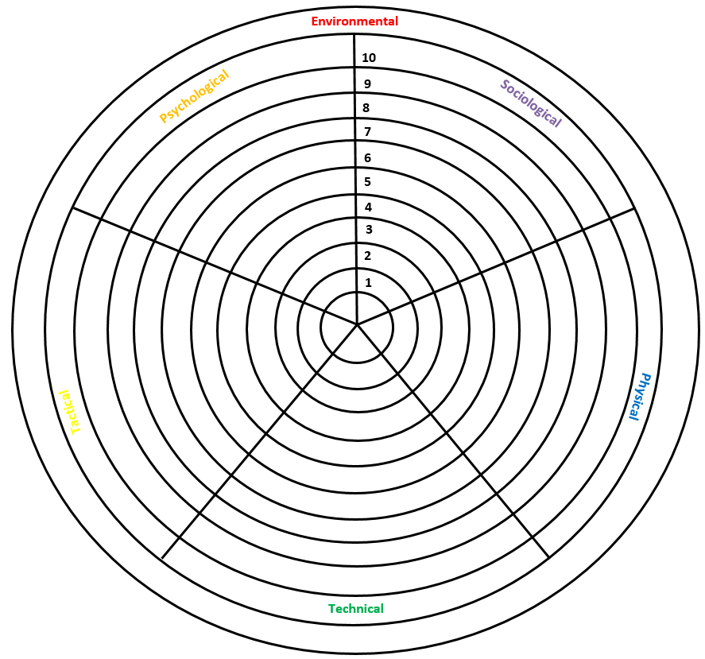
Figure 4. The Locking Wheel Nut Model – a player profile template
Conclusion
The purpose of a player development pathway is to realise the most effective methods to support young players to maximise their potential (Forsman, 2016). MacNamara & Collins (2011) suggest many approaches to talent development have become flawed by an ‘ill-conceived conception’, such as a generalisation concerning the ability to perform as an ‘elite’ player within a chronological age group. Consequently, little consideration may be given towards the factors that contribute to the eventual achievement of elite status as a senior professional (MacNamara & Collins, 2011). Since the objective of talent development should be to identify and then develop young players towards the future performance capacity of professional athletes, attention should logically turn to those attributes required to manage the route of development (Abbott & Collins, 2004). Therefore, this rationalised thinking should be applied whilst using the LWNM, through focussing on the characteristics that an individual has regarding their the capacity to learn and develop, as opposed to concentrating on what the coach already knows and how the player is performing at a particular time during their development (MacNamara & Collins, 2011).
References
Abbott, A., & Collins, D. (2004). Eliminating dichotomy between theory and practice in talent identification and development: Considering the role of psychology. Journal of Sports Sciences, 22(5), 395–408.
Buekers, M., Ibanez-Gijon, J., Morice, A. H. P., Rao, G., Mascret, N., Laurin, J., & Montagne, G. (2017). Interdisciplinary research: A promising approach to investigate elite performance in sports. Quest, 69(1), 65–79.
Butler, R., J., & Hardy, L. (1992). The performance profile: Theory and application. The Sport Psychologist, 6(3), 253–264.
Cushion, C., Ford, P. R., & Williams, M. A. (2012). Coach behaviours and practice structures in youth soccer: Implications for talent development. Journal of Sports Sciences, 30(15), 1631–1641.
Darby, P. (2007). The new scramble for Africa: African football labour to Europe. European Sports History Review, 3(2), 217 –244.
Elferink-Gemser, M. T., Jordet, G., Coelho-e-Silva, M. J., & Visscher, C. (2011). The marvels of elite sports: How to get there? British Journal of Sports Medicine, 45(9), 683–684.
Elliott, R., & Weedon, G. (2011). Foreign players in the English Premier Academy League: “Feet-drain” or “feet-exchange?” International Review for the Sociology of Sport, 46(1), 61–75.
Forsman, H. (2016). The Player Development Process Among Young Finnish Soccer Players: Multidimensional Approach. Unpublished PhD Thesis, University of Jyvaskyla, Finland.
Gagne, F. (2009). Building Gifts into Talents: Detailed Overview of the DMGT. In MacFarlane, B., & Stambaugh, T. (eds.), Leading Change in Gifted Education: The Festschrift of Dr Joyce Van Tassel-Baska (pp. 61–80). Waco, TX: Prufrock Press.
Grossmann, B., & Lames, M. (2015). From talent to professional football – Youthism in German football. International Journal of Sports Science & Coaching, 10(6), 1103–1113.
Gulbin, J. P., & Weissensteiner, J. (2013). Functional Sport Expertise Systems. In Farrow, D., Baker, J., & MacMahon, C. (eds.), Developing Sport Expertise: Researchers and Coaches Put Theory into Practice – Second Edition (pp. 45–67). London: Routledge.
Holt, N. L., & Dunn, J. G. H. (2004). Towards a grounded theory of the psychosocial competencies and environmental conditions associated with soccer success. Journal of Applied Sport Psychology, 16(3), 199–219.
Holt, N. L., & Mitchell, T. (2006). Talent development in English professional football. International Journal of Sport Psychology, 37, 77–98.
Kelly, A. L. (2018). A Multidisciplinary Investigation into the Talent Identification and Development Process in an English Football Academy. Unpublished PhD Thesis, University of Exeter, United Kingdom.
MacNamara, A., & Collins, D. (2011). Development and initial validation of the Psychological Characteristics of Developing Excellence Questionnaire. Journal of Sports Science, 29(12), 1273–1286.
MacNamara, A., & Collins, D. (2014). More of the same? Comment on “An integrated framework for the optimisation of sport and athlete development: A practitioner approach”. Journal of Sports Sciences, 32(8), 793–795.
Mann, D. L., Dehghansai, N., & Baker, J. (2017). Searching for the elusive gift: Advances in talent identification in sport. Current Opinion in Psychology, 16, 128–133.
Meylan, C., Cronin, J., Oliver, J., & Hughes, M. (2010). Talent identification in soccer: The role of maturity status on physical, physiological and technical characteristics. International Journal of Sports Science and Coaching, 5(4), 571–592.
Mills, A., Butt, J., Maynard, I., & Harwood, C. (2012). Identifying factors perceived to influence the development of elite youth football academy players. Journal of Sports Sciences, 30(15), 1593–1604.
Morris, R., Tod, D., & Eubank, M. (2016). From youth team to first team: An investigation into the transition experiences of young professional athletes in soccer. International Journal of Sport and Exercise Psychology, 15(5), 1–17.
Pankhurst, A., & Collins, D. (2013). Talent identification and development: The need for coherence between research, system, and process. Quest, 65(1), 83–97.
Premier League. (2013). Elite Player Performance Plan [online]. Retrieved from: http://www.premierleague.com/content/premierleague/en-gb/youth/elite-player-performance-plan.html [accessed 22nd July 2013].
Reilly, T., Bangsbo, J., & Franks, A. (2000a). Anthropometric and physiological predispositions for elite soccer. Journal of Sports Sciences, 18(9), 669–683.
Reilly, T., Williams, A. M., Nevill, A., & Franks, A. (2000b). A multidisciplinary approach to talent identification in soccer. Journal of Sports Sciences, 18(9), 695–702.
Relvas, H., Littlewood, M., Nesti, M., Gilbourne, D., & Richardson, D. (2010). Organisational structures and working practices in elite European professional football clubs: Understanding the relationship between youth and professional domains. European Sport Management Quarterly, 10(2), 165–187.
Russell, K. (1989). Athletic talent: From detection to perfection. Research and Technology in Sport Science, 9(1), 1–6.
Sarmento, H., Anguera, M. T., Pereira, A., & Araujo, D. (2018). Talent identification and development in male football: A systematic review. Sports Medicine, 48(4), 907–931.
Szostak, R. (2007). How and why to teach interdisciplinary research practice. Journal of Research Practice, 3(2), 1–16.
The FA. (2013). Youth Development Review: Why Do We Make Our Kids Play Like Adults? [Online]. Retrieved from: http://www.thefa.com/my-football/player/youth-football/youth-development-review [accessed 5th July 2013].
Toering, T. T., Elferink-Gemser, M. T., Jordet, G., & Visscher, C. (2009). Self-regulation and performance level of elite and non-elite youth soccer players. Journal of Sports Sciences, 27(14), 1509–1517.
Unnithan, V., White, J., Georgiou, A., Iga, J., & Drust, B. (2012). Talent identification in youth soccer. Journal of Sports Sciences, 30(15), 1719–1726.
Vaeyens, R., Lenoir, M., Williams, M. A., & Philippaerts, R. M. (2008). Talent identification and development programmes in sport: Current models and future directions. Sports Medicine, 38(9), 703–714.
Van Yperen, N. W. (2009). Why some make it and others do not: Identifying psychological factors that predict career success in professional adult soccer. The Sport Psychologist, 23(3), 317–329.
Williams, A. M., & Drust, B. (2012). Contemporary perspectives on talent identification and development in soccer. Journal of Sport Sciences, 30(15), 1571–1572.
Williams, A. M., & Franks, A. (1998). Talent identification in soccer. Sports, Exercise and Injury, 4, 159–165.
Williams, A. M., & Reilly, T. (2000). Talent identification and development in soccer. Journal of Sports Sciences, 18(9), 657–667.
Williams, S., Reilly, T., & Franks, A. (1999). Identifying talented football players: A scientific perspective. Insight, 3(1), 20–25.
Youngblood, D. (2007). Interdisciplinary studies and bridging disciplines: A matter of process. Journal of Research Practice, 3(2), 1–8.
Zuber, C., Zibung, M., & Conzelmann, A. (2016). Holistic patterns as an instrument for predicting the performance of promising young soccer players – A 3-years longitudinal study. Frontiers in Psychology, 7(1088), 1 –10.

