A Planning, Reflection and Progression Toolkit
Nancy Evans and Professor Martin Fautley, 2024
LISTEN
IMAGINE
COMPOSE
Primary

Contents
1. IntroductIon and Welcome 4
Foreword

6
Purpose of toolkit

7
Context

7
Why is composing important?

8
Listen Imagine Compose Primary: the project

8
A manifesto for Listen Imagine Compose Primary  2. ChIldren and ComposIng  A selective history of children composing and publications  Children as composers before the age of 8  Connecting children’s composing with listening and performing How music is constructed  Examining the creative and composing process  A composing process flow chart  A more complex composing process flow chart | 9  10  11  12  14  15  16  18  19
3. PlannIng for composIng In
prImary school 20
Reflecting on composing in school 21
Learning contexts for composing in
primary schools 22
Planning for children’s composing flow chart 24
Thinking about setting composing
briefs/tasks 26
Thinking about musical instruments, voices, sound makers, technology,
software and apps 28
What does a good composing lesson
look and sound like? 30
Building a community of composers
in your class 32
Promoting composing across and
beyond school 33
4. GuIdIng chIldren through the
composIng process 34
How can we prepare for children’s
composing? 35
The composing brief 36
How might children generate musical
ideas, what might they sound like, and how
can you help? 38
Listening and responding 40
How can children be supported to reflect,
evaluate and refine musical ideas – their
own and others? 42
How might children develop, extend and accompany their musical ideas,
what might this sound like and how
can this be supported? 44
How might children select and reject musical ideas and how can you support this? 46
How might children structure their musical ideas and how can you support this? 47
How might the children notate, document
and share their ideas and how can we
support this? 48
How can children be supported to internalise
and embed composing processes and
develop creative aptitudes? 50
Guidelines to share with children to support
them composing in groups 51
Some common problems children encounter when composing and some solutions 52
5. PlannIng for LearnIng 54
Long, medium and short term planning 55
Planning a 6 lesson scheme of work 56
Planning a lesson 56
Planning the learning and doing 57
Lesson planning formats and terminology 60
6. Assessment and ProgressIon  Progression in composing  Planning for progression and attainment in composing  An overview of composing progression | 50  63  66
in stages | 68
Reflecting on becoming a composer 69
Assessment of composing 70
Assessing and documenting progression and attainment in children’s composing Collecting data for progression  7. IncludIng Everyone  Thinking about diversity  Children’s previous musical | 71  72  74 75
experiences and learning | 76
Children’s emerging composer identities 78
Pedagogies to include everyone 81
Organising and managing the class 82
Thinking about the implications of different groups sizes | 83
8. WorkIng In partnershIp | 84
Principles for effective partnership working 85
Practical considerations 87
Composers in schools 88
Involving and working with visiting musicians 92

9. AppendIces 94
Appendix I: Glossary 95
Appendix II: Bibliography 96
Appendix III: Additional reading 96
Appendix IV: Scheme of Work 100
Appendix V: Lesson 102
Appendix VI: Lesson Plan Template 104
Appendix VII: Lesson Plan – skeleton version  Appendix VIII: Reflection on session  (lesson/workshop)  Appendix IX: Reflection on the Children’s  Composing (action research question) Appendix X: Sharing our musical selves  acknowledgements and thanks  DIagrams and figures  A composing process flow chart  A more complex composing process flow chart  Planning for children’s composing flow chart  Thinking about setting composing | 105  106  107  108  111  18  18  24
briefs/tasks | 26
Preparing for composing 39
Long, medium, and short term planning 57
Planning the learning and doing 59
Things to think about when planning 1 60
Things to think about when planning 2 61
Thinking about the implications of different
group sizes 85

I was struck from the very beginning by how much imagination and creativity these children have, and their ability to take on huge concepts. I was really surprised, particularly by the children who aren’t learning instruments.

Composer
1. introduction AND Welcome

For nearly 25 years, in my role as Director of
Learning for Birmingham Contemporary Music Group, I have had the privilege and pleasure of listening to and watching composers of all ages – from pre-concert talks, to informal conversations over food, to observing children of all ages create their own music.
Little did I know when I was in the second GCSE Music cohort in 1989 (with composing as part of the syllabus), that I would end up endlessly fascinated by the process of composing and believing in its centrality to young people’s musical learning and lives. What I remember is that I was full of wild ideas with little clue as to how to realise them or make them better. I had never composed before this point, and I don’t remember receiving much guidance. A setting of the Jabberwocky for brass quintet and voice, a piece for the burbles and hisses of a shortwave radio and a 12-tone piece for wind band(!) emerged, as much influenced by the concerts I was taken to, and the ensembles I played in as a trumpet and cornet player, as anything I had been taught at school.
We expect and look forward to children’s early drawings and paintings and can see the changes and developments emerge before our eyes. We don’t expect children’s drawings to be like those of adults. Yet, we often remain oblivious to children’s early musical offerings, perhaps even to the extent of dismissing them, or considering them unpleasant noise. I’m not talking here about the first stages of learning of a musical instrument such as the piano, guitar or recorder, but the early imaginative musical voices and utterances of children who delight in finding and putting together new sounds, enjoy discovering pleasing rhythms and melodic fragments to repeat and extend, remake songs from old and familiar ones, and explore music apps and software.
If there is anything I would like to come out of this toolkit, it is an appreciation of the diversity and richness of children’s musical voices and an understanding that composing is something any child can do and, with the right support and guidance, make progress.

Nancy Evans, Director of Learning,
Birmingham Contemporary Music Group
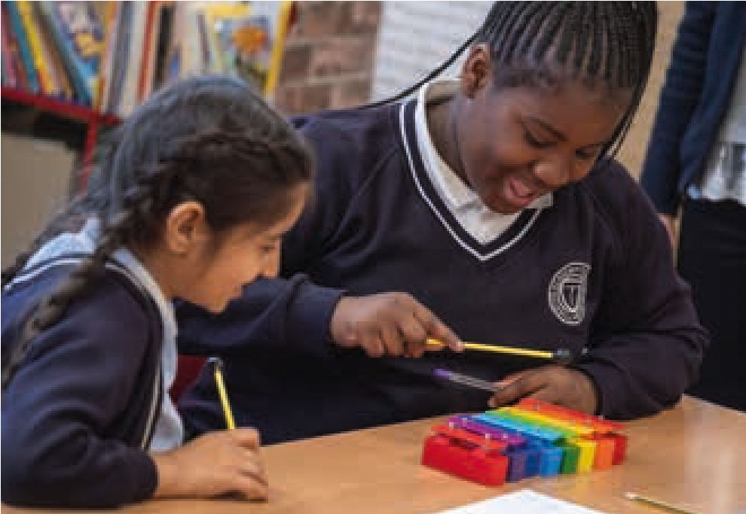
I have worked in music education for a long time, firstly as a schoolteacher for about 20 years, then I returned to full-time study to do a PhD at Cambridge which was concerned with the teaching and learning of composing in schools.
After that I worked in higher education for many more years, with 19 of those years being spent at Birmingham City University. For all of those BCU years I have been working with Nancy and BCMG, and this long-term partnership has really developed my thinking about this important area.
Nancy writes of being in the second cohort for GCSE music, and although I didn’t teach her, I could have done, as I was a head of music then, and jumped at the opportunity to trial GCSE music a year early in 1987 because of the composing component. I had been including composing as a key part of my everyday music lessons since I started teaching, and was desperate to have it as a part of exam work too. After working in schools, I was keen to find out more about composing pedagogies more broadly, hence subsequent doctoral research.
Having since worked researching and writing composing in many guises, I am more convinced than ever that it is a vital part of music education, and should be absolutely central to the subject. I believe music education should not just be ‘about’ music, but needs to involve all children and young people in the creation of their own music. Building on what has gone before, sure, but also finding new things out in the process.
I am keen that this toolkit should prove helpful to a range of audiences, but above all, I hope it ignites some small – or large – sparks in the people who read it, and yes, that means you, too!
Martin Fautley, Emeritus Professor,
Birmingham City University
The purpose of this toolkit
There are many different audiences for this toolkit – classroom primary teachers, primary music leads, specialist primary music teachers, instrumental teachers, composer-educators, workshop leaders, hub leads and orchestral education managers. After much deliberation, we decided to create one version that would work for all audiences. This means that you might find some sections more relevant to you than others.
The purpose of this toolkit is to help teachers and composers support the composing of children and young people. Its focus is on children at Key Stage 2, but also has relevance for those teaching younger or older children. It is intended to help you develop and plan composing activities for young people and to support existing schemes of work (SoWs) – your own, from Listen Imagine Compose Primary (LICP), or from other curriculum providers such as Charanga, Kapow, Music Express, Sing Up, and BBC 10 pieces, among others. Through making suggestions and asking reflective questions the intention of this toolkit is to:
- Deepen your understanding of what composing is
- Help you think about what children’s composing learning looks and sounds like
- Support you to better understand, listen and respond to children’s early musical ideas, compositions and composing processes
- Help you think about what it is to progress as a composer
- Build a culture of composing in your school or within a group of children
This toolkit is designed to help you discover and identify how composing teaching and learning can work best for you, your school, and the children you work with.
In addition, the toolkit aims to advocate for more composing in schools and better understanding of how composing contributes and can be central to children’s overall musical learning and identity.
Context
Composing has been part of the UK National Curriculum since 1992. however, the understanding of children as composers and how they progress is still poorly understood and under researched. Ofsted’s music report Striking the Right Note (2023) highlighted that ‘In most [primary] schools, the weakest aspect of the curriculum was teaching pupils to become better at composition’ and that ‘Very few schools had considered the underpinning knowledge that pupils need in order to learn how to construct and deconstruct music.’
Teachers report that composing is the part of the music curriculum they struggle with most (Berkley, 2001; Ofsted, 2021). Those teachers who are music specialists most frequently come from a performance or academic music background rather than composing. All these factors can result in poorly structured and piecemeal approaches to composing where children repeat the same composerly thinking and doing throughout their primary school life. In addition, schools often rely on external music schemes where composing can be reduced to a painting by numbers approach without a deeper understanding of children as composers and how they learn and progress as composers (Bolden, 2009; Burnard and Younker, 2008). This said, teachers are often highly skilled at supporting children’s creative learning in a range of subjects, using pedagogies for supporting group work, scaffolding learning, planning for differentiation and progress, and using effective questioning and feedback. These skills are highly transferable to supporting children to compose.
The Model Music Curriculum introduced in the UK as an exemplar in 2021 makes suggestions as to what kinds of composing activity might take place in the different years of primary school but does not, nor does it set out to, offer advice on how to support children with their composing. Helpfully it encourages teachers to link listening and performing activity with composing activity. Whilst it invites teachers to ensure their children are familiar with a ‘range of musical styles and genres’, the suggested composing activity is firmly grounded in Western Classical Music with a strong focus on notation. Its model of progression for composing is one of increasing length and complexity i.e. composing short melodic ideas then moving to 8-16 bar melodies, creating simple rhythms then adding pitch, including more pitches, then adding chord sequences, or using more complex structures. Our experience has shown us that children’s composing tends to be less linear and more messy with children using, exploring, and being fascinated by the interrelated elements of music right from the start, and that progression comes from children’s increased understanding, and sophisticated use of, musical elements and sound resources available to them.
National music education initiatives in the last ten years such as Whole Class Ensemble Tuition (WCET) and Sing Up! have focussed on instrumental learning and singing. When done well WCET often includes composing or some form of creative music making, but composing was not a core role of Music Education Hubs in the original National Plan for Music Education (NPME) (2011). In its more recent iteration, it is encouraging to note that composing and creating music are mentioned more frequently in the NPME2 (2022) as part of the overall vision.
Beyond the classroom there are clear progression routes for young people learning a musical instrument (from WCET to beginner ensembles to area ensembles). There is a good understanding of what progression in learning an instrument looks and sounds like, but the same does not exist for young people composing.
There is also a history of composers working with young people to compose and create music as part of orchestral outreach projects both in and out of school. Such projects can often be short term, have a performance outcome or be preparation for attending a concert. This can take the focus away from the composing process and from children’s longer-term learning and progress as composers. Project budgets and planning constraints can sometimes limit the time a composer has to get to know a school, its children, and its curriculum. As well as supporting teachers, this toolkit aims to support composers working on projects as part of these programmes.
This toolkit hopes to make a valuable contribution within this context, to support children’s composing, and to complement other available resources.
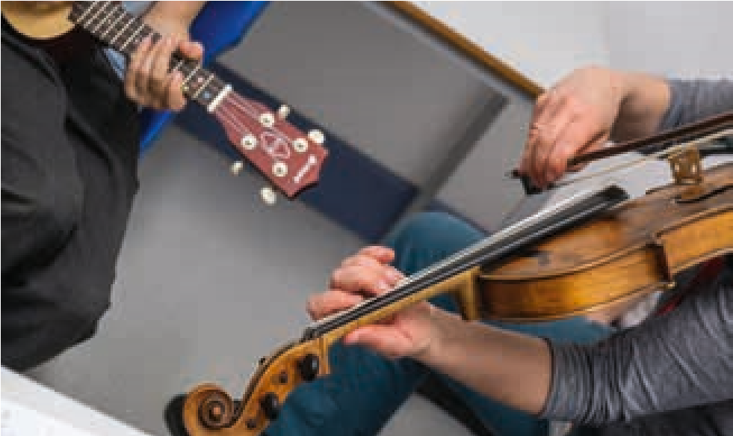
Why is composing important?
When people think about musical learning in schools, it often tends to involve children learning an instrument, singing songs, or playing simple tunes and rhythms on classroom percussion. The idea of children composing is less commonly encountered, and yet we know that young children often spontaneously create their own songs (Davies 1986, Campbell, 1998), and, when given musical instruments, will enjoy experimenting with them to see what they can do. This toolkit emphasises the centrality of composing to children’s musical learning and musical identity and the significant role it has to play – or should have to play – in the music curriculum of every school.
Children have musical voices and musical identities, they are not there simply to repeat what has gone before them, however great and important such music might be. Just as children find their own ways of knowing through their early drawings and paintings, they can also do this through creating their own original music. For some children composing provides them with a different way of making sense of the world around them and adding their own personal voice to this complexity.
In addition to all of this, composing supports children performing and listening to music. When children compose, they are continuously making decisions – how loud/quiet, fast/slow, spikey/smooth, high/ low, high low etc. should a sound, note or rhythm be? This develops an awareness of how expression is created in music and how choices affect the listener. When children compose, they are thinking about the music they create as interconnected musical ideas which can repeat, return, evolve and interact with other voices, instruments, sounds, and musical ideas. This means that when they play the music that other people, maybe famous composers or musicians have created, they bring a new awareness to this, rather than simply following the overall shape and structure of the music. What this can mean is that when playing a piece of music on an instrument or singing, instead of just following the expression marks, instead of just doing what they are told, they are bringing their own personal creativity to the performance. Composing music helps unlock this potential. It supports children to understand music from the inside.

Listen Imagine Compose Primary: the project
This toolkit was developed to support the action research project Listen Imagine Compose Primary (LICP) that ran from 2021-2023.

LICP aimed to:
- Work with teachers and composers to develop meaningful and relevant composing activities for children
- Better understand children’s composing and how they progress as composers
- Improve the quality and frequency of composing in primary schools.
Funded by a Paul Hamlyn Foundation Arts-based Learning grant, the project drew on knowledge and practice developed through previous individual and collaborative projects of Birmingham Contemporary Music Group (BCMG), research partner Birmingham City University (BCU) and Sound and Music (SaM).
LICP involved workshops and action research in six
Birmingham and 3 Bristol primary schools – following 480 children from Year 4 into Year 5. Project activity in schools was supported by reflective symposiums and professional development for teachers and composers.
The research questions the project asked were:
- What can we learn about children in Years 4 and 5 as composers?
- What is it to make progress as a composer in the primary classroom?
- How do we structure or plan activities, lessons and schemes of work to support children’s learning and progress in composing?
- What pedagogies support children learning and progressing as composers?
A manifesto for Listen Imagine Compose Primary The Listen Imagine Compose Primary approach to composing in schools is underpinned by the following values, principles, and understandings:

About composing
- Composing is the playful organisation and manipulation of sound to express and communicate ideas with intention.
- Composing is a way of reflecting on, reinterpreting and/or expressing the world through sound.
- Composing happens differently in different genres and cultures.
- Composing is a process which involves knowledge and skills, imagination and craft.
- Music notation (traditional and graphic) is an important tool for sharing, documenting and recording ideas, not a goal in itself, and a ‘sound before symbol’ approach is encouraged.
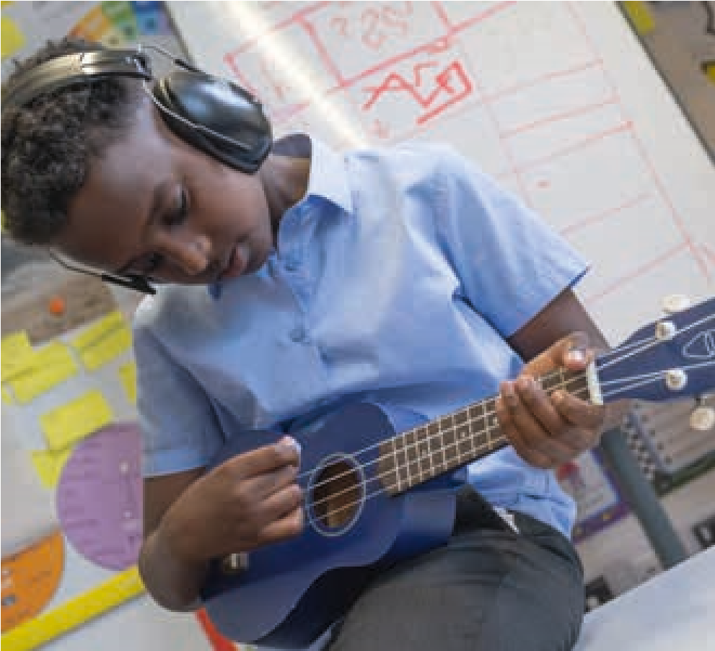

About children composing
- All children are musical, and composing is an inherently human activity and something all children, even the very youngest, can do.
- All children have the right to have their musical voices heard.
- Composing is something which can be taught and learned, and, with the right support, something children can make progress in.
- Creating opportunities for children to compose music supports not only their development as composers but also supports their musical understanding, listening and performing.
- Children should have the opportunity to compose from their own ideas as well as from, and inspired by, given stimuli such as poetry, science, art and diverse musics.
- Children should be given the opportunity to compose for the instruments that they and their classmates play, classroom percussion, voices, found objects, visiting or school-based musicians, school and class ensembles and technology.
- Children should have the opportunity to create music that has a meaningful purpose and that can be shared with others through performances and recordings.
- Children and young people can be musically creative from their very earliest encounters with sound and are able to compose throughout their musical learning journeys using whatever knowledge and skills they have at that moment.

About teaching composing in primary schools
- Classroom teachers as well as specialist music teachers can effectively support children’s progress as composers when given appropriate professional development and guidance.
- Composing is a central part of the music curriculum in primary schools.
This toolkit recognises:
- Children arrive at primary school with a multiplicity of musical experiences and are not empty vessels.
- Understanding about children’s progression in composing is less well developed and documented than their progression in other subjects such as art, creative writing and maths.

LICP has completely thrown open the gates of what musical learning could be and our music curriculum has for more opportunities for children to develop their composerly thinking and build on it over time. Although there might be guides and scaffolds in place, children have more opportunities to take their compositions in their own
- Understanding about children’s musical progression in composing is less well developed and documented than their progression in playing an instrument or singing.
- Many specialist primary music teachers often have a performance rather than composing background.
- Composing in the classroom can present challenges to teachers and schools in terms of space, noise, resources, time and wide differences of musical experience.
- The need to develop knowledge and practice that works in a wide range of schools and that is flexible and responsive to context and community.
- That schools use a variety of curriculum models, resources and learning programmes.
- That in a learning context, the composing process matters equally or possibly more than the final product and should be planned for accordingly.

direction. Teacher
2.

Children and Composing
This section starts with presenting a brief history of children composing in schools. This is followed by setting out a simple trajectory for how children’s composing develops and changes from birth to 8 years old. It details the characteristics of their composing and compositions at different stages before exploring how their composing learning and doing interacts with and influences their other musical learning and doing. The section then moves onto examining the composing process and exploring how music is constructed.
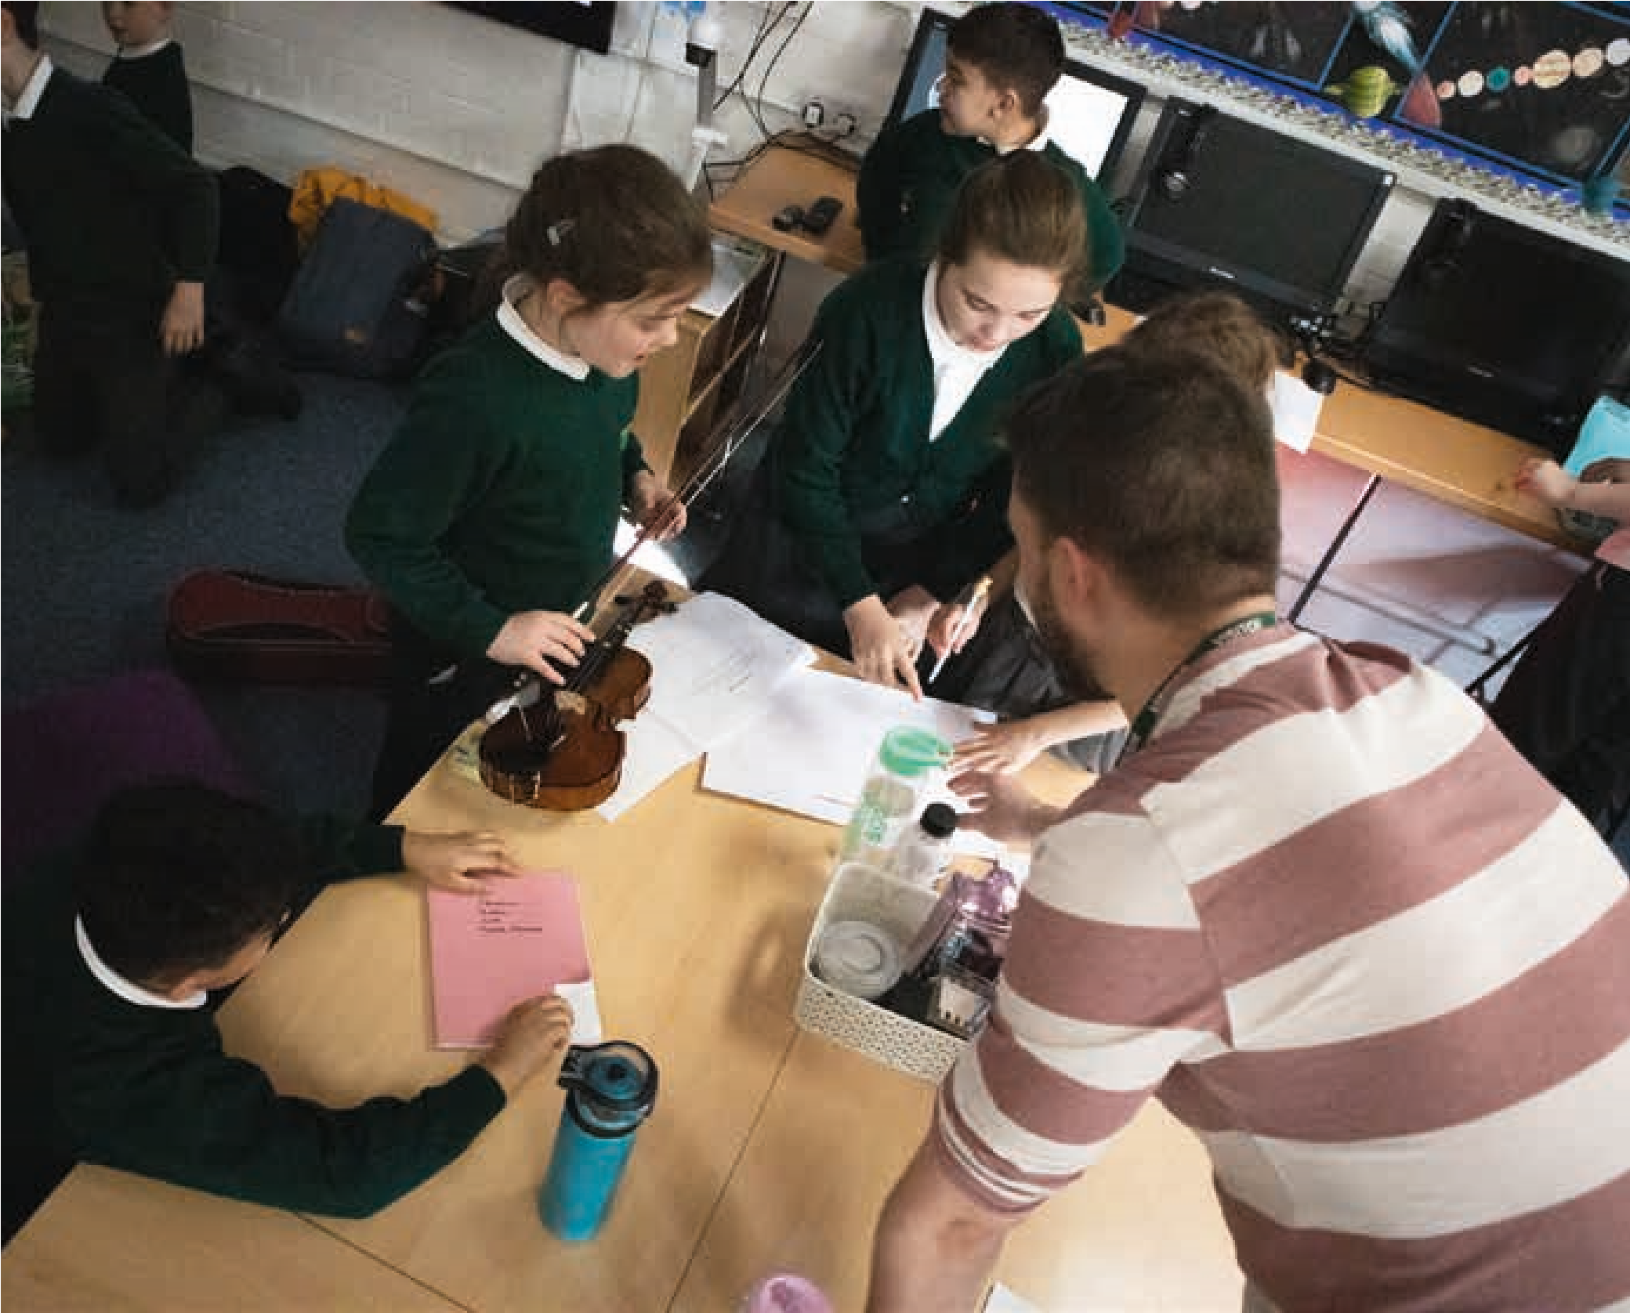

A selective history of children composing and publications

Composing has been a statutory part of the UK National Curriculum (NC) since 1992. [This toolkit refers to the English version of the National Curriculum (DfE, 2013)]. From its first iteration, the National Curriculum for music has been built around three components – listening, performing, and composing. GCSE music was built around these same pillars although over time different weighting has been placed each pillar by the various examination boards. The first GCSE examinations took place in 1988, meaning that teaching for them had begun in 1986.
However, children composing as part of their musical learning pre-dates this by a long way. In the 1920’s composer Carl Orff and his colleague Gunild Keetman developed what has become known as Orff-Schulwerk, or the Orff Approach. Orff believed in the importance and natural capacity of children to participate in the creating and composing of music as well as listening and playing. A later example is from 1959 when composer Peter Maxwell Davies taught at Cirencester Grammar School, where he composed music for young people, involved them in playing new and specially composed music and invited them to compose.
In 1970 the seminal text ‘Sound and Silence’ (Paynter & Aston, 1970) was published. Paynter was a composer, teacher and academic and had been inspired by developments in art and creative writing education where children’s creative outputs were valued and an established part of the curriculum. Music had previously not done this to any great extent, and so Paynter’s work was original in this regard. This work led to the Schools Council Project ‘Music in the Secondary School Curriculum’ (see Paynter, 1982). This project was ground-breaking in that it started from the positionality of the children, and the music they created, normally directly into sound. This work gave rise to a number of publications. Interestingly, Paynter’s PhD thesis started with primary and reception aged children, and it was only later that he moved onto secondary education. He believed in the centrality of what came to be known as ‘creative music’ making to children’s developing musical understanding, and placed composing central to this way of thinking. At the same time as Paynter’s investigations in the primary classroom, the Canadian composer and educator R. Murray Schafer wrote Composer in the Classroom (1965), which explored the creation of new music by children and young people along similar lines to that being explored by Paynter in the UK
Paynter’s work highly influenced on the first orchestral education projects in the 1980s. These projects often focused on composing inspired by ideas from orchestral repertoire or contemporary music. Early pioneers of this work were Gillian Moore working with the London Sinfonietta, and
Richard McNicoll with the London Symphony Orchestra. These projects were often motivated by supporting teachers with the new requirements of the National Curriculum, a desire to encourage an appreciation of contemporary music and a will to give back the communities where they were based.
Over the years there have been a number of noteworthy contributions in terms of books and articles about children composing and the pedagogy of composing. These include: Jeanne Bamberger’s (1982; 1995) research into children’s invented notations, Jo
Glover’s book ‘Children Composing 4-14 (2002), Maud Hickey’s ‘Why and How to Teach Music Composition: A New Horizon for Music Education’ (2003), and a number of books and articles by Pamela Burnard who remains highly active in this area (inter alia Burnard 2000a,b; 2002;; 2018; Burnard & Younker 2002;).
More recently, Sound and Silence celebrated its 50th anniversary, the occasion being marked by a new book, ‘Creative and Critical Projects in Classroom Music: Fifty Years of Sound and Silence’ (Finney et al, 2020). In 2023 The Routledge
Companion to Teaching Music Composition in
Schools – International Perspectives (Devaney, Fautley, Grow, & Ziegenmeyer, Eds) was published and in 2024 The Oxford Handbook of Music Composition Pedagogy (Kaschub (Ed), 2024).
A small number of academic models of children composing also exist, including Webster’s (1988; 1992; 2003a,b) work on creative thinking in music, Fautley’s (2005) model of group composing in the classroom, and Burnard’s (op. cit.) work on routes and pathways. A key contribution to this field was that made by Swanwick and Tillman in their 1986 article ‘The sequence of musical development: a study of children’s compositions’, which presents what has come to be the most well-known model of thinking about children composing, often referred to as the ‘Swanwick-Tilman spiral’ (see also BJME special edition devoted to this, 39,1, 2022).
This is not a comprehensive history or book list but a personal selection which has been influential on our thinking and doing. For more books, chapters and articles please see the bibliography and suggested reading list in the appendices.
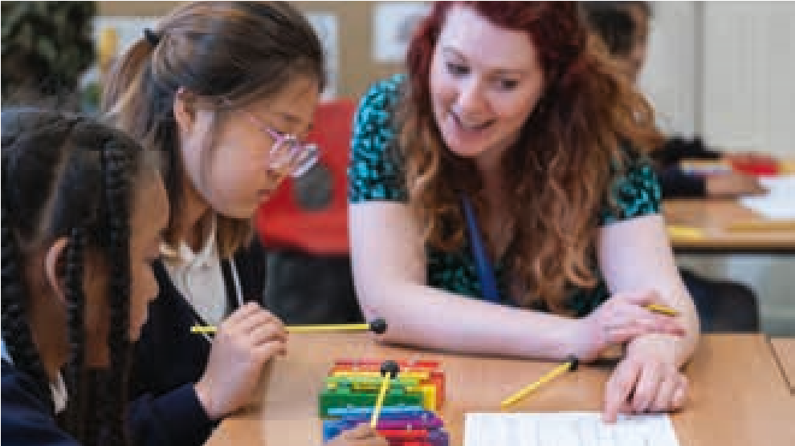
Children composing before the age of 8
This toolkit focuses on children at Key Stage 2 though many parts have relevance for older and younger children. As we plan, it is important to consider the experiences and development of children before this stage as set out below:
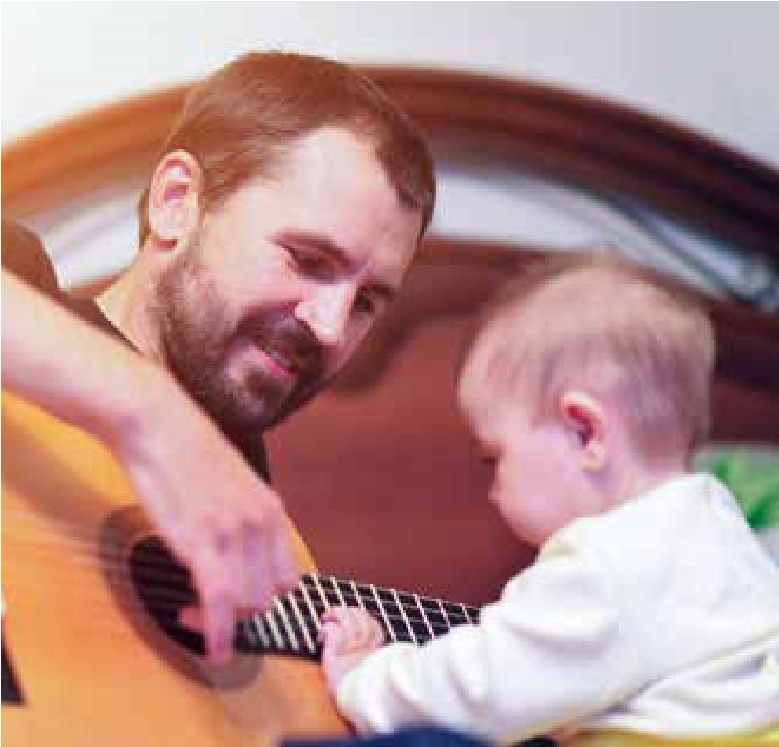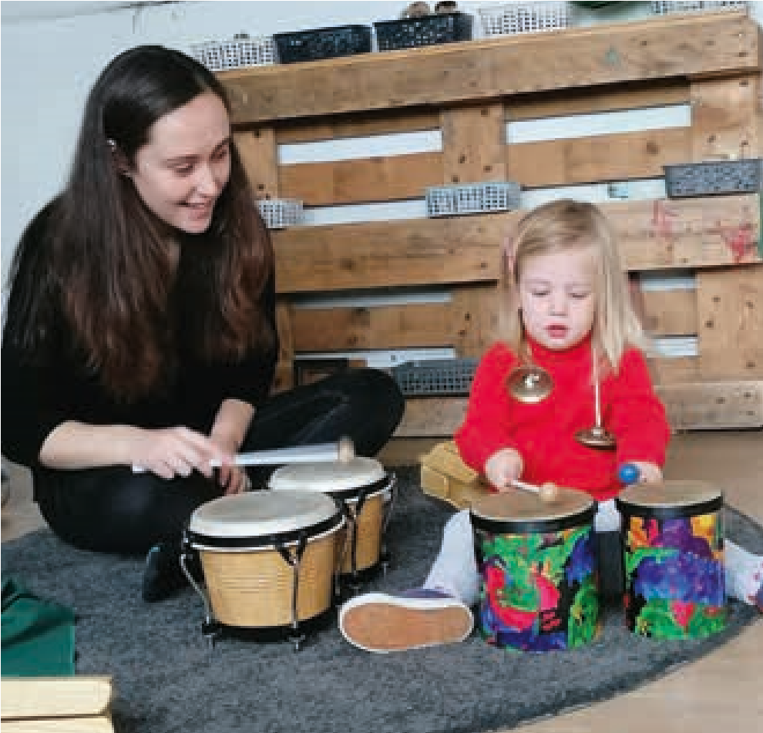
0 – 2 years old
Children create music from a very early age (0-2 years old) starting with vocalisations that often accompany other play or are part of non-verbal conversations with caregivers. As they get older, children start to play around with familiar songs, and create sound patterns and rhythms using everyday objects. These patterns are sometimes repeated, extended and varied. Children’s musical play is often multi-modal, particularly connected to movement, and musical ideas created using instruments are frequently influenced by the shape and affordances of the instrument and any beaters provided. Children of this age are fascinated by the sonic properties of objects and, if available, musical instruments or music technology.
2 – 4 years old
As the child grows older (2-4 years old), if the opportunity is there, musicplay (Young, 2003; 2008) moves onto more purposeful improvising on musical instruments both alone and with a partner. Sometimes these ideas will reveal the child’s musical experiences and cultural influences from home. Children will extend and develop their musical ideas through repetition and through having a listening and responsive music play partner. Musical ideas become longer and begin to involve more than one instrument or sound maker. They will also remember and revisit ideas from one day to the next. It is at this age that children start to create their own ‘invented notations’ where sound can be clearly connected to specific children’s visual marks. These ‘invented notations’ (Bamberger 1982) can emerge accidentally or in response to conscious teaching strategies. Children also start to make up simple songs often borrowing ideas from ones they already know (Campbell, 1991; 2010).
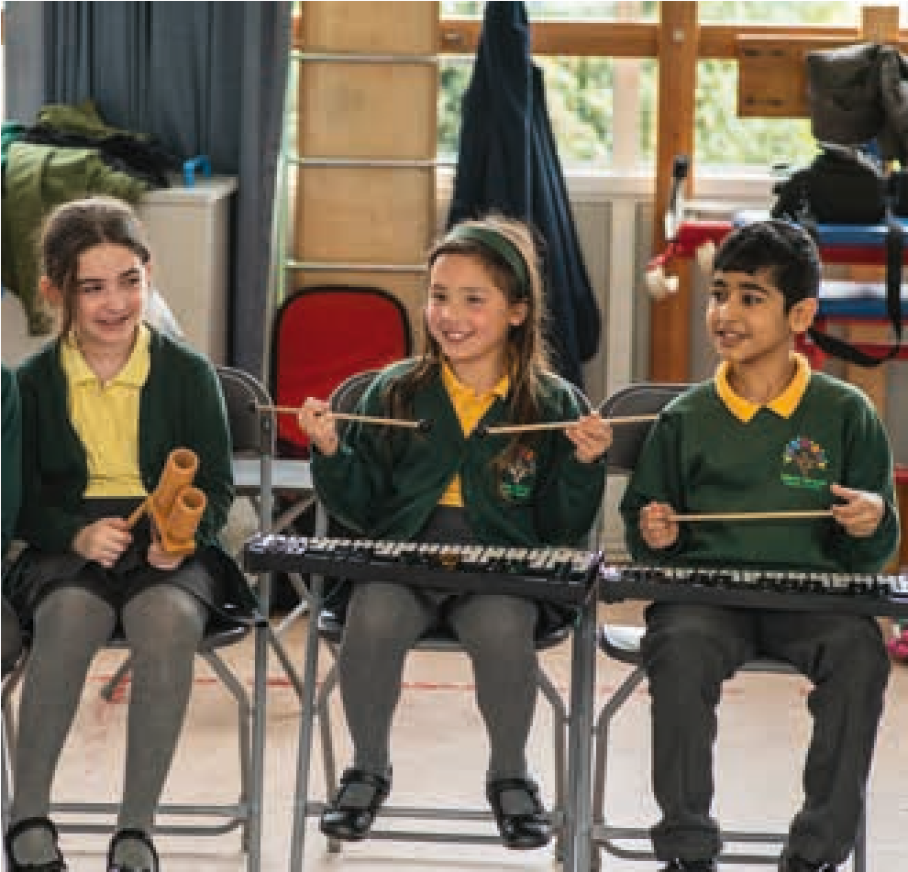
5 – 7 years old
At the age of 5-7 years old, when the child starts school, composing begins to be influenced by what opportunities are made available. Early composing in school can takes different forms and might include creating soundscapes in small groups around a theme or to accompany a story (Burnard & Murphy, 2017); creating simple rhythmic patterns using instruments, body percussion (Upitis, 2013) and other sound makers; creating simple melodies using tuned percussion. Children are often introduced to graphic scores at this age and are invited to create simple symbols to help them organise their musical ideas into simple structures.
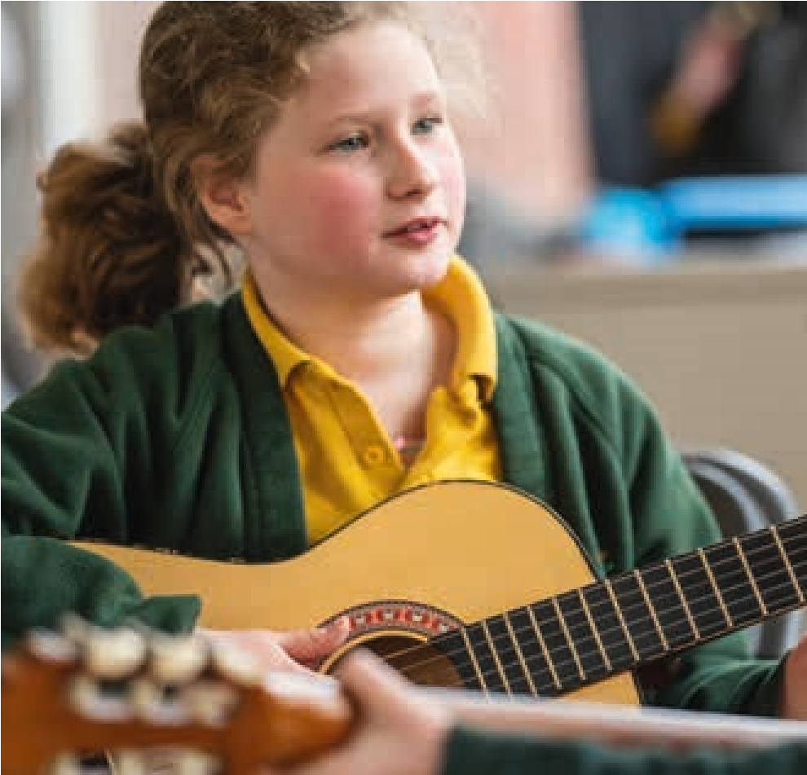
Learning an instrument
For those children who might start to learn a musical instrument at this age – in or out of school – composing might take the form of creating simple melodies and rhythms on their instrument. Imaginative instrumental teachers may invite children to compose using notes, melodies, rhythms found in the pieces they are studying or techniques that they are learning or invite them to create stories that exploit the different sounds their instrument can make. If the children are learning to read traditional notation as part of learning their instrument, composing might also take the form of playing around with simple traditional notation.

It is very important to remember, that there will be a wide variance from one child to another in terms of musical experiences and opportunities. More detailed explorations of children’s composing at different ages and stages can be found in the bibliography and reading list.
Connecting children’s composing with listening

and performing
The UK National Curriculum for Music has three pillars with equal weighting: Performing, Composing, and Listening. In this toolkit, composing is viewed as intrinsically connected to listening and performing. This section explores (a) listening and performing within the composing process, (b) consciously planning for composing activity to connect with listening and performing, (c) what composing can offer listening and performing.
Listening and performing as part of the composing process:
Listening is fundamental to composing. Children need to listen to the musical ideas they have created and be able to evaluate and refine them as well as make decisions about which ideas to keep and get rid of. Over time this ability becomes more and more sophisticated. In the classroom they will not only be listening to their own ideas but to those of others. In most instances of composing in the classroom, children take on the role of composers and performers simultaneously. They perform throughout the composing process and when sharing their final compositions to classmates or a wider audience.
Consciously connecting composing with performing and listening
Listening to music both live and recorded is a valuable source of inspiration for children’s composing. This could be anything – thematic ideas, musical forms, musical fragments, rhythmic ideas, note sets. In a similar way, ideas for composing can be taken from music the children are learning to perform, maybe as part of WCET. This might include taking a melodic fragment and using it to create a set of variations, using a rhythmic pattern to create an ostinato, experimenting with a new playing technique or tone colour. Children derive a double benefit from these mutually reinforcing activities: their instrumental playing nourishes a composerly imagination, and their composing empowers their instrumental expression.
What can composing offer listening and performing?
When children compose, they are actively engaged in making decisions about the qualities, direction, and structure of the music. This supports them to understand how music is constructed and how the inter-related elements of music work together to create expression. This works particularly well if these elements have been highlighted and labelled. When children bring this understanding to listening, they listen as composers and begin to be able to identify different sections, how sections relate to each other, and how and why the music might change over time. Similarly, when they perform on instruments, they begin to perform with an understanding of form, knowing when musical material is revisited and/or varied or when there is a completely new section. They use expression in their playing – dynamics, tone colour, articulation and tempo – in meaningful ways, rather than just following instructions on a page. The motivation to find the sounds they want in their compositions can encourage them to expand their playing abilities, find new notes, sounds and ways of playing. For some children, the freedom and imagination that composing offers can support them to keep playing when struggling or losing interest.
All of this encourages children to engage with sound – the raw material of music. When planned well, composing listening, and performing are mutually reinforcing and develop children’s overall musicality.
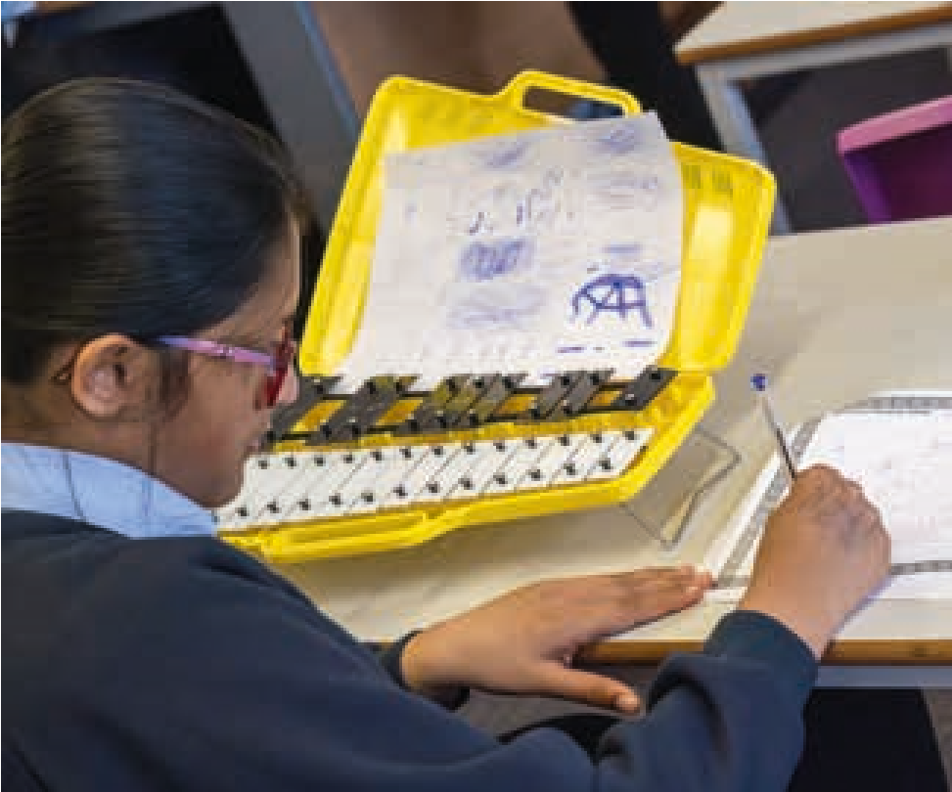

How music is constructed
Music is a time-based art form constructed through the layering and sequencing of musical material. In this context ‘musical ideas’ or ‘musical material’ is taken to mean intentional units of sound created by the composer.
As a composer constructs a new piece of music or song, they have what is in essence a simple set of options open to them – to repeat a musical idea, to vary the idea, to bring back a previous idea, to mix different ideas or to add an entirely new idea.
Which of these a composer decides to do depends on their own aesthetics and what they are trying to communicate. Sometimes, they will be working within historical, stylistic or genre specific musical forms, such as sonata form or verse and chorus, which can determine to a certain extent how this might happen. It is the choices a composer makes i.e. the variation and revisiting of musical material, that gives us the sense of being taken on a journey as we listen.
The listener might perceive these choices or might experience the music as an unfolding whole. Margulis (2014) observes, ‘Music’s repetitiveness is at once entirely ordinary and entirely mysterious. The radio is full of songs whose choruses repeat over and over...Musical repetitiveness is so common as to seem almost invisible’.
Why is this important for the teaching and learning of composing? The idea that music is created as a ‘stream of consciousness’ which unfolds in a linear fashion from beginning to end plays into the notion of composing being something that only magically gifted people can do. It can make the teaching of composing seem daunting and lead to doubting whether children are capable of it. For children learning to compose, needing to come up with continuous musical novelty can seem daunting and dispiriting. If instead we understand music as being built from smaller units of sound which are repeated, revisited, and varied, creating music, and teaching/ supporting children to compose seems an entirely achievable proposition. This is not to underestimate the imagination and craft involved in creating musical ideas in the first place or in making choices as to how that musical material is developed and structured.
What it means is that as well as teaching children composing techniques, a large part of our job as teachers is to support children to make meaningful choices through listening and experimenting with sound, and allowing their musical imaginations to flourish.
It is important to note that choosing what to do next operates at both the micro and macro level. For example, at a micro level, within a musical idea, this might be choosing whether to repeat a note or move to another one in a melody, or, at a macro level, deciding whether to return to the same idea as at the beginning or create a new one.
A musical idea could be a melody, a rhythm, a texture or a musical gesture. These can be given a particular character through dynamics, tempo, intervals, timbre (the colour of the sound), register, ornamentation, articulation, duration or accompaniment. Different musical styles and cultures will use and value these differently.
Whereas sequencing in music refers to the horizontal, temporal organisation of musical stuff, layering in music describes the vertical, synchronic organisation of ideas. Typical layers in music might include a melody at the top with an accompaniment of chords, a drone, an ostinato, a counter melody or more than one of these combined.
When children make musical stuff, their ideas are often messy and complex. Their ideas don’t fit neatly into categories, or they cross over different categories. For them everything is new. Our job is to acknowledge and value their musical utterances, support them to listen, make intentional choices and think in sound, offer rich examples and give creative parameters and limitations to work within, and, when appropriate, teach specific composing techniques and processes.

You kind of feel this incredible feeling that just rushes through here [pointing to heart].

Young person
Examining the creative and composing process
The previous section explored how music is constructed and the stuff it is made from. This section explores the creative process of making music.
Composing music is a creative process with distinct stages involving both imagination and craft. For some composers, especially those with experience, the process might be intuitive and not visible. There are several views of what happens when we are being creative. One of the most widely cited is that of Wallas (1926), who suggested that creativity happens in four stages – preparation, incubation, illumination and verification.
Preparation: a time of research
Incubation: the unconscious mind makes associations, filters and rejects combinations
Illumination: the idea starts to emerge and take form out loud or in the aural imagination
Verification: the creative idea is evaluated and refined
For children, it is likely that the same four stages are integral to their creativity and composing. However, unlike expert composers, children are likely to need support and guidance through them.
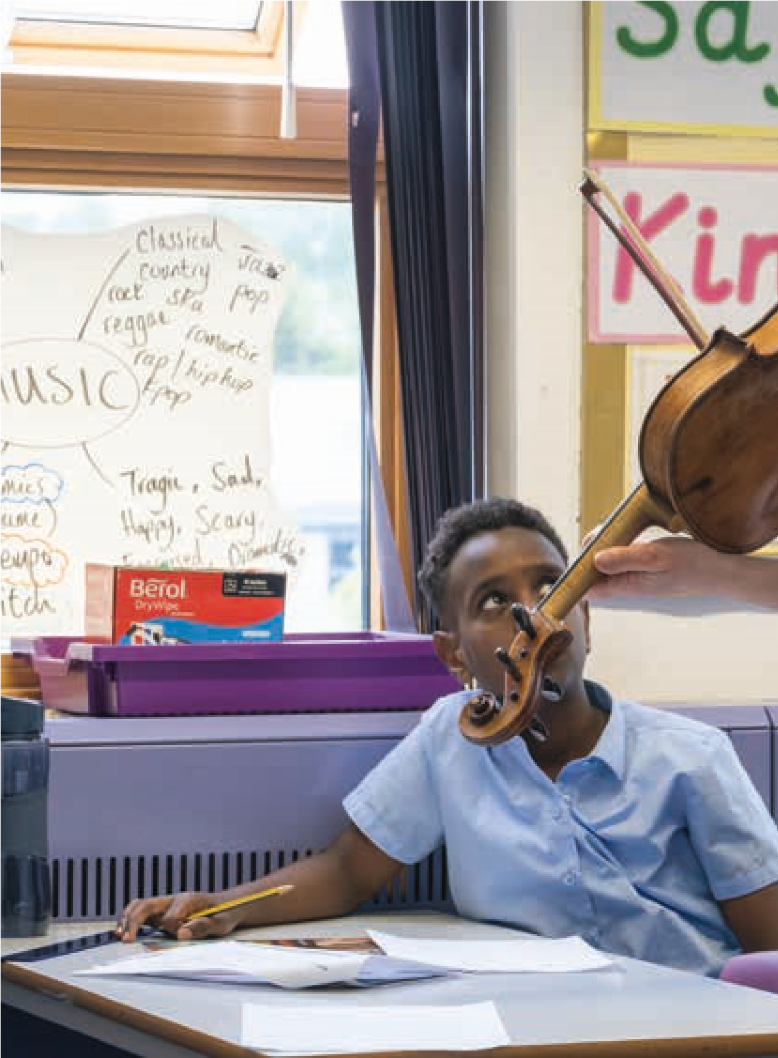
Vygotsky’s (1978) notion of the zone of proximal development (ZPD) is important here. The ZPD is what a child is able to do at any given moment with the help of a ‘more knowledgeable other’. Vygotsky suggests that after the child is shown how to do something, they will be able to do it alone at some point in the future.
Sometimes there is a tendency to require children to go straight to illumination without having had any time for preparation and incubation. We can’t expect children to be able to come up with ideas if preparation and incubation haven’t happened. That expert composers appear to come up with ideas spontaneously belies years and years of practice, an internal library of ideas and an ability to think in sound. With expert composers there will be a spectrum of approaches between those who prefer to work within their aural imagination and those who spend their time at an Instrument or DAW experimenting and improvising to find ideas.
This toolkit explores and encourages both preparation and incubation as part of the composing process. Within the classroom context, incubation can be harder to foster as projects often require moving through tasks without time for daydreaming and experimenting.
What expert composers are also able to do is to work with music material that might not at first seem promising. This can be seen as the process of verification. Children can become dispirited if an idea doesn’t feel ‘right’ straight away and therefore supporting them play with musical ideas in many different ways is important.
The ‘Guiding children composing process’ chapter, breaks down the composing process into practical stages as illustrated in the diagrams on the following pages. This is helpful for the teaching and learning of composing in schools. It is important to note that this process is unlikely to be linear or to be the same for everyone involved. What is important is that as well as teaching composing techniques and skills, we should also teach and help to embed an understanding of process with children.

If you make a mistake, don’t cross it out because actually it makes your work better sometimes. Young person Some reflective questions
- There are different ways of composing, how are these reflected in expert composers?
- Are they appropriate for the ways in which children compose?
- Children are likely to be different from adults when composing – what can we learn about this?
- Composing is not necessarily a linear process, what might the implications of this be?
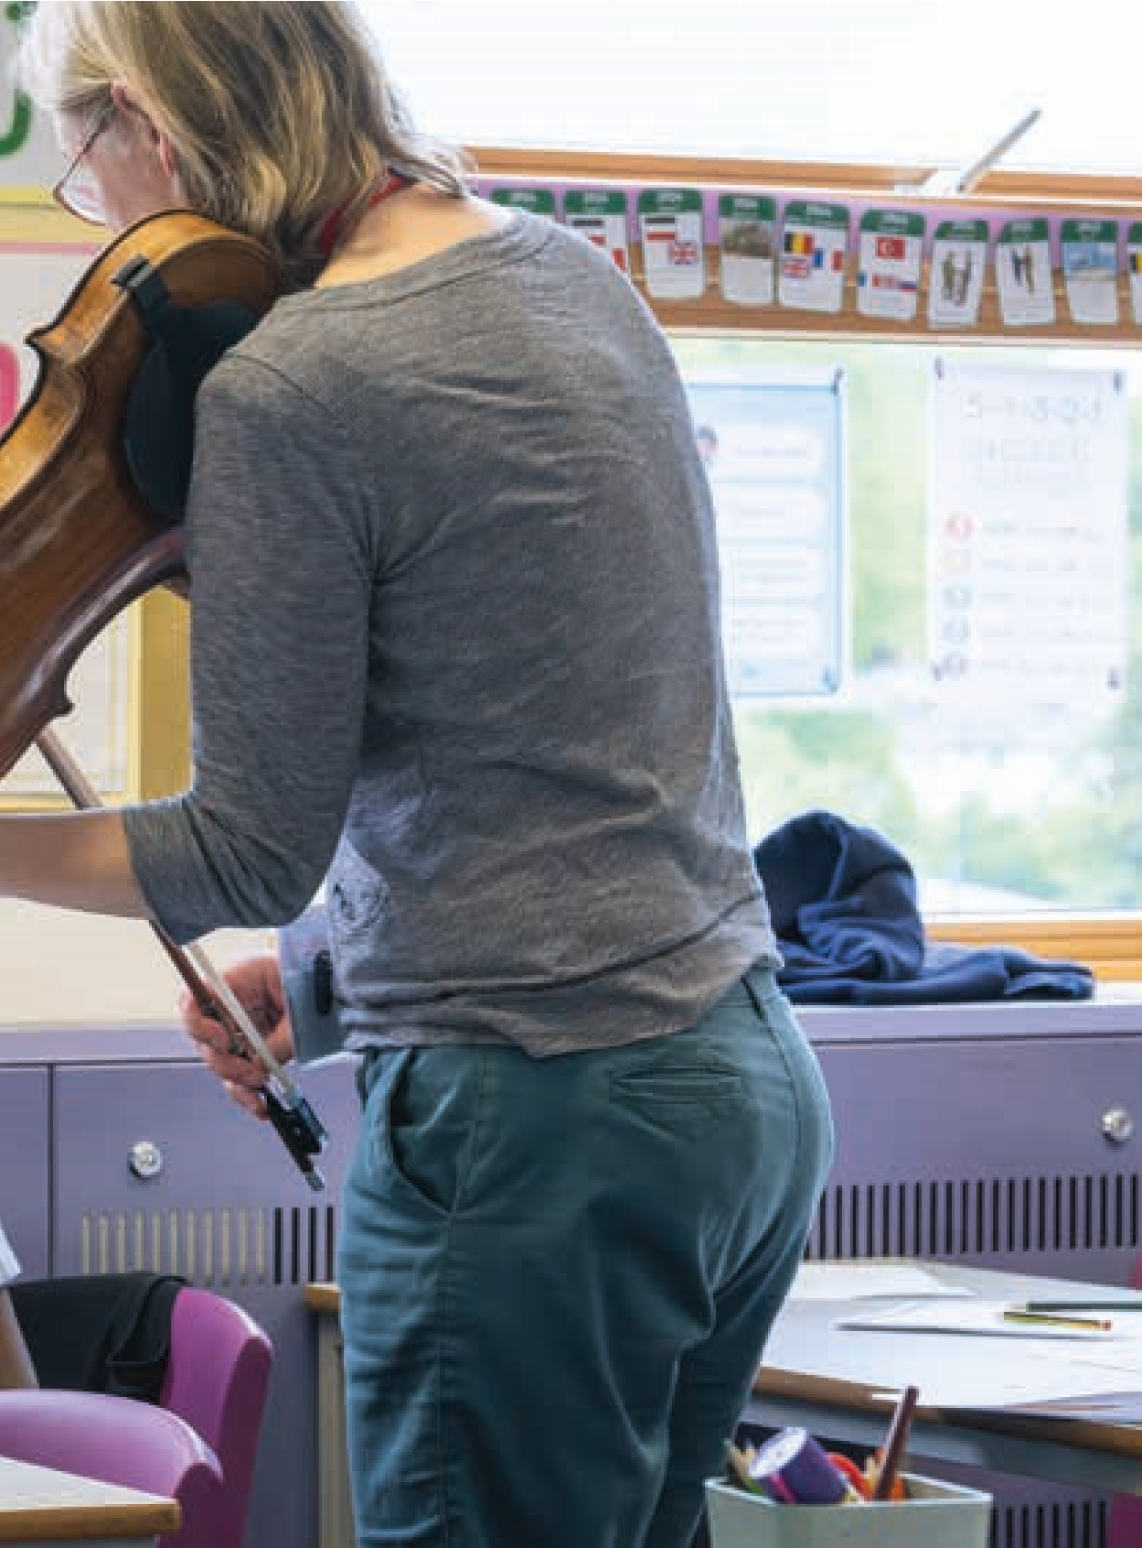
- It can be helpful when children understand the different stages involved, and how this supports them as composers. How can they be helped with this?
- In what ways might children composing be different from that of expert composers?
On the next two pages are a simple and then more complex diagram of how the composing process might be visualised.

A composing process flow chart
Start
Play, Explore

and Improvise
Listen, Imagine

and Mind Map
Structure and

organise ideas
Share or perform to an audience

and receive feedback
Develop and expand ideas
Accompany ideas
Rehearse, listen

and reflect
Create first
musical ideas

A more complex composing process flow chart
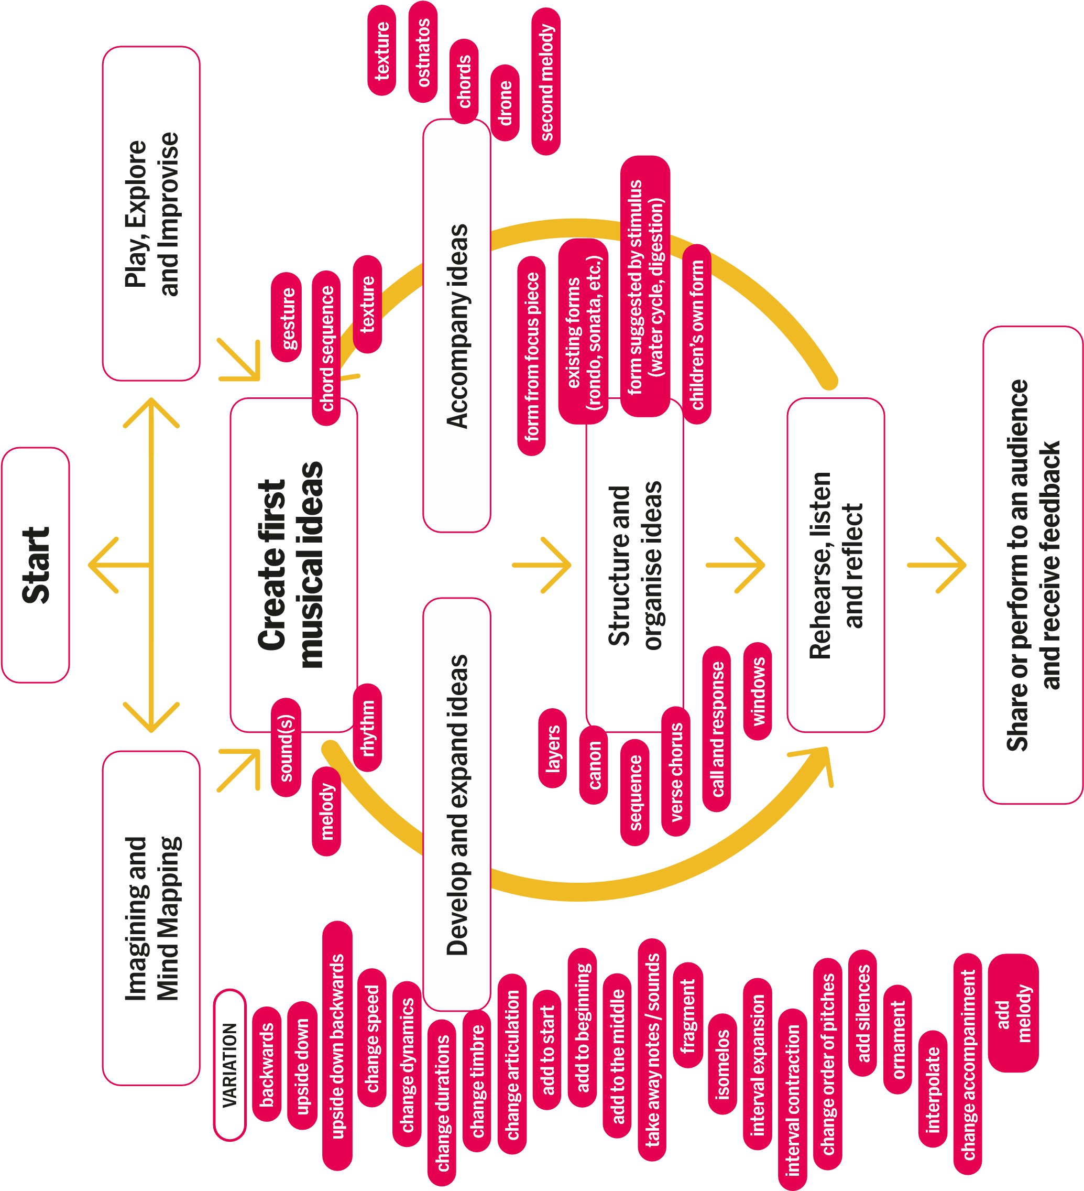
3.
Planning for composing in THE primary school
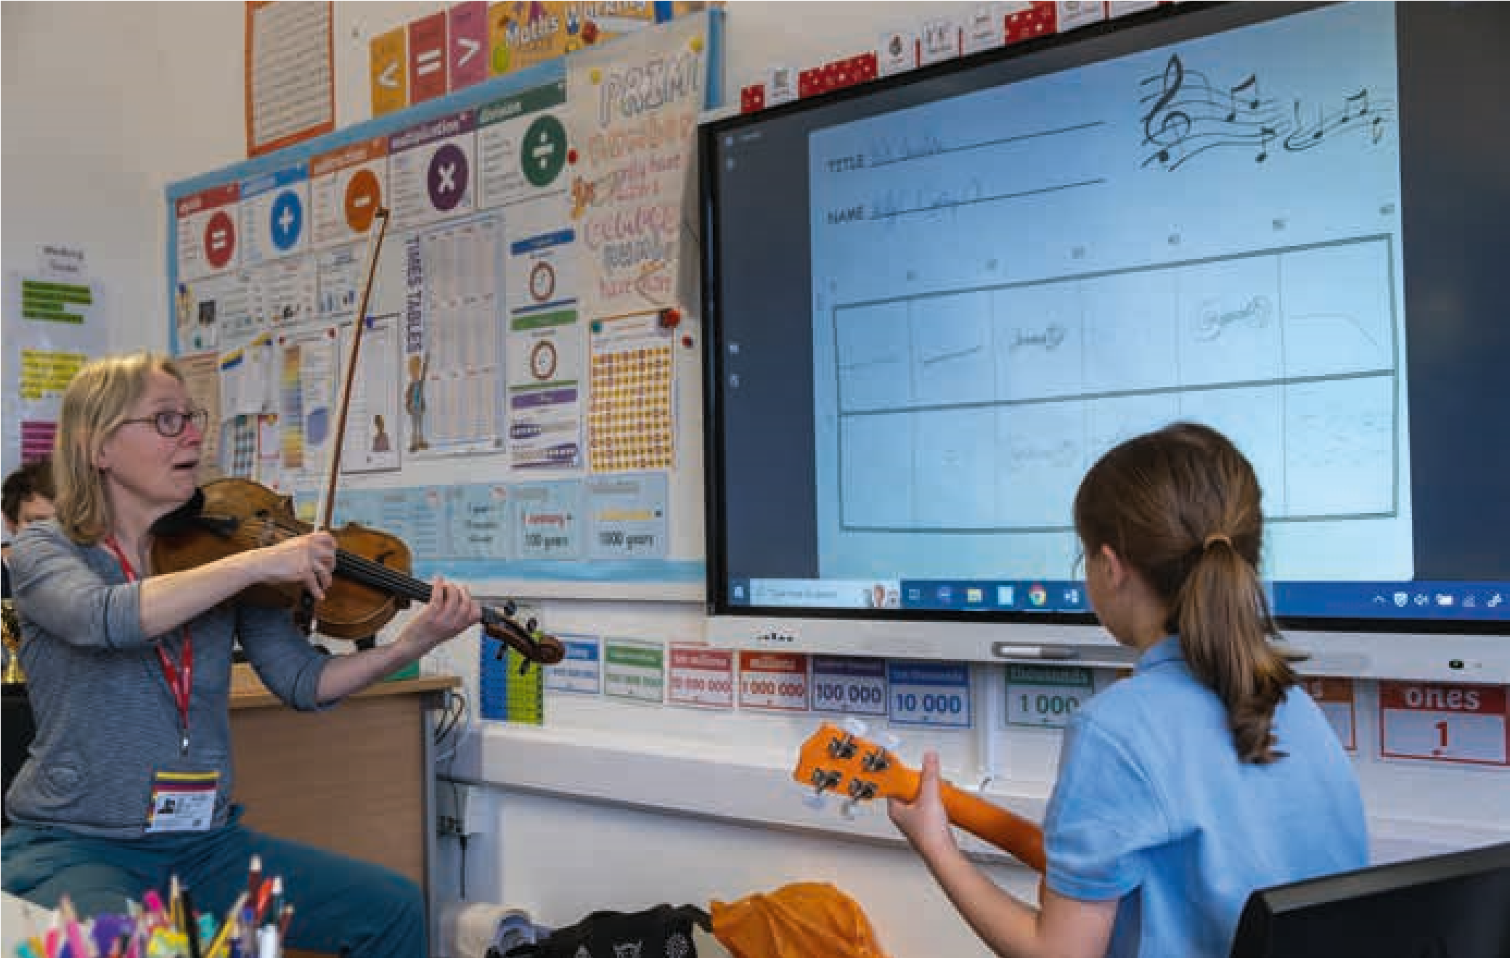
This section invites you to reflect on and evaluate current composing teaching and learning in your school, or in schools you might be invited to work in, through a series of reflective questions. It then considers the different learning contexts for composing, how effective composing tasks can be set and planned for as well as what resources and spaces might be needed. Finally, it reflects on what a ‘good’ composing lesson might look and sound like and makes suggestions of how to build a culture of composing in a class, and across a school.

Reflecting on composing in school
Who teaches music in the school?
- Does the school have a specialist music teacher who teaches all classes?
- Is there someone with musical expertise supporting classroom teachers?
- Does the music coordinator have musical experience?
- Is music taught by a visiting instrumental or singing teacher?
What curriculum materials does the school use? What do they say about composing?
- National Curriculum (NC)
- Model Music Curriculum (MMC)
- Charanga, Kapow, Music Express, Jolly Music, Oak National Academy, BBC 10 pieces, SingUp!, or other curriculum resource
- Teacher or school generated
- A mix of the above
How is the music curriculum and, in particular, composing learning planned?
- Is it topic/project based?
- As a discrete subject?
- Is composing linked to listening activity or to WCIT?
- Is it centrally decided or is there teacher autonomy?
How much time is there each week/term for music? How much time is there for composing?
Where do music lessons, in particular those involving composing, take place?
- In the classroom?
- In the school hall?
- In a special music room?
- Do you have the use of any other extra spaces?
What resources for composing do you have?
- Tuned and untuned classroom percussion
- Instruments the children are learning
- Voices
- Other sound makers
- iPad apps, laptop software etc.
What are staff perceptions of the composing element of the music curriculum and how might you find out?
Demography and community – the cultural backgrounds of the young people
- What music does the class listen to, make, play and perform?
- What cultural backgrounds do the children come from?
- What music are they exposed to at home and in the community?

Learning contexts for composing in

primary schools
This toolkit identifies four possible learning contexts for composing that can be found in schools – Topic/Thematic, Event, Music, and Own Intentions. These categories are not exclusive or necessarily discrete pathways and may overlap. However, they are useful labels for planning and for thinking about connections across the primary school curriculum.
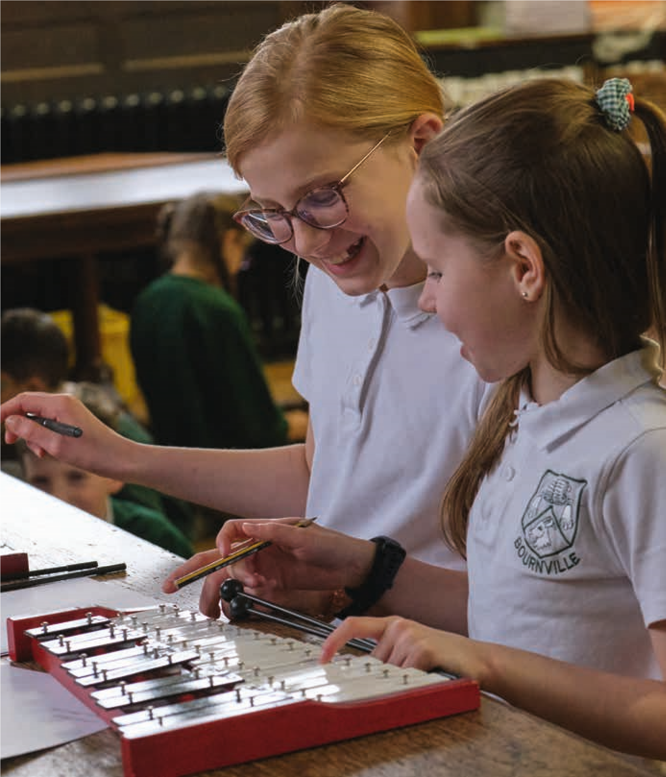

Topic:
This describes the practice of using topics or themes from other parts of the curriculum as a stimulus for children’s composing. Many schools use this approach also known as cross-curricular or project based. This approach gives children a reservoir of ideas to inspire their music and allows them to make connections between different curriculum areas. However, if links are superficial, there is a danger that the trajectory of musical or composing learning becomes secondary to the topic. Therefore, when using this approach, it is important to think about musical progression as well as progression in learning about the topic.
Event:
This describes the practice of asking children to compose for a particular event – for example: the school sports day, planting a tree in the local park, a Christmas concert, special assembly... This approach has many positives in that it gives purpose and a context for the children’s composing. Much music from around the world – both contemporary and historical – has been created to accompany particular events, celebrations and rituals. Obviously, some of these may also have a thematic idea too. As with topicbased approaches, it is important to be clear about the composing learning that will take place.

Music:
This describes the practice of linking composing to other music learning and activity. This might mean taking musical and extra-musical starting points from listening to live or recorded music. Or, music that children are learning to perform in WCIT provides structural, textural, melodic or rhythmic ideas or is linked to learning a particular set of notes or a particular technique. Or there are particular foci on different musical elements that are explored in listening, performing, understanding and composing. This approach has many positives as it connects and reinforces the different aspects of children’s musical experiences and learning.
Own Intentions:
This describes the practice of allowing the children to compose from their own ideas. This can be very liberating for children giving them an outlet for expressing and communicating ideas through the medium of sound. However, for some this might be quite daunting especially for those who have had fewer musical experiences. It is important with this context to scaffold the children through the process and make opportunities for regular sharing.

On the next page is a flow chart that charts the journey from understanding the learning context through to starting to develop a ‘composing brief’.

Planning for children’s composing flow chart
Planning for children’s composing
What is the learning context?
What opportunities for learning does this context offer?
Topic Event Music Own intentions
What possibilities What possibilities What possibilities What possibilities for composing and for composing and for composing and for composing and
composing learning are composing learning are composing learning are composing learning are there? there? there? there?
What possibilities for What is the purpose of How might the How might composing learning about the topic the event or occasion? composing connect to connect with the
are there? performing or listening children’s development
What possibilities for
activity? as composers and
What possibilities for wider musical learning
personal development? wider musical learning are there? What possibilities for
are there? wider musical learning What possibilities for
are there? wider musical learning
are there?
What have the children already done and know?
What do you want the children to learn?
How does this fit into long term planning?
How might planned composing activity fit in with other music activity?
Creating the composing brief/task
What decisions will you make, what decisions will the children make?
The composing brief/
task
Creative limitations or
parameters?
How long?
What
instrumentation?
Where will it be performed?
And to whom?
What starting points
or inspiration?
Is there any

related learning?
Is there any
related listening?
How might it support any
instrumental/vocal learning?
Will there be particular composing
techniques or skills embedded?
Will you/do you want to focus on a particular
stage of the composing process?
Will you give the children
musical material to work with?
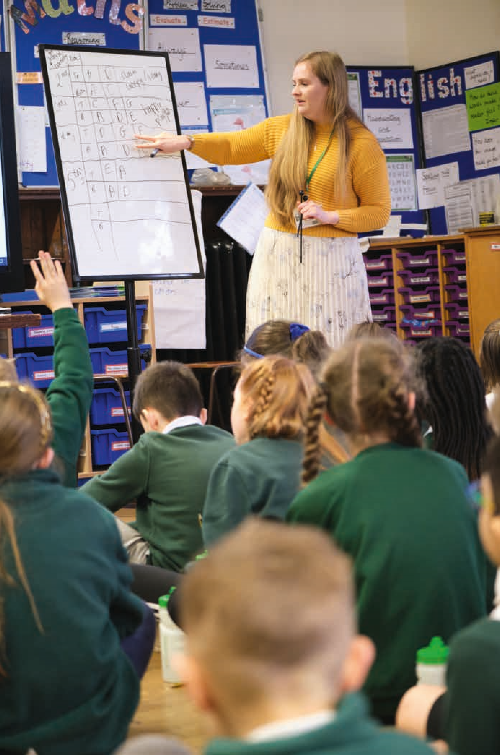

Thinking about setting composing briefs/tasks

Once you have established the learning context and decided which of the four approaches the children’s composing is going to take (Topic, Event, Music or Own Intentions) you will be ready to start to design a composing brief.
A composing brief is the set of instructions or ‘recipe’ for a composition. It is the term used when professional composers are commissioned and describes characteristics such as duration, instrumentation or occasion, among others. In the classroom, setting the composing brief or task is an important part of the teacher’s role and can be broadened to include parameters such as theme, style, initial musical ideas.
Tight/closed brief/task
Setting a composing brief’ is when you decide what decisions you will make and what decisions the children will make. It is useful to think about setting composing briefs as being on a spectrum – at one end of the spectrum we have tightly framed briefs in which the teacher is making the majority of the decisions and at the other open briefs where the children make most of the decisions. There is a place for both, but it is important we understand the implications of where on the spectrum we decide to place our activity in terms of pupil ownership, learning outcomes, creativity, pupil engagement, teacher role, task management, style/genre. The table below sets out some of those implications:
Pupil  ownership | Not much pupil ownership | Pupils have strong sense of ownership
Learning outcomes | Teacher has more control over learning outcomes and specific  skills can be taught | Teacher has less control over learning outcomes. Learning is more individual, diffuse and non-specific
Creativity | Not much opportunity for creativity | Lots of opportunity for creativity, experimentation, risk taking
Pupil  engagement | Students can feel secure and have clear tasks | Students may feel lost, unsure what to do or have too many ideas
Teacher role | More teacher centred teaching style (direct instruction, modelling) | More pupil focussed learning style  (scaffolding, questioning, feedback, activities to stimulate creativity)
Task  management | Pupils move thorough the activity/ process together | Pupils move through the activity/ process at different speeds
Style / genre | There is the opportunity to introduce pupils to music in an unfamiliar style/genre | Pupils tend towards music in a style/genre they know
This table first appeared in Evans, N. & Spruce, G. (2023) ‘Chapter 6: Exploring Composing’. In Cooke, C. & Philpott, C. (Eds), A Practical Guide to Teaching
Music in the Secondary School (Routledge Teaching Guides) pp XX
Loose/open brief/task
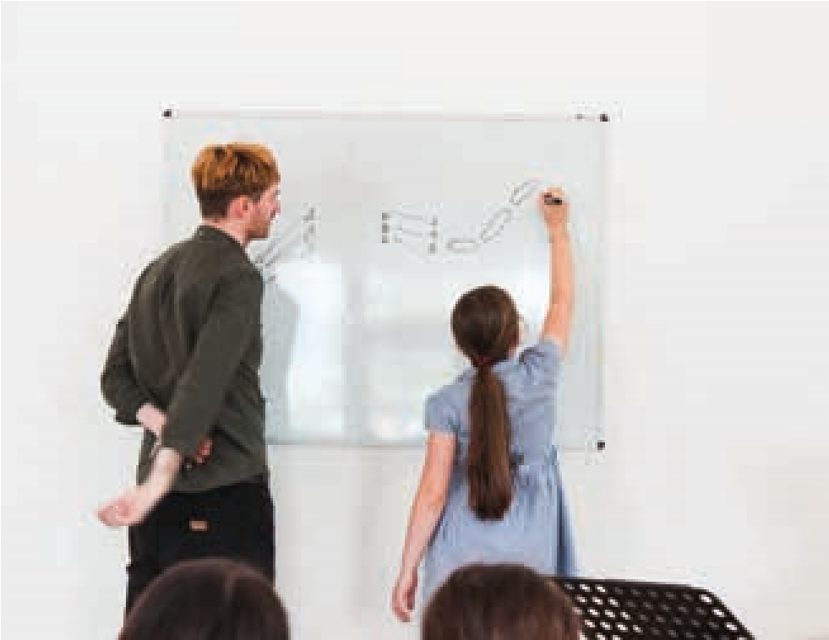
There can be a tendency in teaching composing to gravitate to the extremes of the spectrum where, at one end, composing is reduced to a painting by numbers exercise, and at the other, little guidance or intervention from the teacher takes place. Operating at both extremes can cause a disconnect with pupils.
We want to encourage you to take a more thoughtful and nuanced approach to framing the composition briefs you give your pupils. There is also a wide middle ground to be explored, in which some parameters are thoughtfully set by the teacher to achieve certain learning outcomes, but which leave open space for pupil creativity and ownership.
Like professional composers of all genres, some of your children will enjoy open briefs in which they make most of the decisions and feel it gives them free range for their creativity while others will prefer having parameters to work to and find that the limitations stimulate their creativity.

Some reflective questions
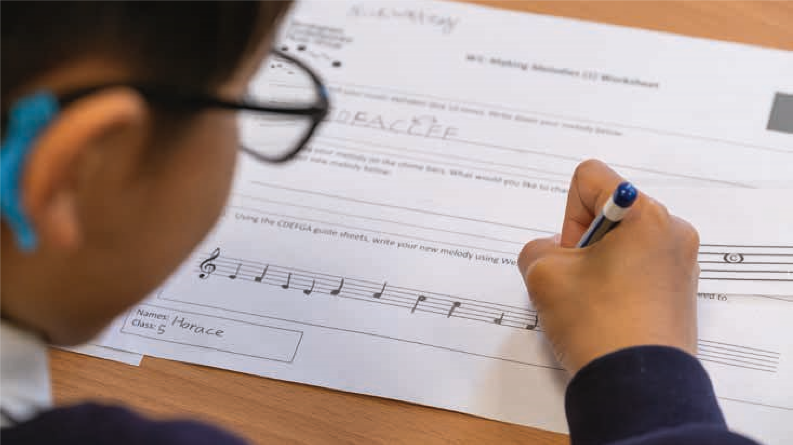
Look at the composing tasks and briefs you set your children and reflect on them in the areas suggested on the previous page.
- Do you know where on the spectrum your composing brief/task sits and what you are trying to achieve with your children? Or whether it is appropriate for your desired learning outcomes?
- Do you offer your children a range of open and closed briefs and tasks? Are you aware which pupils in your class thrive on/respond better to open briefs and which prefer tighter parameters?
- If working with open briefs, what different pedagogies might you need? What role is there for modelling, scaffolding, questioning and feedback techniques?
Thinking about musical instruments, voices, sound makers, technology, software and apps
Thinking about what musical instruments, voices, software/technology/apps and other sound makers the children are going to compose for, and planning your approach in advance, is important and can massively impact on the success of a composing lesson. Most schools will have some classroom musical instruments such as tuned and untuned percussion, access to iPads or laptops and maybe some of the children will be a learning a musical instrument.
Below are some ideas and suggestions to consider:
Sometimes invite children to compose for a particular instrument(s) and sometimes let them have free choice
Chose instruments you think would be appropriate to the task but welcome unusual interpretations and choices
Don’t forget that everybody has a voice, can use body percussion or use objects that make sounds to compose with and for
Know your instrument cupboard or trolley
Sometimes give individuals or small groups similar instruments/sounds makers to allow them to compare and contrast
different ways of using them when composing
If you are exploring music Invest in good If children are
from other cultures, think learning an
about whether the sound beaters – this instrument including resources (instruments, can massively through WCET or voices, technology) you learning outside
are providing will enable help with noise school, invite
the children to be able levels them, and their to compose within that classmates, to musical style, genre, compose for these
culture? And if not, how Encourage children to find instruments might you get close to many different sounds replicating this? and musical ideas on one instrument. Getting Invest in
to know an instrument tuned
Invite children and its affordances is an important part of percussion to compose composing.
for school music ensembles Invite children to compose for visiting and choirs musicians including instrumental teachers
Connect with your Consider how Consider the peripatetic instrumental the instruments/ type and teachers and see what
composing they might ^{sound makers/} distribution of
be doing or could do. This voices that the
can help bridge the gap children use will instruments that
between instrumental impact on noise would allow learning and classroom
music _{levels} children to scale
up small group or individual
Music software and apps can be an effective way pieces into
into composing for some children allowing them to
manipulate musical material in imaginative ways whole class without the need to play an instrument pieces

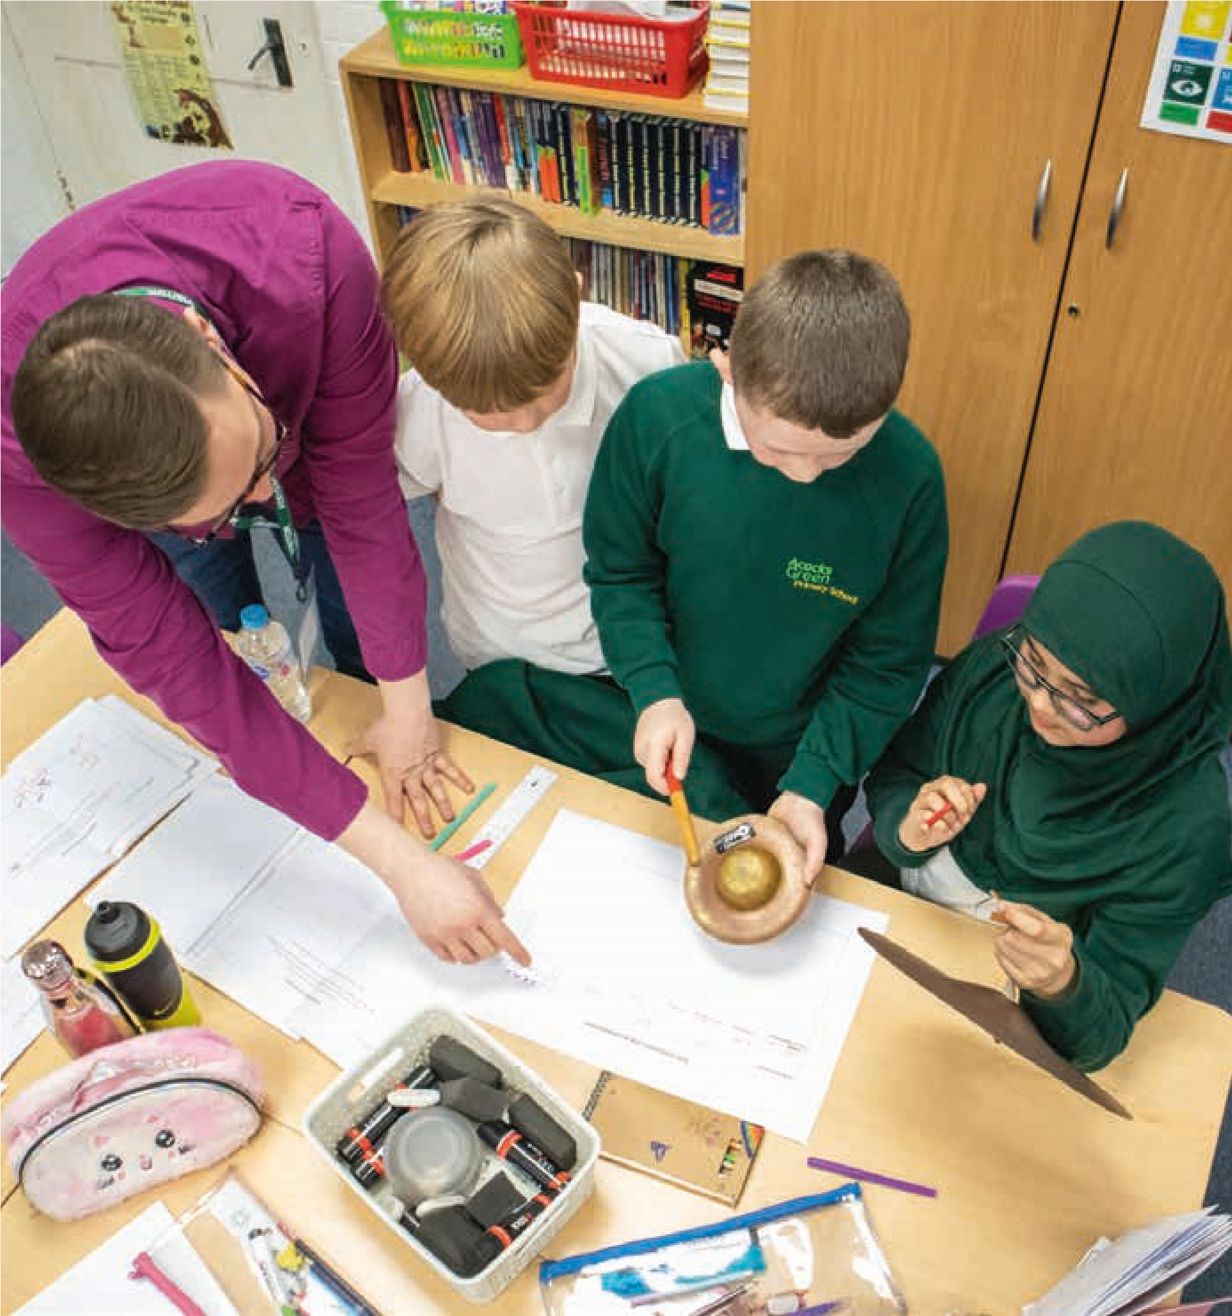
When I’m composing it makes me feel excited
for what it could actually be in the end.
It makes me feel proud.
Young person
What does a good composing lesson look and sound like?
- All children are engaged in the composing task.
- Everyone is engaged in composerly thinking and doing not just a few
- Children are engaging with sound before symbol
- Connections are being made between composing, performing and listening activity
- Current learning is being connected with past learning
- Children are encouraged to share their ideas
- Children are encouraged to engage and be playful with sound
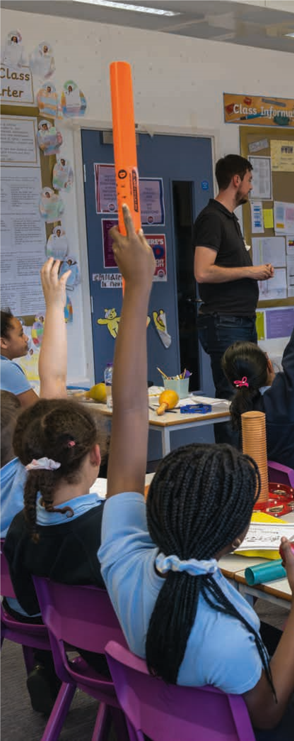
- Small group work is purposeful and the children are supported to work together
- Rich (technical and imaginative) vocabulary is used to describe and talk about the music being created
- Children have an understanding of where they are in the composing process
- There is a balance between making space for quality listening and the busy hum of children making music
Listen Imagine Compose Primary raised the expectations of teachers as to what children are capable of achieving in composition. Headteacher
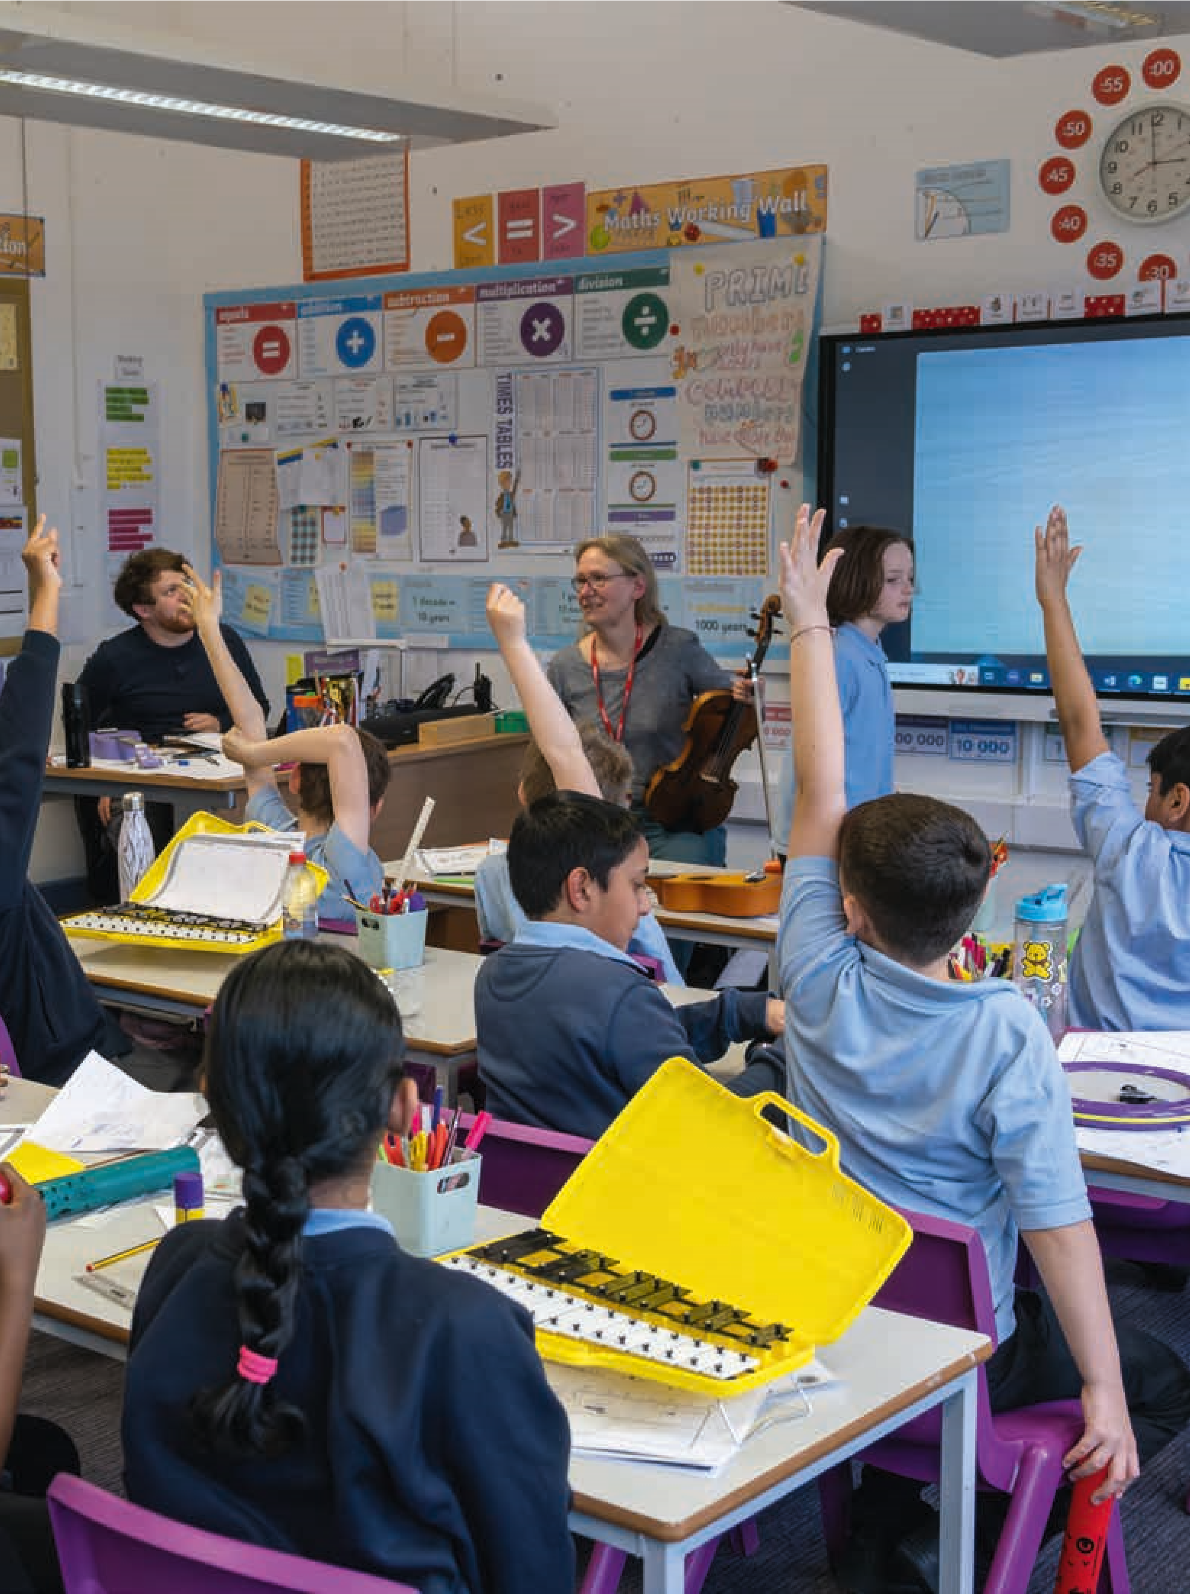

Building a community of composers

in your class
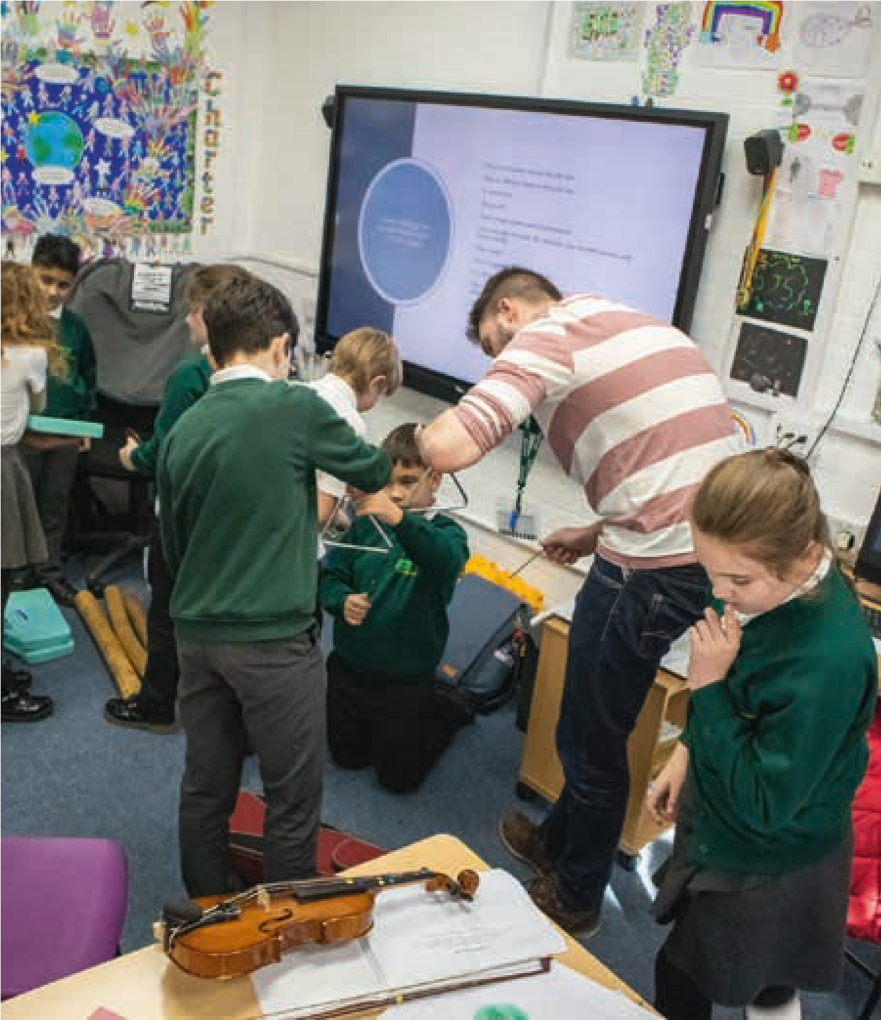

Encourage children to

Plan for a mix of individual,
experiment and take risks small group and whole class composing Promote an ethos of no right or wrong way to do Encourage children to
something compose for instruments
their classmates are
- Where possible, welcome learning and workshop ideas children diverging from your together
plans
- Think of real-life purposes See the children as individual for the children to composers with their compose for
own pathways, identities,
interests and imagination Learn from observing
and listening to children
- Focus on process not the composing – what do they final product talk about in small groups?
What questions do they
- Ensure a mix of working ask? What kinds of ideas do from given starting points, they produce? What ways children’s own ideas and of generating, developing, ideas arrived at through organising and ‘notating’ whole class and small group ideas emerge?
discussions
- Slow down and do more of less
- Provide a musically rich environment including regularly listening to and discussing a wide range of music
- Help the children to make connections between different musics and their
own
- Help the children to build a vocabulary for talking about their music and the music of others
- Try to make the best use of any additional spaces you might have to help noise levels including outside spaces
- Create quieter thinking and planning time away from instruments
- Think about setting up a separate space where the children can independently record their music
- Make opportunities for the children’s music to be performed, presented and listened to by a range of audiences across a range of contexts
- Identify cross-curricular opportunities for composing
- Understand that a creative environment might sound and look messy and noisy
- Support children to experiment with making sounds on a range of instruments as well as other sound makers (including everyday objects) in their classroom and wider environment

Promoting composing across

and beyond school
- Raise awareness of what children are capable of regarding composing
- Advocate for why composing is important in addition to and as part of learning an instrument
- Run professional development sessions for teachers in your school exploring composing
- Make sure you have, or lobby for, quality musical instruments
- Make opportunities for children’s compositions and composing to connect with and celebrate school life
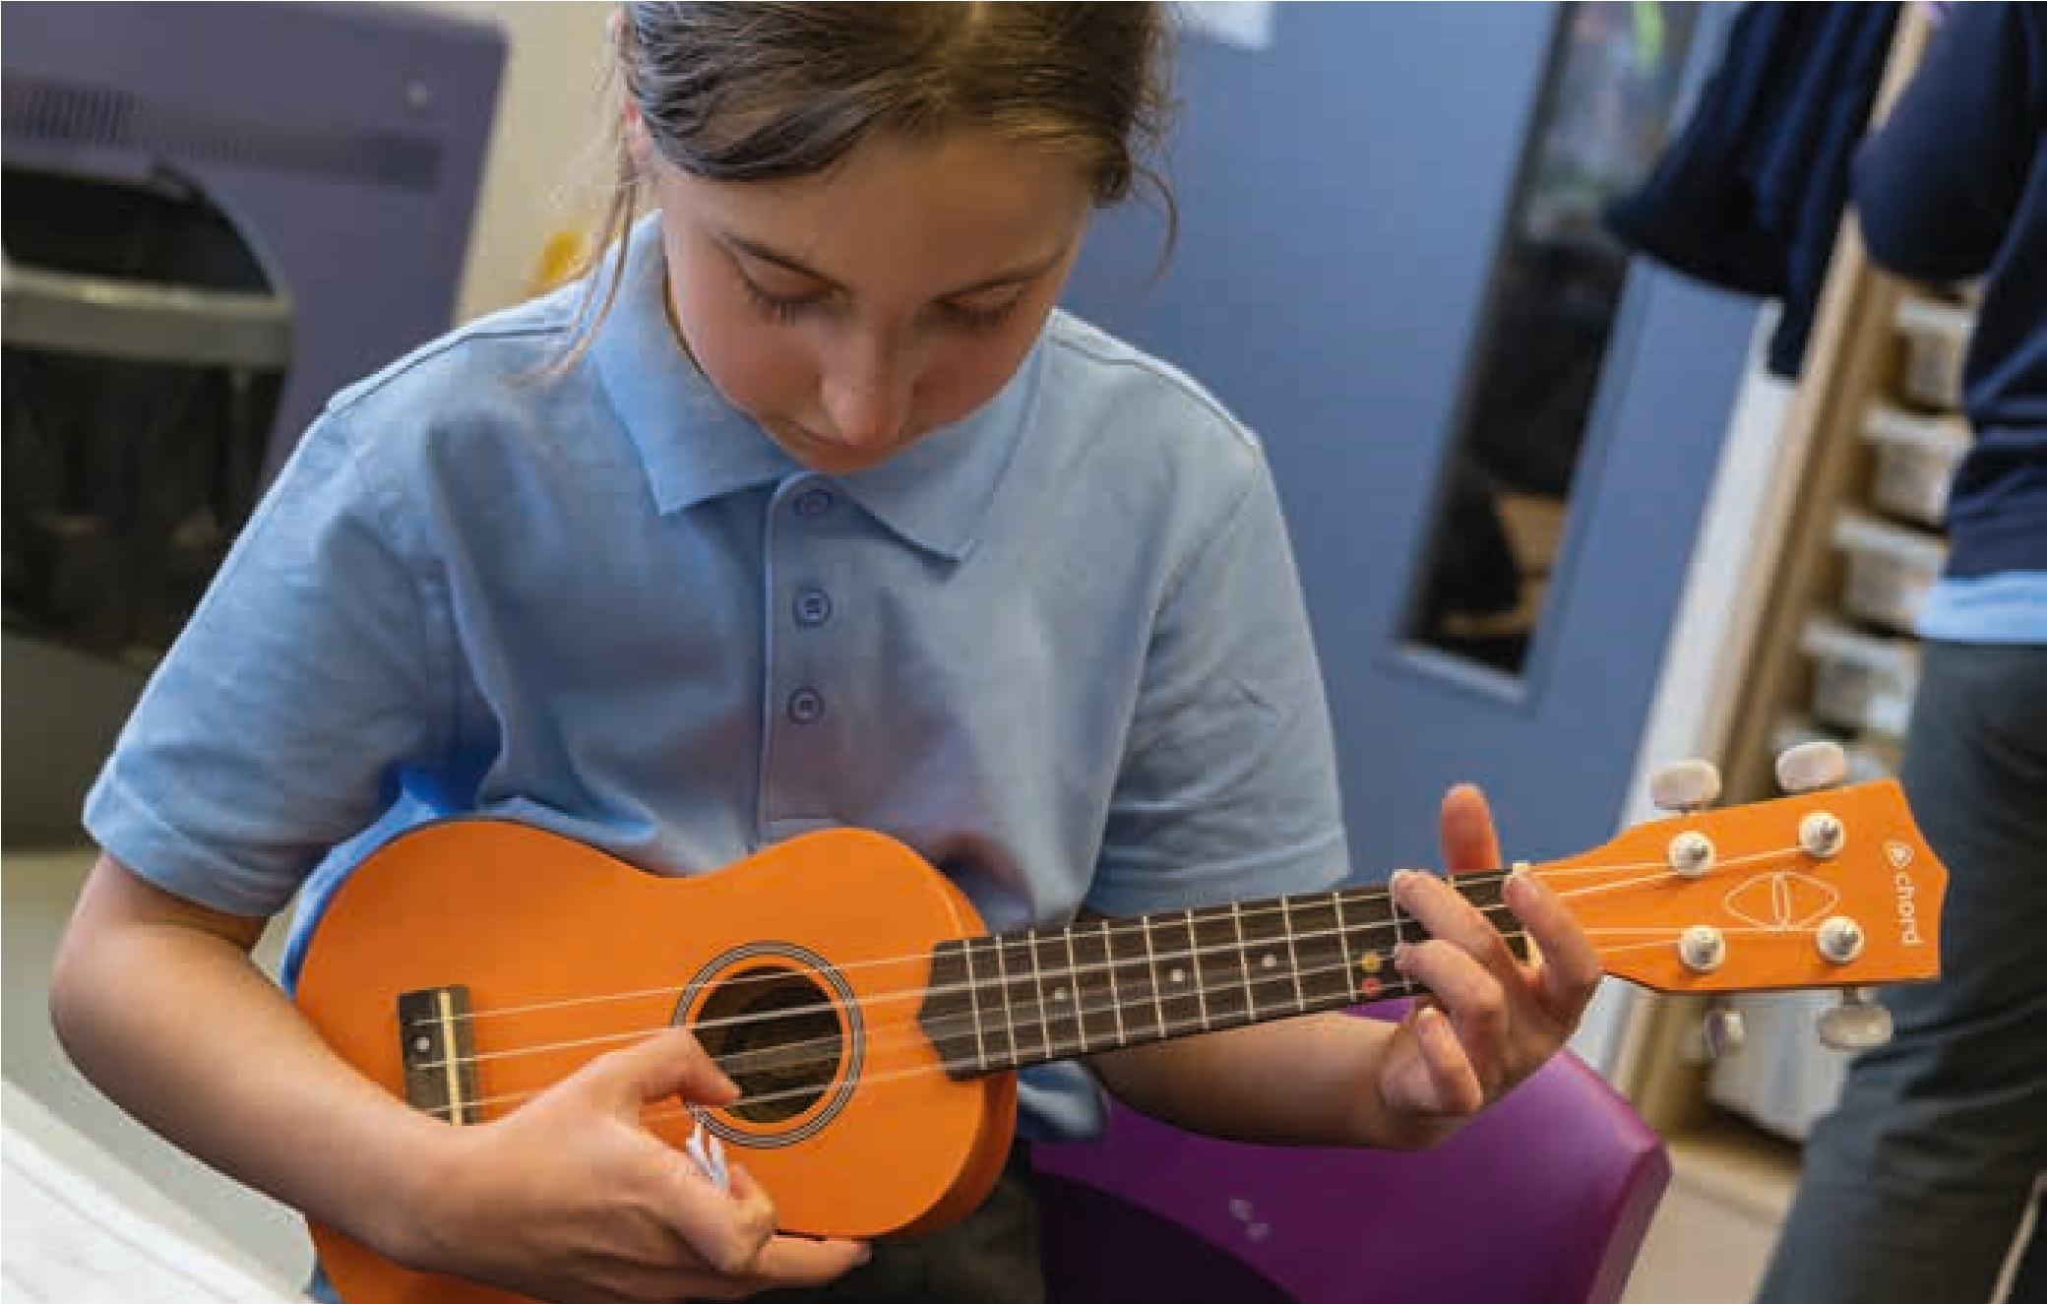
- Encourage teachers to invite their pupils to compose for school occasions
- Share children’s compositions through school assemblies and concerts for families, friends and the wider community
- Share children’s compositions through the school website, recordings, playlists, podcasts, reception room music
- Start an afterschool composing club
- Talk to visiting peripatetic teachers about including composing as part of their offer
- Talk to your Music Hub about local composing opportunities for children and young people
- Invite professional composers to visit your class and school

You can create, you can scrap stuff. Young person

4.
Guiding children through the composing process

This section examines how children can be supported at each stage of the composing process from creating initial musical ideas through to a final polished piece of music.
Composing is a process with distinct stages like any other creative activity – for example writing a story or a poem. The composing process for children we present in this toolkit is just one model.
Composing is not a linear process but one which involves circling back, refining and returning to previous ideas. When we plan composing activity for children we need to plan for these possibilities.
The model we present takes the approach of building from small ideas and expanding these through extension, development and adding new ideas. However, sometimes, children may take a different approach, presenting ‘finished’ short pieces at an early stage. Even when this is the case, much of the guidance given in this toolkit is still relevant and the children can be supported to develop these embryonic ‘complete’ pieces further.
Additionally, we encourage you to take an approach where children are supported to move between individual small musical ideas and the bigger structural planning i.e. thinking about and planning for the overall structure of their composition. You could describe this as moving between the micro and the macro. As explored previously, music is not constructed by putting one note in front of another in a linear way, but through creating webs of interconnected material – organising, layering, collaging them into larger meaningful structures. It is also important to note that there is no one right way to do this.
What is important is that, when composing, the children use their ears to make decisions and choices about how their music should sound and evolve rather than through a given arbitrary technique or process.

LICP made me realise how much emphasis had been on the performance aspect of music previously and although there were elements of composition, these were very structured and scaffolded and limited children’s creativity.

Teacher
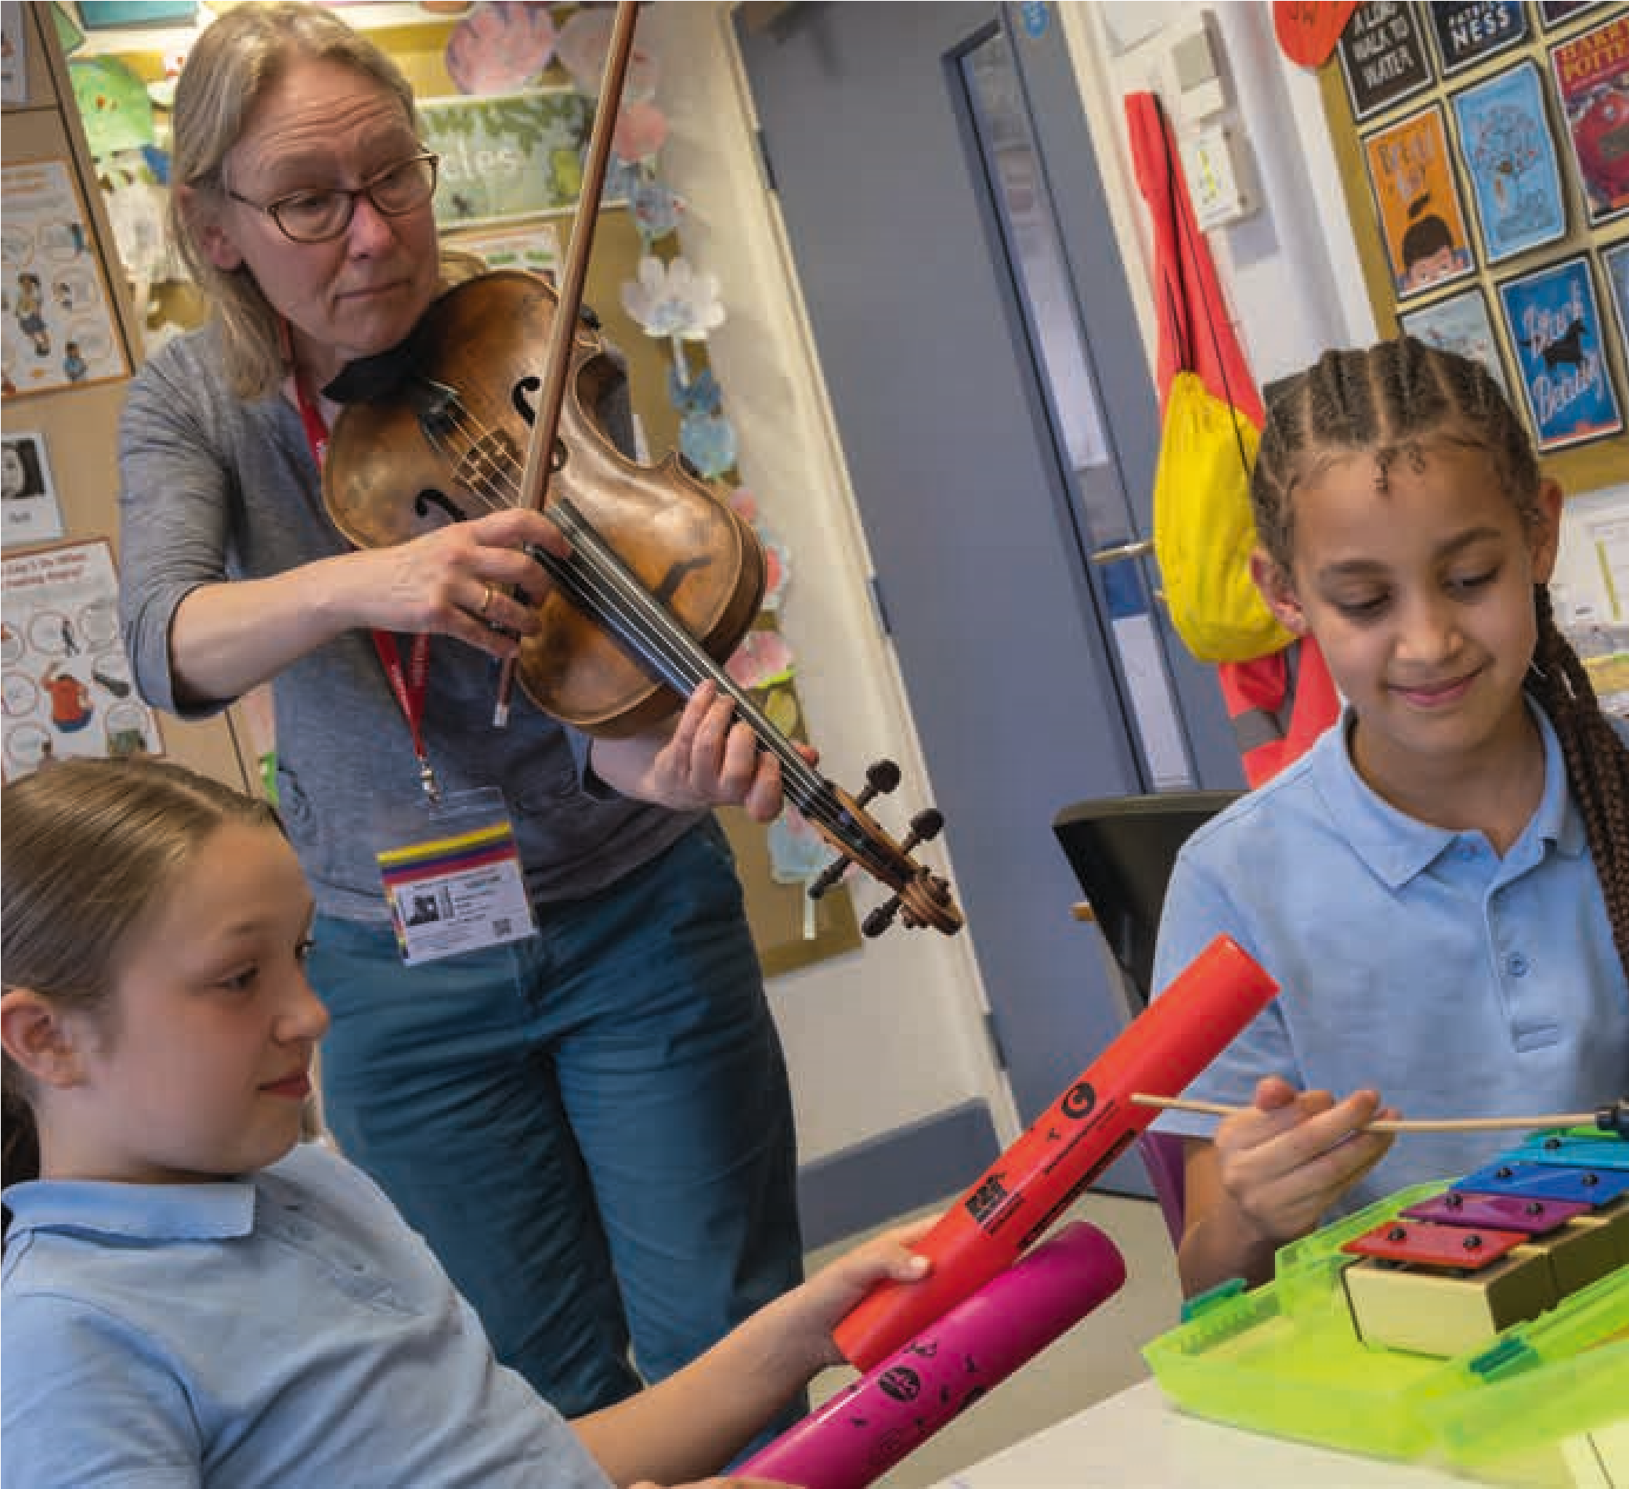
How can we prepare for children’s composing?
Once the composing learning context (page 23 and 24) and the composing brief/task (pages 26 and 27) have been established, planning for how to prepare children for composing can begin. Well-conceived preparatory activities create a fertile ground for children’s ideas to emerge and support them to imagine and embody initial musical material. Sometimes preparation will be musical, sometimes more general research and exploration and sometimes a mixture of both. This preparatory phase is important and needs to be given due time and attention as it helps children to take ownership of ideas and creates a reservoir of ideas they can come back to throughout the process. The suggestion list below is by no means exhaustive.
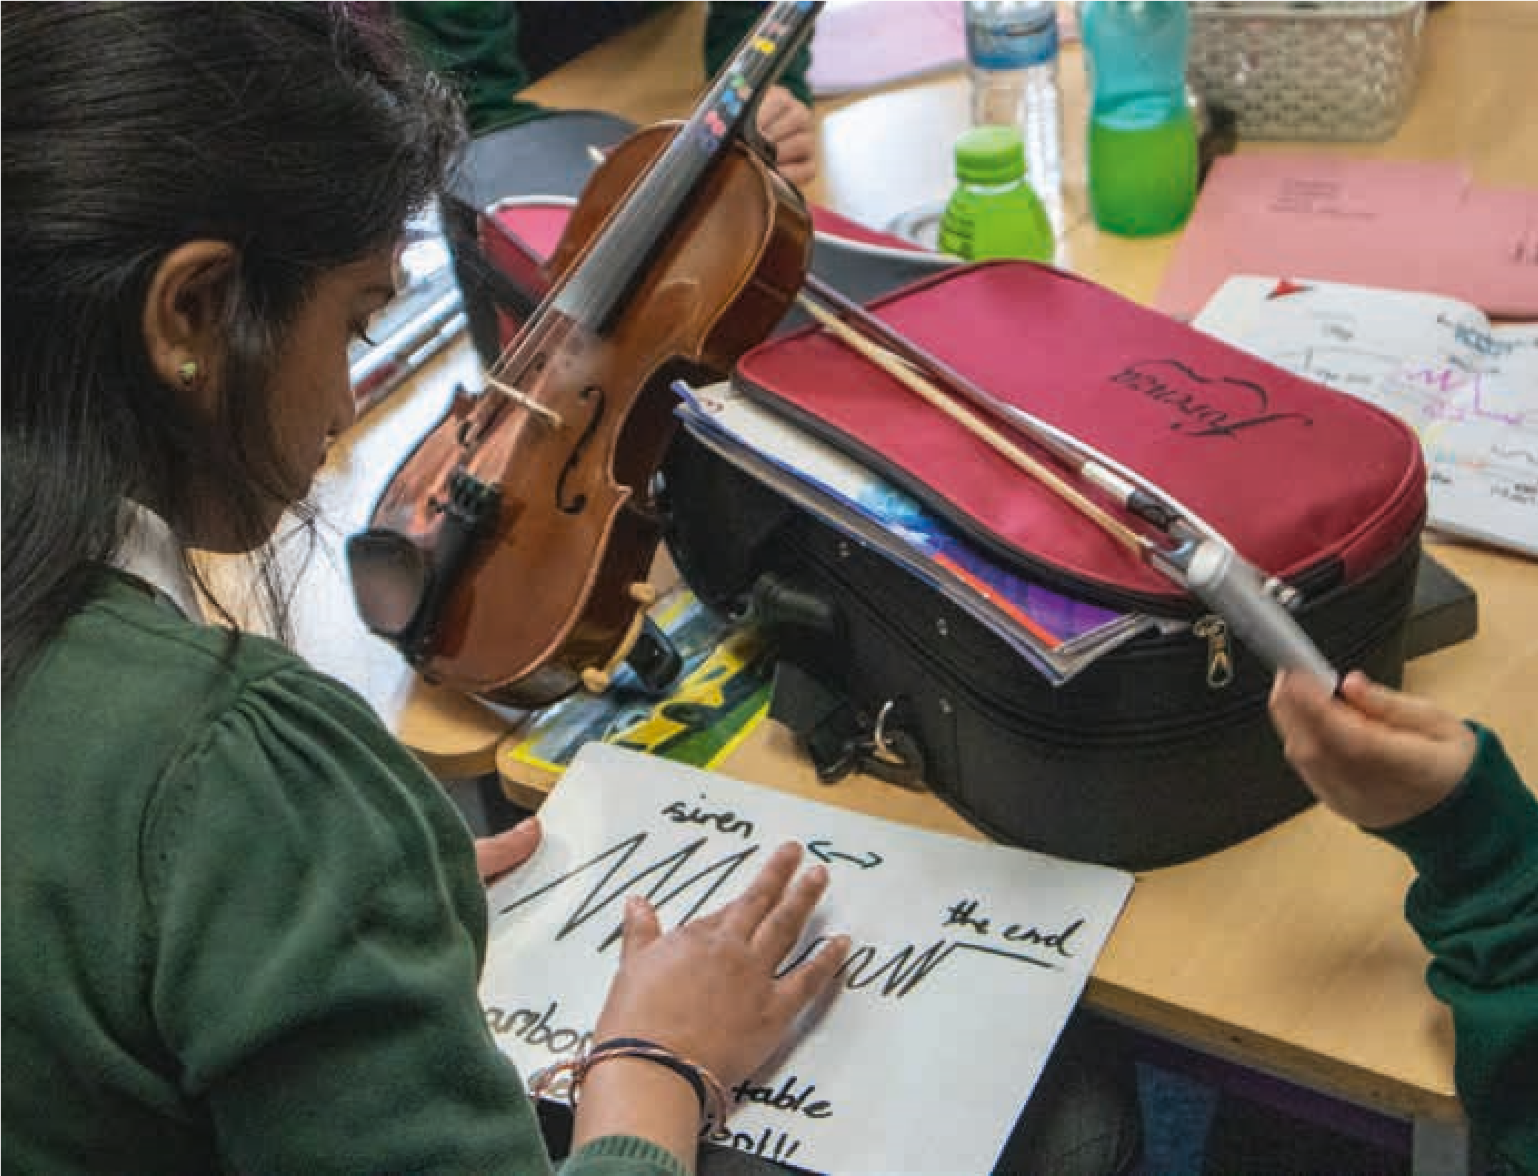
Listen Imagine Compose Primary has encouraged me to take more time over musical exploration and to be confident that sometimes ‘less is more’ when it comes to composing. It was great to see children wanting to develop ideas and to see how they responded to tasks in their own ways. I appreciated seeing how lessons were structured and how outcomes were evaluated and then used to consider the next phase of compositional development. Teacher
Preparing for composing
What is the learning context?
The composing
brief
What opportunities for learning
does this context offer?
Children start composing initial musical ideas
Non-musical preparation for composing
Musical preparation for composing
Immerse self in topic
Do research on topic
Think about the occasion
Think about the character
Visit a place
Observe natural phenomena or scientific
processes
Find out and explore other art form techniques
Create images, photos and or shapes
Look at, images – paintings, drawings,

sculptures, landscapes, photographs
Watch film clips or animations
Create or observe movement/dance sequences
Read poems, stories and other texts
Go for a walk, sit under a tree, doodle

and see/hear what ideas emerge
Make mind maps of the above
Think about how extra-musical ideas

could be used musically – as structures,
gestures, textures, rhythms
Play warm up games
Go on sound walks – imaginary and real
Learn a melody, a rhythm, a technique, new notes
Learn a new piece – discuss and

explore its musical features
Learn a new composing technique
Free improvisation
Guided improvisation with given notes,

melody, rhythm, technique
Explore and learn about the possibilites of
instruments, technology/software/voices/
soundmakers
Listen to recordings of music
Explore and discuss ideas from the above
Listen live or to recordings of soundscapes
Record sounds
Listen to live musicians – in class, visiting
Make a collective or individual library/bank of
notes, interesting sounds etc.
How might children generate musical ideas, what might they sound like, and how can you help?
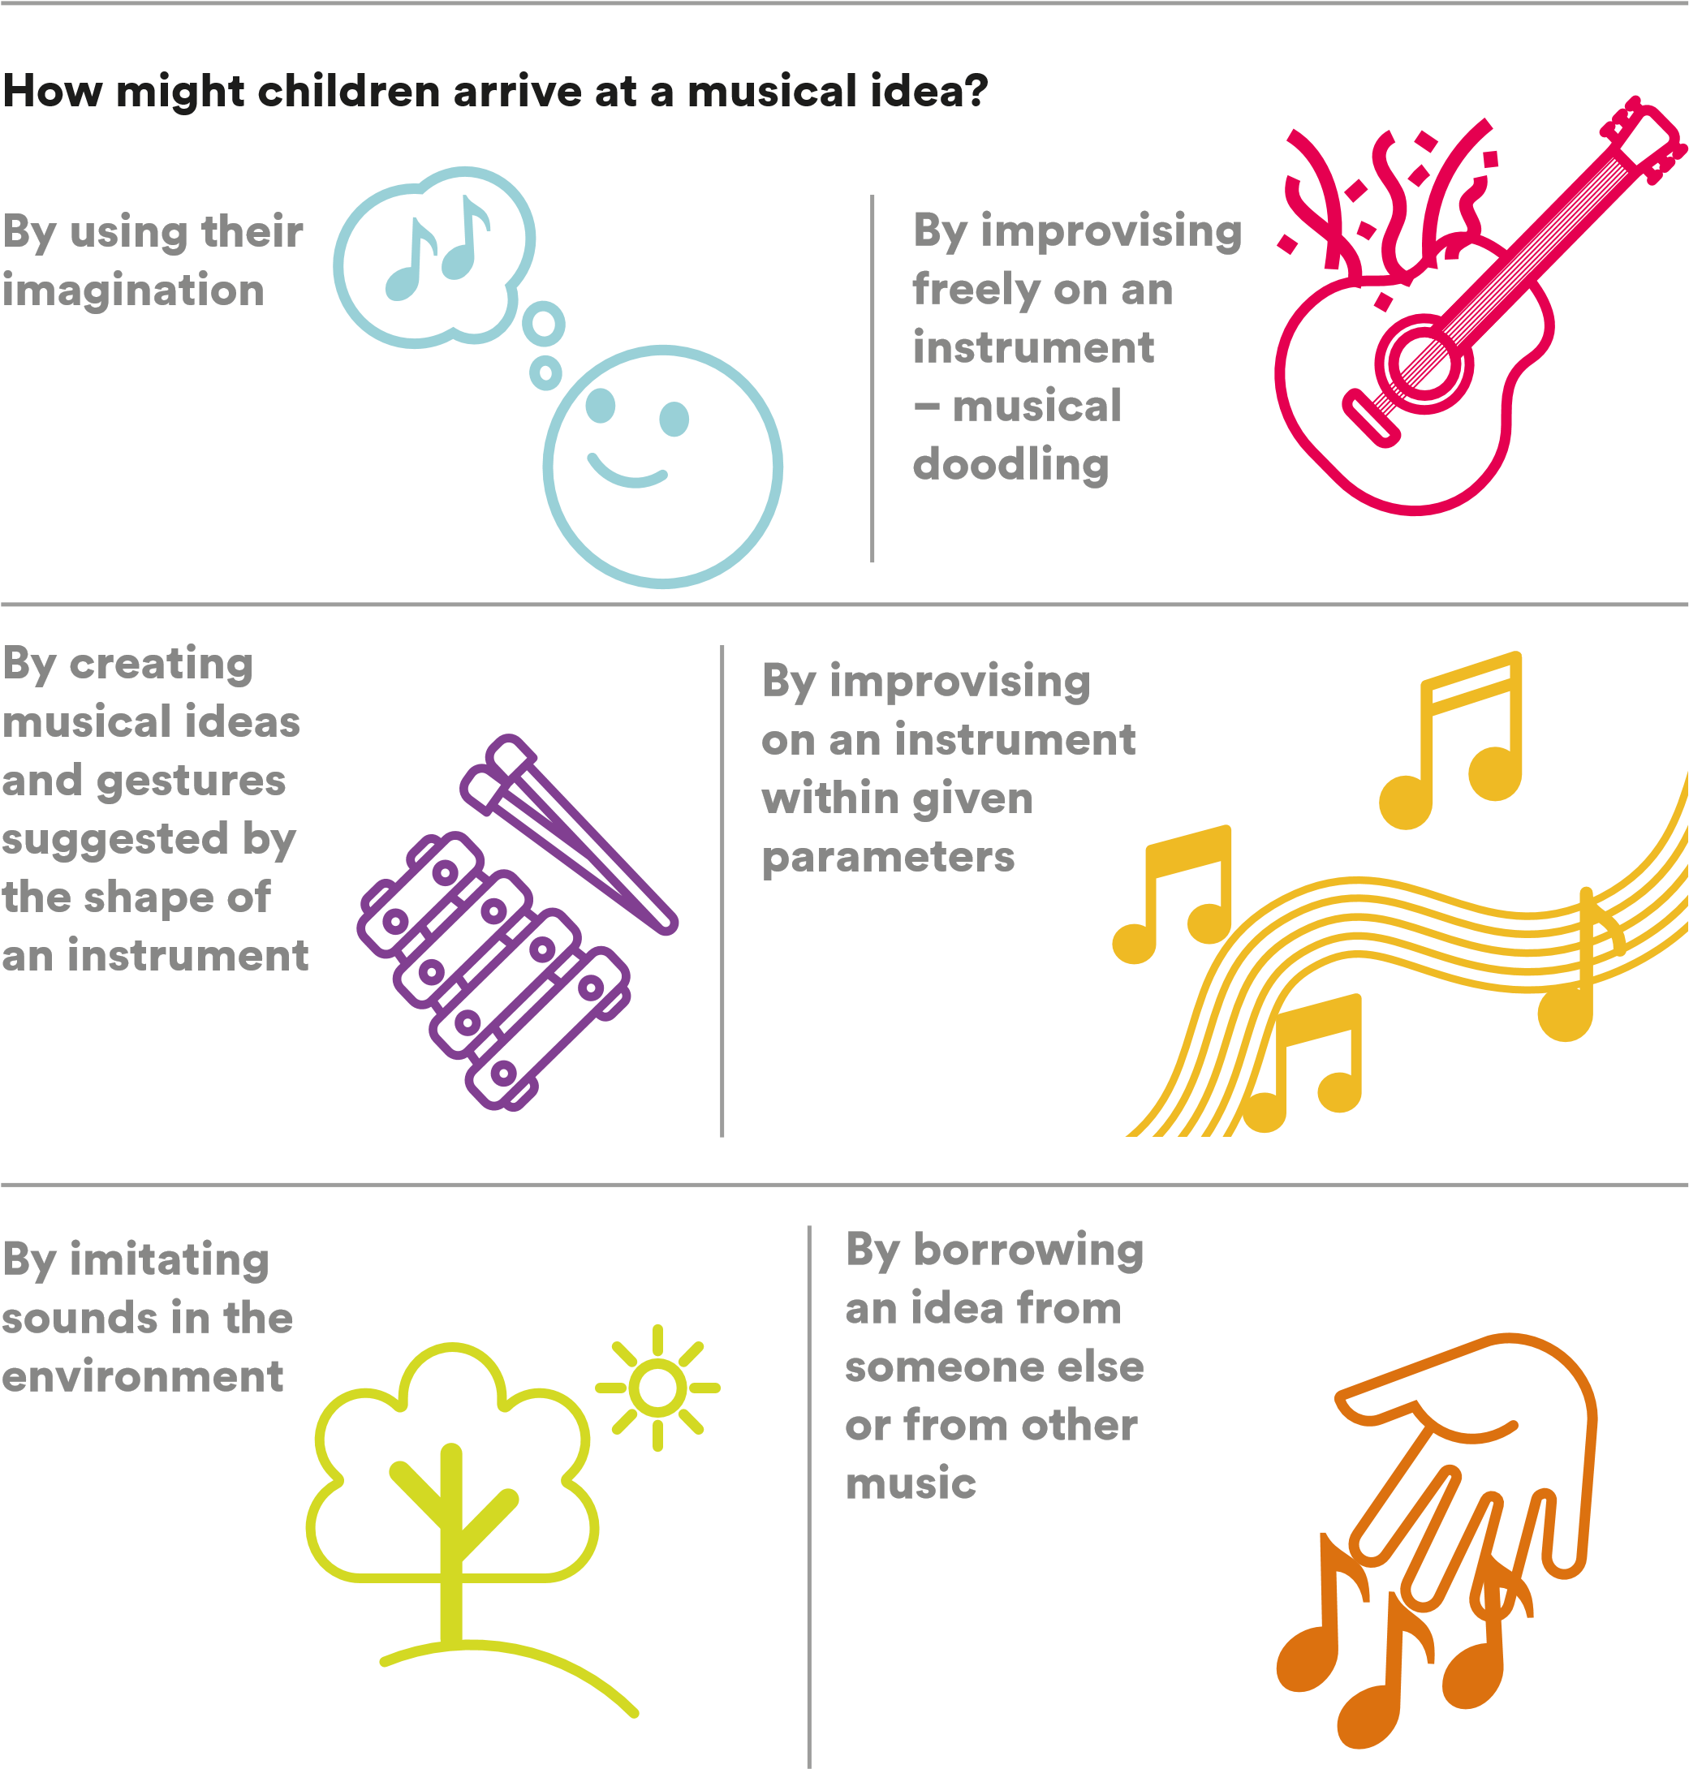

Create a musically rich Ensure there is time for children
environment of playing to explore musical instruments or _{other sound makers before they}
instruments and using compose for them voices
Acknowledge and value Listen to a Sometime give
children’s musical ideas children pre-existing even if different from our wide range _{musical ideas to} own conception of what a of music with ^{work with} musical idea might be

the children
Invite Encourage children Give children children to borrow ideas from parameters and to share music they know as a limitations to work and pool
starting point ^{within} initial ideas
Listen carefully to children’s musical ideas,
even when a bit of a jumble, Encourage, invite and make and help them to pick out time for children to share and
clear ideas which they can
use in their composing pool their initial ideas
Encourage Invite the Learn from other children to children to composers about ‘distil’ the idea talk about where they get their
and give it a their ideas ideas from
– ‘tell me
clear character about….’
Ensure there is lots of thinking, imagining and mind mapping time away from instruments
A sound
A melody
A rhythmic
pattern
A structure
A musical
gesture
A texture
What can I do to help?
What might
initial ideas
sound / be like?
A mini
piece
Create opportunities for different ways to arriving at an idea. Encourage children to generate many responses to a single starting point not just one
Support children to break down longer musical ideas into shorter ones
Recognise that different children at different times might use different methods
Discuss with the children what a musical idea might sound like

Listening and responding
Ideas suggested in this section can and should be used throughout the different stages of the children’s composing.
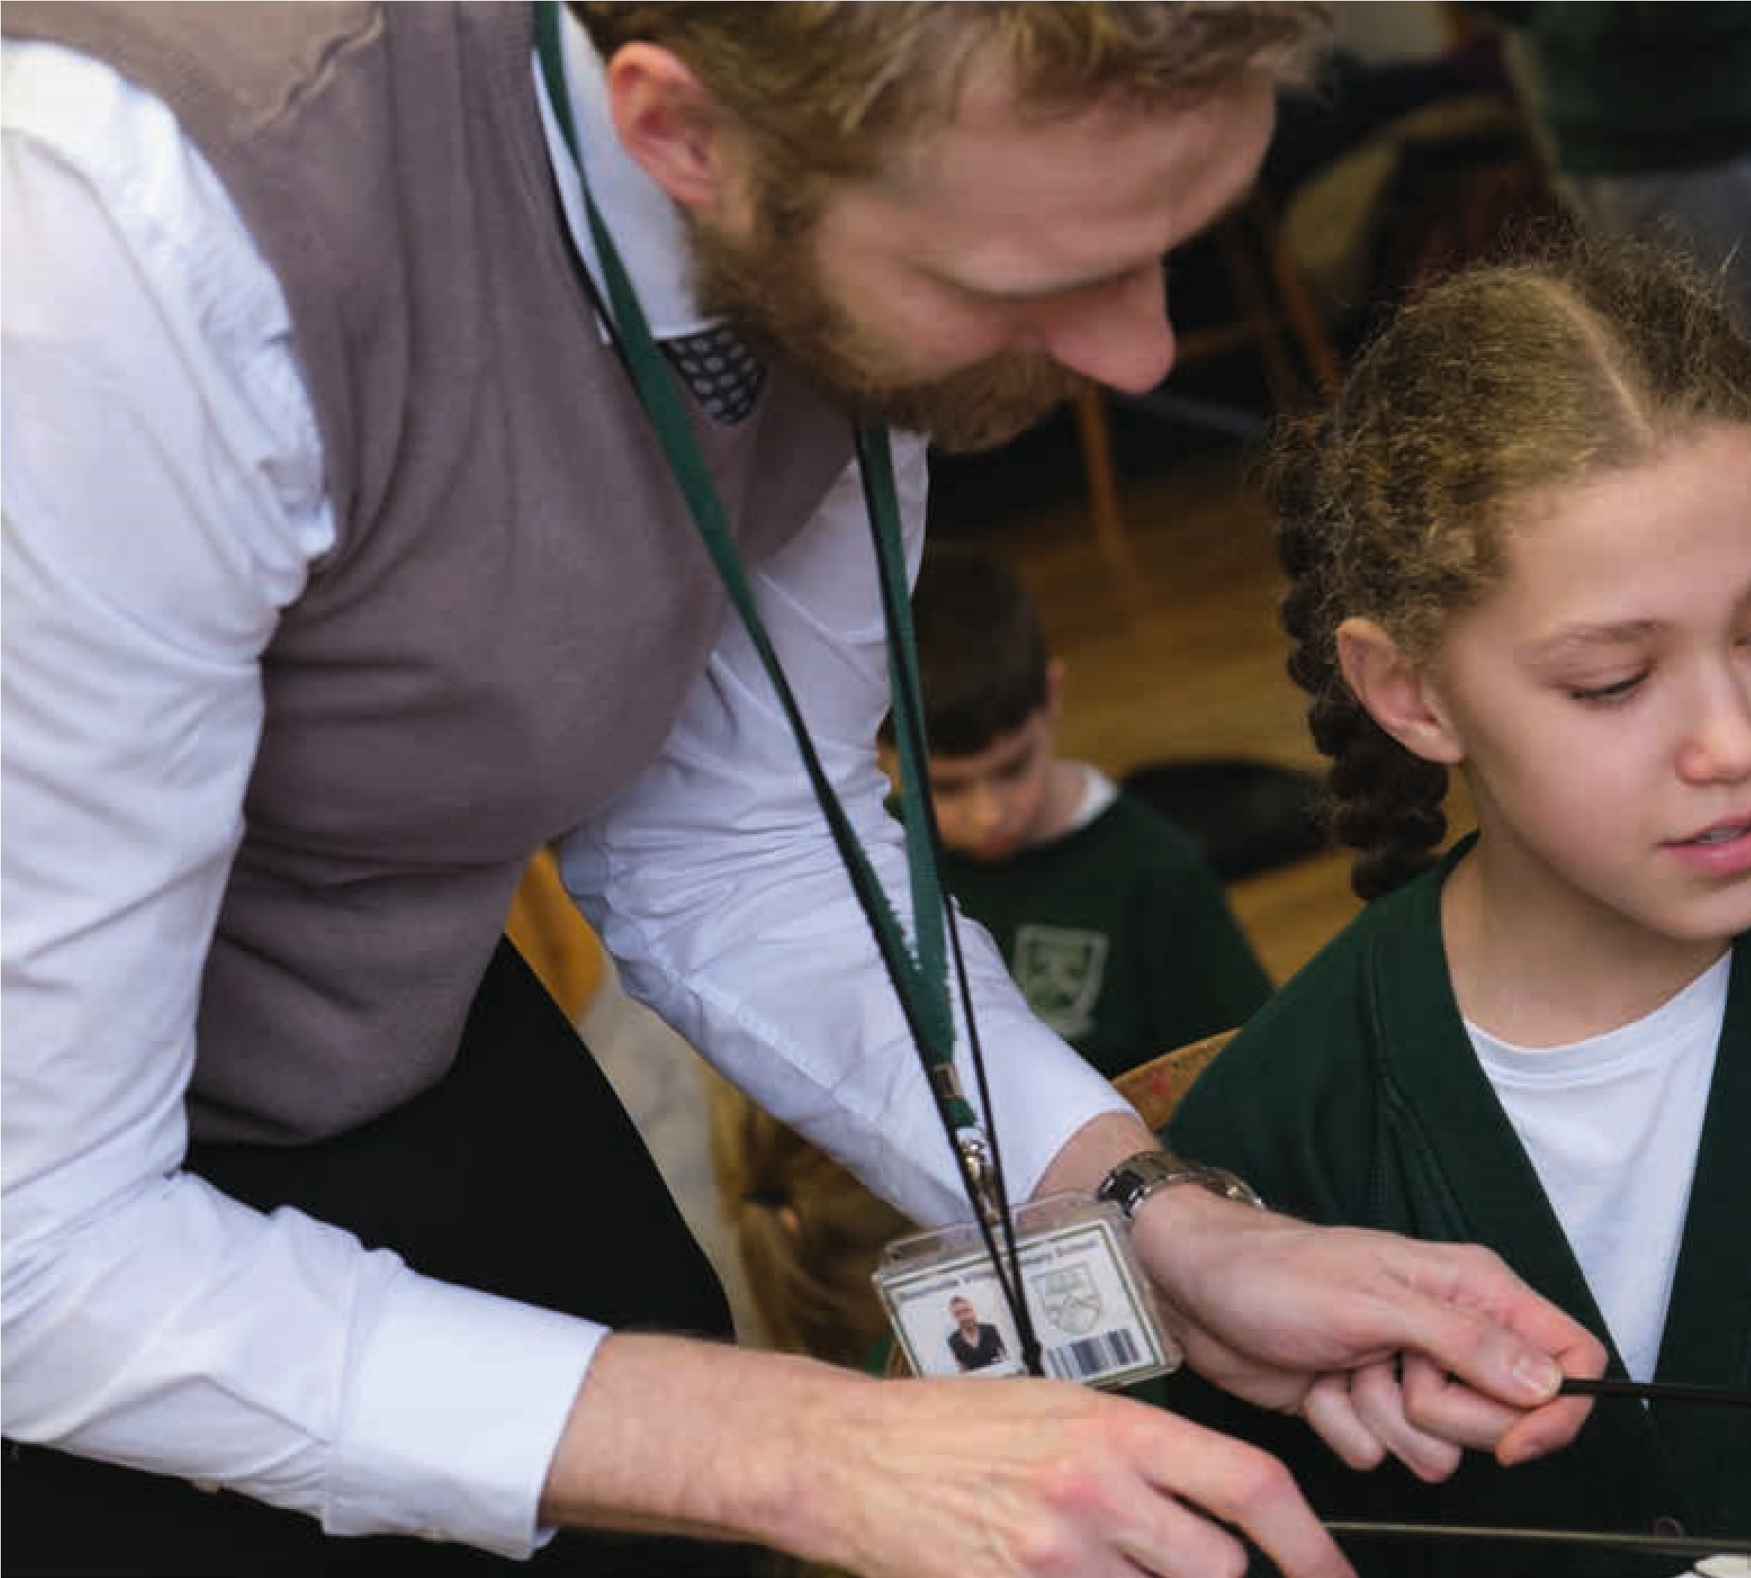
Feedback and reflection support children to develop and refine their musical ideas and helps them build a vocabulary to talk about their music and composing processes. By developing a vocabulary and library of musical features, compositional techniques, processes, concepts and ideas, children build their own internalised composing toolkit which they can draw upon in the future.
As well as creating space at the end of sessions or after specific tasks to share and reflect, pausing the process and doing work-in-progress ‘sharings’ can highlight interesting approaches and or allow you to make important points.

Children are a lot more creative than they often get credit for and if they are given an exciting brief, with lots of opportunities to test and try out their ideas, they will do all of the hard work themselves! Teacher
Some useful principles to remember:
- Don’t be shy to use musical terminology but make sure to explain any unfamiliar words.
- Be imaginative with your language and use the young people’s own descriptions and words. There is no right or wrong way to talk about music.
- Label specific techniques, compositional devices etc. This will help the children internalise them and makes them more likely to use them when composing in the future.
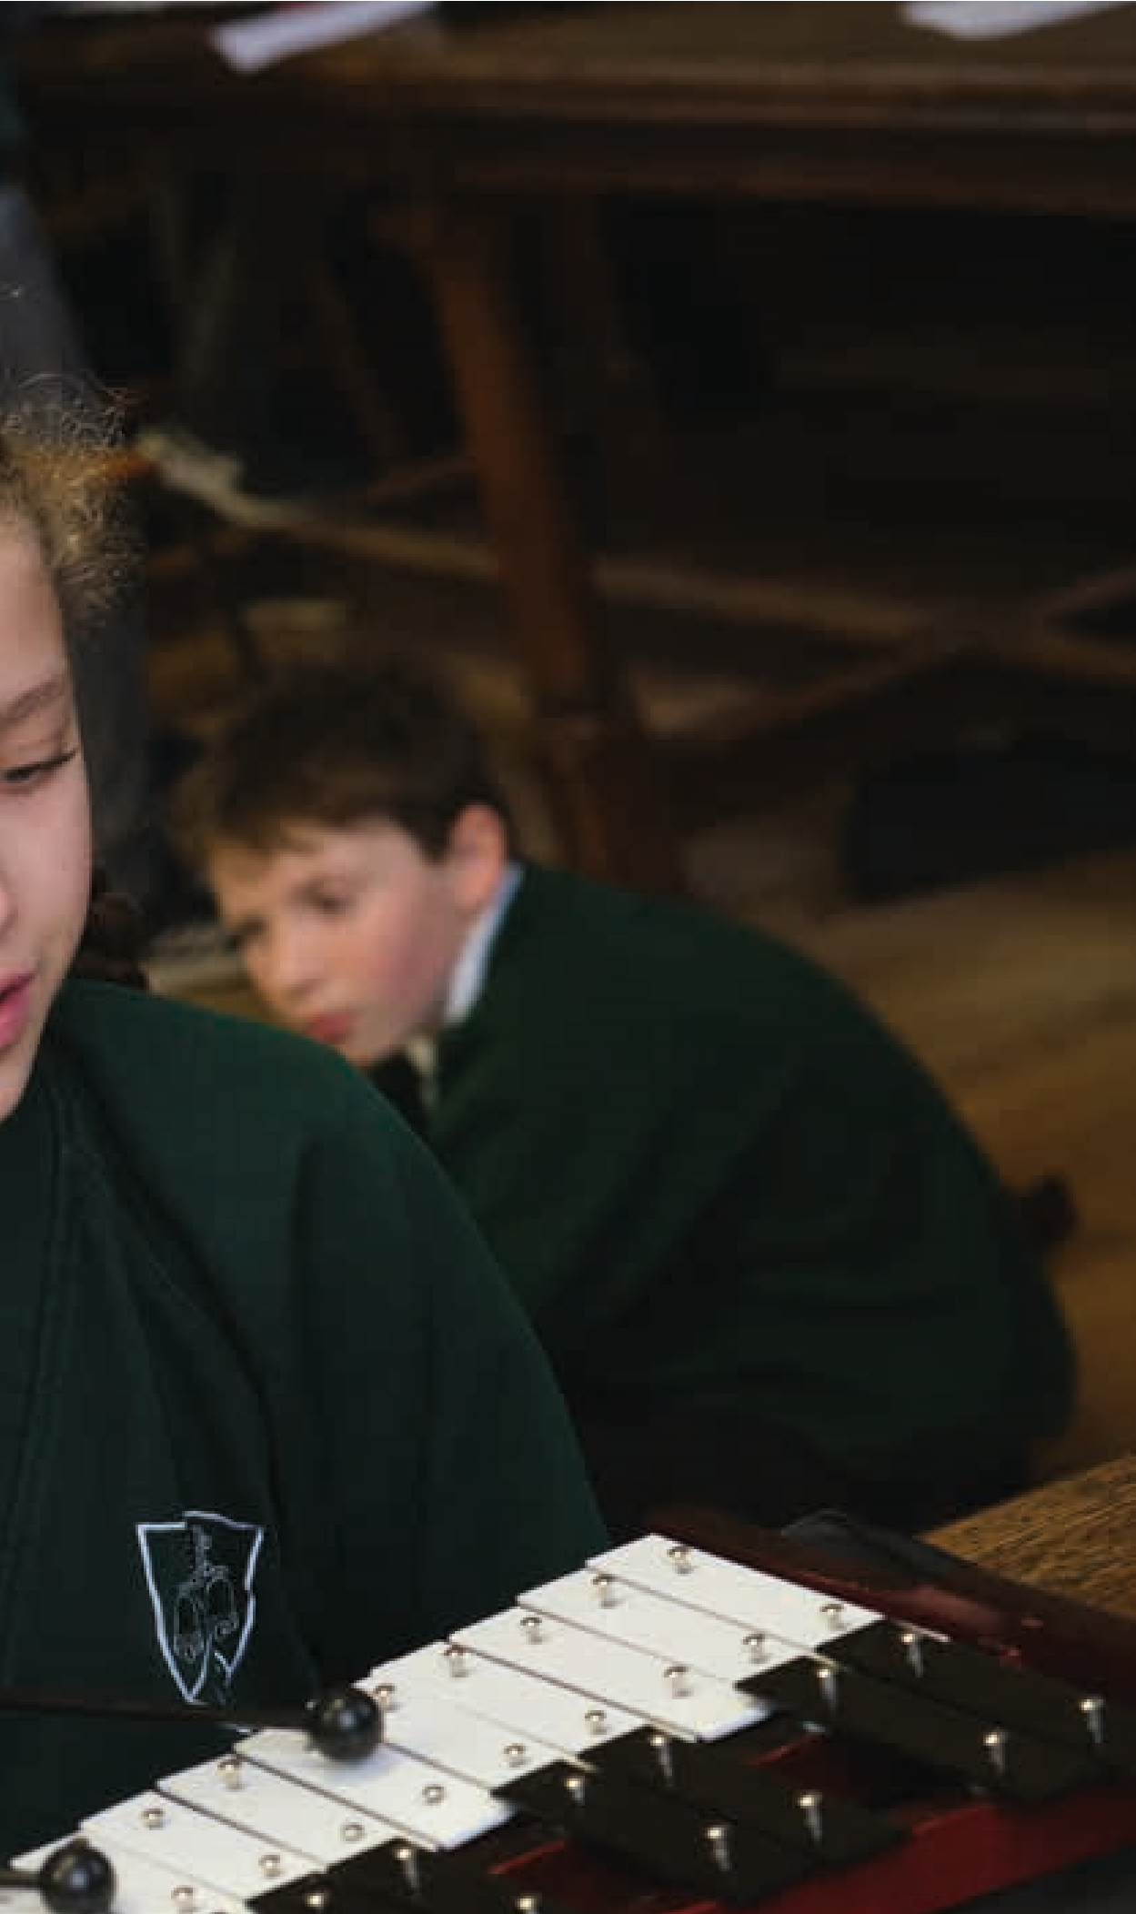
- Invite the children to tell you (and other children) what they have done, how they did it and the choices they made. This will benefit all children in the group and thus build collective knowledge and ways of doing.
When listening to children’s music think about:
- What distinct musical ideas did you hear
- Whether the children are all playing the same idea or different ideas
- How the different sounds/instruments/ musical ideas interact with each other
- Whether, and how, the child(ren) are using the instrument(s) in an interesting way(s)
- Whether there are particularly interesting sounds
- Whether the music stays the same or changes
- How particular musical ideas change over time
- Whether the music has a structure made up of different sections or is the same throughout
- Whether, and how, the music describes what the children say it is about and in what ways it does or does not

How can children be supported to reflect, evaluate and refine musical ideas – their own and others?
Tell me about your music
What is the idea behind your music?
Explain/Describe……..
Why did you choose…?
Can you show me what you were doing?
What is going on at this point?
What do you think was successful?
What do you thinking worked less well?
What changes might you make?
If you had X more minutes,

what would you do?
Questions for teachers and
composer-educators to use to
support pupil self-evaluation:
Can you describe what you heard?

e.g. different sounds/instruments,
(

how the ideas were organised, how

the different instruments/ideas worked
together, use of dynamics….)
What did you imagine, feel when you

heard this music?
What 3 words might you use to describe

this music?
How might you move to this music?
How might you draw this music?
Given what X told you about his music

(
a) what do you think works well?

(
b) what works less well?
Questions for peer
evaluation:
I’ve seen the progress of them [pupils] being able to have more of a refined judgement about whether what they are doing works for them, as to what they want it to sound like, and being able to judge whether it sounds good to them, why it doesn’t, and what to do to change it. I think for me that’s progress in becoming a composer. Teacher
I don’t think xyz worked because……
I can hear…
It sounds like….
At the end, middle, beginning …….
X instrument sounds…….
When X instrument comes in it feels…….
X part sounds….
I think xyz works because…..
Sentence stems for teachers
and composer-educators
giving feedback:
Based on your reflections and what

other people have said, what changes

or additions are you going to/might you

make to your music?
What if you…?
How about trying…?
Can you come up with a solution…?
How about a different idea…?
What would that sound like if…?
How could you…?
Can you produce…?
Sentence stems and questions for
teachers and composer-educators
to support next steps:
How might children develop, extend and accompany their musical ideas, what might this sound like and how can this be supported? How might children develop, extend or accompany an idea?
By being asked  to use a particular  composing technique | By the needs of the narrative/ concept/  structure of a piece | Through improvisation and play | By coming into contact with, or by being influenced by, ideas from other children
or groups

What might developing, extending or accompanying a musical idea sound like?
Playing the same idea on a Adding something new to the beginning, different sound maker or middle and end of an idea
with a different technique
Taking something Making changes to some or Playing the same idea from the beginning, all of the pitches, rhythms or higher, lower, faster,
middle or end of durations slower…
an idea
Adding a melodic or Mixing or combining more
rhythmic ostinato, drone, than one idea chord sequence
What can I do to help?
Encourage children to Introduce and model Give children/groups play the same idea in lots ways to develop, pre-existing musical of different ways and accompany and extend ideas to develop then create a bank of ideas and have lessons discuss the different ways
which solely focus they have developed the
possibilities on this same material

Ask children to Introduce and model clarify their different kinds of intentions so they accompaniment
know why they (melodic or rhythmic ostinato,
might want to drone, chord develop an idea sequence) and have
lessons which solely
focus on this When listening to music
with your children,
listen out for and Encourage discuss how ideas are playfulness and developed, extended or improvisation accompanied. Actively with ideas from
seek music which the outset demonstrates this
Recognise that children might collage ideas or create accompaniments instead of developing ideas
Recognise that children might choose to collage ideas or create accompaniments instead of developing ideas
Invite children to analyse the development, extension and accompaniment of ideas when they play or sing music
Provide physical Give them cards resources such with pitches as large pieces or rhythm
of paper and durations on coloured pens that they can
for the children
to document, move them _{collage and} around and test
organise their different ideas
How might children select and reject musical ideas and how can you support this?
How might the children choose, select and reject musical ideas?
ideas on and orders Because it’s Because
THEIRS!they like them
What can I do to help?
Remind the children of the intention of their piece/music and invite them to evaluate their ideas against this
Ask them whether the idea fits with the other ideas
Because  it fits with another sound | Because  it fits with their idea  for the piece | Because they want to include everybody
Encourage Can they think of them to try out ways to modify the
different idea to make it fit options better?
Is there another section of their music where they might use the idea?

Listen Imagine Compose Primary has significantly increased my confidence to plan and teach effective composition lessons. Teacher
How might children structure their musical ideas and how can you support this?
Where might musical structures come from?
A given A narrative
A natural
or scientific

phenomena
e.g. the water cycle
From listening
and thinking
structure
An idea or concept – light to dark, having a conversation, small to big

What can I do to help?
Encourage the Sometimes, give the Introduce and Sometimes, give children particular
children to try children pre-existing model music structures to
different ways of musical material to different ways work with e.g. binary, ternary, sonata, structure as a task
organising their on its own. Compare, of structuring rondo form, theme and variations, verse musical ideas contrast, share and ideas chorus, call and before deciding discuss the different response
which they prefer approaches and results
Sometimes, give children extra-musical Encourage the When listening to structures to use e.g. a particular story, children to make ^{music with your} a scientific process or natural images of the children, listen out phenomena, a building or image for and discuss the
ideas on paper structure with them.
which they can Actively seek music Invite children to analyse the physically move _{which demonstrates} structure of music they play around to try out different kinds of
or sing different ways of structures
structuring ideas
How might the children notate, document and share their ideas and how can we support this?
It is important to remember that notation of any kind is not the actual music and that not all music needs to be written down or have visual representation. However, children learning to notate compositions in different ways is a useful skill which allows the children to share their ideas with others.
How might children document and share their musical ideas and compositions?

Through given shapes, symbols, images and lines
Through a collectively devised set of shapes symbols images and lines
Through written instructions
Through individually Through traditional notation devised shapes, symbols, images and lines
Through Through using
note names staff notation
In some cases, they children might be given a template to fill or it
could be free form
Through a mixture of these
By telling the musicians By showing the what to do musicians what
to do

What can I do to help?
Show the children a wide range of musical scores and documentation
Encourage children to be as precise as possible unless (a) it’s just an aide memoire (b) they are happy for the musicians to have some creative licence
Encourage performers (visiting musicians, other children) to ask questions of the children to clarify their ideas
Don’t favour one system or another unless teaching something specifically to do with using a particular method
Encourage a sound before symbol approach
Create opportunities where the children are composing for other musicians, so they have to document their ideas especially well
Model using different ways of notating, documenting and sharing
When giving verbal or written instructions encourage the use of precise and descriptive words
Remember the ‘score’ is not the music and that when assessing
a child’s composition this is just one aspect

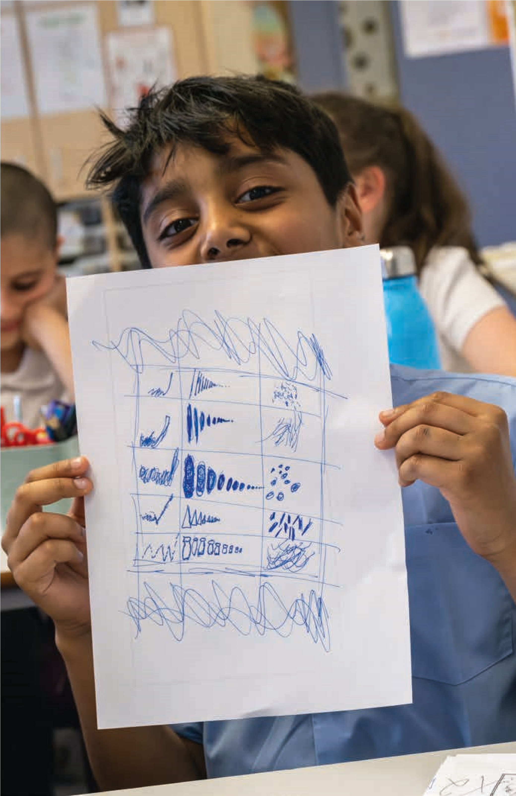
How can children be supported to internalise and embed composing processes and develop creative aptitudes?

So far, this section has explored how to support children through the different stages of the composing process but not how to navigate the process itself. Research has shown that if children understand the composing process, its different stages and where they are in that process, their composing will improve as will their confidence¹. To help with this, we need to support children to internalise and embed the composing process and develop creative aptitudes. Some of this was touched upon in the ‘building a community of composers in your class’ section. Below are some further ideas to support children to develop an awareness of the process and grow in confidence for each stage of the process and in confidence as composers:
- Consciously label the different stages of the process so that children become aware of what they are doing when. Help them to become comfortable with the names of the different stages.
- After open ended composing activity, ask the children to reflect on what they did and in what order. Help by giving them labels when needed.
- Have the poster of the composing process in the classroom that children can refer to.
- Ask the children to describe where in the process they are while composing.
- As a discrete pair or small group activity, give the children cards with the different stages of the composing process on and ask them to put them in an order. See what each group has done and ask them to explain their thinking.
- Connect the composing process to other creative processes more familiar to the children such as creative writing or visual art.
- Find quotations, videos, interviews from a range of different composers talking and writing about how they compose – have them on the walls and/or discuss them with the class.
- Spend time on each stage of the process. i.e. devise composing activity that just explores generating ideas, developing ideas, organising ideas, structuring ideas.
- Consciously stop a particular stage of the composing process and ask the children to move onto the next.

Some reflective questions
- In what ways do/can children and young people start composing?
- What is the place and role of intentionality – ‘pupil voice’?
- What do we know about children’s musical tastes, values and interests? How can we find out?
- Are we clear whether we are asking children to be creative or conform to a stylistic norm when composing? Or somewhere in the middle?
- How will we find out what children already know or can do?
- How much or little do children need to know/ be able to do before composing?
- What is the relationship between learning to play an instrument and learning to compose?
- How do/how can you distinguish composing competence from instrumental technical prowess? Is there a relationship between the two?
1 see teacher thinking on www.listenimaginecompose.com for details

Guidelines to share with children to support them composing in groups:
- Make sure everyone in your group has a chance to share their ideas
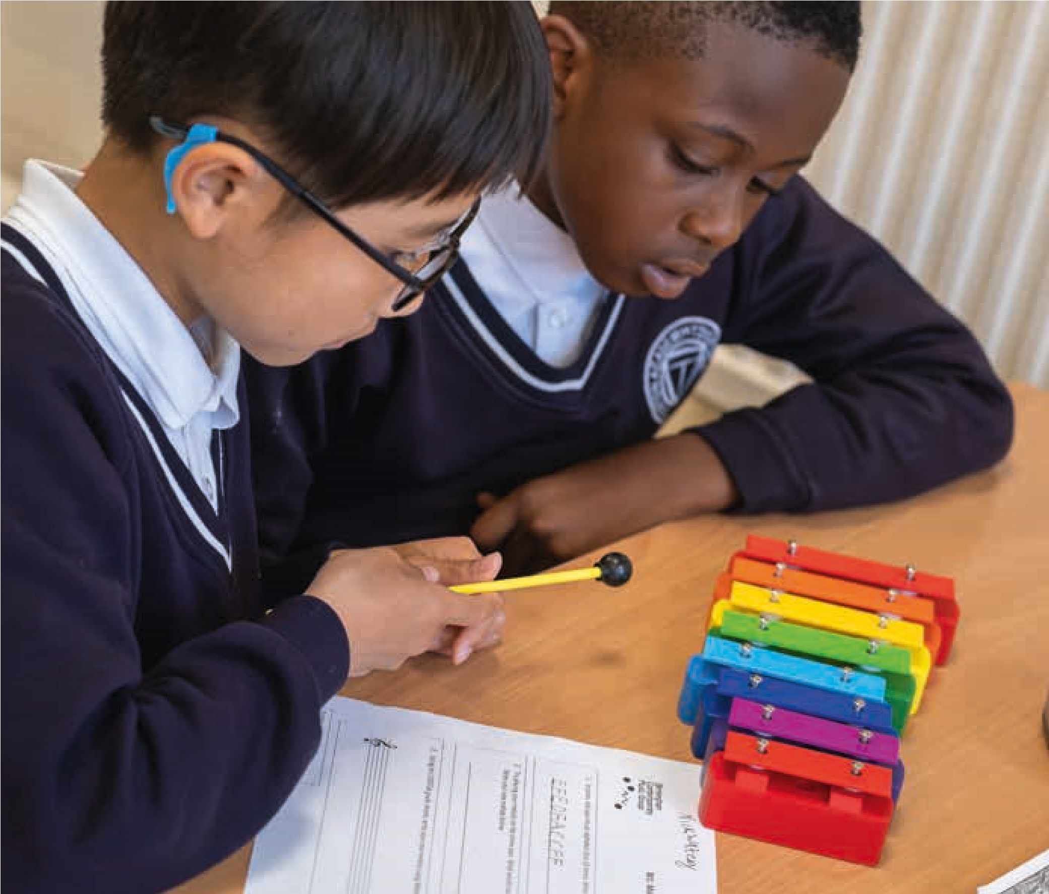
- When choosing which sounds/ideas to use remember to check against your original plan
- How will your piece begin? How will your piece end? Will it change? How will it change? Will your piece have different sections?
- Will the different instruments/members of the group be playing the same idea or different ideas?
- How does what you’re doing fit with what you’ve been asked to do?
- Does your piece have a title? If not, can you think of one?
- Would it help to choose a ‘conductor’ to help with the performance of your music?
Some common problems children encounter

when composing and some solutions

The children’s music sounds the same all the way through
- Invite the children to create a second contrasting section
- Suggest the children experiment with not all the children playing at the same time. i.e. there are sections with just 1 or 2 instruments playing rather than the whole group. Maybe they add 1 instrument at a time or the opposite
- Ask the children to think about the overall shape of their piece
- Give the children a structure to work with or ask them to come up with a structure that takes the listener on a journey
- Do a session focussed on structuring ideas
All the children in a group revert to playing the same repeating idea
- Remind them of their original distinct and different ideas
- Suggest not having all the instruments playing at the same time
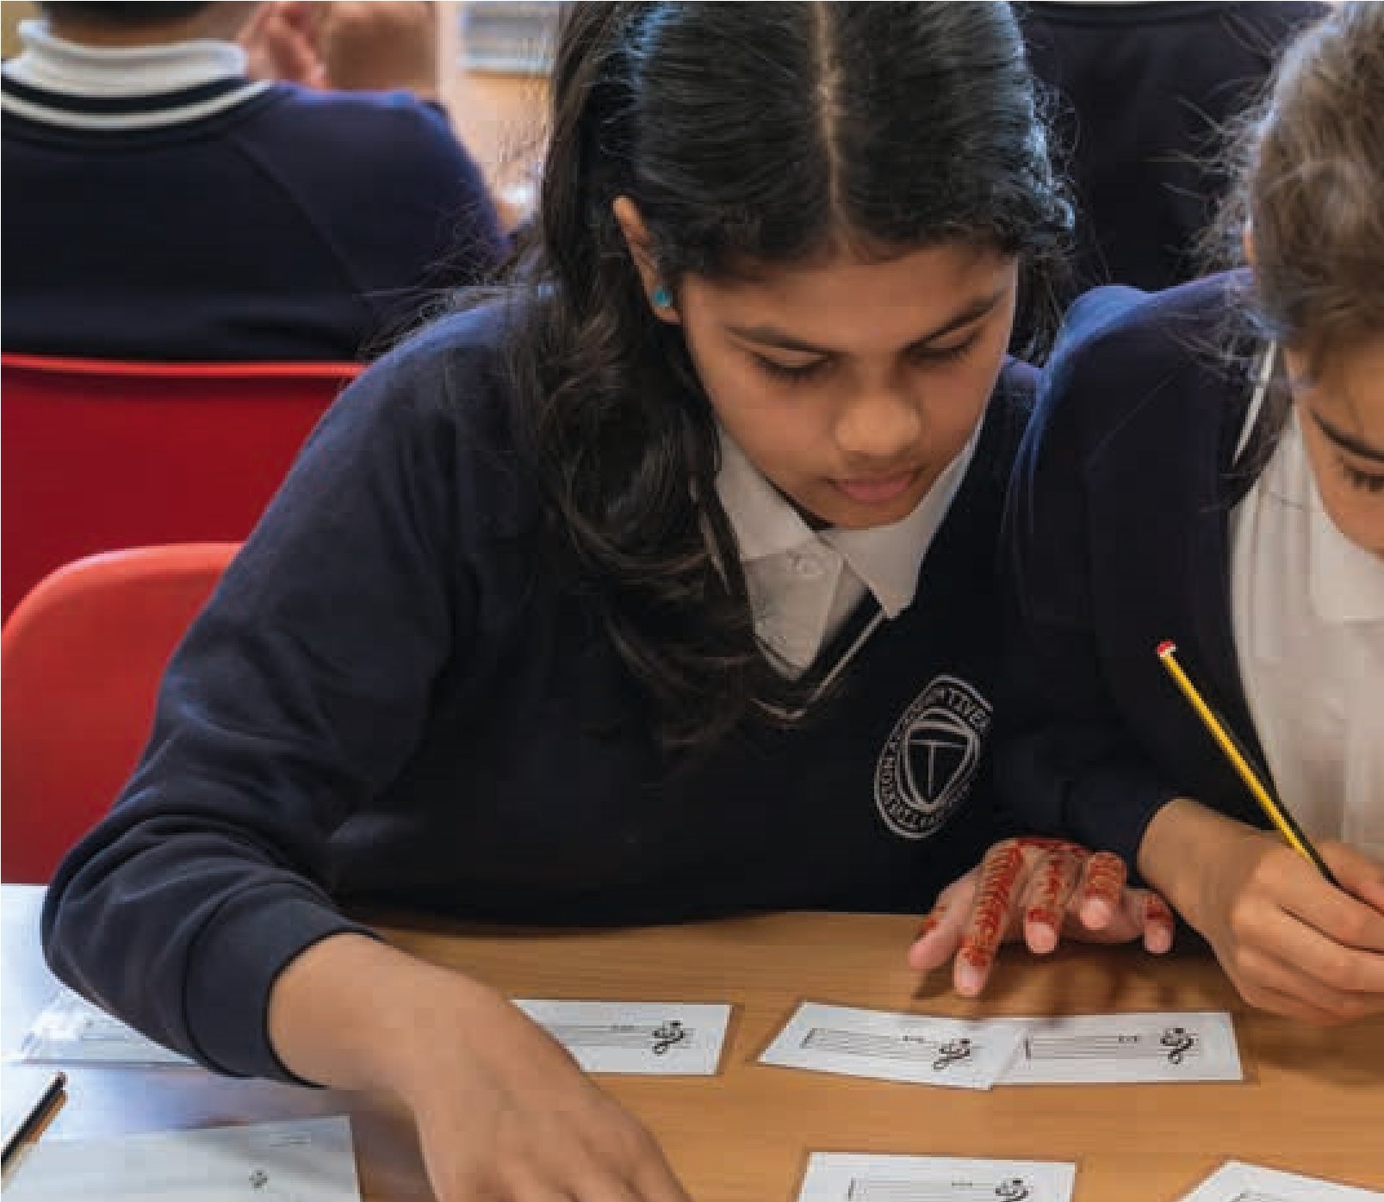
- Ask them to think about sequencing their original ideas and not just layering their ideas. What might determine an order?
- Suggest they take it in turns to be a ‘listener’ so that that they can hear their music as a whole
The children are becoming influenced by the pulse of a neighbouring group
- Remind the children of their original ideas
- If possible, find the group an alternative place to practise?
- Suggest that one group works at documenting their ideas while the other practises and then swap?
The children’s music has no rhythmic interest – just a pulse
- Think about doing a separate activity which supports the children to develop interesting rhythms or gestures
The children are defaulting to ‘idiomatic’ ideas on their instruments – swishing xylophones etc.
- Think about doing a separate activity which supports the children to find different ways of playing each instrument
- Help the child to focus on the intention of this particular piece and the sound and musical ideas needed for it
- Help the children to evaluate whether the sounds fits with the brief
There is no light, shade or silence
- Think about doing a separate activity exploring the use of silence
- Think about doing a separate activity that explore dynamics.
- Listen to and discuss music that uses light, shade or silence
Some of the instrument sounds are getting lost
- Suggest that there are sections where the louder instruments drop out
- Suggest that the children with the louder instruments should always make sure they can hear the quieter instruments
The group has lots of sounds but doesn’t know how to put them together
- Make sure they have time to plan their music away from the instruments so that all the ideas created link together and there is consensus on the kinds of sounds or musical ideas they need
- Use the simple sequencing principle of asking the children whether they want the same idea again, a variation of that idea or something completely different
- Invite individual children to compose by conducting i.e. starting and stopping the different sounds or musical ideas the group has then reflecting together on what worked or didn’t work
- Set a pulse and ask the
children to fit their ideas to the pulse
Some of the instruments or musical ideas don’t seem to fit with others
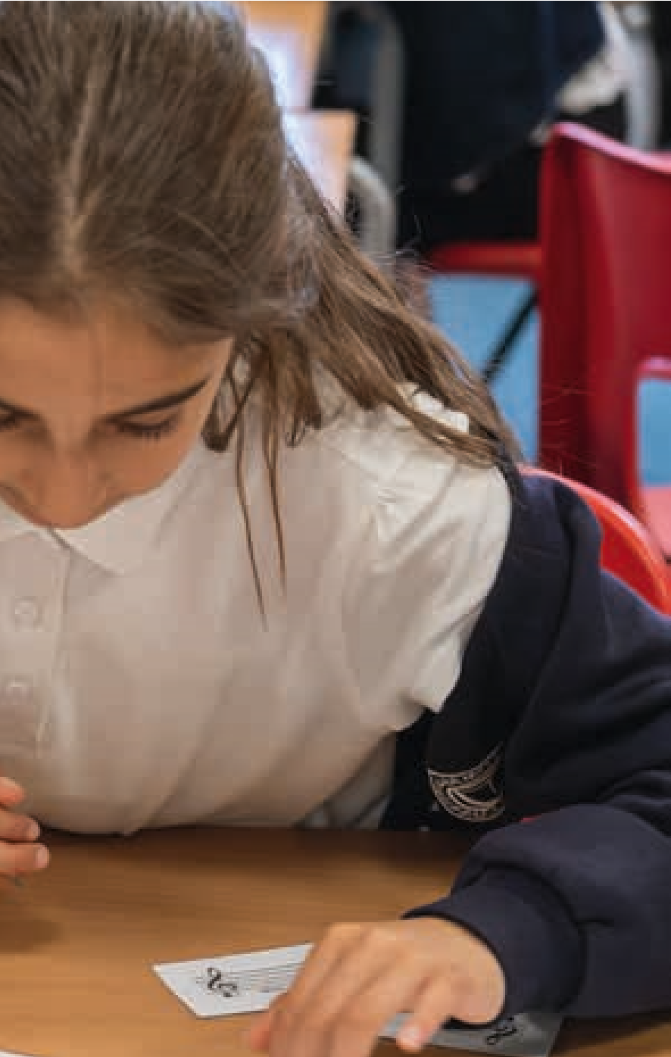
- Make sure they have time to plan their music away from the instruments so that all the ideas created link together and there is consensus on the kinds of sounds or musical ideas they need
- Invite the children to listen carefully and see if they can modify their ideas to work better together
- Maybe one of the ideas or instruments isn’t working and needs to be dropped or form the basis of a new section?
Some children are finding it difficult to come up with ideas.
- Create a pool of ideas before the class starts composing in groups to draw from
- Use a range of approaches to stimulate ideas – movement, visual images, words
- Make sure there is plenty of time built in for experimenting and improvising before starting composing
The children’s ideas seem like a stream of consciousness
- Help the children identify distinct ideas from what they
have produced and develop them
- Be clear about asking for short characterful musical ideas when appropriate.
- Ensure there is time planning the overall piece as well as generating smaller musical ideas
There appears to be no structure to the piece
- Ask the children to return to their plan – does the composing brief give any suggestions?
- Suggest creating one or two new contrasting sections…
- Do lesson just exploring structure by giving children existing music ideas to organise
- Talk about music as a journey or a building which has an overall shape not just one sound after another
- Listen to different examples of music that have clear structures
- Make sure the children have dedicated time to plan the structure and not just make up lots of musical ideas

5.
Planning for Learning
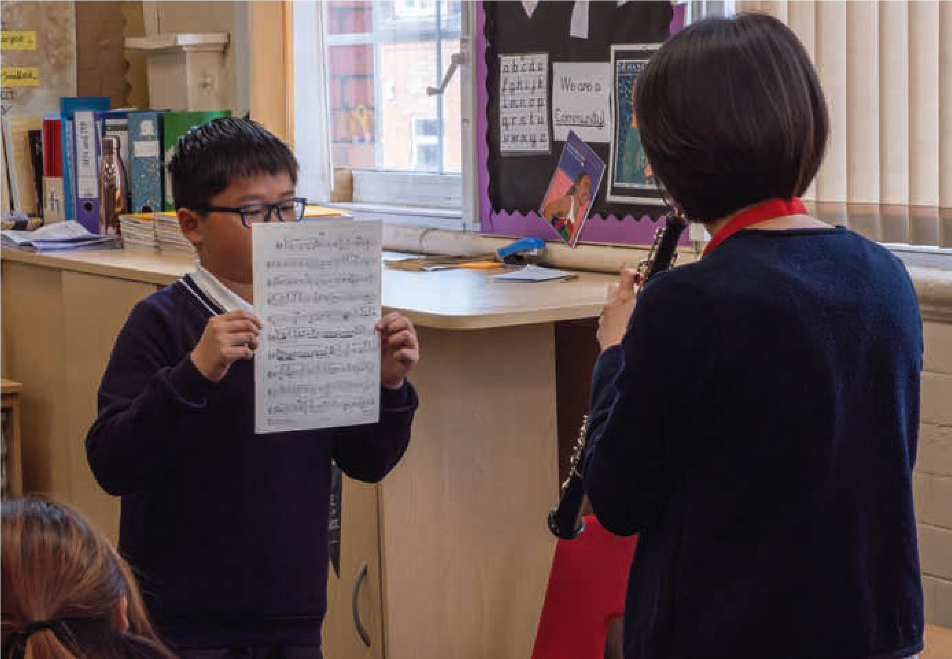
This section is designed to support composers working in schools, but teachers may also find it useful.
It starts by unpicking the different types and timescales of planning that would be found in a school – short, medium and long term – then considers what this might mean for planning a scheme of work of six lessons which focusses on composing. It explains the different terminology that mind be found in school planning documents and what might need to be considered such as aims and objectives, learning outcomes, differentiation, assessment and resources. Most importantly it explores the differences and relationship between learning and doing and the reasons why it is vital to plan for both.
It is an important chapter especially for longer term projects where sustainability and embedding learning is key. The aim is to equip the composer to be able to speak the language of school and of teachers, to know how to plan in a way which is collaborative, and to appreciate the context within which teachers and schools work.

Long, medium, and short term planning
Planning in schools can be divided into three timeframes: short, medium, and long term. Each of these, and their inter-relationship can be visualised as below:
- Short – the plan for the individual lesson – schools will know this as the ‘lesson plan’.
- Medium – the plan for the scheme of work (SOW)
- Long – the plan for progression across year or key stage
Year 5*
1
2
3
4
5
6
Key Stage 2 Overview
Long Term Planning
Medium Term Planning:
Schemes of work
Individual

Lesson Plans
Locus of Planning Momentum
*This can be any year in the Key Stage
(Fautley and Savage, 2008, p74)

After a consideration of the Overview and Long Term Planning thinking, which in many cases are likely to be provided by school curriculum documents, it is then helpful to think about medium term planning for a Scheme of Work, and considering how this sits within the larger timescales.
In this toolkit, planning a Schemes of Work with six lessons is given as an exemplar.

Planning a Scheme of Work
Medium term planning is often known as a Scheme of Work. A composing scheme of work might result in:
- each individual child composing their own piece of music
- each small group composing a piece of music
- a whole class piece
- a mix of the above with different approaches taken at different points in the process
- a series of smaller ‘composing exercises’ done as individuals, small groups or the whole class
A Scheme of Work planning pro-forma can be found in the Appendices. It asks for a number of things to be thought about and planned for – aims and objectives, learning and doing, differentiation, learning objectives, assessment and resources. Making the important distinction between learning and doing is fundamental here. This is explored in more detail later in this section. It is worth pointing out that it is much easier to plan for doing than it is for learning, and yet it is the latter that will be fundamental to both attainment and progression.
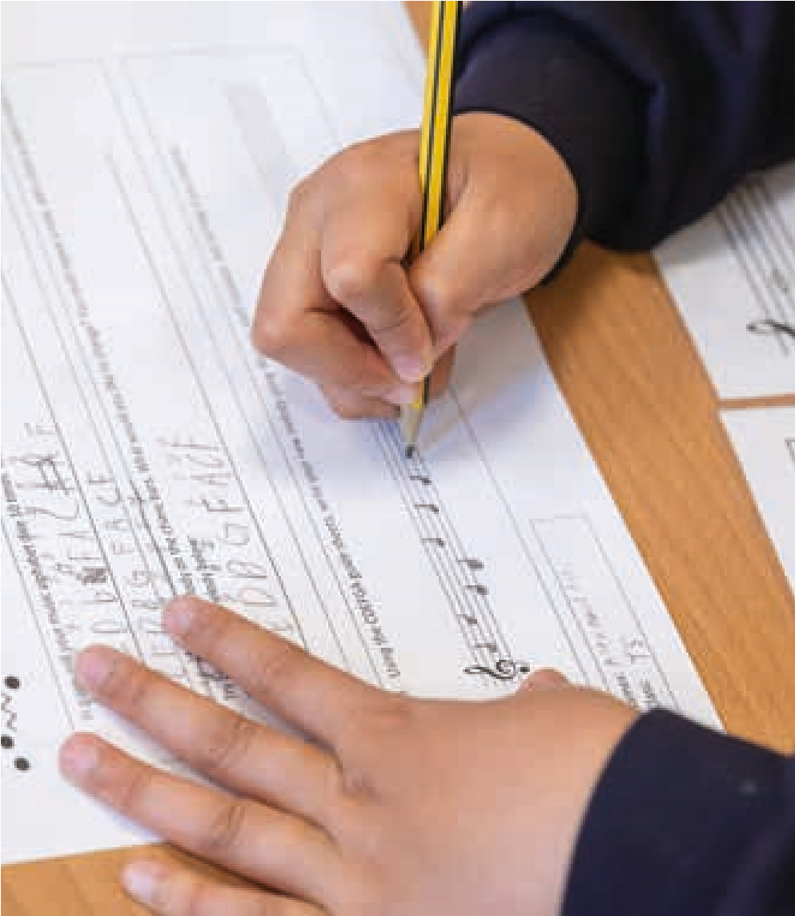
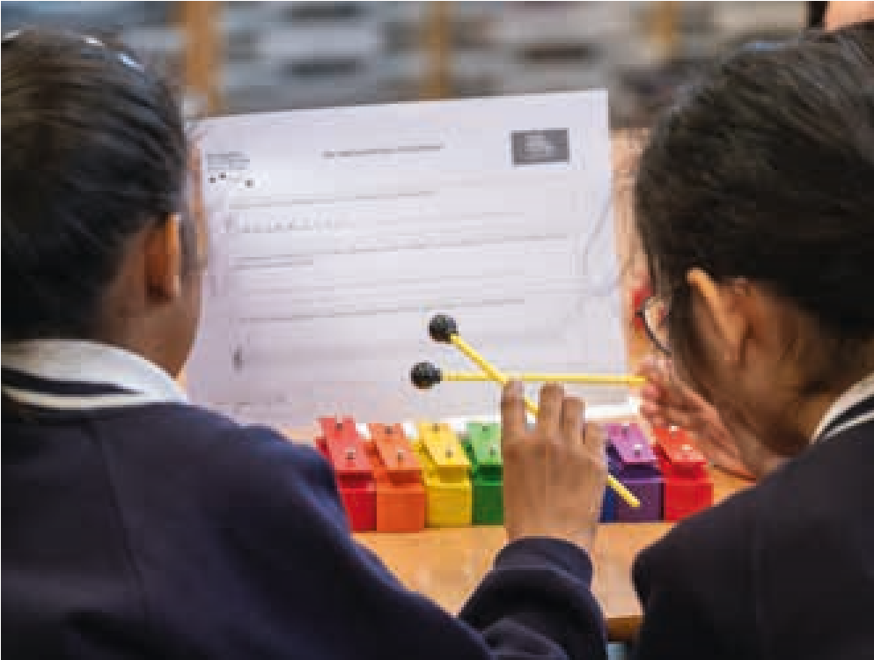

Planning a lesson
Short term planning can also be known as lesson planning. Schools and teachers tend to refer to lesson planning, but for a project where a composer makes a series of visits to a school, this may be thought of as session or workshop planning. In this toolkit, these words are used interchangeably.
A Lesson Plan pro-forma can be found in the Appendices. This again focuses attention onto the differences between learning and doing, and asks the reader to consider both when planning for each individual lesson. The pro-forma also asks for information about differentiation (see page 60), as well as resources. The resources required for a lesson are important to think about in advance. In the case of a visiting composer leading a session or sessions, this needs to be discussed beforehand to ensure that any resources (instruments, photocopying, audio etc.) are readily available on the day and at the time of the lesson. In addition, it is important to establish whose responsibility it is to provide them. One thing this pro-forma does not include but is very useful to consider in advance, is how other adults in the classroom might be deployed and what their role in the session might be. Other adults might include: the Teacher, a teaching assistant (TA), a professional musician, or a visiting peripatetic instrumental music teacher.

Planning the learning and doing
One of the many issues that troubles music education is the differences between learning and doing. In music, we tend to learn how to do something by doing.
Learning

by doing
Understanding
Doing
Understanding
evidenced in
achievement
Identify
Quantify
Help
(
Fautley, 2010, p
96)
…if a student is learning to play the piano, then the evidence of them having successfully mastered various aspects of piano technique is that they are able to play pieces of music on the piano. This is evidencing learning through achievement. It is not the same as repetitive doing. The piano learner will get fed up quickly if they never make progress, and are stuck doing five-finger exercises for weeks on end. For the novice pianist, learning to play pieces of music is what they want to do, and they evidence the results of this learning by being able to perform them. This gives a complex relationship between learning and doing… (Fautley and Savage, 2011)
One of the many ways in which the learning-doing issue manifests itself is to be found in planning.
When planning for musical activity in schools, it is relatively straightforward to think about and plan for ‘doing’, but it is essential that you think about what the children are going to learn as a result of the doing. It is not enough within a school context to believe this will happen by osmosis, to decide retrospectively what has been learnt, or to take a laissez faire approach which just assumes that if the doing is good, learning is bound to happen. Planning can seem like a dance between the two aspects. This can be visualised as below:
Things to think about when planning
Planning
documentation
Doing
What will
they do?
How does
the ‘doing’
help the
learning?
What can
they do
already?
Do they have
the skills to
do it?
What will
they learn?
What do
they know
already?
Are they
ready to learn
it?
Learning
(
Based on Fautley & Savage, 2007, p
34)
In order to help address this matter, before undertaking any form of planning, it is important to ask these questions:
- What have the children already done?
- What do you want the children to learn?
- What do you want the children to do?
- How does doing this help them with musical progress?
How does this fit into
long term planning?
Doing
What Have
they already
done?
What do you
want them to
learn
What will they
need to learn in
future that could
be addressed
here?
Learning
How does this help
with musical progres?
How might the
planned activity
fit in with other
musical activities
Planning

documentation
Things to think about when planning
What will they
need to do in the
future that could
be addressed
here?
- How does this fit into long term planning?
- What will they need to be able to do in future sessions which can be readily addressed at this juncture?
- What will they need to be able to learn in future sessions which can be readily addressed at this juncture?
- How might the planned activity fit in with other musical activity?
Here is a visual representation of these questions:

Lesson planning formats and terminology
Lesson planning documentation is often specific to a school, so a common format cannot be assumed. What many lesson planning pro-formas do adopt is something of this nature:

Aims
Aims are the intentions of the lesson but grounded firmly in reality. Aims need to be specific to the lesson rather than generalised good intentions. They should be challenging for pupils in order to build on previous learning. Aims need to be specific and achievable.

Learning objectives
Learning objectives should state clearly what the pupils will have learned by the end of the lesson. They should be focussed on learning, rather than on the tasks that the pupils will complete. Remember that the context of the learning should be the same for all pupils, although activities will be differentiated to meet pupils’ individual needs. Learning outcomes should be specific, measurable, and achievable within the time frame of the lesson.
Lesson body
Lesson body describes what will be done during the lesson. Key activities and learning sequences should be described here. This section will be concerned with both learning and doing.

Assessment for Learning
This will describe how effectively the pupils will have met the Learning Outcomes. This section needs to be more than mere description. What is important here for you, the teacher, is how do you know? In other words what evidence do you have to say how you are able to judge whether (or not) the Learning Outcomes have been met, and to what extent?

Evaluation
This is your opportunity to develop as a reflective practitioner. This section is important to the successful execution of the project, as well as for the learning that we hope will arise from it. However, it is important to note at this stage that comments in this section should be focussed on learning, and that descriptions of pupil enjoyment and behaviour are only significant in terms of how they affect achievement and progress. (Adapted from Fautley and Savage, 2008) Differentiation
in education, this is sometimes known as adaptive teaching, refers to the ways that teaching and learning can be tailored to the wants and needs of individual pupils in the classes.
…differentiation is about a deliberate pedagogical strategy by which individual teachers create conditions whereby the curriculum is made accessible to individual pupils in ways which are appropriate to their needs, and which allow them
to function to their fullest potential. (Fautley and Savage, 2014)
When planning, it may be useful to think about what forms of differentiation may be required for certain named pupils in the classes. This is so as to ensure that full inclusion of all children and young people can be expected in their music making and composing.

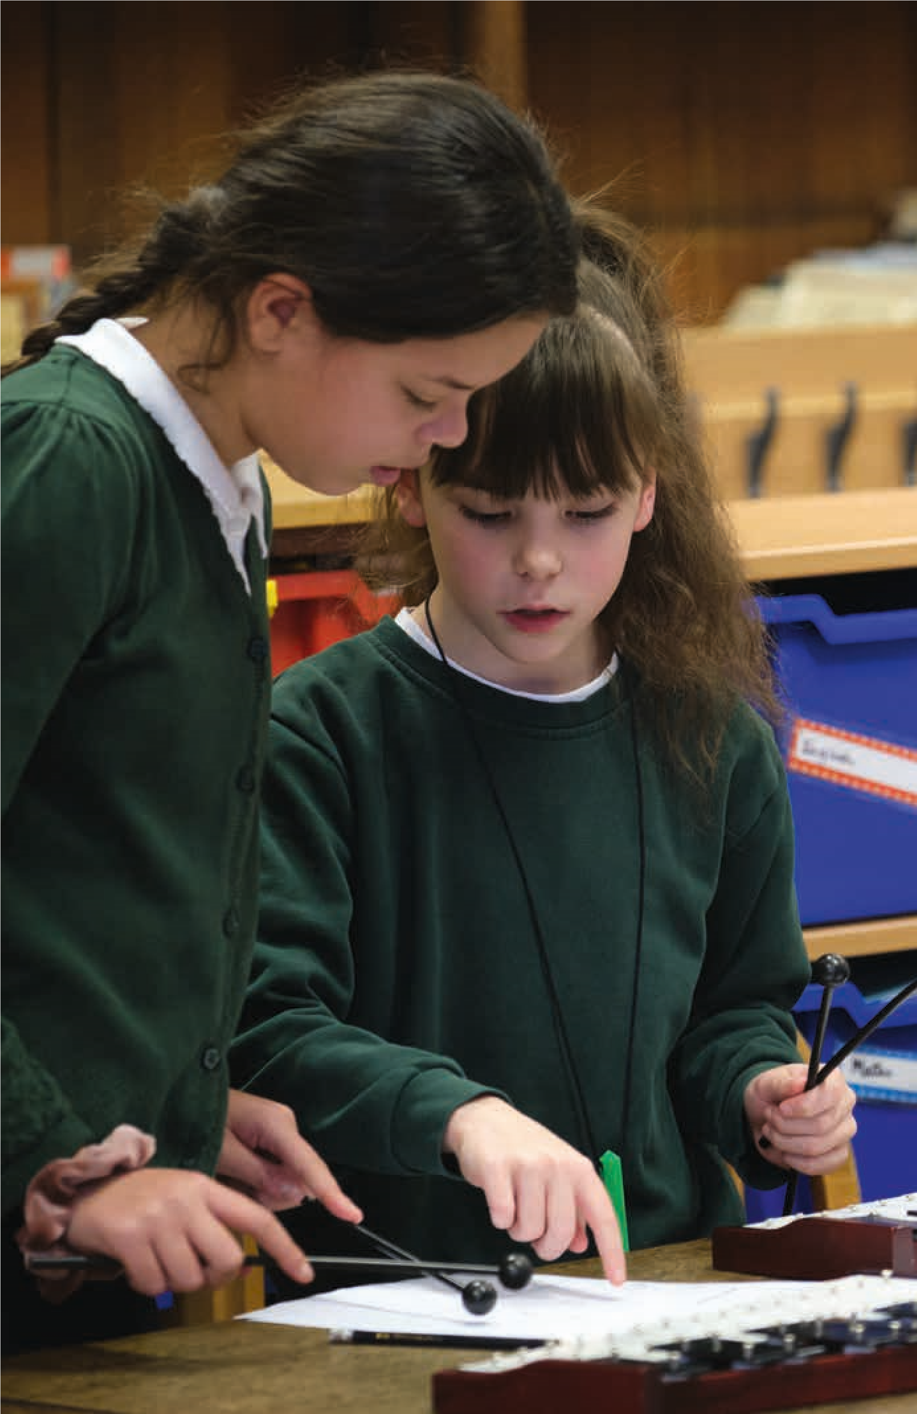
6.
Assessment and Progression
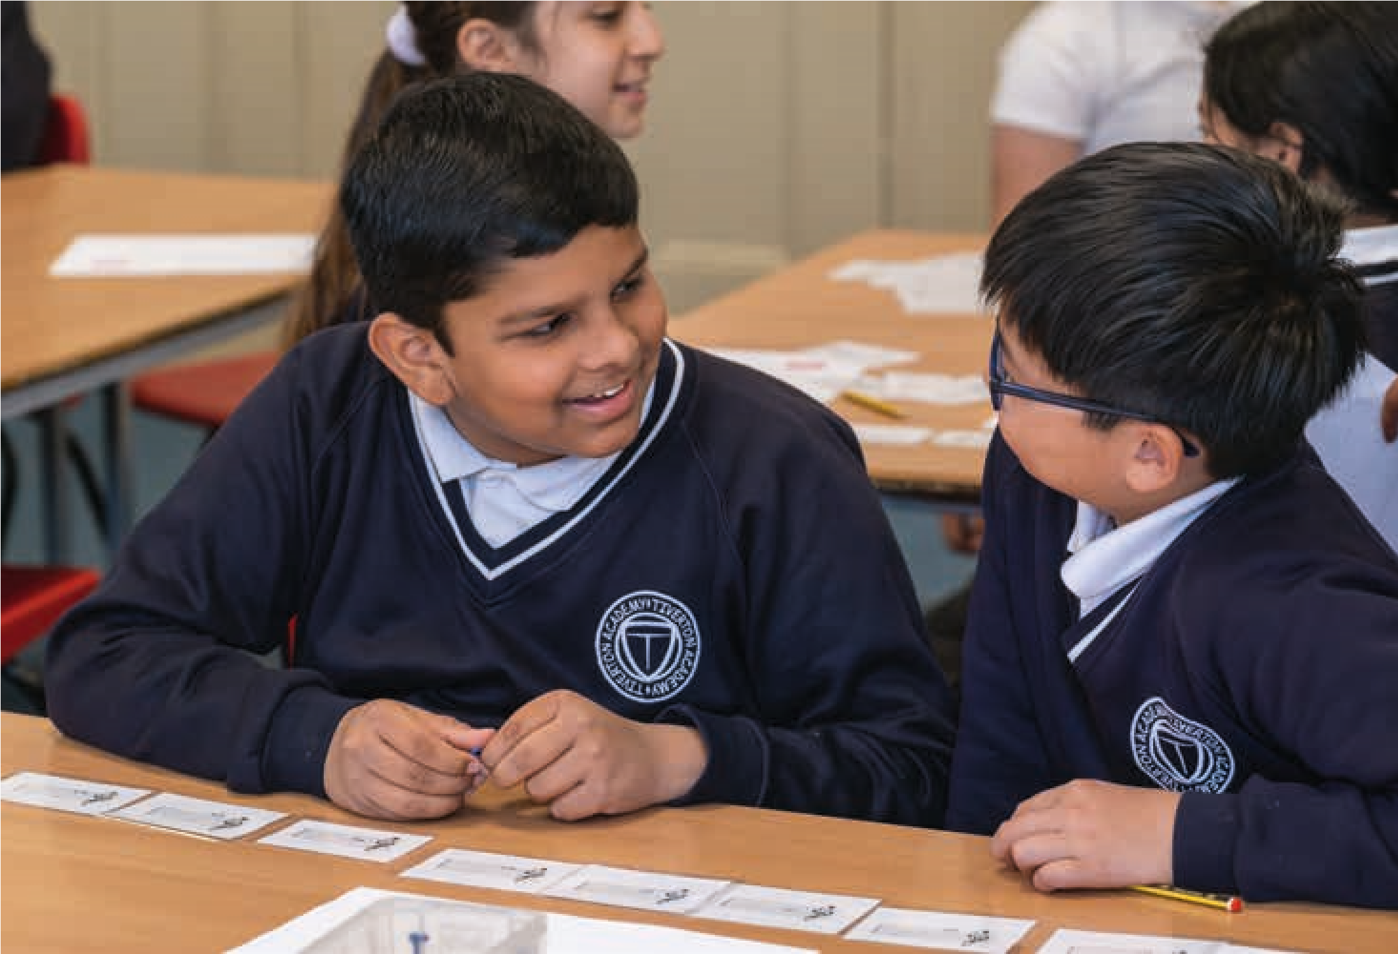
Assessment and progression are both important aspects of teaching and learning.
Whilst they are linked, there are important differences between them too. This toolkit recognises that assessment is a key aspect of contemporary pedagogy, and is also the subject of a great deal of academic research too. For the purposes of thinking about composing in schools, this section is designed to serve both as a brief introduction for those possibly unfamiliar with the area, but also to give those currently engaged in teaching and learning a chance to consider how assessment and progression might have their own special characteristics when considered in relation to the creative act of composing music.

Progression in composing
Progression in learning is a key issue for schools. Teachers want to know about the progress that has been made, by whom, and what this means for both the class and the individual pupils. As the toolkit set out earlier, much more is known about progression in learning a musical instrument, thanks in a large part to criteria set out in graded music examinations and this forming part of the everyday process of teaching and learning an instrument. However, for young and emerging composers no such delineated progression trajectory exists. The very nature of what it means to progress as a composer through the beginning, early, and novice stages is not clear, nor set out in a way which teachers and learners can clearly understand.
Similarly, music services and hubs will also have thought about how progress occurs in whole class ensemble tuition. In terms of classroom music, thinking about progression tends to come from sources such as the National Curriculum for music, and the Model Music Curriculum, which are themselves examples of particular paradigms of progression. More needs to be known specifically about the ways in which children’s progression and development as composers happens, and can be planned for, in the classroom context.
When we talk about progression in composing, we need to distinguish between a consideration of composing as a verb, in other words as an active process, which is distinct from thinking about composition as a noun, the resultant piece of music that emerges from the process. This section of the toolkit concerns itself with the former, composing as a process.

Some reflective questions
- What might be different about a soundscape or a melody a child has composed in Year 5 from one they have composed back in Year 3?
- What might have changed over time in their composerly thinking and doing?
- What is it to get better at composing? What might this look and sound like?
- What should our expectations be at the point they are currently at in their learning journeys, and how should we plan accordingly?
- What is the trajectory? Where do we want the children to be at the end? How do we get to this end point? Is this a linear trajectory of ‘more-ness’?
- What view of progression in composing does the Model Music Curriculum embody? How is this similar – or not – to curricular materials used in your specific context?
- What values and concepts of progress does your planning for progression

I’ve seen the progress of [pupils] being able to have more of a refined judgement about whether what they are doing works for them, as to what they want it to sound like, and being able to judge whether it sounds good to them, why it doesn’t, and what to do to change
it. I think for me that’s progress in becoming a composer. Composer
prioritise? Whose values and interests does this privilege – yours, the children and young people, schools (including as embedded in their curriculum)?
The ideas on the next two pages try to set out what progression and attainment might look and sound like within each stage of the composing process, as well as for other related areas, such as Creating Together, and Rehearsing and Performing. They link to the headings used in the ‘Guiding Children through the Composing Process’ chapter. The statements are not an exhaustive list and could be reframed and adapted to become Learning Objectives or Learning Outcomes¹. It is important to note that these statements are fully concerned with the process of composing, not the final composition that results from the process.
1/ Although these terms have separate meanings in educational literature, for the purposes of this toolkit we are treating them as being the same thing.

Generating musical ideas
Finds it easy to think/make up musical ideas, melodies, rhythms (underline as appropriate) | Generates lots of creative responses to one starting point or musical ideas in response to one starting point | Generates musical ideas through improvisation with sound makers
Generates musical ideas through aural imagination | Generates musical ideas through notation (traditional/graphic) | Generates musical ideas through using music technology/software
Generates musical ideas in a variety of ways | Generates musical ideas from a range of stimuli – art, text, science etc. | Knows how to turn extra-musical ideas into musical ideas
Creates rhythmic patterns, melodies or musical ideas which use, contain, describe, reflect… | Generates musical ideas that use the interconnected elements of music – pitch, duration, dynamics, tempo, timbre, texture
Developing, extending and accompanying musical ideas
Has a range of ways to develop an idea | Combines different ideas effectively | Has a range of ways to extend an idea
Extends ideas using X, Y, Z technique | Develops ideas using X, Y, Z technique | Has a rationale for developing or extending musical ideas
Extends an idea with clear musical intention | Develops an idea with clear musical intention | Has a range of ways to accompany a musical idea
Creates and uses textural accompaniments | Has a range of ways to vary an idea.  Can find lots of potential in one idea | Creates and uses ostinato (melodic or rhythmic) and drone accompaniments
Creates and uses chord sequence accompaniments | Creates an accompaniment with clear musical intention | Has a rationale for developing an accompaniment
Selecting and rejecting ideas
Selects and rejects ideas based on the Can explain their choices when Is confident to get rid of ideas intention of the musicselecting and rejecting ideas
Structuring and organising musical ideas
Imagines and plans the overall structure of a piece early on [rather than putting one thing after another] | Uses given extra musical ideas to structure their ideas – water cycle, narrative etc. | Uses given musical structures to organise their musical ideas
Invents own structures to organise musical ideas | Composes music that has a coherent structure | Has a repertoire of different ways to structure their ideas
Is aware of the impact on the listener when structuring ideas | Organises musical ideas vertically | Organises musical ideas horizontally
Reflecting, evaluating and refining
Revising musical ideas is part of their composing process | Critiques own music | Is happy to refine own music at different points of the process
Demonstrates learning through using ideas from previous projects | Can productively comment on the music of others | Is developing a vocabulary to talk about and describe their music and that of others
Can offer suggestions as to ways forward | Shows clear progress from one composition to another | Takes learning from composing into other musical activity – performing, listening
Creating together
Shares ideas in a group or pair | Adapts own ideas to fit with group or partner | Has confidence and will argue for value of own ideas
Contributes ideas to the group or pair | Helps to organise the group or pair | Takes a leading role in the group
Listens to other children’s or child’s ideas | Is supportive of other children’s or child’s ideas | Negotiates differences in ideas and process within the group or pair
Rehearsing and performing
Knows their role in the group’s music | Takes pride in getting their part right | Takes leadership role in rehearsing and performing
Takes an organising role in rehearsing and performing | Supports those who find  remembering and performing difficult | Deals with performance anxiety in an appropriate manner
Happy to perform own and others’ compositions | Communicates about the music to the audience | Re-joins musical performance after minor mishaps or rests
Follows directions of others or the score
Notating, documenting and sharing
Represents sound and musical ideas using symbols | Uses appropriate symbols to represent sounds | Effectively notates and shares music with others using graphic notation
Creates imaginative graphic representations of their music | Effectively notates and shares their music with others using traditional notation | Effectively notates and shares music using a combination of approaches.
Creates clear written instructions about how to play their music | Instructs others verbally and with clarity how to play their music | Demonstrates to others how their music should go using instruments
Verbally describes their music well to an audience | Documents ideas so that they can be picked up in the next lesson
Internalising and embedding composing processes, developing creative aptitudes
Understands the different parts of the composing/creative process and feels confident with each stage | Feels confident with each stage of the creative composing process | Understands the ordering of the creative composing process
Moves through the different stages of composing without being prompted | Doesn’t give up too soon on ideas | Is ok with ‘getting it wrong’ and being ‘lost’
Has strategies for getting out of being stuck and finds ways forward with challenges | Takes creative risks and is confident to move away from the brief with own ideas. | Enjoys experimenting with and finding interesting sounds on instruments or using voices. Is curious about sound.

Planning for progression and attainment in composing
This toolkit does not see progression in children’s composing as being either one-dimensional, or linear; instead, it takes the stance that it is important to focus attention in on composing as a progressive (in the sense of moving forwards) and developmental activity. Below are some considerations for teachers and composers to think about when planning for progression in composing for all pupils:
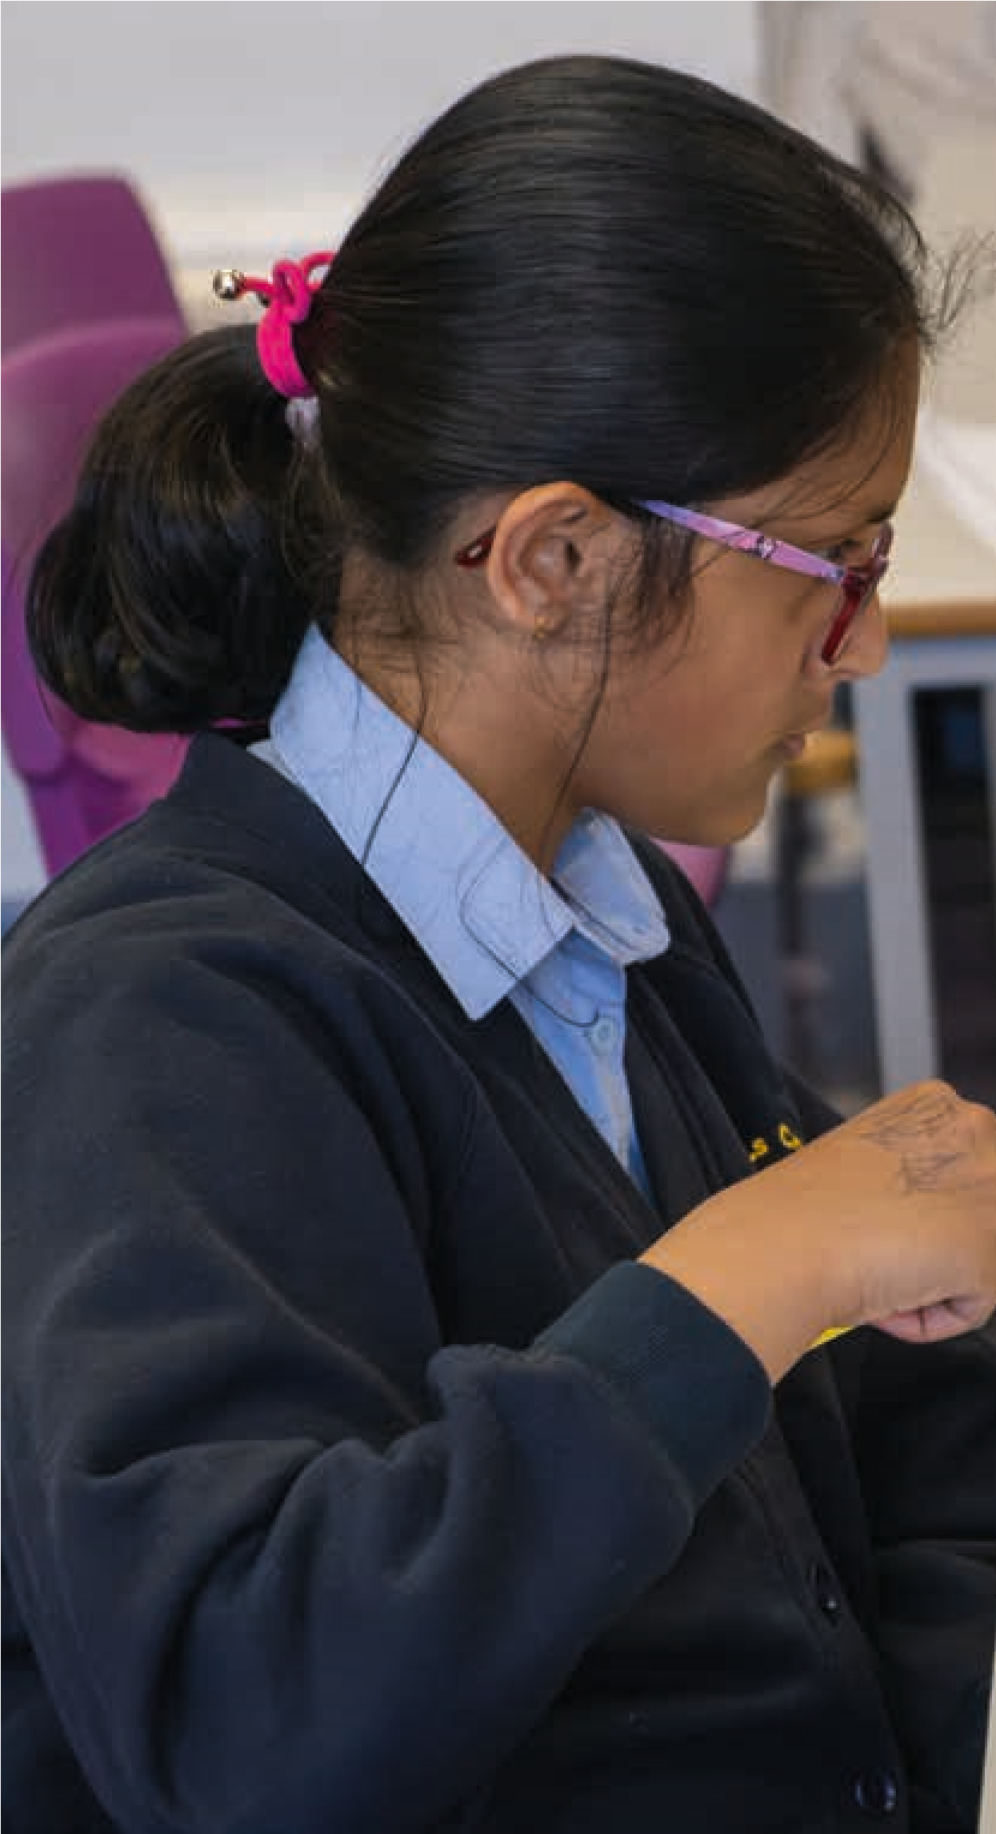
- There is clarity about what progress looks, sounds and feels like
- Progress in composing skills is always considered when planning SOWs
- SOWs are sequenced to enable progression in composing
- Progression is not viewed as linear or the same for all children
- There is an understanding that progress in the process of composing is more or as important as the final product
- Differentiation in progression is planned for
- When composing in small groups or as a whole class, all pupils have the opportunity to meaningfully contribute ideas the collaborative piece
- All pupils have the opportunity to compose individual compositions as well as small and whole class compositions
- All pupils have the opportunity to do composerly thinking and doing at each stage of the composing process
- Feedback, reflection and questioning is planned to allow for formative assessment to take place

Some reflective questions
- When planning for progression, how might the composing activity (‘doing’) change over time? Is it about ‘moreness’ – introducing and using more notes, more musical structures, more types of variation, more composing processes, more composing techniques, more instruments, more stylistic components, longer compositions, more complexity? Or something else?
- What about being able to do more things with more sophisticated materials?
- What might scaffolding entail to ensure progression?
- Is progression in composing genre/style specific? Do you need to consider this when setting Learning Outcomes?
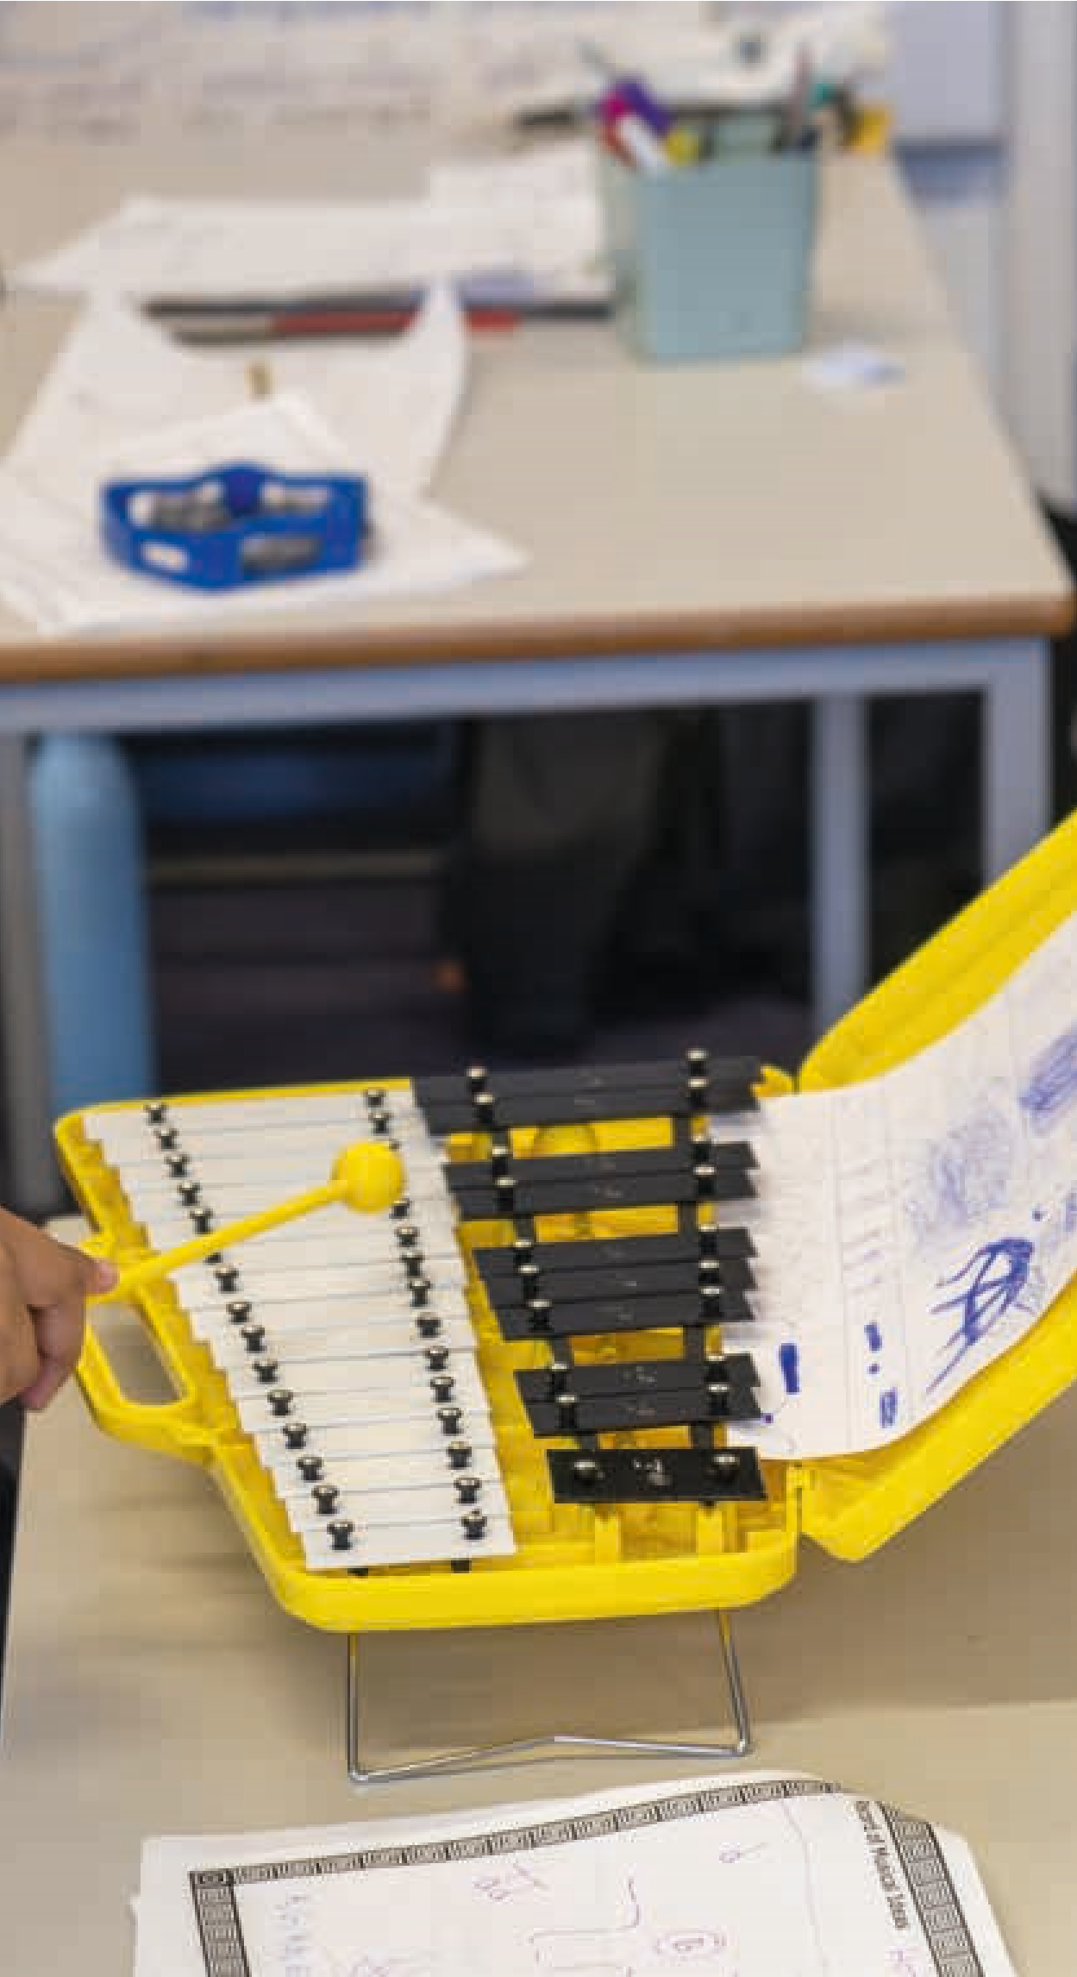
- When setting composing tasks, what is the balance in terms of attainment, between the child(ren) conforming to an established style versus being creative and moving away from the style?
- Is moving from graphic scores to staff notation progression?
- Is a soundscape of less value compositionally than a more traditional Western Classical Music piece?
- What might represent progression and attainment in composing?
I like exploring different sounds to make music. I like it, because you can just play loads of different notes until you find the ones that sound nice together.
Young person

An overview of composing progression in stages
The table below gives an overview approach which aims to give a sense of a child’s progress in composing. The descriptors outline the stages a child might go through:
Stage | Description
Exploratory | The child creates music through improvisation and exploration of instruments, sound makers and voice in which clear but often fleeting musical ideas emerge and are repeated and varied. Structures emerge from the improvisations, explorations and from interactions with others. Strong connection with movement.
Novice | The child creates simple sounds, musical ideas and patterns suggested by the instrument’s affordances, rather than the appropriate to the task, and need guidance to organise these into simple structures. They talk about the sounds they have used
Developing | The child creates and selects sounds and musical ideas appropriate to the task and organises them into simple given structures. They reflect on their choice of sounds and musical ideas.
Emerging | The child creates and selects sounds and musical ideas appropriate to the task, can develop these ideas using simple composing techniques and organise them into simple given structures. They reflect on their piece of music as a whole.
Competent | The child works to a composing brief and is clear about the composing process. They understand the possibilities of instruments and other sound makers and create and select interesting musical ideas to fit with the brief. They can use a range of ways to develop their ideas and able to create their own structures as well as work to given structures. Their final pieces are competent and coherent, and they are able to reflect on and talk about what they have done.
Independent | The child works independently through the composing process from generating original initial ideas to composing music that realises their self-defined intentions. They use instruments and other sound makers with thought, understand and are confident using a range of composing techniques and can reflect on their composing.  They can connect their composing to the music of others.
On the next page is a self-evaluation tool for children to reflect on how they feel they are getting on with their composing. An additional task specific version can be found in the appendices.

Reflecting on becoming a composer
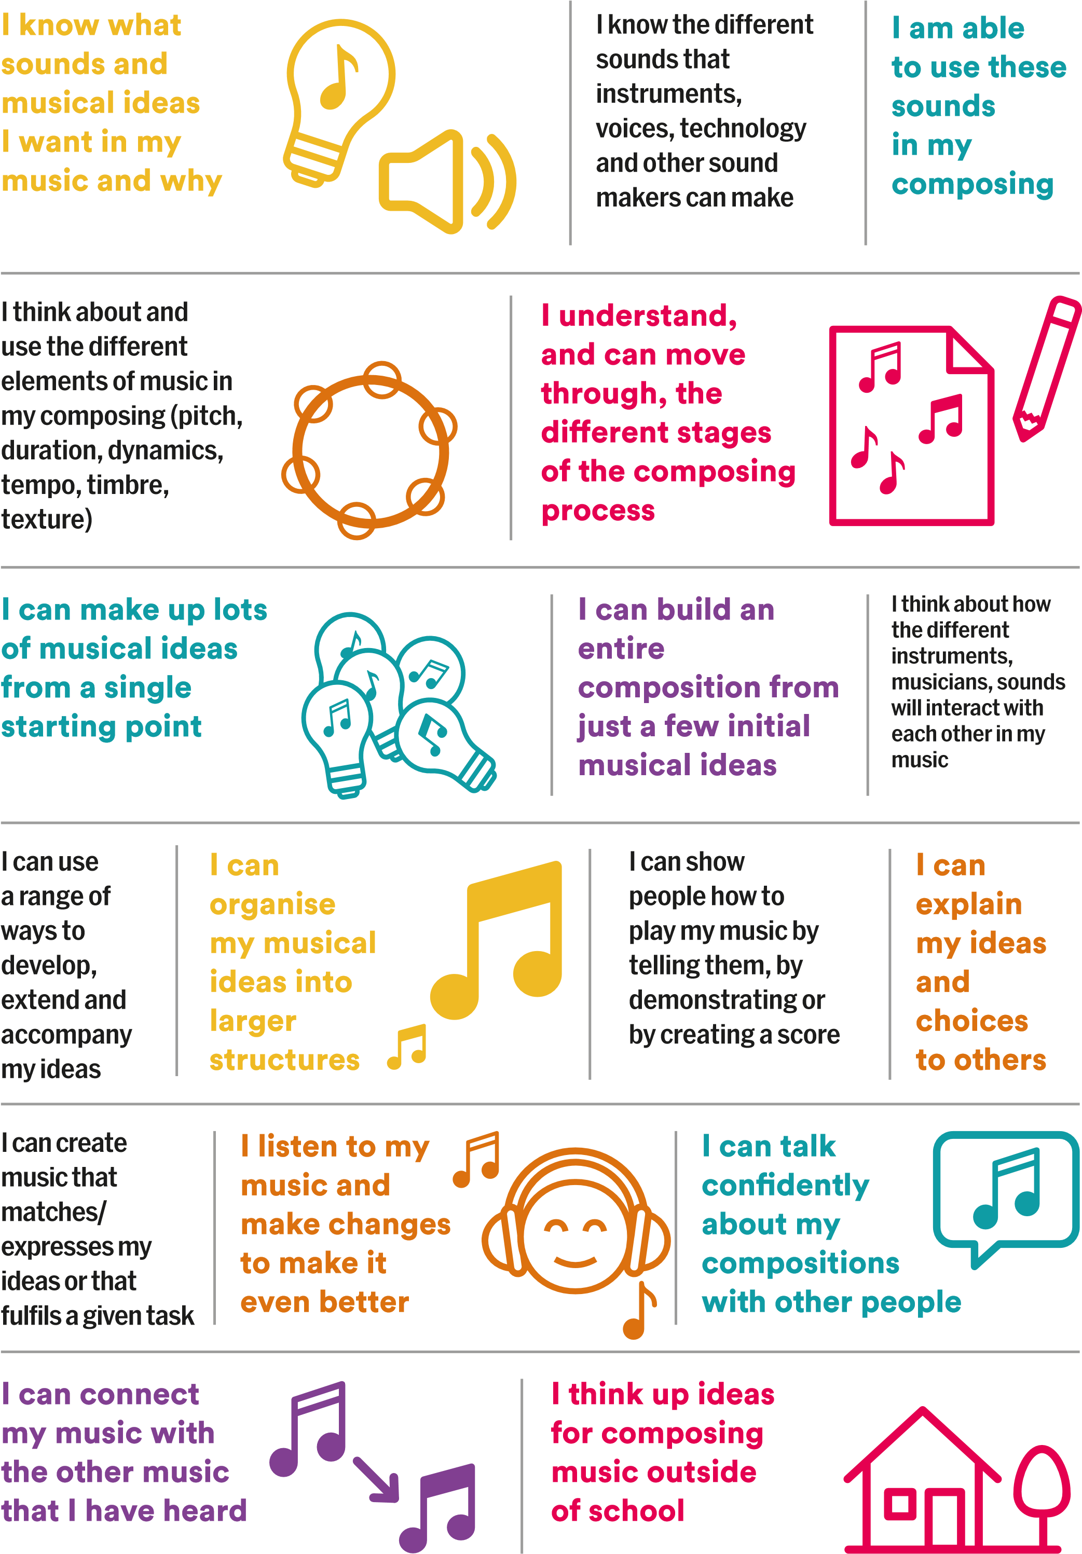

Assessment of composing
Assessment can be a problematic area in music education, but one which is vitally important to teachers, schools, pupils, and parents. In this section, we try to open up thinking about what assessment might entail in the teaching and learning of composing. Each individual school is likely to have its own assessment policy, there may also be progress-tracking systems in place, and so we can only really usefully talk in generalities. In schools teachers often talk about assessment in terms of formative assessment and summative assessment. Here are some simplified definitions of each:
Summative assessment is concerned with certification, marking and grading a piece of student work in some way. Examples of this include graded music exams, SATS, and GCSEs. They are often described as ‘high stakes’ assessments, and can have a significant effect on the future of the pupil concerned. In more everyday terms, summative assessment also happens when a Teacher listens to a group of pupils performing a piece of music they have been rehearsing and give it marks out of ten for how well they did.
Formative assessment or assessment for learning (AfL), on the other hand, is much more bound up in the day-to-day interactions of normal classroom work. It describes the process of eliciting information that will help the pupil and teacher to decide what should be done next in order to develop learning. This is something that many music teachers and composer-educators will be familiar with, listening to a group of pupils working on a composing task and then suggesting ways in which they could develop their work. These kinds of conversations are explored in more detail on 44 and 45 X, the ‘Listening and responding’ section. Similarly reflecting on a lesson, and deciding that the pupils need more time to perform their pieces next lesson is to undertake formative assessment. To have a formative function, the assessment should be used in such a way that it informs the learner about what the next and immediate steps should be. Formative assessment can be thought of as being ‘done with’ the learners, whereas summative assessment is often ‘done to’ them. To put it simply, formative assessment informs future teaching and learning, summative assessment sums up prior learning. It will often be the case the formative assessments made during the course of a lesson will not require any sort of written documentation, or involve giving a grade to the pupils. hen artists in schools work with children and young people, what they will be doing normally involves using formative assessment, although this might not necessarily feel like undertaking assessment. What this formative assessment does involve is having conversations with children and young people. Doing this is true assessment for learning. One of the issues with formative assessment is that, as one teacher put it “it doesn’t feel like doing assessment”! It is important therefore to reiterate that this aspect of promoting assessment in and through composing is what would normally be going on anyway.
When assessing composing it is helpful to distinguish between a number of factors. These include:
- Assessing the process of composing
- Assessing the resultant composition that results
- Assessing the performance of the composition
- Assessing the quality of ideas generated
- Assessing the ways in which the children have worked either solo or as a group
- Assessing progression
- …and many more besides!
As can be seen, some of these assessment modalities are concerned with quality, others with ways of working, and yet others with what might be termed social factors. Whilst it is right and proper that assessments regarding quality will in many instances be formative assessments, and made ‘on the hoof’, it is worth thinking about what is being done in these instances, and what any implications for documenting assessment might be.
Assessing and documenting progression and attainment in children’s composing
Many schools have their own ways of assessing children’s learning, sometimes these run across subjects, and in other cases they are subjectspecific. When thinking about documenting attainment and progression a key question to consider is “who is the assessment for?” (Fautley, 2010). If it is for the children, then what form will it take, and how will it be communicated? It is also necessary to consider how this information can then be used by you, the teachers, the school, the pupils, and their parents. If it is formal documentary evidence that the school requires, then again, what form will it take? Important in these considerations is to think about meaning. What is meaningful for the children and young people might be a comment, whereas formal school systems might require something more reductive, like a grade or a mark. This aspect requires a little more by way of thought, but it is important that it is also manageable, as it is known that assessment systems can become overly burdensome. It is important for everyone involved that this is not the case. However, it is important too that data is obtained as it is necessary to show progression over time during the course of a composing project.
One key aspect of recording attainment and progression is to do just that – to record it, either using video or audio. Whilst there are ethical issues regarding the use of video recording in schools, there tend to be fewer concerns when audio alone is used. Audio recording can be simple, inexpensive, and straightforward. It is important, though, that these recordings are used as part of the teaching and learning process. As Ofsted (2023, para 90) observed:
In most schools, teachers were making video or audio recordings of pupils’ work. In some of these schools, these recordings were being used well, to check whether the school’s intended curriculum aims were being achieved. In contrast, some schools were recording pupils’ work simply for posterity.
For composing work, listening back to a recording is not just good assessment practice, it is also good for teaching and learning too. Audio recording is not the only form or data gathering though, other sources of data collection are available too.
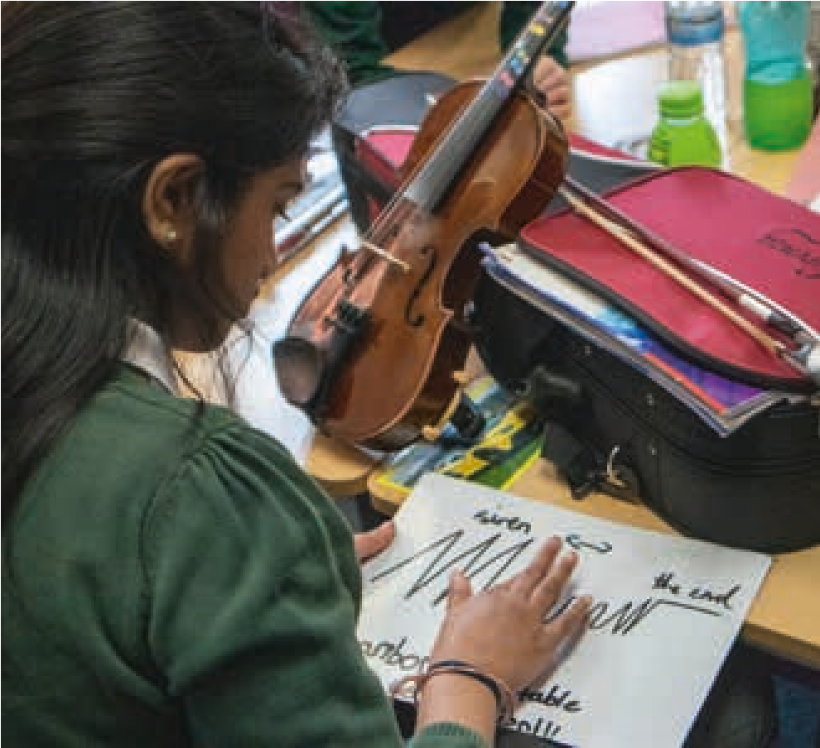
I suppose one of the bigger aspects of their learning was the idea of two notes being played together, because I don’t think they really considered that before. They’ve been very one stick at a time – today they actually seemed to be engaged with it and thinking about the effect of those harmonies.
Teacher

Collecting data for progression
There are many ways to document children’s learning and progression in composing. Below are some suggestions as to how this might be done. It is not the intention or suggestion that all these are done for every scheme of work. Instead, the suggestion is that different approaches are taken depending on the task and on the learning objectives.
Audio and video Audio and video Children talking recordings of the recordings of final about the process of
process compositions composing their music
Scores of final compositons (various notations)
Observations of Composing Observations of previous learning from notebooks, learning being applied to tasks composing being mind maps and taken into other other planning Observations areas of learning documents of children’s
composing processes by
Observations others
of learning from
composing Children being taken writing
into other areas about the of musicality – process of listening and creating performing their music

Using data to document and reflect on children’s learning and progression in composing

Using data collection ideas suggested on the previous page, progression and attainment can be thought about and documented by reflecting on the statements on pages 64 and 65. As explored previously, these make suggestions as to what might progress within each stage of the composing process, as well as for other related areas too, such as Creating Together, and Rehearsing and Performing, and link to the headings used in the ‘Guiding Children through the Composing Process’ chapter. The statements can be reframed, and, with only minimal adaptation, can become task specific and also act as Learning Objectives. Using a system commonly found in primary schools, they can then be used to give an indication as to whether these objectives or outcomes have been met. Below is one suggested way of approaching this:
1/ Decide what it is you want the children to learn and plan/choose your Scheme of Work accordingly
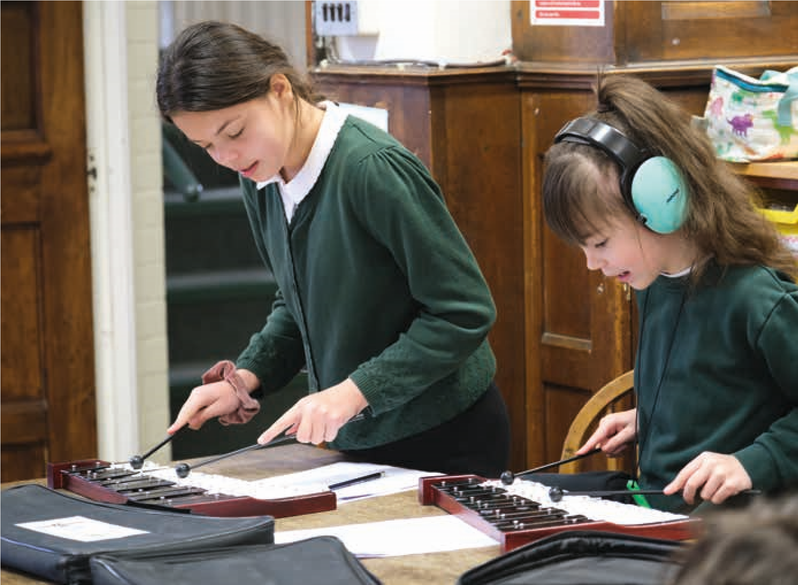
2/ Choose 3-4 statements from across the different areas which link to your SOW and use these to assess your children’s progress.
3/ At the end of the SOW, use three different coloured markers to indicate how well a child is doing in any given area e.g. orange = emerging or satisfactory, green = established or good, pink = exceeding or excellent, or a traffic light system.
Obviously, there are a likely to be a large number of progression statements, and in some instances, documenting this level of detail for individual pupils may be too much, and too onerous. However, hopefully these ideas provide some guidance, which is not available elsewhere, as to what to look out and listen for in children’s compositions.
The statements can also be used to reflect on progress in the longer term and to think about the child’s emerging musical and/or composer identity and voice. The statements can also be reframed or reworded for a child to self-evaluate. A photocopiable versions can be found in the appendices. It is important to note that these statements are fully concerned with the process of composing, and not the final resultant composition.

7.
including Everyone

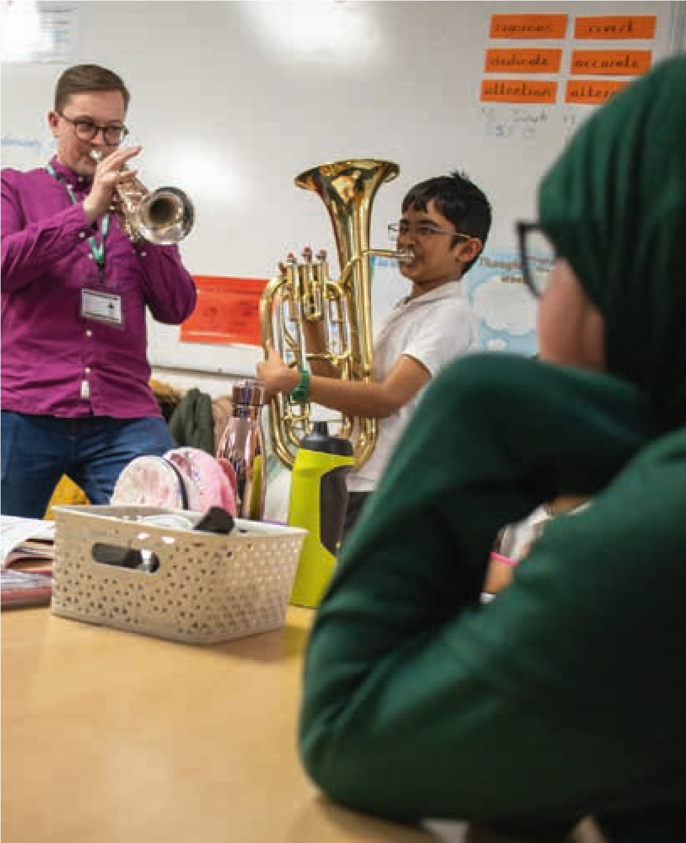
This section explores how composing and music creation takes place in different places and within different cultures and how that effects how children might feel included or excluded in composing activity. It sets out the previous musical experiences’ children might have had in and out of school and how this needs to be considered in planning. Finally, it suggests pedagogical and practical steps to ensure all children feel engaged in composerly thinking and doing.

Thinking about diversity
Including everyone means considering how composing and creating music happens in different places and within different cultures. Considering this is important when you are using music from other cultures in your teaching and supporting children in your class who may come from a different musical culture to your own.
Below are some statements for you to reflect upon followed by some questions to consider when planning composing activity with children. It is important to think of this as a journey, where everyone is starting from different places. Thinking about this and taking small steps is what is important here, not feeling overwhelmed, guilty or lacking in knowledge. Think about authenticity and context and when you need to, ask questions, do research and seek out expertise.
- Music has different functions, purposes and values depending on the musical style, genre or culture
- All musics consider tuning, timbre, timing and texture – but each grants different weighting to them and considers or prioritises these elements to a greater or lesser extent
- In some musical cultures creating music is seen as the preserve of a talented few and in others, it is something that can be practiced by all
- No musical style, genre, culture is static or monolithic
- All musics are continually changing through individual and collective experimentation and through coming into contact with other musics
- New styles and genres are often born in the liminal space between different musical cultures
- Children are not blank slates but bring their own musical experiences, values and tastes into the classroom and into their composing
- Children have a right to have their musical voices heard
- Children have the right to be introduced to a wide range of musical styles, genres and cultures
- Composing happens on a spectrum from conforming to stylistic norms to the composer setting their own parameters
- Composing happens on a spectrum from music defined by notes and rhythm to music which is more interested in gesture, sound, texture and timbre

Some reflective questions
- Why are you choosing to explore and compose in this musical culture, style, genre?
- What is valued in this music?
- In what context is this music played or what function or purpose does is have?
- How is this music usually taught and learned?
- How is composing in this musical style, genre, culture usually learnt and taught?
- What do you need to know or be able to do before you explore this music with your class? To what degree to you need to be able to do/know this? What might be the grey areas here?
- What is it to compose authentically in that style or genre?
- To what degree, and why, might you choose to approach composing within the style or genre differently?
- Do your children have the tools i.e. sound resources (instruments, voices, technology to be able to compose within this musical style, genre, culture? And if not, what can get close to replicating this?
- What connections can be made between this music and other musics?
- In what ways does this music differ from other musics?
- Where on the spectrum between working within stylistic norms and letting the children set their own creative parameters or freely use their imagination, are you placing your composing activity?

Children’s previous musical experiences and learning
Every child will arrive in your classroom with unique, different and differing kinds of musical experiences and learning. Taking this into consideration might make the difference between someone feeling engaged and included or not. The image below shows the kinds of experiences the children in your classes may or may not have had.
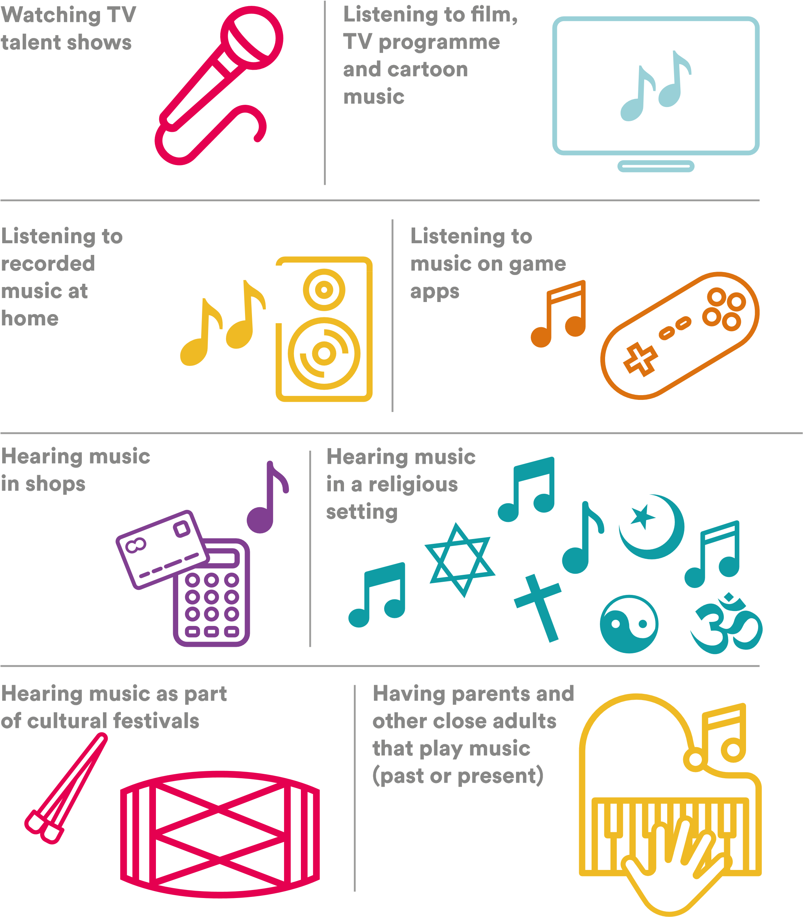
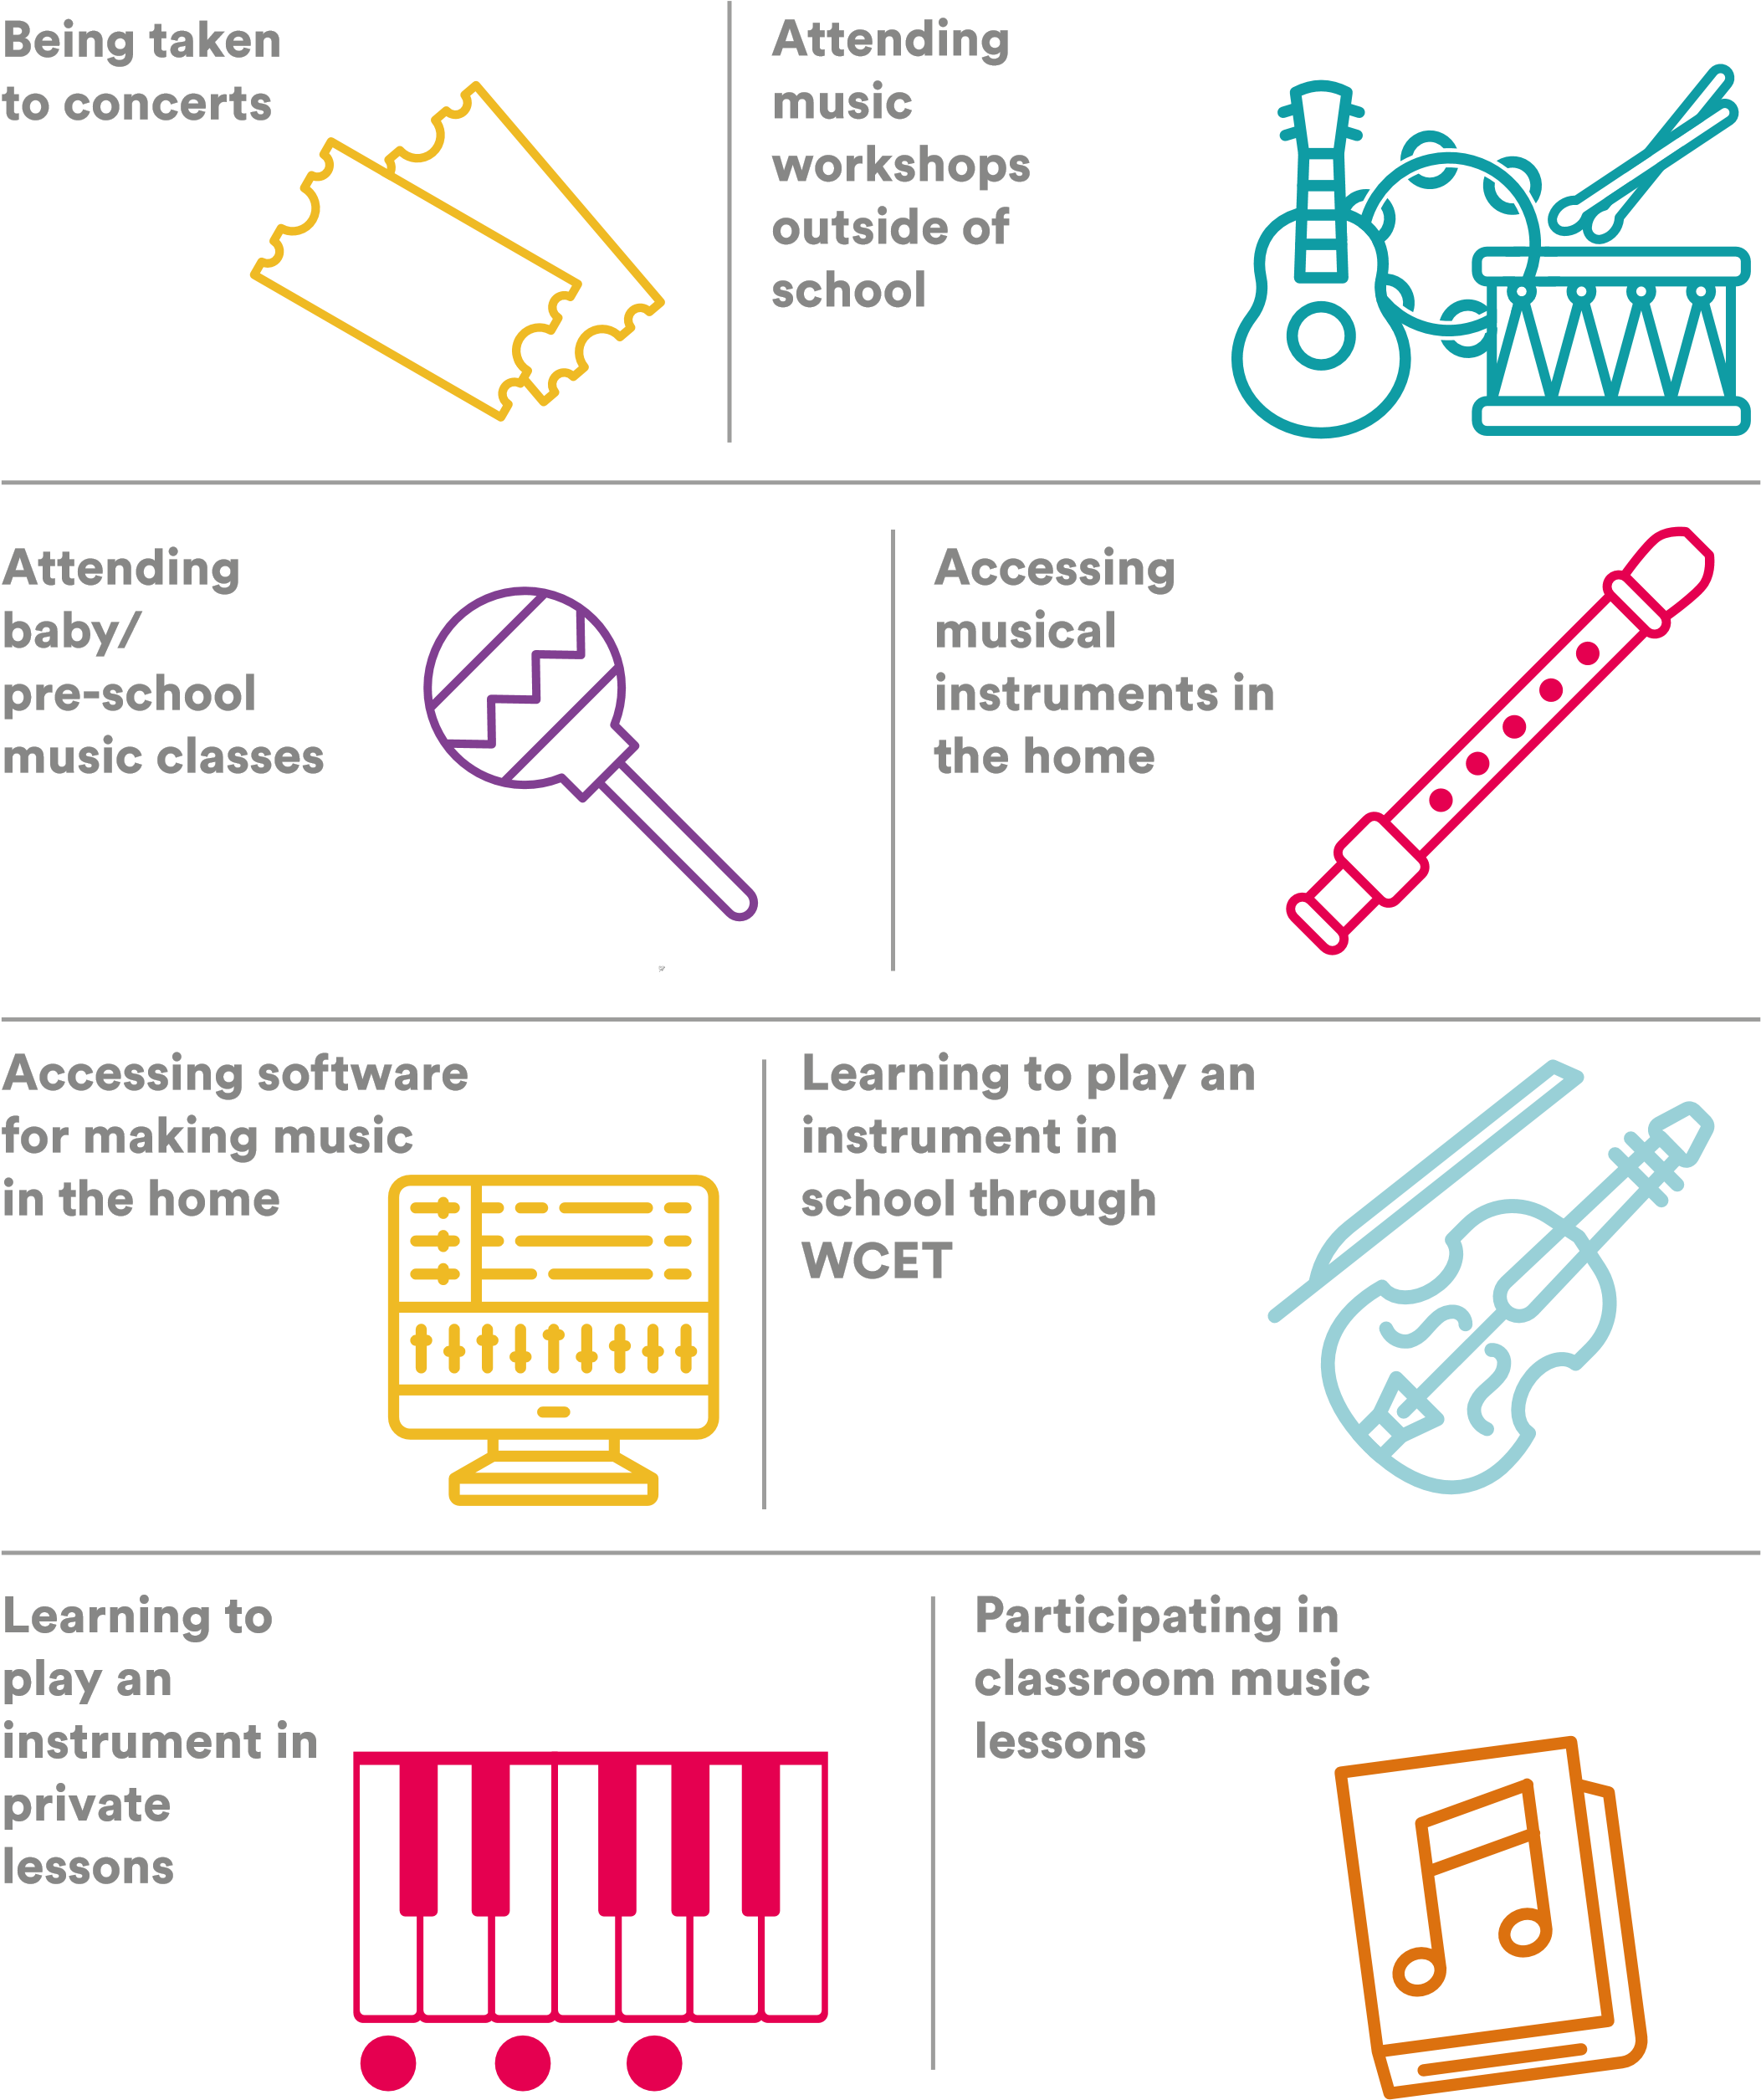

Children’s emerging composer identities
As with professional composers, children have different and preferred ways of working and are motivated, inspired and stimulated to compose differently. Children’s preferred ways of working will emerge over time and are important to consider when planning. Ensuring a wide range of approaches are taken within a lesson, across a SOW or over the year will mean that all children are able to flourish as composers.

Prefers working from own ideas
Prefers to be
given a brief Finding ideas for composing:
Happy to work
from own ideas or from an external brief | Likes to start with a brief but then moves away from it to explore own ideas in a creative productive way.
Finds ideas for composing
through Finds ideas for composing
imagination through improvisation using
Happy working
collaboratively or on
their own
Prefers
working alone
Prefers working collaboratively
in pairs or small groups
particular style
Together or alone?
Finds ideas
for composing
through listening
Finds ideas for
composing through
working with a musician
Finds ideas for composing
through using software/
technology/apps/DAWs
Finds ideas for composing by
using staff notation
Working to a brief:
musical instruments
Prefers composing
from musical
or sound ideas Prefers composing using
extra-musical ideas
Starting points and styles
Prefers working
Is open to within a defined composing in musical style
different musical styles or in no
As children have more opportunities to compose, some children will show a particular affinity for composing. Some identifiers for this might include:
Responding Understanding the technical,
imaginatively to a expressive and sound possibilities of instruments, technology, voices and given brief other sound makers and using them with intention.
Having an identifiable Displaying an musical style/ interest in the identity/sound or detail of sound
an emerging one and how it is
created
Experimenting with Using silence as well different playing as sound effectively.
techniques
Composing or Drawing on influences, having ideas and seeks out inspiration for composing for composing from outside outside of class of school
Having an intention for their music or develops one
Understanding how instruments, sound makers and voices will sound together and assigns particular ideas to particular instruments with intention.
Actively listening to other musics to get ideas
Getting satisfaction from expressing and communicating ideas and feelings through sound/music
Connecting their music to other music

From that first session of composing until today – I don’t know how [the children] have got there so quickly! And I don’t think they understand how difficult that is and how they’ve got there week on week. Teacher
I don’t think if you were to walk into that music session today, you’d say, ‘That child’s got a specific need,’ – once they knew what the task was, they could be
totally independent. Teacher
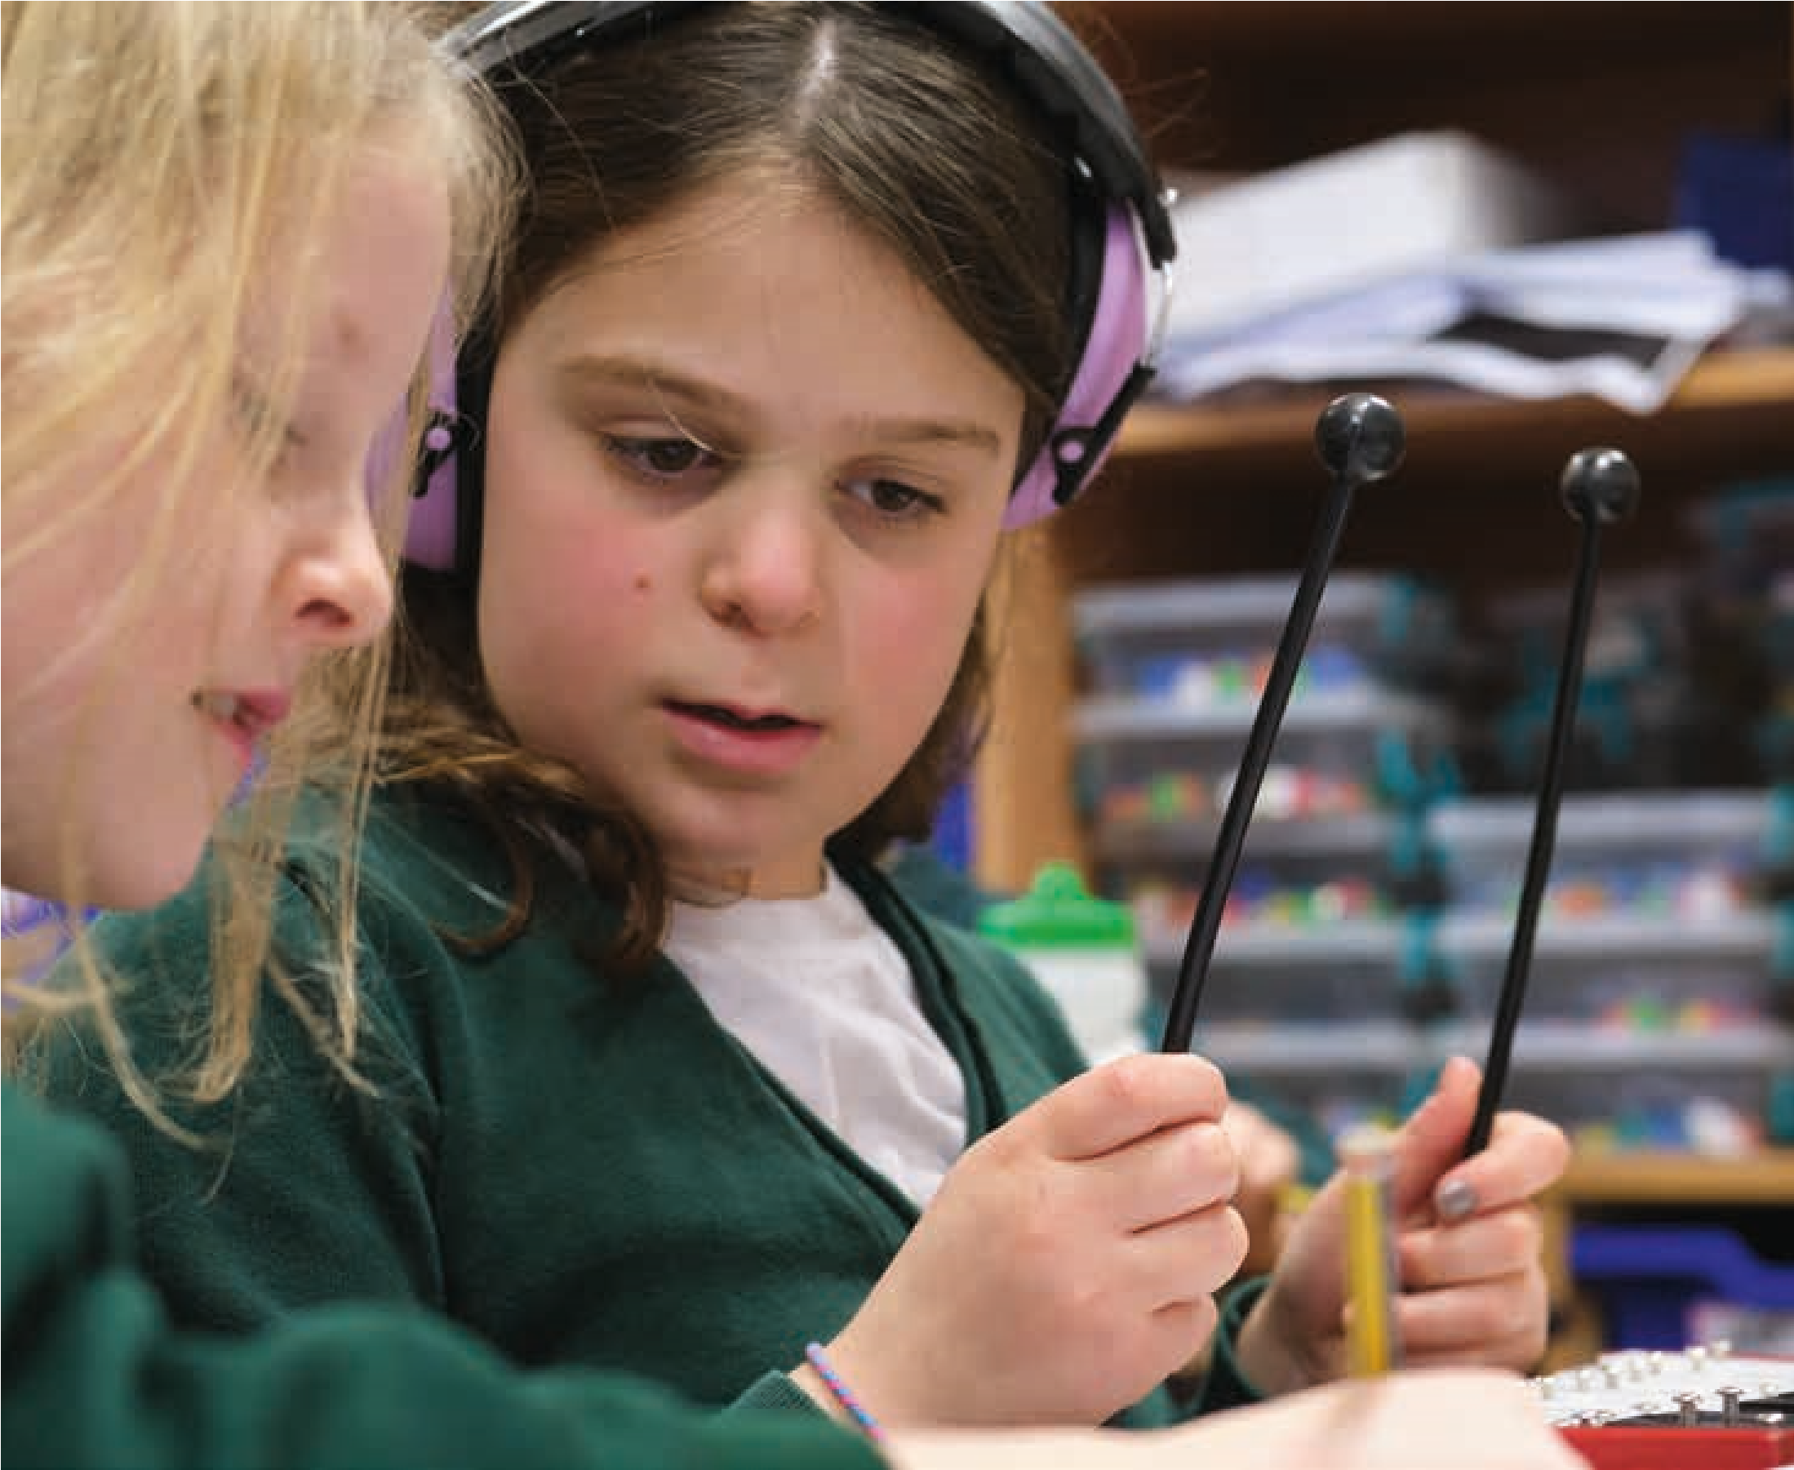

Pedagogies to include everyone
Children in your class with arrive with different and differing amounts of musical experience(s). In music, more than any other subject, the variation and gap can be enormous. It is important that you consider this in your planning. Below are some suggestions to support this.

- Think about and plan for differentiation – what might this mean when composing with children? Different composing activity and tasks will require different approaches.
- Remember the aim is to build and nurture all the children in your class as composers and not to create ‘wow’ pieces of music for performances. This needs to be reflected in your planning.
- Welcome wrong answers as well as right ones. There is often interesting thinking behind the wrong ones which can provide useful teaching moments.
- When asking questions, give children the opportunity to discuss in 2s and 3s before sharing
- When asking questions, wait for every child to have an answer. They can indicate this by putting their hand up when they have an answer.
- Remember it might not always be the most musically literate that will be the more able composers.
- Slow down and do more of less.
- Create different kinds of opportunities to share and pool ideas throughout the composing process. This will support those who find it harder to come up with ideas.
- Support the children to be able to evaluate, justify and explain their ideas.
- Encourage the children to use a range of ways to communicate their music to others – verbally, showing, words and graphic scores as well as traditional music notation.
- Make sure that you devise composing activities that don’t always privilege those learning a musical instrument.
- Explain any musical or technical language you use.
- Be aware that in some cultures, music is frowned upon, and it may be necessary to treat this with some delicacy and care, depending on the home cultures of the school.

Some reflective questions
- What kind of composers do you have in your class?
- Does your planning for composing learning, in the long term, take into account the backgrounds, needs and preferences of all the children in your class?

Organising and managing the class
Composing activity in schools can be done by children working as individuals, in pairs, in small groups or as a whole class. Choosing the right format will have implications for noise levels, participation, and learning. Below are some suggestions to support thinking about and planning the organisation of the class. This is followed by a table outlining the potential implications of choices, what needs to be considered and what solutions there might be.
- Think carefully about what you want the When composing whole class pieces, create children to learn and do and pick the group opportunities for everyone to meaningfully format to suit activity and what you want the contribute towards a whole children to learn
- Think about how the instruments/sound Over time, try to create opportunities for the makers/voices/beaters that you will in relation children to compose as individuals, pairs, small to the task and to how you might group the groups and as a whole group. Small group work children can be the norm so make time for individual or
pair working. Consider giving children roles group work and
teach the children team working skills When picking a group format to work in, consider how that would feel to you as a composer Be aware the bigger the group size the less input an individual child might have Consider how the composing process might be broken down into smaller tasks which could Ensure that all children are doing composerly include a mix of individual, small group and thinking at each stage of the process whatever whole class activity. The same format doesn’t the organisation or format.
need to be used throughout.
- When working with the whole group, particularly Consider that it doesn’t always matter that every when asking questions or asking for ideas, child’s idea makes it into the final piece. What is use pedagogic strategies like pair talk, waiting important is that everyone has done the thinking for hands up and everyone to have an answer, at each stage of the process or the stage of the randomly choosing children to answer process where the learning is focussed.
I’ve seen the children in completely different ways… quiet children have become really enthusiastic and quite loud, leaders have taken a step back – we don’t do that much creative stuff in this school, so it’s really nice to see them working in different ways. Teacher

Working as a whole class  Working in small groups  Working in 2s and 3s  Working as individuals  Thinking about the implications of different groups size | Can be very noisy if everyone is using instruments to do different things at the same time. Each individual does their own composerly thinking. However, individual working doesn’t allow for pooling, sharing, bouncing or cross fertilisation of ideas and weaker children may struggle. The music children create is a true reflection of where they are in their composing journey, but the quality will be variable. However, with good feedback and support, children can make good progress. If smaller achievable sequential tasks are set, progress to higher quality will follow. Children having the opportunity to compose on their own terms with their own ideas without compromise. Working individually is the norm in visual art and creative writing activity. Individual progress can be monitored. Children rely on what they already know. Weaker members of class could struggle. Children feel a strong sense of ownership of the music they have created though some will feel exposed and that their work is not good as good as others. Working as individuals’ positions composing as a solitary activity which is not always the case. You can end up with lots and lots of little pieces which can be hard to manage, document and share How can you create opportunities for sharing and pooling ideas even when the children are composing individual pieces? How will you manage the documenting and recording of lots of small pieces of music? How will you manage the noise levels?  Groups can find it difficult to hear what they are doing and can become distracted and influenced by other groups’ music. Composerly thinking is more distributed though particular individuals can still dominate. Children can pool, share, bounce or cross fertilise ideas with each other. Weaker members of the class can be supported by other members of the group. The quality of music produced can be very good if group members are willing to contribute, negotiate and compromise around a clear idea. There can be problems with quality when compromise means feeling the need to include everyone’s idea, even if those ideas aren’t compatible, or when good ideas are diluted for the sake of fairness. Time is needed to support effective group working. Working in small groups tends to be the norm. An ideal size tends to be 3 though there are good reasons to work in pairs or larger groups or a combination i.e. going from one to the other. It is’s relatively easy to assess individual contributions especially if process documented. Children have the opportunity to learn from each other, learn to negotiate ideas, think out loud together. Depending on the group size children and how well it functioned, children will feel different levels ownership. There can be problems when compromise means feeling the need to include everyone’s idea and the resultant music is just a mishmash of different ideas. Quieter members of groups may still struggle to have their ideas heard. How will you ensure everyone in the group contribute? Why do you think working as a small group is the best to support the learning for this activity? How will you decide how to form the small groups? Are there other spaces the groups could work other than in the classroom?  Noise levels are easier to manage as one person is in charge of the sounds/music stopping and starting. A small number of individuals or the teacher can end up doing all the composerly thinking. Music can be of high quality and made relatively quickly if the adult is making a lot of the decisions or enabling just a few of the children to dictate the content and direction of the piece. Whole class activity can be useful for modelling the composing process, introducing new ideas, working on common problems and sharing possibilities. It can also be an opportunity to compose and perform a whole class piece. It is very hard to disentangle individual contributions. A number of children will not appear to have contributed at all unless managed well. A large majority of the class don’t feel ownership of the music being created. Children can opt out ‘being a composer’. The teacher/ composer can end up making all the important decisions and can turn it into ‘composing on’ rather than ‘composing with or by’ children. What is it you want the children to learn? Why do you think working as a whole group is the best to support the learning? How can you ensure that every child is involved in the thinking and doing? How will you ensure every child is learning?  Noise levels Composerly thinking Quality of the music produced Useful for Progression and learning Ownership Weaknesses Needs considering
8.
Working in partnership
Listen Imagine Compose Primary’s model of working with schools has come about through many years of working with schools on long-term residencies and short-term projects involving composers. Drawing on this knowledge and practice, this section outlines how schools, teachers, music organisations and composers can effectively work together to reap the full benefits of partnership projects and then gives an overview of different models for how schools and composers might work together.
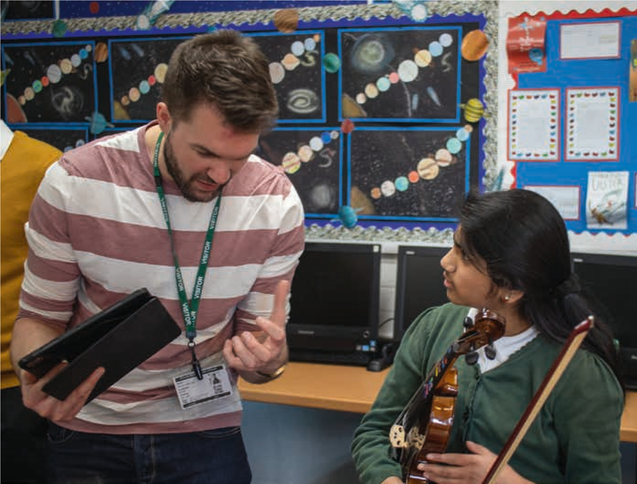

Principles for effective partnership working

Partnership projects bring together teachers, composers and children together, often for the first time. As such, projects will need to accommodate multiple needs, approaches and values. Being aware of and actively addressing partnership dynamics can foster a collaborative ethos and develop effective partnerships from the outset. Below are some principles for effective partnership working between schools and composers:

Clarity of purpose and expectation setting
Establish a shared understanding regarding the purpose of the partnership project. What do you want to get out of working together? What can be achieved in the time available? Is there a final performance element or is this about process? (See Section 3 Planning for composing in primary school for useful project considerations.)

Co-designing or co-constructing a project
Make sure that schools and music organisations both have the opportunity to input into the project – its learning outcomes, timeline, structure, staffing, participating teachers. In the same way, ensure both teachers and composers input into planning the composing activity for the children.

Contextual understanding
Ensure visitors are aware of school-specific opportunities and limitations, musical resources and provision, school curriculum and policies, and issues which could impact on the project. Knowledge of the school’s wider locality and cultural heritage may also be helpful and inspire creative composing ideas. Relationship building
Learn about one another as musical beings – for example, through sharing favourite music, music education histories and experiences and family heritage. See Appendix X for questionnaire ‘Sharing our musical selves’, which was designed by an LICP composer to get to know the teachers and children they were working with. Sharie photos and musical recordings.
Balancing needs
Think about how all project stakeholders’ needs can be balanced. How are these prioritised? How can children’s needs remain at the centre of the project? Be sensitive to how the wider school environment will affect teachers’ needs and demands on their time. Be sensitive to how the composer’s professional life, which is typically freelance and nomadic, will affect their needs and work pattern. Clear roles and responsibilities
Think about how will you work together in the classroom. For instance, will the composer and teacher co-lead? Will the teacher shadow the composer and gradually lead more on tasks? What kind of practical support can the composer and teacher expect from each other during sessions and how will this be communicated?

Having a composer in school working with us on a regular basis has really helped raise the profile and standards of music across school (not just those that they directly worked with) … Having an expert in school showed the children where they could be as adults in later life. It also showed the level of talent to stretch beyond that which they see within school and their own experiences.

Headteacher

Shared expertise
Explore, plan for and utilise teacher and composer expertise in the classroom. This could be an ongoing area for discussion during reflections. How can you ensure both sets of expertise are valued? How can you take time to learn each other’s language and jargon? Can you establish common pedagogical language and connection points? Find opportunities to develop skills together.

Regular communication, planning and reflection
Establish practicalities of how and how often you (teachers and composers) will communicate inbetween sessions. Build in time before and/or after each session to reflect on activity together, using insights gained to shape subsequent session(s). See Appendix VIII for a teacher/composer reflection pro-forma. These questions could also be adapted for children feedback.

Adaptability
Be prepared to formulate new plans and revise project goals in response to what arises in the classroom and during reflections.

Building sustainability and legacy
Where possible involve more than one teacher and the music coordinator or music lead in the project. As well as direct involvement, this could also include whole school CPD, shadowing and/or co-teaching which will help embed practice. Invite SLT to sessions to build their understanding and do so at various points in the project to foreground composing process and product.

Promoting musical progression
Seek out and share local and online opportunities for children to compose outside of school.

Sharing with the wider community
Think about how you might share what you have been doing with the with wider community. What might that look like? How can you ensure it goes beyond your individual school?

Developing a community of practice
Partnerships can incorporate additional project elements, which complement the core project activity in schools and promote a community of practice centred on composing. LICP incorporated reflective symposiums including presentations by teachers, composers, project leads and researchers, professional development for teachers and composers, and mentoring for early career composer-educators. During the beginning phases of LICP, joint seminars served to build relationships, develop a sense of common purpose and set out project practicalities.

Some reflective questions
- Are there any principles for effective partnership working that you would add to the list?
- Think about a partnership project you have previously participated in. What made it successful/unsuccessful?
- How will you explore, negotiate and establish clarity surrounding project purpose and outcomes, roles and responsibilities, communication, expertise and legacy?
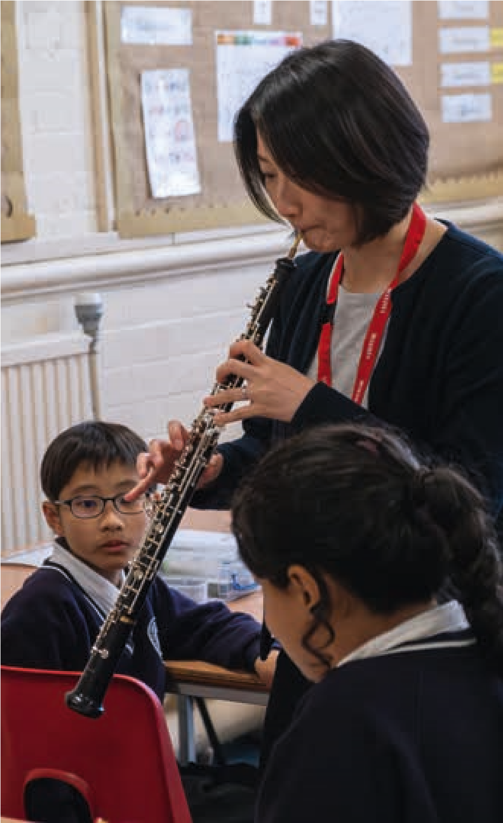

Practical considerations
For teachers
- Host your composer in the classroom before the project begins so they get can get to know the children.
- Give the composer an overview of your school and share school documents such as curriculum plans, schemes of work and, where permitted, information on children’s individual needs.
- Ensure children have had time to learn about the project and ask questions about it. This could take place during the composer’s initial visit.
For schools and SLTs
- Identify potential dates in school calendar for sharing learning and extending project activity, e.g. INSET days for whole school CPD, assemblies for sharing work in progress.
- Ensure that the participating teachers feel supported to reflect with the composer after sessions or after school and to attend project meetings and CPD.
- Make opportunities to say hello to the composer and check how the project is going
- Let composers and music organisations know about potential date clashes well in advance so that sessions can be arranged.
For music organisations
- Take time to understand the school’s needs and community.
- Build in time for the composer to meet and observe the class before starting and to show an interest in wider school life. Prepare a series of questions for the visit (see page 21 for exemplar questions).
- Engage with the school’s SLT before and throughout the project to ensure the teachers’ full involvement (e.g. highlight expected time to attend project meetings, CPD and expected time commitment).
- Where possible, include teaching cover in project budgets so that key teaching staff can fully engage in the project.
For composers
- If possible, arrange to meet and observe the class you will be working before you start.
- Find out as much as you can about the school (see page 21 for exemplar questions).
- Establish when a good time is for reflection and potentially pre-book it as well as finding out when teachers have their PPA (Planning, Preparation and Assessment) time.
- If you require any particular resources, instruments or photocopying doing, make sure these are asked for well in advance and be mindful of teachers’ time.
- If you are working for an organisation keep in touch and share any concerns as early as possible.

Children who sometimes seem to show less interest in singing were really inspired by the composing and loved doing it.
Teacher

Composers in schools
In the UK as well as in other countries, there are a significant number of projects where composers work with children in schools. This section² explores how this might happen and intends (a) to help schools think about what they might want out of working with a composer, and (b) to support composers to reflect on their practice and be able to clearly set out different ways of working to schools. It identifies fours ways of working, of which three are recommended for regular use:
Composing by children
Composing with children
Composing for children
Composing on children
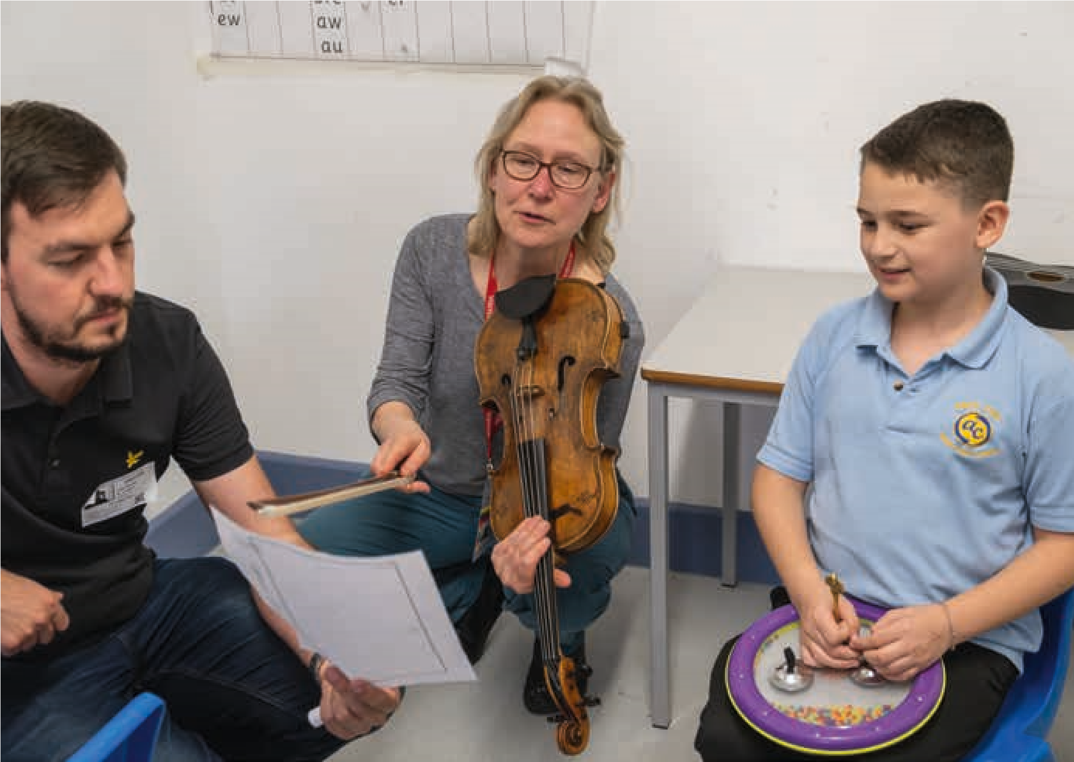
2/ This section is based on Devaney, K., Evans, N., Fautley, M. and Ziegenmeyer, A. (2024) ‘Ways to Teach Composing’. In Devaney, K., Fautley, M., Grow, J. and Ziegenmeyer, A. (Eds), The Routledge companion to teaching music composition in schools: International perspectives, pp. 185-193. New York, Taylor and Francis.

Composing by
This way of working is the subject of this toolkit. The children are the generators and organisers of musical ideas. Here the composer will set up a composing task, and when done well, the professional composer will scaffold this process, maybe breaking it into smaller tasks, listen to the children’s work is in progress, offer suggestions, ask questions, make observations, and give feedback; but the music composed is by the young people involved. There is a wide spectrum within this way of working, from very open briefs where the children make all the decisions to more closely specified ones where the composer makes some of the decisions, for example, the theme, how long, which instruments or specifying a particular set of notes to use.
The focus of such a project will be on children’s learning and doing as composers. Though operating on a spectrum, the decision-making will be firmly with the children. The role of the composer is that of facilitator, they have enabled composing to take place, and have given participants full control over what happens.
Composing with
Here the composer works cooperatively with the children to create a piece of music. In this model, there is cooperation, and power is distributed between the participants. It may that this powersharing is unequal, maybe weighted more towards the composer, but nonetheless all participants have a say in what happens. One of the useful aspects of this way of working is that it effectively models composerly thinking and doing, with the composer often showing the children both what they are doing and, importantly why they are doing it. This modality allows the young participants to have a voice in both the process of composing and in the final composition. Another term that could be used to describe this model is co-creation.
In this way of working, the composer will ask the children to generate ideas for a piece, and then work with the ideas that arise, sharing qualitative decisions about the shape, form, tonality, harmony, and other characteristics of the music with the children concerned. This could be said to be a democratic modality, and endeavours to empower all participants.
[I’ve learnt] how important sound is in a classroom. Teachers are taught to try their best to maintain the silence. This allowed me to realise that sounds/ music is a form of expression and learning. It has a place in the classroom. Teacher
The focus of a project using this model is participation in the creative process and giving children an insight into how a composer works. The decisionmaking is shared between the professional composer and the children. The role of the composer will be to listen to all the ideas, support the children to make decisions, offer and model different scenarios, help shape the final structure and maybe to create the performance materials.
Composing for
In this way of working, the composer is commissioned to compose a piece for a group of children and young people. Here, the composer is using their professional craft, but in a particular and specified way. It can be viewed in the same light as any other commission a composer might receive, For example, composing a piece for a professional string quartet or a brass band. When composing for particular groups of young people, opportunities for the composer to meet the young people might be built in. These provide valuable time (a) for the composer to get a feel for the character and potential of an ensemble or group, to try out work in progress and (b) for the young people to hear about progress of the piece and to get to know the composer and their music.
Composing for an established ensemble, like a youth orchestra will be a very different from composing for a primary school class. With a youth orchestra or similar, there will be established levels of expertise, an understanding of the instrumental forces available and an assumption the children will read standard western staff notation. With a primary school class, none of these are likely to be the case. It’s likely that there will be tuned and untuned classroom percussion available but that the children’s experience of this will be variable, and need exploring. There may well be an element of the composer asking to the children try particular ideas on instruments to see if they work or not. The children are primarily performers not composers in this model, but there is still valuable learning. When done well, such projects open new sound worlds and introduce new playing techniques as well as introducing composing as a living breathing art form to the children that they could aspire too.
The focus of a project using this model will be on children as performers, and offering them the opportunity to experience new sound worlds and try out new playing techniques. The professional composers makes most of the decisions and their role is their professional craft of composing.
Composing on
Whilst there might be valid reasons why the
Composing on mode might be used (explained later), it can also refer to a way of working that purports to give children opportunity to participate, make decisions and be creative, but does not. In this way of working the composer is firmly in the driving seat. Though children might be asked for their ideas, only those the composer likes are used, or the children might be highly directed towards finding a particular sound on a particular instrument. Inevitably only a few children’s ideas make it to the final piece, and therefore children can disengage from the process, or their participation shifts to that of a performer not a creator. This way of working can result in big, exciting performable pieces of music being created quickly, but this is done at the expense of children feeling ownership of the music, or meaningfully participating in the creative process, and mainly involves the children playing a game of ‘guess what the composer wants’.
This way of working is problematic when a proposed composing project has been ‘billed’ as collaborative, or as a learning opportunity, and this is clearly not what has happened. However, when time is tight, and a scheduled final performance is looming, this approach may a reasonable efficacious way of reaching a satisfactory musical result. In this instance, it might be that there has been excellent Composing with or Composing by happening up until to a certain point when time has simply run out.
In this toolkit it is suggested that Composing on may not be the most appropriate way for composing in schools projects to be operationalised. However, as noted above, there may times when it is appropriate, but nonetheless for composing projects – as opposed to performing ones – the other modalities are likely to be more suitable and appropriate.

When I’m composing it makes me feel excited for what it could actually be in the end. It makes me feel proud.

Young person
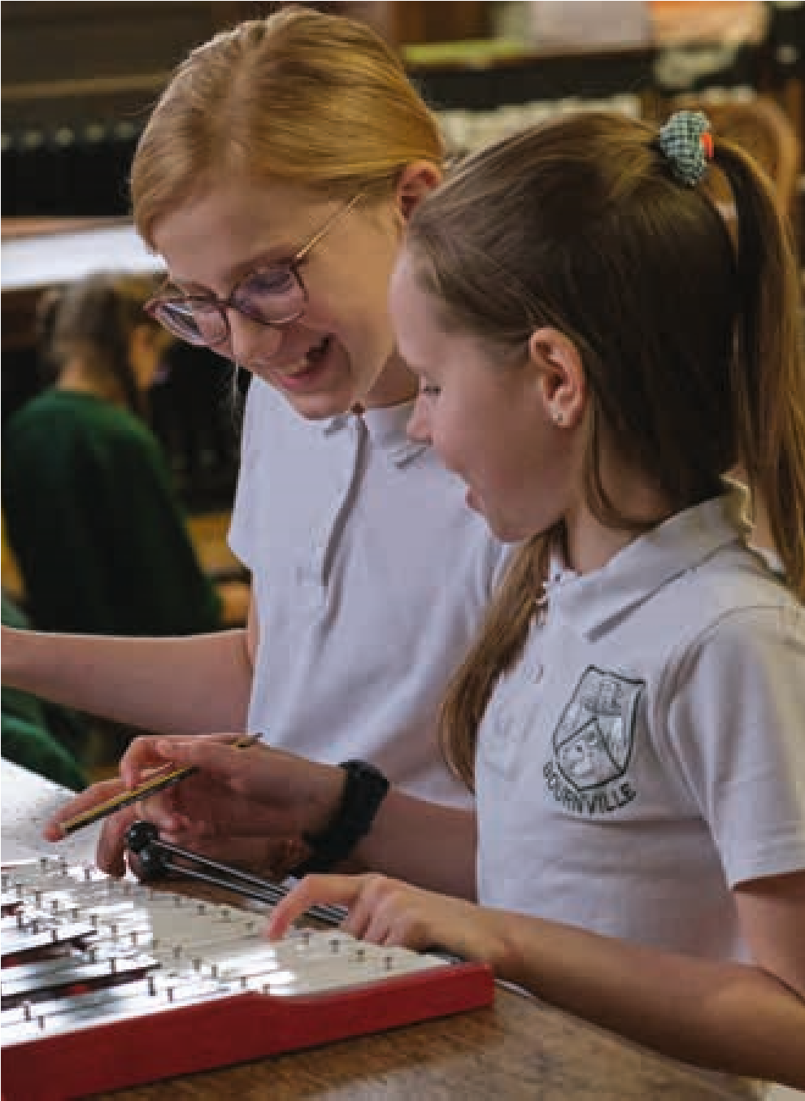

Some reflective questions
- Why might a composer work in a school?
- What might the children learn from working with a composer?
- What will the children do in such a project, what will be their role?
- How will learning from such projects be taken forward and built upon?
- How will any teacher learning be embedded in future teaching and learning?
- What needs to happen in the setting up of such projects to ensure there is not a mismatch of expectations and outcomes?
- How do arts organisations sending composers into schools find the balance between meeting the needs of schools, with challenging the practices they find taking place when appropriate, with meeting their own organisational priorities?
Involving and working with visiting musicians
Inviting a musician or musicians into the classroom and giving children the opportunity to compose for them, can be a very valuable experience. It enables them to:
- Fully inhabit the role of composer instead of being the composer and the performer
- Have their musical ideas fully realised without the limitation of being able to play the instrument
- Learn in depth about the sounds, capabilities and limitations of particular instruments or the voice – something which can be applied to other future composing activity
- Engage in a creative two-way conversation with the musician which allows them to immediately hear what their ideas will sound like and then reflect on them and refine them.
- Have ‘wow’ moments when they realise
‘I composed this!’
- Feel a sense of occasion when their pieces get performed and recorded by a performer Visiting musicians could include:
- Musicians from a local professional orchestra, ensemble or band
- Visiting peripatetic instrumental and vocal teachers
- Student musicians from a local university, college or conservatoire
- Parents who play a musical instrument
- Local musicians from the community
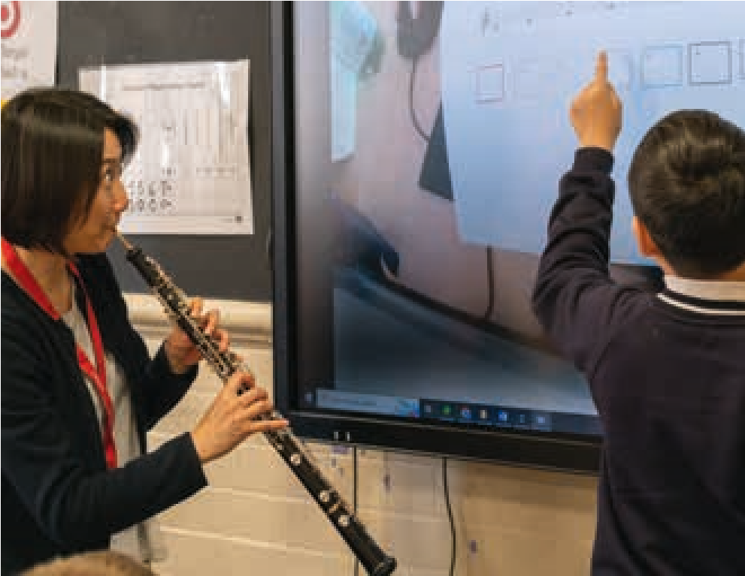
Visiting musicians, as outlined above, will have varying levels of experience and skill for working with children and will need different levels of support. Below are suggestions to help get the most out of visiting musicians for children’s composing. Ideally the visiting musician would make multiple visits during the development of the children’s pieces.
- Make sure the visiting musician(s) is well briefed. Do they understand the purpose of their visit is to support the children to compose for them and their instrument and to perform their final pieces?
- Explain what the children have done previously and what you would like them to get out of the visit(s)
- Explain that it is the process of composing that is most important for the children not the final result
- Ask the musician to be prepared to demonstrate the capabilities and sound possibilities of their instrument or voice
- Ask the musician to suggest contrasting music for their instrument for the children to listen to in advance, during and in between visits
- Work with the children to think of questions to ask the visiting musician about their instrument and about composing for their instrument
- Share with the musician the feedback sentence stems on pages pages 44 and 45
Such sessions work best when the visiting musician:
- Plays amazingly and captivates the children’s attention so that they want to compose for that instrument
- Treats the children’s ideas, even embryonic ones, with seriousness and demonstrates obvious enjoyment in the task
- Asks the children questions to help clarify their intentions
- Suggests and demonstrates alternative options for the child to choose from
- Is prepared to play ideas given in many different forms – staff notation, graphic scores, verbally, through movement, text, or a mixture of all or some of those
- Interprets the child’s music through what they have been given and through questioning the child’s intentions but doesn’t add ideas that are not there
A series of three visits by a musician might consist of:
Visit One:
- A demonstration of their instrument sharing what the instrument can do and the sounds it can make.
- Playing existing pieces of music to showcase the character of the instrument and what it does well.
- The musician inviting the children to compose a new piece of music for them to play and giving them a composing brief (see pages 42 and 43). It will feel extra special coming from the musician!
- The children create simple ideas for the performer to play or improvise on through conducting (movement gestures), mark making (graphic scores ideas) or simple notation
- NB If you aren’t able to have three visits, visit one could be substituted with a short introductory video from the performer which includes a demonstration of the instrument and performance of pieces
(bullets 1 and 2)
Visit Two:
- Collectively, in small groups or individually the children create ideas for the performer to try out.
- There is lots of time for reflection, discussion and refinement of ideas
- Collectively, in small groups or individually the children create 3-5 different musical ideas
- The children start to think how they might develop and expand their ideas through variation, extension and accompaniments.
Visit Three:
- The children present the musician with longer structured pieces of music using ideas created in previous sessions including when the musician was not there.
- The performer plays through the children’s pieces.
- There is lots of time for reflection, discussion and refinement of final pieces.
- The final pieces are performed and recorded.

Having an instrumentalist in the space was the moment where so much clicked for the children I’m working with. It was composing for someone else and being able to experiment and describe a sound and refine that sound. […] that’s unlocked so much composerly thinking and opportunity. Composer

9.
Appendices
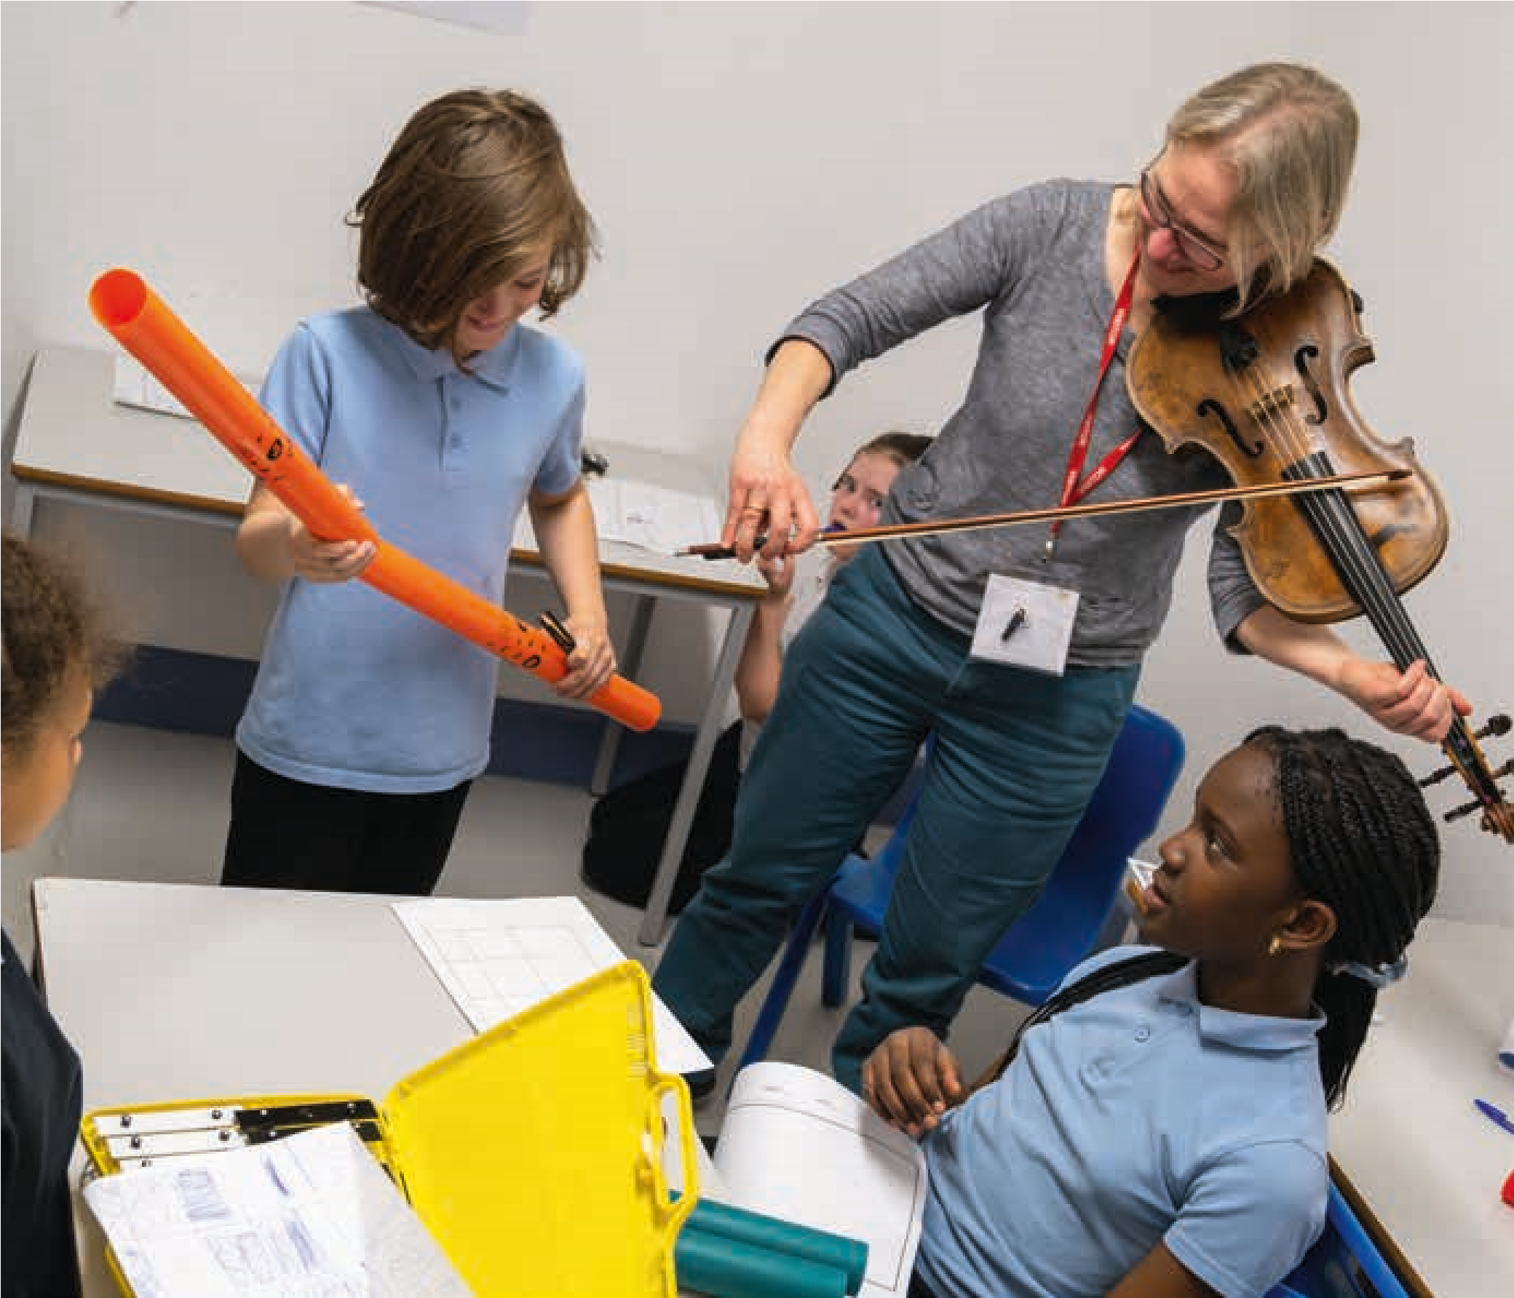

Appendix I: Glossary
Accompaniment | A musical part which provides the rhythmic, textural or harmonic support to the dominant melody or musical idea
Affordances | The possibilities offered by an environment, stimulus or musical instrument
Articulation | The way in which the note or sound is performed – specifically the start and end of the note – for example the note may be short, abrupt, smooth or rounded.
Binary form | Music made of two different sections – sometimes expressed as AB
Call and response | A structure where a ‘leader’ (a person/group) produces a musical idea, which is copied (exactly or altered) by another person or group. This can be used to generate new ideas if those responding by making changes to the leader’s idea.
Canon | Using the same musical idea, but staggering the start time so they overlap, like singing in a round
Chord Sequence | A sequence of different chords
Chord | A group of different notes played simultaneously
Drone | A sustained sound (one, or a few, notes) used as an accompanying idea
Duration | The length of a note or musical idea
Dynamics | How loud or quiet an idea is and how this changes
Extra-musical | Using ideas from a non-musical stimulus, e.g.: picture, environment, story, event
Form | How the musical ideas are organised over time – the structure of the music
Gesture | A musical idea defined by shape and character, rather than specific notes or rhythm
Graphic score | A visual representation of music through visual symbols
Harmony | How individual notes combine vertically
Interval | The distance in pitch between two notes
Melody | A linear succession of musical tones that the listener perceives as a single entity
Ornament | A short decoration or embellishment added to a note
Ostinato (rhythmic) | A repeating rhythm
Ostinato (melodic) | A repeating short melody
Pitch | How high or low a note is
Rhythm | A sequence or pattern of durations
Rondo form | A structure which alternates a main idea with lots of different ideas – sometimes described as ABACABA
Second melody | Another melodic idea – sometimes called a countermelody
Sequence | Repeating the same idea, but changing it over time. A repeating idea which changes over time to lead somewhere else. Repeating an idea, but changing the pitch.
Sonata form | A musical form using at least two musical ideas – both musical ideas are heard at the start and end, and the middle section explores the contrasts between them – another ABA form
Sound before symbol | Practically creating music before notating it
Staff notation | A form of Western classical music notation, where notes are written on 5 lines using symbols such as clefs, crotchets and quavers
Structure | How musical ideas are organised – how musical ideas are used vertically (simultaneously), and horizontally (over time)
Tempo | The speed of the underlying pulse of the music
Ternary form | A structure where the opening and closing sections are the same with a contrasting middle section – sometimes described as ABA
Texture | How the ideas are layered up – some ideas might dominate, others might be accompanying, or they be of equal importance.
Theme and variations | A structure where each section develops the main idea(s) from the piece in different ways – for example, with different dynamics or instruments
Timbre | The features of the sound itself – its volume, its characteristics, its mood
Tonality | The harmonic centre – a piece or idea might be in a major key, a minor key, only use a certain number of notes (e.g.: 5), or have one or a few notes as its ‘home’
Variation | A technique where a musical idea is repeated in an altered form
Verse chorus | A structure taken from song – sections with different words (verses) alternate with a repeated refrain (chorus). This may also include an intro, outro and bridge (link) section.

Appendix II: Bibliography

Bamberger, J. (1982) ‘Revisiting children’s drawings of simple rhythms: A function for reflection-in-action’. In Strauss, S. and Stavy, R. (Eds), U-shaped behavioral growth, pp. 191-226. New York, Academic Press.
Bamberger, J. S. (1995) The mind behind the musical ear: How children develop musical intelligence, Cambridge MA, Harvard University Press.
Berkley, R. (2001) Why is teaching composing so challenging? A survey of classroom observation and teachers’ opinions. British Journal of Music Education, 18, 2, 119-138.
Bolden, B. (2009) Teaching composing in secondary school: A case study analysis. British Journal of Music Education, 26, 2, 137-152.
Burnard, P. (2000a) Examining experiential differences between improvisation and composition in children’s music-making. British Journal of Music Education, 17, 3, 227-245.
Burnard, P. (2000b) How children ascribe meaning to improvisation and composition. Music Education Research, 2, 1, 7-23.
Burnard, P. (2002) Investigating children’s meaning-making and the emergence of musical interaction in group improvisation. British Journal of Music Education, 19, 2, 157-172.
Burnard, P. (2006a) ‘The individual and social worlds of children’s musical creativity’. In McPherson, C. (Ed), The Child As Musician: A Handbook of Musical Development, pp. 353-374.
Oxford, Oxford University Press.
Burnard, P. (2006b) Reflecting on the creativity agenda in education. Cambridge Journal of Education, 36, 3, 313-318.
Burnard, P. (2007) Reframing creativity and technology: promoting pedagogic change in music education. Journal of Music, Technology and Education, 1, 1, 37-55.
Burnard, P. (2012) Musical creativities in practice, Oxford, Oxford University Press.
Burnard, P. (2018) ‘Commentary: Musical creativity as practice’. The Oxford Handbook of Music Education, Volume 2, pp. 319-334. New York, Oxford University Press.
Burnard, P. and Murphy, R. (Eds) (2017) Teaching music creatively, Abingdon, Routledge.
Burnard, P. and Younker, B. A. (2002) Mapping Pathways: fostering creativity in composition. Music Education Research, 4, 2, 245-261.
Burnard, P. and Younker, B. A. (2004) Problem-solving and creativity: insights from students’ individual composing pathways. International Journal of Music Education, 22, 1, 59-76.
Burnard, P. and Younker, B. A. (2008) Investigating children’s musical interactions within the activities systems of group composing and arranging: An application of Engeström’s Activity Theory. International Journal of Educational Research, 47, 1, 60-74.
Campbell, P. (2010) Songs in their heads: Music and its meaning in children’s lives, New York, Oxford University Press.
Campbell, P. S. (1991) The child-song genre: A comparison of songs by and for children. International Journal of Music Education, 1, 14-23.
Davies, C. (1986) Say it till a song comes (reflections on songs invented by children 3–13). British Journal of Music Education, 3, 3, 279-294.
Department for Education (2021) Model Music Curriculum: Key Stages 1 to 3 – Nonstatutory guidance for the national curriculum in England, London, National Archives UK. https://www.gov.uk/search/ guidance-and-regulation
Devaney, K., Fautley, M., Grow,
J. and Ziegenmeyer, A. (Eds), The Routledge companion to teaching music composition in schools: International perspectives, pp. 185-193. New York, Taylor and Francis.
DfE (2013) ‘The National curriculum in England – Framework Document’. London, Department for Education.
DfE and DCMS (2011) ‘The
Importance of Music – A
National Plan for Music Education’. London, Department for Education, and Department for Culture, Media, and Sport.
Fautley, M. (2005) A new model of the group composing process of lower secondary school students. Music Education Research, 7, 1, 39 – 57.
Fautley, M. (2010) Assessment in Music Education, Oxford, Oxford University Press.
Fautley, M. and Savage, J. (2008)
Assessment for Learning and
Teaching in Secondary Schools, Exeter, Learning Matters.
Fautley, M. and Savage, J.
(2007) Creativity in Secondary
Education, Exeter, Learning Matters. after Fautley 2010
Fautley, M. and Savage, J. (2011)
Cross-curricular Teaching and
Learning in the Secondary School: The Arts, Abingdon, Routledge.
Finney, J., Philpott, C. and
Spruce, G. (Eds) (2020) Creative and Critical Projects in Classroom Music: Fifty Years of Sound and Silence, London, Routledge.
Glover, J. (2002) Children Composing 4-14, London, Routledge Falmer.
H M Government UK (2022) The power of music to change lives – A National Plan for Music Education, London, Open
Government Licence – National Archives UK. Available from: https://assets.publishing.service. gov.uk/government/uploads/ system/uploads/attachment_ data/file/1086619/The_Power_ of_Music_to_Change_Lives.pdf
Hickey, M. (2003b) How and why to teach music composition: New horizons for music education, Reston, VA, MENC.
Kaschub. M. (Ed) (2024) Oxford
Handbook of Music Composition Pedagogy. New York, Oxford University Press.
Kinsella, V. and Fautley, M. (2017) Creativity: Getting it Right in a Week, St Albans, Critical Publishing.
Lubart, T. (2010) ‘Cross-cultural perspectives on creativity’. In Kaufman, C. and Sternberg, R. (Eds), The Cambridge handbook of creativity, pp. 265-278. New York, Cambridge University Press.
Margulis, E. H. (2014) On repeat: How music plays the mind, New
York, Oxford University Press, USA.
Ofsted (2021) Research review series: music, London, Ofsted. https://www.gov.uk/government/ publications/research-reviewseries-music
Ofsted (2023) ‘Striking the right note: the music subject report’. London, Office for Standards in Education (Ofsted).
Ofsted: (2023) Striking the right note – the music subject report. London, Ofsted. https:// www.gov.uk/government/ publications/subject-reportseries-music/striking-the-rightnote-the-music-subject-report
Paynter, J. (1982) Music in the secondary school curriculum, Cambridge, Cambridge University Press.
Paynter, J. and Aston, P. (1970)
Sound and Silence, Cambridge, Cambridge University Press.
Schafer, M. (1969) The New Soundscape, Canada: BMI.
Schafer, R. M. (1976) Creative Music Education: A Handbook for the Modern Music Teacher, London, Macmillan.
Schafer, R. M. (1986) The thinking ear: complete writings on music education, Toronto, Arcana Editions.
Swanwick, K. and Tillman, J. (1986) The sequence of musical development: a study of children’s compositions. British Journal of Music Education, 3, 3, 305-309.
Upitis, R. (2017) ‘Using a wholemusic approach creatively’. In Burnard, P. and Murphy, R. (Eds), Teaching music creatively, pp.
159-169. Abingdon, Routledge.
Vygotsky, L. (1978) Mind in Society, Cambridge, MA, Harvard University Press.
Wallas, G. (1926) The Art of thought, London: Watts.
Webster, P. (1988) ‘Creative thinking in music’. In Gates, J. (Ed), Music Education in the United States, Tuscaloosa, University of Alabama Press.
Webster, P. (1992) ‘Research on Creative Thinking in Music’. In Colwell, R. (Ed), Handbook of Research on music teaching and learning, New York, Schirmer.
Webster, P. (2003a) Asking Music Students to Reflect on Their Creative Work: encouraging the revision process. Music Education Research, 5, 3, 243-248.
Webster, P. (2003b) ‘”What
Do You Mean, Make My Music
Different”? Encouraging
Revision and Extensions in Children’s Music’. In Hickey, M.
(Ed), Why and How to Teach Music Composition: A New
Horizon for Music Education, pp. 55-68. Reston, Virginia, MENC.
Young, S. (2003) Music with the Under-Fours, London, Routledge.
Young, S. (2008) Collaboration between 3-and 4-year-
olds in self-initiated play on instruments. International Journal of Educational Research, 47, 1, 3-10.
APPENDIX III: Suggested other reading – a selective list
Bamberger, J. (2013) Discovering the musical mind: A view of creativity as learning, Oxford, Oxford University Press.
Burland, K. and Davidson, J.
W. (2001) Investigating Social
Processes in Group Musical Composition. Research Studies in Music Education, 16, 1, 46-56.
Christophersen, C. and Kenny, A. (2018) Musician-teacher collaborations: Altering the chord, New York, Routledge.
Craft, A. (2000) Creativity across the primary curriculum : framing and developing practice, London, Routledge.
Craft, A. (2001) ‘Little c
Creativity’. In Craft, A., Jeffrey,
B. and Leibling, M. (Eds), Creativity in Education, London, Continuum.
Craft, A. (2005) Creativity in Schools – Tensions and Dilemma, Abingdon, Routledge.
Craft, A., Jeffrey, B. and Leibling, M. (Eds) (2001) Creativity in
Education, London, Continuum.
Cooke, C. and Philpott, C.
(Eds) (2022), A Practical
Guide to Teaching Music in the
Secondary School (Routledge
Teaching Guides) Abingdon, Routledge
Daubney, A. and Fautley, M. (2014) ‘The National Curriculum for Music – An assessment and progression framework’. London, The Incorporated Society of Musicians.
Davies, C. (1992) Listen to my song: a study of songs invented by children aged 5 to 7 years. British Journal of Music Education, 9, 19-48.
Dennis, B. (1970) Experimental music in schools: Towards a new world of sound, London, Oxford University Press Music Department.
Department of Education and
Science and Welsh Office (1987) The National Curriculum 5-16: a consultation document, London, Department of Education and Science.
DfEE/QCA (1999) The National
Curriculum – Music, London,
HMSO.
Fautley, M. and Daubney, A. (2019a) Curriculum and assessment in music education – the research context. An explanation of the process underpinning the production of the ISM materials, London, ISM (Incorporated Society of Musicians)
Fautley, M. and Daubney, A. (2015) An assessment and progression framework for music – secondary, London, Incorporated Society of Musicians (ISM). www.ism.org/ nationalcurriculumMFAD
Fautley, M. and Daubney, A. (2019) A revised framework for curriculum, pedagogy and assessment in key stage 3 music, London, Incorporated Society of Musicians (ISM).
Fautley, M. and Savage, J. (2014)
Lesson Planning for Effective Learning, Abingdon, Open University Press.
Hickey, M. (2000) ‘The Use of consensual assessment in the evaluation of children’s music compositions’. In Woods,
C., Luck, G., Brochard, R., Seddon, F. and Sloboda, J.
(Eds), Proceedings of the Sixth
International Conference on
Music Perception and Cognition, Keele, UK, Keele University, Department of Psychology.
Hickey, M. (2001) ‘More or less creative? A comparison of the composing processes and products of “highly creative” and “less creative” children composers’. 2nd International research in Music Education conference, Exeter, UK.
Hickey, M. (2003a) ‘Creative
Thinking in the Context of Music
Education’. In Hickey, M. (Ed), Why and How to Teach Music Composition: A New Horizon for Music Education, pp. 31-54. Reston, Virginia, MENC.
Hickey, M. (2007) ‘Assessing
Creativity: An Oxymoron’. In Brophy, T. S. (Ed), Assessment in Music Education. Integrating Theory and Practice. Proceedings of the 2007 symposium on Assessment in Music Education. University of Florida., pp. 195-204. Chicago, GIA Publications.
Hickey, M. (2012) Music Outside the Lines: Ideas for Composing in K-12 Music Classrooms, New York, Oxford University Press.
Hickey, M. and Webster, P. (2001) Creative Thinking in Music. Music Educators Journal, 88, 1, 19-23.
Kaschub, M. and Smith, J. (2009)
Minds on Music. Composition for
Creative and Critical Thinking, Lanham, Maryland, MENC, in partnership with Rowman and Littlefield Education.
Kaschub, M. and Smith, J. (2013) Composing our future : preparing music educators to teach composition, New York, Oxford University Press.
Odam, G. (1995) The sounding symbol: Music education in action, Cheltenham, Nelson Thornes.
Swanwick, K. (1988) Music, Mind, and Education, London: Routledge.
Swanwick, K. (1994) Musical Knowledge – Intuition, Analysis and Music Education, London, Routledge.
Swanwick, K. (1999) Teaching music musically, London, Routledge.
Swanwick, K. and Taylor, D. (1982) Discovering Music, London: Batsford.
Webster, P. and Hickey, M. (1995) Rating Scales and their use in Assessing Children’s Music Compositions. Quarterly Journal of Music Teaching and Learning, 6, 4, 28-44.

Appendix IV: Scheme of Work [ ]
School: | Class: | Date range (from-to):
Number of lessons: | Duration of lessons: | Number of Pupils:
Aims and objectives (descriptive paragraph):
The purpose(s) of this scheme of work are to… in order to… by/through…

Activity: Intended ‘Doing’:
Outline the musical activities that will be taking place here
In order to achieve the aims and objectives, during this scheme the pupils will…
•
•
•
•
•
Intended composing learning:
By the end of the scheme, pupils will….
•
•
•
•
•
Intended musical learning:
By the end of the scheme, pupils will…..
•
•
•
•
•
Other learning:
By the end of the scheme, pupils will
•
•
•
•
Useful intended learning sentence stems:
- Be able to generate, analyse, recognise, create, compose, use, structure, develop, refine, evaluate, compare, document, express, explain, share, document, score, refine, select, translate, perform, tell, change, describe, evoke, combine, modify, suggest, apply, respond, plan, model…
- Know how to…
- Understand how…
Prior knowledge and experience:
How does this SOW fit with what has gone before and what is to come?

Curriculum linkages (cross-curricular or music curriculum):
Associated listening (please put links in where possible):
Learning objectives (3-5) for SOW (see pages 64–65 for suggestions):
Composing aspect: | Learning objectives: | Evidence suggested:
E,g. Generating ideas | Child can generate multiple ideas from a single stimulus | Listen to recordings 12 and 17
E.g. Selecting and Organising ideas | Selects and rejects ideas based on the intention of the music | Listen to recordings 5 and 6 Children’s reflection sheets

Appendix V: Lesson No.… [ ]
Date: | Time of Session: | Duration:
Aims and objectives (descriptive paragraph):
The purpose(s) of this lesson are to…….in order to……by/through…….

Activity: Intended ‘Doing’:
In order to achieve the aims and objectives, during this session the pupils will …
•
•
•
•
•
Intended composing learning:
By the end of the scheme, pupils will….
•
•
•
Intended musical learning:
By the end of the scheme, pupils will…...
•
•
•
Other learning:
By the end of the scheme, pupils will…
•
•
•
Useful intended learning sentence stems:
- Be able to generate, analyse, recognise, create, compose, use, structure, develop, refine, evaluate, compare, document, express, explain, share, document, score, refine, select, translate, perform, tell, change, describe, evoke, combine, modify, suggest, apply, respond, plan, model…
- Know how to……. • Understand how
Resources required:
Think of ‘resources’ in full – equipment, instruments, audio recorders, recordings, PowerPoints, handouts et.
Associated listening (YouTube, Spotify etc.):
Appendix VI: Lesson Plan Template
Lesson plan:
Timing
What
Description
Configuration:
(
individual, pair,
small group,
whole group etc.)
Resources:
(
instruments, tech,
handouts, PPs,
listening)
Notes:
(
differentiation, roles,
notes to self etc.)
notes to self at the beginning of the session – room set up, equipment etc. Deployment and roles of other adults in the room
[
]

Appendix VII: Lesson Plan – Skeleton Example | Notes ( differentiation, roles of adults, notes to self etc.) Set up the room, make sure you have …… If 3 notes are too many reduce Remind children and teachers what we are looking for. Spotlight interesting ideas throughout. Allow children to listen back to their own composing.  Resources Whiteboard PowerPoint with melody/images… Glockenspiels, drums… White boards and pens Recordings Listening handout/ prompts Audio recorder Reflection sheets/ questions  Configuration: ( individual, pair, small group, whole group etc. Whole group Whole group Small groups, pairs, individuals…. Whole group  Description Ask the children what you did last time Explain briefly what you are going to do today Follow me Circle clap Teach the children xyz Allow the children to explore…. Mind map ideas…. Give the children a series of ways in which they might develop their musical ideas…. Ask the children to pick 3 of their ideas and…. Ask the children to listen to X piece of music – what do they notice….[link to audio]  What Recap and Intro Warm-ups Learn melody/find sounds/create rhythms/ experiment with 3 notes etc. Model composing Composing – developing ideas Composing – structuring ideas Listening and responding to X piece Share back and record  Timing 5 mins 10 mins 10 mins 5 mins 15 mins 15 mins 10 mins 10 mins

Appendix VIII: Reflection on Lesson (Session or Workshop) | Scheme of Work [………………], Lesson (Session or Workshop) [No. ……..] | Date:  Class:  School: | Professional practice reflection  What aspects of the session were successful, and why?  What is the evidence for this?  Were there any aspects of the session that were less successful?  Why do you think this was?  What additional, unexpected or unplanned outcomes were apparent  in this session?  What are your action points for the next time you work with this class?  (  Transfer to the next session plan for this group/lesson  )

Appendix IX: Reflection on the Children’s Composing  Scheme of Work – [………………], Session/Lesson/Workshop [………………] | Date: What interesting things did you notice about children composing in this session? NB we use the word ‘notice’ in this document, there are no specific parameters for this, you can notice them for any reason you like! What is the evidence you have for this? Choose (and name) 3-6 children, distributed throughout the attainment spectrum, who you noticed for any reason today, and write a sentence or two about each.  Class:  What did you notice about children composing (individuals or  groups or the whole class) that made you think they had made  some progress in their composing?  School:

Appendix X: Reflecting on creating my music (task specific)
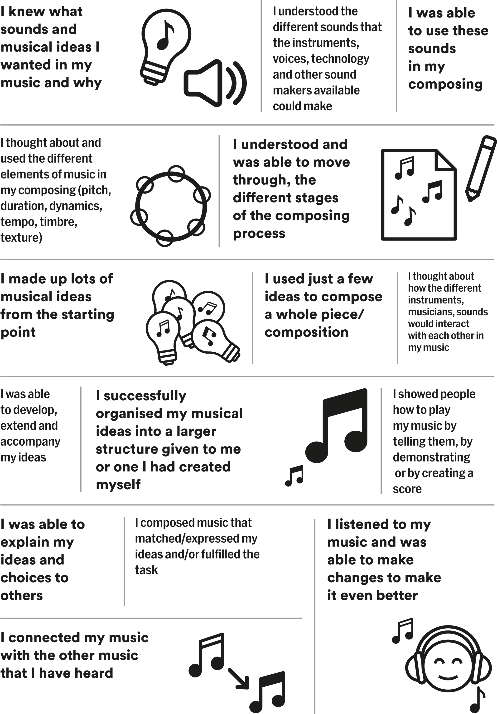
/ What music do you like to listen to?
1
/ What would you like to do in our music time?
5
Appendix XI: Sharing musical selves
/
2

Write about one of your favourite songs or pieces of music. What do you like
about it?
6
/

Which countries do you and your family

have connections to?
/
3

Do you play any musical instruments?

Which instruments?
7
/ Which languages do you speak?
/
4

Please write the name of, or draw, a musical instrument that you would like to play:
8
/ Please draw a picture of you and your music:
Class

Name

Credit: Natalie Mason
Acknowledgements:
Many thanks to all the people who proofread and commented on this and earlier versions, in particular, Dr Emma Nenadic, Gary Spruce, Dr Anthony Anderson, Naomi Wellings, Beatrice Hubble, Dan Jones, and the LICP Steering Group.
Photos: Kate Green, Alex Walker, Jonathan Lee
Design: Keith Dodds
We would like to thank:
The project partners:
Sound and Music
Services for Education
Bristol Beacon
The participating schools:
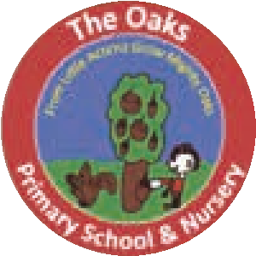
Acocks Green Primary
School, Birmingham
Tiverton Academy,
Birmingham
The Oaks Primary
School, Birmingham
Bournville Village School,
Birmingham
Allens Croft Primary
School, Birmingham
Horfield CofE Primary

School, Bristol
Wallscourt Academy,

Bristol
Fair Furlong Primary
School, Bristol
The composers:
Michael Betteridge, Chloe Knibbs, Natalie Mason, Germa Adan, Angela Slater, Robert Crehan, Richard Barnard, Will Frampton, Kala Chang

Our funder:
This toolkit and the associated project were made possible through a Paul Hamlyn Foundation Arts-based Learning grant.
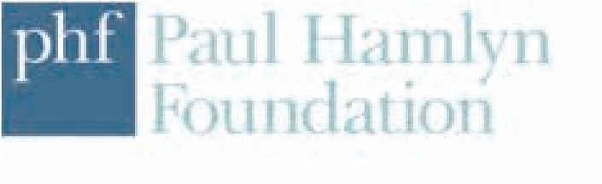

Listen Imagine Compose Primary –
A Planning, Reflection and Progression Toolkit
Nancy Evans and Professor Martin Fautley
Published by Birmingham Contemporary Music Group and Birmingham City University, Birmingham, UK
ISBN: 978-1-904839-99-6
©2024 Nancy Evans and Professor Martin Fautley All rights reserved.
We would love your
feedback on this toolkit
to help shape future editions.

bcmg.org.uk

Composing feels really amazing because it’s a bit like carving: you start off with nothing and then it comes to something, and for that to come from you is quite an amazing feeling. It’s not just something you hear, it’s something within you.

Young person

