**Mechanical pretreatment of waste paper for biogas production**

C. Rodriguez1,*, A. Alaswad2, Z. El-Hassan1, A.G. Olabi1

1 Institute of Engineering and Energy Technologies, School of Engineering and Computing, University of the West of Scotland, Paisley PA1 2BE, UK.

2 School of Engineering and the Built Environment, Birmingham City University, Birmingham B5 5JU, UK.

Abstract

In the anaerobic digestion of lignocellulosic materials such as waste paper, the accessibility of microorganisms to the fermentable sugars is restricted by their complex structure. A mechanical pre-treatment with a Hollander beater was assessed in order to reduce the biomass particle size and to increase the feedstock’ specific surface area available to the microorganisms, and therefore improve the biogas yield. Pretreatment of paper waste for 60 min improves the methane yield by 21%, from a value of 210 ml/gVS correspondent to untreated paper waste to 254 ml/gVS. 30 min pretreatment have no significant effect on the methane yield. A response surface methodology was used in order to evaluate the effect of the beating time and feedstock/inoculum ratio on the methane yield. An optimum methane yield of 253 ml/gVS resulted at 55 min beating pretreatment and a F/I ratio of 0.3.

*Keywords*: renewable energy, biogas, biomass, waste paper, mechanical pretreatment, anaerobic digestion

Abbreviations: AD, anaerobic digestion; ANOVA, analysis of variance; BT, beating time; CCD, central composite design; CHPP, combustion and heat power plant; F/I, feedstock/inoculum; KDP, potassium dihydrogen phosphate; MC, moisture content; MSW, municipal solid waste; RSM, response surface methodology; TS, total solids; VFA, volatile fatty acids; VS, volatile solids.

* Corresponding author.

E-mail address: [cristina.rodriguez@uws.ac.uk](mailto:cristina.rodriguez@uws.ac.uk)

# introduction

Paper and cardboard are a heterogeneous mixture of plant material such as cellulose, hemi-cellulose, lignin and filling material such as clay and calcium carbonate. Chemical additives (i.e. rosin, alum, starch) are added to modify quality of the material and its properties such as brightness, opacity, or glossiness. Cellulose is the major biodegradable fraction of waste paper but lignin is a recalcitrant compound for anaerobic digestion and reduces the bioavailability of the cellulose (Zheng et al., 2014). Residual contents of chemicals used during processing, such as talc or sodium silicate may still be found in the paper product and consequently also in waste paper (European IPPC Bureau, 2013; Gran, 2001; Villanueva and Eder, 2011). In Europe the per capita consumption of paper and board was 137 kg in 2012, in United Kingdom the total consumption was 1,0095,000 tonnes (Magnaghi, 2014). The biggest source of recovered paper is industry and businesses with the 52% of the total, this covers the converting losses (cuttings and shavings) and returns of unsold newspapers and magazines. Around 10% comes from offices, and the remaining 38% from households (The Bureau of International Recycling, n.d.).

In United Kingdom, waste paper is mainly disposal to landfill, becoming the major contributor to municipal solid waste by both volume (reaching the 50%) and weight. The space for approved and licensed landfills will run out by 2020 (Infraestructure and Projects Authority, 2016). This fact alongside with leaching and greenhouse gases emissions from the landfills requires other ways of waste paper treatment. A major way of paper waste recycling is in paper mills, but some other uses are being investigated such as construction materials (Folorunso and Anyata, 2007; Sutcu et al., 2014), animal bedding (Ward et al., 2000), composting (Alvarez et al., 2009) or as a fuel (Brummer et al., 2014; Li and Liu, 2000). Many studies have been carried out about the anaerobic digestion of pulp and paper sludge (Lin et al., 2011; Meyer and Edwards, 2014; Priadi et al., 2014; Szeinbaum, 2009) and municipal solid waste (MSW) (partially composed by paper and cardboard) (Kayhanian and Rich, 1995; Lo et al., 2012). In anaerobic digestion, hydrolysis appears to be the rate-limiting step highly particulate waste, like paper waste (Palenzuela Rollón, 1999). During this stage the degradation of cellulose and recalcitrant compounds like lignin occurs. Hydrolysis depends on multiple factors such as the particle sizes of the substrate, pH and enzymatic permeability of the substrate’s membranes (Montingelli et al., 2015; Silvia Tedesco et al., 2014). The availability of the substrates for the enzymatic attack will be achieved through the increment of the specific surface area and breakdown the crystalline structure. In recent years different technologies for biomass pretreatment have been developed in order to increase the availability of substrate for anaerobic digestion (Kumar et al., 2009; Menind and Normak, 2008). Breaking down lignin, disrupting the crystalline structure of cellulose and increasing its surface can be attained by pre-treatment methods, so that micro-organisms can more easily access the cellulose (Behera et al., 2014). Although performing pre-treatment makes the process more complicated and expensive, it can improve the process efficiency and reduce the whole cost so that a positive energy balance can be obtained compared with non-pre-treated biomass (Hendriks and Zeeman, 2009; Rodriguez et al., 2015). Mechanical, ultrasounds, microwave, thermal, chemical and biological are the main pretreatment methods applied (C. Rodriguez et al., 2016; Cristina Rodriguez et al., 2016). Mechanical techniques are the most efficient pretreatment for biomass with complex structures, milling sisal fibres up to 2mm of particle size improved the methane yield by 23% (Mshandete et al., 2006), the use of two commercially available heavy plates, resulted in 25% increase in the methane yield of ensiled meadow grass compared to the untreated feedstock (Tsapekos et al., 2015). Mechanically milled rice straw achieved a 85% extra methane than untreated material (Sasaki et al., 2016). Beating pretreatment with a Hollander beater for 15 min improved the biogas yield of macroalgaes Laminaria sp. by 36% and Ascophyllum nodosum by 26% (M.E. Montingelli et al., 2016; Montingelli et al., 2017).

Only two pretreatment techniques have been reported in the literature to improve the biodegradability of paper and cardboard: mechanical and biological. The mechanical pretreatment consisted in shred the paper and cardboard fraction of municipal solid waste before anaerobic digestion but it has no significant effect on biogas yields and on kinetics (Pommier et al., 2010). Better results were obtained when filter paper, waste paper, newspaper and cardboard were pretreated with a thermophilic cellulose-degrading consortium (MC1). After 55 days of anaerobic digestion, the methane yield of pretreated filter paper, waste paper, newspaper and cardboard were 277, 287, 192, and 231 ml CH4/gVS respectively, with corresponding increases of 33%, 34%, 156%, and 141% with respect to the untreated materials (Yuan et al., 2012). However biological pretreatments are slow processes, usually with residence times of 10–14 days, they require large amount of space and each feedstock requires a specific enzyme, forcing to study an enzyme-substrate specificity (Rodriguez et al., 2015).

This paper investigates the improvements provided by a Hollander beater pretreatment. This technique is based on the same ‘comminution’ concept proposed by all other mechanical treatments. The Hollander beater has never been used as mechanical pretreatment machine on paper wastes. Seeing that this proposed pretreatment has already proved its effectiveness when applied to seaweed biomass with an improvement in biogas yield up to 20% (S. Tedesco et al., 2014; Tedesco et al., 2013), in this study it has been applied to paper wastes in batch mode.

# MATERIALS AND METHODS

## Feedstock and inoculum

Waste paper was collected from recycle bins at the School of Computing and Engineering at the University of West of Scotland (UWS) in Paisley, Scotland (Figure 1). This paper was mostly one side printed and was cut by a shredder Fellowes Powershred C-320 in 0.6 x 29.7 cm pieces. The sludge used as inoculum was provided by the Energen Biogas Plant (Cumbernauld, Scotland), and stored in a fridge at 4°C. The plant uses food and food processing residues as a feedstock, the process is carried out under thermophilic conditions.

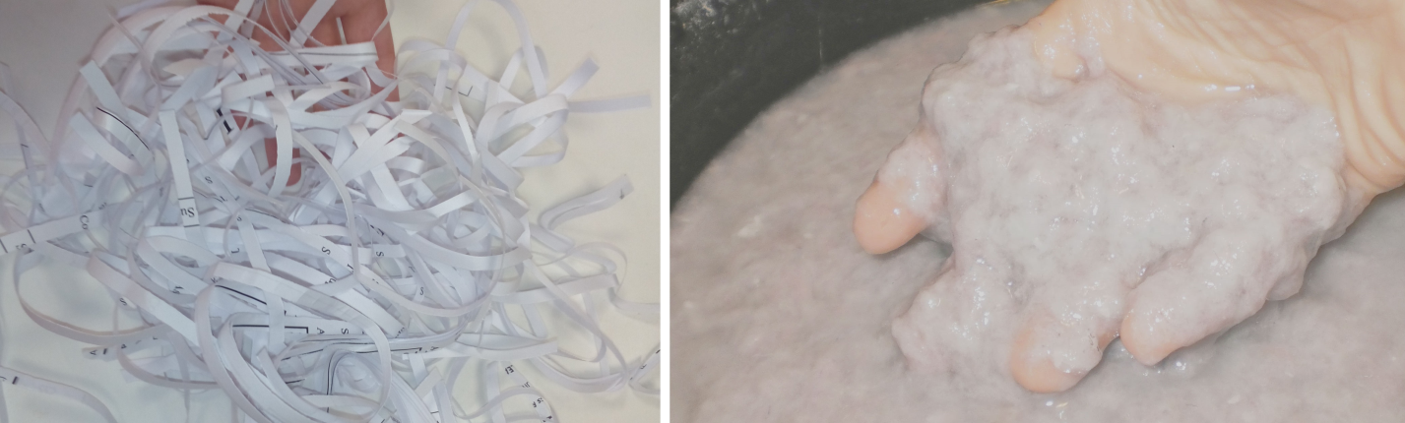

Figure 1. Shredded paper (before pretreatment) and paper pulp (after pretreatment).

The total solids (TS) and volatile solids (VS) of the waste paper were calculated by duplicate and were obtained by submitting random samples of pretreated waste paper at 105°C (for TS) and 550°C (for VS) until constant weight. The sludge’s characterization is provided by the supplier. The methane production is provided in terms of volume per gram of VS (ml/gVS). The characterization of the paper and the sludge is detailed in Table 1.

Table 1. Waste paper and sludge characterization.

|  |  |  |  |  |
| --- | --- | --- | --- | --- |
| Parameters | Sludge | Untreated paper | 30 min  pret. paper | 60 min  pret. paper |
| Total Solids (%) | 5 | 95 | 3 | 3 |
| Volatile Solids (% of TS) | 63 | 99 | 97 | 97 |
| Ash content (% of TS) | 37 | 1 | 3 | 3 |

## Hollander beater pretreatment

The machine consists of a modified Hollander beater (Figure 2). This beater is normally used in the paper industry (Lumiainen, 2000). Most of the mechanical pretreatments can be done in existing facilities previously used for other purposes and other materials. This is a great advantage as these facilities only need with minor changes or adjustments in order to use them in the biomass pretreatment process.

The feedstock is exposed to the shear action in the beater, blades and grooves exercise a cutting action while the high pressure and speed reached under the drum beats the mixture. The biomass should be soaked prior its treatment in the beater, in the case of paper as it is a thin and absorbent material, it can be soaked for one hour (Cerda, 2008; Osorio, 2010). The capacity of the beater is about 1 kg of dry biomass, but this can vary depending upon the type of feedstock.

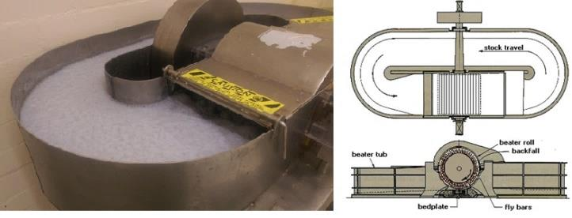

Figure 2. Hollander beater in operation with waste paper.

Samples were taken at 30 and 60 min of beating pretreatment. The samples were taken from the bend before the bladed drum in the middle of both the width and height of the channel to take the most representative sample.

## Experimental set-up

The bioreactors consisted of 500 ml Erlenmeyer flasks with working volume of 400 ml connected through a system of valves and plastic pipes to airtight Linde PLASTIGAS bags for biogas collection (Figure 3). To clear up any trace of oxygen from the system and preserve the anaerobic conditions, nitrogen was flushed into the reactors headspace during 5 min and then removed. This operation was done three times. The reactors were placed in a water-bath to keep a mesophilic temperature of 37°C.

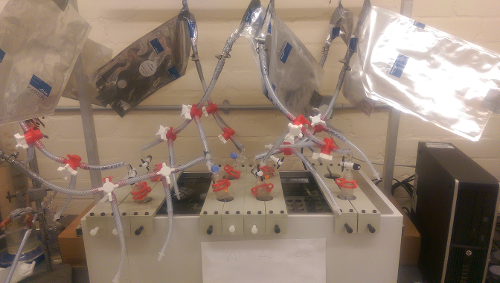

Figure 3. Anaerobic reactors with biogas collection systems.

Reactors were fed with a fixed amount of 200ml of sludge (inoculum), while different quantities of pulp (beated paper) were required to have different F/I ratios as (0.3, 0.5 and 0.7). The pH was adjusted to 7.00±0.15 with potassium dihydrogen phosphate (KDP) as a buffer solution. The reactors corresponding to the untreated samples were fed with shredded paper. In order to assess the inoculum contribution to the methane production, control batches were prepared in the same way except for the paper addition. Flasks were daily shaken during the process in order to favour the degasification of the substrate and the contact between the biomass and the inoculum. Each test was conducted by duplicated, and the average results were reported in this paper.

For gas volume measurement was used a graduated upside-down cylinder connected to a bubbling flask in order to maintain the necessary oxygen-free conditions and avoid air infiltrations. A gas analyser (Drager X-Am 7000.) was used to determine the biochemical composition of the obtained biogas The digestion was stopped according to (VDI-Gesellschaft Energietechnik, 2006) when the daily biogas production rate was found to be less than 1% of the overall volume produced. The biogas volumes are given for a dry gas in standard conditions of temperature (0°C) and pressure (1 atm). As the biogas produced is saturated with water vapour, the water content was removed from the results as well. The inoculum contribution to biogas production was never higher than 10%

## Design of experiments

The experiment was planned according to a response surface methodology (RSM) for two factors, beating time and F/I ratio with three levels; the response was the biogas production per g of volatile solids (VS). RSM is characterized by high adherence to the experimental data describing the reality being studied, the method captures accurate efficient approximations for accurate data from numerical or practical experiments at discrete data points in the design space (Benyounis and Olabi, 2008). Moreover, RSM methods are able to exhibit the factor contributions from the coefficients in the regression model and identify the insignificant factors and thereby can reduce the complexity of the problem (Montingelli et al., 2017). Response surface methodology consists of a group of mathematical and statistical techniques used in the development of an adequate functional relationship between a response of interest, *y*, and a number of associated control (or input) variables denoted by *x1, x2,…, xk..* Usually, a second order polynomial as shown in Equation 1 is used in RSM to describe the true functional relationship between the independent variables and the response surface:

 (1)

where the values of the model coefficients b0, bi, bii and bij are estimated using regression analysis (Maria E. Montingelli et al., 2016). In this study, the RSM was applied through a central composite design (CCD) to fit a model by least squares technique. CCD is a factorial or fractional factorial design with centre points, augmented with a group of axial points (also called star points) that led to curvature estimation. It can be used a central to efficiently estimate first- and second-order terms and model a response variable with curvature by adding centre and axial points to a previously-done factorial design (Ahmadi et al., 2005; Ryan, 2007; Vining and Kowalski, 2010).

The arrangement of CCD as shown in Table 2 was in such a way that allows the development of the appropriate second order polynomial equation.

Table 2. Arrangement of the CCD for the two independent variables used in the present study

|  |  |  |
| --- | --- | --- |
| Experiment no | Variable levels/coded values | |
| Beating time (x1) | Feedstock/Inoculum ratio (x2) |
| 1 | -1 | -1 |
| 2 | 0 | -1 |
| 3 | 1 | -1 |
| 4 | -1 | 0 |
| 5 | 0 | 0 |
| 6 | 1 | 0 |
| 7 | -1 | 1 |
| 8 | 0 | 1 |
| 9 | 1 | 1 |

Factor levels and independent input variables are respectively 0, 30 and 60 minutes for the beating time (BT) and 0.3, 0.5 and 0.7 for feedstock/inoculum ratio (F/I). Level 0 of factor BT represents untreated paper waste.

The adequacy of the models is tested through the analysis of variance (ANOVA). The statistical significance of the models and of each term is examined using the sequential F-test and lack-of-fit test. If the Prob. > F of the model and of each term in the model does not exceed the level of significance (in this case α = 0.05) then the model may be considered adequate within the confidence interval of (1 - α). An adequate model means that the reduced model has successfully passed all the required statistical tests and can be used to predict the responses or to optimize the process. The values of R2, adjusted-R2, predicted-R2, lack of fit and adequate precision of models are obtained to check the quality of the suggested polynomial. The statistical study was performed using the Design Expert software version 9.

## Methane production rate

A first order model (Equation 2) was used to describe the progress of cumulative methane production obtained from the batch experiments (Jokela et al., 2005; Lin et al., 2011).

 (2)

where B (t) is the cumulative methane production (ml/gVS), B0 is the maximum methane production (ml/gVS), k is the methane production rate constant (d-1), and t is the time (d). Biodegradability results were compared after a significance statistical analysis by using analysis of variance (ANOVA) for a single factor. Statistical significance was established at p < 0.05 level.

# results AND DISCUSSION

## Methane production

The present means and standard deviations of performed experiments are shown in Table 3.

Table 3. Experimental results obtained at the end of the biodegradability tests

|  |  |  |  |  |
| --- | --- | --- | --- | --- |
| Ratio F/I | Beating time (min) | Methane production (ml/gVS) | k (d-1) | pH |
| 0.3 | 0 | 210±8 | 0.12±0.01 | 7.13±0.07 |
| 30 | 199±7 | 0.18±0.01 | 6.65±0.14 |
| 60 | 253±12 | 0.14±0.01 | 7.04±0.08 |
| 0.5 | 0 | 132±7 | 0.20±0.01 | 7.05±0.06 |
| 30 | 120±9 | 0.24±0.01 | 6.70±0.20 |
| 60 | 215±9 | 0.10±0.01 | 6.98±0.10 |
| 0.7 | 0 | 107±4 | 0.24±0.01 | 6.89±0.27 |
| 30 | 112±12 | 0.21±0.01 | 6.98±0.06 |
| 60 | 175±11 | 0.09±0.01 | 7.03±0.04 |

The methane yield decreased with increased ratio F/I for all pretreatment times. For the untreated paper, the methane yield decreased by 37% from 210 ml/gVS correspondent to ratio 0.3 to 132 ml/gVS for ratio 0.5. For 60 min pretreated paper, the methane yield at ratio 0.7 was 175 ml/gVS, which was a 31% less than for a ratio of 0.3. F/I ratio affects the methane production rate, the consumption of VFAs and the methane yield. To achieve maximum methane yields and a stable process, the F/I ratio is a crucial parameter and should be lower than 1 in terms of VS. An optimum F/I ratio ensures the presence of the groups of microorganisms required for the complete anaerobic digestion (Ali Shah et al., 2014). Knowing the optimum F/I ratio allows a better exploitation of the feedstock. Feeding the reactor with high quantities of biomass that the inoculum is not able to process lead to a loss of feedstock, that is not digested. Methane yield for untreated macroalgal at F/I 0.7 was 49% lower than for F/I 0.3, this stands for half of the biomass not digested, when the biomass is beated for 60min, the decreased in methane yield from 0.3 to 0.7 F/I is 30%, this means, 30% of the digested biomass at low F/I ratio was not digested at F/I 0.7. Similar results were achieved on sunflower oil cake anaerobic degradation with the methane yield decreasing considerably from 227 to 107 ml/gVS when the F/I increased from 0.33 to 2, showing a marked influence of this parameter on methane yield (Raposo et al., 2008). On municipal solid waste degradation, the optimum F/I ratio were the lowest value tested (Boulanger et al., 2012), a maximized biogas production from cattle manure was obtained at a minimum F/I tested (Johari and Widiasa, 2012). However, in other cases the F/I ratio had minor effect in the methane yield (Eskicioglu and Ghorbani, 2011; González-Fernández and García-Encina, 2009). The influence of the F/I ratio on the methane yield depends also in the F/I ratio range tested; near the optimum F/I ratio the influence will be less noticeable.

Figure 4. Methane production for low (0.3) and high (0.7) F/I

At the early stages of the degradation (day 7) for a F/I ratio of 0.3, the methane yield from 30 min beated samples is 13% higher than for untreated material (Figure 4). 60 min beated paper produced 43% more methane than untreated biomass on the same day. These improvements continued in day 14 of digestion, when 30 min pretreatment improved the methane yield by 8% and 60 min pretreatment by 26%. The methane yields improvements on day 14 are roughly the half of improvements in day 7, and at the end of the digestion only 60 min pretreatment achieved a positive effect on the methane yield. Higher methane production rate constants were achieved for 30 min beating pretreatment at F/I ratios of 0.3 and 0.5, however the final methane production is lower than for 60 min pretreatment. This trend can be explained due to that the first step of lignocellulosic materials degradation is hydrolysis of the cellulose. It takes place at the surface of the cellulose fibers; therefore, more beated samples achieved more specific surface area accelerating the hydrolysis. The low first order constants and high final methane productions achieved for 60min beated samples shows that contrary to expected, the hydrolysis of cellulose is maybe not the limiting step of the waste paper degradation process. agreed well with Keymer et al. (Keymer et al., 2013), who noticed that the high pressure thermal hydrolysis pretreatment had no effect on the methane production rate but significantly improved the final methane yield of *Scenedesmus* microalgae; similar results were obtained with olive mill solid waste, where co-digestion with *D. salina* improved the total methane production but had negative effect on the initial degradation rate (Fernández-Rodríguez et al., 2014).

At the end of the degradation, the methane yield for a ratio F/I of 0.3 decreased by 5% when the paper waste was beated for 30 min, such percentage is not statistically significant when compared with the batch duplicates, so it can be concluded that 30 min pretreatment at 0.3 F/I ratio have no effect on the methane yield . When the pretreatment time was increased to 60 min, the methane yield increased by 21% from 210 ml/gVS correspondent to the untreated paper to 253 ml/gVS. The present result from non beated paper is consistent with the data from Eleazer et al (Eleazer et al., 1997), where waste paper yield 220 mlCH4/gVS. A short beating time (30min) increases the methane production rate however; the final methane yield is much lower compared to 60min beating pretreatment. The pretreatment seems start to be effective after 60 min being that methane production for 60 min treatment is higher than for both untreated and 30 min treated paper.

## Process modelling

The experimental factors, F/I and BT were checked in three levels. Beating time varies between 0 and 60 minutes and ratio feedstock/inoculum varies between 0.3 and 0.7. The response was the methane production given in ml per g of volatile solids (ml/gVS). Parameters and results are presented in Table 4.

Table 4. Experimental factors and response in arrangement for the CCD used in the present study

|  |  |  |  |
| --- | --- | --- | --- |
| Experiment nº | Experimental factors | | Response |
| Beating time (min) | Ratio F/I | Methane yield (ml/gVS) | |
| 1 | 0 | 0.3 | 210 | |
| 2 | 0 | 0.5 | 132 | |
| 3 | 0 | 0.7 | 107 | |
| 4 | 30 | 0.3 | 199 | |
| 5 | 30 | 0.5 | 120 | |
| 6 | 30 | 0.5 | 120 | |
| 7 | 30 | 0.7 | 112 | |
| 8 | 60 | 0.3 | 253 | |
| 9 | 60 | 0.5 | 215 | |
| 10 | 60 | 0.7 | 175 | |

For the optimization through the RSM of the methane yield, the model F-value of 36.43 implies the model is significant. The model terms of R2 = 0.9785, adjusted-R2 = 0.9517, predicted-R2 = 0.8127, all these values are very close to 1 and so indicate the adopted model is adequate. The final mathematical model associated to the response in terms of actual factors in Equation 3 and the ANOVA test is shown in Table 5.

 (3)

**Table 5**. ANOVA test from response surface design for methane yield.

|  |  |  |  |  |
| --- | --- | --- | --- | --- |
| Source | Sum of Squares | Mean Square | F Value | p-value Prob > F |
|  |  |  |  |  |
| Model | 24086.82 | 4817.36 | 36.43 | 0.0020 |
| A-Beating time | 6248.03 | 6248.03 | 47.25 | 0.0023 |
| B-F/I ratio | 11869.52 | 11869.52 | 89.77 | 0.0007 |
| AB | 151.39 | 151.39 | 1.14 | 0.3449 |
| A^2 | 3785.40 | 3785.40 | 28.63 | 0.0059 |
| B^2 | 1169.52 | 1169.52 | 8.85 | 0.0410 |
| Residual | 528.90 | 132.22 |  |  |
| Cor Total | 24615.72 |  |  |  |

The response surface obtained from the model illustrated in Figure 5a shows that higher methane yields are obtained at high beating times and low F/I ratios. The predicted vs. actuals plot (Figure 5b) shows that these values were distribute near to a straight line and a satisfactory correlation between them is observed. This demonstrates that the model can be effectively applied for mechanical pretreatment with a Hollander beater for paper waste.

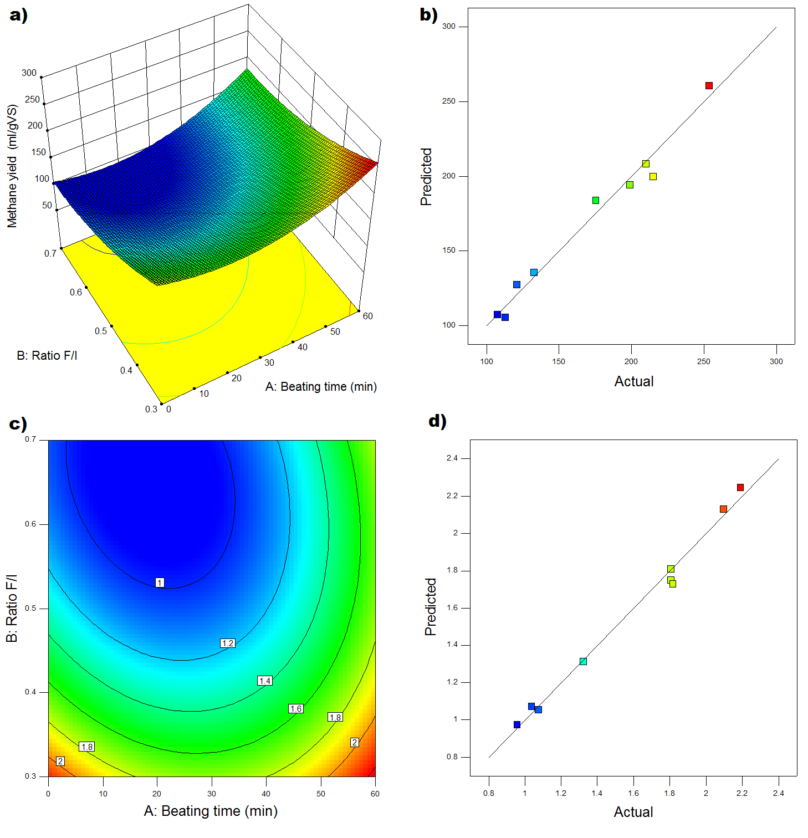

Figure 5. Response surface plot in 3D for methane yield (a) and scatter diagram for methane yield (b).

The perturbation plot in Figure 6a shows how the methane yield is affected by the input variables beating time and F/I ratio, both variables have an exponential effect on the methane production. Increasing B (F/I ratio) the methane yield will decrease exponentially. The effect of the beating time is the opposite, methane yield increases exponentially with the pretreatment time. The effect of pretreatment has a similar behaviour at low and high F/I ratios (Figure 6b). For a F/I ratio of 0.7, the methane yield achieved a minimum around 27 min of pretreatment, for ratio F/I of 0.3 the minimum is achieved at around 23 min.

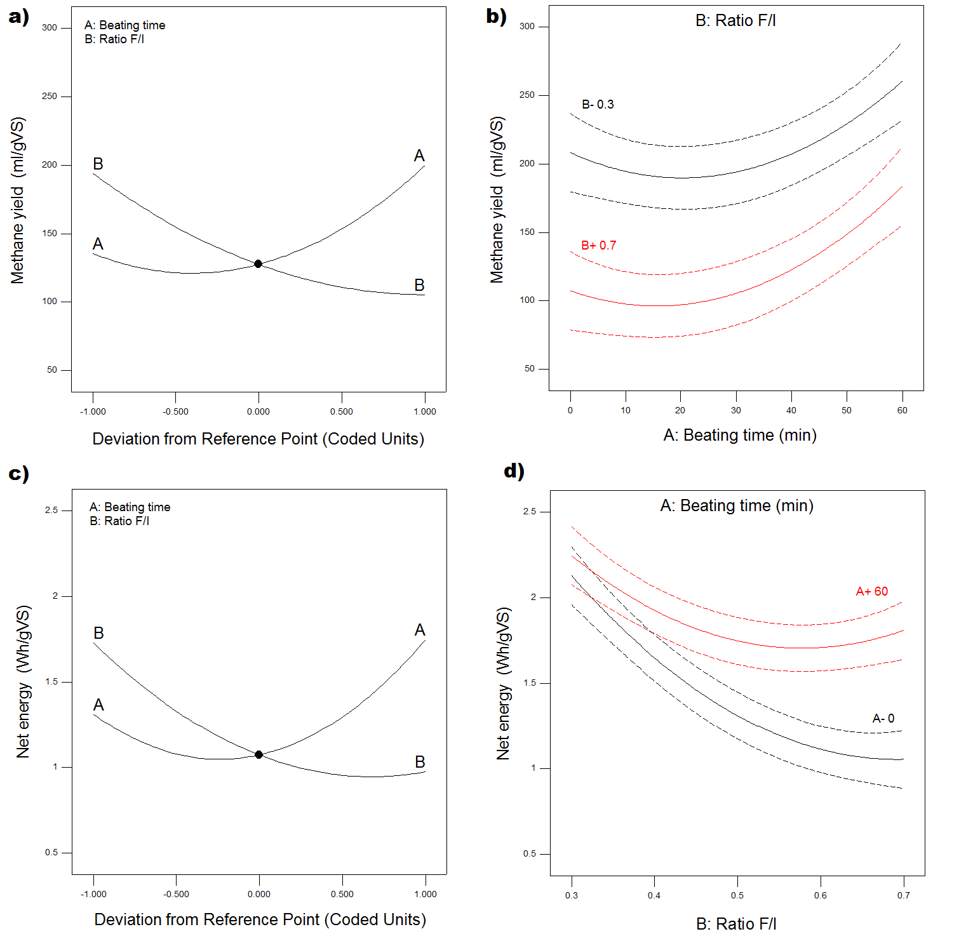

Figure 6. Perturbation plot for methane yield (a) and interaction plot for methane yield (b).

## Methane yield optimization

Based on the response surface model showed in Equation 3, which describes the effects of process parameters on the methane production, an optimization study was conducted using Design-expertV9 software. The optimization criteria combine the productivity with the cost of the process, the methane yield was maximized with level 5 and beating time was minimized with level 1 while F/I ratio was permitted to vary in the same range as in Table 4.

The optimal methane yield of 245 ml/gVS from the numerical optimisation was found at BT= 55 min and F/I ratio= 0.3, allowing 17% extra methane when compared to the maximum methane production for untreated paper. The graphical optimization allows a selection of the optimum process parameters by means of visual inspection. The yellow areas on the overlay plot (Figure 7) that represent the values that meet the proposed criteria is delimited by the curves corresponding to the optimization criteria set by the authors.



Figure 7. Graphical optimization for maximizing methane yield while minimizing beating time.

Three confirmation experiments (including the optimal point) were carried out using new test conditions to verify the adequacy of the models. The experimental conditions, the actual and predicted values and the percentages of error are summarizes in Table 7. Considering that anaerobic digestion is a biological process highly influenced by the inoculum, the percentages of error are all within acceptable tolerances.

Table 7. Validation experiments

|  |  |  |  |  |
| --- | --- | --- | --- | --- |
| Experiment | Beating time (min) | Ratio F/I |  | Methane yield (ml/gVS) |
| 1 | 15 | 0.6 | Actual | 115 |
| Predicted | 104 |
| Error (%) | 9.33 |
| 2 | 45 | 0.4 | Actual | 179 |
| Predicted | 190 |
| Error (%) | -6.41 |
| 3 | 55 | 0.3 | Actual | 245 |
| Predicted | 260 |
| Error (%) | -60.4 |

# Conclusions

The experimental work shows the methane yields obtained from the digestion of waste paper inoculated with sludge from a biogas production plant. Pretreated waste paper with a Hollander beater for 60 min improved the methane yield by 21%. 30 min pretreatment have no significant effect on the methane yield even if the methane production rates increased. The highest methane yields were achieved at F/I ratio 0.3 for all pretreatment times.. An optimization study was performed to reduce the operating costs and time associated to the pretreatment and maximizes the productivity. The aim is maximizing the methane production while minimizing the pretreatment time. An optimized methane yield of 245 ml/gVS was achieved for 55 min of beating pretreatment and a F/I ratio of 0.3 allowing 17% more methane than non beated waste paper.

The above findings summarize that mechanical pretreatment of waste paper in a Hollander beater led to an increase in the final methane yields rather than the reaction kinetics. Further work will focus on improving the anaerobic digestibility of mechanically pretreated waste paper through its codigestion with a high nitrogen content feedstock as seaweed.

**REFERENCES**

Ahmadi, M., Vahabzadeh, F., Bonakdarpour, B., Mofarrah, E., Mehranian, M., 2005. Application of the central composite design and response surface methodology to the advanced treatment of olive oil processing wastewater using Fenton’s peroxidation. J. Hazard. Mater. 123, 187–195. doi:10.1016/j.jhazmat.2005.03.042

Ali Shah, F., Mahmood, Q., Maroof Shah, M., Pervez, A., Ahmad Asad, S., 2014. Microbial ecology of anaerobic digesters: the key players of anaerobiosis. ScientificWorldJournal. 2014, 183752. doi:10.1155/2014/183752

Alvarez, J.V.L., Larrucea, M.A., Bermúdez, P.A., Chicote, B.L., 2009. Biodegradation of paper waste under controlled composting conditions. Waste Manag. 29, 1514–9. doi:10.1016/j.wasman.2008.11.025

Behera, S., Arora, R., Nandhagopal, N., Kumar, S., 2014. Importance of chemical pretreatment for bioconversion of lignocellulosic biomass. Renew. Sustain. Energy Rev. 36, 91–106. doi:10.1016/j.rser.2014.04.047

Benyounis, K.Y., Olabi, A.G., 2008. Optimization of different welding processes using statistical and numerical approaches – A reference guide. Adv. Eng. Softw. 39, 483–496. doi:10.1016/j.advengsoft.2007.03.012

Boulanger, A., Pinet, E., Bouix, M., Bouchez, T., Mansour, A.A., 2012. Effect of inoculum to substrate ratio (I/S) on municipal solid waste anaerobic degradation kinetics and potential. Waste Manag. 32, 2258–2265. doi:10.1016/j.wasman.2012.07.024

Brummer, V., Jurena, T., Hlavacek, V., Omelkova, J., Bebar, L., Gabriel, P., Stehlik, P., 2014. Enzymatic hydrolysis of pretreated waste paper--source of raw material for production of liquid biofuels. Bioresour. Technol. 152, 543–7. doi:10.1016/j.biortech.2013.11.030

Cerda, M., 2008. Arqueologia industrial, First. ed. Universitat de Valencia, Valencia.

Eleazer, W.E., Odle, W.S., Wang, Y.-S., Barlaz, M.A., 1997. Biodegradability of Municipal Solid Waste Components in Laboratory-Scale Landfills. Environ. Sci. Technol. 31, 911–917. doi:10.1021/es9606788

Eskicioglu, C., Ghorbani, M., 2011. Effect of inoculum/substrate ratio on mesophilic anaerobic digestion of bioethanol plant whole stillage in batch mode, Process Biochemistry. doi:10.1016/j.procbio.2011.04.013

European IPPC Bureau, 2013. Best Available Techniques (BAT) Reference Document for the Production of Pulp, Paper and Board 899.

Fernández-Rodríguez, M.J., Rincón, B., Fermoso, F.G., Jiménez, A.M., Borja, R., 2014. Assessment of two-phase olive mill solid waste and microalgae co-digestion to improve methane production and process kinetics. Bioresour. Technol. 157, 263–269. doi:10.1016/j.biortech.2014.01.096

Folorunso, O.P., Anyata, B.U., 2007. Potential uses of waste paper/sludge as a ceiling material. Res. J. Appl. Sci. 2, 584–586.

González-Fernández, C., García-Encina, P.A., 2009. Impact of substrate to inoculum ratio in anaerobic digestion of swine slurry. Biomass and Bioenergy 33, 1065–1069. doi:10.1016/j.biombioe.2009.03.008

Gran, I.R., 2001. Characterisation of MSW for Combustion Systems.

Hendriks, a T.W.M., Zeeman, G., 2009. Pretreatments to enhance the digestibility of lignocellulosic biomass. Bioresour. Technol. 100, 10–8. doi:10.1016/j.biortech.2008.05.027

Infraestructure and Projects Authority, 2016. National Infrastructure Delivery Plan 2016–2021. London.

Johari, S., Widiasa, I.N., 2012. The Effect of Feed to Inoculums Ratio on Biogas Production Rate from Cattle Manure Using Rumen Fluid as Inoculums. Internat. J. Waste Resour. 2, 1–4.

Jokela, J.P.Y., Vavilin, V.A., Rintala, J.A., 2005. Hydrolysis rates, methane production and nitrogen solubilisation of grey waste components during anaerobic degradation. Bioresour. Technol. 96, 501–8. doi:10.1016/j.biortech.2004.03.009

Kayhanian, M., Rich, D., 1995. Pilot-scale high solids thermophilic anaerobic digestion of municipal solid waste with an emphasis on nutrient requirements. Biomass and Bioenergy 8, 433–444. doi:10.1016/0961-9534(95)00043-7

Keymer, P., Ruffell, I., Pratt, S., Lant, P., 2013. High pressure thermal hydrolysis as pre-treatment to increase the methane yield during anaerobic digestion of microalgae. Bioresour. Technol. 131, 128–33. doi:10.1016/j.biortech.2012.12.125

Kumar, P., Barrett, D.M., Delwiche, M.J., Stroeve, P., 2009. Methods for Pretreatment of Lignocellulosic Biomass for Efficient Hydrolysis and Biofuel Production. Ind. Eng. Chem. Res. 48, 3713–3729. doi:10.1021/ie801542g

Li, Y., Liu, H., 2000. High-pressure binderless compaction of waste paper to form useful fuel. Fuel Process. Technol. 67, 11–21. doi:10.1016/S0378-3820(00)00092-8

Lin, Y., Wang, D., Li, Q., Huang, L., 2011. Kinetic study of mesophilic anaerobic digestion of pulp & paper sludge. Biomass and Bioenergy 35, 4862–4867. doi:10.1016/j.biombioe.2011.10.001

Lo, H.M., Chiu, H.Y., Lo, S.W., Lo, F.C., 2012. Effects of different SRT on anaerobic digestion of MSW dosed with various MSWI ashes. Bioresour. Technol. 125, 233–8. doi:10.1016/j.biortech.2012.08.084

Lumiainen, J., 2000. Refining of chemical pulp, in: Paulapuro, H. (Ed.), Papermaking, Part 1: Stock Preparation & Wet End. Tappi, pp. 87–105.

Magnaghi, G., 2014. RECOVERED PAPER MARKET IN 2012. Brussels.

Menind, A., Normak, A., 2008. Study on Grinding Biomass as Pre-treatment for Biogasification.

Meyer, T., Edwards, E.A., 2014. Anaerobic digestion of pulp and paper mill wastewater and sludge. Water Res. 65, 321–49. doi:10.1016/j.watres.2014.07.022

Montingelli, M.E., Benyounis, K.Y., Quilty, B., Stokes, J., Olabi, A.G., 2017. Influence of mechanical pretreatment and organic concentration of Irish brown seaweed for methane production. Energy 118, 1079–1089. doi:10.1016/j.energy.2016.10.132

Montingelli, M.E., Benyounis, K.Y., Quilty, B., Stokes, J., Olabi, A.G., 2016. Optimisation of biogas production from the macroalgae Laminaria sp. at different periods of harvesting in Ireland. Appl. Energy 177, 671–682. doi:10.1016/j.apenergy.2016.05.150

Montingelli, M.E., Benyounis, K.Y., Stokes, J., Olabi, A.G., 2016. Pretreatment of macroalgal biomass for biogas production. Energy Convers. Manag. 108, 202–209. doi:10.1016/j.enconman.2015.11.008

Montingelli, M.E., Tedesco, S., Olabi, A.G., 2015. Biogas production from algal biomass: A review. Renew. Sustain. Energy Rev. 43, 961–972. doi:10.1016/j.rser.2014.11.052

Mshandete, A., Björnsson, L., Kivaisi, A.K., Rubindamayugi, M.S.T., Mattiasson, B., 2006. Effect of particle size on biogas yield from sisal fibre waste. Renew. Energy 31, 2385–2392. doi:10.1016/j.renene.2005.10.015

Osorio, G.A., 2010. Análisis FMECA a sistema de posicionamiento de platinas de refinadora de pulpa de papel diseñada para papelera Gubelin Ltda. Universidad Austral de Chile.

Palenzuela Rollón, A., 1999. Anaerobic digestion of fish processing wastewaters with special emphasis on hydrolysis of suspended solids. A.A.Balkema, P.O.Box 1675,3000 BR Rotterdam, Netherlands.

Pommier, S., Llamas, A.M., Lefebvre, X., 2010. Analysis of the outcome of shredding pretreatment on the anaerobic biodegradability of paper and cardboard materials. Bioresour. Technol. 101, 463–8. doi:10.1016/j.biortech.2009.07.034

Priadi, C., Wulandari, D., Rahmatika, I., Moersidik, S.S., 2014. Biogas Production in the Anaerobic Digestion of Paper Sludge. APCBEE Procedia 9, 65–69. doi:10.1016/j.apcbee.2014.01.012

Raposo, F., Borja, R., Rincon, B., Jimenez, A.M., 2008. Assessment of process control parameters in the biochemical methane potential of sunflower oil cake. Biomass and Bioenergy 32, 1235–1244. doi:10.1016/j.biombioe.2008.02.019

Rodriguez, C., Alaswad, A., Benyounis, K.Y., Olabi, A.G., 2016. Pretreatment techniques used in biogas production from grass. Renew. Sustain. Energy Rev. 68, 1193–1204. doi:10.1016/j.rser.2016.02.022

Rodriguez, C., Alaswad, A., El-Hassan, Z., Olabi, A., 2016. Optimization of the anaerobic digestion process of mechanically pretreated algae, in: Ban, M., Duić, N., Costa, M., Schneider, D.R., Guzović, Z. (Eds.), 11th Conference on Sustainable Development of Energy, Water and Environment Systems, SDEWES. Faculty of Mechanical Engineering and Naval Architecture, Zagreb, Lisbon, p. 0679 1-12. doi:ISSN 1847-7178

Rodriguez, C., Alaswad, A., Mooney, J., Prescott, T., Olabi, A.G., 2015. Pre-treatment techniques used for anaerobic digestion of algae. Fuel Process. Technol. 138, 765–779. doi:10.1016/j.fuproc.2015.06.027

Ryan, T.P., 2007. Modern Engineering Statistics. John Wiley & Sons, Inc., Hoboken, NJ, USA. doi:10.1002/9780470128442

Sasaki, K., Okamoto, M., Shirai, T., Tsuge, Y., Fujino, A., Sasaki, D., Morita, M., Matsuda, F., Kikuchi, J., Kondo, A., 2016. Toward the complete utilization of rice straw: Methane fermentation and lignin recovery by a combinational process involving mechanical milling, supporting material and nanofiltration. Bioresour. Technol. 216, 830–837. doi:10.1016/j.biortech.2016.06.029

Sutcu, M., del Coz Díaz, J.J., Álvarez Rabanal, F.P., Gencel, O., Akkurt, S., 2014. Thermal performance optimization of hollow clay bricks made up of paper waste. Energy Build. 75, 96–108. doi:10.1016/j.enbuild.2014.02.006

Szeinbaum, N., 2009. Assessment of anaerobic treatment of select waste streams in paper manufacturing operations. Georgia Institute of Technology.

Tedesco, S., Benyounis, K.Y., Olabi, a. G., 2013. Mechanical pretreatment effects on macroalgae-derived biogas production in co-digestion with sludge in Ireland. Energy 61, 27–33. doi:10.1016/j.energy.2013.01.071

Tedesco, S., Mac Lochlainn, D., Olabi, A.G., 2014. Particle size reduction optimization of Laminaria spp. biomass for enhanced methane production. Energy 76, 857–862. doi:10.1016/j.energy.2014.08.086

Tedesco, S., Marrero Barroso, T., Olabi, a. G., 2014. Optimization of mechanical pre-treatment of Laminariaceae spp. biomass-derived biogas. Renew. Energy 62, 527–534. doi:10.1016/j.renene.2013.08.023

The Bureau of International Recycling, n.d. Ten questions on paper recovery and recycling [WWW Document]. URL http://www.bir.org/industry/paper/ten-questions-on-paper-recovery-and-recycling/ (accessed 2.13.15).

Tsapekos, P., Kougias, P.G., Angelidaki, I., 2015. Biogas production from ensiled meadow grass; effect of mechanical pretreatments and rapid determination of substrate biodegradability via physicochemical methods. Bioresour. Technol. 182C, 329–335. doi:10.1016/j.biortech.2015.02.025

VDI-Gesellschaft Energietechnik, 2006. Fermentation of organic materials Characterisation of the substrate, sampling, collection of material data, fermentation tests. VDI-Gesellschaft Energietechnik, Dusseldorf.

Villanueva, A., Eder, P., 2011. End-of-waste criteria for waste paper: Technical proposals. Seville, Spain.

Vining, G.G., Kowalski, S., 2010. Statistical Methods for Engineers. Cengage Learning.

Ward, P.L., Wohlt, J.E., Zajac, P.K., Cooper, K.R., 2000. Chemical and physical properties of processed newspaper compared to wheat straw and wood shavings as animal bedding. J. Dairy Sci. 83, 359–67. doi:10.3168/jds.S0022-0302(00)74887-9

Yuan, X., Cao, Y., Li, J., Wen, B., Zhu, W., Wang, X., Cui, Z., 2012. Effect of pretreatment by a microbial consortium on methane production of waste paper and cardboard. Bioresour. Technol. 118, 281–8. doi:10.1016/j.biortech.2012.05.058

Zheng, Y., Zhao, J., Xu, F., Li, Y., 2014. Pretreatment of lignocellulosic biomass for enhanced biogas production. Prog. Energy Combust. Sci. 42, 35–53. doi:10.1016/j.pecs.2014.01.001