Birmingham City University Repository

Hammond, Laura

Geographical Profiling in a Novel Context: Prioritising the Search For New Zealand Sex Offenders

Original Citation

Hammond, Laura (2013) Geographical Profiling in a Novel Context: Prioritising the Search For New Zealand Sex Offenders. Psychology, Crime and Law, 20 (4). pp. 358­371. ISSN 1068­316X

This is an Accepted Manuscript of an article published by Taylor & Francis Group in Psychology, Crime and Law, available online: http://www.tandfonline.com/ 10.1080/1068316X.2013.793331

Geographical Profiling in a Novel Context

Geographical Profiling in a Novel Context:

Prioritising the Search for New Zealand Sex Offenders

Laura Hammond*

International Research Centre for Investigative Psychology

* Correspondence to:

Dr Laura Hammond

International Research Centre for Investigative Psychology

R2-12, Department of Behavioural Sciences,

University of Huddersfield, Queensgate Campus.

HD1 3DH

Email: l.hammond@hud.ac.uk

1

Geographical Profiling in a Novel Context

Abstract

The present work examines the use and value of geographical offender profiling methodologies within a novel context, considering both theoretical and practical issues relating to their application.

Two separate studies are presented. The first examined the effectiveness of a geographical profiling system (Dragnet) for a sample of 101 New Zealand sex offenders, comparing findings with those obtained for a U.K. serial rape sample. Search costs and search cost functions (relating proportions of the samples to the amounts by which the areas needing to be searched in order to locate offenders were reduced by the system) showed Dragnet to make significantly less accurate geographical profiling predictions for NZ offenders. It is argued that this is because the spatial behaviour of NZ offenders violates many of the assumptions that Dragnet and other similar geographical profiling systems rely upon.

A second study then explored whether calibration of the geographical profiling system to the local context enhanced the accuracy of predictions made. A logarithmic function was found to provide the best fit to data on the distances travelled by the NZ sex offenders, and was consequently incorporated into the geographical profiling predictions made by Dragnet. However, the effectiveness of the system was not significantly enhanced as a result of this calibration process.

The implications of these findings for the general utility of geographical profiling are discussed, and ways in which GP systems might be developed in order to broaden their scope and applicability are suggested.

Keywords: Geographical Profiling; Sex Offences; Journey-to-Crime; Dragnet

2

Geographical Profiling in a Novel Context

Background to the Research

This project was the result of an overseas institutional research visit funded by the Economic and Social Research Council as part of the author’s doctoral research program. The New Zealand Police Criminal Profiling Unit acted as a host, and provided access to archival data on convicted sex offenders which was used to gain the geographical information necessary for the analyses presented.

Acknowledgements

Without a number of people this project would not have taken place, and they deserve a great deal of recognition and thanks. Firstly, thank you to the members of the New Zealand Police Criminal Profiling Unit, to Mary Goddard for helping to set this all up, to Brett Pakenham, David Scott, and particularly to Russell Lamb for his endless assistance in compiling the sample and data. Thank you the New Zealand Police for acting as a host institution, and to the RESC for permitting the work to take place. A special thank you to Rebecca Morton and the ESRC for the award enabling the project, and last, but by certainly no means least, I’d like to say thank you to Professor David Canter for all of his help in the preparation of this article and in the project itself, as well as for his constant supervision and support. It is greatly appreciated.

NB: The author also wishes to thank two anonymous reviewers for their helpful comments and feedback on earlier versions of this work.

3

Geographical Profiling in a Novel Context

Introduction

Geographical offender profiling (Canter and Youngs, 2008a; 2008b) is a technique which in recent years has come more and more to the fore, being increasingly utilized by police and law enforcement agencies around the world to make predictions about where the perpetrator of a series of offences might be most likely to reside on the basis of the distribution of their crimes. A variety of geographical profiling systems are becoming relatively commonplace within the investigative domain. Regardless of the specific system being used, their basic operating procedures are essentially the same; mathematical functions, delineated from empirical findings on the journey to crime and offence distribution, are applied in order to assign probabilities to the regions around a crime series, generating a probability surface to indicate the likelihood of an offender residing at various locations within the area (Canter and Hammond, 2006).

Considerable support, both anecdotal and empirical, has been provided for the usefulness of geographical profiling (e.g. Canter, Coffey, Huntley and Missen, 2000; Rossmo, 2000; Canter, 2004; Canter and Hammond, 2006; 2007; Paulsen, 2006a; 2006b; Hammond and Youngs, 2011). However, as a result of data availability and data gathering issues, evaluation studies have almost wholly been conducted on British and North American samples drawn from single jurisdictions (Paulsen, 2006). There is consequently a pressing need for research into the effectiveness of geographical profiling for offending samples drawn from a wider range of contexts.

The present research therefore examines the effectiveness of one of the most commonly used geographical profiling systems, Dragnet, for a sample of sex offenders drawn from across New Zealand. Comparisons are made between NZ and UK samples in terms of prediction accuracy, and the potential value of calibrating the system to the localized conditions that the NZ context affords is addressed. Findings form the basis of a discussion of the general utility of existent geographical profiling methodologies.

4

Geographical Profiling in a Novel Context

There are several reasons to expect that geographical profiling procedures may not be as effective for NZ offenders as they are for their Anglo-American counterparts, whose behaviour on which such systems are based. The applicability of models of criminal spatial behaviour and, consequently, the efficacy of geographical profiling methods will, as Beauregard, Proulx and Rossmo (2005) discuss, be influenced by a wide range of environmental factors. These include; target backcloth; arterial roads and highways; boundaries (both psychological and physical); zoning (industrial, commercial, residential); land use (e.g., stores, bars, businesses); and neighbourhood demographics and characteristics (e.g. race, socio-economic status) (Rossmo, 2000; 2001). Edwards and Grace (2006) propose, the New Zealand context is ‘likely to represent a different profile in terms of environmental and geographic factors that impinge upon offending behaviour compared to prior research…’ (Edwards and Grace, 2006; p. 221).

Lundrigan and Czarnomski (2006) present strong arguments as to why empirical models of criminal spatial behaviour are unlikely to effectively capture the movements and crime patterns of NZ serial offenders, discussing in depth a number of factors that will limit their potential applicability in making predictions about home-crime relationships. For example; the mathematical functions that geographical profiling systems use to make predictions as to likely offender residence assume universally short home-crime distances that demonstrate a strong distance decay pattern (cf. Canter and Hammond, 2006; Hammond and Youngs, 2011). However, as Lundrigan and Czarnomski (2006) demonstrate, the average distances travelled by NZ offenders and the ranges over which they operate tend to be far greater than those reported in the literature for samples from other parts of the world. They find a mean home-crime distance of 17km (around 10.5 miles) for NZ sex offenders. For British and American samples reported means for sexual offenders range from 1.15 miles (Rhodes and Conly, 1981) to 3.14 miles (Warren, Reboussin, Hazelwood, Cummings, Gibbs and Trumbetta, 1998). The form and gradient of the decay function that distributions of the distances NZ offenders travel to offend follow is therefore likely to differ significantly from those derived for samples from the U.K. and the U.S.
5

Geographical Profiling in a Novel Context

Further, it has frequently been argued within the literature that geographical profiling will only be successful in cases where the offender is a ‘Marauder’ (Canter and Larkin, 1993), their home being located within the area circumscribed by their crimes (Rossmo, 2005; Snook, Zito, Bennell & Taylor, 2005; Bennell & Corey, 2007; Paulsen, 2007). In the few cases where some success in geographically profiling ‘commuters’ (those who reside outside of their criminal domain) has been reported, search areas and resultant search cost measures have tended to be far higher than those of marauding offenders (e.g. Laukkanen and Santilla, 2006).

Whilst a marauding crime pattern has been found to dominate for most samples (for example; in 87% of U.K rape series in the sample of Canter and Larkin’s original 1993 study), the findings of both Edwards and Grace (2006) and Lundrigan and Czarnomski (2006) show that New Zealand serial offenders are equally likely to display a commuting pattern of offending as a marauding one.

From what we know of the spatial behaviour of NZ serial offenders, then, their crime patterns will frequently violate the core assumptions that geographical profiling methods rely upon. It would therefore be expected that in many instances geographical profiling would be relatively ineffective within the NZ context, and in those cases where it was of value, the efficacy with which it prioritised the search for NZ offenders would be less than that for British or American samples.

6

Geographical Profiling in a Novel Context

Data and Methodology

Data Source:

The data utilized in the present work was drawn from the archives of the New Zealand Police Criminal Profiling Unit (CPU). The CPU hold details and case files on thousands of solved and unsolved serious sexual offences, representing the majority of crimes committed across the whole of New Zealand since 1970. ¹

Since 1999 a centralised database has been used to aid in the identification and linking of sex offence series. It features known, convicted sexual offenders, with information being collated from reports sent in from police stations on sexual offences, both historical and current. Demographic and geographical data on the offender, the victim, and the offence (the behavioural characteristics of the crime and the nature and location of the crime scene) are coded by the CPU in searchable terms that are featured in the database to enable crimes to be linked and the characteristics of offence series to be studied².

Delineating Crime ‘Series’:

This database was used to identify linked, solved sexual offence series (where convictions had been obtained for all of the offences), for which complete geographical/locational data was available.

All cases had to be classified as being a sexual offence (e.g. indecent assault, rape) in order to be included in a series and, following the protocol developed by Lundrigan and Czarnomski

- Whilst most of the sexual offences committed across the country are reported to the C.P.U. (and therefore included within their databases) this is currently not a mandatory requirement for police forces, and so inclusion is reliant upon the motivation of the officers/departments investigating (or having investigated) the case. Therefore not all NZ sex offences feature in the database; a limitation of the data source that must be noted.

- As Lundrigan and Czarnomski (2006) observe, data compiled from a range of different sources and coded in such a way is likely to be variable in terms of both the quantity and quality of the information incorporated, being strongly influenced by the objectivity of the persons collating it. This must also be noted as a limitation of the data source, and taken into consideration when drawing conclusions on the basis of analysis of the data.

7

Geographical Profiling in a Novel Context

(2006) for the determination of sexual offence series, each series had to feature at least one ‘sexual violation’³ offence in order to be included within the final sample.

All offence series for which home and offence locations could be reliably determined were included in the sample (with all crimes in each series being linked to a single home location). Those for whom such information could not be validated were necessarily excluded.

There has been a degree of debate within the literature as to the number of crimes required for a series to be amenable to geographical profiling methodologies. Levine (2005) argues for a minimum of ten cases, although the basis for this proposition is somewhat unclear. Rossmo (2000) proposes that a five or more offences are necessary for geographical profiling to be of value. This assertion is made on the basis of a random numbers trial (a ‘Monte Carlo’ analysis), in which ‘a computer program is used to generate random crime site coordinates based on a fixed-buffer distance decay function’ (Rossmo, 2000, p.206). As Canter (2005) observes, such a trial is clearly artificial in the extreme, making it difficult to draw any reliable conclusions about minimum requirements for successful profiling.

Whilst it is generally accepted that the more cases that are included in an analysis the more reliable statistical estimates are likely to be (Wilson and Maxwell, 2007), as Canter (2005) discusses, published studies employing non-artificially selected samples of actual crimes (e.g. Canter et al., 2000) demonstrate that there is no empirical necessity for a five or more crimes. Indeed, a number of examples have shown geographical profiling to be of value in one-off cases or series consisting of few crimes (Canter, 2005).

The present work therefore made no assumptions about the minimum number of crimes required for successful geographical profiling, with series comprising two or more cases identified by the police as having been committed by the same individual.

- In New Zealand, the legal definition of sexual violation includes penetration of any part of the victim’s body or any object manipulated by the offender to the victim’s vagina or anus. It also includes connection between the mouth or tongue of either the victim or offender and the genitalia of the other person (Lundrigan and Czarnomski, 2006; p.20).

8

Geographical Profiling in a Novel Context

Sample:

The final sample consisted of 101 sexual offence series, each comprising a minimum of two offences committed within New Zealand between 1970 and 2007. In total 603 offences were included in the sample, with a mean of 5.97 (median = 4.25; S.D. = 9.667) crimes per series. The maximum number of offences included in any series was 50.

Preparation and Utilisation of the Data:

Locational information on each of the crimes comprising the present sample was drawn from the NZ Police C.P.U. databases, and consisted of address details and geocodes for both the offender’s home (where they were listed as residing at the time that the offence was committed) and the place where the offence was committed. Offence locations were taken as being where the crime actually took place as opposed to the victim-offender encounter location, which could not always be reliably inferred. If the offence occurred somewhere other than a registered address (e.g. in a park, car park or other such outdoor space), then the geocode for the nearest identifiable point was used. Whilst this meant that in some cases measurements of distance between offender’s home and crime locations were slightly inaccurate, these inaccuracies were typically so small (a matter of metres) that it was deemed appropriate for such offences to remain part of the sample.

Distances between home and offence locations were calculated directly from the geocodes.

Euclidean (‘crow-flight’) distances were used throughout, in line with previous research⁴.

Data files suitable for use within a geographical profiling system were created from the geocodes, containing information on scaling and relative spacing of home and offence locations. Plots were created for each of the offence series, and these formed the basis of the geographical profiling analyses conducted.

⁴ Whilst straight-line distances undoubtedly underestimate the actual lengths of the journeys made by the offenders from their homes to their crime locations, as Lundrigan and Czarnomski (2006) observe, there is no way of determining the actual routes taken by offenders or the starting points of their journeys to crime. Therefore, as Hammond (2009) discusses in some detail, Euclidean measures are best available option for research into offending spatial behaviour.

9

Geographical Profiling in a Novel Context

Geographical Profiling of Offence Series: Dragnet

The Dragnet geographical offender profiling system, developed by David Canter and colleagues at the International Centre for Investigative Psychology at the University of Liverpool⁵ was used to construct geographical profiles for the sample in the present work. Whilst there are many other geographical profiling packages available (see Paulsen, 2006a; 2006b; for a detailed review and comparison of the main systems offered), Dragnet was used because it is one of the most freely and widely available of the different systems. Moreover, there has been a considerable amount of empirical research exploring the efficacy of the system and the range of parameters within which it operates (cf. Canter et al., 2000; Canter and Hammond, 2006; 2007; Hammond and Youngs, 2011), which enabled comparisons to be made between results obtained for the present New Zealand sample and those reported for other offending cohorts.

The Dragnet system operates by examining a series of crime locations, plotted onto a grid which represents the region over which they occurred, and indicating a potential search area, defined by the size of the range over which the crimes were committed. All of the squares within the grid are initially assigned equal probabilities of them containing the home or base of the perpetrator of that series of crimes. Gravitational models are then applied, in order to produce a prioritized map, or ‘chloropleth’, of the search area, in which the probabilities of each of the squares containing the offender’s residence are weighted accordingly. The resultant probability plot is produced by adding together the probabilities of the offender being based at varying distances from each of the crime sites, then dividing those probabilities into deciles, with each decile being assigned a different colour, depending on the probability value assigned to that area. This plot is used to determine the most likely location of the offender’s residence/base on the basis of the crime distribution.

- For more information on the Dragnet system or to obtain a copy of the latest version, please contact Laura Hammond at the International Research Centre for Investigative Psychology (l.hammond@hud.ac.uk) or visit www.ia-ip.org.

10

Geographical Profiling in a Novel Context

Geographical profiles were constructed for each of the crime series in the present sample using Dragnet, and the effectiveness of the system in prioritising the search for New Zealand sex offenders was then determined.

Determining the Effectiveness of Geographical Profiling Predictions:

There are a number of different measures that can be used to assess the effectiveness of geographical profiling methods (cf. Paulsen, 2005; 2006). One is ‘Search Cost’, detailed by Canter et al. (2000). The search cost represents the proportion of the total offence area that has to be searched in order to locate the home of the offender, and is calculated by dividing the search area (the overall area needing to be searched, starting from the point predicted to be the most likely to contain the offenders home) by the total area (the area over which the offence series occurred). The search cost has been found to be an immensely useful measure of the practical utility of spatial behavioural measures (e.g. Canter et al., 2000; Canter & Hammond, 2006; 2007; Hammond and Youngs, 2011), and for this reason it is the principle measure of profiling effectiveness employed in the present study.

Average search cost values merely provide gross indicators of the effectiveness of a geographical profiling system. The utilisation of ‘search cost functions’, relating proportions of the sample to the search costs produced, is therefore of value. The search cost function, as defined by Canter and Hammond (2006), represents the relationship between the proportion of the total area searched and the proportion of offenders located for each search cost interval value. It is used in the present work to assess the effectiveness of Dragnet for NZ offenders relative to other samples, and to examine the impact of calibration of the system to the NZ context on the accuracy of predictions made.

11

Geographical Profiling in a Novel Context

Study 1: The Effectiveness of GOP for NZ Offenders

Whilst anecdotal accounts of the success and value of geographical profiling systems abound in the publications of the method’s exponents, relatively few empirical assessments of the effectiveness of geographical profiling strategies have been presented within the literature. As a result there are few figures against which to make comparisons.

Moreover, there are no independent published accounts utilising search cost measures of the success of geographical profiling systems for serial rape or sexual assault samples. As Hammond (2009) observes, given the different contextual demands and environmental constraints afforded by different crime types, offending spatial patterns, and thus the relative efficacy of different geographical profiling methods, are likely to vary depending on the nature of the offence. It would therefore be inappropriate to compare findings for NZ sex offenders with previously reported findings for other crime types.

In order to enable a direct evaluation of the validity and utility of geographical profiling for NZ offenders relative to samples from other parts of the world findings for the present sample were directly compared with an equivalent sample of 24 British rape series⁶. This sample was compiled using the same criteria and restrictions as those applied for the NZ offence series (with a mean of 4.75 crimes per series).

The search cost function produced when geographical profiles were constructed for the New Zealand sex offenders using Dragnet⁷ is presented in Figure 1., below;

(Figure 1. here)

- This comparison sample was kindly made available by the International Research Centre for Investigative Psychology at the University of Huddersfield (www.hud.ac.uk/IRCIP).

- A range of distance measures, decay functions and normalisation parameters may be used with Dragnet (see Canter et al., 2000, for details). However, for simplicity, system defaults were used for this comparison analysis - Mean Interpoint Distance for normalisation, Euclidean distance measures and a negative exponential decay function with a β-value of 1 (y = 0.5 e ^{-β x})

12

Geographical Profiling in a Novel Context

The mean search cost for the sample was 0.38 (median = 0.25, S.D. = 0.3863). This means that, on average, around 40% of the total area over which a crime series occurred had to be searched, starting from the point predicted to be the most likely to contain the home or base of the offender, before the offender’s home was located. Or, put another way; for NZ offenders the geographical profiles reduced the area that would need to be searched in order to locate an offender by an average of 60%.

The search costs produced by the U.K. serial rape sample were notably lower, with a mean less than half that of the NZ sample (0.17; Median = 0.11; S.D. = 0.1794). A non-parametric independent samples t-test found the differences in search costs for the two populations to be highly significant (p < 0.01).

Variations between the samples in terms of the efficacy with which the Dragnet system operated are neatly visualised in a comparison of the search cost functions for each (Figure 2.).

(Figure 2. here)

Whilst the shape and form of the functions for the two samples mirror each other at the lowest level of measurement (the percentage of the sample producing a search cost of 0.1 or less), for the U.K. sample there is a marked increase in the cumulative proportions of the sample obtaining search costs of 0.2, 0.3, 0.4 and 0.5 (to the extent that around 95% of the sample achieve search costs of 0.5 or less). The ascent of the search cost function for the NZ sample is markedly slower. There is a distinct elbow in the curve at 0.1, from which it levels out, illustrating relatively similar cumulative proportions across the middle search cost values. Only 65% of the NZ sample achieved a search cost of 0.5 or less, and 20% of the sample did not produce a search cost lower than 1 (i.e. the geographical profile did not reduce the area needing to be searched in order to locate the offender at all).

13

Geographical Profiling in a Novel Context

It is therefore clear that Dragnet was much more effective at prioritising the search for the U.K. offenders than for the NZ sample. To enable consideration as to why this might have been the case, the average home-crime distances for each of the samples and their relative proportions of commuters and marauders were compared.

The mean home-crime distance for the NZ sample was found to be 14.77 km (Median = 2.69km; S.D. = 160.167), whereas the mean home-crime distance for the U.K serial rapists was just

7.79km (Median = 3.77km; S.D. = 16.84), significantly lower (p < 0.01, as determined using a non-parametric t-test). These differences provide one means of explicating the variations observed in the efficacy of Dragnet for the two samples for, as discussed above, the system operates on the assumption that home-crime distances will tend to be short, and will follow a strong distance decay pattern. Average distance values suggest that the U.K. sample meets these assumptions to a far greater degree than their NZ counterparts.

More importantly though, 82% of the NZ sample displayed a commuting pattern of criminal activity, whereas there was an equal split (50/50) of commuters and marauders in the U.K. sample. This is likely to be the main reason for the higher search costs observed for New Zealand offenders; As Laukkanen and Santilla (2006) have demonstrated, the more focused crime dispersion patterns of commuters generate larger search areas and ensure that geographical profiling methods are less efficient and accurate at predicting likely home location.

Average search costs were subsequently compared between commuters and marauders in the NZ sample, in order to establish the basic relationship between the geometrical distribution of offences and the reliability/accuracy of predictions made as to likely home location. Means of 0.3998 and 0.1833 were found for the two spatial groupings, respectively. A non-parametric Mann-Whitney U test showed commuters and marauders to differ significantly in terms of the search costs produced (p<0.001).

As would be predicted on the basis of the literature, then, the search costs produced by those comprising the commuting sub-set of the NZ generated higher search costs than the marauding
14

Geographical Profiling in a Novel Context

component of the sample. It is therefore proposed that the dominance of commuters in the NZ sample (but not in the U.K. sample) is the main reason for the lower geographical profiling effectiveness observed for the NZ sample in the comparisons presented.

Study 2: The Impact of Local Calibration on Geographical Profiling Effectiveness

As Canter and Hammond (2006) discuss in some detail, with the increasing use of geographical profiling systems it is important that research examine in detail the most appropriate mathematics for characterising patterns in criminal journeys, exploring how different mathematical functions impact upon the effectiveness of such systems. They propose that the more accurately a function represents the relationships between home and crime locations for any given sample, then the lower the search costs produced when that function is implemented within a geographical profiling system are likely to be. They tested this proposition using a sample of U.S. serial killers, finding that despite significant differences in the degree to which different forms of function fitted journey-to-crime data for the sample the accuracy of predictions made by Dragnet was not significantly affected when different functions were utilized

Hammond and Youngs (2011) also examined the impact of different decay functions on the accuracy of predictions made by Dragnet, this time in relation to the spatial distribution of offences committed by serial burglars. They too found no significant differences in the search costs produced when different functions were employed within the system. They concluded that whilst decay functions have important theoretical implications for understanding offender spatial behaviour, the particular variants used are unlikely to have any extensive impacts on geographical profiling systems as they currently exist.

Bennell, Emeno, Snook, Bennell, Taylor and Goodwill (2009), however, find to the contrary. They show that decay functions calibrated to a particular sample produce more accurate predictions of offender residence than the standard algorithms traditionally utilised within

15

Geographical Profiling in a Novel Context

geographical profiling systems. They argue that calibrated functions capture the unique characteristics of the sample (e.g. with respect to offence, offender, and/or environmental characteristics) on the basis of which predictions are made to a greater extent than uncalibrated functions and are therefore likely to produce more accurate predictions than uncalibrated functions (and human judges) that do not take such characteristics into account.

The literature is thus presently divided as to the benefits of using decay functions that are calibrated to local conditions within current geographical systems, and it is clear that further research is required to determine the extent to which different forms of function impact upon the accuracy of predictions made.

The present NZ sample provides an ideal means of testing the impacts of calibrated functions, given that the series display very different spatial characteristics (in terms of home-crime distances and spatial distribution patterns, as illustrated above) to those from which the standard decay functions employed within geographical profiling systems were derived.

One of the inherent values of the Dragnet geographical profiling system is that the user is able to define the mathematical functions that the system employs in its prioritisations. It is therefore possible to delineate the function that provides the best fit to the distance distribution of any given sample and utilise this in constructing geographical profiles, thus calibrating the system to that particular sample.

To establish which of a variety of possible forms of function provided the best approximation for the journeys-to-crime of the NZ offenders, using the full set of home-crime distances for the sample grouped into distance intervals, a distance frequency distribution was created (Figure 3). The best fits of each of four main forms of function, shown within the literature to be of value in characterising distance distributions for criminal samples (Canter and Hammond, 2006; Hammond and Youngs, 2011), were then determined (Figure 4).

16

Geographical Profiling in a Novel Context

(Figure 3. here)

(Figure 4. here)

The fits of the different functions were measured using R² values; the higher the R² value, the better approximation of the shape of the distribution the function was taken to be (for detailed discussion of the use of R² values as a measure of function fit see Kent, 2003; p.68). The R² values for each of the four functions, and the formulae representing their best-fit forms, were as follows:

LOGARITHMIC

y = 35.5531 + (-10.2676). In x | R² | = 0.87
QUADRATIC
y = 0.0103x² + (-1.1896) x + 25.7324 | R² | = 0.71
NEGATIVE EXPONENTIAL
_{y = 5.8958 e} – (-0.0614) x | _{R}2 | = 0.59
LINEAR
y = -0.3025 x + 14.2803 | R² | = 0.46

The logarithmic function thus provided the closest approximation to the distribution of the distances travelled by the NZ offenders, followed by the quadratic function. The linear function and, surprisingly, the exponential function which has previously been found to be a good fit to such distributions (Canter & Hammond, 2006; 2007), both provided relatively poor approximations of the sample’s home-crime distance patterns.

Geographical profiling analyses were re-run for the NZ sample using the optimal calibrated decay function⁸, and compared with those produced using the default negative exponential Dragnet function (Figure 5).

- Normalisation parameters and distance measures were kept constant.

17

Geographical Profiling in a Novel Context

(Figure 5 here)

Whilst the search costs produced when an optimal function was employed were slightly lower than those generated by the default function (a mean of 0.38 was found for both, but the optimum function produced a median search cost of 0.22 and the default function a median of 0.25), the differences in the search costs produced by the default and optimal functions were not found to be significant (p > 0.5). Thus, calibrating the system to fit patterns of spatial behaviour generated by the NZ context did not enhance the efficacy or efficiency of the system to any notable extent.

Discussion

The present findings on the use of the Dragnet geographical profiling system within the New Zealand context and its efficacy in prioritizing the search for NZ sex offenders have obvious implications for the practical utility of such systems. They show that whilst geographical profiling methodologies may be valuable to a degree when applied outside of their previous domains, they are likely to be less effective in novel contexts than with the samples for and upon which they were created, highlighting the need for the development and refinement of such methods in order to enhance their broader applicability.

Indeed, what the present findings are most demonstrative of are the inherent weaknesses of geographical profiling systems in their current form, illustrating how impoverished the models upon which such systems are based actually are (Canter, 2005). Block and Bernasco (2009) argue that geographical profiling systems downplay environmental influences on criminal spatial behaviour, with limited consideration of the target backdrop and opportunity structure within which the offences are taking place. The present work supports this proposition by demonstrating that search costs produced by Dragnet for NZ offenders are significantly higher than those for a British sample, the system and its mathematical functions being evidently far more suited to the environmental context afforded in the U.K. (effectively the base context for the system) than that of New Zealand.

18

Geographical Profiling in a Novel Context

Weaknesses in current geographical profiling systems are further exemplified by the lack of impact of calibration observed in the present work. This may, in part, have been a function of a lack of precision in the data employed and the low numbers of offences incorporated in some of the series. Tests of the system with other samples would help to extrapolate such findings. It is also likely that the normalization of more extreme values as well as the averaging processes that take place within the software helped negate the impact of calibration (Canter and Hammond, 2006).

Nonetheless, the fact that calibrating the decay function to the NZ sample did not significantly improve the accuracy of the predictions that the system made illustrates limitations in the reliability and robustness of decay-based models for simulating offender travel patterns, suggesting that a single decay function cannot capture the degree of variation in criminal spatial patterns displayed by the present sample. Indeed, it would be rather naive to presume that it could; the extensive research into criminal spatial behaviour that has been presented over the years has shown that criminals display a large range of different offending patterns, operating over ranges of different sizes (e.g. Canter and Larkin, 1993), with different degrees of offence dispersion (e.g. Goodwill and Alison, 2005; Hammond, 2009), and a range of temporal and sequential patterns (e.g. Lundrigan and Canter, 2001). The failure of models to adequately account for such variations in crime series distribution will of course impose limits on geographical profiling effectiveness.

As illustration of this point, Dragnet did work well for some of NZ cases - however, this was only for those series displaying a simple, generic marauding distribution with the crimes centred around the home of the offender. In instances where the offender was commuting away from their home to commit their crimes, covering greater distances with more geographically dispersed offences (as was more frequently the case for NZ sex offence series) geographical profiling predictions were far less accurate. These findings emphasise the important role that offence morphology plays in determining the amenability of offence series to geographical profiling.

19

Geographical Profiling in a Novel Context

In summary, then, the current findings emphasise the need for further empirical research to both elucidate the range of forms that crime distributions can take and to account for the measurable influences on criminal spatial behaviour that generate these different forms of distribution. It might then be possible to delineate a fuller range of spatial behavioural models, and to determine when and under what circumstances each is most likely to be of value in characterising home-crime relationships for any given series or sample. Some tentative steps have been taken in this direction. Hammond (2009), for example, explores the relationships between spatial/geometrical attributes of crime and geographical profiling effectiveness, showing that the amenity of a series to geographical profiling is determined by a wide range of co-occurring factors. More recently a range of alternatives to aggregate decay functions have been proposed within the literature. The forerunner of these is the modelling of home-crime relationships using a Bayesian approach, a process which directly calibrates analyses to the locale or context within which an offence series occurs (e.g. Levine, 2009). However, published research on their use and applicability is subject to the same criticisms that apply to the vast majority of existent geographical profiling studies; it has utilised only British and American samples drawn from localized geographical regions or particular police jurisdictions. As such, we know little about the broader applicability and general utility of these methods.

More reliable and robust models of criminal spatial behaviour would, in turn, enable the development of more sophisticated and refined geographical profiling procedures that might more effectively predict likely home location for offenders displaying a range of different crime patterns, operating under various different contextual and environmental constraints. This is surely where the future of geographical profiling lies if its methods and systems are to have any degree of reliable applicability within differing and novel contexts.

20

Geographical Profiling in a Novel Context

References:

Beauregard, E., Proulx, J. & Rossmo, D.K. (2005) Spatial Patterns of Sex Offenders: Theoretical, Empirical and Practical Issues. Aggression and Violent Behavior, 10 (5); pp.579-603.

Bennell, C. & Corey, S. (2007) Geographic Profiling of Terrorist Attacks. In R.N. Kocsis (Ed.).

Criminal Profiling: International Theory, Research and Practice. Tolowa, NJ: Humana Press.

Bennell, C., Emeno, K., Snook, B., Taylor, P.J. and Goodwill, A.M. (2009) The Precision, Accuracy and Efficiency of Geographic Profiling Predictions: A Simple Heuristic Vs. Mathematical Algorithms. Crime Mapping: A Journal of Research and Practice, 1 (2); 65-84.

Block, R. & Bernasco, W. (2009) Finding a Serial Burglar’s Home Using Distance Decay and Origin-Destination Patterns: A Test of Empirical Bayes Journey-to-Crime Estimation in the Hague. In Journal of Investigative Psychology and Offender Profiling: Special Issue on Bayesian Journey to Crime Estimation, 6 (3); 187-211.

Canter, D. (2004). Mapping Murder. London: Virgin Books.

Canter, D. (2005). Confusing Operational Predicaments and Cognitive Explorations: Comments on Rossmo and Snook et al. Applied Cognitive Psychology, 19(5); 663-668.

Canter, D., Coffey, T., Huntley, M. & Missen, C. (2000). Predicting Serial Killers’ Home Base Using a Decision Support System. Journal of Quantitative Criminology, 16, 4; 457 – 478.

Canter, D. & Hammond, L. (2006) A Comparison of the Efficacy of Different Decay Functions in Geographical Profiling for a Sample of U.S. Serial Killers. Journal of Investigative Psychology and Offender Profiling, 3; 91-103.

Canter, D. & Hammond, L. (2007) Prioritising Burglars: Comparing the Effectiveness of Geographical Profiling Methods. Police, Practice and Research, 8(4); 371-384.

Canter, D. & Larkin, P. (1993). The Environmental Range of Serial Rapists. In Canter, D. & Alison, L. (Eds.). Criminal Detection and the Psychology of Crime. Aldershot, Dartmouth: Ashgate.

Canter, D. & Snook, B. (1999). Modelling the Home Location of Serial Offenders. Paper for Expanding the Boundaries: The Third Annual International Crime Mapping Research Conference – Orlando, December, 1999.

21

Geographical Profiling in a Novel Context

Canter, D. & Youngs, D. (Eds.) (2008a) Principles of Geographical Offender Profiling. Aldershot, Ashgate,

Canter, D. & Youngs, D. (Eds.) (2008b) Applications of Geographical Offender Profiling.

Aldershot, Ashgate.

Edwards, M.J. & Grace, R.C. (2006) Analysing the Offence Locations and Residential Base of Serial Arsonists in New Zealand. Australian Psychologist, 41(3); 219-226.

Goodwill, A.. & Alison, L. (2005) Sequential Angulation, Spatial Dispersion and Consistency of Distance Attack Patterns from Home in Serial Murder, Rape and Burglary. Psychology, Crime & Law, 11(2); 161-176.

Hammond, L.(2009) Spatial Patterns in Serial Crime: Modelling Offence Distribution and Home-Crime Relationships for Prolific Individual Offenders. Unpublished Doctoral Thesis: University of Liverpool, U.K.

Hammond, L. and Youngs, D. (2011) Decay Functions and Criminal Spatial Processes: Geographical Offender Profiling of Volume Crime. Journal of Investigative Psychology and Offender Profiling, 8 (1); 90 – 102.

Kent, J. (2003). Using Functional Distance Measures When Calibrating Journey to Crime Distance Decay Algorithms. MSc Thesis: Louisiana State University.

Laukkanen, M. and Santilla, P. (2006). Predicting the Residential Location of a Serial Commercial Robber. Forensic Science International, 157 (1); 71-82.

Levine, N. (2005). CrimeStat III. Crime Mapping News. 7(2), Spring. 8-10.

Levine, N. (2009) Introduction to the Special Issue on Bayesian Journey-to-Crime Modelling.

Journal of Investigative Psychology and Offender Profiling, 6 (3); 167 – 185.

Lundrigan, S. & Canter, D. (2001). A Multivariate Analysis of Serial Murderer’s Disposal Site Location Choice. Journal of Environmental Psychology, 21; 423-432.

Lundrigan, S. & Czarnomski, S. (2006). Spatial Characteristics of Serial Sexual Assault in New Zealand. The Australian and New Zealand Journal of Criminology. 32 (2); 218-231.

22

Geographical Profiling in a Novel Context

Wilson, R.E. and Maxwell, C.D. (2007) Research in Geographic Profiling. Police Practice and Research, 8 (4); 313 - 319.

Paulsen, D.J. (2006a) Connecting the Dots: Assessing the Accuracy of Geographic Profiling Software. Policing: An International Journal of Police Strategies and Management, 29 (2); 306-334.

Paulsen, D. (2006b). Human vs. Machine: A Comparison of the Accuracy of Geographic Profiling Methods. Journal of Investigative Psychology and Offender Profiling, 3(2); 77-89.

Paulsen, D. (2007) Improving Geographic Profiling Through Commuter/Marauder Distinction.

Police Practice and Research, 8 (4); 347-357.

Rossmo, D.K. (2000). Geographic Profiling. Boca Raton, FL. CRC Press, LLC.

Rossmo, D.K. (2001) Evaluation of Geographic Profiling Search Strategies. Paper presented at the meeting of the American Society of Criminology; Atlanta, Georgia (November).

Rossmo, K. (2005). Geographic Heuristics or Shortcuts to Failure?: Response to Snook et al.

Applied Cognitive Psychology, 19 (5); 531-678.

Snook, B., Zito, M., Bennell, C., & Taylor, P.J. (2005). On the Complexity and Accuracy of Geographic Profiling Strategies. Journal of Quantitative Criminology, 21 (1); 1-26.

Warren, J., Reboussin, R., Hazelwood, R.R., Cummings, A. Gibbs, N., and Trumbetta, S. (1998). ‘Crime Scene and Distance Correlates of Serial Rape’. Journal of Quantitative Criminology. 14 (1); 35-59.

23

Geographical Profiling in a Novel Context

Figure 1: Search Cost Function for a Sample of NZ Sex Offenders (N=101)
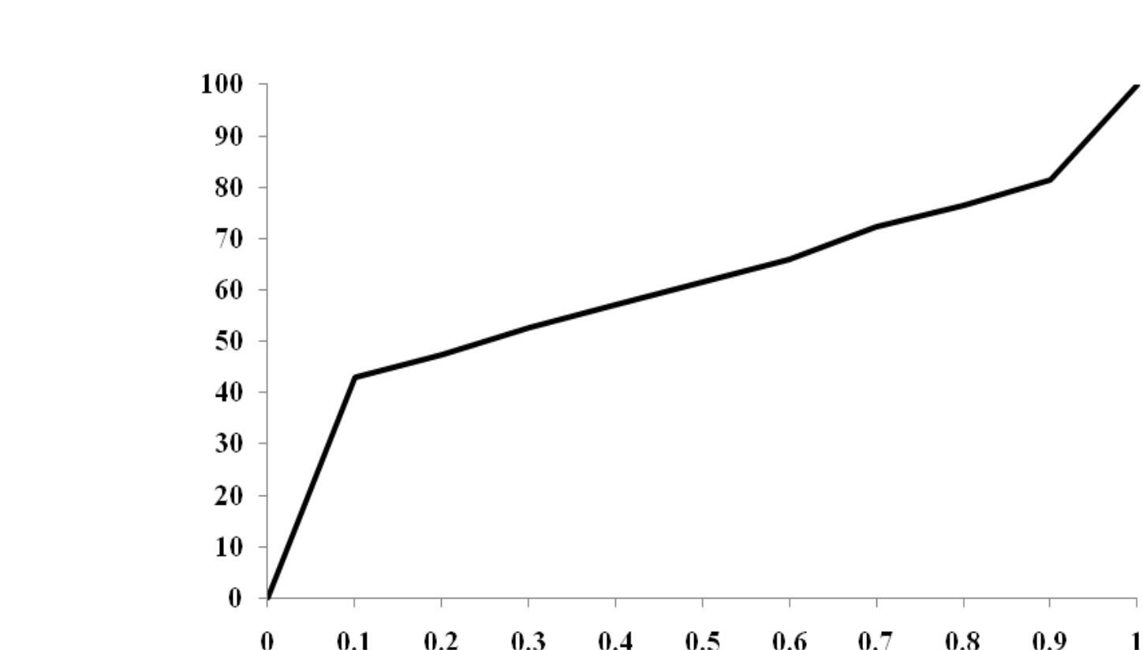

Cum. % of Sample

Search Cost

24

Geographical Profiling in a Novel Context

Figure 2: Comparison of Search Costs Functions for 101 New Zealand Sex Offenders and 24 Serial Rapists From The U.K.
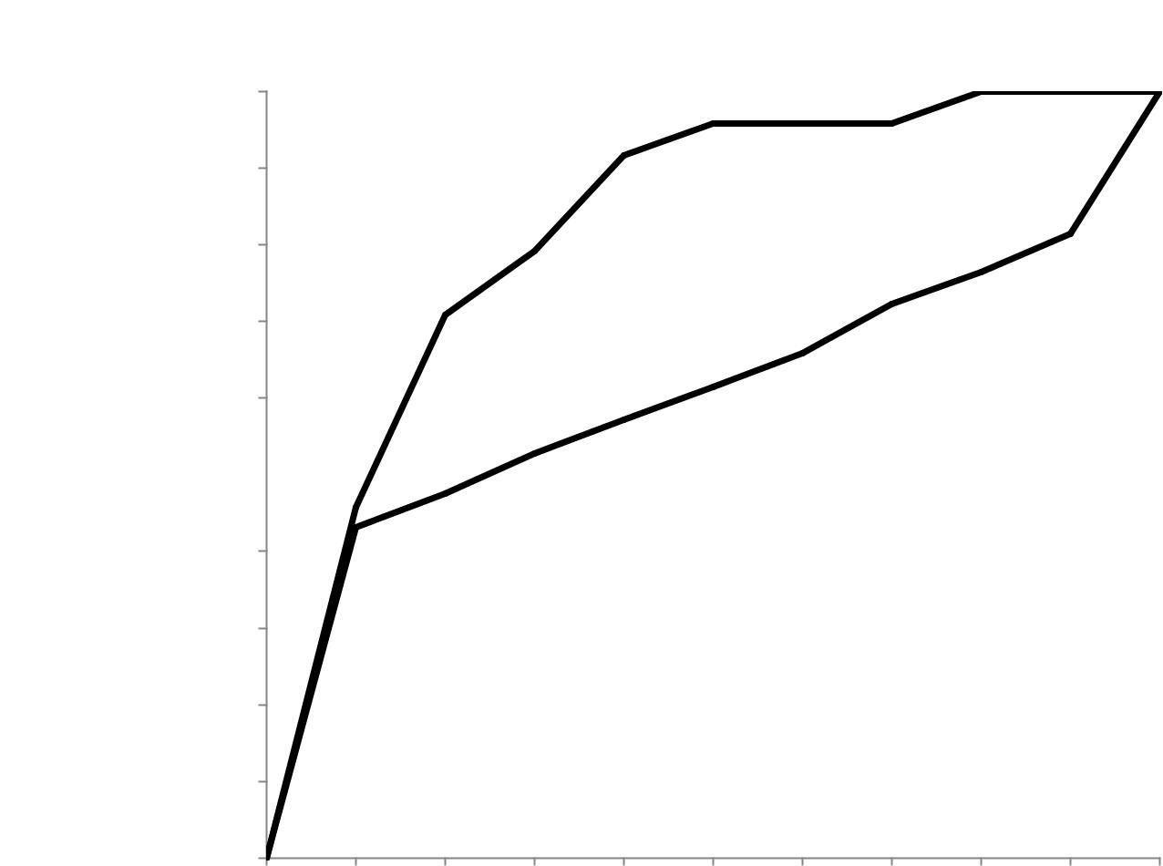

Cum. % of Sample

100

90

80

70

60

50 |  |  |  | NZ Sample

U.K. Sample

40

30

20

10

0

0 0.1 0.2 0.3 0.4 0.5 0.6 0.7 0.8 0.9 1

Search Cost

25

Geographical Profiling in a Novel Context

Figure 3: Distribution of the Distances Travelled to Offend by a Sample of New Zealand Sex Offenders (N=101)

Number of Trips
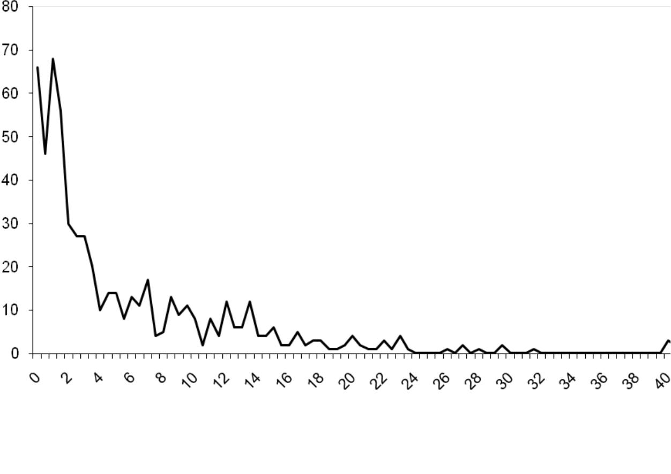

Distance From Home (km)

26

Geographical Profiling in a Novel Context

Figure 4: Decay Functions Fitted to the Distribution of Distances Travelled to Offend by New Zealand Sex Offenders
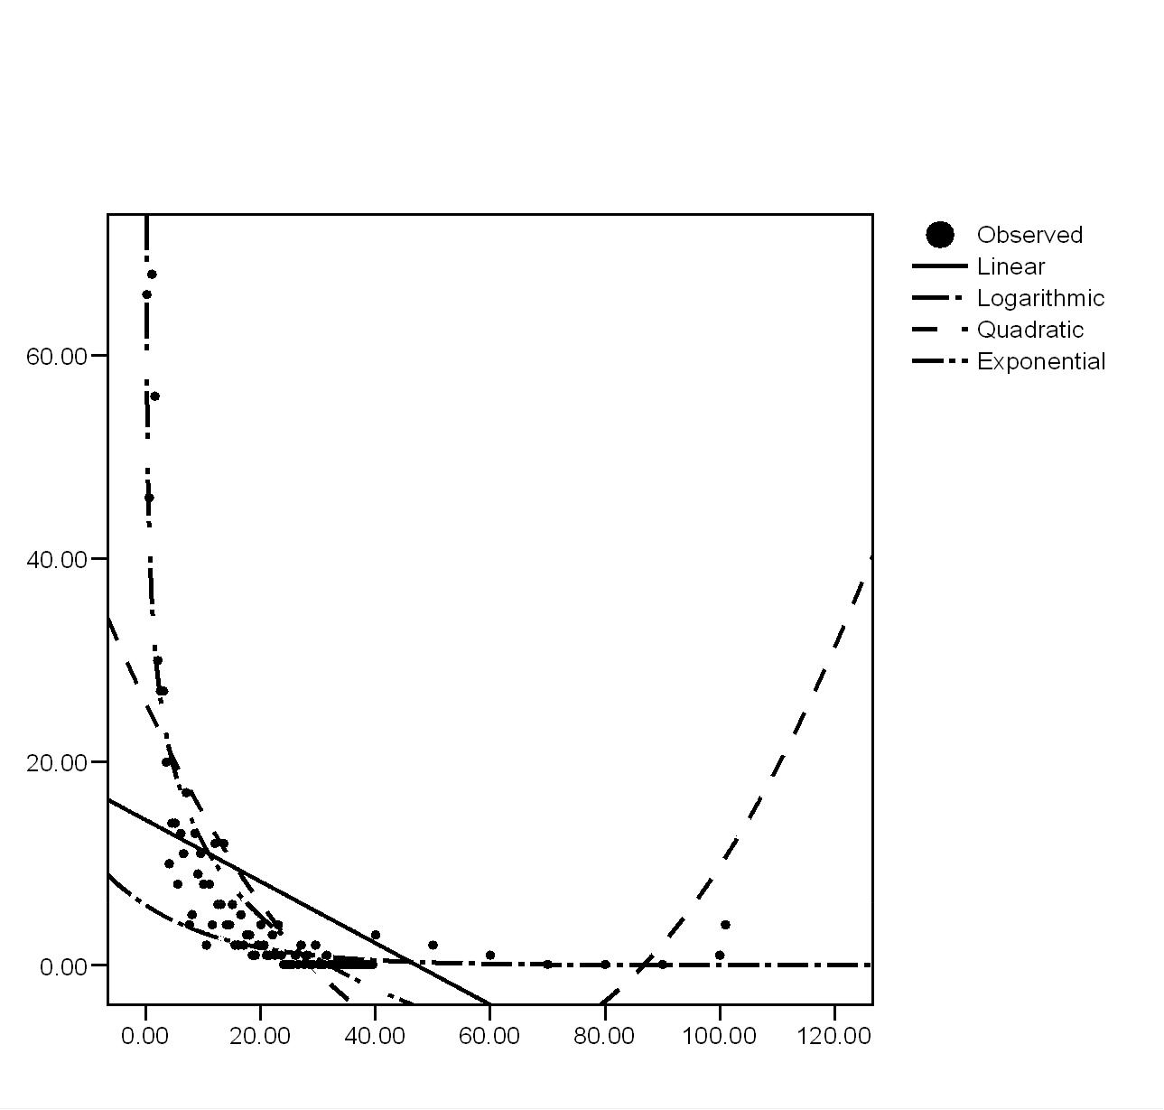

27

Geographical Profiling in a Novel Context

Figure 5: Comparison of Search Costs for 101 New Zealand Sex Offenders when Default and Optimal Decay Functions Were Used in Dragnet

Cum. % of Sample
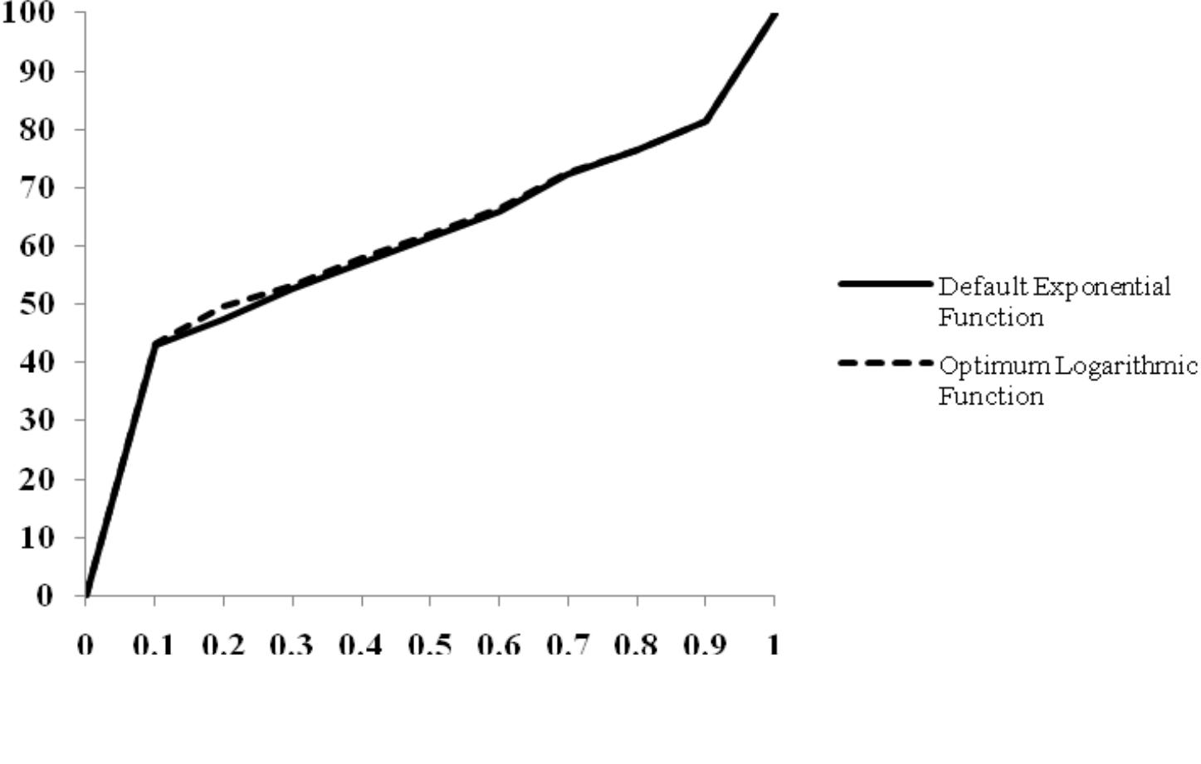

Search Cost

28

