Guerrilla gardening and green activism: Rethinking the informal urban growing movement

Michael Hardman^{a,} , Lovemore Chipungu^{b}, Hangwelani Magidimisha^{b}, Peter J. Larkham^{c}, Alister J. Scott^{d}, Richard P. Armitageª

- University of Salford, Salford, UK

- University of KwaZulu-Natal, South Africa

- Birmingham City University, UK

- University of Northumbria, UK

ABSTRACT

Green activism and guerrilla gardening lie at the more informal end of the urban food growing movement, but little is known about the extent of this practice or the future of such unplanned activities. Accordingly, this paper firstly explores a range of informal Urban Agriculture practices, illuminating the practice within Europe, North America, Africa and other continents. The paper then proceeds to focus explicitly on Salford, UK, where guerrilla gardening is being encouraged by the local authority. Using ethnographic and interview data, we focus on the actors involved, their relationship with authority and the wider impact of their activities; exploring their mo-tives, aspirations, values and beliefs. The results reveal the ability of the informal movement to regenerate ‘forgotten’ space and bring communities together, and the ‘darker’ side of the activity, with actors sometimes restricting access to colonised land. Ultimately, the paper reveals how this movement is expanding and that more research is required to better understand the actions of those who pursue a more informal approach to urban gardening and those who seek to regulate land use activity.

1. Introduction

With populations rising and cities expanding there is a nascent de-bate surrounding idea of productive urban landscapes and their ability to tackle food chain disconnects (Wiskerke & Viljoen, 2012). At the forefront of this debate is the practice of Urban Agriculture (UA) which is on the rise across the globe (Moragues Faus & Morgan, 2015; Noori et al., 2016); fundamentally, the concept revolves around the growing of food or rearing of liverstock in cities (Caputo, 2012). Arguments for UA vary, ranging from its potential to cut food supply chains and re-locate production closer to urban consumers, to the social contributions of the concept such as its perceived ability to bring together commu-nities through allotments, communal gardens and other such spaces (Gorgolewski, Komisar, & Nasr, 2011; Wiskereke & Viljoen, 2012). The latter is often argued to be the core reason for the practice in the Global North, with yield deemed minimal since spaces are relatively small and used predominantly for recreational purposes (Wiltshire & Geoghegan, 2012). Nevertheless, technologies such as hydroponics and aquaponics are testing this argument and enabling vertical systems and high yield

even in the smallest of spaces (Hardman & Larkham, 2014). Meanwhile, in the Global South, there is emerging discussion on the importance of UA and its ability to enable citizens in deprived areas to survive through providing the urban poor with much needed access to fresh produce (Chipungu, Magidimisha, Hardman, & Beesley, 2015).

Urban growing encompasses an array of practices and spaces, from traditional allotments to community gardens and larger spaces such as urban farms and rooftop developments. Yet to date many of these spaces are poorly defined and explored (Caputo, 2012). If we take the example of an urban farm, it becomes clear how this larger form of UA not only lacks coverage in both academic and non-academic literature, but also a distinct definition, with Hanson, Marty, and Hanson (2012, p.

- attempt perhaps closest: ‘an urban farm is an intentional eﬀort by an individual or a community to grow its capacity for self-suﬃciency and well-being through the cultivation of plants/animals’. Indeed, the very notion of UA is contested, with questions surrounding whether the term focuses purely on food growing activities or constitutes any form of agricultural activity within the city context (Lohrberg, Licka, Scazzosi, & Timpe, 2015).

Fig. 1. The world’s largest rooftop urban farm in Brooklyn, New York City, USA (Hardman, 2013).
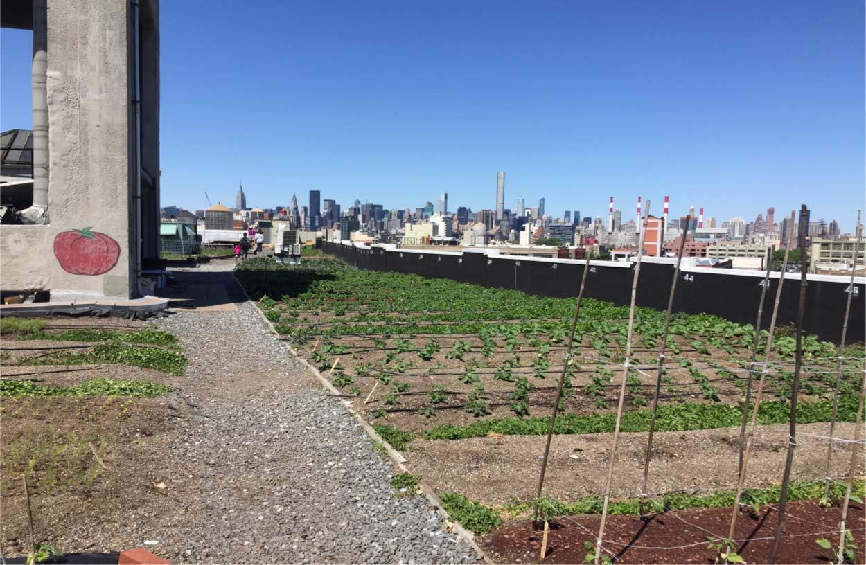

In terms of exemplars of UA practice, Fig. 1 depicts a large-scale form of the activity, in this case Brooklyn Grange Rooftop Farm in New York City, USA. The figure highlights the potential for UA and how the practice can involve projects which employ gardeners and operate as a business, with the project shown in the figure growing some 50,000lbs of vegetables each year (Brooklyn Grange Rooftop Farm, n.d.). This large-scale form of activity is growing, with companies such as Gotham Greens (2016) starting new UA projects across North America and employing more people within the sector. Within the UK there is a rise in this large-scale form of the practice, with aqua farms, hydroponic, rooftop and conventional urban farms appearing more and more (see for instance Sustainable Food Cities, 2017).

Proponents of UA often cite Detroit (USA) and Havana (Cuba) as exemplars in which the practice has made significant impacts in cities: regenerating space, feeding residents in deprived areas and helping to create more sustainable economies (Giorda, 2012; Ioannou, Moran, Sondermann, Certoma, & Hardman, 2016). In both these spaces, UA has been successful and contributes significantly to both economies. This has in turn enabled residents of the two cities to have better access to food and obtain new skills which could help with future employment opportunities. There are other exemplars, such as New York City’s urban farms and community gardens (McKay, 2011) alongside high-tech projects in Singapore (see One World, 2012).

Within academia, an recent argument surrounds the potential for UA to create a more socially ‘just’ food system (Alkon & Agyeman, 2011). Whilst the link between food justice and UA has a solid research base in North America, there is little exploration elsewhere, particularly in the European and UK contexts (Tornaghi, 2014). There is also emerging research which focuses on the multiple environmental bene-fits derived through UA, particularly its contribution to regulating and provisioning ecosystem services (UKNEAFO, 2014). However this has led to calls for more research around the risk associated with such practices, particularly in relation to the contaminated land upon which many of the projects are constructed (Chipungu et al., 2015). Yet, whilst there is a blossoming research base on the formal element of UA, there is scant regard for researching the more informal approaches (Zanetti, 2007).

Indeed, evidence demonstrates how many successful UA projects began through an informal approach and legitimised to seize on funding and opportunities to grow their action (Hardman & Larkham, 2014). Guerrilla gardening is a broad term which is associated with actors occupying space for the growing of vegetables or plants without permission (McKay, 2011). Guerrilla gardening is a global movement and is apparent in every country, from Africa to China, the USA and UK, students, businessmen, the elderly and others are regularly practising

the activity (Reynolds, 2008). The perception that guerrilla gardening is merely small-scale is incorrect, with the global Incredible Edible movement and many more formal projects owing their success to the informal practice (Scott et al., 2013). This paper explores informal UA and provides an insight into practices around the globe, drawing on a range of case studies before focussing on a local authority in the UK which is actively encouraging citizens to adopt a more informal route.

- Pursuing an informal agenda

‘Guerrilla gardening has seen increased practice and popular media coverage over the last 5 years, but has yet to receive much attention from the academic sphere. This is likely due to guerrilla gardenings’ conceptual fuzziness – its relational and contextual nature makes

collapsing it to a specific definition diﬃcult’

(Crane, Viswanathan, & Whitelaw, 2013, p. 76)

In a similar manner to the wider practice of UA, the idea of an in-formal approach is ill-defined and elusive. When raised, the informal movement is often linked to the idea of guerrilla gardening, a broad term which encompasses any form of growing activity conducted without the permission of the land owner (McKay, 2011; Reynolds, 2008). In academic literature the two are used alongside one another uncritically, often without a clear definition of either practice. Guerrilla gardening is a militaristic term and is often stigmatised as an activity of younger radicals with a deep political agenda (see for instance McKay, 2011). Furthermore, there is often a perception that those practising guerrilla gardening are adopting an illegal rather than merely an in-formal approach (Adams, Scott, & Hardman, 2013; Hung, 2017).

With the lack of arrests and no documented prosecutions, guerrilla gardening is more appropriately conceptualised as an informal act as opposed to an illegal act (Adams, Hardman, & Larkham, 2015; Reynolds, 2008). Although no guerrillas have been arrested, there are several instances relating to threats to detain, such as Richard Reynold; his encounter with London’s Metropolitan Police whilst gardening in the British capital (YouTube, 2008). Under UK law, guerrilla gardening would not constitute criminal damage and thus the Police Oﬃcer in question was incorrect in this video (Hardman, 2013). Perhaps the most unlawful action of a typical guerrilla gardener is their avoidance of obtaining planning permission or dealing with the bureaucracy of local authorities through avoiding risk assessments, insurance and other such paperwork usually required to establish a formal site (Zanetti, 2007). Ironically, one could argue that the idea of participatory planning may give these actors a voice and enable some avoidance of the informal occupation of land. This concept involves involving the community and

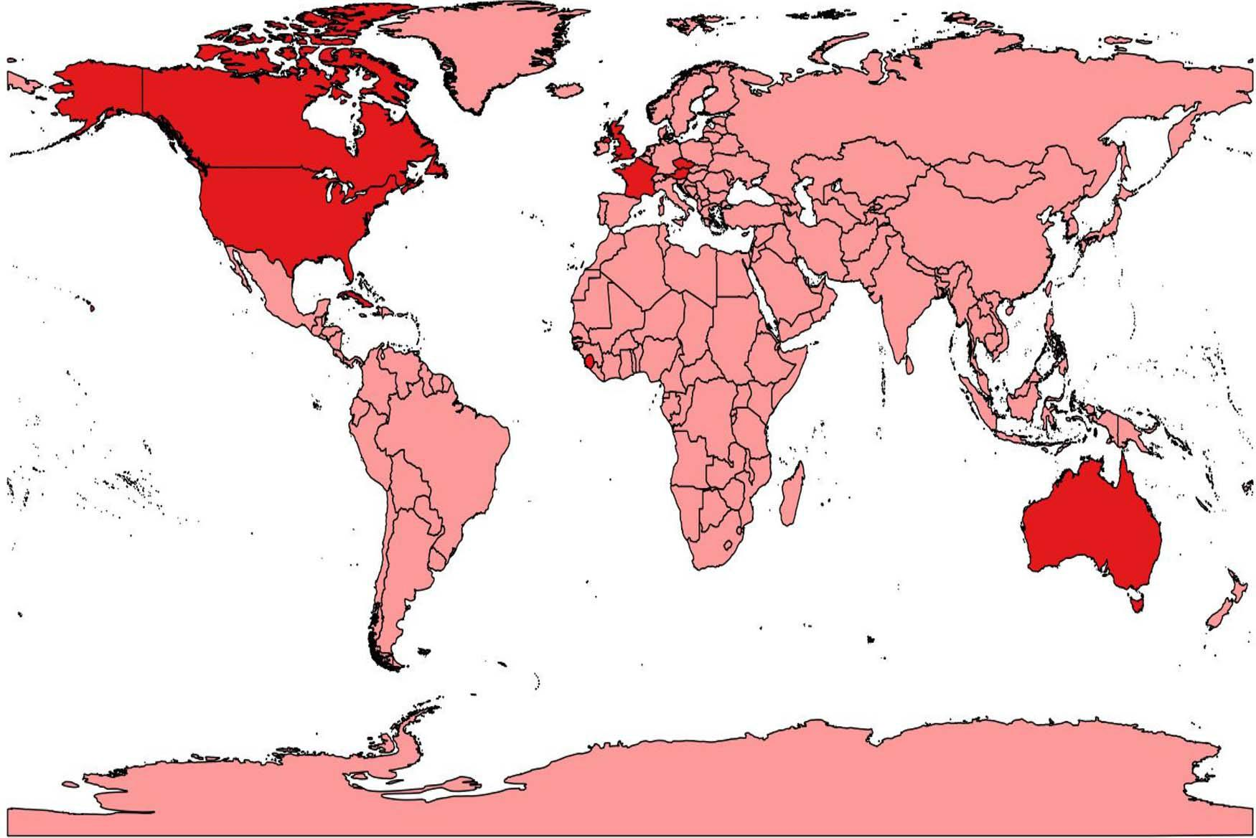

Fig. 2. A GIS analysis of the location of published academic studies prior to 2016 on guerrilla gardening, the majority of which are in the Global North (Armitage and Hardman, 2016).

interested parties in planning processes, with tools such as neighbour-hood planning proving population within the UK context (see for in-stance the DCLG, 2012).
The motivations for employing a guerrilla gardening approach vary; from actors who are confused about how to obtain permission for a legitimate community garden or similar space through the planning system, to others who pursue it for a ‘thrill’ where challenging authority becomes the core motivation (Adams & Hardman, 2014). A review of the literature shows that a lack of knowledge regarding the regulatory planning environment a is a core reason for those adopting a more informal approach (Adams et al., 2013; Crane et al., 2013; Tracey, 2007; Reynolds, 2008). For instance, in the UK Scott et al. (2013) argue that the planning system is often perceived to be disabling with regard to innovative activities such as UA and, in this case, has pushed some to adopt diﬀerent tactics to enable such activities to occur. However, the authors identify a number of ‘hooks’ (opportunities) in existing UK policy in which planners can act as enablers but warn that such uptake is reliant on their ‘willingness to engage widely in a new constructive dialogue and way of working that crosses the planning and environ-ment divide’ (Scott et al., 2013, p. 44). In this sense they are discussing the Ecosystem Approach and Ecosystem Service concepts which oﬀer an opportunity for UA to be increased in cities.

With regards to obtaining planning permission, a considerable amount of UK-based UA advisory bodies stipulate that groups and in-dividuals must seek guidance on whether they require such consent before creating spaces for food cultivation, regardless of whether it is eventually required (Community Land Advisory Service, 2012; Federation of City Farms and Community Gardens, 2009; PlanLocal, 2012). In this case, planners are the individuals who can either support, or restrict, UA practices (Neegard, Drescher, & Kouame, 2012; Shackleton, 2012). It is here that the risk-adverse planning system can frustrate locally-based initiatives even though suitable planning tools are available to enable such activities to occur (White & Natelson, 2012). For example Scott (2001) found that often the micropolitics and personalities of individual planning oﬃcers played a key role in whe-ther a particular development was supported. Furthermore, the Welsh

Rural Observatory (2012, p. 17) critique restrictive planning practice in parts of the UK where ‘planning was identified as a major barrier to the formation of new community growing sites and activities’. This problem reflects a lack of mutual understanding of the nature of the activity and the complexities of planning law (Scott et al., 2013).

“Established growing projects and groups also reported problems in negotiating the planning system. It was suggested that there were diﬃculties on both sides, with many communities and groups often lacking the necessary expertise and experience in dealing with the planning system, and planners uncertain about how to deal with applications for community growing activities”

(Welsh Rural Observatory, 2012, p. 17)

A considerable number of sites analysed in this Welsh Rural Observatory report were of an urban origin and a core issue identified was the lack of contact with the planning system. Such a barrier re-sonates well with the guerrilla gardening literature which identifies similar issues, resulting in many actors adopting the informal approach as a last resort in an attempt to enable the activity to take place (see for example Reynolds, 2008). Similar arguments can be found in the in-ternational context, with studies in Africa, North America and beyond revealing issues with their respective planning systems (see for instance Chipungu et al., 2015; Crane et al., 2013). For instance, in many African countries planning policy often restricts UA and thus actors resort to guerrilla gardening on a mass scale (Chipungu et al., 2015); this results in vegetables being grown in often contaminated land and often across private property.

3. Exploring practice

This paper now proceeds to provide a worldwide overview of dif-ferent approaches across the globe and examples of informal UA on the ground. To date, few studies interact closely with the informal or ‘guerrilla’ movement (see Fig. 2 and Crane et al., 2013; Zanetti, 2007). As Fig. 2 demonstrates, the majority of these studies focus on the practice within the Global North, predominantly in North America (see

for example, Hardman, 2009, 2013; Harrison, 2010; Zanetti, 2007). Furthermore, the authors observing the guerrilla gardening practices are often informal gardeners themselves, which arguably argue creates an issue around objectivity.

One of the few to explore guerrilla gardening up close is that by Crane et al. (2013) who focussed on how guerrilla groups formed and practiced within Kingston, Ontario. Their findings revealed the spec-trum of actors involved and how the activity had a positive impact on the surrounding environment; beautifying neglected space and bringing production into the heart of the city. In particular, they highlight the positive aspects of adopting such an approach ‘actions like guerrilla gardening encourage and promote open expression and agency provide powerful opportunities to reclaim city space as a lived project’ (Crane et al., 2013, p. 85). They conclude by arguing that more encouragement is required for such self-expression which will enable more citizens to become involved and reclaim neglected spaces within our cities.

Whilst there is a burgeoning literature base, there is still a distinct lack of a critical lens placed on guerrilla gardening in both academic and non-academic literature. From Reynolds (2008) to Crane et al. (2013), McKay (2011) and beyond, the explorations so far are largely positive. We have previously conducted a series of studies on guerrilla gardeners, predominantly in the West Midlands region of the UK, analysing their practices and the impact of their activities on the sur-rounding area; our core aim to critically analyse the practices of the groups involved. Our findings highlighted a diversity of individuals involved in the informal movement; from teachers to planners, students and the elderly. The data also revealed the darker side to the action, with actors colonising land not only without the permission of the local authority, but also the communities which surrounded the spaces (Hardman & Larkham, 2014). This resulted in some locals becoming disgruntled with the action and angry with the lack of consultation and local authority enforcement. In one case, guerrilla gardeners would colonise the land and plant vegetables but would not maintain the space on a regular basis. Ironically, this soon led to the informal intervention adversely impacting on the aesthetics of the space, with a severe lack of maintenance resulting in the vegetation dying (see Hardman & Larkham, 2014).

However, there are also examples that show the positive impact and multiple benefits of those cultivating land without permission. For ex-ample Caldmore Guerrillas, who operate in Walsall, UK, was formed by a Polish migrant who wanted to connect with the community and help to regenerate leftover space in Walsall. Through guerrilla gardening she was able to bring together the fragmented community and create a community garden in the heart of a deprived area. The activity soon flourished and, like so many successful cases, soon transitioned into a
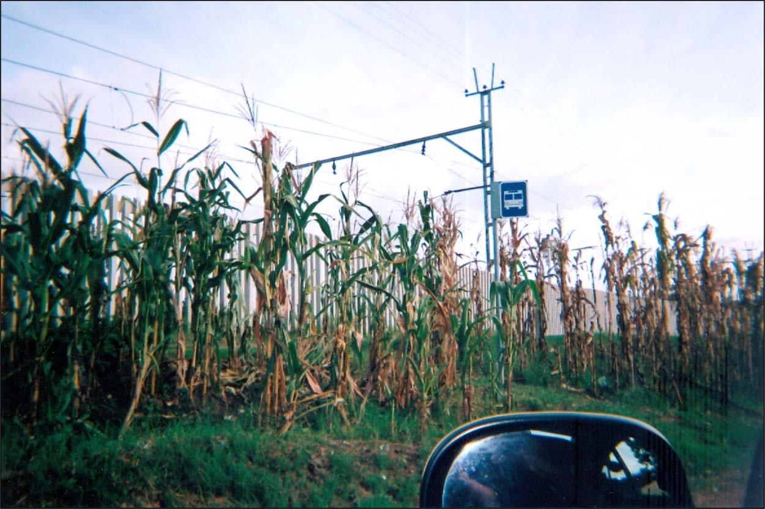
permitted form of gardening which was able to grow further and obtain local funding.

Whilst many of these studies focus on English-speaking countries, there is an array of evidence to show how the informal movement is just as rife in other areas of the globe (Crane et al., 2012; Hung, 2017; Wiskerke & Viljoen, 2012). As previously mentioned, Cuba is an ex-emplar of guerrilla gardening on a large scale given that much of the activity is informal and without the consent of the appropriate au-thority. There is evidence for guerrilla gardening in Pakistan (Cityfarmer, 2013), China (guerrillagardening.org, n.d.), Hong Kong (Hung, 2017) and many other non-English speaking countries (see guerrillagardening.org for a list and links for each country). Within these contexts the subversive nature of the activity results in connec-tions relying on face-to-face contact rather than through social media, possibly due to the lack of widespread access to such technology and tools in parts of the Global South.

3.1. Guerrilla gardening in South Africa and the UK

In order to provide a flavour of the diverse nature of guerrilla ac-tivity we now draw on our recent in South Africa and the UK to show practice on the ground; providing a snapshot of contrasting work in the Global South and North. With the former, we provide a brief overview of action and then with the latter add some empirical material from a case study in Salford, UK. In terms of the South Africa, we begin by focussing on Umlazi, which is the second largest township (after Soweto) in Durban, South Africa. Development of the Umlazi township began in 1961 and by 1965 it was opened for occupation (Minnaar, 2001).

The Umlazi township inherited the aftermaths of the apartheid government characterised with spatial and economic isolation. Due to its sheer size, the typical problems of severe housing shortage, major informal settlements, and high levels of unemployment were magnified. The area is not only an economic heartland of Durban, but also an environmental hotspot characterised by heavy industrial and large-scale residential development located in close proximity in a topo-graphically contained region. Hence the practice of UA in this area represents a diversity of agricultural practices which have evolved from apartheid restrictions to current mixed typologies consisting of com-munal and individual gardeners operating on both subsistence and commercial levels. Though predominantly practiced by women, it is fulfilling nutritional and economic demands among the urban poor.

With regard to the informal movement, most of the UA practiced falls within this definition. The practice of guerrilla gardening in the Umlazi area is a common phenomenon on road verges, where

Fig. 3. guerrilla gardening at a bus stop in Umlazi (Chipungu et al., 2015).

9

municipal infrastructure (in the form of road signage and electricity power-lines) compete for space with crops as shown in Fig. 3. On the other hand, open spaces, meant to accommodate other social functions, have been overtaken by similar activities. In this case, the residents are colonising any form of leftover space for UA activities, allowing them to add to their diets and grow food within close proximity to their dwellings.

The extent of informal activity is also due to the lack of support for formal UA by authorities, with significant barriers facing those who wish to pursue more legitimate routes (Chipungu et al., 2015). As Arku, Mkandawire, Aguda, and Kuuire (2012) note, there is a general lack of encouragement and enabling around formal UA in African cities, with planners and other key gatekeepers not realising the wider environ-mental and social benefits of the practice. Chipungu (2011) blame the historical development of many African cities which prevented the practice developing in the heart of the urban centres. Due to the risk of the informal approach in Africa, predominantly surrounding soil con-tamination, there have been calls for more funding and support to en-courage more legitimate projects to ensure that public health is not endangered through the use of heavily-contaminated land for guerrilla gardening activities (Chipungu et al., 2015; Haysom, 2007). Guerrilla gardening is not merely concentrated in South Africa but spreads across the continent itself, with activity in the likes of Kenya, Zimbabwe to the far reaches of Libya and other nations (Chipungu et al., 2015).

In terms of the Global North, and specifically the European context, there is a wide range of informal guerrilla practices on the continental mainland, with activities in Spain, France, Germany and elsewhere (see Bell et al., 2016); although this range is not reflected in published academic material displayed in Fig. 2. An example from our own re-search can be seen in Nitra, Slovakia, where guerrilla gardening has acted as a mechanism for reclaiming unused land and starting a wider green movement. Close to the urban centre, in the year 2010 students colonised leftover patches of greenspace and began an informal allot-ment site. This attracted others interested in the idea of UA before the students eventually applied for permission to use the space legally. Retrospective permission was granted by the local authority and now a successful project entitled ‘Hyde Park’ occupies the space, attracting local residents and students alike to the area (Hide Park, 2016).

Whether in the Global North or South, guerrilla gardening is an activity which has a profound impact on the area in which it is prac-ticed. Nevertheless, a connection between all these case studies is often the lack of encouragement from authorities for this route; rather actors pursue the authority once an informal project is established. As Reynolds (2008) argues, such activity either eventually fails or legit-imises in order to grow and seize on support. This is particularly re-levant in the South Africa case study in which guerrilla gardening was practiced on a large-scale. We now, in contrast focus on an example of a local authority embracing the informal movement and which is issuing a call for actors to help transform neglected space on a large scale in the UK; drawing on empirical material, we add to the case studies explored in this section. We then reflect on this approach before critiquing whether informal UA should be encouraged on a wider scale.

4. Embracing informality: a case study of Salford, UK

Salford, a city in the North West region of the UK, is one of the country’s most deprived areas (ONS, 2016). It is located in close proximity to Manchester and historically has oﬀered supporting ser-vices for its larger rival. In 2012 Salford City Council commissioned a master plan for a large regeneration project in the heart of the city (see Pendleton Together, 2013). The regeneration aimed to rejuvenate an area known as Pendleton through creating new homes and employment opportunities for residents. The investment into this scheme stands at around £650,000,000 and involves changing the urban fabric entirely: reducing brutalist tower blocks, creating new jobs in the city and adding green infrastructure to the area (Salford City Council, 2016).

Through the consultation process, planners and other key actors embraced the idea of UA and embedded the concept within the mas-terplan. This included areas for new allotment sites, temporary com-munity gardens and the development of a large commercial urban farm. Interestingly, the masterplan fits well with Viljoen’s (2005) Continuous Productive Urban Landscape (CPUL) concept, with the linking together of UA sites through green corridors and other such tools. The urban farm acts as a hub for the regeneration, with the allotments, community gardens, orchards and other UA connected to the space. Therefore there is a conscious eﬀort by the local authority to link together the spaces and create an inter-connected network of UA across Salford. This also ties in well with key national UK policies such as the National Planning Policy Framework (NPPF) and the Natural Environment White Paper (NEWP) which urge actors to maintain and improve the natural en-vironment; the latter also explicitly mentions the need to enhance green corridors, which aligns with the plan of a CPUL network by Salford (DEFRA, 2011; DCLG, 2012).

In the Salford context, planners are championing a radical form of UA through the creation of a commercial urban farm in the heart of the city’s most deprived area. Salford is not alone in the UK as there are similar examples including Brighton and Bristol which demonstrate how planners are beginning to embrace the idea of UA (Wilson, 2014). In the Brighton example planning guidance now exists for decision-makers to consider UA in new developments within the city (see Brighton and Hove Council, 2011). There are also planned commercial farms in other areas around the country, including in Oldham which was recently labelled the UK’s most deprived town (BBC News, 2016). However, unlike these other cities, Salford is the first to actively en-courage the informal movement in this landscape through using a variety of marketing tools to call out to guerrilla gardeners to help re-generate land and enable UA within the city. This adoption of guerrilla gardening is the first of its kind and thus presents an interesting model to critically analyse.

Methodologically our research in this area focussed on mapping guerrilla activity before conducting a series of unstructured and semi-structured interviews alongside ethnographically-informed observation with three groups which operate in the city. Through using a mixed methods approach we were able to gather an array of data, both sub-jective and objective on the activities taking place. The primary aim here was to understand practice from the key actors on the ground, both the guerrillas and local authority alike. The ethnographic element in-volved attending digs and tours of previous sites by the guerrilla gar-deners. An interview was also conducted with the lead regeneration oﬃcer who was the main actor behind the local authority’s drive to encourage guerrilla gardening in the city. This was in order to discover why the local authority was adopting such a proactive approach and its ambitions for the activity. Through conversations and desktop research, three core groups were found to be operating in the area:

- Incredible Edible Salford – started through guerrilla gardening in Eccles, a district of Salford before legitimising their activities. Some 20 people are involved in this group and range from retired in-dividuals to horticultural experts and businessmen.

- The ‘Guerrilla Gardener’ – a lone gardener who colonises patches of land around the area, mainly for beautification purposes.

- The ‘Pendleton Guerrillas’ – a semi-formal group which is being used by the authority to attract others to the area. This mainly consists of local authority and community volunteers with around 5 in total.

The informal movement in Salford is extremely diverse, with a wide range of ages involved and individuals from diﬀerent backgrounds. With Incredible Edible Salford and the Pendleton Guerrillas, this mainly involved local residents from deprived backgrounds, whereas the Guerrilla Gardener was a member of staﬀ at the nearby University. There were a variety of reasons for their activities; from greening the urban environment to raising awareness around UA to the average

Salfordian. The latter connected all three, who viewed UA as a potential tool for those with poor diets to have better access to fresh produce. As the leader of Incredible Edible Salford stated, ‘we were able to put that food out in the urban setting to support people who may not have ac-cess to free fruit and vegetables, might not even have the knowledge of what to grow, where to grow, what they can do with the food’. This was reinforced by the solo ‘Guerrilla Gardener’ who felt that such activity was needed in the locale alongside beautification, ‘there’s a real need to get people growing their own fruit and vegetables in Salford’.

‘Guerrilla gardening revives spaces – creating noise and getting people engaged. It is fun, informal and a catalyst for bringing people together. There is an informal movement in Salford. We’ve seen things just ‘pop-up’ in places!’

(Lead Project Oﬃcer, Salford City Council)

In terms of the third group explored, the Pendleton Guerrilla group was created through a local authority oﬃcer responsible for the large regeneration project in the city. In this case, he viewed guerrilla gar-dening as a mechanism for starting a grassroots movement in the city which would enable residents to have a more intimate connection with the space. His vision was to grow the movement and allow the com-munity to take ownership of spaces; adopting small patches of green-space and larger ones within the regeneration area. A core reason for this encouragement was his view that the space was overly-protected with large amounts of fencing, CCTV and other negative features, ‘we want to create a friendlier place, remove the fences and get people growing stuﬀ’ (Lead Project Oﬃcer, Salford City Council).

He viewed guerrilla gardening as the perfect tool through which to push change from the bottom up. The Pendleton Guerrillas was branded by the project oﬃcer who then pushed for community members to take ownership of the brand; ironically this somewhat positions the activity as top-down and as a hijacking of the guerrilla brand. During the in-terview, his passion and enjoyment for the concept were evident ‘Ron Finley [a Los Angeles guerrilla gardener] is great, we really need our own Ron in Salford’ (Lead Project Oﬃcer, Salford City Council). His reference to Ron Finley here demonstrates his wider knowledge around the practice. He also appeared to take inspiration from Africa, North America and other global practices and wished to replicate the best of them within the Pendleton context: ‘I really would like people to get involved – the more the merrier!’ (Lead Project Oﬃcer, Salford City Council). This support goes beyond mere encouragement and involves the gifting of land to guerrilla groups if they wish to use it. This actor now occupies a political position overseeing a large area of the city and still actively encourages the practice. Through doing so he influences local policy and attitudes towards guerrilla gardening.

With the Pendleton Guerrillas one could question whether this constitutes being part of the informal movement as it appears to be encouraged (even initiated) by the local authority. It must be noted that our observations nevertheless revealed that planning permission, risk assessments and other such rigorous procedures were largely ignored. Rather the Pendleton Guerrillas (in a similar manner to the wider guerrilla movement) adopted space without direct consent and per-mission. Activities of this group included the creation of a ‘guerrilla orchard’ and a range of temporary sites across the city. Fig. 4 shows one of the ‘meanwhile sites’ which used militaristic signage to raise awareness amongst the local community, attempting to ensure that the activity was connected with the guerrilla group and not the wider au-thority. Fundamentally, meanwhile sites are temporary spaces: often stalled development or leftover land in which innovative activities can take place.

Observations were carried out on a variety of projects undertaken by the Pendleton Guerrillas, with the most recent, a guerrilla orchard, being created in February 2016. This was a large project which aimed to reclaim a site previously inaccessible to the community. In this case the Pendleton Guerrilla group used trees donated by a local celebrity and planted 20 adjacent to the main road running through the city of

Salford. Their aim was to ‘provide free fruit to the community’ whilst simultaneously improving the aesthetics of the area (Pendleton Guerrilla member). Through doing so they aimed to raise the profile of guerrilla gardening and more formal types of UA in the city, encoura-ging other community members to join the action. We conducted much of the observational element of the study in Salford and witnessed a large turnout to this particular form of action, with an array of students, locals and some authority members making an appearance.

In terms of other guerrilla practices, Incredible Edible Salford de-monstrates the potential of informal action to make a significant impact in a deprived area. The group formation shared many characteristics with the Incredible Edible Todmorden group, using an informal ap-proach before proceeding to a more legitimate body which would en-able it to access funding. Through adopting a range of meanwhile sites, obtained through working with the local planners and other key actors, they were able to grow their action and involve residents across Salford. Eventually the group was able to purchase sites and have a permanent physical and social footprint on the city’s landscape, ‘we have a farm now and sites across Salford, working with the NHS, Age UK and others’ (leader of Incredible Edible Salford).

Observational work with Incredible Edible Salford was more sporadic due to the varied nature of their activities. Whilst out creating spaces for UA, either with permission or without, it was clear the group had an intimate connection with the community. They often used bi-zarre growing methods to attract attention, such as using leftover bot-tles to grow vertically for instance or placing planters in very busy lo-cations. This acted as a mechanism to ignite conversation with passers-by who in turn became interested in their practices and engaged with them about the concept of UA. In turn, this helped the Incredible Edible Salford group to spread their message and encourage others to become involved in the wider movement.

Whilst these two groups are quite vocal about their activities and easy to locate through social media, the solo self-proclaimed Guerrilla Gardener demonstrates how there is often a plethora of activity which is ongoing and diﬃcult to track. The discovery of this informal action in Salford was largely by accident, with the Guerrilla Gardener opting to take a much more secretive approach: ‘I just get on with things and plant stuﬀ here and there’ (Salford Guerrilla Gardener). This correlates with earlier research which shows how many groups prefer this ap-proach and are not vocal about their work, rather they prefer to hide from the media and cultivate space without the knowledge of others (Flores, 2006; Hardman & Larkham, 2014). This solo guerrilla was en-couraged by the local authority’s encouragement of the activity and viewed it as a positive move, ‘I’d like to get involved and help, it makes me feel less nervous about doing stuﬀ’ (Salford Guerrilla Gardener).

This removal of persecution was exactly the reason the lead project oﬃcer wished to encourage the informal movement in Salford: ‘we wanted to take away this idea that it wasn’t allowed… we really want people to get involved in whichever way they want to’ (Lead Project Oﬃcer, Salford City Council). Although this strategy may work with some individuals, previous research has shown how the ‘naughty’ angle is a key driver for many taking part in this movement (Hardman & Larkham, 2014). Many groups also use guerrilla gardening as a tool to challenge authority and the right of the city, which again could be an obstacle to embracing the underground movement. Through removing the thrill element – the idea that you could be ar-rested for planting flowers or growing produce – the local authority may be pushing away more ‘radical’ guerrilla gardeners.

Nevertheless, the authority’s stance in this context appears to have encouraged more residents to be involved in the informal route. Discussions with those taking part in activities revealed how many were happy with how easy it was to be involved with UA in the city and how the bureaucracy was largely removed. Through pushing for a more informal approach, the local authority has removed the barriers pre-venting the community becoming involved in the UA movement and has ultimately impacted positively on the area. Many of the guerrilla

Fig. 4. a meanwhile site complete with signage by the Pendleton Guerrillas (photograph courtesy of Project Oﬃcer).
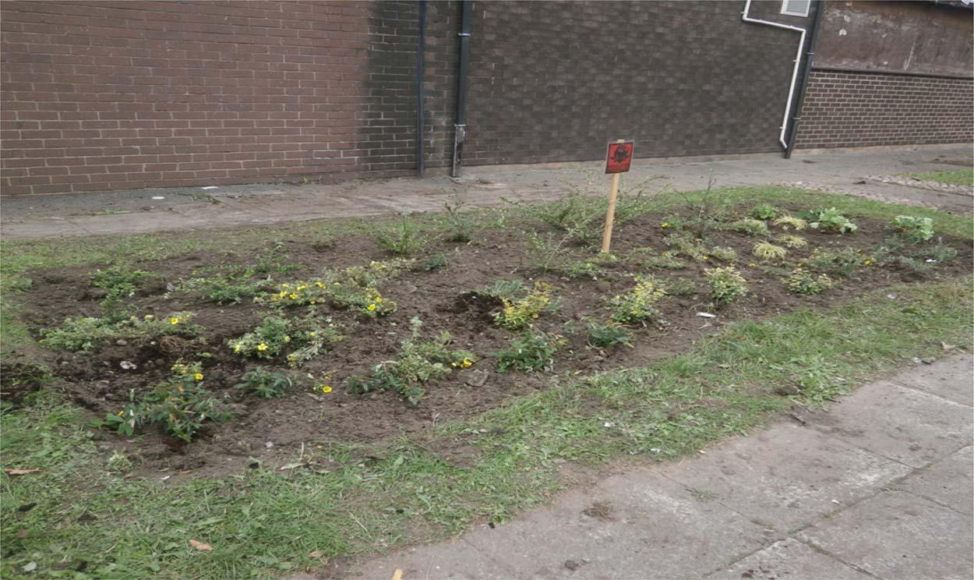

gardeners surveyed revealed how they intended to apply for permission to grow their activities and, like so many other groups, seize on funding for their projects.

5. Moving forward: should we encourage guerrilla gardening?

The Salford case study raises the notion of how best to address the rise in the informal approach and whether encouragement or restriction is preferred. In this case the authority has embraced and enabled a range of informal UA activities across the city. The result is that more residents are engaging in informal activities within the area and feel empowered to help revitalise space. This in turn has enabled the local authority to entice those practising informal action onto a more legit-imate path, through oﬀering land to enable their action to grow and have a wider impact on the city’s inhabitants. However, one must question those involved and whether the informal approach is in-clusive; contrary to formal UA, which has often involves a need to embrace communities and those wishing to use the space, the informal route does not necessarily have this option and practice diﬀers widely between groups. As previous research has shown, there is a darker side to this action and a risk that a small element of the wider community is making self-interested decisions without consultation (Adams et al., 2015; Crane et al., 2013). This is even more important when one con-siders the possibility of transient communities (e.g. students) changing space without the permission or inclusion of the local residents.

The Salford example challenges many of the negative assumptions of local authorities and planners on their risk aversion to radical con-cepts such as UA and the use of meanwhile sites for innovative activities (Scott, Carter, Brown, & White, 2009; Tornaghi, 2012; White & Natelson, 2012). A crucial element of this wider criticism is the disjointed approach to approving projects; decisions are argued to be subjective and vary from authority to authority and across scales (Adams et al., 2013; Scott, 2001). Whilst one may understand the po-sitives of a UA project, others may view it in a diﬀerent manner (Scott & Carter, 2012). This is evident with the example of Incredible Edible Todmorden, which has been fortunate enough to have a proac-tive local authority interested in the notion of UA (IET, 2011). Never-theless, Reed et al. (2010) demonstrate how key actors, such as plan-ners, are generally risk adverse and embedded within legislation which guides the practice. In the UK, the planning system’s reliance on leg-islation, particularly the Town and Country Planning Act (1990), which characterises agricultural activity in a rigid manner, is argued by Adams et al. (2013) to be a major obstacle for UA. Scott (2001) explains that projects which do not conform to the act are deemed ‘unsustainable’ in most cases, but the decision to approve a space is solely in the hands of the planning oﬃcer/councillor dealing with the case: decisions are highly subjective.

Adding to this critique, Reynolds (2008, p. 33) is extremely negative towards planning practice, explaining that ‘planning rules and codes of conduct’ create places without personality or landscapes of order (Qvistrom 2007). Through adopting an informal route Reynolds (2008) argues that this can add much needed character and diversity to the local urban landscape, with actors not restricted to spatial norms and able to act outside of restrictions often imposed on more formalised projects. Adding to this, Crane et al. (2013) argue that guerrilla gar-dening is a practice which brings creativity and innovation to our urban landscapes. Their case study in Canada demonstrates how guerrilla gardeners can interpret the cityscape diﬀerently and, in this case, use large amounts of available space for their UA action.

The hardline anti-planning rhetoric presented above by Reynolds suggests that it will be more diﬃcult to work alongside more radica-lised guerrilla gardeners. Indeed, many guerrillas were angry with re-cent UK Government eﬀorts to bring about a ‘Big Society’ agenda in which volunteers would eﬀectively replace/add value to frontline au-thority services; in this case, the rebellious gardeners were worried that, if they adopted a formal approach, their action would be aligned to this ideal. Such groups and individuals will be reluctant to work with au-thorities who may wish to encourage the activity. McKay (2011) has a negative view of such rhetoric and argues that Reynolds’ philosophy is too militarised in parts and isolated from other aspects of guerrilla gardening. A core critique by McKay (2011) revolves around the numbering system devised by Reynolds: those who sign up to his site are given a tag, with Reynolds adopting 001. In this case, McKay (2011) feels that Reynolds is a self-imposed general of the movement.

Since our research demonstrates how many are pursuing the in-formal approach purely for ease, through the idea that they do not understand the procedure for applying for formal permission, there is a real opportunity here to seize upon this interest. A simple solution could involve raising awareness of the procedures through providing more information, perhaps targeting existing UA provision first before the general population. In doing so more formalised UA projects could be encouraged and prevent individuals from pursuing the informal route; using charters, policies and other mechanisms to support the practice. Another solution here could see more authorities following Salford’s lead through the embracement of those practising without permission. In a similar manner to Salford, some form of loose control could be implemented which still allows actors some freedom with their eﬀorts.

Indeed, the very notion of formalised guerrilla gardening is an oxymoron; many pursue the activity predominantly due to its informal nature (McKay, 2011). As Reynolds (2008) shows, guerrilla gardeners have a passion for taking back control and not fitting with authority views. If planners and other key actors were to legitimise their action this could take away crucial elements of the subversive practice. Taking away the informal nature of the activity will render guerrilla gardening

to merely transition to formal gardening, with many actors not wishing to pursue the activity without the former element (Hardman & Larkham, 2014). Some work is needed here to engage core guerrilla gardeners around this idea and how both parties, the planners and informal actors, can work together to enable greener and more productive cities.

Ultimately more research is required on the nature, extent, variety and success of practice and to uncover the benefits derived from adopting an informal approach to UA. Along with more work with of-ficials – in particular planners – there is a need to delve further into practices located in the Global South and to move away from the UK and USA which dominate the literature base. Perhaps more urgently there is a need for a more thorough quantitative exploration into the risk associated with both formal and informal UA practices, discovering the levels of contaminants in community gardens, allotments and other such spaces. In arguing for more research into these particular areas we hope more studies will add to the emerging research base around in-formal UA and provide more of an insight into this secretive world.

References

Adams, D., & Hardman, M. (2014). Observing guerrillas in the wild: Reinterpreting practices of urban guerrilla gardening. Urban Studies, 51(6), 1103–1119. http://dx. doi.org/10.1177/0042098013497410.

Adams, D., Scott, A. J., & Hardman, M. (2013). Guerrilla warfare in the planning system: Revolution or convergence in sustainable planning discourse? Geografiska Annaler, 95(4), 375–387. http://dx.doi.org/10.1111/geob.12031.

Adams, D., Hardman, M., & Larkham, P. (2015). Exploring guerrilla gardening: gauging public views on the grassroots activity. Local Environment, 20(10), 1231–1246. http://dx.doi.org/10.1080/13549839.2014.980227.

Alkon, A. H., & Agyeman, J. (2011). Cultivating food justice: Race, class and sustainability.

London: MITA Press.

Arku, G., Mkandawire, P., Aguda, N., & Kuuire, V. (2012). Africa’s quest for food security: What is the role of UA? Occasional paper No. 19.1. Zimbabwe: The African Capacity Building Foundation in Harare.

Armitage, R. P., & Hardman, M. (2016). Back to the future? Retracing our Relationship with Food in the City. Paper presented at: RGS-IBG Annual Conference.

BBC News. (2016). Most deprived town in England is Oldham. [Online] Available at: http:// www.bbc.co.uk/news/uk-england-35842488. (Accessed 16 April 2016).

Bell, S., Fox-Kamper, R., Keshavarz, N., Benson, M., Caputo, S., Noori, S., et al. (2016).

Urban allotment gardens in Europe. New York: Routledge.

Brighton and Hove Council. (2011). PAN06: Food growing and development. [Online] Available at: http://www.brighton-hove.gov.uk/sites/brighton-hove.gov.uk/files/ downloads/ldf/PAN6-Food_Growing_and_development-latest-Sept2011.pdf. (Accessed 03 March 2017).

Brooklyn Grange. (n.d.). Brooklyn grange rooftop farm. [Online] Available at: http://www.

brooklyngrangefarm.com/. (Accessed 03 April 2016).

Caputo, S. (2012). The purpose of urban food production in developed countries. In A. Viljoen, & J. S. C. Wiskerke (Eds.). Sustainable food planning: Evolving theory and practice. Wageningen: Wageningen Academic Publishers.

Chipungu, L., Magidimisha, H. H., Hardman, M., & Beesley, L. (2015). The importance of soil quality in the safe practice of urban agriculture in Zimbabwe, Kenya and South Africa. In F. Q. Brearley, & A. D. Thomas (Eds.). Land-Use change impacts on soil processes: Tropical and Savannah ecosystems. Wallingford: CABI.

Chipungu, L. (2011). Insights into urban development control challenges: A case study of operation murambatsvina/restore order in Zimbabwe. Journal of the Built and Human Environment Review, 4(2), 17–32.
Cityfarmer. (2013). Crops in pots. [Online] Available at: http://www.cityfarmer.info/ 2013/10/07/crops-in-pots-karachi-pakistan/. (Accessed 03 March 2016).
Community Land Advisory Service (2012). Frequently asked questions for community growing groups. England, London: CLAS.

Crane, A., Viswanathan, L., & Whitelaw, G. (2013). Sustainability through intervention: a case study of guerrilla gardening in Kingston, Ontario. Local Environment, 18(1), 71–90. http://dx.doi.org/10.1080/13549839.2012.716413.
DCLG. (2012). National policy planning framework. [Online] Available at: http://www. communities.gov.uk/planningandbuilding/planningsystem/planningpolicy/ planningpolicyframework/. (Accessed 19 February 2017).
DEFRA (2011). The natural choice: Securing the value of nature. London: HM Government.

Flores, C. H. (2006). Food not lawns: How to turn your garden and neighbourhood into a

community. White River Junction, VT: Chelsea Green.

Giorda, E. (2012). Farming in mowtown: competing narratives for urban development and urban agriculture in detroit. In A. Viljoen, & J. S. C. Wiskerke (Eds.). Sustainable food planning: Evolving theory and practice. Wageningen: Wageningen Academic Publishers.

Gorgolewski, M., Komisar, J., & Nasr, J. (2011). Carrot city: Creating places for urban

agriculture. New York: Monacelli Press.

Gotham Greens. (2016). Our farms. [Online] Available at: http://gothamgreens.com/our-farms/. (Accessed 18 April 2016).

Guerrillagardening.org. (undated). Guerrilla gardener forum. [Online] http://www.
guerrillagardening.org/community/index.php. (Accessed 23 March 2016).

Hanson, D., Marty, E., & Hanson, M. (2012). Breaking through concrete: Building an urban

farm revival. Berkeley: University of California Press.

Hardman, M., & Larkham, P. J. (2014). Informal urban agriculture: The secret lives of

guerrilla gardeners. London: Springer.

Hardman, M. (2009). Uncovering the truth behind guerrilla gardening: A comparative study of two south manchester based groups, unpublished MA dissertation. The Manchester Metropolitan University.

Hardman, M. (2013). The secret life of guerrilla gardeners, unpublished PhD thesis.

Birmingham City University.

Harrison, C. E. (2010). Rethinking the divide: Beyond the politics of demand versus the politics of the act debate, unpublished PhD thesis. University of Exeter.

Haysom, G. (2007). Urban agriculture and food security. In J. V. Braun (Ed.). Towards a healthy and sustainable world food situation 2020–2050. Zurich: International Research Food Policy Institute.
Hide Park. (2016). About the project. [Online] Available at: http://www.hidepark.sk/.

(Accessed 18 April 2016).

Hung, H. (2017). Formation of new property rights on government land through informal Co-Management: Case studies on countryside guerrilla gardening. Land Use Policy, 63, 381–393.
IET. (2011). What we do. [Online] Available at: http://www.incredible-edible-todmorden.

co.uk/projects. (Accessed 10 October 2015).

Ioannou, B., Moran, N., Sondermann, M., Certoma, C., & Hardman, M. (2016). Grassroots gardening movements: towards cooperative forms of green development? In S. Bell, R. Fox-Kamper, N. Keshavarz, M. Benson, S. Caputo, S. Noori, & A. Voigt (Eds.).
Urban allotment gardens in Europe. New York: Routledge.

Lohrberg, F., Licka, L., Scazzosi, L., & Timpe, A. (2015). Urban agriculture Europe. Berlin:

Jovis.

McKay, G. (2011). Radical gardening: Politics, idealism and rebellion in the garden. London:

Frances, Lincoln.

Minnaar, A. (2001). The new vigilantism in post-1994 South Africa: Crime prevention or an expression of lawlessness? Durban: Institute for Human Rights and Criminal Justice Studies.
Moragues Faus, A., & Morgan, K. J. (2015). Reframing the foodscape: The emergent world of urban food policy. Environment and Planning A, 47(7), 1558–1573. http://dx.doi. org/10.1177/0308518X15595754.

Neegard, A., Drescher, A. W., & Kouame, C. (2012). Urban and peri-urban agriculture in African cities. In M. M. Shackleton (Ed.). African indigenous vegetables in urban agri-culture. London: Routledge.

Noori, S., Benson, M., Gawryszewska, B. J., Hardman, M., Kasemets, K., Partalidou, M., et al. (2016). Urban allotment garden: a case for place-making. In S. Bell, R. Fox-Kamper, N. Keshavarz, M. Benson, S. Caputo, S. Noori, & A. Voigt (Eds.). Urban al-lotment gardens in Europe. New York: Routledge.

ONS. (2016). Towns and cities analysis. [Online] Available at: http://www.ons.gov.uk/ releases/townsandcitiesanalysis. (Accessed 18 March 2016).

One World. (2012). Farming in the sky in Singapore. [Online] Available at: https:// ourworld.unu.edu/en/farming-in-the-sky-in-singapore. (Accessed 20 March 2017).

Pendleton Together (2013). An ideal for living. Salford City Council: Salford.

PlanLocal. (2012). Seeking planning permission. [Online] Available at: http://www. planlocal.org.uk/pages/the-planning-system/seeking-planning-permission-for-a-community-project. (Accessed 14 January 2016).

Reed, M. S., Evely, A. C., Cundill, G., Fazey, I., Glass, J., Laing, A., et al. (2010). What is social learning? Ecology & Society, 15(4) [Response 1].

Reynolds, R. (2008). On guerrilla gardening: A handbook for gardening without permission.

London: Bloomsbury.

Salford City Council. (2016). Regeneration. [Online] Available at: https://www.salford.

gov.uk/regeneration. (Accessed 10 May 2016).

Scott, A. J., & Carter, C. E. (2012). Planning on the edge. Green Places, 17–20.

Scott, A. J., Carter, C. E., Brown, K., & White, V. (2009). ‘Seeing is not everything’:

Exploring the landscape experiences of diﬀerent publics. Landscape Research, 34(4), 397–424. http://dx.doi.org/10.1080/01426390903009289.
Scott, A. J., Carter, C. E., Larkham, P., Reed, M., Morton, N., Waters, R., et al. (2013). Disintegrated development at the rural urban fringe: Re-connecting spatial planning theory and practice. Progress in Planning, 83, 1–52. http://dx.doi.org/10.1080/ 01426390903009289.

Scott, A. J. (2001). Contesting sustainable development: Low-impact development in pembrokeshire coast national park. Journal of Environment, Policy and Planning, 3, 573–587. http://dx.doi.org/10.1002/jepp.96.
Shackleton, C. M. M. (2012). African indigenous vegetables in urban agriculture. Routledge:

London.

Sustainable Food Cities. (2017). About sustainable food cities. [Online] Available at: http:// sustainablefoodcities.org/about. (Accessed 16 February 2017).

Tornaghi, C. (2012). Public space, urban agriculture and the grassroots creation of new commons. In A. Viljoen, & J. S. C. Wiskerke (Eds.). Sustainable food planning: Evolving theory and practice. Wageningen: Wageningen Academic Publishers.

Tornaghi, C. (2014). Critical geography of urban agriculture. Progress in Human Geography, 38(4), 551–567. http://dx.doi.org/10.1177/0309132513512542.

Town and Country Planning Act. (1990). Revised town and country planning act. [Online] Available at: http://www.legislation.gov.uk/ukpga/1990/8/contents. (Accessed 21 December 2015).
Tracey, D. (2007). Guerrilla gardening: A manualfesto. Gabriola Island, BC: New Society Publishers.

UKNEAFO (2014). Synthesis of key findings. London: Department for Environment, Food and Rural Aﬀairs.

Welsh Rural Observatory (2012). Community food grown in wales. Cardiﬀ: Welsh Government.

White, H., & Natelson, S. (2012). Good planning for good food. In A. Viljoen, & J. S. C. Wiskerke (Eds.). Sustainable food planning: Evolving theory and practice. Wageningen: Wageningen Academic Publishers.

Wilson, J. (2014). Urban agriculture should be actively encouraged. [Online] Available at: http://www.theplanner.co.uk/opinion/urban-agriculture-should-be-actively-encouraged. (Accessed 21 April 2016).
Wiltshire, R., & Geoghegan, L. (2012). Growing alone, growing together, growing apart? In A. Viljoen, & J. S. C. Wiskerke (Eds.). Sustainable food planning: Evolving theory and practice. Wageningen: Wageningen Academic Publishers.
Wiskerke, J. S. C., & Viljoen, A. (2012). Sustainable urban food provisionning: challenges for scientists, policymakers, planners and designers. In A. Viljoen, & J. S. C. Wiskerke (Eds.). Sustainable food planning: Evolving theory and practice. Wageningen:

Wageningen Academic Publishers.

YouTube. (2008). Guerrilla gardening with Richard Reynolds. [Online]. Available at:

https://www.youtube.com/watch?v=L8WTlqiwYdQ. (Accessed 21 February 2017).

Zanetti, O. (2007). Guerrilla gardening—Geographers and gardeners, actors and networks: Reconsidering urban public space, unpublished MA dissertation. Queen Mary University of London.

