Delivery Note
姓名name | Stephen Bottomley | 國籍nationality | British
Email | stephenbottomley@hotmail.com | 聯絡電話phone | +44 (0) 7812040068
地址address | 10 Victoria Park Neuk, Trinity, Edinburgh, EH64NG Midlothian, Scotland, United Kingdom, GB

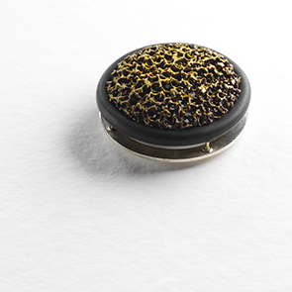 Moss Brooch
1 做品名稱(中英文)： Moss Brooch, 2014
材質materials (中英文) | Copper, Bronze, White Metal, Stainless Steel and Enamel
產品尺寸size | Approx 45mm Diameter
產品簡介(中英文)description | Brooch

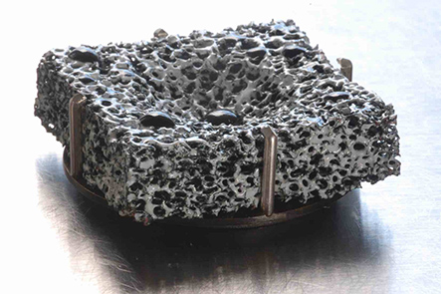
Heat Exchange
2 做品名稱(中英文)：Heat Exchange Brooch 2012
材質materials (中英文) | Copper, Bronze, White Metal, Stainless Steel and Enamel
產品尺寸size | 30mm x 30 x 8mm
產品簡介(中英文)description | Brooch

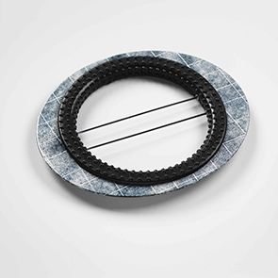
Traces Black

- 做品名稱(中英文)： Traces Black
材質materials (中英文) | enamel, steel + rubber
產品尺寸size | Approx 110 x 95 x 4 mm
產品簡介(中英文)description | Brooch
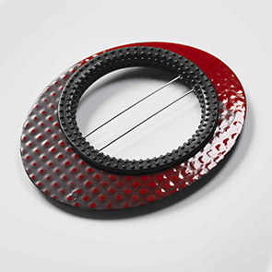Traces Red
- 做品名稱(中英文)： Traces Red
材質materials (中英文) | enamel, steel + rubber
產品尺寸size | Approx 110 x 95 x 4 mm
產品簡介(中英文)description | Brooch

