With Other Eyes
Exhibition list

Name | Stephen Bottomley
Number of photos sent | 6
Number of pieces sent | 7
Details of pieces/ work
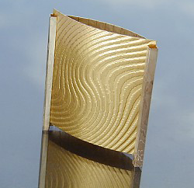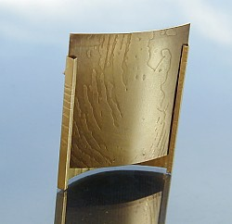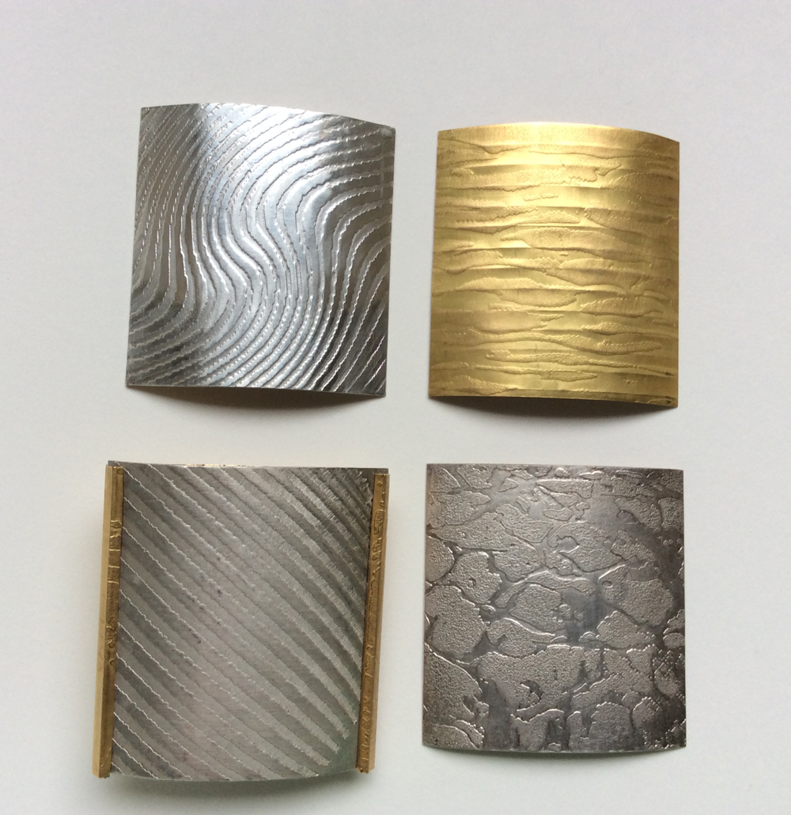
Ref  Title of piece | SB1  Frame Brooch
No of pieces | 1 (with four changeable panels/screens)
Description | 1 x Brooch and 4 panels
Materials | Precious yellow metal with precious yellow & white metal changeable panels / screens
Technique/s used | Scoring, folding, embossing, digital image transfer
Dimensions | 40 x 45 x 16 mm
Date made | 1998
Insurance value | £2000
Artist’s Price | £1500
R.Retail Price | £3000
Photo supplied?  Photographer credit | Yes  Artist

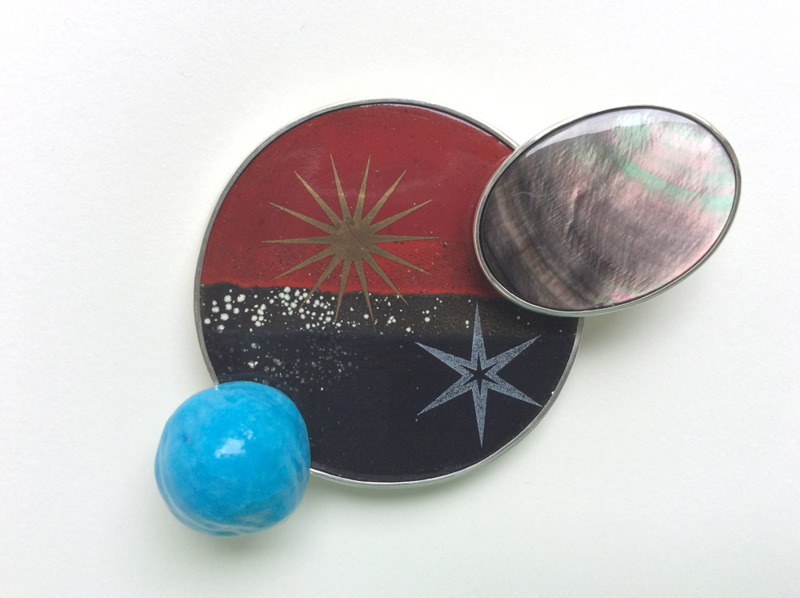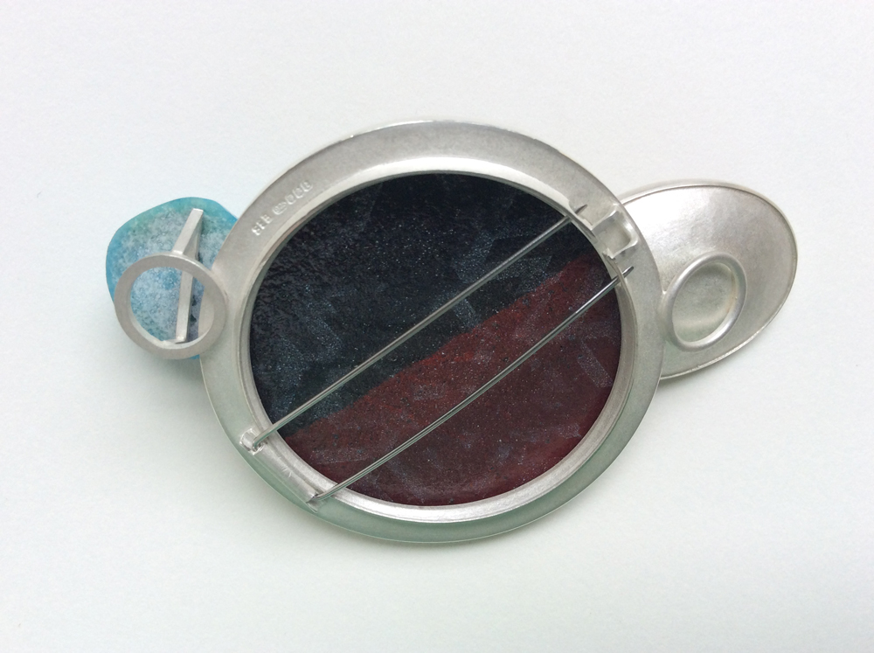
Ref  Title of piece | SB2  Space
No of pieces | 1
Description | Brooch
Materials | Silver, enamel, steel, faience, mother-of-pearl
Technique/s used | Enamelling, Egyptian paste making and stone setting
Dimensions | 46mm x 73mm x 13mm
Date made | 2018
Insurance value | £900
Artist’s Price | £700
R.Retail price | £1400
Photographer credit | Yes, Artist

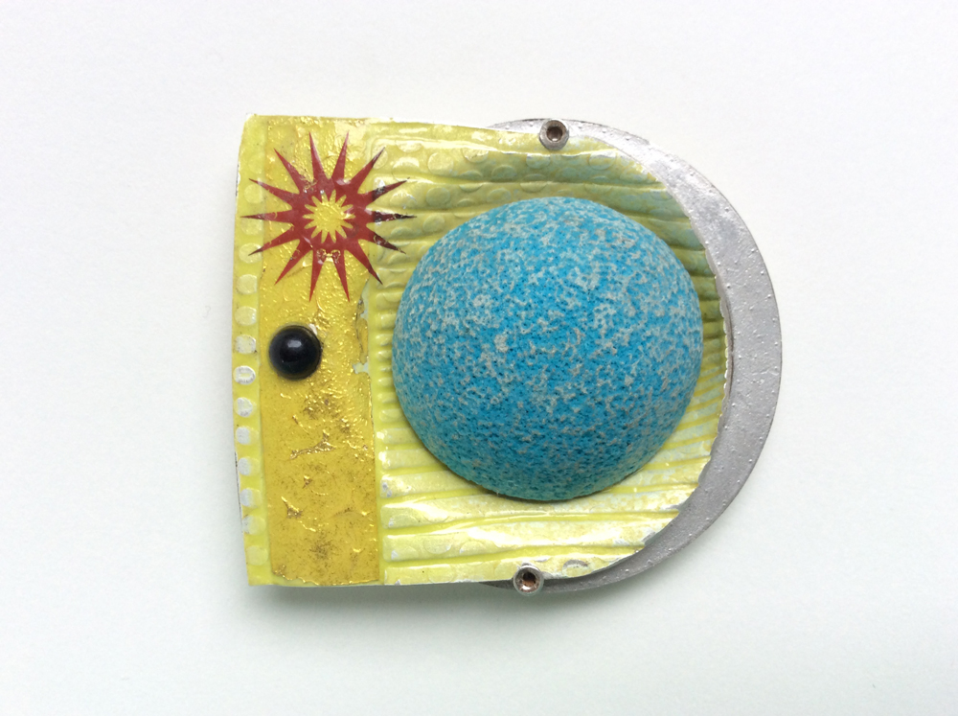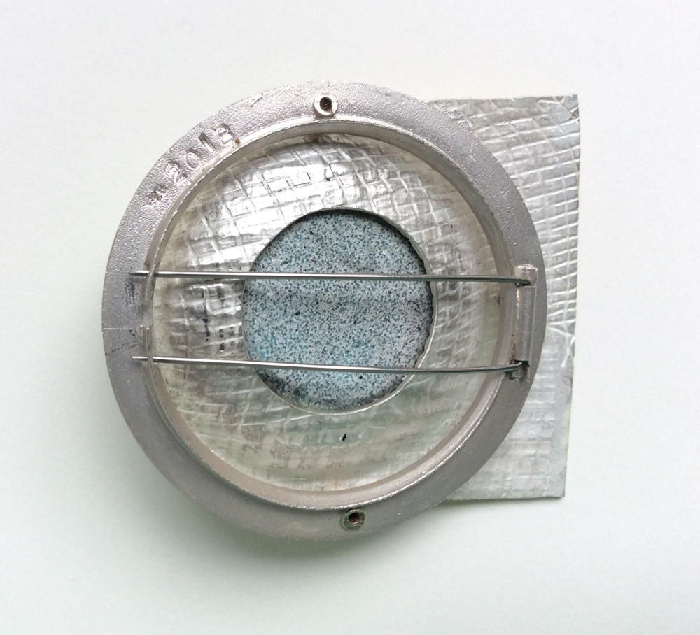
Title of piece | Pulp
No of Pieces | 1
Description | Brooch
Materials | Silver, enamel, faience and stone
Technique/s used | Enamelling, Egyptian paste making and stone setting
Dimensions | 50 x 47 x 15mm
Date made | 2018
Insurance value | £600
Artist’s Price | £450
R.Retail Price | £900
Photographer credit | Yes, Artist

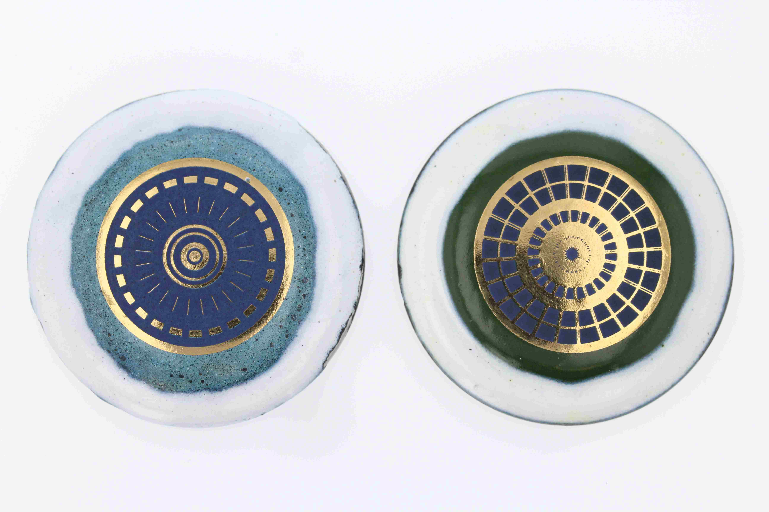
Title of piece | Watcher(s)
No of pieces | 4
Description | Brooch
Materials | Enamelled Steel re-cycled watch cases with 22K gold image
Technique/s used | Enamelling
Dimensions | 42mm Diam x 6mm depth
Date made | 2018
Insurance value | £100
Artist’s Price | £ 85
R.Retail Price | £170
Photographer credit | Yes , Artist

