Note of work to be delivered for ACJ 20:20 Exhibition

 | Title | Year | Materials | Size | Insurance value  (Not For Sale) | Notes
1 | 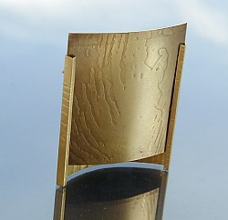 |  |  |  |  | Below: examples of other panels and back and front view of brooch (middle of two rows)
 |  |  |  |  |  | 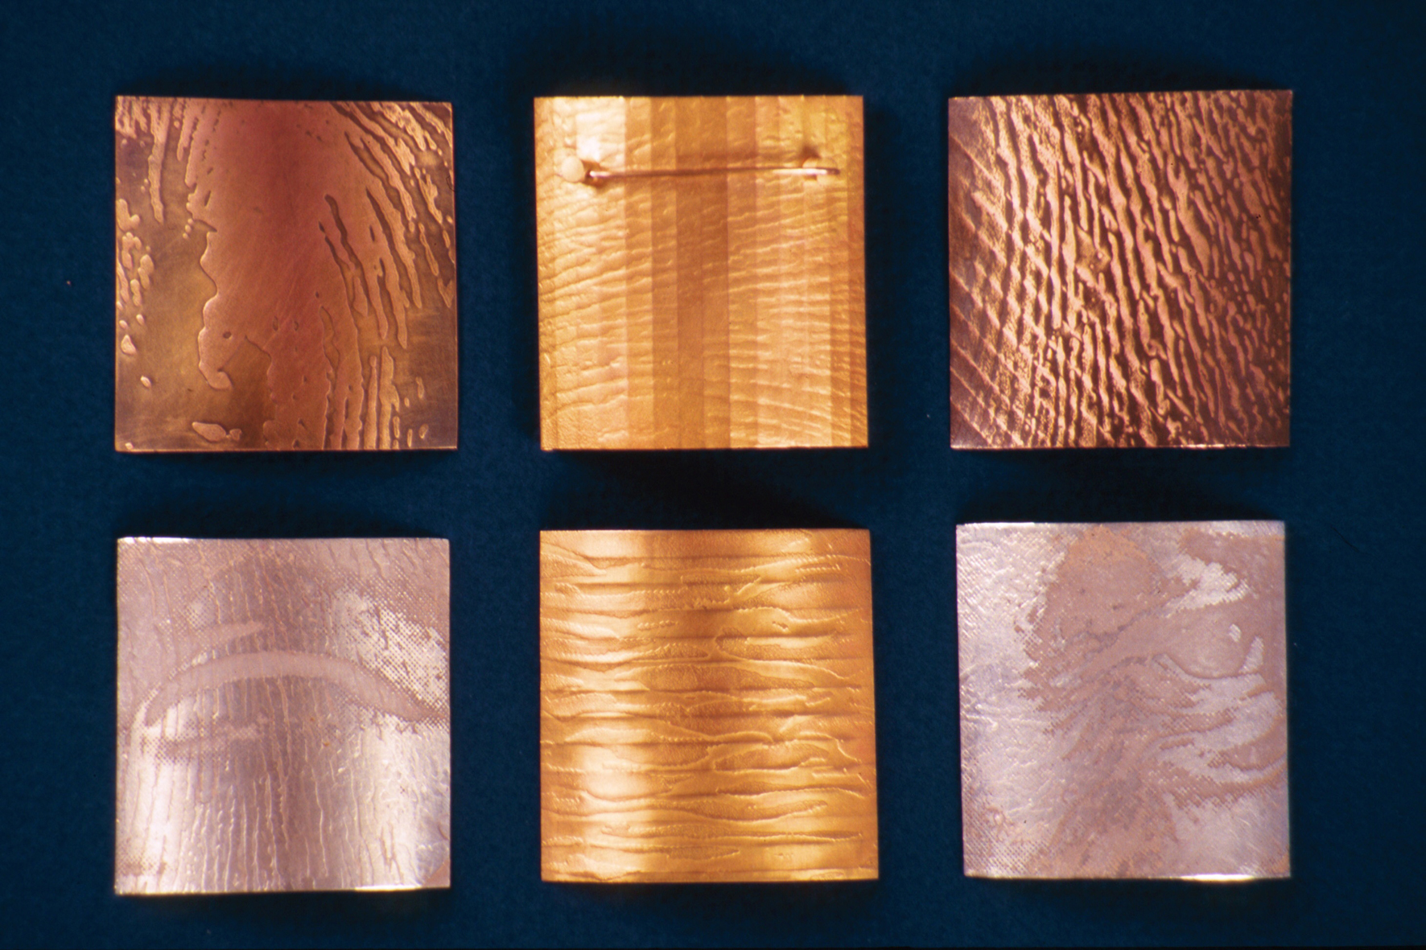
 | Frame Brooch  (+ 3 panels:  Maelström  Twister  Stripes) | 1998 | Precious yellow metal | 40 x 45 x 16 mm | £2500 | N.B  Please slide Interchangeable precious yellow metal panels in carefully, singly only. Only loadable from the top end of the brooch.
2 | 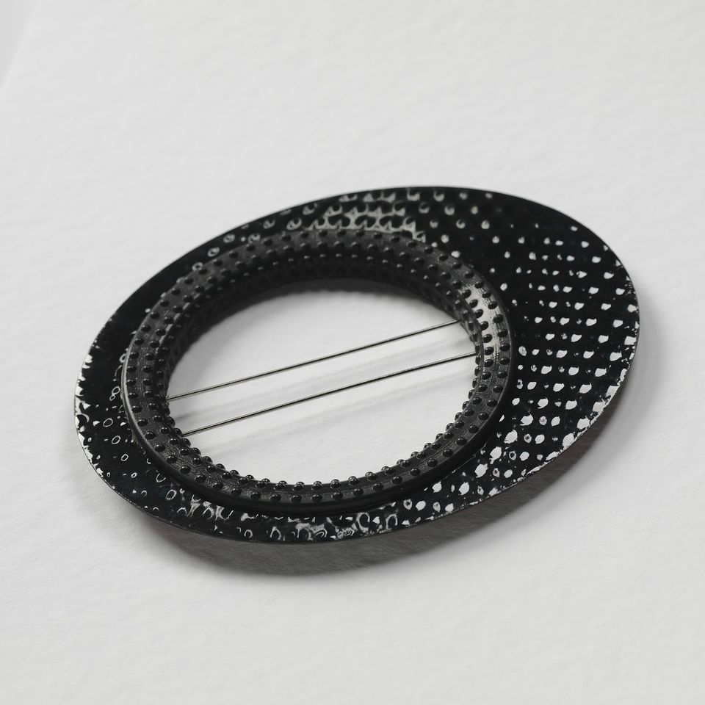
 | Black Traces.  Brooch | 2015 | enamel, steel and rubber | 110 x 95 x 4 mm | £500 | Please handle with care, enamel is a glass, ceramic and metal mix can be brittle and prone to chips if miss-handled.

