IRAQ: LEST WE FORGET | Lily Hamourtziadou
Posted on December 20, 2016 by globalfaultlines

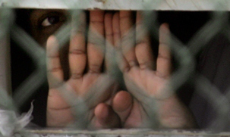
‘A soldier of the Great War, known unto God’, read some headstones. So many have died unidentified in two world wars and many other conflicts, revolutions, revolts and raids. In all the ways we humans find to kill each other, there are always victims who die nameless and remain so. They often become part of a number, their small un-named contribution to a large figure highlighting the devastating loss of life.
The Unknown Warrior in Westminster Abbey is a memorial to the dead of World War One, particularly those who have no known grave. To die nameless seems so much sadder, so much worse than dying named, known and acknowledged. Anonymity in death almost suggests the dead was not only unidentified, but also unacknowledged and unloved. There is a loneliness in a death that goes undocumented, or remains anonymous. The death of a ‘Jane Doe’, or a ‘John Doe’ can trigger decades-long investigations, for to be able to identify a corpse is an important aspect of honouring the dead.
In Iraq thousands are buried in mass graves, never identified, and thousands die every year in acts of terror, acts of war, acts of fanaticism, imperialism and the struggle for power. Many of them are and remain un-named, unknown, at least to those of us not personally connected to them. This year’s victims were no exception. Of the nearly 16,000 civilians who perished in violence in Iraq, very few were reported as the individuals they were in life, with their name, age, occupation and other details about them that made them who they were, the unique life lost.
But a few were named and recorded as more than numbers, their dignity somewhat restored in their remembrance, after their inglorious deaths. Let us not forget those innocents. Let each month bear witness to at least one of them, remembered in their untimely deaths as the rights-bearing, vulnerable, ‘worlds entire’ they were.
On January 1, Nibras Ahmed Al-Muhamy was killed in an air strike in Hay Al-Sina’a, in Heet. A ‘precision’ air strike that was not meant to kill civilians.
(https://www.iraqbodycount.org/database/incidents/d11630b)
Stop all the clocks, cut off the telephone
Farouk Abdel-Razzaq al-Hamdani, an appeal judge, was executed in
Athba village, south of Mosul, on February 24, after many months of imprisonment by ISIS members.
(https://www.iraqbodycount.org/database/incidents/a3855)
Prevent the dog from barking with a juicy bone
On March 25 a suicide bomber exploded near Hay al-Shuhadaa stadium in
Asriyah village, Alexandria, killing 40 people, many of them young boys. Among the victims were,
Mohaned Khazaal (10)
Walid Adil Abed (16)
Bilal al-Janabi (13)
Karrar Abbas Ali al-Idani (13)
Saifullah al-Ansari (16)
Ahmed Aasim Abdulkhuder (10)
(https://www.iraqbodycount.org/database/incidents/a4139)
Silence the pianos and with muffled drum
Bring out the coffin, let the mourners come
On April 29 Dr Ziad Kalaf, a university professor, was killed in an air strike in Mosul.
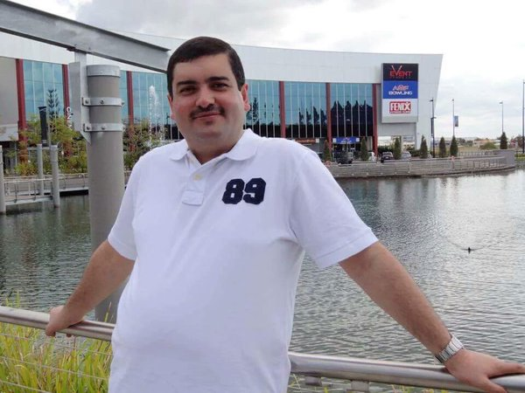
(https://www.iraqbodycount.org/database/incidents/a4558)
Let aeroplanes circle moaning overhead
Scribbling on the sky the message He Is Dead
Salman Ali, an employee at the Ministry of Education, was shot dead on his way home in central Baquba, on May 25.
(https://www.iraqbodycount.org/database/incidents/a4569)
Put crepe bows round the white necks of the public doves,
Let the traffic policemen wear black cotton gloves
On June 20 Ahmed Mohammed Humaidi, editor-in-chief of the weekly Al-Madeena newspaper, was found tortured and burnt to death in the Kooka Jal area, along the Kirkuk-Erbil road.
(https://www.iraqbodycount.org/database/incidents/a4927)
He was my North, my South, my East and West,
My working week and my Sunday rest
Saif Ali al-Hamdani, an engineer, was killed in Dibis on July 9. “A source at the Interior Ministry said that an employee of the Ministry of Electricity, was killed by unidentified armed attack, west of Kirkuk,” reported AFP, ” while returning to his home after the end of his work.”
(https://www.iraqbodycount.org/database/incidents/d12230)
My noon, my midnight, my talk, my song
Widad Hussein Ali (28) was a Kurdish journalist, a Reuters reporter with alleged ties to the Kurdistan Workers Party. He was abducted and tortured to death in August in Dohuk, his body found on August 13 on the side of a road. “Mr. Ali’s body displayed serious wounds and bruising, in addition to severe injuries to his head, which strongly suggested that Mr Ali was subjected to severe beatings and other forms of ill-treatment that resulted in his death”, reported Mehr News (‘UN official condemns killing of Kurdish journalist’, August 16).
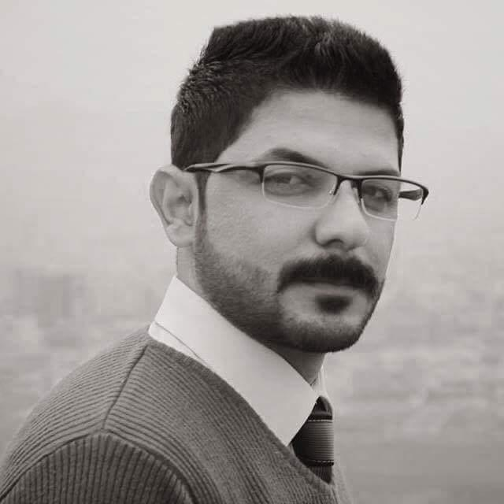
(https://www.iraqbodycount.org/database/incidents/a5216)
I thought that love would last for ever: I was wrong
On September 16 four members of two families were killed in an air strike near Haji Osman mosque, in the Al-Marhala al-Ola area in Rawa. Two of them were young boys. Brothers Walid Khaled Hammad Ngelan and Hamed Khaled Hammad Ngelan were killed with their father, Khaled Hammad Ngelan.
(https://www.iraqbodycount.org/database/incidents/d12597)
The stars are not wanted now: put out every one
On October 25 Yasin al-Obeidi, university professor at the Technical Academy of Kirkuk, was shot dead in south Kirkuk.
(https://www.iraqbodycount.org/database/incidents/d12724)
Pack up the moon and dismantle the sun
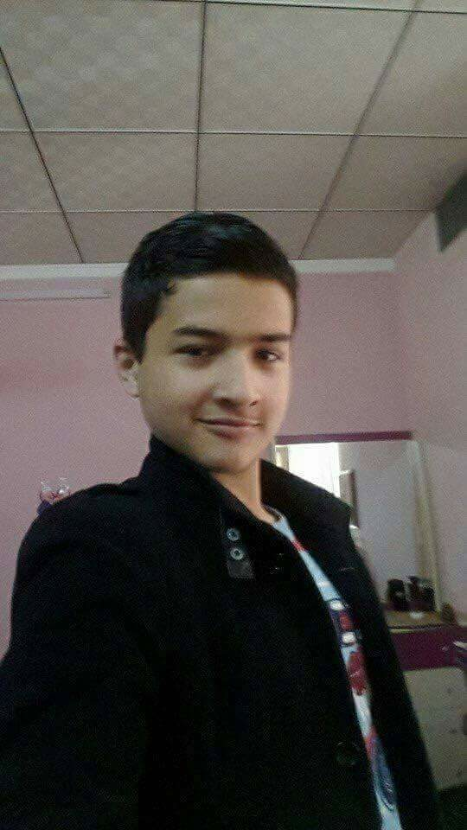
Four-year-old Laila Raed Saad was kidnapped, tortured and murdered, on November 14, her small body publicly displayed in Kirkuk.
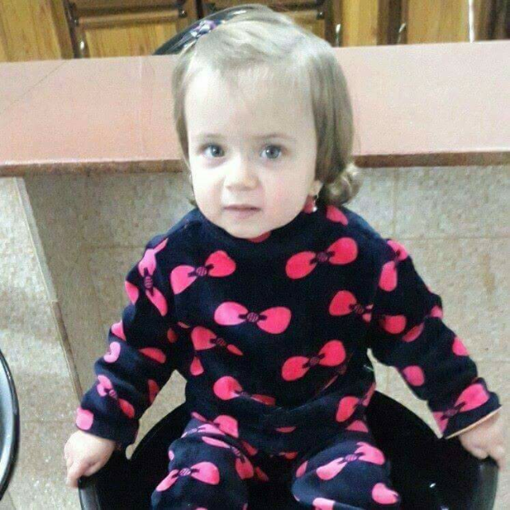
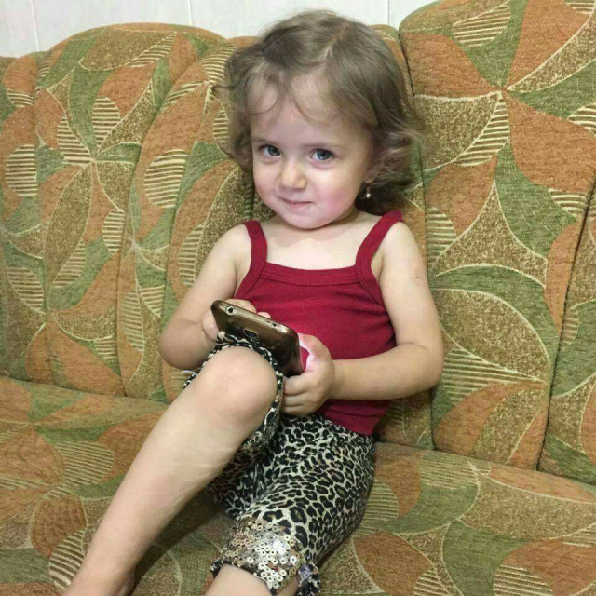
Pour away the ocean and sweep up the wood
An air strike took the lives of an entire extended family on December 11.
Haj Mumtaz Abdullah Majid, Ammar Mumtaz Abdullah, wife Lina, children Ahmed and Abdul Rahman, Mumtaz Mustafa Abdullah and daughter Ghani Mumtaz, and young Waleed (child), all members of the same family, were killed by an air strike in Al-Falah neighbourhood in Mosul.
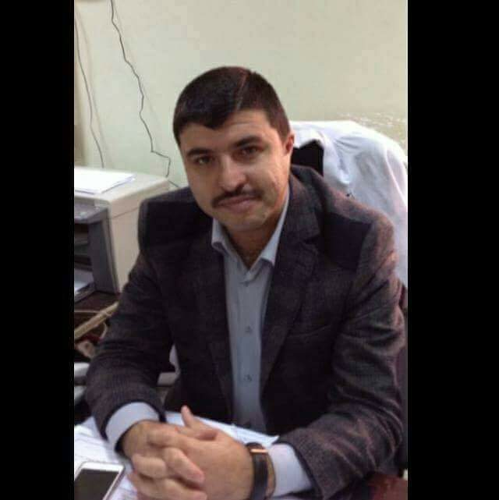
For nothing now can ever come to any good

