This is the accepted version of the manuscript:
Howard, C. J., Boulton, H., Bedwell, S. A., Boatman, C. A., Roberts, K. L., & Mitra, S. (in press). Low frequency repetitive transcranial magnetic stimulation to right parietal cortex disrupts perception of briefly presented stimuli. Perception

Low frequency repetitive transcranial magnetic stimulation to right parietal cortex disrupts perception of briefly presented stimuli

Christina J. Howard¹, Hayley Boulton¹, Stacey A. Bedwell², Charlotte A. Boatman¹, Kate L. Roberts¹ and Suvobrata Mitra¹
Nottingham Trent University¹, Birmingham City University²

Right parietal cortex has recently been linked to the temporal resolution of attention. We therefore sought to investigate whether disruption to right parietal cortex would affect attention to visual stimuli presented for brief durations. Participants performed a visual discrimination task before and after 10 minutes rTMS (1Hz) to right or central parietal cortex as well as 20 minutes after the second block. Participants reported the spatial frequency of a masked Gabor patch presented for a brief duration of 60, 120 or 240ms. We calculated error magnitudes by comparing accuracy to a guessing model. We then compared error magnitudes to blocks with no stimulation, producing a measure of baselined performance. Baselined performance was poorer at longer stimulus durations after right parietal than central parietal stimulation, suggesting that right parietal cortex is involved in attention to briefly presented stimuli, particularly in situations where rapid accumulation of visual evidence is needed.

Introduction

Parietal cortex function has traditionally been linked to the control of spatial attention, with damage to this area particularly in the right hemisphere often resulting in hemispatial neglect (Vallar and Perani 1986; Driver and Mattingley 1998). More recently, right parietal cortex has been described as underlying a ‘when’ pathway (Battelli et al., 2007). Consistent with this view, transcranial magnetic stimulation (TMS) over right posterior parietal cortex (PPC) has been shown to affect auditory duration estimation (Alexander et al., 2005), right inferior parietal cortex is recruited in time interval encoding (Rao et al., 2001) and patients with damage to right inferior parietal cortex are impaired at judging time intervals (Danckert et al. (2007).

Not only is parietal cortex, particularly in the right hemisphere, important for attention to moments and intervals in time, but it also appears to be important for judging the order of events. Rorden et al. (1997) showed that patients with right parietal damage showed impaired performance in temporal order judgements (TOJ) and Roberts et al. (2012) reported inferior parietal and temporoparietal involvement in TOJ tasks, especially in the right hemisphere. Similarly, Woo et al. (2009) showed that TMS to right PPC caused impairments in TOJ tasks whereas TMS to left PPC had no effect. Relatedly, Agosta et al. (2017) demonstrated that patients with damage to right parietal cortex were impaired on simultaneity judgements. Their results implicated the right temporoparietal junction (TPJ) as critical for this task since TMS applied here in healthy participants produced a similar impairment. Tyler, Contò and Battelli (2018) also showed that artificially facilitating TPJ activity using high frequency transcranial random noise stimulation (hf TRNS) increased TOJ performance particularly in left visual field, related to right TPJ function. Related to TOJ tasks, Battelli et al. (2003) showed that patients with right parietal damage had a deficit in flicker asynchrony detection, a task requiring attention to the relative timing of stimulus onsets and offsets.

Consistent with these emerging findings, Howard et al. (2016) showed that patients with parietal damage were impaired on a task involving high temporal resolution of attention, requiring reporting the features of briefly presented stimuli at different temporal frequencies. In a somewhat similar task using rapid serial visual presentation stimuli it has also been shown that patients with damage to inferior parietal lobe exhibit unusually severe attentional blink effects (Husain et al., 1997; Shapiro et al. 2002). Relatedly, Battelli et al. (2001) reported that patients with right parietal lesions showed deficits in apparent motion perception, a function which requires the linking of discrete events that occur close in time to one another through a common motion percept. Therefore there is a growing body of evidence that parietal cortex, particularly in right hemisphere and more inferior and posterior areas is involved in temporal aspects of attention. We therefore sought to investigate whether disruption to right parietal cortex in comparison to central parietal cortex would affect attention to briefly presented visual stimuli in healthy adults.

We first measured the speed with which healthy participants could accumulate visual information, using Gabor patches with variable spatial period as used by Howard et al. (2016). We then applied inhibitory rTMS either to right parietal or central parietal cortex to assess the effect on performance. In the patient study of Howard and colleagues (Howard et al., 2016), individuals with parietal damage were impaired at selecting temporal intervals at relatively fine timescales and showed recovery of performance when coarser time intervals were selected. However, at the fastest rate of change, these stimuli were still relatively slow at 5 Hz (200ms per stimulus presentation). We reasoned that, if right parietal cortex in particular is involved in setting the speed of visual information accrual or the finest timescale at which information can be sampled by attention, then we should see an effect of TMS to right cortex in these discrimination tasks with briefly presented stimuli. If right parietal cortex is purely involved in the speed of visual information accrual, then we should see more effect at the longer durations, since by definition, effects of speed build up over time. At the very shortest durations, even normal performance without disruption effects will be limited by the temporal resolution of attention, often integrating stimuli over minimum periods of around 100ms (e.g. Holcombe, 2009). Therefore we may also not expect to see effects at the very shortest durations if disruption after TMS to right parietal cortex particularly reduces the temporal resolution of attention.

Method

Participants
Participants were 42 (15 male) individuals (18-35 years old, mean =23 years, SD=5.1 years) recruited from a paid participant panel and undergraduate students from Nottingham Trent University. Individuals were paid £30 or given course credits for their time. In accordance with Rossi, Hallett, Rossini and Pascual-Leone (2009), all participants were screened for exclusionary criteria before participating. All participants reported normal or corrected-to-normal vision and 40 identified as right handed.

TMS Protocol
Participants took part in testing sessions on two separate days. We administered rTMS using the Magstim Rapid2 through a 70mm double air film coil placed tangentially over the scalp and guided by Visor2 neuro-navigation software. Participants sat in a Rogue Research chair with the coil positioned by the articulating support arm and steadied by hand if required. Upon giving consent, participants were given a brief demonstration of single pulse TMS on their arm at 65% output. The task was explained and at least 10 practice trials at each presentation duration were given, followed by ten-minutes rest before the experiment commenced.

On each day, participants completed three blocks of trials (Figure 1). First, participants completed a pre-rTMS block (block 1). Offline rTMS stimulation was then applied for 10 minutes (site of stimulation on the first day was counterbalanced between participants), and the post-rTMS (block 2) trials immediately followed this. After the post-rTMS block, there was a washout period of 20 minutes, after which participants completed the follow up (block 3) trials.

Immediately preceding block 2, participants received 10 minutes of 1 Hz rTMS (total 600 pulses). The stimulator output was set at 65% maximum capacity in line with similar research (e.g. Dormal et al., 2008). The ANT Neuro Visor2 XT neuronavigation system was used to digitise a model of the participant’s head and a standard MRI dataset was mapped to the model. Based on this mapping, rTMS was delivered to the Talairach co-ordinates (from Koessler et al., 2009) for Pz (central parietal) or P4 (right parietal) in the standard International 10-20 Electrode Placement EEG system (P4: x 44.2, y -65.8, z 42.7, Pz: x 0.7, y -69.3, z 56.9). Participants returned over 24 hours later to complete the second day of testing.

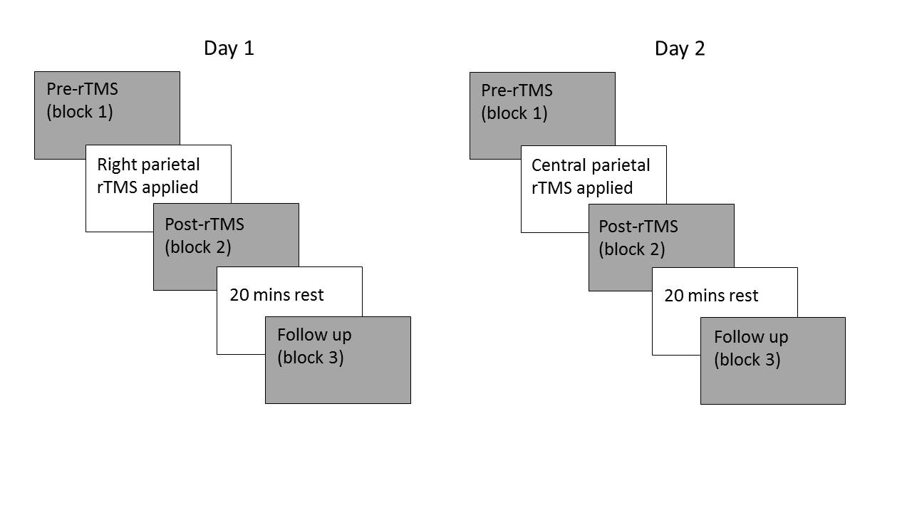
Figure 1: Schematic of the three blocks of trials (grey boxes) on the two testing days. In this example, the participant undertook right parietal stimulation on day 1 and central parietal stimulation on day 2.

Procedure
Each block comprised 276 trials with 92 trials at each of the three stimulus durations of 60ms, 120ms and 240ms. Within each block there were two 30 second breaks after the 92nd and 184th trials.Participants reported the spatial frequency of a briefly presented and subsequently masked Gabor patch. Participants viewed stimuli on a 19.5 inch (1024x768 pixels) CRT screen refreshing at 85 Hz. After an inter-trial interval of 1000ms (see Figure 2) the target Gabor patch (Gaussian envelope σ=1.1°, from 0.02cd/m² to: 120.00cd/m² ) with spatial period 0.4, 0.8, 1.2, or 1.6dpc was then presented for either 60, 120 or 240ms. On the next frame a central plaid mask was presented with four response options along the vertical midline of the screen. These four possible response alternatives possessed spatial periods of 0.4 (uppermost), 0.8, 1.2, and 1.6 (lowest) dpc. Participants pressed ‘1’, ‘2’, ‘3’ or ‘4’ keys to indicate that the uppermost, second from top, second from lowest or lowest Gabor, respectively, matched the target Gabor.

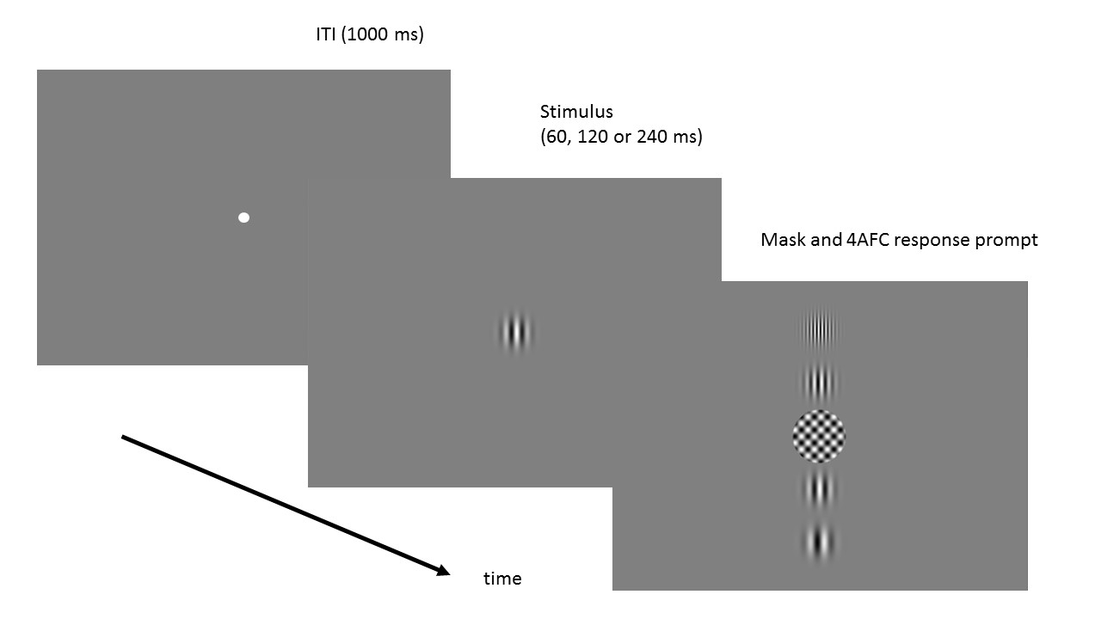
Figure 2: Typical trial timeline. Here, the participant is presented with a patch with spatial period 1.2dpc corresponding to the path third from the top in the test array.

A pilot study (15 participants, 6 male, 18-35, mean =22 years, SD = 3.9) was conducted to identify appropriate stimulus durations using an identical procedure with the following differences: there were 240 trials per participant, 40 trials at each of 6 durations (35, 60, 105, 140, 200 and 250ms) presented in a quasi-randomised order. In this study we also piloted the TMS procedure but these data are not included here.

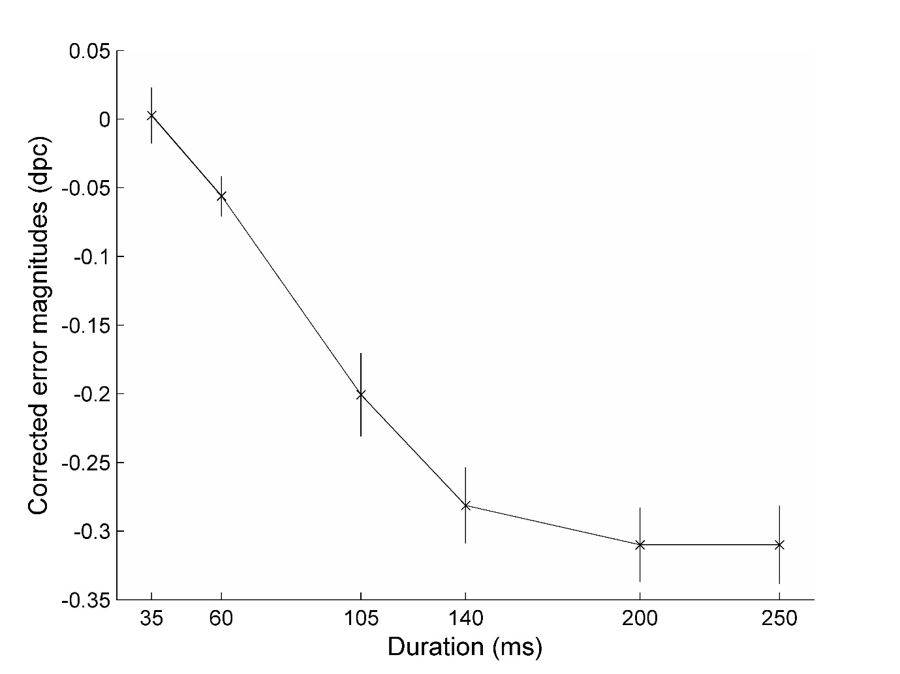
Figure 3: pilot performance at the different presentation durations. See Results section for description of calculation of corrected error magnitudes.

Pilot data (Figure 3) show that by around 50ms, performance appears to have deviated from the guessing model and reaches asymptote by around 200ms. We used this to select three presentation durations for the main experiment: one value that should be relatively near to the departure from guessing, one in the centre of the performance range and one at a long duration where under normal conditions, maximum performance should be reached. Interestingly, asymptotic performance appears to be around 200ms indicating temporal integration over a window of approximately 200ms, consistent with previous work for continuously monitoring spatial periods (Howard & Holcombe, 2008).

Results
On every trial, we calculated the error magnitude, which is the difference between the correct spatial period and the reported spatial period. We ran a guessing simulation in which one or other of the two central spatial periods are selected randomly on every trial and compared to the correct answer on that trial. We then calculated the magnitude of errors for this guessing model and compared actual performance with this guessing model (see Table 1), producing corrected error magnitudes (as per Howard et al., 2016). Here, zero indicates responses predicted from guessing, and negative values indicate responses for which the actual error magnitudes are smaller than those predicted from the guessing model.

Duration | 60ms | 120ms | 240ms
Day of right parietal stimulation
Pre-rTMS (block 1) | -0.0679  (SD=0.0983) | -0.2811  (SD=0.0616) | -0.3256  (SD=0.0537)
Post-rTMS (block 2) | -0.0904  (SD=0.0792) | -0.2683  (SD=0.0801) | -0.3002  (SD=0.0890)
Follow up (block 3) | -0.0917  (SD=0.0981) | -0.2760  (SD=0.0612) | -0.3321  (SD=0.0525)
Day of central parietal stimulation
Pre-rTMS (block 1) | -0.0671  (SD=0.1124) | -0.2534  (SD=0.0975) | -0.3215  (SD=0.0567)
Post-rTMS (block 2) | -0.0841  (SD=0.1161) | -0.2634  (SD=0.0778) | -0.3246  (SD=0.0630)
Follow up (block 3) | -0.0816  (SD=0.1160) | -0.2708  (SD=0.0652) | -0.3236  (SD=0.0410)

Table 1: mean corrected error magnitudes (dpc) in each block

To calculate baselined error magnitudes, we subtracted the corrected error magnitudes for post-rTMS trials (block 2) from pre-rTMS trials (block 1) and as another comparison, we subtracted block 2 error magnitudes from those produced in follow up trials (block 3) (see Figure 4). Comparing block 2 with block 1, a 2 (site: right parietal, central parietal) by 3 (duration: 60, 120, 240ms) ANOVA showed no main effect of stimulation site (F(1,41)=2.93, p=0.09), a main effect of duration (F(1.50, 61.56)=4.05, p=0.03) and a significant interaction between stimulation site and stimulus duration (F(2,82)=3.71, p=0.03). Critically, this interaction shows that the effect of site is exaggerated for slower presentation durations. Post-hoc comparisons did not survive a conservative threshold of p=0.05/3=0.017 (this might have changed with greater statistical power, though it is not possible to determine this on the basis of the data presented here) but trended in this direction (60ms: p=0.501, 120ms: p=0.027* significant only prior to correction, 240ms: p=0.060).

Comparing blocks 2 and 3, there were no main effects of stimulation site (F(1,41)=0.53, p=0.47) or stimulus duration (F(1.50, 61.56)=0.89, p=0.42) and no interaction (F(2,82)=1.87, p=0.16). To examine possible TMS carryover effects in block 3, we compared performance in blocks 2 and 3, in both cases baselining relative to pre-TMS (block 1) performance in a 2 (site: right parietal, central parietal) by 3 (duration: 60, 120, 240ms) by 2 (block: 2, 3) ANOVA, producing a main effect of duration (F(2,82)=3.54, p=0.03) but not of block or site (p>=0.08). Interactions were not significant (p>= 0.20) except for the significant interaction between site and duration (F(2,82)=5.61, p<0.01), again showing an exaggerated effect of site for slower presentations.

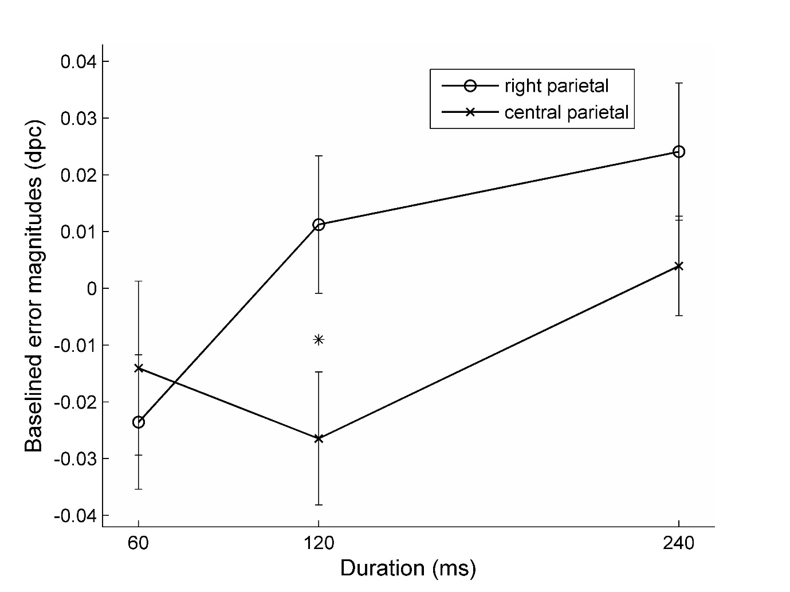

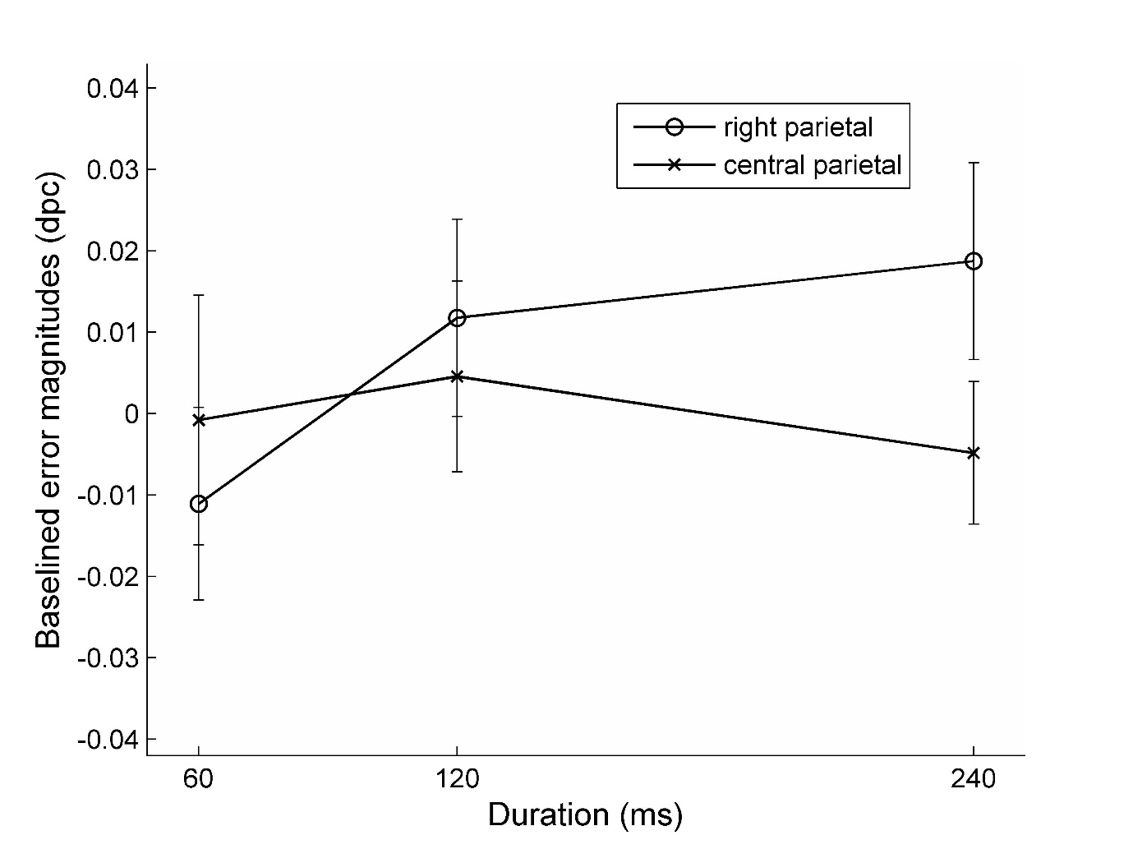
Figure 4: Baselined error magnitudes comparing block 2 performance either with block 1 (upper panel) or block 3 (lower panel). Error bars indicate standard errors.

Discussion
The interaction between TMS stimulation site and stimulus duration indicates that right parietal cortex is important for the processing of these briefly presented stimuli. In particular, the difference arises at longer durations, showing that right parietal cortex function enables the sustained improvement in performance normally seen as the stimulus duration is increased. In other words, the accumulation of visual information under central stimulation is greater for longer stimulus presentations than that seen with right stimulation. This is consistent with a reduction in the benefit of information accrual over time when right parietal function is inhibited. Speed of information accrual has been shown to be sensitive to several factors including the presence or absence of distractors (Kent, Howard & Gilchrist, 2012) and set size (Guest et al., 2015). If visual information about the target stimulus is accrued more slowly, then this would lead to the pattern of performance we see here with little or no difference effects at the very shortest durations with an emerging difference at longer, though still brief (< quarter of a second), durations. These specific effects of right parietal stimulation are demonstrated here in comparison to central parietal stimulation and this is consistent with accumulating evidence that right parietal cortex plays a key role in temporal aspects of attention. Future work comparing disruption at right parietal sites to sites outside of parietal cortex or using sham stimulation would therefore be less stringent tests and may actually produce larger effects than those reported here, since our results represent the (conservative) difference between central parietal and right parietal involvement in temporal aspects of attention.

It seems possible that carryover effects were present in block 3 since inclusion of this block in the comparison with pre-TMS block 1 still produced an interaction between stimulation site and stimulus duration. Although previous work typically describes rTMS effect durations up to ~20 minutes (Sandrini, Umiltà & Rusconi, 2011), researchers often describe spacing their TMS conditions by an hour or more (e.g. Mansur et al, 2005) to avoid such carryover effects.

As expected, we also confirmed that healthy younger adults can perform the task at much shorter timescales than some patients with parietal lobe damage were able to in Howard et al. (2016). In this study, although healthy older adult controls could perform significantly better than chance at the shortest duration used (200ms), many patients could not perform above chance levels at this speed. Howard et al. (2016) suggested that some of these patients may have suffered with poor temporal resolution of attention since their performance recovered at slower presentation rates. This suggests a larger temporal integration window over which visual information could be accumulated. In the data presented here, inhibition of right parietal function may also have caused a longer temporal integration window, causing inappropriate visual integration of the target stimulus with the mask that immediately followed it. At shorter presentations, this may not show up since performance may be limited here by the normally operating limited temporal resolution of visual attention at around ~10 Hz (Holcombe, 2009). At longer durations above the normal limits of the attentional system, temporal selection can exclude the mask from the period over which visual information is integrated, thus aiding target discrimination. However, this selection is perhaps compromised after right parietal stimulation leading to poorer performance than we see after central parietal stimulation condition. Another possibility is that a change in visual information accrual speed causes a change in the size of the temporal integration window.

A role for parietal cortex in setting temporal resolution for perception is consistent with evidence that right parietal damage causes impairments in a flicker asynchrony perception (Battelli et al., 2003). Detecting that events are synchronous requires precise temporal registration of the timing of both events as well as the perceptual comparison between the two sets of timings. For this reason these data are also consistent with reports of parietal involvement in temporal order judgements (e.g., Rorden et al. 1997; Baylis et al. 2002; Davis et al. 2009; Roberts et al., 2012; Snyder & Chatterjee, 2004; Woo et al. 2009) especially in right parietal cortex.

Parietal function has also been linked to wider attentional phenomena such as the attentional blink (AB) which is commonly observed when observers attempt to report two targets occurring in quick succession in a rapid serial visual presentation (RSVP) stream. Parietal damage can result in an exaggerated attentional blink (Husain et al., 1997) and rTMS to right PPC appears to modify the AB (Cooper et al., 2004). Coull et al. (1996) found reported parietal activation for attention directed to items in a rapidly presented stream and suggested a role in sustained attention. Similarly, Rueckart and Grafman (1998) suggested that the fronto-parietal network is involved in attending to and detecting targets in a serial visual presentation. If parietal cortex particularly in right hemisphere is involved in setting the speed of visual information processing and the temporal windows within which visual information is integrated, then effects for rapid presentations of stimulus streams would be expected. Apparent motion displays also involve the integration of visual information over sequential time periods and therefore it is perhaps not surprising to see that right parietal cortex is involved in perceiving apparent motion effects (Battelli et al. 2001).

These findings suggest that right parietal cortex is involved in tasks requiring visual attention to briefly presented stimuli, in particular when this involves rapid accumulation of visual evidence. It is also consistent with a parietal locus for the setting of attentional temporal resolution, as previously suggested and with the idea of a “when” pathway for perception through the right parietal lobe (Battelli et al. 2007; 2008).

References
Agosta, S., Magnago, D., Tyler, S., Grossman, E., Galante, E., Ferraro, F., Mazzini, N., Miceli, G. & Battelli, L., (2017). The pivotal role of the right parietal lobe in temporal attention. Journal of Cognitive Neuroscience. 29 (5), 805-815.

Alexander, I., Cowey, A., & Walsh, V. (2005). The right parietal cortex and time perception: back to Critchley and the Zeitraffer phenomenon. Cognitive Neuropsychology, 22:306–315.

Battelli, L., Cavanagh, P., Intriligator, J., Tramo, M. J., Hénaff, M. A., Michèl, F., & Barton, J. J. (2001). Unilateral right parietal damage leads to bilateral deficit for high level motion. Neuron. 32:985–995.

Battelli, L., Cavanagh, P., Martini, P., & Barton, J. J. (2003). Bilateral deficits of transient visual attention in right parietal patients. Brain. 126:2164–2174.

Battelli, L., Pascual-Leone, A., & Cavanagh, P. (2007). The ‘when’ pathway of the right parietal lobe. Trends in Cognitive Science. 11(5):204–210.

Battelli, L., Walsh, V., Pascual-Leone, A., & Cavanagh, P. (2008). The ‘when’ parietal pathway explored by lesion studies. Current Opinion in Neurobiology. 18:120–126.

Baylis, G. C., Simon, S. L., Baylis, L. L., & Rorden, C. (2002). Visual extinction with double simultaneous stimulation: what is simultaneous? Neuropsychologia. 40:1027–1034.

Cooper, A. C. G., Humphreys, G. W., Hulleman, J., Praamstra, P., & Georgeson, M. (2004). Transcranial magnetic stimulation to right parietal cortex modifies the attentional blink. Experimental Brain Research. 155(1):24–29.

Coull, J. T., Frith, C. D., Frackowiak, R. S. J., & Grasby, P. M. (1996). A frontoparietal network for rapid visual information processing: a PET study of sustained attention and working memory. Neuropsychologia. 34:1085–1095.

Danckert, J., Ferber, S., Pun, C., Broderick, C., Striemer, C., Rock, S., & Stewart, D. (2007). Neglected time: impaired temporal perception of multisecond intervals in unilateral neglect. Journal of Cognitive Neuroscience. 19:1706–1720.

Davis, B., Christie, J., & Rorden, C. (2009). Temporal order judgments activate temporal parietal junction. Journal of Neuroscience. 29(10):3182–3188.

Dormal, V., Andres, M., & Pesenti, M. (2008). Dissociation of numerosity and duration processing in the left intraparietal sulcus: a transcranial magnetic stimulation study. Cortex, 44(4), 462-469.

Driver, J., & Mattingley, J. B. (1998). Parietal neglect and visual awareness. Nature Neuroscience. 1:17–22.

Guest, D., Howard, C. J., Brown, L. A., & Gleeson, H. (2015). Aging and the rate of visual information processing. Journal of Vision, 15(14):10, 1–25, doi:10.1167/15.14.10.

Holcombe, A. O. (2009). Seeing slow and seeing fast: two limits on perception. Trends in Cognitive Science. 13(5):216–221.

Howard, C. J., Bashir, N., Chechlacz, M., & Humphreys, G. W. (2016). Neural mechanisms of temporal resolution of attention. Cerebral Cortex, 26(7), 2952-2969.

Howard, C. J., & Holcombe, A. O. (2008). Tracking the changing features of multiple objects: Progressively poorer perceptual precision and progressively greater perceptual lag. Vision Research, 48(9), 1164-1180.

Husain, M., Shapiro, K., Martin J., & Kennard, C. (1997). Abnormal temporal dynamics of visual attention in spatial neglect patients. Nature. 385:154–156.

Kent, C., Howard, C. J., & Gilchrist, I. D. (2012). Distractors slow information accumulation in simple feature search. Journal of Vision, 12(1):13, 1–12.

Koessler, L., Maillard, L., Benhadid, A., Vignal, J. P., Felblinger, J., Vespignani, H., & Braun, M. (2009). Automated cortical projection of EEG sensors: anatomical correlation via the international 10–10 system. Neuroimage, 46(1), 64-72.

Mansur, C. G., Fregni, F., Boggio, P. S., Riberto, M., Gallucci-Neto, J., Santos, C. M., ... & Pascual-Leone, A. (2005). A sham stimulation-controlled trial of rTMS of the unaffected hemisphere in stroke patients. Neurology, 64(10), 1802-1804.

Rao, S. M., Mayer, A. R., & Harrington, D. L. (2001). The evolution of brain activation during temporal processing. Nature Neuroscience. 4: 317–323.

Roberts, K. L., Lau, J. K. L., Chechlacz, M., & Humphreys, G. W. (2012). Spatial and temporal attention deficits following brain injury: a neuroanatomical decomposition of the temporal order judgement task. Cognitive Neuropsychology. 29(4):300–324.

Rossi, S., Hallett, M., Rossini, P. M., & Pascual-Leone, A., (2009). The Safety of TMS Consensus Group. (2009). Safety, ethical considerations, and application guidelines for the use of transcranial magnetic stimulation in clinical practice and research. Clinical Neurophysiology, 120(12), 2008-2039.

Rueckart, L., & Grafman, J. (1998). Sustained attention deficits in patients with lesions of posterior cortex. Neuropsychologia. 36:653–660.

Rorden, C., Mattingley, J. B., Karnath, H-O., & Driver, J. (1997). Visual extinction and prior entry: impaired perception of temporal order with intact motion perception after unilateral parietal damage. Neuropsychologia. 35(4):421–433.

Sandrini, M., Umiltà, C., & Rusconi, E. (2011). The use of transcranial magnetic stimulation in cognitive neuroscience: a new synthesis of methodological issues. Neuroscience & Biobehavioral Reviews, 35(3), 516-536.

Shapiro, K., Hillstrom, A. P., & Husain, M. (2002). Control of visuotemporal attention by inferior parietal and superior temporal cortex. Current Biology. 12:1320–1325.

Snyder, J. J., & Chatterjee, A. (2004). Spatial-temporal anisometries following right parietal damage. Neuropsychologia. 42: 1703–1708.

Tyler, S. C., Contò, F., & Battelli, L. (2018). Rapid Improvement on a Temporal Attention Task within a Single Session of High-frequency Transcranial Random Noise Stimulation. Journal of Cognitive Neuroscience, 1-11.

Vallar, G., & Perani, D. (1986). The anatomy of unilateral neglect after right hemisphere stroke lesions. A clinical/CT-scan correlation study in man. Neuropsychologia. 24:609–622.

Woo, S. H., Kim, K. H., & Lee, K. M. (2009). The role of the right posterior parietal cortex in temporal order judgment. Brain and Cognition. 69:337–343.

