Curriculum planning and classroom music
Martin Fautley
Birmingham City University

The announcement that there is to be a working party looking into music teaching and learning in schools is very much to be welcomed. The announcement from the minister, Nick Gibb that he has asked “…a panel of musicians and educationalists to draw up a new model curriculum which will give a detailed year-by- year template for study” (Gibb, 2019) can only be for the good. I notice, however, that very few of the panel are school curriculum theorists, and so in this piece I would like to very politely, I hope, draw their attention to some matters of curriculum theory for classroom music teaching and learning which I hope will prove helpful; this is the spirit in which I am writing this piece, anyway!

One of the first things I would like to say is that in my own curriculum research thinking I have found the words of Rudyard Kipling quite helpful (Now I know Kipling is hardly the most politically correct of authors, so apologies!). These are:

I keep six honest serving-men
(They taught me all I knew);
Their names are What and Why and When
And How and Where and Who.
(Rudyard Kipling, The Elephant’s Child)

In particular I think that it is all too easy to start a curriculum planning group with the wrong one of Kipling’s ‘serving-men’, namely what. In fact this is so easy that we can often see whole KS2 and KS3 music curricula founded solely on the what of lesson planning, in other words on what the children and young people will do. Much harder, but much more profitable in the long term, is to start with why. This is especially important when the curriculum committee will be thinking about classroom music in schools. This may be an obvious thing to say, but I’ll say it anyway: Curriculum music at KS2 and KS3 is NOT only a pathway to instrumental music learning outside the classroom, it is a thing in itself, or Ding an sich, in the words of Kant. This does need stating at the outset, as one of the issues that can be problematic is to try and apply instrumental teaching and learning techniques to the classroom, this is a different thing. So start elsewhere!

Alongside why will be running the what question. The rookie error is to launch straight into what without considering the why, but also the where and who. One of the things we have known for many years in classroom music education is that a ‘one-size-fits-all’ actually doesn’t! It is here, in the overlapping of these questions that any music curriculum will run up against a highly problematic and contentious issue in classroom music education, namely hegemony. We have known for some year (e.g. Shepherd et al., 1977) that whose music matters to children and young people in our schools. In childhood and emerging adolescence music is often closely bound up with personal identity, and we need to think about that too. There is an existing literature on identities in music education, (Hargreaves & Marshall, 2003; Hargreaves et al., 2005a; Hargreaves et al., 2005b; MacDonald et al., 2002), and this may well be worth perusing.

It will be a category error to assume in classroom music a linearity of approach by all the children and young people in the class at the same time. One of the reasons that graded music exams such as those offered by Trinity College London, and the ABRSM work well is that they are predicated on a linearity of progression, but that this progression is individuated, in other words kids and adults take grade 3 when they are ready. Another aspect of the category error is to mistake syllabus for curriculum. An exam syllabus in instrumental music has considerable assessment backwash on the curriculum, but it is not itself the curriculum. (I’ll say more about assessment later!) Again, who, and where matter for this.

Another music curriculum issue that should arise is the difference between planning for doing and planning for learning. The former is really easy in music, for example, “they are going to sing a song”; yes ok, but what are they learning? “They’re learning to sing the song”; yes, but that’s a poor answer, what in particular are they learning in this song?

We have a particular view of understanding in music, where children and young people learn to do something by doing it (seems obvious, eh?) and show they understand it by being able to do it. This gives a cycle of activity as shown in this figure:

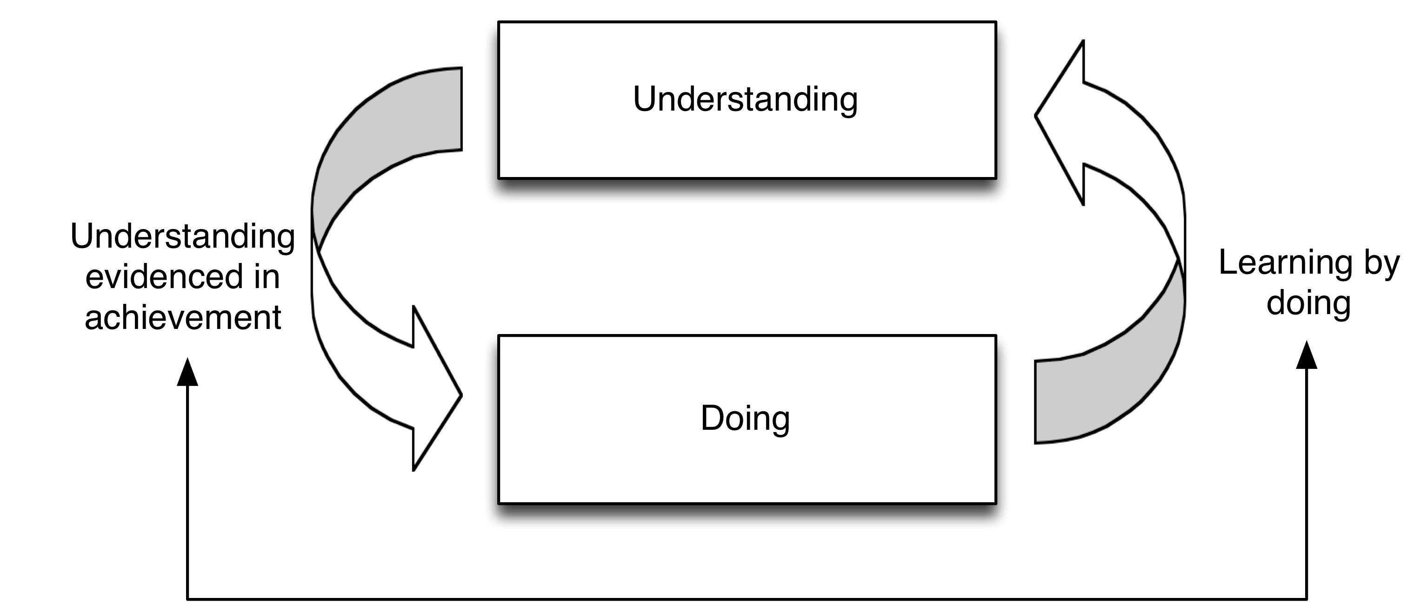

To explain, we wouldn’t book an oboe player for a gig on the basis of them being able to write a good essay on the history of the oboe, and likewise this is similar for classroom music – think about what it is that the children should learn, and then how you will know they have learned it – this is key to good assessment in music education (again, more on this later!). Writing about something is not a substitute for doing it.

Which takes us to another Kipling question, when. Rephrasing this when in music curriculum terms leads us to the words progress and progression. These have dual meanings in music education, to progress at something, and progression routes, e.g. school choir -> area choir -> borough choir. In the classroom progress needs thinking about carefully. What will be qualitatively different – we would hope better – at the end of a programme of study compared with the beginning? Simply more breadth is not enough, this has led to what I call the “Cook’s tour” of musical topics curriculum. Depth of learning is where strong engagement comes in curriculum music. Long term progress, over years, is difficult to plan for, but that is how KS2 and KS3 operate. They are not a six-week programme of whizz-bang music experiences, culminating in a great concert somewhere impressive, they are a slow-and-steady slog through developmental musical learning. What you do here (wherever here is) needs to build cumulatively so that it is in place for the future. This long term curriculum planning is hard, there are no two ways about it, and needs very careful thought.

Which brings us to knowledge. There is a long-standing row on social media concerning knowledge vs skills in education, I would like to think that we in music education are aware that both are needed for effective learning to take place. But to really think about knowledge in classroom music we need to think about knowledge types. One simple way of thinking about knowledge is to divide things into ‘knowing how’ and ‘knowing that’ (Ryle, 1949). This links closely to the notions of ‘declarative knowledge’ and ‘procedural knowledge’. Declarative knowledge, which can be spoken, relates to ‘knowing that’. Procedural knowledge is connected with ‘knowing how’, as procedures are often of the ‘how to’ type. In music education both types are needed for a single outcome. A non-clarinettist can learn the fingering for a F#, knowing that a certain combination of keys need to pressed – declarative knowledge – but be utterly unable to get a sound out of the instrument, as knowing how to get a sound out of the instrument is procedural knowledge.

Specific to music education, Swanwick and Taylor took the two types of knowledge under discussion, and added to them:

- Know how: .. to spell a word...to manipulate a musical instrument
- Knowing that:...2+7=9...Beethoven wrote nine symphonies
- Knowing him/her/it:.. a painting...specific knowledge of a musical work
- Knowing what’s what:...what we like...what we value. (Swanwick & Taylor, 1982 p.7)

This gives us a lot of knowledge types! This all matters, as the curriculum committee will be needing to think about all of these things.

Which brings us to another of Kipling’s serving-men, the one that doesn’t start with a w, the question of how. This provides yet another knowledge classification, and was described by Shulman, who differentiated between subject knowledge, and pedagogic content knowledge, or PCK. PCK relates specifically to teaching, and is

…most useful forms of representation of these ideas, the most powerful analogies, illustrations, examples, explanations, and demonstrations – in a word, the ways of representing and formulating the subject that make it comprehensible to others (Shulman, 1986 p.6). ‘

Pedagogical content knowledge also includes an understanding of what makes the learning of specific topics easy or difficult: the conceptions and preconceptions that students of different ages and backgrounds bring with them to the learning....’ (Shulman, 1993 p.85).

This will be yet another key issue to think about, especially at KS2, where we know that some primary teachers are not confident in teaching aspects of music. The curriculum committee will need to help these teachers with not only the what of music subject content, but the how of the PCK that they may need assistance with. This cannot automatically be assumed.

But linked to this too is the notion of epistemic ascent.

Epistemic ascent has been described as a developing mastery and expertise in stages through practical activity…and as a means of structuring concepts from higher to lower complexity in ascending pedagogical framing… (Anderson, 2019)

The reason for placing epistemic ascent here is that although it sounds as if it may be a complex academic thing, it is in fact really important, and especially so in music teaching and learning, although outside the field of curriculum theorists, tends to be very little talked about. For example, consider this extract:

It has for some time been a commonplace of curriculum design that subject knowledge amounts to much more than the amassing of propositions. A straightforward inference from this by now uncontroversial thought is that expertise in a subject involves practical knowledge concerning the management of and exploration of propositional relations, acquaintance with key objects, events, states and processes and, not least, acquaintance with practical procedures for gaining and validating new knowledge. (Winch, 2013)

This takes us back to an earlier point, that in order to be musical, children and young people have to make music, but do so in a logical sequence. A key problem in music education is actually a problem of epistemic ascent, and that is the issue of reading western musical staff notation.

One of Nick Gibb’s key focuses for this review is this statement:

I want every child to leave primary school able to read music, understanding sharps and flats, to have an understanding of the history of music, as well as having had the opportunity to sing and to play a musical instrument. (Gibb, 2019)

This has caused a bit of a furore on social media, but let us stop and consider what it means. To do this, let me assume that like me, you can’t speak Russian (apologies to those that can!). There’s a piece by Rachmaninov I like whose title is its first line:

Богородице Дево, радуйся

Now, were I to be presented with that, I would have no idea how to say (or sing) that, let alone what it means. But you can find plenty of Russian Cyrillic character charts online, and you can spell out the letters. Doing so, you find this is Bogoroditse Dyevo, raduisya. Indeed, industrious children could learn the Cyrillic characters off by heart, and spell them out one letter at a time. But ask them to say the words out loud, or, even more importantly, tell you what the words mean, and they won’t have a clue! But learning the letters off by heart might mean they can ‘read’ Russian. But can they? After all, they can neither read the whole word nor say what it means. OK, now do the same with this:

As with the Russian above, children can learn the letter names off by heart, and repeat those back; indeed, worksheets with many varieties of the C-A-B-B-A-G-E notes above were common at one time. But there is a flaw in this way of working, which is if children are given this:

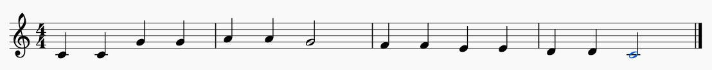

and can only tell the letter names, but not sing the song, or recognise “Twinkle twinkle” from the music, then can they be said to truly ‘read’ music? This is where the epistemic ascent issue comes in, in that we need to move from note naming to musical understanding.

Now, a lot of people say “music is a universal language”, personally, I don’t agree. To be technical, music lacks lexical indexation, you can’t say “can I have a cheese sandwich” in music, for example. But the epistemic ascent notational dichotomy we have been looking at means that for some educators knowledge of music notation needs to be taught to precede musicking, whereas for others it should be taught alongside, or after. This is the ‘sound before symbol’ argument. I am not going to open this can of worms much further, but I implore expert musicians everywhere not to confuse reading music, with note-naming, with being musical. In many cases those of us who do read music learned to do so alongside learning to play an instrument. In my case it was infant school, and the red “school recorder book 1”. My infant classmates and I learned recorder notes and their notation alongside each other. So please, music experts, think about the multimodal nature of musical learning, and epistemic ascent, and don’t confuse the one with the other.

Which brings me to my final point, that of assessment. This is, to bend Kipling a little, the question of how much. Now, in my assessment book (Fautley, 2010), I make a big deal out of the correct assessment question being not ‘what should I be assessing?’ but instead asking ‘who is the assessment for?’. And I will do that again now. I don’t want to be too politically controversial, but neoliberal thinking tends to want things to be ‘measurable’, and preferably simply (for which read ‘cheaply’) measured. And what is simpler and cheaper than a pencil-and-paper test? But caveat educator. Easy, and probably markable by a computer, would be the Russian letter names, or CABBAGE task from above. But is this musical? Does it tell us if the children and young people know what the music means? This aspect will need treating with great care by the expert panel, because any politician will want to be able to say “thanks to my initiative X% of children in school in school can now read music”. Beware of this, and remember Adrian Mole:

Got full marks in the geography test today. Yes, I am proud to report that I got twenty out of twenty! ... There is nothing I don’t know about the Norwegian leather industry (Townsend, 1982)

Does he really know everything there is to know on the Norwegian leather industry? In a similar vein does answering 10 questions on letter names and # and b signs mean a child can read music? Really?

My final point for the curriculum committee to think about is what some call the “if I were you” fallacy. You’re not them. You’re an expert pianist, guitarist, singer, whatever. We know that for a number of primary class teachers the thought of singing solo in front of their class will send them into paroxysms of fear, hatred, and loathing. Yes, sure, there will be many for whom this is not the case (including all the readers of this magazine, obviously!) but remember the frightened few. If the new curriculum plan involves complex activities that require extensive CPD for generalist classroom teachers to be able to deliver, then in some schools it might simply be ignored. Yet the “if I were you” fallacy means sometimes planners don’t see why what is not a problem for them, is for other people.

So, in conclusion, I wish the curriculum committee well, they have an enormous and very important task ahead of them, and being an academic maybe my final piece of advice (which is a bit “well he would say that wouldn’t he”), is please remember there is a huge history of classroom curriculum work, research, and publications in music teaching and learning over many, many years in England. Just because you may not know about it (why should you, it’s not in your daily remit) doesn’t mean that it doesn’t exist. As the lawyers say ignorantia juris non excusat, (ignorance of the law is no excuse), well, ignorance of music education’s extensive history and philosophy is not an excuse either. Please don’t start by trying to re-invent the wheel, school teachers throughout the land have perfectly serviceable cars with good, well-formed, circular wheels on them already. Your job is to make those cars more efficient!

REFERENCES
Anderson, A. (2019) 'Happy accidents? Music teacher perceptions of curriculum design at Key Stage 3 in the English Secondary School. Unpublished PhD Thesis'. Birmingham, Birmingham City University.
Fautley, M. (2010) Assessment in Music Education, Oxford, Oxford University Press.
Gibb, N. (2019) 'Forget Spotify: I want every child to leave primary school able to read music'. The Times, London.
Hargreaves, D. & Marshall, N. (2003) Developing identities in music education. Music Education Research, 5, 3, 263-273.
Hargreaves, D., Welch, G., Purves, R. & Marshall, N. (2005a) 'Effective teaching in secondary school music: teacher and pupil identities ESRC End of award report, Award R000223751. Executive Summary'.
Hargreaves, D. J., Welch, G., Purves, R. & Marshall, N. (2005b) 'Effective teaching in secondary school music: teacher and pupil identities. ESRC End of award report, Award R000223751'.
MacDonald, R., Hargreaves, D. & Miell, D. (2002) Musical identities, Oxford, Oxford University Press.
Ryle, G. (1949) The concept of mind, Harmondsworth, Penguin Books.
Shepherd, J., Virden, P., Vulliamy, G. & Wishart, T. (1977) Whose Music? A Sociology of Musical Languages, London: Transaction Books.
Shulman, L. (1993) 'Those who understand: Knowledge growth in teaching'. In Pollard, A. & Bourne, J. (Eds), Teaching and Learning in the Primary School, London, Routledge.
Shulman, L. S. (1986) Those who understand: knowledge growth in teaching. Educational Research Review, 57, 1, 4-14.
Swanwick, K. & Taylor, D. (1982) Discovering Music, London: Batsford.
Townsend, S. (1982) The Secret Diary of Adrian Mole aged 13 3/4, London, Methuen.
Winch, C. (2013) Curriculum design and epistemic ascent. Journal of Philosophy of Education, 47, 1, 128-146.

When I say ‘instrumental’ I am normally subsuming vocal within this, sorry!

