The university as agent of change in the city:
Co-creation of live community architecture

Sara, Rachel*; Jones, Matthew
Department of Architecture & Built Environment, University of the West of England, Bristol, UK.

*Corresponding Author’s email address: rachel.sara@uwe.ac.uk

Abstract
Universities have a civic responsibility towards the cities of which they are a part. This is typically operationalized through Outreach and Engagement, which aims to share and apply the expertise and knowledge generated by the university with communities. The model is typically a one-direction path from the University to communities, but there is potential for the engagement to take on more of a two-way collaboration, in which there is an intent to generate new knowledge and enact positive change. This paper reflects on the practice of hands-on-bristol, a collective bringing community members, architects, trainee architects, and academics together to co-create projects. This practice is conceived as a form of Spatial Civic Agency that empowers a community organization to participate in making and re-making their places. Projects typically involve a process of co-creation, bringing into consciousness the conditions that shape a community’s place in their world and catalyzing possibilities that seemingly cannot otherwise be unlocked. The paper analyses the process of the projects using four key civic agency concepts which identify a need to: Involve the citizen as co-creator; Engage with public and community places; Reconceptualise the role of the professional; and Understand democracy as a lived social and cultural experience grounded in everyday life. The analysis suggests that this participatory approach to education questions the primary focus of education as provider of practice-ready graduates and makes a place for the University as civic agent with transformative potential to co-create more sustainable, resilient communities.

Keywords: Community; University; Civic agency; Co-creation; Live projects

INTRODUCTION
Universities, as quasi-public agents, have a civic responsibility towards the cities and communities of which they are a part. The ambition to make a positive contribution to society is on most University’s mission statements, and increasingly this contribution is conceived of in relation to the local community, as well as wider society as a whole. Local engagement is typically operationalized through Outreach and Engagement activities, which aim to share and apply the expertise and knowledge generated by the university - with and for communities. The model is generally conceived of as a one-direction path from the University to communities, in which communities are passive recipients of this knowledge. However, the principles of civic agency identify a potential for the engagement to take on more of a two-way collaboration, in which there is a transformative intent to enact positive change and where new knowledge and understandings are both generated by, and shared with, the civic society.
In the field of architecture and the built environment, the role of civic society is increasingly recognised as playing a key part in developing sustainable cities. The UN’s sustainable development goals identify making ‘cities inclusive, safe, resilient and sustainable’ as one of the key 17 goals to transform our world (UN, 2015). Within this, the New Urban Agenda (2016) identifies the aim to work towards cities that ‘are participatory, promote civic engagement, engender a sense of belonging and ownership among all their inhabitants, prioritize safe, inclusive, accessible, green and quality public spaces that are friendly for families, enhance social and intergenerational interactions, cultural expressions and political participation, as appropriate, and foster social cohesion, inclusion and safety in peaceful and pluralistic societies, where the needs of all inhabitants are met…’ (UN, 2016:4) This emphasises the role that social and cultural aspects play in the development of sustainable places.

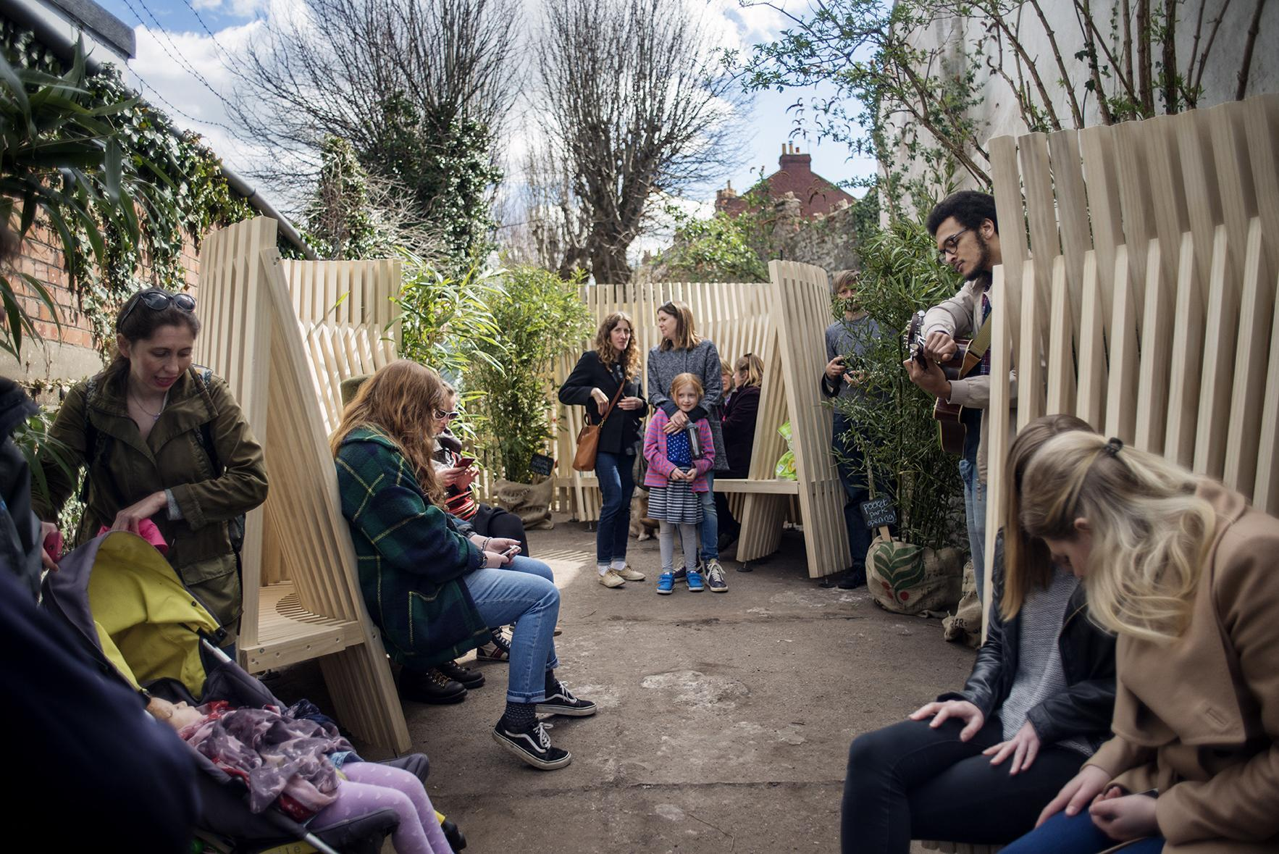

Figure 1. Ebenezer Gate Pocket Park, Bristol Community/University co-design project (Image: Marcus Way, 2016).
In response to both of these converging agendas, we present a new model of University engagement in the city that aims to draw on the resources and expertise of the University to facilitate collaborative and participatory civic engagement projects. The intention is that through action-based design projects community members, academics, students and experts can engage in processes which enable all participants to generate and share knowledge, develop skills and transform environments (see for example fig 1). In essence these projects bring a group of people together to collaboratively identify and explore a particular real-life problem, with the intention of making either physical and/or social positive change. The approach draws on a tradition of service learning as developed by social reformer and educationalist John Dewey at the end of the 19th century, which can be understood as a movement ‘based on the belief that education must centre on resolving society’s most clamouring problems while at the same time encouraging the engagement of future professionals to prepare them for a lifelong commitment to civic involvement’ (Salama, 2015: 217). It is a model that could work across many disciplines, but is explored here in the particular context of architecture.
At the start of the 21st century, this notion of service learning is increasingly introduced into architecture education through a variety of field experience approaches, known fairly interchangeably as live projects, community design, service learning and design-build (Sara 2011; Anderson and Priest, 2012; Harris, 2014; Salama, 2015; Stonarov, 2018). In pedagogical discourse within architectural education, these approaches are recognised as a model of educational practice within the design studio, addressing a perceived gulf between learning in architecture schools and the realities of professional life in a rapidly changing industry (Nicol & Piling, 2000; Salama, 2015; Masdeu & Fuentes, 2017). However, the broad model of service learning can be criticised for exemplifying a one-directional flow of knowledge - from the University to the community.
This paper reflects on the practice of hands-on-bristol, a collective bringing community members, architects, trainee architects, and academics together to co-create live community architecture projects. The practice of the collective is conceived as a form of Spatial Civic Agency (see below for a discussion of the terms) that empowers a community or not-for-profit organization to participate in making and re-making their places. From a University perspective projects are undertaken as ‘participatory action research’ (Forester, 1999) which make use of student and academic time to engage in an ongoing process of community participation and co-creation through physical and speculative interventions in the city. The approach prioritises a shift from working for to working with community groups and understands the engagement as a process through which knowledge is collectively created rather than by which it is disseminated. This has a transformative aim to bring into consciousness the conditions that shape a community’s place in their world (hooks, 1994) and can catalyze possibilities that seemingly cannot otherwise be unlocked. This participatory approach questions the primary focus of education as provider of practice-ready graduates and makes a place for the University as civic agent of change in the city.

Understanding civic agency
Civic agency can be understood by unpicking the meaning of the two terms. The term agency is used to describe the ‘ability of the individual to act independently of the constraining structures of society’ (Awan et al., 2011). This implies a certain individual capital that is not necessarily inherent in all communities. The term civic emphasises a focus on the city – and therefore those ‘constraining structures’ might be understood as those structures that act upon the city, in particular those structures that constrain the ways in which communities can affect the city. In addition the term ‘civic’ also implies a democratic responsibility associated with being a citizen – so the term begins to introduce idea of public responsibility inherent in participating in the city.
Civic agency has been described as ‘the capacity of each individual, working alone or in groups, to view what happens in the world in a critical way and to … bring about positive change’ (Forestiere, 2015). Civic agency implies a cooperative and collective approach, which involves institutions of all scales alongside individuals (Boyte, 2007). It therefore suggests interplay between the role of the institution (in this case the University) and the role of the individual. Here we define civic agency as the ability of communities to actively come together to make positive changes.

The following list synthesises 4 key characteristics of civic agency as aiming to:

- Involve the citizen as co-creator – ‘the citizen as co-creator is a problem-solver and co-producer of public goods, a far more robust definition than volunteer, voter, protestor, client, or customer’ (Boyte, 2007; Arnstein 1969). This raises the responsibility to proactively involve diverse participants (Dahlgren, 2006: 279).
- Engage with public and community places – ‘Public work is rooted in the life of places. We need [to develop] a new appreciation for places as the root system of a democratic society…reconnecting mediating institutions like schools, businesses, congregations, unions, and non-profits with local communities’ (Boyte, 2007). It is the material fabric that arguably provides the framework for community action and is a key step in reaching groups that would otherwise not participate in the public sphere (Dahlgreen, 2006).
- Reconceptualise the role of the professional – ‘This civic approach to social science also implies a profound reworking of the professional role, from service deliverer and outside expert to collaborator, organizer, and catalyst - "on tap not on top"’ (Boyte, 2007). This raises questions about the validity of knowledge and its authentication but does not imply the erosion of professional expertise – it instead acknowledges that the professions are not the only source of knowledge.
- Understand democracy as a lived social and cultural experience grounded in everyday life (Stewart, 2000 & Agre, 2004) - This positions citizenship as enacted throughout society at a whole range of scales, including through practical, direct action. (Dahlgren, 2006) It also acknowledges that engagement in democracy is a process of community engagement (rather than solely concerned with elections, laws, and institutions) and as such ‘citizenship [is] in part, a question of learning by doing’ (Dahlgren, 2006).

In this paper, these four principles are used to position and analyse the work of hands-on-bristol (fig. 2) in order to critique its activities as a form of civic agency – both to critically reflect on the participatory action research, but also to further analyse the principles of civic agency as a model of university-community action. In addition the principles of spatial agency (Awan et al., 2011) are identified as representing an expanded understanding of architecture, beyond the mere production of buildings to include activities which identify the construction of space as a social as well as a physical practice (Rice & Littlefield, 2014). In this way the activities undertaken by the collective are conceptualised as Spatial Civic Agency.
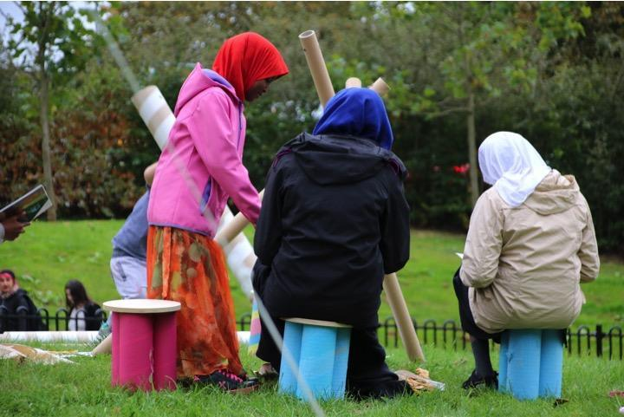
Figure 2. Participatory workshop at Junction 3, Bristol (Image: Hands-on-bristol, 2016).

Methods
The practice of hands-on-bristol is based on the principles of public work (Boyte, 2007) and is organized around identifying, framing and responding to public problems that have a spatial or built environment context. The basis for this collaborative endeavour is the live project, an educational method that occupies the interstitial space between disciplines (Harris, 2014) and creates opportunities for situated learning between the academy and the everyday (Sara, 2011). The live project is defined by the Live Project Network as comprising “the negotiation of a brief, timescale, budget and product between an educational organisation and an external collaborator for their mutual benefit. The project must be structured to ensure that students gain learning that is relevant to their educational development” (Live Projects Network, 2017). The range of project types that are considered ‘live’ is varied, from hands-on 1:1 construction projects to client-initiated and participatory community-based design to activism and feasibility studies. As educational practice, live projects are distinct from much other academic learning in their engagement with external collaborators with real needs from outside the academy. They bring together architectural students, educators and non-architects in cooperation to generate an outcome that is of benefit to all parties. The aim is to develop a critical position from which students can bridge the divide between education and practice, aiding the development of professional and collaborative skills which are otherwise difficult to simulate in the academy (Sara, 2008; Maturana, 2010, Ashkan, 2016).
However despite the potential to benefit students’ learning, often live projects can be criticised as working for rather than working with community groups, thus minimising the opportunity for participants to work collectively and to co-create knowledge, as well as reducing the potential for community civic engagement and participation. In response to this critique, Hands on Bristol developed the live project model to proactively work with communities as a part of the process. Hands on Bristol’s live community architecture projects are then defined as:
‘a form of spatial agency which involve a community or not-for-profit organization in collaborating with architects and/or architecture students to co-create a brief, timescale, budget, product and process for their mutual benefit, with the intention of making a positive impact in these communities’ (Hands On Bristol, 2017).
These projects work on a zero budget model and only for groups who are worthy causes and would otherwise not have access to architectural guidance due to a lack of funding. We actively seek out groups with which to work, and over time have clarified an intention to work with diverse groups who represent communities, charities and not-for-profit organisations. It is an important principle of the practice that we are not ourselves driven by a profit-motive, nor are we working in a way that takes away from professional architectural practice or exploits student labour for anything other than public good. This means that we are confident that we are not taking work from local practices and also that students do not feel that they are being exploited by working for 'free', an oft cited criticism of live projects (Salama, 2015). Once projects become funded (if for example the work we do is submitted for a funding bid) then we collaborate with local small practices to help realise (and indemnify) any built elements to the project.
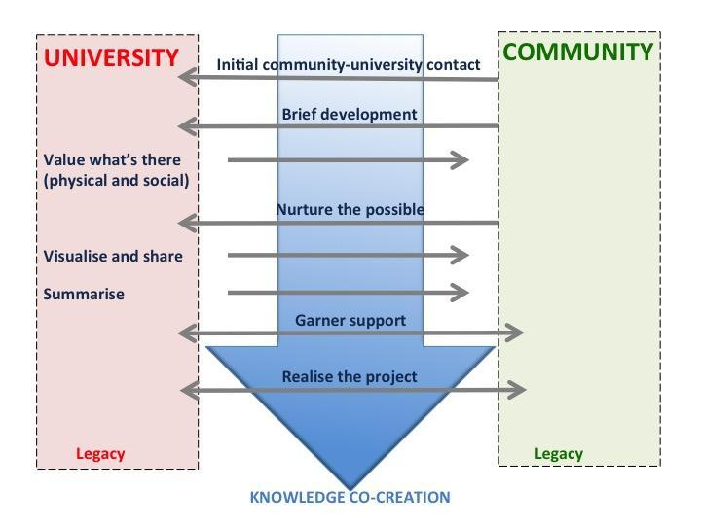
The process is inspired by muf architecture/art’s maxim to ‘Value what's there, nurture the possible, define what's missing’ (Schonfield et al., 2001; muf, 2009). Projects typically take the following format (see fig. 3):
Figure 3. Live community architecture project outline (Image: Hands-on-bristol, 2017).
- Initial community-university contact - Community contact the university with an identified
- problem or need or academics contact a community group to propose a project
- Brief development - Meet with the client group and potential stakeholders and users to frame the ‘problem’ to develop a detailed brief for the project. This is an engaged and participatory process of identifying stakeholders, listening, researching, negotiating, clarifying, problem-framing, synthesising and communicating
- Value what’s there (physical) - Survey, record, and produce drawings/models of the existing conditions/ existing site/existing uses as appropriate
- Value what’s there (social) – Identify and diagram the network of ‘actors’ or stakeholders involved in the project (after Petrescu, 2013)
- Nurture the possible - Engage with as wide a variety of potential stakeholders in the project as possible – use participatory practices to co-develop initial design ideas (after muf, 2009)
- Define what’s missing - Develop creative proposals – Use architectural expertise to develop initial design ideas into workable solutions
- Visualise and Share – visualize the creative proposals and share these with client and stakeholder groups
- Summarise the process – produce a design report which summarises the process described above.
- Garner support – the resources developed in the previous stages are used to gain funding, negotiate permissions and build momentum for the project (by community groups in collaboration with University participants)
- Realise the project – Work collaboratively and inclusively to realise the project pulling in expertise from both within and beyond the community and university collaboration where necessary.
- Legacy – Develop a ‘sustainable legacy’ for the project – how can the project progress in a way that is self-sustaining and uses the resources of the community and the university to provide ongoing support.

Through engaging in these steps we undertake a range of projects, which include involving communities in repurposing existing buildings; restoring neglected sites, Bristol; establishing community green spaces; designing temporary buildings for community use; community wild swimming; and co-building projects. These projects are analysed from the perspective of the four characteristics of civic agency in the following sections.

1. Involve the citizen as co-creator
All the projects involve communities within the creative process from the initial brief development to the nurturing of what is possible. Live community architecture projects can be seen as a vehicle for introducing a series of unknowns including the client group, the users, student dynamics and the brief, which through the interactions facilitates a more inclusive idea of a learning community. In particular this raises students’ awareness of the complexities of working with others unlike themselves, where ‘cooperation becomes a demanding effort’ (Sennett, 2013). This collaboration has a developmental and pedagogical benefit; as Harris describes, ‘live projects may be one of the few opportunities for a largely white middle class student cohort to interact and collaborate with people whose perspectives and experiences are radically different from their own before they enter professional life’ (Harriss, 2015: 202). This can be identified this as a transformative model of education which embraces the ‘practice of freedom’ and brings into consciousness ‘the conditions that shape the [participant’s] places in the world’ (Friere, 1989). It is important to understand that this transformative quality is not limited to the learning and development of ‘students’ but (when the process works well) can be understood as transformative for all participants.
However, it is the way in which participation is realised that is important here. Arnstein (1969) defines a ladder of participation (see fig. 4) with ‘informing’, ‘consultation’ and ‘placation’ as a form of tokenism, whereas ‘partnership’, ‘delegated power’ and ‘citizen control’ are forms of participation which give citizens power. It is the upper rungs of the ladder which we aim to work with in our university-community partnered projects, although there are stages in the project (when we are presenting co-created design ideas) that there is a role for ‘informing’.
Figure 4. Arnstein’s ladder of participation (redrawn from Arnstein 1969).
The projects are typically characterised by processes higher up Arnstein’s ladder of participation (see fig. 5). However the principle of delegated power is important here as it identifies a role for expert knowledge and skills in developing designs, synthesising projects that with work within (or challenge) the existing frameworks and communicating co-created ideas in a way that allows others to ‘buy-in’ to the project.

Figure 5. Typical live community architecture project aligned with the stages of Arnstein’s ladder of participation.
2. Engage with public and community places
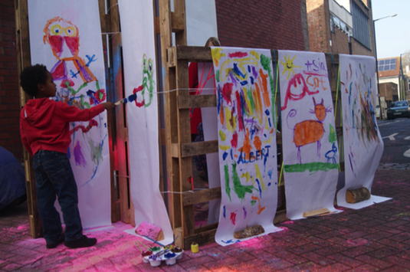
The projects we undertake are all fundamentally rooted to places. It is interesting that while architecture typically involves responding to real sites, this is often undertaken at a distance from both the physical and the social context of projects. In hands-on-bristol collaborative projects, we typically spend long periods of time on location, establishing links with local people who are not necessarily already connected to the community organisation who we are working with, but who could nonetheless be affected by the project (see fig. 6). This is important not just for the development of the project, but also as a part of the University–Community partnership, so the University itself establishes direct connections to the community places of its city.
Figure 6. Public art gallery event in Bedminster, Bristol (Image: Hands-on-bristol, 2015).
.
3. Reconceptualise the role of the professional
These projects shift the emphasis on the role of the professional in two ways – firstly by shifting the locus of knowledge generation from the University to the community, and secondly by shifting the locus of power from the expert working for, to the expert working with. For students involved in the projects it can be seen as a form of situated education – in which individuals acquire their professional skills through engagement with real-life situations. This has positive benefits for students in building their capacity for problem solving, collaborating and managing resources (Harriss, 2015), making them potentially more valuable to employers (RIBA, 2011). Projects can be seen as a collaborative ‘test bed’, allowing aspiring architects to explore what collaboration means in an industry where, “decentralised decision making, information sharing, teamwork and innovation are key” (Harriss, 2012: 186).
In addition however, we can understand all the participants’ engagement in the project as a process of knowledge generation. In this way those professional and education processes are opened-up to a wider, more diverse group of people (after Bourdieu & Passeron, 1964). Behind this ambition is the aim to build community capacity to empower diverse groups and simultaneously to invite others to partake in a particular community of practice (in this case architecture). The approach has particular theoretical underpinning informed by the principles of critical pedagogy, in which there is an attempt to enable positive changes (Friere, 1989; Wink, 2005).

4. Understand democracy as a lived social and cultural experience grounded in everyday life
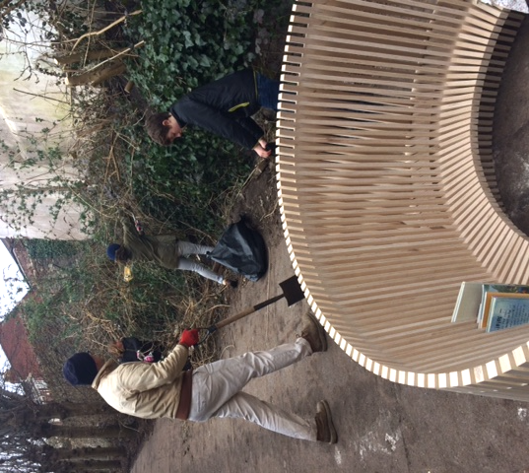
The projects, in being situated within the community, tend to bring everyday activities into the process. A focus on participatory practices leads to activities like litter picking, site clearance (see fig. 7), hosting a market stall and community art activities (see fig. 6). ‘Civic agency involves an ethos that maintains that individuals living in vibrant democracies need to listen, to learn, to interact, to deliberate, and to problem solve’ (Forestiere, 2015). University-Community collaborative projects draw on these bottom-up, direct action approaches to both make immediate positive physical changes, but also to help to co-create communities and build social capital (see fig. 7). The process has the potential to empower both parties to feel able to participate in the making and re-making of their community places and to claim their right to the city: both fundamental qualities of developing sustainable, resilient communities.

Figure 7. Community site clearance day, Ebenezer Gate, Bedminster, Bristol (Image: Hands-on-bristol, 2016).

Discussion: Transferring the process
The key lessons learned from analysing these projects as a form of civic agency identifies a number of ways in which the university can act as an agent of change in the city. The example discussed here is in the co-creation of live community architecture, but there is potential for the model to work in a range of disciplines. There are four key conditions which emerge as conditions which might allow successful university-civic engagement:
- Identified Need - An identifiable real-world issue or need is valuable in order to provide an incentive for engagement, to catalyze thinking and bring people together around a common cause.
- Potential for Change - The potential for the engagement to make some form of change with a potential for action - to engage creatively to resist, act upon and/or challenge existing societal structures, conditions, practices or places.
- Citizen controlled, collaborative approach - Potential for the exchange and generation of knowledge in a way that brings together disciplinary expertise with ‘on-the-ground’ expertise. This includes the need for a shared ‘language’ to collaboratively visualise the problem or situation and understand some of the processes necessary to develop responses, whilst allowing areas of ‘delegated power’ in which disciplinary expertise is necessary.
- Place-based - The project should connect with participants’ lived and everyday experiences through links with real-world situations outside of university settings in order to emphasise the shift in the location of knowledge, education and power. Genuine place-based engagement needs time for the engagement to develop.

These conditions imply potential for civic agency projects across a range of disciplines, from the creative arts (including literature, film, fine art, advertising and marketing, crafts, design, fashion, TV, video, radio and photography, IT, software and computer services, publishing, museums, galleries and libraries, music, performing and visual arts) to professional and/or vocational subjects (including law, medicine, construction) and the social sciences (anthropology, archaeology, cultural, linguistics, economics, microeconomics, macroeconomics, geography, history, cultural studies, economics, political science, international relations, psychology, sociology, criminology). The potential for civic change is enormous.

Conclusions
Universities can play a key role in the democratic and sustainable development of cities by working in collaboration with communities to enhance their capacity for collective action. This paper presents the example of how architecture courses can be used to generate civic collaborations, but the lessons are broadly transferrable. The principle of involving citizens as co-creators; Engage with public and community places; Reconceptualise the role of the professional; and Understand democracy as a lived social and cultural experience grounded in everyday life. In particular the project enable students to develop a range of skills beyond those found in typical academic work and in particular those which are hard to simulate in the academic setting: collaboration, peer learning, negotiating, communicating, and professionalism.
Understood as a form of Spatial Civic Agency, live community architecture projects facilitate several shifts in the location of knowledge, education and power. Through Spatial Civic Agency Universities shift from sharing the knowledge that is created within the University, to collaboratively creating knowledge in situ with communities. This also shifts the locus of education from its location within the academy, to establishing a learning community embedded in community places. In turn, this shifts the locus of power, from being largely held by professional experts at a distance from those they work for, to the empowerment of all participants in the process to be able to directly affect environments. In this way the approach can be seen as transformative, both for the participants and the city. Ultimately the model has the potential to change both the way in which we think about Universities as well as the way in which we think about cities. The city (and the communities which constitutes it) becomes an agent of change for the University, as much as the University is an agent of change for the city.

References
Agre, P. E. (2004). The Practical Republic: Social Skills and the Progress of Citizenship. In A. Feenberg and D. Barney (Eds.). Community in the Digital Age (pp.201–23). Lanham, MD: Rowman and Littlefield.
Anderson, J. and Priest, C. (2014). Developing an inclusive definition, typological analysis and online resource for live projects. Architecture Live Projects: Pedagogy into Practice.
Arnstein, S. R. (1969). A Ladder Of Citizen Participation. Journal of the American Planning Association, 35(4), 216-224.
Awan, N. Schneider, T. and Till, J. (2011). Spatial Agency: Other Ways of Doing Architecture. London, UK: Routledge.
Bourdieu, P. and Passeron JC. (1964). Les Héritiers. Les étudiants et leurs études. Paris: Ed. de Minuit.
Boyte, H. (2007) Building civic agency: the public-work approach. From Open Democracy: Free Thinking for the World https://www.opendemocracy.net.
Dahlgren, P (2006). Doing citizenship. European Journal of Cultural Studies, 9 (3), 267-286.
Forester, J. (1999). Deliberative Practitioner: Encouraging Participatory Planning Processes. Cambridge, Mass: MIT Press.
Forestiere, C. (2015). Promoting Civic Agency Through Civic-Engagement Activities: A Guide for Instructors New to Civic-Engagement. Journal Of Political Science Education 11 (4), 455-471.
Ashkan, M. (2016). The Phenomenological Evaluation Of Teaching Professionalism In The Architecture Design Studio Culture: A Case at the University of Kansas, ArchNet-IJAR : International Journal of Architectural Research; Cambridge 10 (1), 41-61.
Friere, P. (1989). Pedagogy of the Oppressed. New York: Continnuum.
hooks, b. (1994). Teaching to Transgress. Education as the practice of freedom, London: Routledge.
Harriss, H. (Ed.) (2012) Architecture Live Projects, Oxford School of Architecture 2010-12. Oxford: Oxford Brookes University.
Harriss, H.. (2014). Architecture Live Projects: Pedagogy into Practice. London: Routledge.
Masdéu, M. & Fuentes, J, (2017). Reconceptualizing The Design Studio in Architectural Education: Distance Learning and Blended Learning as Transformation Factors. Archnet-IJAR - International Journal of Architectural Research, 11 (2) 06-23.
Maturana, B. (2010). How Spike and the Slumdweller Find Reality In Design Studio Handouts: An Exploration of Reality In the Design Studio. Archnet-IJAR - International Journal of Architectural Research, 4 (2/3). 158-173.
muf architecture/art & J&L Gibbons (2009). Making Space in Dalston. London: Design For London.
Nichol, D. and Pilling, S. (2000). Changing Architectural Education: Towards a New Professionalism. London ; New York: E & FN Spon.
Petrescu, D. and Petcou, C. (2013). Tactics for a Transgressive Practice. in Sara, R and Mosley, J (eds.) The Architecture of Transgression, Architectural Design, London: Wiley and Sons.
RIBA, (2011). Building Futures: The Future for Architects? London: RIBA.
Rice, L. and Littlefield, D. (2014). Transgression: Towards an Expanded Field of Architecture. London, UK: Routledge.
Salama, A.M.A. (2015). Spatial Design Education: New Directions for Pedagogy in Architecture and Beyond. Surrey: Ashgate.
Sara, R. (2011). Learning from life: Exploring the potential of live projects in higher education. Journal for Education in the Built Environment, 6 (2) 8-25.
Sara, R., Daniels, S., Marco, E., Jones, M. and Burch, J. (2017). Hands On Bristol. http://www.hands-on-bristol.co.uk [Accessed 03.01.18].
Schonfield, K., Dannatt, A., Ainley, R. & muf (2001). This Is What We Do: A Muf Manual. London: Ellipsis.
Stewart, A (2000). Theories of Power and Domination. London, UK: Sage.
Stonarov, T. (2018). The Design-Build Studio: Crafting Meaningful Work in Architecture Education, New York; Abingdon: Routledge.
UN General Assembly (2016). New Urban Agenda, Resolution adopted by the General Assembly on 23 December 2016, Seventy-first session, Agenda item 20. From http://habitat3.org/wp-content/uploads/New-Urban-Agenda-GA-Adopted-68th-Plenary-N1646655-E.pdf [Accessed 03.01.18].
UN (2015). Sustainable Development Goals: 17 Goals to Transform Our World, 25th September 2015, http://www.un.org/sustainabledevelopment/sustainable-development-goals/ [Accessed 24.03.17]
Wink, K. (2005). Critical pedagogy: Notes from the real world. New York: Pearson.

