This is the accepted version of the manuscript published by Elsevier in Appetite, available online: https://doi.org/10.1016/j.appet.2019.104489

Exploring the roles of Physical Effort and Visual Salience within the Proximity Effect

Daniel Knowles, Kyle Brown, Silvio Aldrovandi

DOI: 10.1016/j.appet.2019.104489

To appear in: Appetite

Received Date: 17 July 2019

Revised Date: 10 October 2019

Accepted Date: 10 October 2019

Please cite this article as: Knowles D., Brown K. & Aldrovandi S., Exploring the roles of Physical Effort and Visual Salience within the Proximity Effect, Appetite (2020), doi: 10.1016/j.appet.2019.104489

Exploring the roles of Physical Effort and Visual Salience within the Proximity Effect

Daniel Knowles, Kyle Brown, Silvio Aldrovandi

All Authors:
Department of Psychology, School of Social Sciences, Birmingham City University,
Curzon Building, 4 Cardigan Street, Birmingham, B4 7BD,
United Kingdom

Corresponding Author: Daniel.Knowles@bcu.ac.uk

Abstract
Background: Recent work has explored the effectiveness of the Proximity Effect, where increasing the physical distance between consumer and snacks reduces intake. Foods requiring less effort to attain, or being more visually appealing, are seen to be consumed more. Relatedly, perceived effort and visual salience are suggested mechanisms for the proximity effect, but no prior studies have directly manipulated these in association with the effect. Two between-subjects studies conducted in university laboratories are presented.
Method: Twenty chocolate brownies that were either wrapped or unwrapped (Study 1, N=85), or 250g of M&M’s, either colourful or plain brown (Study 2, N=80), were presented as effort and salience manipulations respectively to participants at either 20cm or 70cm. Consumption was measured as ‘likelihood of consumption’ (Yes/No) and ‘actual consumption’ (units/grams). Potential moderating variables including perceived effort and perceived visual salience were also measured.
Results: Likelihood of consumption was positively predicted by perceived visual salience in both Studies, and by distance in Study 2. Significant main effects of distance, p <.001, $ȵ^{2}$=.102 (20cm > 70cm), effort, p <.001, $ȵ^{2}$=.089 (unwrapped > wrapped), and distance x effort interaction, p=.003, $ȵ^{2}$=.111, were observed in Study 1 for actual consumption. A main effect of distance was found in Study 2 for actual consumption, p<.001, $ȵ^{2}$=.062 (20cm > 70cm). Perceived visual salience positively correlated with actual consumption in both Studies.
Conclusions: Increasing physical effort and placing snacks further away appear to act independently and interactively to reduce snack consumption. Manipulating snack colour does not appear to influence consumption, whereas perceptions of visual salience appear to influence consumption. As such, perceived visual salience and physical effort are thought to be key mechanisms underpinning the proximity effect.
Pre-registration: Both Studies were pre-registered on the Open Science Framework (Study 1: 10.31234/osf.io/rmnys; Study 2: 10.31234/osf.io/u8bsz).
Keywords: Proximity, Effort, Salience, Nudging, Food Consumption, Choice Architecture.

Introduction

Background
Global obesity prevalence is increasing yearly, with little probability of halting the rise if current trends continue (Di Cesare et al., 2016; World Health Organization, 2013). While many individuals intend to change such behaviour, this often does not result in behaviour change (Hollands, French, et al., 2016; Webb & Sheeran, 2006). Many popular interventions incite behaviour change without the conscious awareness of individuals through manipulating and changing the environment, commonly known as choice architecture and nudging (Hansen, 2016; Marteau et al., 2012; Thaler & Sunstein, 2008). One method in particular exploits the effect of placing foods further away to reduce consumption, known as the proximity effect (Bucher et al., 2016; Hollands et al., 2019).

Proximity Effect
The proximity effect has been observed across both larger food environments where individuals must walk to different options (Baskin et al., 2016; Langlet, Fagerberg, Glossner, & Ioakimidis, 2017; Meiselman, Hedderley, Staddon, Pierson, & Symonds, 1994; Vanata, Ph, Hatch, & Depalma, 2011), as well as in micro-environment context where individuals can reach different options whilst remaining seated (20cm - 70cm: Hunter, Hollands, Pilling, & Marteau, 2019; Hunter, Hollands, Couturier, & Marteau, 2018; Maas, de Ridder, de Vet, & de Wit, 2012). Maas and colleagues found a proximity effect between the consumption of chocolate M&M’s at 20cm and 70cm, but no difference in consumption between 70cm and 140cm. As such, the distances of 20cm and 70cm have since been adopted in more recent research (Hunter et al., 2018, 2019; Knowles, Brown, & Aldrovandi, 2019). While the proximity effect is found to be relatively consistent, little is known about the underpinning mechanisms or what is causing the effect to occur (Bucher et al., 2016). Hollands et al. (2019) recently presented an overall medium effect size for the proximity effect with a reduction in snack consumption when placed further away, in agreement with Bucher et al. (2016), but suggest more emphasis should be placed on exploring the proximity effect in field settings to more fully understand the effect and its associated mechanisms.
Recent research has identified that the proximity effect is unlikely to be moderated by cognitive load or level of education, and suggests the effect may operate via non-conscious processes (Hunter et al., 2018). However, this research does not offer new suggestions or add evidence to any prior mechanism for potentially underpinning the effect. Both Maas et al., (2012) and Hunter et al. (2018) observed that individuals perceived more effort was required to attain a snack from 70cm away compared to 20cm, but neither study reported inferential analyses to discuss the potential relationship between perceived effort and consumption. As these studies manipulated distance, it can be considered that effort to obtain the snack also changed accordingly. However, neither study implemented a direct manipulation of “actual” physical effort required to obtain the snack, such as unwrapping the snack in order to consume it, so it is not known whether increasing distance is a true method of increasing effort (Brunner, 2013). A specific physical effort manipulation would allow the effects of distance and effort to be disentangled in order to more fully explore whether effort is a mechanism which may explain the proximity effect.
Relatedly, Maas et al. (2012) proposed that perceptions of how salient a snack appears to the consumer may moderate the proximity effect. While Maas et al. (2012) and Hunter et al. (2018) found that participants rated M&M’s as equally visually salient regardless of the relative position of the M&M’s, neither study explored the potential relationship between visual salience and consumption. Similarly, Privitera and Creary (2013) examined the proximity effect whilst directly manipulating snack visibility, observing higher consumption of both apple slices and carrot sticks presented closer than further away. However, snacks were presented at either arm’s reach (30cm) or on a nearby counter (2m away), so outcomes are less comparable to the studies by Hunter et al. (2018, 2019) and Maas et al. (2012) due to the increased distances relative to the consumer. Nonetheless, each of the aforementioned studies show a general trend that increasing distance decreases the amount consumed (Hollands et al., 2019). However, little is known regarding the mechanisms which cause this effect, with Maas et al. (2012) proposing salience and effort as the two key mechanisms.

Physical Effort
It is considered that individuals often follow behaviours which are met with the least resistance, and so are the easiest to conduct (Tolman, 1932; Waugh & Gotlib, 2008). In particular, this can be seen when making food choices (Brunner, 2013). While much of the past research exploring the role of effort on food choice solely measured whether or not an individual consumed, research specifically examining how much is consumed is more scarce (Brunner, 2013; Meyers & Stunkard, 1980). Previous research by Singh and Sikes (1974) found that consumption of cashew nuts was reduced when the cashews were wrapped in foil, but this was not replicated with chocolates. A cause of this may be due to chocolate generally being liked more than cashews, so individuals were willing to exert more effort to attain chocolate than cashews (Rozin, Levine, & Stoess, 1991). More recently, Brunner (2013, Studies 1 and 2) saw that consumption of chocolates was significantly reduced when chocolates were presented with a thin wrapper compared to when unwrapped chocolates were presented, opposing the outcome presented by Singh and Sikes (1974). In a separate experiment, Brunner (2013, Study 3) found that consumption of dried fruit was significantly lower when asked to use sugar tongs (higher effort) than their fingers (lower effort), suggesting not only does increasing effort decrease consumption, but this effect may occur regardless of snack type.
Similarly, Rozin et al., (2011, Study 4) illustrated that salad bar items were served 16.5% less when using tongs compared to spoons, as using tongs is thought to require more effort than using spoons to serve oneself. Rozin and colleagues suggested that a likely mechanism to explain the difference in consumption for both proximity and effort effects may stem from Tolman’s Law of Least Effort (Tolman, 1932). The Law of Least Effort states that individuals aim to expend the minimum level of physical effort to conduct an activity, a principle which is consistent with the findings of both proximity and effort research. This relates well with the general concept of nudges working through influencing our automaticity, with Kahneman, (2013) referring to the law of least effort as being applicable not only in physical but also cognitive actions (Bargh, 2002; Bargh, Schwader, Hailey, Dyer, & Boothby, 2012; Dijksterhuis, Smith, van Baaren, & Wigboldus, 2005; Sunstein, 2016). For this reason, it can be considered that the effort effect demonstrated by Brunner (2013) and Rozin et al., (2011) may also explain the proximity effect, with individuals only consuming if the effort required is low. As such, effort may moderate the proximity effect, with the effect being reduced or eliminated should physical effort be increased too high.

Salience/Visual Cues
While the effort required to attain a food may influence consumption, the first interaction with food in most cases is visual (Delwiche, 2012; Piqueras-Fiszman & Spence, 2014; Spence, 2018; Wadhera & Capaldi-Phillips, 2014). Therefore, it is probable that manipulating this visual interaction may influence our consumption and perception of foods. Wadhera and Capaldi-Phillips (2014) suggest that visual cues can act either independently or interactively with other effects, influencing perceptions of taste and attractiveness of foods when visual presentation is altered (i.e. changing colour of serving apparatus or the food/drink item itself; Jansen, Mulkens, & Jansen, 2010; Morrot, Brochet, & Dubourdieu, 2001; Piqueras-Fiszman, Alcaide, Roura, & Spence, 2012). In addition, when cues are removed such as through opaque wrapping or blindfolding participants, consumption is reduced further, illustrating how visual cues can significantly influence consumption (Barkeling, Linné, Melin, & Rooth, 2003; Johnson, 1974). These previous findings demonstrate how we rarely depend solely on our internal cues to inform consumption, but rather rely on the external cues offered by the environment (Schaefer & Magnuson, 2014).
Deng and Srinivasan (2013) explored the relationship between visual cues and consumption by manipulating the visibility and visual attractiveness of snacks, finding that colourful, visually attractive snacks (colourful Froot Loops) were consumed in greater quantity than visually plain, monochrome snacks (plain Cheerios). Similarly, whilst exploring the proximity effect, Privitera and Creary (2013) found that more apple slices were consumed when visible (presented in a transparent container) than not visible (presented in an opaque container). This visibility effect was seen to positively interact with distance, thus reiterating how manipulation of both factors can increase overall differences in consumption. However, the effect did not occur with carrot sticks, suggesting that the visibility effect may be sensitive to the characteristics of a snack, such as carrots being less attractive or salient to consumers when compared to apple slices. It is important to note, however, that Privitera and Creary (2013) did not measure participants’ perceptions of the snacks on offer were, so it is not known whether apples offered a higher total perceived salience than carrot sticks, which could have influenced consumption. While visibility and visual salience are two distinct yet related concepts, Privitera and Creary (2013) assert that snack visibility determines consumption and may be sensitive to snack-type, whereas outcomes from Knowles et al., (2019) imply perceived visual salience may be less sensitive to snack-type, as seen with associations between visual salience rating and consumption of both healthy and less healthy snacks.

Current Studies
The present studies aim to be the first to experimentally manipulate effort (Study 1), and visual appearance (Study 2) to explore whether effort or visual salience influence the proximity effect through manipulating physical effort (Study 1) and snack colour (Study 2), in addition to snack distance (both Studies). Pre-registered Study protocols were produced and published before commencing data collection, outlining the methodology including manipulations of wrapping a snack to increase effort, and colour of snack, as well as design, sample size, and analysis methods (Knowles, Brown, & Aldrovandi, 2018a, 2018b). In line with the associated Study protocols, the Studies follow 2(distance 20cm, 70cm) x 2(effort; wrapped, unwrapped) and 2(colour type; multi-coloured, monochrome brown) between-subjects designs respectively. Both Studies measured consumption outcomes on two levels (likelihood of consumption, and actual consumption), as well as using a questionnaire to gather self-report data on perceived visual salience, perceived effort, and other potentially influencing factors.

Hypotheses

Study 1. The aims of Study 1 can be expressed in the following hypotheses:
H1a: Likelihood of consumption and actual consumption will be higher when brownies are presented at 20cm than 70cm from the individual.
H1b: Likelihood of consumption and actual consumption will be higher when brownies are presented unwrapped (low effort) than when brownies are presented with a film wrapper (high effort).
H1c: A significant interaction between snack proximity and effort level is hypothesised for both likelihood of consumption and actual consumption, which would indicate that effort is a likely moderator for the proximity effect.

Additional Outcomes.

H1d: Visual salience ratings will be similar across all conditions.
H1e: Perceived effort will be higher for wrapped conditions than unwrapped conditions.

Study 2. The aims of Study 2 can be expressed in the following hypotheses:
H2a. Likelihood of consumption and actual consumption (g) will be higher when M&M’s are presented at 20cm than 70cm
H2b. Likelihood of consumption and actual consumption (g) will be higher when multi-coloured M&M’s are presented than brown M&M’s.
H2c. Likelihood of consumption will be significantly predicted by the interaction term of distance and colour type.
H2d. There will be a significant interaction between colour type and distance on actual consumption.

Additional Outcomes
H2e. Visual salience ratings will be significantly higher for multi-coloured M&M’s than brown M&M’s.
H2f. Perceived effort ratings are expected to be higher when M&M’s are presented at 70cm than 20cm.
H2g. It is hypothesised that actual consumption will have a significant positive correlation with visual salience rating.

Study 1

Methods

Participants
Effect sizes from previous literature (proximity: $ȵ^{2}$ = .159, Knowles et al., 2019; effort: $ȵ^{2}$ = .091, Brunner, 2012, Study 2) were used for power analysis, setting alpha at .05, suggesting sample sizes of 44 and 80 were required to achieve a power of 80% for each effect size respectively. The larger sample size was chosen to ensure both suggested sample sizes were met. The Study was not powered to detect a difference in participant characteristics such as the effect of BMI or age. The present Study oversampled to N = 85 in order to replace any individuals who moved the bowl of brownies within the Study. The Study was advertised as a student stress Study in order to reduce demand characteristics (similarly seen in Hunter et al., 2018; Maas et al., 2012), with participants invited to participate through an online research scheme at a West Midlands University. Individuals with known food allergies, intolerances, or food-related illnesses, and individuals who participated in a similar previous Study (Knowles et al., 2019b) were ineligible for participation. Individuals received 30 minutes-worth of research credits for participation and were asked to refrain from consuming food for 2 hours prior to their timeslot.
Outliers whose actual consumption was above 2 standard deviations (N = 4), and the single participant who moved the bowl (N = 1) were removed from the main sample, resulting in a main sample of N = 80. Two participants correctly identified the Study intent but were maintained for the sample. The sample consisted both of individuals who consumed any amount of snacks, and who did not consume any snacks, thus resulting in a positively skewed dataset. No transformations were conducted on the main sample, with individuals who did not consume any snacks being removed for subsequent sensitivity analyses, somewhat normalising the data. The main sample (N = 80) consisted of 85% females, largely due to the voluntary sampling method and a high proportion of female students at the institution, with a similar number of females in each condition. The sample had a mean age of 21.21 years (SD = 2.34), mean BMI of 24.91 ${kg/m}^{2}$ (SD = 4.75, range = 17.18 – 43.46), and were mainly White British (46%). Descriptive results for each condition can be found online (See Online Supplementary Materials (OLSM) 1).

Design
Participants were assigned to one of four conditions through the use of a randomised number sequence in a 2(distance; 20cm, 70cm) x 2(effort; low/unwrapped, high/wrapped) between-subjects design, resulting in four conditions. Randomisation and sampling were not stratified by sex or BMI, but a randomisation check was implemented to ensure samples were similar on participant characteristics. Bowl position was measured from the closest edge of the table to the participant to the front edge of the bowl in a straight line, with the bowl presented directly in front of the participant to reduce handedness bias. A selection of neutral magazines with no food-related articles or prompts were located on the left-hand side of the table, with a computer keyboard and mouse directly in front of the participant, and a computer screen located 1 meter from the participant (See Figure 1).
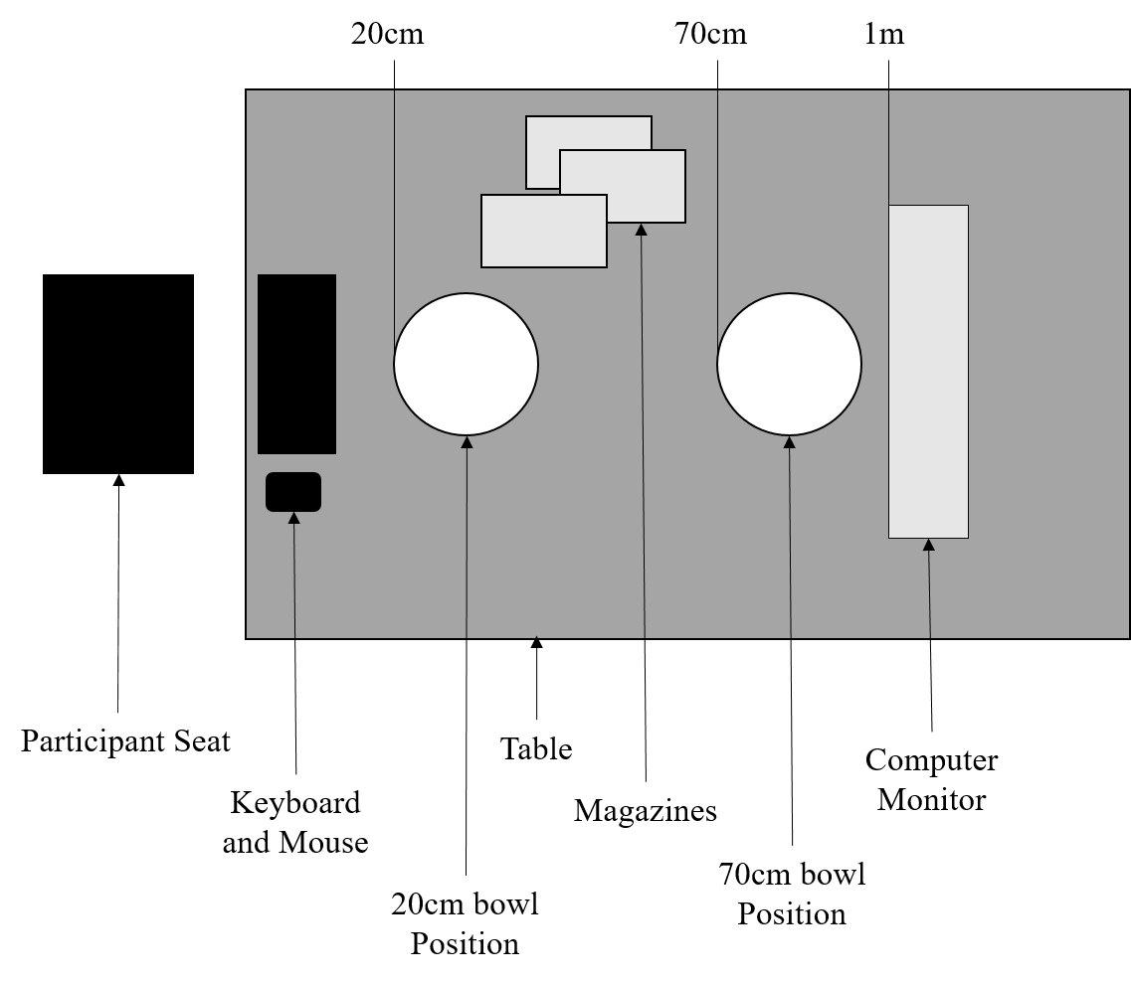
Figure 1: Layout of the Testing Area

Materials
Chocolate brownies were used for the Study as a result of a pilot Study (N = 330) asking individuals how much they liked 48 different foods and drinks. Chocolate brownies were liked significantly more than chocolate M&Ms and offered consistent size and shape to be easily wrapped and unwrapped (For pilot data, see Knowles et al., 2018a). Within each trial, 20 brownies (2.7cm x 2.7cm x 1.5cm, 10g~11g, 43kCal per brownie) were presented to participants in a transparent, circular bowl (15cm diameter). Brownies in the high-effort conditions were wrapped in a single layer of plastic film. To control for the visual appearance of brownies potentially being altered by the wrapping, visual salience ratings were measured and controlled for across conditions. Brownies were counted before and after each trial to calculate consumption, with each bowl being fastened to the table with Velcro pads (not visible to participants) to minimise bowl movement. Only one individual moved the bowl from the Velcro pad.

Questionnaire. Each participant was asked to complete a two-part questionnaire, presented on a 27” screen placed 1 meter from the participant, and consisted of the following measures as outlined in the corresponding pre-registered Study protocol (Knowles et al., 2018a):
Perceived Effort: Perceived effort was measured using a 5-item, 5-point Likert scale anchored by Completely Disagree (1) and Completely Agree (5) similar to those used by Maas et al (2012; i.e. The brownies were within each reach). This was also used as a manipulation check to ensure wrapped brownies required more effort to consume than unwrapped brownies.
Visual Salience: Visual salience was measured with a 5-item, 5-point Likert scale anchored by Completely Disagree (1) and Completely Agree (5), based on the questions used by Maas et al (2012; i.e. The brownies looked irresistible).
Eating Behaviour: The Three Factor Eating Questionnaire - revised 18 (TFEQ-r18, Karlsson, Persson, Sjöström, & Sullivan, 2000) was used to measure participant’s cognitive restraint, emotional, and uncontrolled eating levels. These factors may influence or interact with the effects seen in the Study, as well as being used for a randomisation check.
Food Liking: Participants were asked to rate how much they like a short list of commonly eaten snacks and foods (i.e. Red grapes, Dairy milk chocolate, Brownies) on a 100 point VAS, anchored with 1 (Not at all) and 100 (Very much).
Recollection of consumption: Individuals were asked to rate how clearly they remember how many brownies they consumed (1-100 VAS), then asked to enter a numerical value for the number they believe they ate, followed by how confident the consumer feels with this answer (1-100 VAS).
Awareness of the Study: As suggested by Hollands, Marteau, and Fletcher (2016), a funnelled debrief procedure was implemented which asked increasingly specific questions to assess how aware individuals were of their consumption (i.e. Did the fact you were in a laboratory influence your behaviour? Did the wrappers/unwrapped brownies affect how many you ate?). Responses to these questions were used to determine how aware individuals were of their consumption, and of the Study.
Hunger: Hunger and fullness (reverse scored) were measured using two separate 100-point Visual Analogue Scales asking how hungry and how full the participant feels, each anchored with ‘Not at All’ and ‘Very’. These questions were asked on each part of the questionnaire to determine whether hunger had reduced after individuals had consumed snacks.
Stress: In keeping with the cover story, Cohen et al.’s (1983) 10 item Perceived Stress Scale was used to measure participants stress on a 5 point scale, anchored with Never (0) and Very Often (4).
Handedness: The Edinburgh Handedness Inventory (Veale, 2014) was used to measure handedness, with a 5-point scale anchored with ‘Always Left’ and ‘Always Right’.
Tiredness: As tiredness can be considered to impact food choice (Brondel, Romer, Nougues, Touyarou, & Davenne, 2010; Greer, Goldstein, & Walker, 2013), tiredness was measured using a two 100-point VAS items asking participants how tired and how awake they currently feel (reversed), anchored from ‘Not at All’ and ‘Very’, similar to the tiredness measure in Higgs & Donohoe, (2011).
Demographics: Age, Sex, Ethnicity, and Socio-Economic Position (using education level and postcode) were measured to attain an overview of the sample.
BMI: BMI was calculated by measuring participants height (via stadiometer) and weight (via digital weighing scale) to attain an overview of the sample.

Procedure
Participants were invited to attend a single 30-minute laboratory session on the campus of a West Midlands University between 10:00 and 16:30. After being seated and providing consent, the researcher read a pre-prepared script, informing the participant on what they are asked to do within the Study. Participants were asked to complete a 2-part questionnaire which acted as both part of the cover story and provided self-report responses for multiple variables (as above). Participants were allocated 10-minutes to complete the first part of the questionnaire, during which they were told they could freely eat the brownies provided. The first part of the questionnaire consisted of questions relating to age, gender, ethnicity, SEP, hunger, stress, handedness, and tiredness, presented in the stated order. Upon completing the first part of the questionnaire, participants were asked to browse the magazines provided in their remaining time and refrain from any mobile device use. Brownies could be consumed at any time during this 10 minute time period, as participants were not restricted from selecting and consuming brownies whilst completing questions. The researcher answered any questions the participant had, then excused themselves from the room. After the 10 minutes had expired, the researcher returned to the laboratory, removed the bowl of brownies, and asked the participant to complete the second part of the questionnaire. This part consisted of items relating to hunger and stress as a follow-up from the first half, followed by perceived effort, visual salience, recollection of consumption, food liking, eating behaviour (TFEQ-r18), Study awareness, demographics, and BMI, presented in the stated order. The researcher then left the laboratory for a second time and waited for the participant to reach the final questions regarding BMI, where the researcher then re-entered the laboratory. Participant’s height and weight were measured for BMI calculations, then the participant submitted their questionnaire and were debriefed the true intent of the Study.

Data Analysis
A randomisation check was conducted in order to identify if conditions were similar for each characteristic variable (age, BMI, hunger, eating behaviour, tiredness, brownie liking, and stress), and a manipulation check to determine whether wrapping brownies in a thin layer of film significantly increased perceived effort as intended. Perceived effort and visual salience ratings were compared across conditions with separate 2(distance; 20cm, 70cm) x 2(effort level; unwrapped, wrapped) ANOVA’s. To assess likelihood of consumption, participants who consumed no brownies were scored ‘0’, and those who consumed at least 1 brownie were scored ‘1’ for analysis. A binary logistic regression was conducted to assess likelihood of consumption, with three models being tested; main effects only, main effects and interaction, and main effects, interaction, and covariates.
Actual consumption was assessed with a 2(distance; 20cm, 70cm) x 2(effort; wrapped, unwrapped) ANCOVA. Perceived effort and visual salience were planned covariates, along with any participant characteristic identified as being significantly different across conditions. Post-hoc analysis was conducted for any potential interaction outcome where relevant. Secondary outcomes were explored with correlational and 2x2 ANOVA analyses between variables from the questionnaire and consumption of brownies. Finally, sensitivity analysis was planned to assess whether the results of each main analysis test was sensitive to the inclusion of any individuals who moved the brownies, or inclusion of outliers, with the same testing being conducted where applicable. Analyses were conducted in R (v3.5.0).

Results

Descriptive Analysis
Descriptive analysis and a 2x2 ANOVA randomisation check were conducted, finding that conditions were similar for characteristic variables, p’s > .341 (see OLSM 1). Paired samples t-tests showed there were no significant differences for any condition between the first and second measurement of stress or hunger, p > .430. Mean likelihood and actual consumption across conditions is shown in the supplementary materials (see OLSM 1, Table 1).

Perceived Effort. Main effects of distance, F(1, 76) = 14.189, p < .001, $ȵ^{2}$ = .161, and physical effort, F(1, 76) = 5.284, p = .024, $ȵ^{2}$ = .065, were found, with brownies positioned at 70cm (M = 1.84, SD = .59) requiring more perceived effort to attain than those at 20cm (M = 1.42, SD = .44), and wrapped brownies (M = 1.76, SD = .58) requiring more perceived effort to attain than unwrapped brownies (M = 1.51, SD = .53). No two-way interaction was found, p = .268. The two main effect results suggest the physical effort manipulation was successful (See Table 1 for means). Reliability of the perceived effort measure was low, α = .48.
Visual Salience. A main effect of visual salience was found, F(1, 76) = 6.073, p = .016, $ȵ^{2}$ = .074, with unwrapped brownies (M = 3.55, SD = .91) receiving a higher visual salience rating than wrapped brownies (M = 3.04, SD = .98). No main effect of distance, p = .107, or two-way interaction, p = .241, were found. This shows that the inclusion of the plastic wrap lowered visual salience, but brownies being placed further away did not (See Table 1 for means). Reliability of the visual salience measure was α = .82.
Table 1: Mean Perceived Effort and Visual Salience of each condition
 |  | Perceived Effort |  | Visual Salience
 |  | N | M (SD) | N | M (SD)
20cm | Unwrapped | 20 | 1.22 (.35) | 20 | 3.85 (.89)
 | Wrapped | 20 | 1.61 (.45) | 20 | 3.09 (.82)
 | Total | 40 | 1.42 (.44) | 40 | 3.47 (.93)
70cm | Unwrapped | 21 | 1.78 (.53) | 21 | 3.26 (.85)
 | Wrapped | 19 | 1.92 (.66) | 19 | 3.00 (1.15)
 | Total | 40 | 1.84 (.59) | 40 | 3.13 (1.00)
Total | Unwrapped | 41 | 1.51 (.53) | 41 | 3.55 (.91)
 | Wrapped | 39 | 1.76 (.58) | 39 | 3.04 (.98)
 | Total | 80 | 1.63 (.56) | 80 | 3.30 (.97)
Note: Bold = Significant at p < .05

Likelihood of Consumption
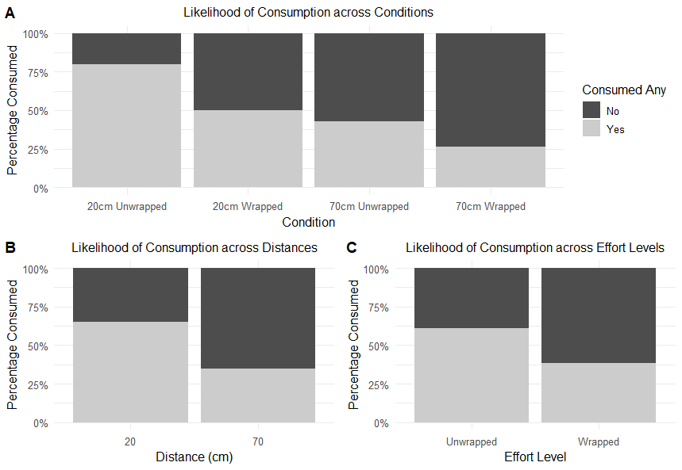
The proportion of participants who consumed any snack was calculated (see figure 2), displaying that 80% of individuals in the 20cm unwrapped condition consumed any brownies, compared to 50% at 20cm wrapped, 42.9% at 70cm unwrapped, and 26.3% at 70cm wrapped. This suggests consumption follows the pattern outlined in hypothesis 3 and suggests an additive effect of physical effort and distance reducing the likelihood of consumption.

Figure 2: Likelihood of brownie consumption across conditions (%), where individuals who ate at least 1 brownie are considered together.
Binomial regression models were conducted to predict likelihood of consumption (See Table 2). The most accurate model was seen to be model 3, which included covariates of visual salience and perceived effort, accounting for 61.6% variance (Nagelkerke${ R}^{2}$) and correctly classifying 83.8% of cases. In the model, only visual salience predicted likelihood of consumption (B = 2.37, p < .001), with higher visual salience ratings correlating with more brownies being consumed, N = 80, r = 0.67, p < .001. Distance (model 1, B = -1.35, p = .004; model 2, B = -1.67, p = .019), and physical effort (model 1 only, B = -1.06, p = .032) predicted consumption when covariates were not included, but not observed in model 3, suggesting the effects may have been driven by visual salience in these models. Perceived effort and the interaction between distance and physical effort did not predict likelihood of consumption in any models, p’s > .515.
 |  | Coefficients |  |  | 95% CI [Odds Ratio]
 |  | B [SE] | Wald Z | p | Lower | OR | Upper
Model 1  $R^{2}$ = 0.188 | Constant | 1.19 [0.45] | 2.67 | .004 | 1.43 | 3.29 | 8.93
 | Distance | -1.35 [0.49] | -2.74 | .006 | 0.09 | 0.26 | 0.66
 | Physical Effort | -1.06 [0.49] | -2.15 | .032 | 0.13 | 0.35 | 0.89
Model 2  $R^{2}$ = 0.194 | Constant | 1.39 [0.56] | 2.48 | .013 | 1.47 | 4.00 | 13.96
 | Distance | -1.67 [0.72] | -2.35 | .019 | 0.04 | 0.19 | 0.71
 | Physical Effort | -1.39 [0.72] | -1.94 | .052 | 0.06 | 0.25 | 0.96
 | Distance : Effort | 0.64 [0.99] | 0.65 | .515 | 0.27 | 1.91 | 13.76
Model 3  $R^{2}$ = 0.616 | Constant | -7.02 [2.16] | -3.25 | .001 | < .001 | < .001 | .004
 | Distance | -1.25 [1.02] | -1.22 | .221 | 0.03 | 0.29 | 2.00
 | Physical Effort | -0.46 [1.01] | -0.46 | .648 | 0.08 | 0.63 | 4.54
 | Salience | 2.37 [0.55] | 4.27 | < .001 | 4.14 | 10.68 | 37.87
 | Perceived Effort | 0.06 [0.63] | 0.10 | .923 | .30 | 1.06 | 3.67
 | Distance : Effort | -0.66 [1.42] | -0.46 | .643 | .03 | 0.52 | 7.94
Table 2. Regression models to predict likelihood of consumption
Note: Bold = Significant at p < .05

Actual Consumption
Primary Outcomes: A significant main effect of effort was found, F(1, 74) = 22.31, p < .001, $ȵ^{2}$ = .089, with higher actual consumption of unwrapped (M = 1.95, SD = 2.01) than wrapped brownies (M = .72, SD = 1.05; See Figure 3, Panel A). A main effect of distance was also found, F(1, 74) = 20.13, p < .001, $ȵ^{2}$ = .102, with more brownies consumed when presented at 20cm (M = 1.95, SD = 1.94) than at 70cm (M = .75, SD = 1.21; See Figure 3, Panel B). Further, the interaction between effort and distance was also found to be significant, F(1, 74) = 9.221, p = .003, $ȵ^{2}$ = .111, with Tukey’s HSD corrected post hoc tests indicating that actual brownie consumption was higher in the 20cm unwrapped condition (M = 3.10, SD = 2.02) than the 70cm unwrapped (M = 0.86, SD = 1.28), p < .001, 20cm wrapped (M = 0.80, SD = 0.95) p < .001, and 70cm wrapped (M = 0.63, SD = 0.63), p < .001. No differences were found between the 20cm wrapped, 70cm wrapped, and 70cm unwrapped conditions, p’s > .61 (See Figure 3, Panel C, and OLSM 1, Table 1). A main effect of visual salience was also found, F(1, 74) = 37.77, p < .001, $ƞ^{2}$ = .302. Post hoc analysis showed an overall significant positive correlation between visual salience and number of brownies consumed, N = 80, $R$ = .68, p < .001. This was also found within each condition,$r$’s > .468, p’s < .037, all positively correlating with actual consumption. No significant effect of perceived effort was found, p = .591.
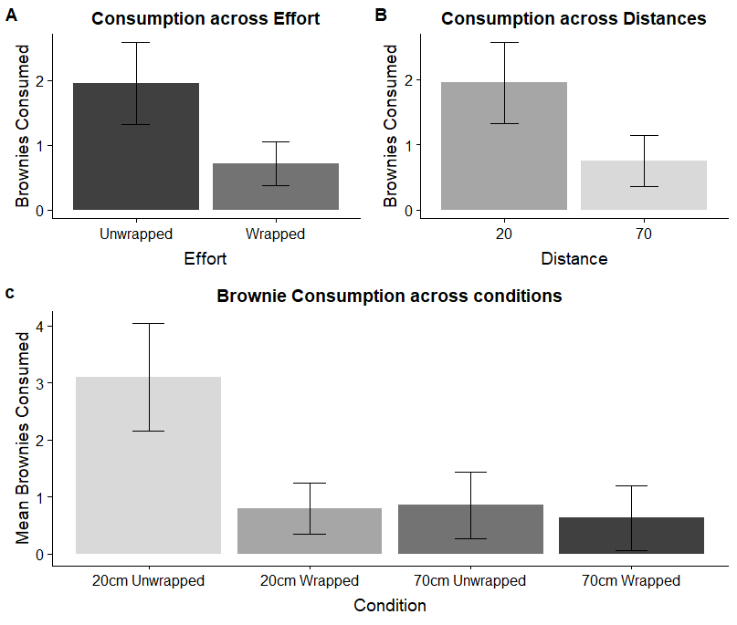
Figure 3: Brownie consumption across conditions and each main effect.

Secondary and Exploratory Outcomes
Eating behaviours: Separate correlational analyses between the number of brownies consumed and eating behaviours sub-scales, as indexed by the TFEQ (Karlsson et al., 2000; cognitive restraint, uncontrolled eating, emotional eating) were conducted, finding no significant relationship between amount of brownies consumed and any eating behaviour measure, $r$’s > .044, ps > .701.
Recollection of Consumption: No main effects or two-way interactions were found for how clearly individuals recalled their consumption, p’s > .083. When the ‘Confidence in recollection’ responses were analysed, main effects of distance (p = .098) and effort (p = .090) were not significant, but there was a significant interaction between the factors, F(1, 75) = 6.471, p = .013. Individuals in the 20cm unwrapped condition (M = 86.16, SD = 26.31) were less confident in their response than the 70cm unwrapped (M = 99.62, SD = 1.75, p = .018), 20cm wrapped (M = 99.75, SD = 1.12, p = .018) conditions, and the 70cm wrapped condition (M = 97.11, SD = 11.25, p = .086). This result may be caused by a higher standard deviation in responses in the 20cm unwrapped condition than the three other conditions, likely caused by the limited number of individuals who did consume in these three other conditions.
Sensitivity Analysis. Main analyses were repeated with the whole sample including outliers and bowl movers (N = 85), and with a sub-sample consisting of only consumers (N = 40). The binary logistic regression on likelihood of consumption was not conducted with the N = 40 sample due to the sub-sample only consisting of consumers, and so unable to predict likelihood of consumption. The regression on the 85 participant sample showed that only visual salience predicted likelihood of consumption, B = 2.49, p < .001, at 84.7% case accuracy, as with the main analysis. Neither distance nor effort predicted likelihood of consumption. Hence, the inclusion of outliers or bowl movers did not influence the results (See OLSM 2, Table 1).
When analyses were conducted for actual consumption, outcomes were the same as in main analysis, with the addition of a perceived effort main effect, F(1, 79) = 9.28, p = .003, $ƞ^{2}$ = .144, through higher perceived effort yielding lower consumption. Hence, main analysis findings were repeated with the added effect of perceived effort (See OLSM 2, Table 2 and 3, for full outcomes). Similarly, when analyses on actual consumption were repeated with the sub-sample of only consumers (N = 40), main effects of distance and effort, and an interaction between the two were found, p’s < .036. Interestingly, the main effect of visual salience was not found to be significant, p’s > .097, indicating visual salience rating was not related to actual consumption when only considering those who initiated consumption (See OLSM 2, Table 2). These results show that the outcomes of the main analysis were not sensitive to the inclusion of outliers, but visual salience did not relate to actual consumption when only those who consumed were considered.

Study 1 Discussion
Overall, the Study showed that individuals were less likely to consume chocolate brownies if they were placed further away, required higher effort to consume, or perceived as less visually salient. Perceived effort was not found to predict the likelihood of consumption, but was seen to be low in reliability so may explain the lack of significance. Actual brownie consumption was influenced by both distance and effort level individually, as well as an interaction between the two. No proximity effect was found when brownies were wrapped, indicating that the effort effect may override the proximity effect for actual consumption, and may potentially explain a large degree of variance in the proximity effect as an underpinning mechanism. Visual salience was found to strongly relate to the number of brownies consumed, with individuals who rated the brownies as more visually salient consuming more brownies than those providing a low salience rating. This outcome appeared to be independent of distance. Sensitivity analyses showed almost all main results were the same when outliers were included, apart from visual salience ratings not being associated with actual consumption in the sub-sample of individuals who did consume and perceived effort being associated to actual consumption when outliers were included. These suggest visual salience may be a mechanism for whether consumption of a snack should be initiated, rather than directly influencing how much of a snack to consume, whereas perceived effort may influence how much of a snack is consumed. To investigate the effects of visual salience further, a second Study was conducted.

Study 2

Methods
Participants
Power analysis was conducted with effect sizes of $ƞ^{2}$= .102 (Study 1), and $R^{2}$= .10 (Privitera & Creary, 2013), setting alpha at .05, suggested a sample of between 68 and 76 to achieve a power of 80%. Additionally, the suggestion by Robinson, Bevelander, Field, and Jones (2018; Simmons, Nelson, & Simonsohn, 2011) of attaining at least 20 observations per condition was considered, requiring a sample of 80 in order to meet this criterion for the interaction. Exclusion criteria were implemented, with those who had a known food allergy, illness, food-related disorder, or had participated in Study 1 being unable to participate.
Eighty participants were recruited for the Study through an online recruitment system at a University in the West Midlands, England. The data were positively skewed due to a high proportion of individuals not consuming any snacks. No transformations on the data were conducted, with sensitivity analyses conducted with a sub-sample containing only those individuals who consumed at least 1 M&M, thus removing individuals who did not consume any snacks, as in Study 1. The sample consisted mainly of females (83.75%), with 53.75% of the total sample identifying as White British or Irish. Most (85%) identified as undergraduate students (10% postgraduate, 5% fewer than 5 GCSE’s). The mean age of the overall sample was 23.81 years (SD = 7.93), with a mean BMI of 25.82${kg/m}^{2}$ (SD = 6.24). A breakdown of each condition can be seen in the additional materials (See OLSM 3, Table 1).

Design and Materials
A 2(distance; 20cm, 70cm) x 2(colour type; multi-coloured, monochrome) between-subjects design was used to explore the role of visual salience on the proximity effect. The Study presented participants with 250g (+/- .5g) of multi-coloured M&M’s (red, green, blue, yellow), or solely brown M&M’s, dependant on condition, in a 17cm diameter clear, circular bowl. Brown M&M’s were chosen as the monochrome snack after pilot Study results found that brown M&M’s were significantly less visually attractive/salient than a variety of mixed colour M&M’s, and represented a larger colour contrast than brownies on a white plate vs brownies on a brown plate (See OLSM 3, Table 2). Each 250g bowl of M&M’s contained an estimated 480kCal. The layout of apparatus was the same as in Study 1, with the exception of snack type (M&M’s rather than brownies) being presented, and that the keyboard was not presented to participants until the start of the second part of the questionnaire (See Figure 1). Questions which required a keyboard entry were moved to the second part of the questionnaire accordingly, with only the mouse required for the completion of the first part of the questionnaire.

Procedure
The procedure was the same as in Study 1, with individuals being asked to complete a two-part questionnaire with snacks present for the first part. Questionnaire items were the same as in Study 1, with questions relating to sex, education level, ethnicity, hunger, stress, handedness, and tiredness presented on the first part in the stated order. Items relating to age, postcode, tiredness, hunger, stress, perceived effort, perceived visual salience, recollection of consumption, food liking, eating behaviour (TFEQ-r18), Study awareness, height, and weight were presented in the specified order on the second part of the questionnaire.

Data Analysis
Individuals who consumed more than 2 standard deviations from their conditional mean were retained for primary analysis of the whole sample, but were removed for later sensitivity analysis, as the previous Study found that outliers did not impact the overall outcomes. Further, the associated Study protocol stated that any individual who moved the bowl, and therefore not adhering to the intended procedure, would be removed from analyses. However, no individual moved the bowl, and so no individuals were removed due to this. A randomisation check was conducted to compare conditions on characteristic variables (BMI, age, hunger, and tiredness), with a 2x2 ANOVA manipulation check for perceived visual salience also conducted. Any variable seen to differ between conditions was included as a covariate in analysis. A binary logistic regression was conducted to explore the likelihood of consumption, with models of 1) main effects only, 2) main effects and interaction, and 3) main effects, interaction, and covariates of visual salience and perceived effort. Post-hoc correlation analyses were conducted where relevant to understand the relationship between actual consumption and any significant predictors.
Actual consumption of M&M’s was explored with a 2(distance; 20cm, 70cm) x 2(colour type; multi-coloured, monochrome) between-subjects ANCOVA, with perceived effort and visual salience inputted as covariates. The fully factorial design allowed examination of both the main effects, interaction, and role of covariates. Post hoc tests were conducted to follow up on significant interactions, with correlational analysis being conducted to explore the secondary outcomes of hypotheses H2e-g.

Results

Descriptive Analysis
Randomisation Check. No significant differences were found between conditions for any of the aforementioned characteristic variables, p > .094 (See OLSM 3, Table 1). A main effect was found for emotional eating ratings between individuals who were presented with snacks at 20cm (M = 2.22, SD = 0.80) and those presented with snacks at 70cm (M = 2.62, SD = 0.85), p = .035, but had no influence on either measure of consumption, p = .224, so were not included in main analysis (See OLSM 4). Mean consumption across the conditions is presented in the additional materials (see OLSM 3, Table 1).
Perceived Effort. A main effect of distance on perceived effort was found, F(1, 76) = 13.525, p < .001, $ƞ^{2}$ = .151, with lower perceived effort ratings to attain the M&M’s from 20cm (M = 1.62, SD = 0.68) than 70cm (M = 2.27, SD = 0.96). The main effect of colour type was not significant, p = .595. However, a significant interaction was observed, F(1, 76) = 9.024, p = .004, $ƞ^{2}$ = .106, with participants in the multi-coloured condition perceiving less effort was required to attain the M&M’s from 20cm (M = 1.40, SD = 0.52) than from 70cm (M = 2.59, SD = 0.87), p < .001. Reliability of the measure was found to be α = .68. However, reliability analysis showed that the measure would be α =. 80 if item 3 (“Before reaching the M&M’s, I had to do something else”) was removed from the construct, but doing so did not influence any consumption outcomes.
Visual Salience. No main effect of distance, p = .12, or colour type, p = .53, or interaction between distance and colour type, p = .064, was found, indicating participants perceived the M&M’s as similarly salient regardless of colour or position. This indicated the colour manipulation was not successful. Reliability of the measure was α = .88, with each item α >= .83.

Likelihood of Consumption
The proportion of participants who consumed any snack in each condition was calculated (See Figure 4), with 85% of individuals consuming in the 20cm multi-coloured condition, 70% in the 20cm monochrome, 25% in the 70cm multi-coloured, and 45% of individuals in the 70cm monochrome condition.
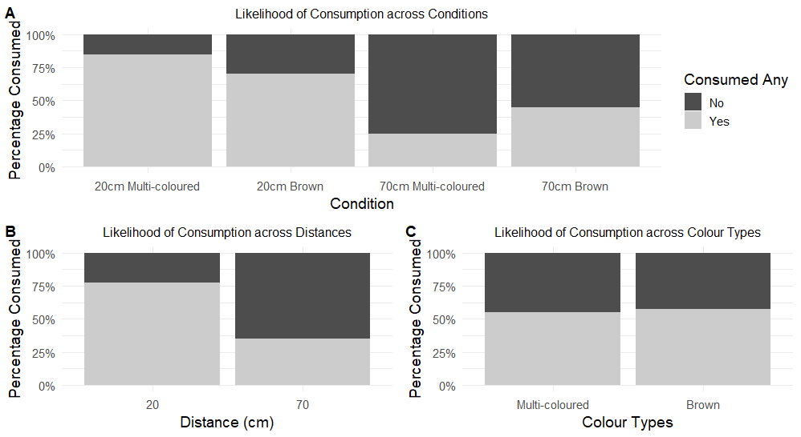
Figure 4. Comparison of likelihood of consumption across conditions (Panel A), across distance positions (Panel B), and across colour type (Panel C).
Results of the binary logistic regression showed that model 3 predicted likelihood of consumption best, accounting for 70.2% variance (Nagelkerke${ R}^{2}$) and 87.5% accuracy (See Table 3). Distance (B = -3.13, p = .025) and perceived visual salience (B = 2.00, p < .001) were the only significant predictors of likelihood of consumption. Individuals who had M&M’s positioned closer to them were more likely to consume than individuals who did not. Perceived visual salience significantly correlated with likelihood of consumption, N = 80, r = .696, p < .001. Colour type did not influence consumption in any model, p > .264.

 |  | Coefficients |  |  |  | 95% CI [Odds Ratio]
 |  | B [SE] | Wald Z | p | Lower |  | OR | Upper
Model 1  $R^{2}$ = .233 | Intercept | 1.176 [.45] | 2.618 | .009 | 1.344 |  | 3.240 | 7.811
 | Distance | -1.857 [.50] | -3.688 | < .001 | 0.058 |  | 0.156 | 0.419
 | Colour type | 0.125 [.50] | 0.249 | .803 | 0.426 |  | 1.133 | 3.013
Model 2  $R^{2}$ = .274 | Intercept | 1.735 [0.63] | 2.770 | .006 | 1.661 |  | 5.667 | 19.336
 | Distance | -2.833 [0.81] | -3.491 | < .001 | 0.012 |  | 0.059 | 0.289
 | Colour type | -0.887 [0.79] | -1.118 | .264 | 0.087 |  | 0.412 | 1.952
 | Distance : Colour | 1.785 [1.05] | 1.703 | .089 | 0.764 |  | 5.961 | 46.520
Model 3  $R^{2}$ = .702 | Intercept | -4.509 [1.57] | -2.874 | .004 | 0.001 |  | 0.011 | 0.238
 | Distance | -3.131 [1.40] | -2.237 | .025 | 0.003 |  | 0.044 | 0.679
 | Colour type | 0.224 [1.09] | 0.205 | .837 | 0.147 |  | 1.252 | 10.668
 | Visual Salience | 2.002 [0.46] | 4.381 | < .001 | 3.023 |  | 7.403 | 18.128
 | Perceived Effort | -.063 [0.51] | 1.632 | .900 | 0.349 |  | 0.939 | 2.527
 | Distance : Colour | 0.642 [1.63] | 0.394 | .694 | 0.078 |  | 1.901 | 46.563
Table 3: Regression models to predict likelihood of M&M consumption
Note: Bold = Significant at p < .05

Actual Consumption
A main effect of distance was found for the amount of M&M’s consumed, F(1, 74) = 15.823, p < .001, $ȵ^{2}$ = .062, with individuals consuming more M&M’s when presented at 20cm (M = 22.94g, SD = 24.49g) than at 70cm (M = 7.02g, SD = 17.86g). Differences in actual consumption between the two colour types was not significant, F(1, 74) = 3.198, p = .078, $ȵ^{2}$ = .027, but showed a trend to suggest more multi-coloured M&M’s (M = 18.56g, SD = 26.25g) were consumed than brown monochrome M&M’s (M = 11.40g, SD = 17.66g). No 2-way interaction between M&M colour and distance was observed, p = .605, with consumption between the 20cm multi-coloured (M = 28.88g, SD = 27.04), 20cm monochrome (M = 16.99g, SD = 20.63), 70cm multi-coloured (M = 8.23g, SD = 22.41), and 70cm monochrome (M = 5.82g, 12.20) being similar (See Figure 5 and OLSM 3, Table 1). Further, a main effect of visual salience was found, F(1, 74) = 32.961, p < .001, $ȵ^{2}$ = .311, with higher perceived visual salience scores being significantly correlated with higher total consumption of M&M’s, N = 80, r = 0.57, p < .001. This trend was seen at both overall and within-condition levels (See OLSM 4, Figure 1).
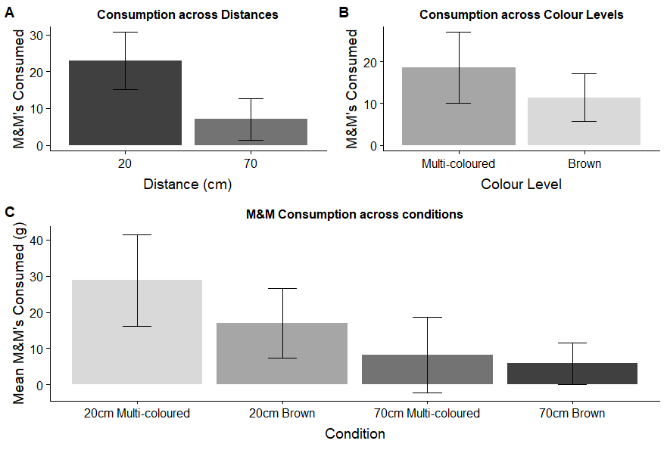
Figure 5: Mean consumption across across each main effect (Panel A & B), with consumption across conditions (Panel C), for the main sample (N = 80).
Sensitivity Analysis. Three individuals were removed due to consuming more than 2 standard deviations above their condition mean, resulting in a sub-sample of N = 77 being used to assess the impact of outliers on the results. Both likelihood of consumption and actual consumption analyses were the same as main analysis (See OLSM 4, Tables 2 and 3).
A further sub-sample containing only consumers (N = 45) was also created to assess the impact of the manipulation on only those who consumed (similar to in Hunter et al., 2018). Analysis to assess likelihood of consumption in this sub-sample was not conducted, as the subsample only contained those who had consumed. In actual consumption analyses, no main effects of distance, p = .193, colour type, p = .067, perceived effort, p = .766, or interaction, p = .293, were found. A main effect of visual salience was found as in main analysis, F(1, 39) = 8.367, p = .006, $ȵ^{2}$=.186. As in main analysis, visual salience positively correlated with amount consumed, R = 0.36, N = 45, p = .014.
In line with Simmons et al., (2011), main analysis was conducted with no covariates (2x2 ANOVA), in order to determine the influence of such factors, showing the main effect of distance remained significant, F(1, 76) = 11.20, p = .001, $ȵ^{2}$ = .128, with no main effect of colour, p = .137, or interaction, p = .322, as seen in main analysis (See OLSM 4, Table 1). Hence, it can be asserted that the covariates do not impact the consumption outcomes.
Exploratory Outcomes. As emotional eating scores differed between distances, this was added as a covariate to actual consumption analysis. Additionally, BMI and hunger were inputted into the ANCOVA as covariates as they are often thought to be associated with overall consumption, but there was no significant impact for any of these factors, p’s > .068 (See OLSM 4, Table 4). Correlations between M&M liking rating and amount of M&M’s consumed were conducted, finding a weak but significant relationship, r = .27, p = .014.

Study 2 Discussion
Study 2 showed that M&M’s were more likely to be consumed, and consumed in a greater quantity, when presented 20cm away from the consumer than when presented 70cm away, displaying proximity effects at each form of consumption (actual and likelihood). Despite mean visual salience scores being similar across colour types, indicating the manipulation of colour type was not successful, there was a non-significant trend to show that more visually colourful M&M’s were consumed more than plain brown M&M’s. Perceived visual salience strongly correlated with both likelihood of consumption and actual consumption, with higher rating relating to higher consumption. Sensitivity analyses showed that outcomes were the same regardless of the exclusion of outliers, further implying that the proximity effect appears to be robust. Future research may wish to measure visual salience before and after snack consumption in order to gain additional data on factors which may influence visual salience, and explore whether consuming the snack results in the snack being perceived as more salient.

General Discussion

Likelihood of Consumption
Two Studies presented chocolate-based snacks at either 20cm or 70cm from individuals and measured the likelihood and actual amount of consumption, while also manipulating the effort required to consume chocolate brownies (Study 1), and the visual colour of M&M’s (Study 2). In both Studies, individuals were more likely to consume a snack when they were presented at 20cm from the individual compared to 70cm away, in line with previous findings by Hunter et al., (2018, 2019) and Maas et al., (2012). In Study 1, a proximity effect was only found when perceived visual salience rating was not controlled for, suggesting that the proximity effect is nullified when considering self-perceived visual salience rating. Hence, H1a is partially accepted. Similarly, a significant, albeit weakened, effect was found for the manipulation of wrapping chocolate brownies in a thin layer of clear plastic wrap, as the wrapping only influenced likelihood of consumption when covariates such as visual salience were not controlled for. Despite likelihood of consumption not being discussed by Brunner (2013) or by Singh and Sikes, (1974), the present findings are thought to be in line with the findings of wider-scale field Studies such as presented by Meyers and Stunkard (1980) which indicate individuals are more likely to consume ice cream when the cooler lid is open. However, there is little laboratory evidence to compare with the present Study.
In Study 2, distance consistently predicted likelihood of consumption, accepting H2a and showing a robust proximity effect. This result corroborates the finding of Maas et al., (2012), and follows the same trend suggested in Hunter et al., (2018). Study 2 also found that perceived visual salience predicted likelihood of consumption, with those who rated the M&M’s as more salient being more likely to consume. This outcome was found regardless of M&M colour type, meaning that manipulating the physical colour type to either be multi-coloured or monochrome brown did not influence the likelihood of consumption, rejecting H2b. While the likelihood of consumption is not often reported within Studies explicitly exploring effects of changing colour on overall consumption, the finding contradicts the findings of Deng and Srinivasan, (2013; Piqueras-Fiszman & Spence, 2014) who found that more colourful snacks are often consumed more frequently than less colourful snacks. However, the result may be due to the manipulation of visual appearance not being fully successful, with visual salience rating for the two snack colour types being similar. Hence, future research with a more robust manipulation of snack colour and visual salience may be conducted to explore the relationship between proximity and visual salience.
Taken together, both Studies show that self-reported visual salience strongly correlated with likelihood of consumption, with those who rated the respective snack as more salient being more likely to have consumed the snack. While this result is correlational, so causation cannot be determined, it may be that individuals who perceive the snack to be more “tempting” and “cannot resist” the snack are more likely to consume (Maas et al., 2012). However, as visual salience rating data were collected after consumption had occurred, individuals could have had a stronger memory of the snack if they had consumed more, thus leading to an increased salience rating (Holtzman, 2006). Therefore, future studies may wish to develop a method of measuring visual salience before or during consumption while maintaining a convincing cover story (Knowles, Brown, & Aldrovandi, 2019b). All results across each of the Studies were similar in sensitivity analysis, with only minor variates in significance and beta-values, so it can be asserted that the proximity effect of likelihood of consumption is largely robust.

Actual Consumption
A significant proximity effect for the amount consumed was found in each Study, with actual consumption being higher when snacks were presented at 20cm than 70cm from the individual, accepting hypotheses H1a and H2a. These main findings of significant proximity effects in each Study reiterate the findings of Maas et al., (2012) and of Privitera and colleagues (2013, 2014), but differs from the recent findings of Hunter et al., (2018, 2019). Of the present findings, study 1 differs largely from those presented by Hunter and colleagues, as the brownies used are much larger snack units than raisins or M&M’s, so less easily comparable. Conversely, Study 2 can more directly be contrasted with the Studies by Hunter et al., (2018, 2019), as each involve presenting M&M’s to participants. While only 250g of M&M’s were presented in the present Study, whereas bowls of 1000g were presented in Hunter et al., (2018), it is unlikely that the portion presented is the cause of the difference, as Maas et al., (2012) found a strong proximity effect whilst presenting 1000g of M&M’s. As methodologies and procedures between Studies are similar, it is plausible that the differences in findings may stem from the amounts consumed at each distance, as Hunter et al. (2018) saw much higher actual consumption at 70cm than in the present Studies (Hunter et al., 2018: 30.5g M&M’s, present Studies: < 10g of brownies, 7.0g of M&M’s). Future studies may wish to further explore causes of the heightened actual consumption of distant snacks in the studies by Hunter and colleagues. Overall, the present Studies contribute to the consensus of Bucher et al. (2016) and Hollands et al. (2019) that the proximity effect is generally robust.
When considering the effort manipulation employed in Study 1, fewer brownies were consumed when the effort to consume them was high (wrapped brownies) compared to when effort was low (unwrapped), accepting H1b. This effect is similar to that of Brunner (2013) and Rozin et al., (2011), showing that the amount consumed can be reduced by increasing effort required. As hypothesised in H1c, a significant interaction was also found between distance and effort. As the proximity effect was seen to occur independent of effort, effort partially moderates the proximity effect for the total amount consumed, with the two effects also working independently. A strong proximity effect was seen for unwrapped brownies, but no proximity effect for wrapped brownies. Hence, when effort is increased to a level where individuals no longer feel the reward is worth the effort exerted, the proximity effect disappears. Choice architects may be able to inform future public health and further reduce both actual and likelihood of consumption by exploiting both manipulations together, thus potentially lowering daily calorie intake. As little is known about the longer-term effectiveness of choice architecture such as the proximity effect, future studies may wish to explore the longer-term effects of the proximity and effort effects to determine whether calorie consumption can be meaningfully reduced through exploiting the proximity effect (Marchiori, Adriaanse, & De Ridder, 2017).
Study 2 found a trend to suggest that more visually attractive, colourful M&M’s were consumed more than visually plain brown M&M’s, but neither this nor the interaction reached significance, rejecting H2b and H2c. Previous studies outside of the proximity effect domain suggested that individuals would consume significantly more of a visually colourful snack than a visually plain snack, but this was not found (Deng & Srinivasan, 2013; Wadhera & Capaldi-Phillips, 2014). This may be explained by the limited manipulation of snack colour, as individuals perceived multi-coloured and monochrome brown M&M’s to offer similar levels of salience which deviated from pilot Study outcomes. When sensitivity analysis was conducted on only those who did consume in Study 2, the visual salience effect was no longer significant. While this non-significant outcome may be due to under-powering, it may suggest that perceived visual salience may have led to the initiation of consumption, but not significantly influence how much was consumed. The data of the present Study are not able to determine a causal relationship, so future Studies may wish to create a Study which allows for a deeper exploration into the relationship between perceived salience and both actual and likelihood of consumption.
The results of each Study were not sensitive to the inclusion of outliers. When the sub-sample of only consumers were used for analysis in Study 1, the proximity and effort effects remained significant, but visual salience was no longer significantly related to actual consumption. In the equivalent sample in Study 2 (only consumers), no proximity effect was found, and a weaker correlation between actual consumption and visual salience rating observed. Taken together, these results suggest that salience may act as a mechanism which initiates consumption, but has a lesser role on the amount consumed. Further exploration into this area is required, as the present Studies cannot fully explain the role of salience within the proximity effect.

Perceived Effort and Visual Salience
The visual salience measure used in both Studies was found to have strong internal consistency across both Studies. Within the findings of Study 1, wrapped brownies were rated as less visually salient than non-wrapped brownies. A plausible explanation of this could be that the scent of the brownies may have been blocked by the thin plastic wrap, causing individuals to perceive the brownie as less ‘nice’ or appetising compared to those who were able to smell the brownies. In Study 2, snacks were rated as similarly visually salient, despite physical colour differences. As such, the measure may not discern between snacks of different visual appearance, or may be influenced by non-visual aspects of the snack, such as smell. In contrast to Study 1, the M&M’s in Study 2 would have smelt similar regardless of what colour their sugar-shell was, potentially leading to similar results on the visual salience scale. Therefore, the current visual salience measure may be a more generalised measure of salience, such as the wording of the measures being more closely related incentive salience, such as items referring to how “nice” or “irresistible” the snack is (Berridge & Robinson, 2017).
The Studies reiterated previous findings of Hunter, Knowles, Maas, and their respective colleagues in that snacks positioned at 70cm are perceived to require more effort to attain than those positioned at 20cm. The Study also confirmed that adding a layer of wrapping to a snack increases the effort required to consume it, as shown by Brunner (2013). Overall perceived effort ratings were similar between those who did consume and those who did not consume, and did not translate to any difference in likelihood or actual consumption, other than in sensitivity analysis of Study 1, suggesting that perceived effort does not predict or influence overall consumption. This may be due in part to the low reliability of the measure (α = 0.48 – 0.68) compared to the previously reported reliability by Maas et al. (2012, α = 0.89). It could also be suggested that the measure has a low consistency due to individuals rating effort on a subjective scale with no objective measure to rate effort on. Future Studies may wish to develop a more consistent perceived effort scale or re-wording the current scale to enhance internal reliability.

Limitations
As previously discussed, the snack colour manipulation may be identified as a limitation of Study 2, but can potentially be explained. Firstly, while the visual salience construct may be effective and reliable at measuring overall visual salience, the measure may not be sensitive enough to measure differences in the appearance of the food items. As previously referred to, the visual salience construct measures how “irresistible” or “nice” a snack appears (Maas et al., 2012). It can be argued that how “irresistible” or “nice” a snack appears does not inherently refer to visual elements such as snack colour, and so does not fully encompass visual salience. Hence, the visual salience construct may not be sensitive enough to identify differences in the visual salience of different coloured items, as chocolate may be equally as ‘tempting’ regardless of snack colour (Rozin et al., 1991). Secondly, olfactory sense input of snacks may influence visual salience results despite not being a visual factor. A future study conducting cluster or factor analysis to identify which measures relate more strongly to visual salience would be required to confirm if this is the case, and assist in the development of a more robust visual salience measure.
Further, it could be considered that individuals may have chosen to not consume the snacks in either Study due to them not liking the snack on offer. However, liking ratings of each respective snack were collected via the questionnaire, with conditions not being different on brownie liking (Study 1) and M&M liking (Study 2), so the effect of this can be considered to be mitigated. Finally, the laboratory environment may have limited the results of the present Studies, as participants’ behaviour may have been influenced by the laboratory surroundings compared to more familiar environments where food would be consumed such as a mock kitchen (Privitera, Cooper, & Cosco, 2012; Privitera & Creary, 2013; Privitera & Zuraikat, 2014). Alternatively, the effect could be explored in field settings, such as those conducted by Rozin et al., (2011) and Kroese, Marchiori, and De Ridder (2016), where snack position can be manipulated in ‘real-world’ environments such as supermarkets and workplaces. While not conducted within a field environment, the present findings may be applicable to snacking behaviour in workplace offices. In these office scenarios, individuals may reduce their actual consumption of less-healthy snacks by placing them further away, by increasing physical effort to consume them such as by using wrappers, or by reducing the visual saliency of the snack. Similarly, the present findings may inform wider public health if applied to café tills where sweet less-healthy snacks are often displayed and selected. If these snacks are presented further away, selection and consumption may be reduced. The present findings are generally in line with previous conclusions stating snacks placed closer are consumed more than those further away (Bucher et al., 2016; Hollands et al., 2019). In agreement with Hollands et al. (2019), future studies may wish to explore the proximity effect in larger field environments and with the food industry to examine how these seemingly robust effects translate to influencing real-world consumption and improving wider public health, but would require stringent procedures and control of the manipulation to determine a meaningful outcome.

Overall Conclusion
Considered together, the proximity effect was observed across two Studies, with both actual and likelihood of consumption being higher when snacks are presented at 20cm from the individual than 70cm. The two Studies indicate that physical effort may somewhat moderate the proximity effect, with perceived visual salience potentially dictating whether to initiate consumption whilst having a lesser impact on how much to consume when snacks are placed at different distances. In particular, increasing physical effort with plastic wrappers diminished the proximity effect, indicating that if effort is high, consumption is similar regardless of position. Results of the second Study indicate that the proximity effect is likely to occur regardless of snack colour, although further research is required to determine a consistent visual salience manipulation. The outcomes of the Study add to and consolidate the knowledge of the proximity effect, whilst also informing future public health policy through encouraging choice architects to design food environments with less-healthy food items positioned further away from consumers to reduce overall consumption of less-healthy snacks. Future studies may wish to explore whether increasing visual salience and reducing effort alongside manipulating distance can increase the consumption of healthier foods such as fruits and vegetables, as well as explore how effects translate from laboratories to more naturalistic environments such as cafés and workplace settings.
Acknowledgements and Declarations
Daniel Knowles (DK) is a PhD student under the supervision of Dr Kyle Brown (KB) and Dr Silvio
Aldrovandi (SA). KB and SA are Senior Lecturers of Applied Psychology at Birmingham City
University. DK planned the studies, with revisions and feedback provided by KB and SA. The studies was carried out by DK, with the manuscript drafted by DK under the supervision and feedback of KB and SA. Data analysis was carried out by DK. All authors have read and approved the final version of the manuscript. This study was ethically approved by the Birmingham City University Ethics Committee. Informed consent was attained from participants prior to each trial, with all data being kept anonymous and stored securely. The authors declare they have no competing interests. The first author (DK) is funded as a PhD student at Birmingham City University. The Doctoral Research College had no part in designing the study, collecting or analysing data, or preparing the manuscript. This research did not receive any specific external grant from funding agencies in the public, commercial, or not-for-profit sector.

Reference List
Bargh, J. A. (2002). Reflections and Reviews Losing Consciousness : Automatic Influences. Journal of Consumer Research, 29(September), 280–285. https://doi.org/10.1086/341577
Bargh, J. A., Schwader, K. L., Hailey, S. E., Dyer, R. L., & Boothby, E. J. (2012). Automaticity in social-cognitive processes. Trends in Cognitive Sciences, 16(12), 593–605. https://doi.org/10.1016/j.tics.2012.10.002
Barkeling, B., Linné, Y., Melin, E., & Rooth, P. (2003). Vision and eating behavior in obese subjects. Obesity Research, 11(1), 130–134. https://doi.org/10.1038/oby.2003.21
Baskin, E., Gorlin, M., Chance, Z., Novemsky, N., Dhar, R., Huskey, K., & Hatzis, M. (2016). Proximity of snacks to beverages increases food consumption in the workplace: A field study. Appetite, 103, 244–248. https://doi.org/10.1016/j.appet.2016.04.025
Berridge, K. C., & Robinson, T. E. (2017). Incentive Sensitization Theory. 71(8), 670–679. https://doi.org/10.1037/amp0000059.Liking
Brondel, L., Romer, M. A., Nougues, P. M., Touyarou, P., & Davenne, D. (2010). Acute partial sleep deprivation increases food intake in healthy men. American Journal of Clinical Nutrition, 91(6), 1550–1559. https://doi.org/10.3945/ajcn.2009.28523
Brunner, T. A. (2013). It takes some effort . How minimal physical effort reduces consumption volume. Appetite, 71, 89–94. https://doi.org/10.1016/j.appet.2013.07.014
Bucher, T., Collins, C., Rollo, M. E., McCaffrey, T. A., De Vlieger, N., Van der Bend, D., … Perez-Cueto, F. J. A. (2016). Nudging consumers towards healthier choices: a systematic review of positional influences on food choice. British Journal of Nutrition, 115(12), 2252–2263. https://doi.org/10.1017/S0007114516001653
Delwiche, J. F. (2012). You eat with your eyes first. Physiology and Behavior, 107(4), 502–504. https://doi.org/10.1016/j.physbeh.2012.07.007
Deng, X., & Srinivasan, R. (2013). When do transparent packages increase (or decrease) food consumption? American Marketing Association, 77(4), 104–177.
Di Cesare, M., Bentham, J., Stevens, G. A., Zhou, B., Danaei, G., Lu, Y., … Cisneros, J. Z. (2016). Trends in adult body-mass index in 200 countries from 1975 to 2014: A pooled analysis of 1698 population-based measurement studies with 19.2 million participants. The Lancet, 387(10026), 1377–1396. https://doi.org/10.1016/S0140-6736(16)30054-X
Dijksterhuis, A., Smith, P. K., van Baaren, R. B., & Wigboldus, D. H. J. (2005). The Unconscious Consumer: Effects of Environment on Consumer Behavior. Journal of Consumer Psychology, 15(3), 193–202. https://doi.org/10.1207/s15327663jcp1503_3
Greer, S. M., Goldstein, A. N., & Walker, M. P. (2013). The impact of sleep deprivation on food desire in the human brain. Nature Communications, 4, 2259. https://doi.org/10.1038/ncomms3259
Hansen, P. G. (2016). The Definition of Nudge and Libertarian Paternalism: Does the Hand Fit the Glove? European Journal of Risk Regulation, 7(1), 155–174. https://doi.org/10.1017/S1867299X00005468
Higgs, S., & Donohoe, J. E. (2011). Focusing on food during lunch enhances lunch memory and decreases later snack intake. Appetite, 57(1), 202–206. https://doi.org/10.1016/j.appet.2011.04.016
Hollands, G. J., Carter, P., Anwer, S., King, S. E., Jebb, S. A., Ogilvie, D., ... & Marteau, T. M. (2019). Altering the availability or proximity of food, alcohol, and tobacco products to change their selection and consumption. Cochrane Database of Systematic Reviews, (9). https://doi.org/10.1002/14651858.CD012573.pub3
Hollands, G. J., French, D. P., Griffin, S. J., Prevost, A. T., Sutton, S., King, S., & Marteau, T. M. (2016). The impact of communicating genetic risks of disease on risk-reducing health behaviour: systematic review with meta-analysis. BMJ, (October), i1102. https://doi.org/10.1136/bmj.i1102
Hollands, G. J., Marteau, T. M., & Fletcher, P. C. (2016). Non-conscious processes in changing health- related behaviour : a conceptual analysis and framework. Health Psychology Review, 10, 381–394. https://doi.org/10.1080/17437199.2015.1138093
Holtzman, J. D. (2006). Food and Memory. Annual Review of Anthropology, 35(1), 361–378. https://doi.org/10.1146/annurev.anthro.35.081705.123220
Hunter, J. A., Hollands, G. J., Couturier, D.-L., & Marteau, T. M. (2018). Effect of snack-food proximity on intake in general population samples with higher and lower cognitive resource. Appetite, 121, 337–347. https://doi.org/10.1016/j.appet.2017.11.101
Hunter, J. A., Hollands, G. J., Pilling, M., & Marteau, T. M. (2019). Impact of proximity of healthier versus less healthy foods on intake: A lab-based experiment. Appetite, 133(May 2018), 147–155. https://doi.org/10.1016/j.appet.2018.10.021
Jansen, E., Mulkens, S., & Jansen, A. (2010). How to promote fruit consumption in children. Visual appeal versus restriction. Appetite, 54(3), 599–602. https://doi.org/10.1016/j.appet.2010.02.012
Johnson, W. G. (1974). Effect of cue prominence and subject weight on human food-directed performance. Journal of Personality and Social Psychology, 29(6), 843–848. https://doi.org/10.1037/h0036390
Kahneman, D. (2013). Thinking Fast and Slow. In Farrar, Straus & Giroux, New York (Vol. 1). https://doi.org/10.1017/CBO9781107415324.004
Karlsson, J., Persson, L. O., Sjöström, L., & Sullivan, M. (2000). Psychometric properties and factor structure of the Three-Factor Eating Questionnaire (TFEQ) in obese men and women. Results from the Swedish Obese Subjects (SOS) study. International Journal of Obesity, 24(12), 1715–1725. https://doi.org/10.1038/sj.ijo.0801442
Knowles, D., Brown, K., & Aldrovandi, S. (2019a). Exploring incentive salience in relation to pre and post-consumption measures within the proximity effect: A study protocol. In PsyArXiv.
Knowles, D., Brown, K., & Aldrovandi, S. (2019b). Exploring the underpinning mechanisms of the proximity effect within a competitive food environment. Appetite, 134(December 2018), 94–102. https://doi.org/10.1016/j.appet.2018.12.005
Knowles, D., Brown, K. G., & Aldrovandi, S. (2018a). Exploring the role of Effort within the Proximity Effect: A Study Protocol. 1–29. https://doi.org/10.17605/OSF.IO/RMNYS
Knowles, D., Brown, K. G., & Aldrovandi, S. (2018b). Exploring the role of Visual Salience within the Proixmity Effect: Registered Report (Vol. 1).
Kroese, F. M., Marchiori, D. R., & De Ridder, D. T. D. (2016). Nudging healthy food choices: A field experiment at the train station. Journal of Public Health (United Kingdom), 38(2), e133–e137. https://doi.org/10.1093/pubmed/fdv096
Langlet, B., Fagerberg, P., Glossner, A., & Ioakimidis, I. (2017). Objective quantification of the food proximity effect on grapes, chocolate and cracker consumption in a Swedish high school. A temporal analysis. PLOS ONE, 12(8), e0182172. https://doi.org/10.1371/journal.pone.0182172
Lind, M., Visentini, M., Mäntylä, T., & Missier, F. Del. (2017). Choice-Supportive Misremembering : A New Taxonomy and Review. 8(December). https://doi.org/10.3389/fpsyg.2017.02062
Maas, J., de Ridder, D. T. D., de Vet, E., & de Wit, J. B. F. (2012). Do distant foods decrease intake? The effect of food accessibility on consumption. Psychology & Health, 27(sup2), 59–73. https://doi.org/10.1080/08870446.2011.565341
Marchiori, D. R., Adriaanse, M. A., & De Ridder, D. T. D. (2017). Unresolved questions in nudging research: Putting the psychology back in nudging. Social and Personality Psychology Compass, 11(1), 1–13. https://doi.org/10.1111/spc3.12297
Marteau, T. M., Hollands, G. J., & Fletcher, P. C. (2012). Changing Human Behavior to Prevent Disease: The Importance of Targeting Automatic Processes. Science, 337(6101), 1492–1495. https://doi.org/10.1126/science.1226918
Mather, M., & Johnson, M. K. (2000). Choice-supportive source monitoring: Do our decisions seem better to us as we age? Psychology and Aging, 15(4), 596. https://doi.org/10.1037/0882-7974.15.4.596
Meiselman, H. L., Hedderley, D., Staddon, S. L., Pierson, B. J., & Symonds, C. R. (1994). Effect of Effort on Meal Selection and Meal Acceptability in a Student Cafeteria. Appetite, 23(1), 43–55. https://doi.org/10.1006/appe.1994.1033
Meyers, A. W., & Stunkard, A. J. (1980). Food Accessibility and Food Choice. Archives of General Psychiatry, 37(10), 1133. https://doi.org/10.1001/archpsyc.1980.01780230051007
Morrot, G., Brochet, F., & Dubourdieu, D. (2001). The color of odors. Brain and Language, 79(2), 309–320. https://doi.org/10.1006/brln.2001.2493
Piqueras-Fiszman, B., Alcaide, J., Roura, E., & Spence, C. (2012). Is it the plate or is it the food? Assessing the influence of the color (black or white) and shape of the plate on the perception of the food placed on it. Food Quality and Preference, 24(1), 205–208. https://doi.org/10.1016/j.foodqual.2011.08.011
Piqueras-Fiszman, B., & Spence, C. (2014). Colour, pleasantness, and consumption behaviour within a meal. Appetite, 75, 165–172. https://doi.org/10.1016/j.appet.2014.01.004
Privitera, G. J., Cooper, K. C., & Cosco, A. R. (2012). The influence of eating rate on satiety and intake among participants exhibiting high dietary restraint. Food and Nutrition Research, 56, 1–6. https://doi.org/10.3402/fnr.v56i0.10202
Privitera, G. J., & Creary, H. E. (2013). Proximity and Visibility of Fruits and Vegetables Influence Intake in a Kitchen Setting Among College Students. Environment and Behavior, 45(7), 876–886. https://doi.org/10.1177/0013916512442892
Privitera, G. J., & Zuraikat, F. M. (2014). Proximity of foods in a competitive food environment influences consumption of a low calorie and a high calorie food. Appetite, 76, 175–179. https://doi.org/10.1016/j.appet.2014.02.004
Robinson, E., Bevelander, K. E., Field, M., & Jones, A. (2018). Methodological and reporting quality in laboratory studies of human eating behavior. Appetite. https://doi.org/10.1016/j.appet.2018.02.008
Rozin, P., Levine, E., & Stoess, C. (1991). Chocolate craving and liking. Appetite, 17(3), 199–212. https://doi.org/10.1016/0195-6663(91)90022-K
Rozin, P., Scott, S., Dingley, M., Urbanek, J. K., Jiang, H., & Kaltenbach, M. (2011). Nudge to nobesity I: Minor changes in accessibility decrease food intake. Judgment and Decision Making, 6(4), 323–332. https://doi.org/10.1111/j.1753-4887.2009.00206.x
Schaefer, J. T., & Magnuson, A. B. (2014). A Review of Interventions that Promote Eating by Internal Cues. Journal of the Academy of Nutrition and Dietetics, 114(5), 734–760. https://doi.org/10.1016/j.jand.2013.12.024
Simmons, J. P., Nelson, L. D., & Simonsohn, U. (2011). False-positive psychology: Undisclosed flexibility in data collection and analysis allows presenting anything as significant. Psychological Science, 22(11), 1359–1366. https://doi.org/10.1177/0956797611417632
Singh, D., & Sikes, S. (1974). Role of past experience of food-motivated behavior of obese humans. Journal of Comparative and Physiological Psychology, 86(3), 503–508. https://doi.org/10.1037/h0036247
Spence, C. (2018). Background colour & its impact on food perception & behaviour. 68(February), 156–166. https://doi.org/10.1016/j.foodqual.2018.02.012
Sunstein, C. R. (2016). Nudges That Fail. Working Paper, 1411(2015), 1–20. https://doi.org/10.2139/ssrn.2809658
Thaler, R. H., & Sunstein, C. R. (2008). Nudge: Improving Decisions about Health, Wealth, and Happiness (Vol. 1). https://doi.org/10.1017/CBO9781107415324.004
Tolman, E. C. (1932). Purposive behavior in animals and men. In Purposive behavior in animals and men. Berkeley, CA, US: University of California Press.
Vanata, D. F., Ph, D., Hatch, A. M., & Depalma, G. (2011). Seating Proximity in a Cafeteria Influences Dessert Consumption among College Students. International Journal of Humanities and Social Science, 1(4), 1–6.
Veale, J. F. (2014). Edinburgh Handedness Inventory–Short Form: a revised version based on confirmatory factor analysis. Laterality: Asymmetries of Body, Brain and Cognition, 19(2), 164–177.
Wadhera, D., & Capaldi-Phillips, E. D. (2014). A review of visual cues associated with food on food acceptance and consumption. Eating Behaviors, 15(1), 132–143. https://doi.org/10.1016/j.eatbeh.2013.11.003
Waugh, C. E., & Gotlib, Æ. I. H. (2008). Motivation for reward as a function of required effort : Dissociating the ‘ liking ’ from the ‘ wanting ’ system in humans. 323–330. https://doi.org/10.1007/s11031-008-9104-2
Webb, T. L., & Sheeran, P. (2006). Does changing behavioral intentions engender behavior change? A meta-analysis of the experimental evidence. Psychological Bulletin, 132(2), 249–268. https://doi.org/10.1037/0033-2909.132.2.249
World Health Organization. (2013). Global action plan for the prevention and control of noncommunicable diseases 2013-2020. World Health Organization, 102. https://doi.org/978 92 4 1506236

